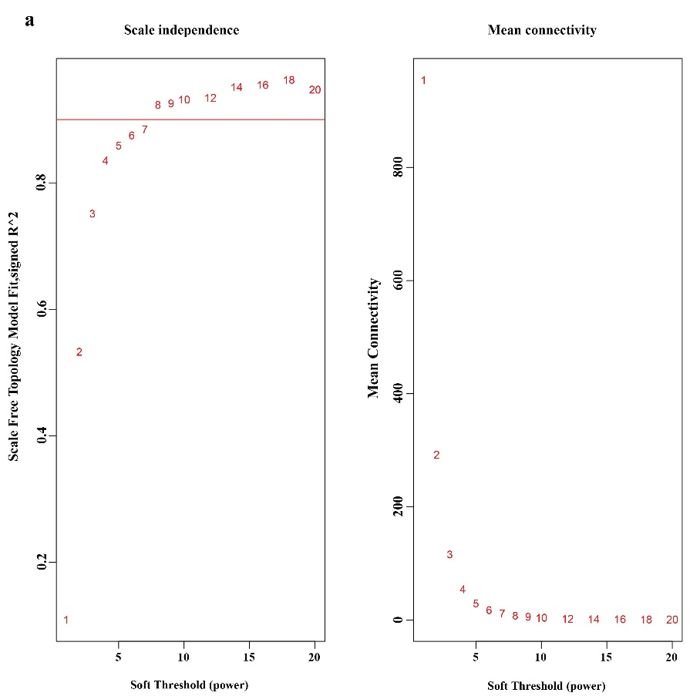
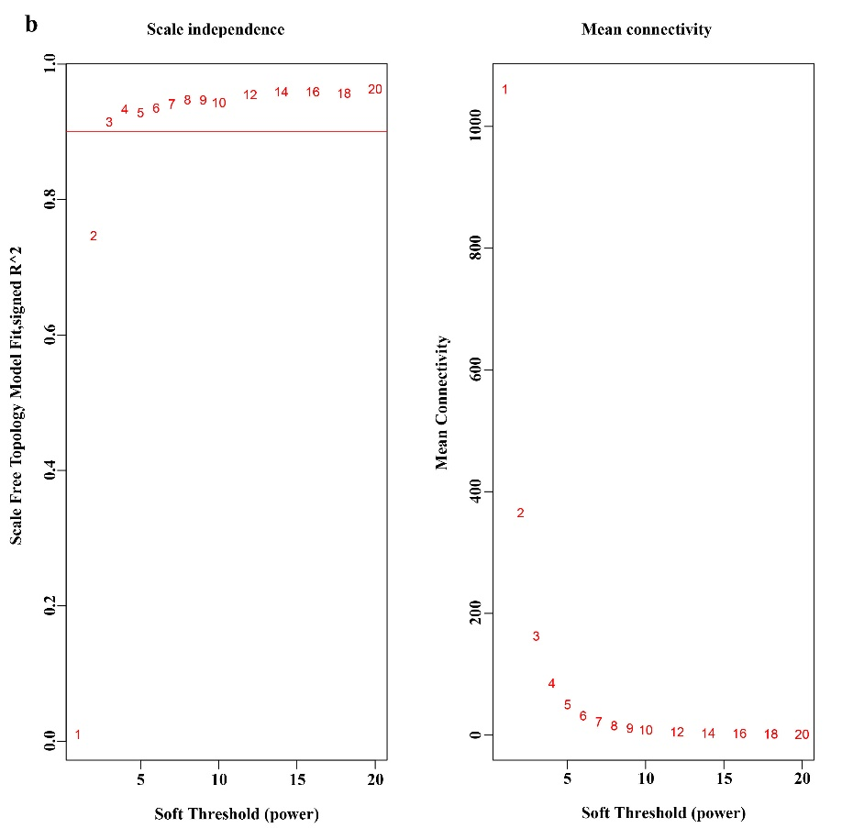
Suppletary Figure S1. soft-thresholding values estimation. Scale independence and mean connectivity of various soft-thresholding values (β) in (a) negative and (b) positive model.

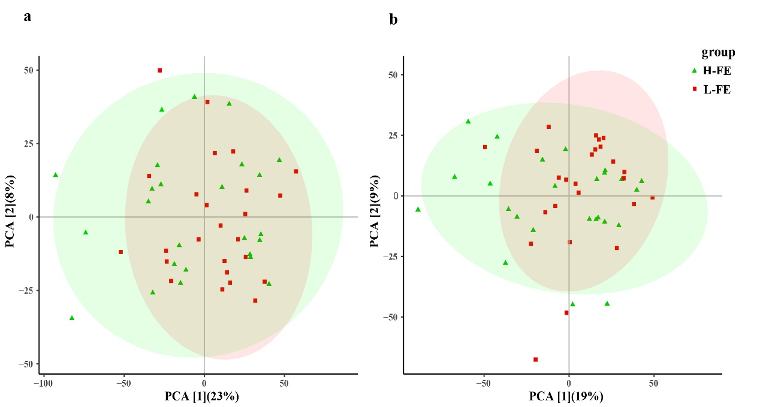
Suppletary Figure S2. Principal Component Analysis (PCA) scores plots based on LC/MS data of fecal samples from H-FE (green) and L-FE (red) of (a) positive and (b) negative model.
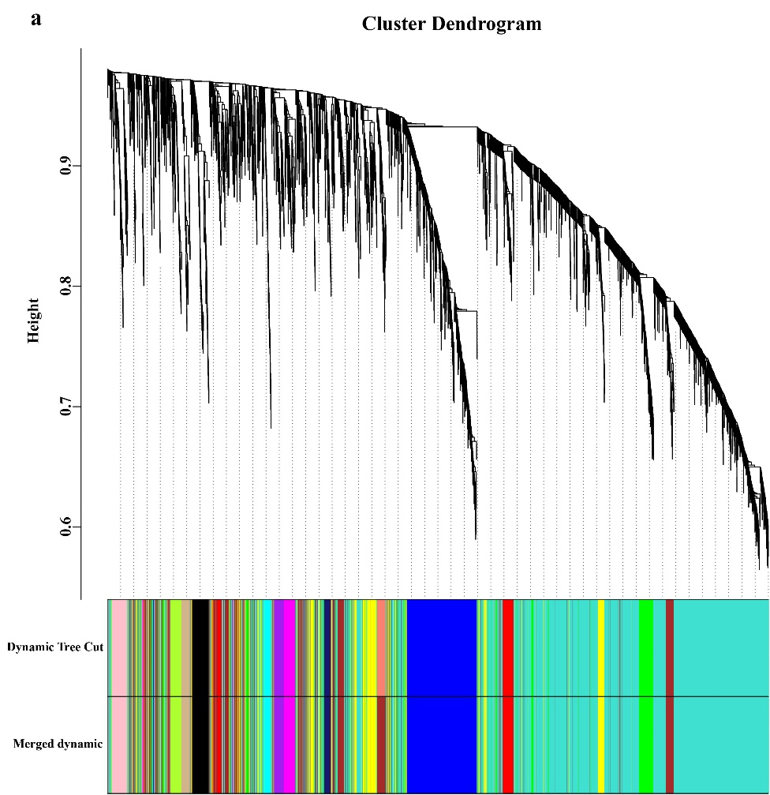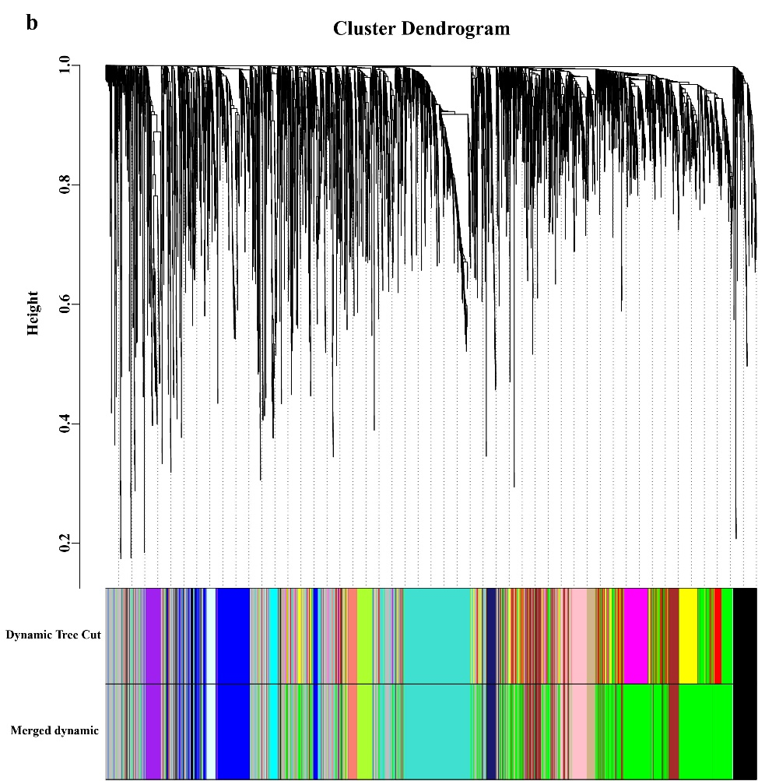
Suppletary Figure S3. Clustering dendrogram and module-trait correlation plots. Each coloured row represents a colour-coded module which contains a group of highly connected metabolic features. A total of 14 and 14 modules was identified in (a) positive and (b) negative model, respectively.

