Supplementary Information
Table S1 Source, catalog number, and purity of the materials used in this study.

Material | Source | Cat No.
Hematoxylin and Eosin Staining Kit | HaoKebio, Hangzhou, China | HK2019
Sirius Red Staining Kit | HaoKebio, Hangzhou, China | HK2021
Cytokeratin 19 Monoclonal antibody | Proteintech, Wuhan, China | 60187-1-Ig
IL-6 Recombinant monoclonal antibody | Proteintech, Wuhan, China | 83795-7-RR
p21 Polyclonal antibody | Proteintech, Wuhan, China | 28248-1-AP
EPCAM/CD326 Polyclonal antibody | Proteintech, Wuhan, China | 21050-1-AP
SOX9 Monoclonal antibody | Proteintech, Wuhan, China | 67439-1-Ig
Anti-CDKN2A/p16INK4a antibody - N-terminal | Abcam, Cambridge, UK | ab189034
Albumin Polyclonal antibody | Proteintech, Wuhan, China | 16475-1-AP
Goat Anti-Mouse IgG H&L (HRP) | Abcam, Cambridge, UK | ab205719
Goat Anti-Rabbit IgG H&L (HRP) | Abcam, Cambridge, UK | ab205718
Donkey anti-Mouse IgG (H+L) Highly Cross-Adsorbed Secondary Antibody, Alexa Fluor™ Plus 647 | Thermo Fisher Scientific, MA, USA | A32787
DAPI Staining Solution | Solarbio, Beijing, China | C0060
iFluor® 488 tyramide | AAT Bioquest, CA, USA | 11060
CY5 tyramide | AAT Bioquest, CA, USA | 11066
iFluor® 430 Tyramide | AAT Bioquest, CA, USA | 45096
iFluor® 680 Tyramide | AAT Bioquest, CA, USA | 45113
Fluoromount-G® | SouthernBiotech, AL, USA | 0100-01
2-octynoic acid-BSA | Ruixibio, Xi'an, China | R-C-1206
Pertussis toxin | Sigma-Aldrich, St. Louis, USA | 516562-M
Incomplete Freund's adjuvant | Sigma-Aldrich, St. Louis, USA | F5506
Complete Freund's adjuvant | Sigma-Aldrich, St. Louis, USA | F5881
Berberine chloride | MedChemExpress, NJ, USA | HY-18258
Bovine serum albumin | MedChemExpress, NJ, USA | HY-D0842
Y-27632 | MedChemExpress, NJ, USA | HY-10071
Human IL-6 Elisa Kit | ZCIBIO, Shanghai, China | ZC-32446
Human TNF-α Elisa Kit | ZCIBIO, Shanghai, China | ZC-35733
Human IL-8 Elisa Kit | ZCIBIO, Shanghai, China | ZC-32449
Human CXCL2 Elisa Kit | ZCIBIO, Shanghai, China | ZC-34458
Human CXCL10 Elisa Kit | ZCIBIO, Shanghai, China | ZC-57631
SA-β-gal staining Kit | ZCIBIO, Shanghai, China | ZC-2190
Phalloidin Peptide | Sigma-Aldrich, St. Louis, USA | P5282
Osmium tetroxide | Sigma-Aldrich, St. Louis, USA | 201030
Primocin | InvivoGen, CA, USA | ant-pm-2
AO/PI Double Staining Kit | Countstar, Shanghai, China | RE010212
Countstar Chamber Slide | Countstar, Shanghai, China | CO010101
Matrigel Matrix | Corning, NY, USA | 356231
Falcon 100 μm Cell Strainers | Corning, NY, USA | 352360
Falcon 24-well Clear Flat Bottom TC-treated Multiwell Cell Culture Plate | Corning, NY, USA | 353935
Penicillin/streptomycin | Thermo Fisher Scientific, MA, USA | 15140122
GlutaMAX Supplement (100×) | Thermo Fisher Scientific, MA, USA | 35050061
DMEM/F12 Medium | Thermo Fisher Scientific, MA, USA | 11320033
HEPES | Thermo Fisher Scientific, MA, USA | 15630080
BSA | MedChemExpress, NJ, USA | HY-D0842
Normal Goat Serum | Abcam, Cambridge, UK | ab7481
Phosphate buffered solution | Biosharp Life Sciences, Hefei, China | 163202
Red blood cell lysis buffer | Biosharp Life Sciences, Hefei, China | BL503A
4% Paraformaldehyde | Biosharp Life Sciences, Hefei, China | BL539A
TRIzol™ Reagent | InvivoGen, CA, USA | 15596018CN
RNeasy Plus Mini Kit | Qiagen, CA, USA | 74134
PrimeScript™ RT Reagent Kit with gDNA Eraser | Takara, Kusatsu, Japan | RR047A
TB Green Premix Ex Taq | Takara, Kusatsu, Japan | RR420A
TrypLE™ Express | Thermo Fisher Scientific, MA, USA | 12604013
Cell Recovery Solution | Corning, NY, USA | CLS354253
Tween 20 | Beyotime, Shaihai, China | ST1727

Table S2 Types and specifications of the devices and equipment used in this study.
Devices and equipment | Type | Specification
Centrifuge | Eppendorf, Hamburg, Germany | 5424 R
Centrifuge | CenLee, Changsha, China | TDL5M
Cell incubator | Thermo Fisher Scientific, MA, USA | 3111
Automated cell counter | Countstar, Shanghai, China | Mira FL
Real-time PCR system | Applied Biosystems, California, USA | ViiA7
PCR system | Applied Biosystems, California, USA | ProFlex™ PCR
Homogenizer | Bertin Technologies, Paris, French | Precellys 24
Microplate reader | Molecular devices, California, USA | SpectraMax i3x
Embedding machine | Jun Jie, Wuhan, China | JB-P5
Slicer | Leica, Shanghai, China | HistoCore MULTICUT R
Inverted microscope | Leica, Shanghai, China | DM ILM
Fluorescence microscope | Zeiss, Jena, Germany | LSM T-PMT confocal microscope
Transmission electron microscope | Hitachi, Tokyo, Japan | HT7800
Sequenator | Illumina, California, USA | Novaseq 6000
Agilent 2100 Bioanalyzer | Agilent Technologies, Santa Clara, CA, USA | 2100
Spectrophotometer | Thermo Fisher Scientific, MA, USA | NanoDrop2000

Table S3 List of primer pairs employed in quantitative real-time PCR assays for the target genes. GAPDH was used for normalization.

Gene | Forward sequence (5’-3’) | Reserve sequence (3’-5’)
Human
TNF-α | GCTGCACTTTGGAGTGATCG | ATGAGGTACAGGCCCTCTGA
IL-6 | ATGAGGAGACTTGCCTGGTGAA | CTCTGGCTTGTTCCTCACTACTCTC
CXCL10 | GCCATTCTGATTTGCTGCCTT | CGTGGACAAAATTGGCTTGC
GAPDH | GGAAGCTTGTCATCAATGGAAATC | TGATGACCCTTTTGGCTCCC
IL-8 | CAGTTTTGCCAAGGAGTGCTAA | AAACTTCTCCACAACCCTCTGC
CX3CL1 | GGGAATGGACGAGTCTGTGG | ACGGGAGGCACTCGGAAAA
CXCL2 | CAAACCGAAGTCATAGCCACA | TCCTTCAGGAACAGCCACCA
Mice
IL-6 | TAGTCCTTCCTACCCCAATTTCC | TTGGTCCTTAGCCACTCCTTC
TNF-α | GGTGCCTATGTCTCAGCCTCTT | GCCATAGAACTGATGAGAGGGAG
cxcl10 | ATCATCCCTGCGAGCCTATCCT | GACCTTTTTTGGCTAAACGCTTTC
GAPDH | CATCACTGCCACCCAGAAGACTG | ATGCCAGTGAGCTTCCCGTTCAG
CXCL6 | CCGCTGGCATTTCTGTTGCTGT | CAGGGATCACCTCCAAATTAGCG
IL-8 | CAAGGCTGGTCCATGCTCC | TGCTATCACTTCCTTTCTGTTGC
α-sam | TGCTGACAGAGGCACCACTGAA | CAGTTGTACGTCCAGAGGCATAG
CXCL10 | ATCATCCCTGCGAGCCTATCCT | GACCTTTTTTGGCTAAACGCTTTC

Figure S1. LEfSe analysis of the gut microbiota among the three groups at the genus level.
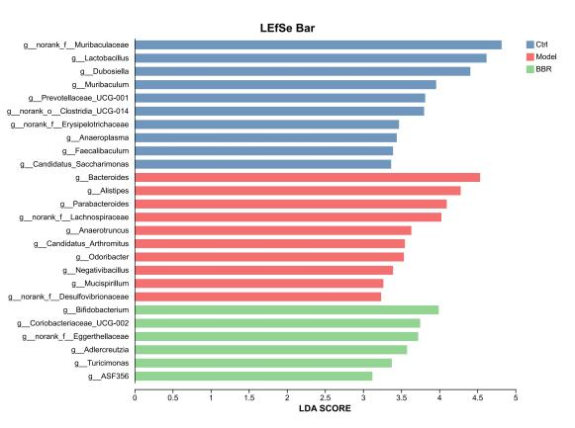
Figure S2. Relative abundance of bacteria among the three groups at the genus level.

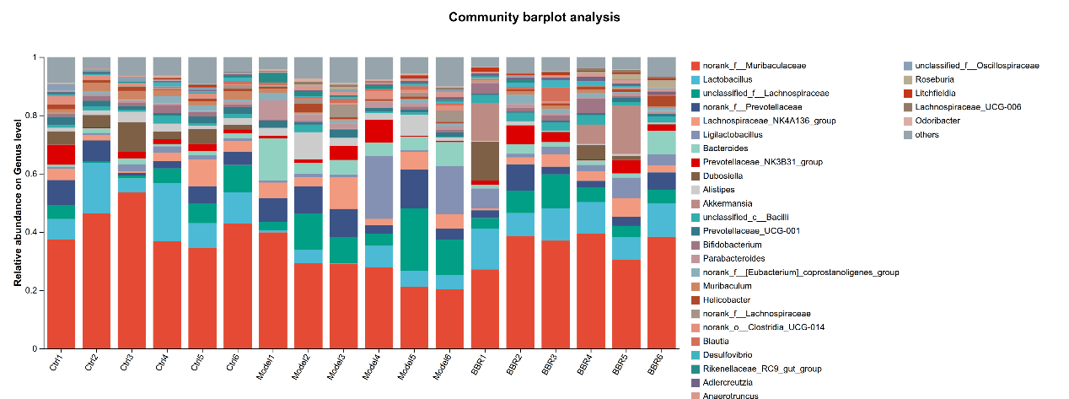
Figure S3. LEfSe analysis of the gut microbiota among the three groups at the family level.
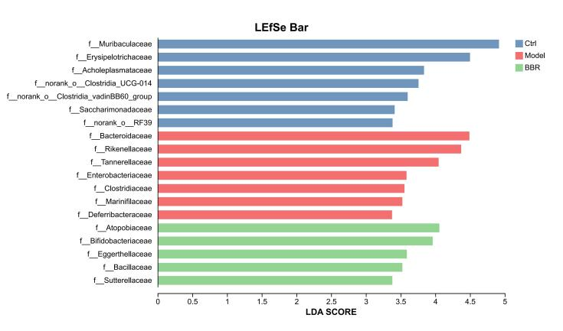
Figure S4. Relative abundance of bacteria among the three groups at the family level.
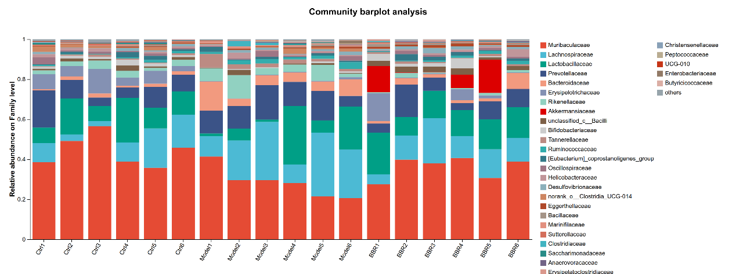

Figure S5. Numbers of differentially expressed proteins, including upregulated and downregulated proteins, among the three groups.
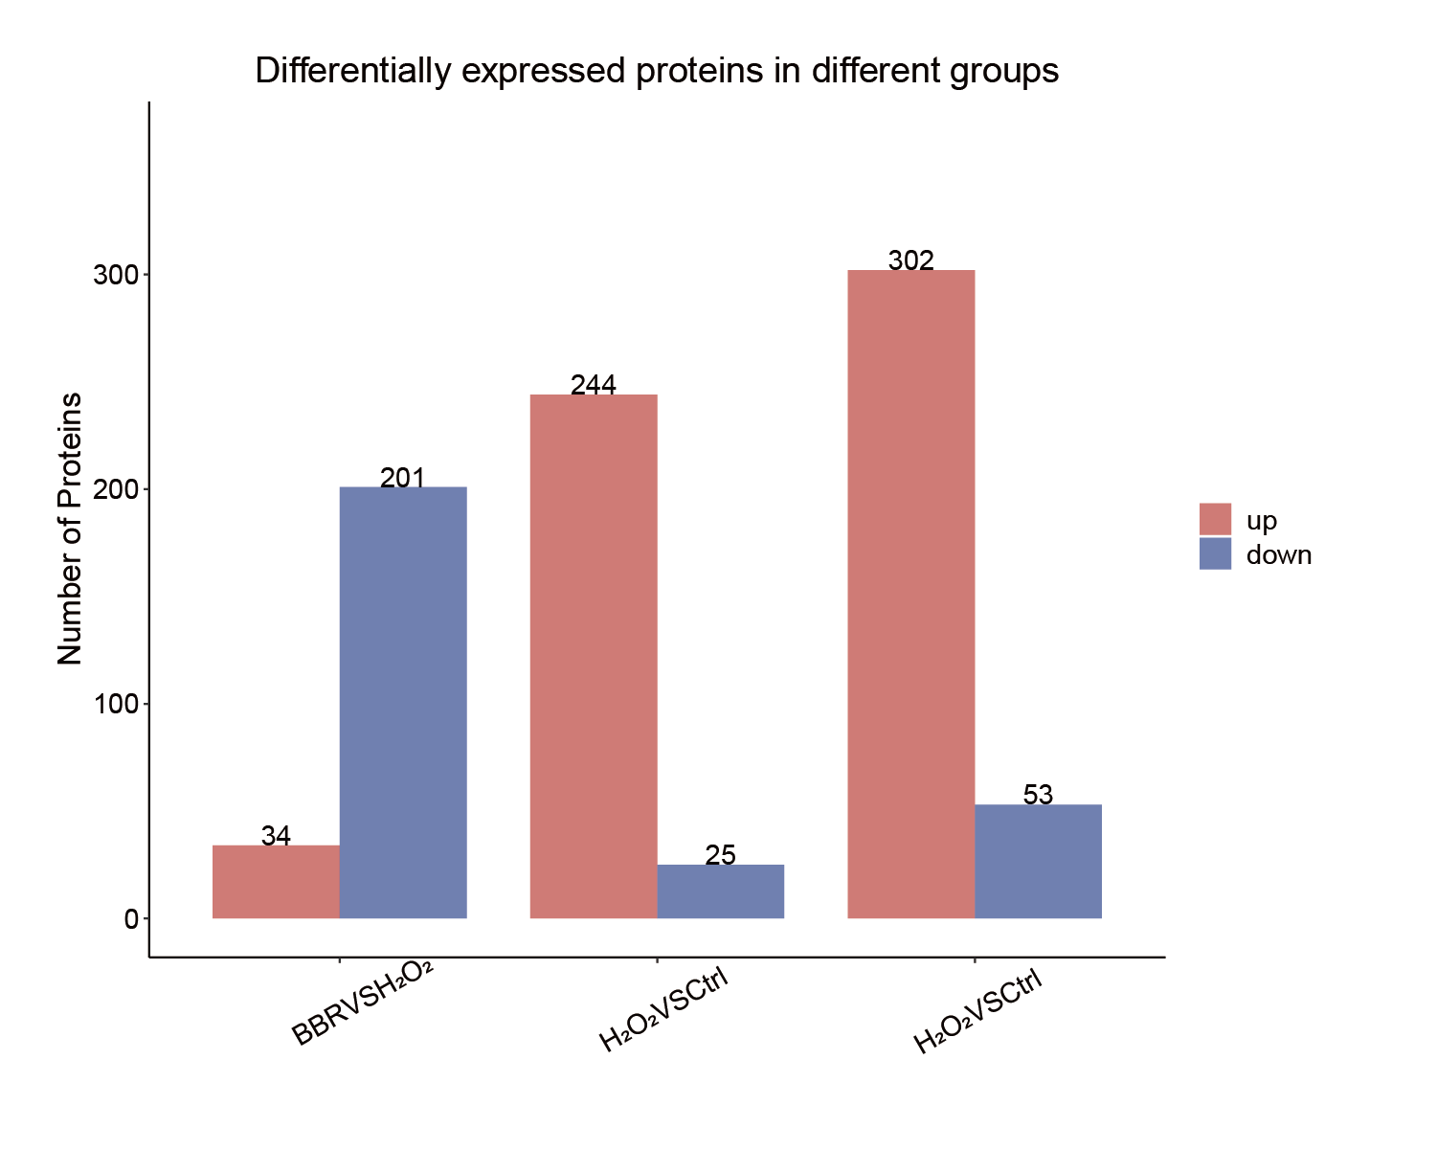
Methods
Establishment and Intervention of Human Bile-Derived Cholangiocyte Organoids
Fresh bile was collected from postoperative drainage of patients undergoing endoscopic retrograde cholangiopancreatography (ERCP) or percutaneous transhepatic cholangial drainage (PTCD) into sterile containers containing pre-cooled preservation buffer (DMEM/F-12 supplemented with 1% GlutaMAX, 1% HEPES, and 3% penicillin–streptomycin). Samples were maintained on ice throughout processing.
A 20-μL aliquot of bile was mixed with an equal volume of AO/PI staining solution, and cell viability was assessed using an automated cell counter. Samples with cell viability >80% were used for subsequent experiments.
To minimize cell loss, pipette tips, microcentrifuge tubes, and other plasticware were pre-rinsed with PBS containing 7.5% bovine serum albumin (BSA). Bile samples were diluted with five volumes of preservation buffer, passed through a 100-μm cell strainer, and centrifuged at 300 × g for 5 min at 4°C. The resulting pellet was resuspended in red blood cell lysis buffer and incubated at 4°C for 10 min with gentle agitation every 2 min. Lysis was terminated by adding two volumes of preservation buffer, followed by centrifugation at 300 × g for 5 min at 4°C.
The pellet was resuspended in 1 mL preservation buffer and centrifuged again at 300 × g for 5 min at 4°C. After discarding the supernatant, the washing step was repeated once. Cells were finally resuspended in 1 mL preservation buffer, and cell number and viability were reassessed. Following a final centrifugation at 300 × g for 5 min at 4°C, the total number of viable cells was calculated.
Cells were mixed with Matrigel at a density of 1 × 10⁵ cells per 50 μL and plated as domes in the center of 24-well plates. After polymerization at 37°C for 20 min, 500 μL of organoid culture medium (DMEM/F-12 supplemented with 0.1% Y-27632 and 0.2% Primocin) was added to each well. Organoids were maintained in a humidified incubator at 37°C with 5% CO₂. The culture medium was refreshed every 48–72 h, and organoid morphology was monitored every other day using an inverted microscope.
For passaging, culture medium was aspirated and an appropriate volume of buffer was added to gently triturate the domes and detach the basement membrane matrix. The suspension was collected into a 15-mL tube, followed by the addition of 5 mL Cell Recovery Solution. Samples were incubated on a rocking platform at 4°C for 15 min to dissolve the matrix. Organoids were then pelleted by centrifugation at 300 × g for 5 min, and the supernatant was discarded. The pellet was resuspended in buffer and centrifuged again at 300 × g for 5 min, after which the supernatant was removed.
The organoid pellet was subsequently resuspended in TrypLE™ Express and incubated on a rocking platform at room temperature for 10 min to facilitate dissociation. The digestion was terminated by adding an equal volume of buffer, followed by centrifugation at 300 × g for 5 min. After removal of the supernatant, organoids were passaged at a ratio of 1:3, mixed with fresh basement membrane matrix, and replated as described above.
This study was approved by the Clinical Research Ethics Committee of the First Affiliated Hospital, Zhejiang University School of Medicine (No. IIT20220456B–R1)

16S rRNA gene sequencing and analysis
Genomic DNA was extracted from the contents of the colon and assessed by 1% agarose gel electrophoresis. The V3–V4 hypervariable region of the bacterial 16S rRNA gene was amplified using barcoded primers 338F (5′-ACTCCTACGGGAGGCAGCAG-3′) and 806R (5′-GGACTACHVGGGTWTCTAAT-3′) under optimized PCR conditions with a low and consistent number of cycles across all samples. PCR amplification was performed using TransStart FastPfu DNA Polymerase (TransGen Biotech) on an ABI GeneAmp® 9700 thermocycler. Each sample was amplified in triplicate, pooled, and purified using a gel extraction kit. Amplicon concentrations were quantified by fluorescence-based methods, and equimolar amounts of PCR products were pooled for library preparation.
Sequencing libraries were constructed using the TruSeq™ DNA Sample Prep Kit and subjected to paired-end sequencing on an Illumina NextSeq 2000 platform according to the manufacturer’s instructions.
Paired-end reads were demultiplexed, quality filtered, and merged based on overlapping regions. High-quality sequences were denoised using the DADA2 algorithm to generate amplicon sequence variants (ASVs) and their corresponding abundance profiles. Based on ASV data, downstream analyses including taxonomic assignment, microbial diversity analysis, and differential abundance analysis were performed.
All data analyses were performed using the Majorbio/I-Sanger Cloud Platform (https://cloud.majorbio.com or https://cloud.i-sanger.com). Alpha diversity indices, including Sobs, Chao1, and Shannon indices, were calculated using the Mothur software, and differences in alpha diversity among groups were assessed using the Wilcoxon rank-sum test. Principal coordinate analysis (PCoA) based on Bray–Curtis dissimilarity was conducted to evaluate the similarity of microbial community structures among samples, and statistical significance of group differences was assessed using permutational multivariate analysis of variance (PERMANOVA). In addition, differential taxa from the phylum to genus levels were identified using linear discriminant analysis effect size (LEfSe) with an LDA score > 3 and P < 0.05.
Transcriptome sequencing and analysis
To profile the transcriptomic alterations in liver organoids across experimental groups, total RNA was extracted from harvested organoids and liver tissues using TRIzol reagent according to the manufacturer’s protocol. RNA purity and quantification were evaluated using the NanoDrop2000 spectrophotometer (Thermo Scientific, USA). RNA integrity was assessed using the Agilent 2100 Bioanalyzer (Agilent Technologies, Santa Clara, CA, USA). Then the libraries were constructed usingVAHTS Universal V10 RNA-seq Library Prep Kit (Premixed Version) according to the manufacturer’sinstructions. The transcriptome sequencing and analysis were conducted by OE BiotechCo., Ltd.(Shanghai, China).
Differential expression analysis was performed using the DESeq2. Q value < 0.05 and foldchange > 2 or foldchange < 0.5 was set as the threshold for significantly differential expression gene (DEGs). Based on the hypergeometric distribution, GO, KEGG pathway, Reactome, and WikiPathways enrichment analysis of DEGs were performed to identify the significantly enriched terms using R (v 3.2.0). Gene Set Enrichment Analysis (GSEA) software was used to perform GSEA. R (v 3.2.0) was used to draw the column diagram and bubble diagram of the significant enrichment term.
Olink proteomic analysis
Organoid supernatant was collected and subjected to proteomic analysis using the Olink® Explore HT (Olink Proteomics AB, Uppsala, Sweden) according to the manufacturer's instructions. The technology behind the Olink protocol is based on Proximity Extension Assay (PEA)(Assarsson et al., 2014), coupled with readout via next- generation sequencing (NGS). The assay enables the detection of up to 5416 proteins in 172 samples simultaneously, using only 2 µL of serum/plasma sample. In brief, pairs of oligonucleotide-labeled antibody probes designed for each protein bind to their target, bringing the complementary oligonucleotides in close proximity and allowing for their hybridization. The addition of a DNA polymerase leads to the extension of the hybridized oligonucleotides, generating a unique protein identification “barcode”. Next, library preparation adds sample identification indexes and the required nucleotides for Illumina sequencing. Prior to sequencing using the Illumina® NovaSeq™ 6000, libraries go through a bead-based purification step and the quality is assessed using the LabChip GX Touch (Revvity Health Sciences, Inc., Waltham, MA). The raw output data is quality controlled, normalized and converted into NPX®, Olink’s proprietary unit of relative abundance. Data normalization is performed using an internal extension control and an external plate control to adjust for intra- and inter-run variation. All assay validation data (analytical range, intra-plate and inter-plate assay precision data etc.) are available on manufacturer's website (www.olink.com).

References
ASSARSSON, E., LUNDBERG, M., HOLMQUIST, G., BJöRKESTEN, J., THORSEN, S. B., EKMAN, D., ERIKSSON, A., RENNEL DICKENS, E., OHLSSON, S., EDFELDT, G., ANDERSSON, A.-C., LINDSTEDT, P., STENVANG, J., GULLBERG, M. & FREDRIKSSON, S. 2014. Homogenous 96-plex PEA immunoassay exhibiting high sensitivity, specificity, and excellent scalability. PloS One, 9, e95192.

