Three versus seven days of apramycin treatment for post-weaning diarrhoea in piglets: a cluster-randomised non-inferiority field trial
Emma Smedsgaard Byskov¹, Laura Goncalves Pereira¹, Mattia Pirolo¹, Ken Steen Pedersen¹, Luca Guardabassi¹, Peter Damborg¹*
¹Department of Veterinary and Animal Sciences, University of Copenhagen, 1870 Frederiksberg C, Denmark

* Correspondence: pedam@sund.ku.dk

Running title: Apramycin Treatment Duration in Diarrheic Piglets
Supplementary Material
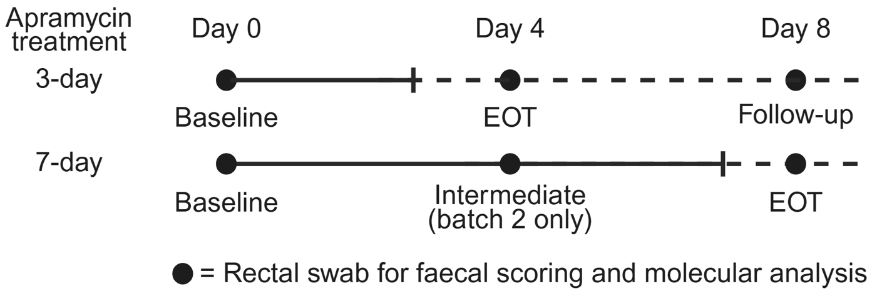

Supplementary Figure S1. Study design, sampling schedule, and analytical workflow.
Piglets from one herd were enrolled in two batches (14 pens each) and randomised (1:1) to 3- or 7-day apramycin treatment. Rectal swabs were collected at baseline (Day 0), Day 4, and Day 8. EOT occurred at Day 4 (3-day group) and Day 8 (7-day group). Selected samples were pooled at pen level and analysed by qPCR for aac(3)-IV relative to 16S.

Supplementary Table S1. Screening of candidate herds for inclusion in the apramycin treatment-length trial
Herd | Visit date | Clinical pattern of PWD | Diagnostic findings (summary) | Apramycin susceptibility context | Suitability assessment
Farm A | 25 Aug 2025 | Very low incidence of diarrhoea 1–2 days post-weaning | Haemolytic E. coli F18 isolated without enterotoxin genes (non-ETEC). F4 detected by PCR but not isolated | F18 isolate resistant (MIC >64 µg/mL) | Low clinical incidence and unclear ETEC involvement; unsuitable for trial
Farm B | 23 Sep 2025 | Mild and sporadic diarrhoea 9–13 days post-weaning; few clinically affected piglets | Haemolytic F18 ETEC detected (STa/STb toxins) | Susceptible (MIC 4 µg/mL) | Clinical incidence too low to reach target sample size
Farm C | 07 Oct 2025 | Reported recurrent PWD outbreaks affecting ~⅓ of nursery section | Haemolytic F18 detected; isolates toxin-negative in follow-up sampling | Resistant isolates detected (MIC >64 µg/mL) | High clinical incidence but unclear toxin profile and inconsistent diagnostics
Farm D | 09 Dec 2025 | Consistent PWD affecting most pens 3–4 days post-weaning | Haemolytic E. coli isolated. Batch 1 diagnostics identified F4-positive ETEC (ST1/ST2 toxins); batch 2 diagnostics identified both F4-positive and F18-positive ETEC | Mixed susceptibility pattern (F4 susceptible; F18 resistant) | Selected herd: consistent clinical outbreaks, sufficient case load, and logistical feasibility for trial

Supplementary Table S2. Herd-level diagnostic findings in the selected herd during the study period
Batch | Sampling context | Isolate ID | Pathotype | Toxin profile | Apramycin MIC (µg/mL) | Interpretation
Batch 1 | Pre-study (Dec 2025) | Isolate 1 | F4-positive ETEC | STa + STb | 8 | Susceptible
Batch 2 | Inclusion (Jan 2026) | Isolate 1 | F4-positive ETEC | STa + STb | 4 | Susceptible
Batch 2 | Inclusion (Jan 2026) | Isolate 2 | F18-positive ETEC | LT | >64 | Resistant
Batch 2 | Inclusion (Jan 2026) | Isolate 3 | F18-positive ETEC | LT | >64 | Resistant

