Supplementary information

Supplementary information S1:

Carbon source concentrations of different synthetic wastewater used for reactors 1, 2, 3, 4, and 5 were acetate (3.42 g/L), propionate (2.67 g/L), butyrate (2.29 g/L), valerate (1.7 g/L) and lactate (3.11 g/L), respectively. The content of inorganic and trace element in these synthetic wastewaters was consistent, NH₄Cl (183.4 mg/L), MgSO₄·7H₂0 (670 mg/L), EDTA (110 mg/L), CaCl₂·2H₂0 (80 mg/L), K₂HPO₄ (48 mg/L), KH₂PO₄ (38 mg/L), FeCl₃·6H₂0 (1.5 mg/L), H₃BO₃ (0.15 mg/L), CuSO₄·5H₂0 (0.03 mg/L), KI (0.03 mg/L), MnCl₂·4H₂0 (0.12 mg/L), Na₂MoO₄·2H₂0 (0.06 mg/L), ZnSO₄·7H₂0 (0.12 mg/L), CoCl₂·6H₂0 (0.15 mg/L) and thiourea (10 mg/L). Thiourea was added to inhibit nitrification. The pH of synthetic wastewater was adjusted to 7.0±0.1.

The SBR reactor consists of an aeration system, a substrate transfer pumping system and a stirrer (Figure S1). In the feeding phase of a cycle, 1 L of fresh synthetic wastewater is pumped into the SBR. The air pump then pumps air through the aerator into the SBR to maintain fermentation broth dissolved oxygen (DO) above 4 mg/L. During the first approximately 1 hour of aeration, the SBR is in the feast stage (carbon source is still present) and the DO concentration is maintained at a low level. As the carbon source is depleted and the SBR enters the subsequent famine phase, the DO concentration suddenly rises to high levels. After 650 minutes of aeration, the aeration was stopped and the sludge in the SBR began to settle, which took 50 minutes. Finally, 1L of the supernatant was discharged from the SBR. The next step is to start a new cycle of the above.

Supplementary information S2:

The fermentation broth was collected in a 10 ml centrifuge tube and centrifuged at 15°C, 6000 rpm for 5 min, the supernatant was removed and the biomass sample was retained. The sludge samples were frozen at -80°C for 24h and then lyophilized in a vacuum freeze dryer for 24h. The lyophilized sample was placed in a pressure-resistant hermetically sealed digestion tube and reacted with 2 ml of chloroform and 2 ml of esterification solution (1 L of methanol containing 1 g of benzoic acid and 30 ml of sulfuric acid) for 6 h at 105°C. After the reaction, the solution was cooled to room temperature, 1 ml of distilled water was added and shaken vigorously, and the lower organic phase was stratified and analyzed by GC-MS (QP2010SE, SHIMADZU, Japan). The chromatographic column was SHIMADZU SH-Rxi-5ms (30m×0.25mm×0.25μm). The specific parameters were as follows: high purity helium as carrier gas, 1.2 ml/min; inlet temperature of 250°C; column oven heating program: initial temperature of 40°C, followed by 10°C/min to 280°C and maintained for 5 min; mass spectrometry interface temperature of 280°C; quaternary rod temperature of 120°C; ion source temperature of 250°C; solvent delay time of 2.5 min; and full scan mode (m/z: 40-600. z: 40-600) was used.) Benzoic acid was used as the internal standard to quantify the monomers of PHA in the samples by using the peak area ratio and content of monomers standard (sigma, methyl 3-hydroxybutyrate, methyl 3-hydroxypentanoate, methyl 3- hydroxyisobutyrate, and methyl 3-hydroxyhexanoate) to benzoic acid as the standard curve.

Supplementary information S3:

The anaerobic fermentation reactor utilized was a fully stirred tank anaerobic digestion system, featuring a working volume of 2.4 liters. The inoculum employed was seed sludge sourced from a laboratory-scale straw anaerobic co-digestion acidogenesis reactor. The feed substrate consists of a blend of corn cobs (or corn stover), excess sludge sourced from a municipal sewage treatment plant, and water, with a Total Solids (TS) content of 10% and a Carbon-to-Nitrogen (C/N) ratio of 40. The organic loading rate (OLR) of the reactor was sustained at 9 g volatile suspended solids (VSS) per liter per day (g VSS/L/d), and the sludge retention time (SRT) was set at 10 days. The temperature of the reactor was maintained at 37°C, the pH value ranged from 5.5 to 6.0, and the stirring rate was set at 100 rpm. The fermentation broth underwent centrifugation at a speed of 100,000 rpm for a duration of 5 minutes. Subsequently, the supernatant was carefully collected and passed through a 0.45 µm filter membrane to obtain a clarified solution suitable for PHA synthesis fermentation.
Supplementary figures:

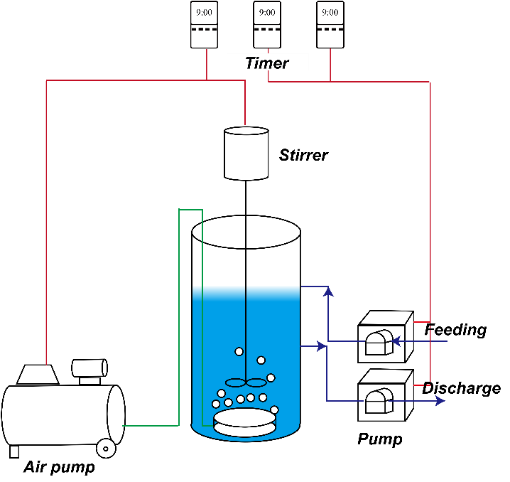
Fig. S1 Schematic diagram of SBRs
Fig. S2 The PHA biosynthesis pathway (A). Numbers (1) – (20) correspond to enzymes in the pathway and are provided for cross-referencing with detailed metabolic information in Table S2. (B) Total abundance and transcriptional activity of putative PHA-storing populations in MMCs across different time points.

