Supplementary Information
for
Fluorine-incorporated strain-released large ZnSe/ZnS:F quantum dots enabling high-efficiency and stable pure-blue light-emitting diodes

Zhiwei Long¹, Jiayun Sun¹, Qi Xiong¹, Xiaoyong Mo², Yulin Mao³, Guichuan Xing³, Wallace C.H. Choy¹*
¹Department of Electrical and Computer Engineering, The University of Hong Kong, Pokfulam Road, Hong Kong, People’s Republic of China.
²University Central Facilities, The University of Hong Kong, Pokfulam Road, Hong Kong, People’s Republic of China.
³Institute of Applied Physics and Materials Engineering, University of Macau, Avenida da Universidade, Taipa, Macau, People’s Republic of China
*Corresponding author: chchoy@eee.hku.hk

Supplementary Table S1 | The elastic constants and Young’s moduli of Cd, Zn-based chalcogenides, and noble metals.
Cubic structure |  | Lattice constant  (a₀, Å) | Elastic constants (GPa) |  |  | Young’s modulus  (E, GPa) | Bulk modulus  (B, GPa)
 |  | Lattice constant  (a₀, Å) | C₁₁ | C₁₂ | C₄₄ | Young’s modulus  (E, GPa) | Bulk modulus  (B, GPa)
ZnS | 5.34 |  | 118 | 72 | 75 | 119.1 | 87.3
ZnSe | 5.62 |  | 94 | 61 | 64 | 95.5 | 72.0
ZnTe | 6 |  | 82 | 42 | 55 | 90.1 | 55.3
CdS | 5.94 |  | 67.2 | 55.7 | 29.3 | 42.8 | 59.5
CdSe | 6.16 |  | 58.8 | 48.9 | 25.2 | 36.8 | 52.2
CdTe | 6.64 |  | 59 | 41.8 | 22.3 | 41.3 | 47.5
Ag | 4.08 |  | 1.24 | 0.94 | 0.46 | 0.81 | 1.04
Au | 4.08 |  | 1.92 | 1.63 | 0.42 | 0.78 | 1.73
The data are obtained by using generalized gradient approximation (GGA) approximation at ambient pressure¹⁻³
Materials with low Young’s modulus can tolerate higher lattice strain, enabling a coherent shell growth. Consequently, a shell layer of soft material can be coherently grown onto a wide variety of nanocrystals with precise control of shell thickness^{4,5}. For instance, uniform spherical Au/CdS core/shell nanocrystals can be obtained despite a large lattice mismatch of 43%⁶. Recently, the CdSe/CdS QD system with precisely controlled shell thicknesses have been extensively investigated, attaining a CdS shell thickness of up to 20 MLs while simultaneously maintaining high PL QYs and uniform morphologies^{7,8}. In contrast, high Young’s modulus materials can have large strain energies and easily to form dislocation defects resulting in irregular shell morphologies as shell thickness exceeds a critical value, known as island growth or Stranski-Krastanov growth^{9,10}. Nevertheless, the research on growing uniform ZnS shells on crystalline QDs with thickness exceeding 4 MLs remains limited due to its high Young’s modulus.

Supplementary Table S2 | Comparison of ZnSe and doped ZnSe QD-based QLEDs in previous literatures with the current work.
QD structure | Device architecture | EL  (nm) | EQE  (%) | Luminance  (cd m⁻²) | Ref.
ZnSe QD-based QLEDs
ZnSe/ZnS | ITO/ZnO/QDs/CBP/MoO₃/Al | 441 | / | 1,170 | Appl. Phys. Lett., 103, 053106 (2013).
ZnSe/ZnS | ITO/PEDOT:PSS/PVK/QDs/ZnO/Al | 429 | 7.8 | 2,632 | Nanoscale, 7, 2951–2959 (2015).
ZnSe/ZnS | ITO/PEDOT:PSS/TFB:PVK/QDs/ZnO/Al | 429 | 7.4 | 2,856 | Org. Electron., 25, 178–183 (2015).
ZnSe/ZnS | ITO/PEDOT:PSS/PVK/QDs:TPD/ZnMgO/Al | 434 | 6.9 | 450 | Small, 16, 2002109 (2020).
ZnSe/ZnS | ITO/PEDOT:PSS/PVK/QDs/ZnMgO/Al | 445 | 12.2 | 1,055 | Nano Lett., 21, 7252–7260 (2021).
ZnSe/ZnS | ITO/PEDOT:PSS/PVK/QDs/ZnSnO/Al | 443 | 13.6 | 1,031 | ACS Photonics, 9, 1400–1408 (2022).
ZnSe/ZnS | ITO/PEDOT:PSS/TFB/QDs/ZnMgO/Al | 456 | 4.2 | 1,223 | Nano Res., 17, 7020–7026 (2024).
ZnSe/ZnS | ITO/PEDOT:PSS/PF8Cz/QDs/ZnMgO/Al | 451 | 24.5 | 17,140 | This work
Te doped ZnSe QD-based QLEDs
ZnSeTe/ZnSe/ZnS | ITO/PEDOT:PSS/PVK/QDs/ZnMgO/Al | 445 | 4.2 | 1,195 | ACS Appl. Mater. Interfaces, 11, 46062–46069 (2019)
ZnSeTe/ZnSe/ZnSeS/ZnS | ITO/PEDOT:PSS/PVK/QDs/ZnMgO/Al | 520 | 7.6 | 18,420 | Chem. Mater., 32, 5768–5775 (2020).
ZnSeTe/ZnSe/ZnSeS/ZnS | ITO/PEDOT:PSS/PVK/QDs/ZnMgO/Al | 447 | 9.5 | 2,904 | ACS Energy Lett., 5:1568–1576 (2020).
ZnSeTe/ZnSe/ZnS | ITO/PEDOT:PSS/TFB/QDs/ZnMgO/Al | 460 | 20.2 | 88,900 | Nature, 586, 385–389 (2020)
ZnSeTe/ZnSe/ZnSeS/ZnS | ITO/PEDOT:PSS/TFB/QDs/ZnMgO/Al | 523 | 10.1 | 83,556 | ACS Energy Lett., 8, 1131–1140 (2023).
ZnSeTe/ZnSe/ZnS | ITO/PEDOT:PSS/TFB/QDs/ZnMgO/Al | 452 | 18.0 | 3,520 | Small, 19, 2303247 (2023).
ZnSeTe/ZnSe/ZnS | ITO/PEDOT:PSS/TFB/QDs/ZnMgO/Al | 448 | 10.9 | 10,240 | Adv. Funct. Mater., 34, 2313811 (2024).
ZnSeTe/ZnSe/ZnS | ITO/PEDOT:PSS/TFB/QDs/ZnMgO/Al | 463 | 17.2 | 13,677 | Chem. Eng. J., 489, 151347 (2024)
ZnSeTe/ZnSe/ZnSeS/ZnS | ITO/PEDOT:PSS/PF8Cz/QDs/ZnMgO/Al | 520 | 21.7 | 52,040 | Nat. Commun., 16, 1945 (2025).
ZnSeTe/ZnSe/ZnSeS/ZnS | ITO/PEDOT:PSS/TFB/QDs/ZnMgO/Al | 521 | 20.6 | 106,054 | Sci. Bull., 70, 1619–1626 (2025).
ZnSeTe/ZnSe/ZnS | ITO/PEDOT:PSS/TFB/QDs/ZnMgO/Al | 452 | 23.6 | 13,296 | Nat. Photon. 20, 571–578 (2026).
Te, S co-doped ZnSe QD-based QLEDs
ZnSeTeS/ZnSe/ZnS | ITO/PEDOT:PSS/PF8Cz/QDs/ZnMgO/Al | 460 | 24.7 | 36,850 | Nature 639, 633–638  (2025)
Yb doped ZnSe QD-based QLEDs
Yb: ZnSe/ZnS | ITO/PEDOT:PSS/TFB/QDs/ZnMgO/Ag | 455 | 1.35 | 1,337 | Adv. Mater. 37, 2501500 (2025).
Cl doped ZnSe QD-based QLEDs
Cl: ZnSe/ZnSe/ZnS | ITO/PEDOT:PSS/TFB/QDs/ZnMgO/Al | white | 15.0 | 26,000 | Nat. Photon. 19, 952–959 (2025).

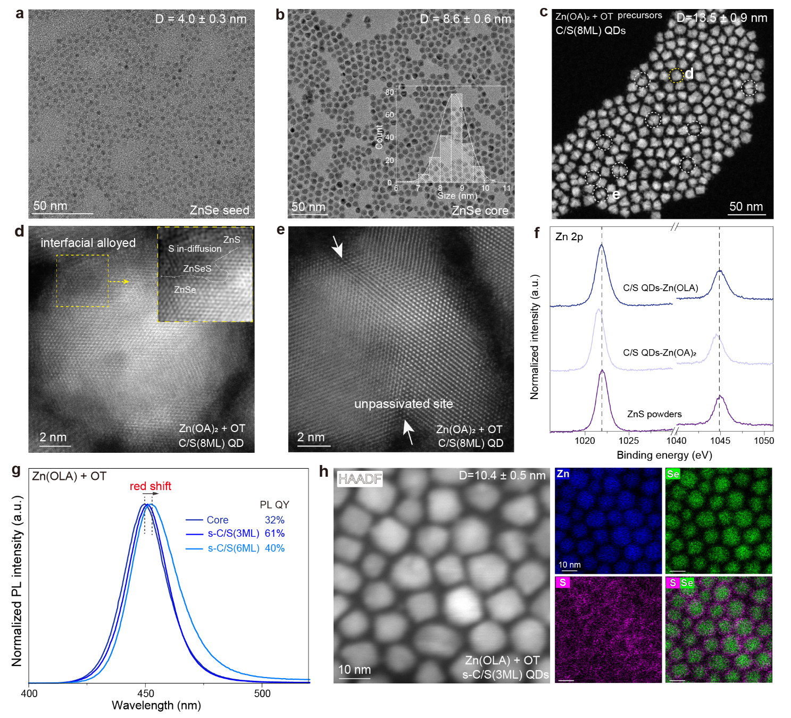

Fig. S1. The synthesis of C/S QDs with different shell precursors. a, TEM image of the ZnSe seed. b, TEM image and size distribution statistic of the obtained large ZnSe core QDs. c, STEM image of the ZnSe/ZnS QDs obtained from low-reactivity Zn(OA)₂ precursor. d, HR-STEM of interfacial alloyed C/S QD e, HR-STEM of defective C/S QD. f, XPS Zn 2p profiles of ZnSe/ZnS QDs obtained from low-reactivity Zn(OA)₂ precursor and high-reactivity Zn(OLA) precursors, with ZnS powders as reference. The Zn 2p spectrum of QDs obtained from Zn(OA)₂ shows lower binding energies compared with ZnS powders, indicating uncovered ZnSe core surfaces or Zn vacancy defects in the ZnS shell^{11,12}. g, PL spectra of s-C/S QDs with different shell thicknesses obtained from Zn(OLA) precursor. h, STEM and elements distribution of s-C/S QDs with shell thickness of 3 MLs.

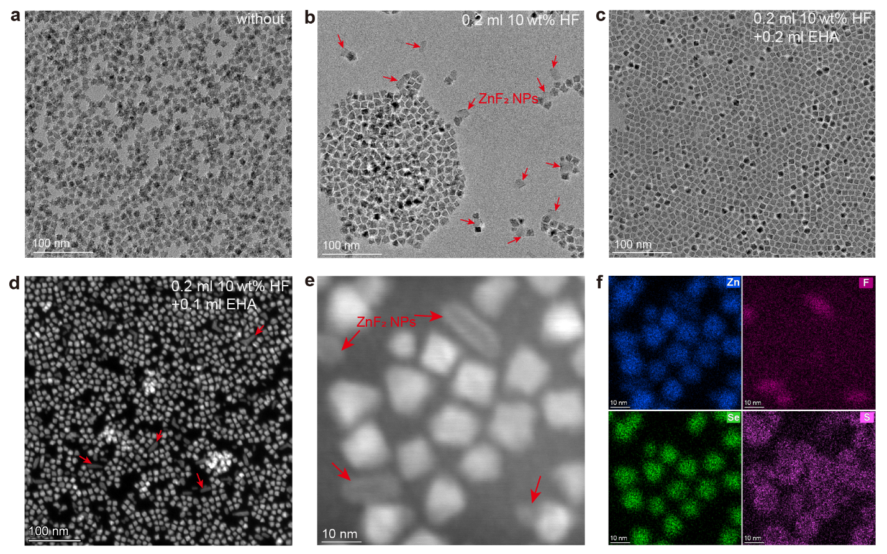

Fig. S2. TEM images of as-synthesized C/S QDs under three control series. a, The pristine C/S QDs sample without HF and EHA treatment. b, C/S QDs obtained by adding 0.2 ml of 10 wt% HF during the shell growth. c, C/S QDs obtained by adding 0.2 ml of 10 wt% HF and 0.2 ml of EHA during the shell growth. d-f, STEM image of C/S QDs obtained by adding 0.2 ml of 10 wt% HF and 0.1 ml of EHA, and the corresponding elements distribution mapping images. During the shell growth, when only HF is added to the C/S QD solution, the enriched F ions would bond with the Zn precursor to form ZnF₂ nanoparticles.

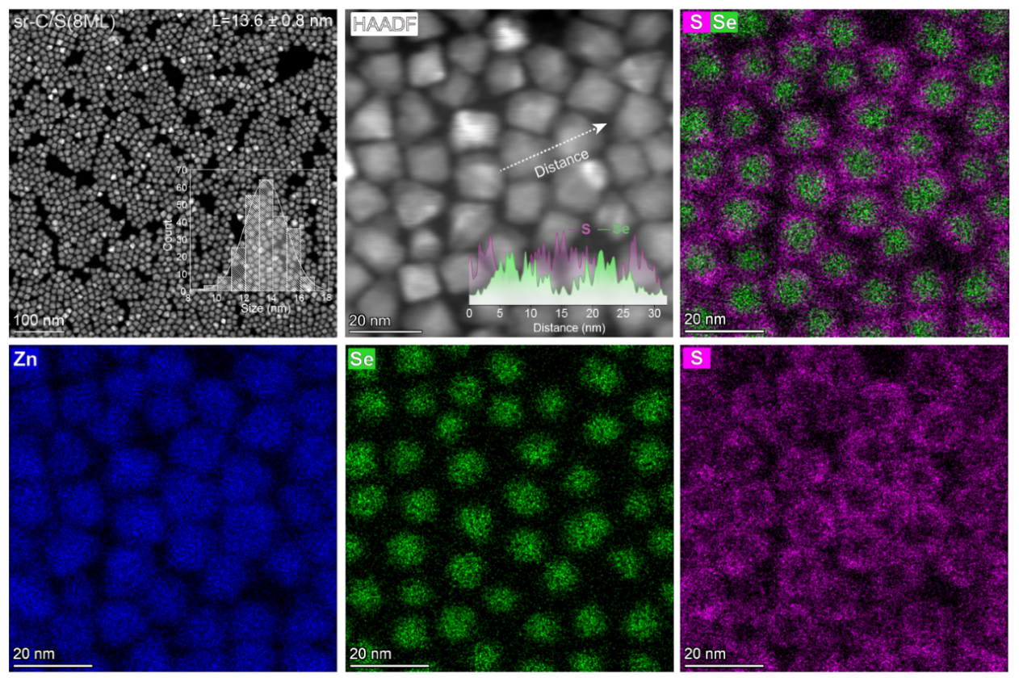

Fig. S3. STEM images and elements distribution mapping of thick-shell sr-C/S(8ML) QDs.

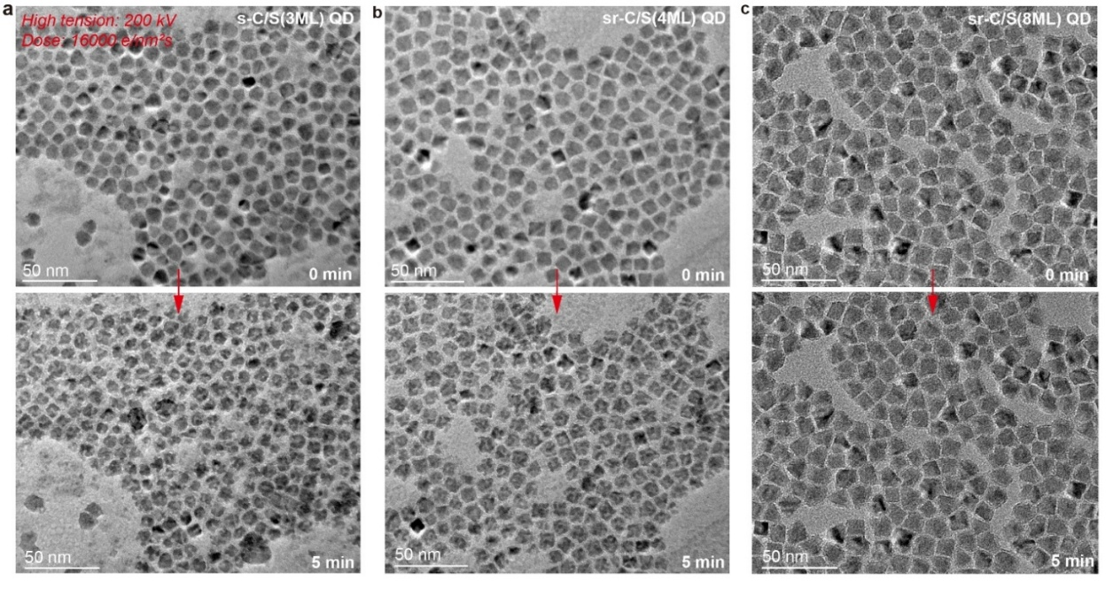

Fig. S4. Structure stability test of QDs by electron beam irradiation. Morphology evolution of (a) s-C/S(3ML), (b) sr-C/S(4ML), and (c) sr-C/S(8ML) QDs under electron beam irradiation with indicated times. After electron beam irradiation at a dose of 16,000 e/nm²·s for five minutes, voids observed in TEM result of the thin-shell s-C/S(3ML) QDs. By contrast, the thick-shell sr-C/S(8ML) QDs do not exhibit void formation after irradiation.

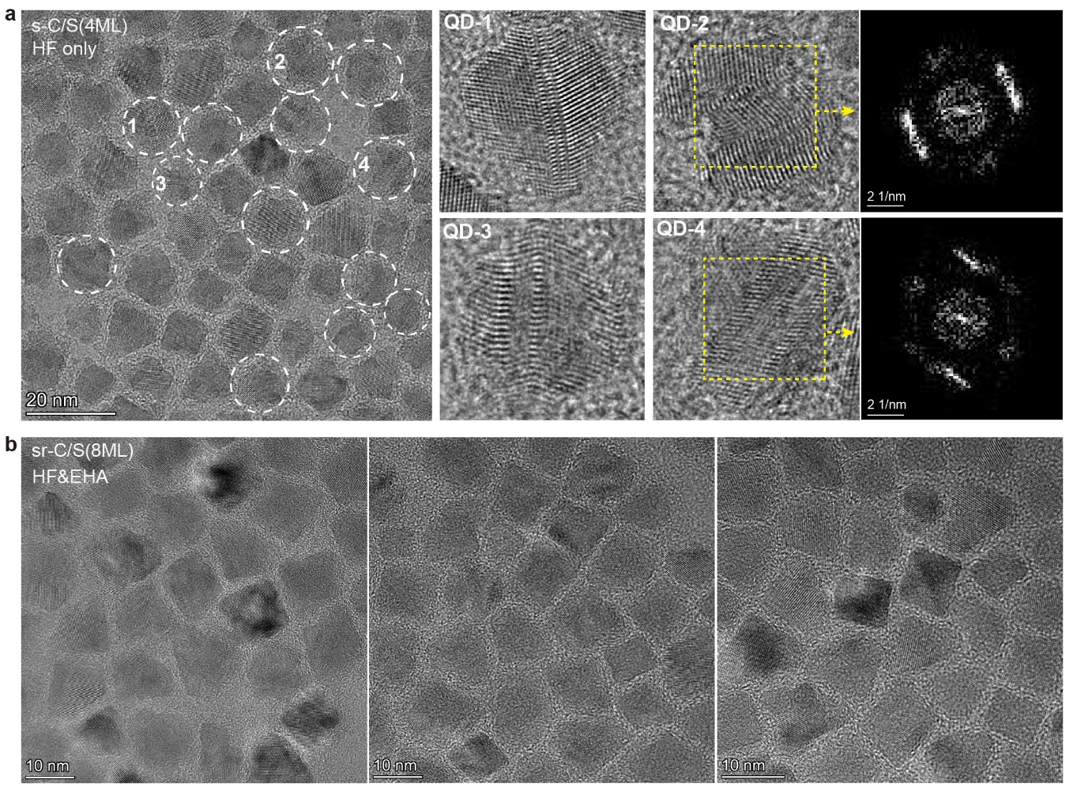

Fig. S5. High-resolution TEM images QDs. a, s-C/S QDs. A certain proportion of s-C/S QDs with shell thickness of ~4 MLs show distorted lattice arrangement, which are marked with dashed circle. b, The TEM images sr-C/S QDs, which show no lattice-distorted QDs.

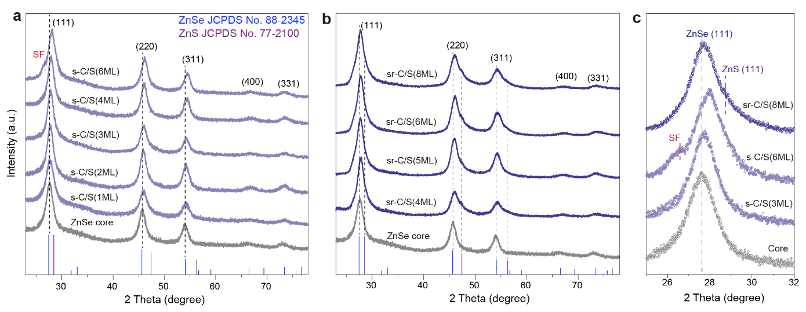

Fig. S6. XRD patterns of s-C/S and sr-C/S QDs. a, s-C/S QDs with different shell thicknesses obtained from high-reactivity Zn(OLA) and OT shell precursors. b, sr-C/S QDs obtained from Zn(OLA) and OT shell precursors with the additives of HF and EHA. c, The XRD patterns of different shelled QDs in a range of 25-32°.

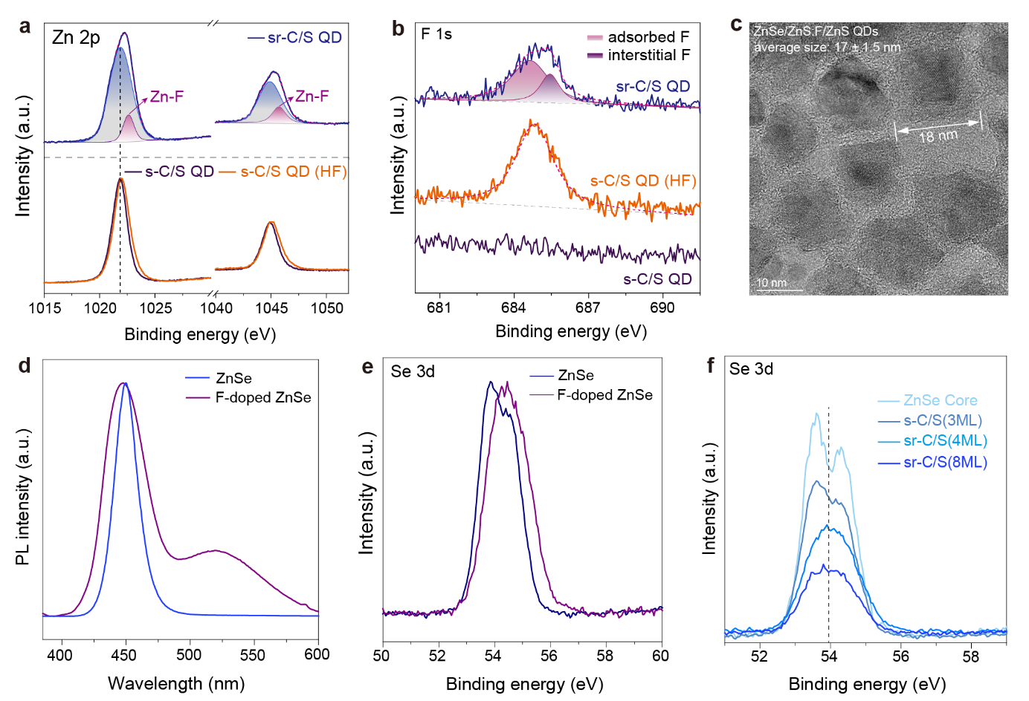

Fig. S7. a, XPS spectra of Zn 2p for the indicated QDs. b, XPS spectra of F 1s for the indicated QDs. c, HR-TEM image of the double-shelled ZnSe/ZnS:F/ZnS QDs, which were obtained by epitaxially growing thin ZnS shell onto the sr-C/S(8ML) QDs. d, Normalized PL spectra of shell-doped ZnSe/ZnS QDs and core-doped ZnSe/ZnS QDs. e, Se 3d XPS spectra of ZnSe and core-doped ZnSe/ZnS QDs. f, Se 3d XPS spectra of ZnSe core and indicated core/shell QDs.

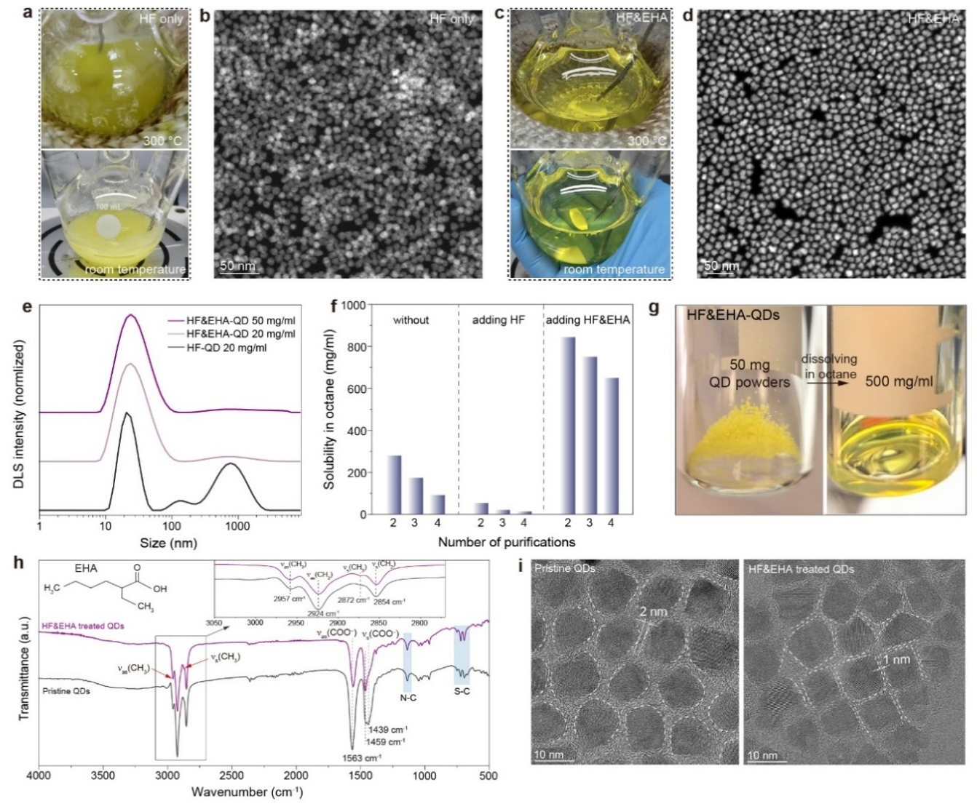

Fig. S8. Enhanced dispersibility of QDs with EHA ligands. a, Photographs of crude QD reaction solution after injecting 0.3 ml of diluted HF solution at 300 °C (top) and cooled down to room temperature (bottom). b, STEM images of HF treated QDs. c, Photographs of HF&EHA treated QDs solution. d, STEM image of HF&EHA post-treated QDs. e, Size distribution of QDs dispersed in octane measured with DLS characterizations for HF-treated, HF&EHA-treated C/S QDs at the specified concentrations. f, Variation of solubility of QDs in octane with the number of purifications. g, Photographs of dried QD powders and the QD solution obtained by directly dissolving the powders in octane. h, FTIR spectra of pristine QD powders and HF&EHA-treated QD powders; all QDs were washed 3 times with n-hexane and ethanol. i, High-resolution TEM image of the pristine QDs and HF&EHA treated QDs terminated with EHA, OLA and OT ligands, showing a narrower interdot spacing.

Noted that the reaction solution changed from clear to turbid when HF was introduced alone during the subsequent shell growth (Fig. S8a), the obtained QDs tend to aggregate (Fig. S8b). Because hydrogen ions can effectively detach the long-chain ligands and the surface-adsorbed F ions significantly reduce the solubility of QDs in nonpolar solvents¹³. After adding moderate EHA, the turbid QD solution became clear and free from aggregates even for highly-packed QDs (Fig. S8c,d). The dynamic light-scattering (DLS) measurements of purified QDs validate that the addition of EHA can effectively prevent the aggregation of QDs in solution even under high concentrations for the purified QDs (Fig. S8e). The EHA molecule contains eight carbon atoms with a branched-chain structure, which increases the intramolecular entropy and minimizes the enthalpy for destroying the chain−chain interactions, thus substantially enhancing the solubility of large-sized QDs¹⁴.The solubility of resultant HF&EHA-treated QDs maintains 650 mg/ml after four rounds of purification (Fig. S8f). Importantly, after being dried under vacuum, the purified QD powders can be completely dispersed in octane with a concentration of up to 500 mg/ml (Fig. S8g). Fourier transform infrared spectroscopy (FTIR) spectra of the pristine and HF&EHA-treated QDs are shown in Fig. S8h. The characteristic vibration intensity of −CH₃ (2957 cm⁻¹ and 2872 cm⁻¹) of the HF&EHA-treated QDs is enhanced while the intensity of −COO⁻ vibrations (1563 cm⁻¹ and 1439 cm⁻¹) is reduced, indicating the replacement of long-chain ligand oleic acid by EHA. Additionally, the intensity of −CH₂ vibrations is distinctly reduced, indicating a lower ligand density, which can also be confirmed by the TEM characterizations that show narrower interdot spacings (Fig. S8i).

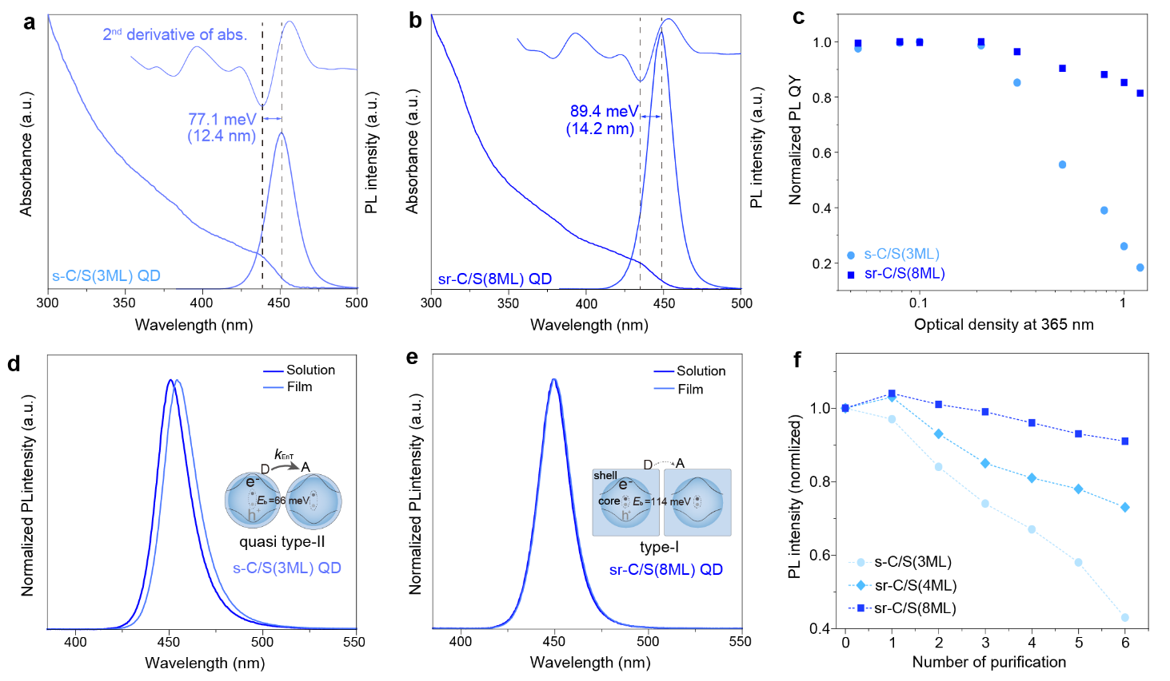

Fig. S9. Suppressed electronic coupling energy transfer in thick shelled QDs. a, Absorption, second derivative of absorption, and PL spectra of s-C/S(3ML) QDs. b, sr-C/S(8ML) QDs. c, Normalized PL QY of C/S QDs at different optical densities. d, Concentration-dependent spectra C/S QDs. e, Dependence of PL peak and FWHM of C/S QDs on QD concentration. f, Comparison of the PL QYs of QD solution and film for the indicated QDs. g-h, Comparison of the PL spectra of QD solution and film for the s-C/S(3ML) and sr-C/S(8ML) QDs. Inset: scheme of core/shell QD structure and the anticipated carriers’ distribution function, as well as the energy transform (k_{EnT}) process between adjacent QDs, donor (D) to acceptor (A). i, Evolution of PL intensity of QDs with the number of washing purification.

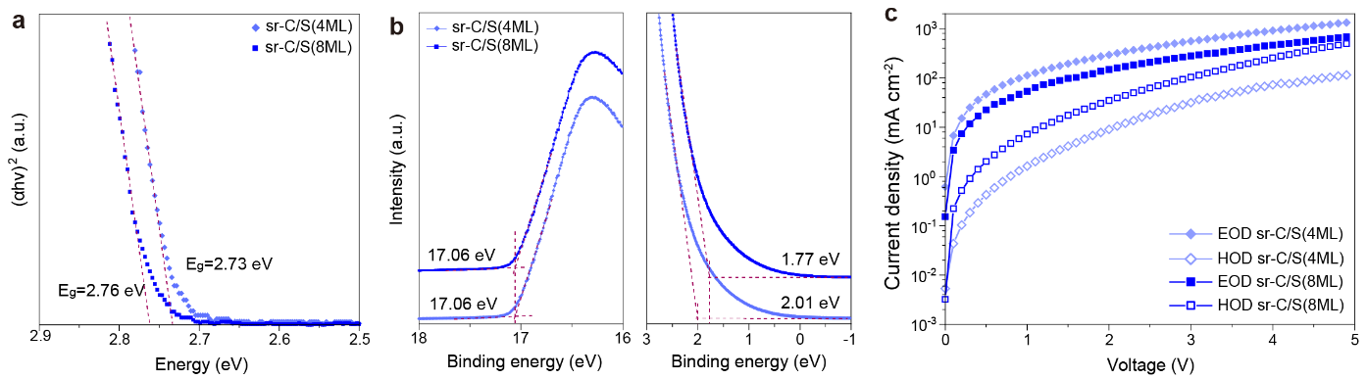

Fig. S10. Shell thickness-dependent electrical properties. a, The tauc plots of sr-C/S QDs with shell thicknesses of 4 and 8 MLs, respectively. b, The UPS spectra of the high-binding energy secondary electron cut-off regions and the valence-band edge regions. c, Current density–voltage characteristics of hole-only and electron-only devices with indicated QDs.

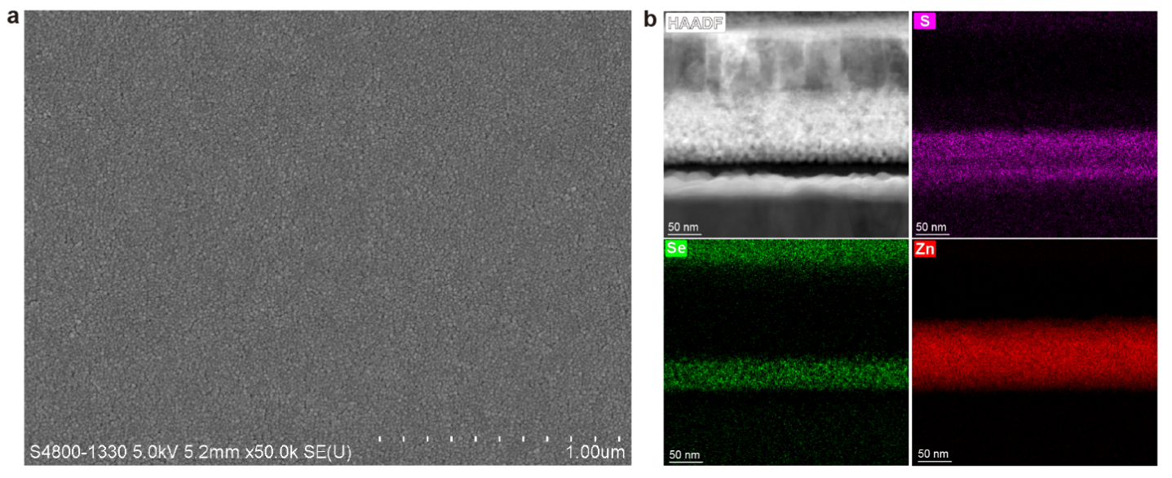

Fig. S11. a, SEM image of the QD layer. b, Cross-sectional TEM image of QLED fabricated with thick-shell sr-C/S(8ML) QDs, and the corresponding EDS mapping images of S, Se and Zn elements.

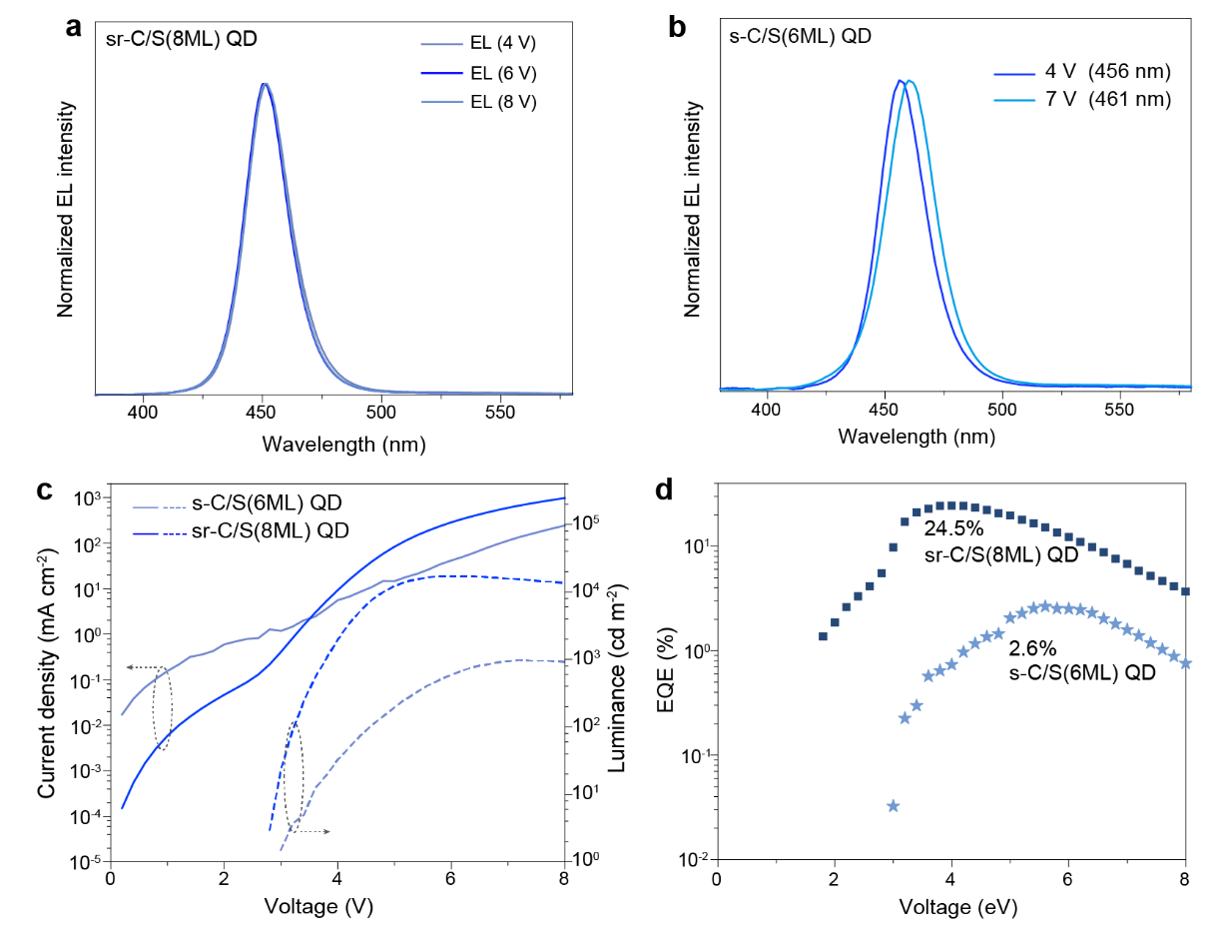

Fig. S12. a, Normalized EL spectra of thick-shelled sr-C/S(8ML) QDs under different working voltages. b, EL spectra of thick-shelled s-C/S(6ML) QDs under different working voltages. c, Voltage-dependent current density (left axis) and luminance (right axis) of thick-shelled s-C/S(6ML) and sr-C/S(8ML) QDs. d, Voltage-dependent EQEs of thick-shelled s-C/S(6ML) and sr-C/S(8ML) QDs.

References
1. R. Khenata et al., Elastic, electronic and optical properties of ZnS, ZnSe and ZnTe under pressure. Comput. Mater. Sci. 38, 29–38 (2006).
2. L. Guo, S. Zhang, W. Feng, G. Hu, W. Li, A first-principles study on the structural, elastic, electronic, optical, lattice dynamical, and thermodynamic properties of zinc-blende CdX (X= S, Se, and Te). J. Alloy. Compd. 579, 583–593 (2013).
3. J. Neighbours, G. Alers, Elastic constants of silver and gold. Phys. Rev. 111, 707 (1958).
4. Zhang, J., Tang, Y., Weng, L. & Ouyang, M. Versatile strategy for precisely tailored core@shell nanostructures with single shell layer accuracy: the case of metallic shell. Nano Lett. 9, 4061–4065 (2009).
5 Ge, F. et al. Elucidating Facet-Dependent Photocatalytic Activities of Metastable CdS and Au@ CdS Core–Shell Nanocrystals. ACS Appl. Mater. Interfaces. 16, 32847–32856 (2024).
6 Zhang, J., Tang, Y., Lee, K. & Ouyang, M. Nonepitaxial growth of hybrid core-shell nanostructures with large lattice mismatches. Science 327, 1634–1638 (2010).
7 Lv, L. et al. Synthesis of weakly confined, cube-shaped, and monodisperse cadmium chalcogenide nanocrystals with unexpected photophysical properties. J. Am. Chem. Soc. 144, 16872–16882 (2022).
8 Lei, H. et al. Weakly confined semiconductor nanocrystals excel in photochemical and optoelectronic properties: evidence from single-dot studies. J. Am. Chem. Soc. 146, 21948–21959 (2024).
9 Gong, K. & Kelley, D. F. A predictive model of shell morphology in CdSe/CdS core/shell quantum dots. J. Chem. Phys. 141 (2014).
10 Jiang, Z.-J. & Kelley, D. F. Stranski–Krastanov shell growth in ZnTe/CdSe core/shell Nanocrystals. J. Phys. Chem. C 117, 6826–6834 (2013).
11 Y. He et al., 3D hierarchical ZnIn₂S₄ nanosheets with rich Zn vacancies boosting photocatalytic CO₂ reduction. Adv. Funct. Mater. 29, 1905153 (2019).
12 Z. Long et al., The strain effects and interfacial defects of large ZnSe/ZnS core/shell nanocrystals. Small 20, 2306602 (2024).
13 Kovalenko, M. V., Scheele, M. & Talapin, D. V. Colloidal nanocrystals with molecular metal chalcogenide surface ligands. Science 324, 1417–1420 (2009).
14 Yang, Y. et al. Entropic ligands for nanocrystals: from unexpected solution properties to outstanding processability. Nano Lett. 16, 2133–2138 (2016).

