Supplementary Material
Fusobacterium nucleatum predicts a risk for esophageal squamous cell carcinoma
Running title: F. nucleatum is a risk factor in ESCC
Chao Shi^{1,2#}; Zhen Li^{3,4#}; Jiawen Zheng^{1,2}; Weimin Kong¹; Taibing Fan³; Dongdong Jian³; Xiaolei Cheng³; Huan Zhao⁵; Jie Ma^{1,2*}; Hao Tang^{3*}; Yongjun Guo^{1,2*}

Additional Supporting Information may be found in the online version of this article at the publisher’s website:
Table S1. Signature microbiota profiles in the comparison of norma and tumor groups at phylum, class and genus levels

Kingdom | Phylum | Class | Order | Family | Genus | P-value
Bacteria | Proteobacteria | Gammaproteobacteria | Enterobacteriales | Enterobacteriaceae | Klebsiella | 2.10E-11
Bacteria | Firmicutes | Clostridia | Clostridiales | Lachnospiraceae | Lachnospiraceae_NK4A136_group | 2.91E-09
Bacteria | Firmicutes | Clostridia | Clostridiales | Lachnospiraceae | NA | 1.29E-08
Bacteria | Firmicutes | Clostridia | Clostridiales | Lachnospiraceae | NA | 2.63E-08
Bacteria | Proteobacteria | Gammaproteobacteria | Enterobacteriales | Enterobacteriaceae | Klebsiella | 4.66E-08
Bacteria | Proteobacteria | Alphaproteobacteria | Sphingomonadales | Sphingomonadaceae | Sphingomonas | 1.02E-07
Bacteria | Proteobacteria | Alphaproteobacteria | Rhizobiales | Beijerinckiaceae | Methylobacterium | 5.13E-06
Bacteria | Actinobacteria | Actinobacteria | Micrococcales | NA | NA | 7.65E-06
Bacteria | Proteobacteria | Gammaproteobacteria | Betaproteobacteriales | Burkholderiaceae | Parasutterella | 2.32E-05
Bacteria | Actinobacteria | Actinobacteria | Pseudonocardiales | Pseudonocardiaceae | Pseudonocardia | 3.04E-05
Bacteria | Firmicutes | Clostridia | Clostridiales | Lachnospiraceae | Lachnospiraceae_NK4A136_group | 8.79E-05
Bacteria | Actinobacteria | Actinobacteria | Corynebacteriales | Corynebacteriaceae | Lawsonella | 0.000197
Bacteria | Actinobacteria | Actinobacteria | Propionibacteriales | Propionibacteriaceae | Cutibacterium | 0.000211
Bacteria | Firmicutes | Bacilli | NA | NA | NA | 0.000287
Bacteria | Firmicutes | Bacilli | Bacillales | Staphylococcaceae | Staphylococcus | 0.000318
Bacteria | Proteobacteria | Gammaproteobacteria | Enterobacteriales | Enterobacteriaceae | Escherichia/Shigella | 0.000361
Bacteria | Actinobacteria | Actinobacteria | Corynebacteriales | Corynebacteriaceae | Corynebacterium | 0.000368
Bacteria | Proteobacteria | Gammaproteobacteria | Pseudomonadales | Moraxellaceae | Enhydrobacter | 0.000441
Bacteria | Firmicutes | Bacilli | Lactobacillales | Lactobacillaceae | Lactobacillus | 0.00052
Bacteria | Actinobacteria | Actinobacteria | Micrococcales | Brevibacteriaceae | Brevibacterium | 0.000732
Bacteria | Actinobacteria | Actinobacteria | Corynebacteriales | Corynebacteriaceae | Corynebacterium_1 | 0.000943
Bacteria | Proteobacteria | Alphaproteobacteria | Rhizobiales | Xanthobacteraceae | NA | 0.001109
Bacteria | Proteobacteria | Gammaproteobacteria | Betaproteobacteriales | Burkholderiaceae | Massilia | 0.001151
Bacteria | Proteobacteria | Gammaproteobacteria | Betaproteobacteriales | Burkholderiaceae | Lautropia | 0.001241
Bacteria | Firmicutes | Bacilli | Lactobacillales | Streptococcaceae | Streptococcus | 0.001334
Bacteria | Actinobacteria | Acidimicrobiia | Microtrichales | Ilumatobacteraceae | NA | 0.001365
Bacteria | Actinobacteria | Actinobacteria | Corynebacteriales | Corynebacteriaceae | Lawsonella | 0.001593
Bacteria | Proteobacteria | Gammaproteobacteria | Betaproteobacteriales | Burkholderiaceae | Limnobacter | 0.001597
Bacteria | Firmicutes | Clostridia | Clostridiales | Lachnospiraceae | NA | 0.001673
Bacteria | Proteobacteria | Alphaproteobacteria | Caulobacterales | Caulobacteraceae | Brevundimonas | 0.001819
Bacteria | Proteobacteria | Gammaproteobacteria | Enterobacteriales | Enterobacteriaceae | Pluralibacter | 0.001876
Bacteria | Proteobacteria | Gammaproteobacteria | Pseudomonadales | Pseudomonadaceae | Pseudomonas | 0.001911
Bacteria | Firmicutes | Bacilli | Lactobacillales | Carnobacteriaceae | Atopostipes | 0.002462
Bacteria | Proteobacteria | Gammaproteobacteria | Pseudomonadales | Moraxellaceae | Acinetobacter | 0.002498
Bacteria | Firmicutes | Clostridia | Clostridiales | Lachnospiraceae | Lachnospiraceae_NK4A136_group | 0.002846
Bacteria | Proteobacteria | Gammaproteobacteria | Betaproteobacteriales | Neisseriaceae | Neisseria | 0.002894
Bacteria | Bacteroidetes | Bacteroidia | Flavobacteriales | Flavobacteriaceae | Flavobacterium | 0.002901
Bacteria | Proteobacteria | Gammaproteobacteria | Pseudomonadales | Moraxellaceae | Acinetobacter | 0.003132
Bacteria | Proteobacteria | Gammaproteobacteria | Pseudomonadales | Pseudomonadaceae | Pseudomonas | 0.003142
Bacteria | Firmicutes | Clostridia | Clostridiales | Peptostreptococcaceae | Peptostreptococcus | 0.003537
Bacteria | Firmicutes | Clostridia | Clostridiales | Lachnospiraceae | Lachnospiraceae_NK4A136_group | 0.003708
Bacteria | Firmicutes | Bacilli | Lactobacillales | Carnobacteriaceae | Atopostipes | 0.003941
Bacteria | Firmicutes | Bacilli | Bacillales | Staphylococcaceae | Staphylococcus | 0.00411
Bacteria | Firmicutes | Bacilli | Bacillales | Staphylococcaceae | Staphylococcus | 0.004828
Bacteria | Proteobacteria | Gammaproteobacteria | Enterobacteriales | Enterobacteriaceae | Klebsiella | 0.004951
Bacteria | Fusobacteria | Fusobacteriia | Fusobacteriales | Fusobacteriaceae | Fusobacterium | 0.005224
Bacteria | Firmicutes | Clostridia | Clostridiales | Lachnospiraceae | Lachnoclostridium | 0.005595
Bacteria | Proteobacteria | Gammaproteobacteria | Betaproteobacteriales | Burkholderiaceae | Delftia | 0.005693
Bacteria | Actinobacteria | Actinobacteria | Actinomycetales | Actinomycetaceae | Actinomyces | 0.006516
Bacteria | Firmicutes | Bacilli | Lactobacillales | Lactobacillaceae | Lactobacillus | 0.006664
Bacteria | Firmicutes | Clostridia | Clostridiales | Lachnospiraceae | Lachnospiraceae_NK4A136_group | 0.007205
Bacteria | Actinobacteria | Actinobacteria | Corynebacteriales | Corynebacteriaceae | Corynebacterium_1 | 0.007597
Bacteria | Firmicutes | Bacilli | Lactobacillales | Carnobacteriaceae | Dolosigranulum | 0.007696
Bacteria | Firmicutes | Clostridia | Clostridiales | Lachnospiraceae | Butyrivibrio | 0.007814
Bacteria | Firmicutes | Bacilli | Lactobacillales | Aerococcaceae | Aerococcus | 0.008266

Table S2. Differential analyses of pT stage patients

 |  |  |  |  |  | Comparison:  pT3 vs pT1 |  |  | Comparison:  pT3 vs pT2
Kingdom | Phylum | Class | Order | Family | Genus | log2FoldChange | Pvalue | Padj | log2FoldChange | Pvalue | Padj
Bacteria | Firmicutes | Bacilli | Lactobacillales | Lactobacillaceae | Lactobacillus | -24.81 | 1.25E-16 | 6.12E-15 | -22.38 | 2.89E-16 | 1.83E-14
Bacteria | Proteobacteria | Alphaproteobacteria | Acetobacterales | Acetobacteraceae | Acetobacter | -25.12 | 5.77E-17 | 5.64E-15 | -22.29 | 4.21E-16 | 1.83E-14
Bacteria | Bacteroidetes | Bacteroidia | Cytophagales | Cyclobacteriaceae | Algoriphagus | -24.64 | 5.81E-10 | 1.06E-08 | -21.77 | 1.73E-09 | 2.21E-08
Bacteria | Proteobacteria | Gammaproteobacteria | Oceanospirillales | Halomonadaceae | Carnimonas | -23.82 | 2.43E-13 | 5.92E-12 | -20.81 | 2.50E-12 | 5.36E-11
Bacteria | Proteobacteria | Gammaproteobacteria | Betaproteobacteriales | Burkholderiaceae | Hydrogenophaga | -23.69 | 1.89E-14 | 6.91E-13 | -21.37 | 3.97E-14 | 1.08E-12
Bacteria | Proteobacteria | Gammaproteobacteria | Betaproteobacteriales | Burkholderiaceae | Methylibium | -24.67 | 2.34E-13 | 5.92E-12 | -21.07 | 7.02E-12 | 1.09E-10
Bacteria | Proteobacteria | Gammaproteobacteria | Betaproteobacteriales | Methylophilaceae | Methylophilus | -24.77 | 8.88E-17 | 6.12E-15 | -20.70 | 3.19E-14 | 9.95E-13
Bacteria | Proteobacteria | Gammaproteobacteria | Betaproteobacteriales | Methylophilaceae | Methylotenera | -24.61 | 1.64E-13 | 4.97E-12 | -20.06 | 5.02E-11 | 6.84E-10
Bacteria | Actinobacteria | Actinobacteria | Corynebacteriales | Mycobacteriaceae | Mycobacterium | -25.78 | 9.13E-11 | 1.91E-09 | -24.10 | 2.57E-11 | 3.74E-10
Bacteria | Actinobacteria | Actinobacteria | PeM15 | NA | NA | -29.78 | 1.57E-14 | 6.57E-13 | -28.98 | 2.00E-16 | 1.83E-14
Bacteria | Bacteroidetes | Bacteroidia | Chitinophagales | Saprospiraceae | NA | -24.22 | 6.33E-13 | 1.43E-11 | -21.07 | 6.88E-12 | 1.09E-10
Bacteria | Proteobacteria | Gammaproteobacteria | Betaproteobacteriales | Burkholderiaceae | Noviherbaspirillum | -27.96 | 1.23E-18 | 2.10E-16 | -23.56 | 3.81E-16 | 1.83E-14
Bacteria | Proteobacteria | Alphaproteobacteria | Sphingomonadales | Sphingomonadaceae | Novosphingobium | -26.56 | 1.20E-16 | 6.12E-15 | -23.27 | 1.82E-15 | 6.61E-14
Bacteria | Bacteroidetes | Bacteroidia | Bacteroidales | Prevotellaceae | Prevotella_7 | 9.14 | 1.41E-03 | 1.88E-02 | 8.85 | 6.06E-04 | 6.29E-03
Bacteria | Proteobacteria | Gammaproteobacteria | Betaproteobacteriales | Burkholderiaceae | Ramlibacter | -26.34 | 1.43E-18 | 2.10E-16 | -22.53 | 1.73E-16 | 1.83E-14
 |  |  |  |  |  | Comparison:  pT4 vs pT1 |  |  | Comparison:  pT4 vs pT2
Kingdom | Phylum | Class | Order | Family | Genus | log2FoldChange | Pvalue | Padj | log2FoldChange | Pvalue | Padj
Bacteria | Proteobacteria | Gammaproteobacteria | Pasteurellales | Pasteurellaceae | Actinobacillus | -20.17 | 9.67E-05 | 0.0087 | -15.85 | 0.0017 | 0.037
Bacteria | Fusobacteria | Fusobacteriia | Fusobacteriales | Fusobacteriaceae | Fusobacterium | -21.75 | 1.69E-05 | 0.0027 | -16.27 | 0.00095 | 0.031
Bacteria | Firmicutes | Bacilli | Bacillales | Family_XI | Gemella | -21.63 | 1.27E-07 | 4.00E-05 | -18.87 | 2.29E-06 | 0.00035
Bacteria | Proteobacteria | Alphaproteobacteria | Sphingomonadales | Sphingomonadaceae | Novosphingobium | -20.64 | 0.00018 | 0.011 | -17.35 | 0.0012 | 0.031

Table S3. Microbiota associated with clinical characters in ESCC

Clinical Characters | Age  (<60 vs≥60) | Gender  (Male vs Female) | Smoking  (Yes or No) | Drinking  (Yes or No) | Lymph node metastasis  (Yes or No) | Tumor location  (Top vs Middle down) | pT stage  (pT1-2 vs pT3-4) | Clinical tumor stage  (I-II vs III) | G stage  (G1-2 vs G3)
Mean Value
Chao1 | 998.12 vs 1019.43 | 978.85 vs 1042.29 | 996.88 vs 1019.62 | 1028.43 vs 968.48 | 679.54 vs 1052.507 | 1297.66 vs 952.97 | 1094.03 vs 843.77 | 1011.25 vs 984.73 | 950.03 vs 988.71
Shannon index | 5.54 vs 5.69 | 5.62 vs 5.68 | 5.53 vs 5.76 | 5.72 vs 5.54 | 4.96 vs 5.75 | 6.07 vs 5.55 | 5.86 vs 5.22* | 5.67 vs 5.64 | 5.33 vs 5.54
PD_whole_tree | 488.09 vs 474.33 | 509.35 vs 421.33 | 509.44 vs 441.94 | 521.15 vs 420.91 | 375.97 vs 495.69 | 602.67 vs 451.27 | 493.81 vs 450.37 | 480.52 vs 464.56 | 422.13 vs 491.23
Observed species | 729.48 vs 734.63 | 732.41 vs 726.89 | 740.55 vs 724.81 | 763.69 vs 695.29 | 509.5 vs 769.91 | 921.18 vs 693.51 | 790.09 vs 626.27 | 741.26 vs 720.91 | 681.74 vs 741.78
*P-value <0.05.

Figure S1. The relative abundance of bacteria at Class levels in both N and T groups.

Figure S2. Fusobacterium is anaerobic, gram-negative bacteria and normally treated as pathogen, which discovered as increasing relative abundance in tumor groups (P=0.0052).
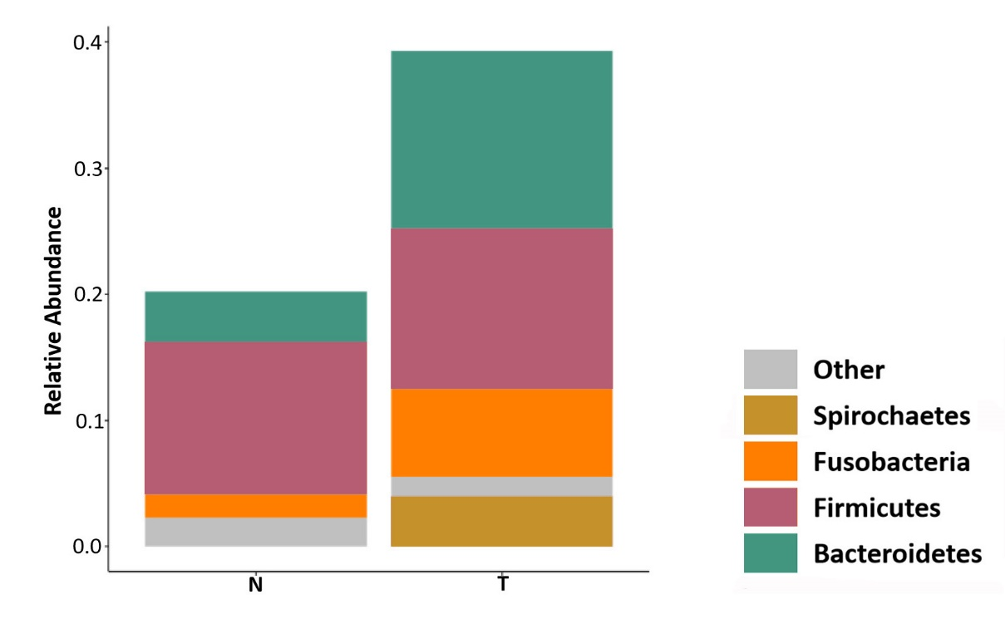

Figure S3. The results of heatmap showed that the relative abundance of Fusobacterium (P=0.039) and Prevotella (P=0.0379) were corrected with clinical stage in ESCC, where were higher in tumor than in corresponding normal tissues, without IA stage.
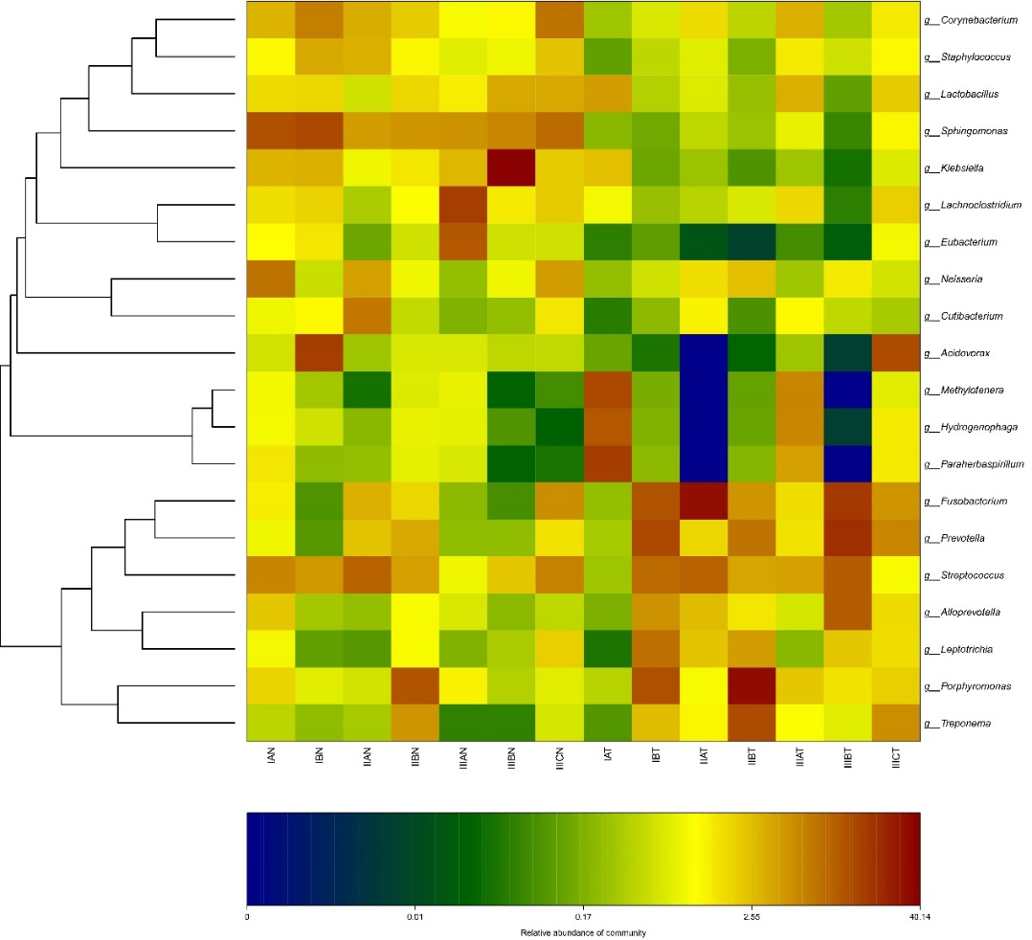
Figure S4. Fusobacteria and Bacteroidetes increased significantly in pT3-4. Group A consisted of pT1 and pT2, Group B consisted of pT3 and pT4. Gram-negative bacteria(A), gram-positive bacteria(B) and anaerobic bacteria(C) in the flora were taken as the object of analysis, respectively.

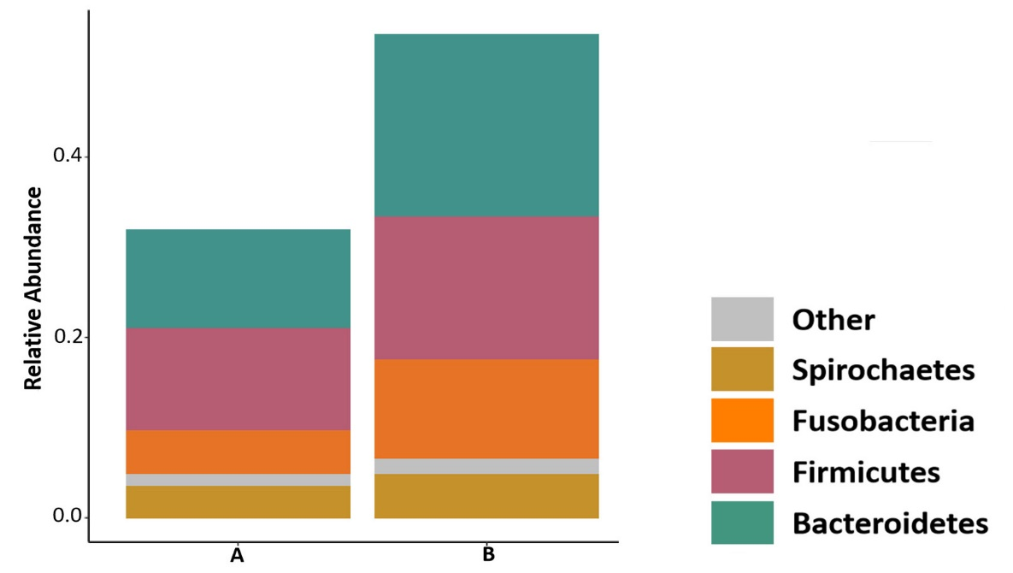

Figure S5. The relative F. nucleatum DNA levels in ESCC tumor tissues had no significant difference among patient's age, gender, smoking history, drinking history, lymph node metastasis and G stage.
Figure S6. GO and Protein domain enrichment analysis of high-risk mutant genes in 7 F. nucleatum-negative samples. (A) GO functional enrichment analysis; (B) Protein domain enrichment analysis. The P value lower than 0.05 of all mutant genes in the figure.
