Table S1. Primer sequences used for quantitative RT-PCR
Gene | Primers (F=forward, R=reverse)
GAPDH-Human | F: CCATGTTCGTCATGGGTGTG
GAPDH-Human | R: CAGGAGGCATTGCTGATGAT
IL-6-Mouse | F: CTTCCATCCAGTTGCCTTCT
IL-6-Mouse | R: ATTAAGCCTCCGACTTGTGAA
CD86-Mouse | F: GACCGTTGTGTGTGTTCTGG
CD86-Mouse | R: GATGAGCAGCATCACAAGGA
CD206-Mouse | F: GGTGGCTTATGGGATGTTTTG
CD206-Mouse | R: CATTTGGGTTCAGGAGTTGTTG
Arg-1-Mouse | F: TGGCTTGCGAGACGTAGAC
Arg-1-Mouse | R: GCTCAGGTGAATCGGCCTTTT
TNF-α-Mouse | F: TGTCTCAGCCTCTTCTCATTC
TNF-α-Mouse | R: GCCATTTGGGAACTTCTCATC
TGF-β-Mouse | F: ATTCCTGGCGTTACCTTGG
TGF-β-Mouse | R: CCTGTATTCCGTCTCCTTGG
IL-1β-Mouse | F: ATCTCGCAGCAGCACATC
IL-1β-Mouse | R: CAGCAGGTTATCATCATCATCC
Occludin-Mouse | F: GGAAGAGCAGGAAGGTCAAAGA
Occludin-Mouse | R: CGCCGCCAGTTGTGTAGTC
Claudin-1-Mouse | F: CTGTGGATGTCCTGCGTTTC
Claudin-1-Mouse | R: TACCATCAAGGCTCGGGTTG
ZO-1-Mouse | F: GAAGATCGCGTCCCCATGTAT
ZO-1-Mouse | R: TGGGTAGGGCTGTTTGTCATC
β-actin-Mouse | F: CTCTTTTCCAGCCTTCCTTCTT
β-actin-Mouse | R: GAGGTCTTTACGGATGTCAACG

Fig. S1 CCK-8 assay results of RAW 264.7, BMDMs and Caco-2 cells

Fig. S2 (A, B) Migration assay of Caco-2 cells and quantitative analysis. (C, D, E) qPCR analysis of Tight junction protein (Occudin, Claudin-1, ZO-1). (n = 3). ⁎p<0.05, ⁎⁎p < 0.01
Fig. S3 (A) Serum biochemical analysis assessing hepatic and renal functions: CREA. (B-D) Organ indices of the Lung, Heart and Kidney. (n = 6). ⁎p<0.05, ⁎⁎p < 0.01.

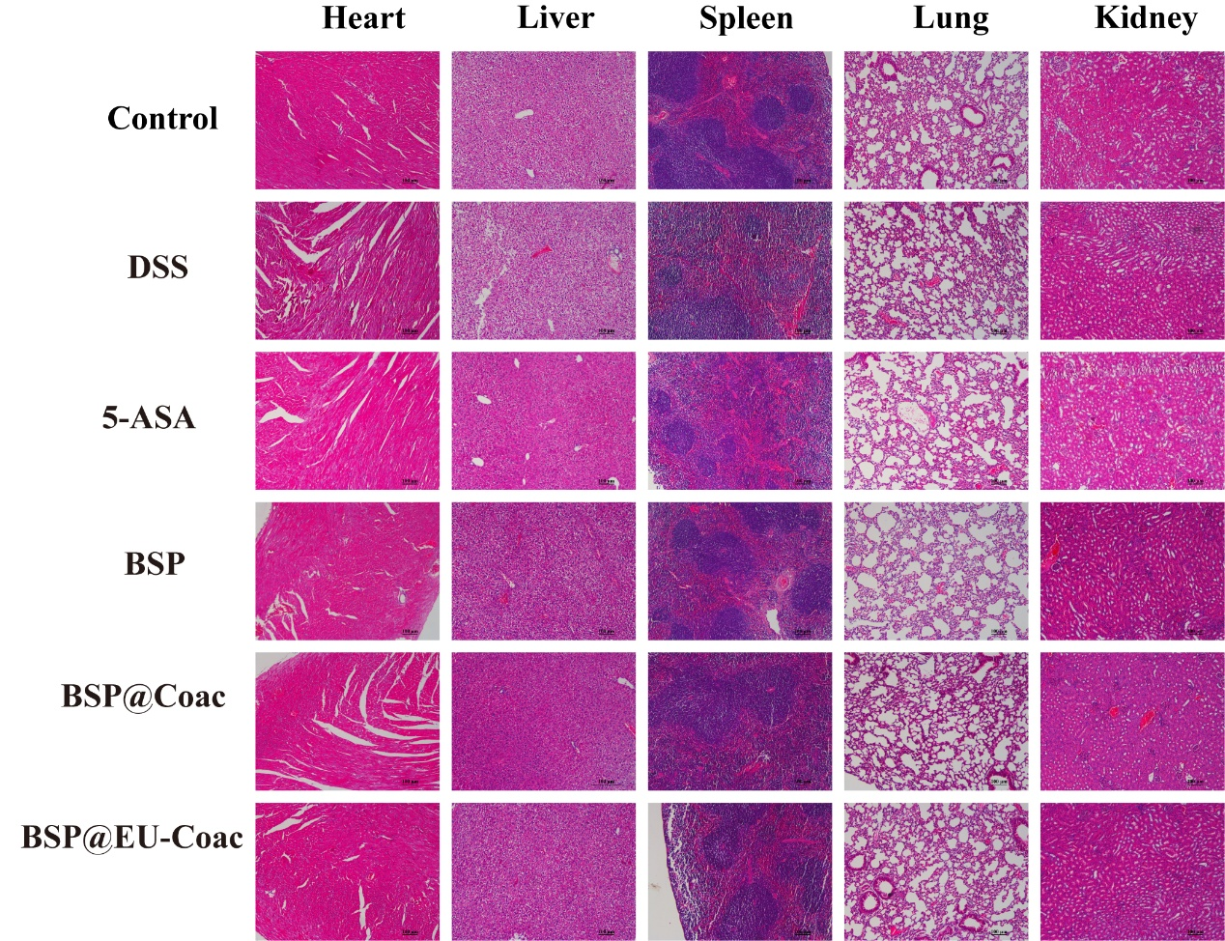
Fig. S4 H&E-stained tissue sections (Heart, Liver, Spleen, Lung, Kidney).

Fig. S5 Ex vivo imaging of the heart, liver, spleen, lung, and kidney and corresponding fluorescence quantification (n = 3). ⁎p<0.05, ⁎⁎p < 0.01.

