Supplementary material – Lyon finite element model
- Methods
  - QCT scanning and mechanical testing
The dataset of fresh frozen human femurs used in this study was described in (Gardegaront et al. 2024). Briefly, this dataset consisted of 16 intact femurs and 6 femurs (3 pairs) with drilled defects located in the femoral shaft, lower part or upper part of the femoral neck to simulate metastatic lesion. Femurs were cut at 15cm below the lesser trochanter and scanned (GE Revolution CT-scan, 200 mAs, 120 kV, voxel size: 0.7 × 0.7 × 1.2 mm³) along with a K₂HPO₄ calibration phantom (Mindways Model 3, Mindways® Inc., Austin, TX, USA). Following imaging, distal and proximal parts of each femur were embedded in polymethylmethacrylate (PMMA) resin blocks (58 mm from the distal end for the distal part and 10 mm from the upper part of the femoral head for the proximal part) and rigidly fixed in the experimental setup for mechanical testing (Riglet et al. 2020). Loading was applied on the proximal part with a 20° angle between the vertical and the diaphyseal axis to mimic single leg stance. A surface laser scan (METRIS 5128) was performed to obtain the 3D orientation of each femur. Then, each femur was loaded in quasi-static compression (12 mm/min) until failure using a servo-hydraulic testing machine (Instron 8802), following four cycles of pre-loading at 0.4 mm.
  - Finite element model
From the scans, subject-specific finite element (FE) models of each femur were created, based on (Duchemin et al. 2008). This FE model is referred to as “Lyon model”. Femurs were semi-automatically segmented using 3DSlicer (4.10.0, slicer.org). A registration algorithm was developed in Python based on the Coherent Point Drift (Myronenko and Xubo Song 2010) to orient the 3D extracted geometry as in the experimental setup. Then, the linear relationship between Hounsfield units (HU) of the scan and K₂HPO₄ density, $ρ_{K2HPO4}$, was performed automatically using the calibration phantom. K₂HPO₄ density was then converted to equivalent CaHA density using the following relationship (Faulkner et al. 1993):
$$ρ_{CaHA}=1.15×ρ_{K2HPO4}-0.0073$$
Femurs were meshed using 150,000 second-order tetrahedral elements (Ansys 2021R). CaHA density was converted into Young’s modulus as described in (Duchemin et al. 2008) and each element was assigned a Young’s modulus value with a material step of 50 MPa using QCTMA (pypi.org/project/qctma). The distal shaft was fixed and a vertical load was applied on the femoral head. Failure occurred when a critical volume of 0.33% of contiguous elements reached a stress value above their ultimate stress, as described in (Duchemin et al. 2008). For each femur, numerical failure load was compared to experimental failure load. Results were compared with the failure loads obtained using a non-linear model on the same dataset, referred to as “Leuven model” (Gardegaront et al. 2024).
- Results and Discussion
A Bland-Altman plot comparing the numerical and experimental failure loads is shown in Figure S1, for Lyon and Leuven models. For Lyon model, the average bias was -795 N, but the numerical failure load was 37% higher compared to experimental failure load for intact femurs, while it was 7% lower for femurs with defects. The average bias was lower compared to Leuven model (-2941 N). The limits of agreement were [-5671 N; 4079 N] for Lyon model, in the same range as for the Leuven model ([-7436 N; 1554 N]). A correlation plot between numerical and experimental failure loads is given in Figure S2, for both models. The coefficients of determination were in the same order of magnitude for Lyon (R² = 0.48) and Leuven (R² = 0.61) models.
Although the performance of Lyon model seems to be slightly inferior compared to Leuven model in terms of correlation with experimental data, the limits of agreement between numerical and experimental failure loads are in the same range. The higher bias for Leuven model can be due to the experimental conditions that differ compared to the dataset used to validate the model (length from the top of the femoral head to the distal diaphysis, and orientation of the setup) (Gardegaront et al. 2024). The coefficient of determination for Lyon model (R² = 0.48) is lower compared to the model developed by Duchemin et al (R² = 0.84) (Duchemin et al. 2008). This difference can be explained by a (i) calibration of the original model on a specific dataset, which can result in a potential overfitting, and (ii) different experimental conditions between each dataset. Indeed, transposing a model to another dataset can show different performances (Gardegaront et al. 2024).
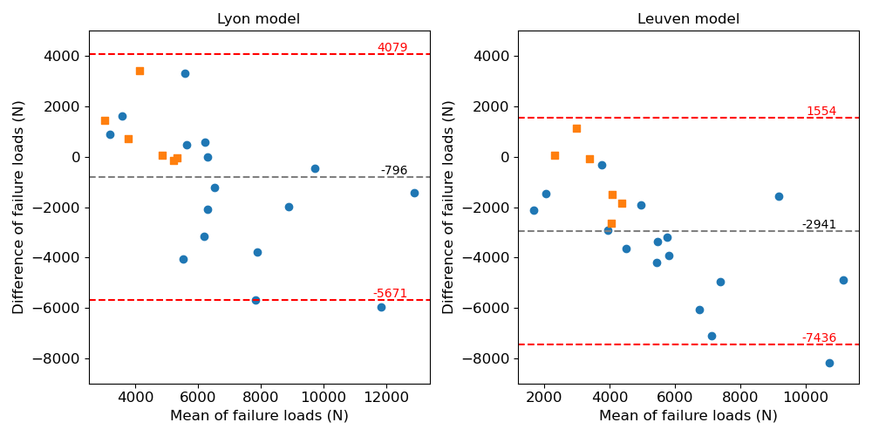
Figure S1 –Bland-Altman plot showing agreement between numerical and experimental failure loads obtained using Lyon model (left) and Leuven model (right). Differences (numerical failure load – experimental failure load) are displayed. The dashed grey line indicates the mean difference, the red dash lines indicate the upper and lower limits of agreement. Blue circles: intact femurs; orange squares: femurs with defect.
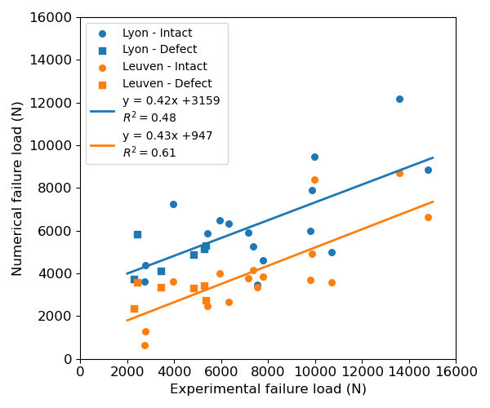
Figure S2 - Correlation plot between numerical and experimental failure loads obtained using Lyon model (blue) and Leuven model (orange). Circles: intact femurs; Squares: femurs with defect. Regression equations are displayed.

References
Duchemin L, Mitton D, Jolivet E, Bousson V, Laredo JD, Skalli W. 2008. An anatomical subject-specific FE-model for hip fracture load prediction. Computer Methods in Biomechanics and Biomedical Engineering. 11(2):105–111. https://doi.org/10.1080/10255840701535965
Faulkner KG, Glüer CC, Grampp S, Genant HK. 1993. Cross-calibration of liquid and solid QCT calibration standards: corrections to the UCSF normative data. Osteoporos Int. 3(1):36–42. https://doi.org/10.1007/BF01623175
Gardegaront M, Sas A, Brizard D, Levillain A, Bermond F, Confavreux CB, Pialat J-B, van Lenthe GH, Follet H, Mitton D. 2024. Inter-laboratory reproduction and sensitivity study of a finite element model to quantify human femur failure load: Case of metastases. Journal of the Mechanical Behavior of Biomedical Materials. 158:106676. https://doi.org/10.1016/j.jmbbm.2024.106676
Myronenko A, Xubo Song. 2010. Point Set Registration: Coherent Point Drift. IEEE Trans Pattern Anal Mach Intell. 32(12):2262–2275. https://doi.org/10.1109/TPAMI.2010.46
Riglet L, Confavreux C, Chaudier P, Pialat J-B, Bermond F, Gardegaront M, Follet H, Mitton D. 2020. Ex vivo experiments on femurs to assess metastatic bone strength. Computer Methods in Biomechanics and Biomedical Engineering. 23(sup1):S260–S261. https://doi.org/10.1080/10255842.2020.1815312

