Supplementary Materials
- Appendix S1
All ICA examinations were performed by experienced interventional cardiologists. After local anesthesia with 2% lidocaine, vascular access was obtained via the right radial artery using a 6F sheath. Heparin (3,000 U) and nitroglycerin (200 μg) were administered intra-sheath before angiography. Based on angiographic stenosis severity, target segments were selected for FFR assessment. A guiding catheter was positioned at the coronary ostium, and a pressure wire was advanced distal to the lesion to record baseline FFR, followed by hyperemic FFR after intravenous adenosine infusion (140–180 μg/kg/min). FFR measurements were interpreted independently by two physicians, with disagreements resolved by a senior reader. For smaller branches, FFR values were assigned to the corresponding major coronary artery (LAD, LCX, or RCA).

II.
 | Vessel |  | p - value
 | FFR > 0.8 (n=139) | FFR ≤ 0.8 (n=151) | p - value
LL(mm) | 19.20 (10.95-34.65) | 32.70 (17.55-46.80) | <0.001
LV(mm³) | 731.55 (536.67-902.31) | 614.60 (457.88-765.86) | 0.001
VV(mm³) | 931.17 (633.92-1161.55) | 882.19 (671.35-1056.93) | 0.353
MLA(mm²) | 2.16 (1.53-2.88) | 1.17 (0.72-1.71) | <0.001
MDS(%) | 58.47 (47.60-65.43) | 70.02 (59.92-83.20) | <0.001
MAS(%) | 73.02 (61.80-82.05) | 86.21 (76.27-93.57) | <0.001
Calcified Volume (mm³) | 9.63 (1.60-46.21) | 46.15 (4.08-107.23) | <0.001
Non-Calcified Volume (mm³) | 67.52 (20.79-149.54) | 114.84 (52.12-219.67) | <0.001
Lipid Plaque Volume (mm³) | 3.06 (0.57-12.89) | 7.79 (2.23-19.63) | 0.001
Fibrous Fatty Volume (mm³) | 28.75 (6.44-61.00) | 43.95 (12.95-76.46) | 0.004
Fibrotic Plaque Volume (mm³) | 32.23 (11.61-71.02) | 60.17 (26.13-115.73) | <0.001
Quantitative Plaque Burden
TPB (%) | 10.47 (5.43-22.01) | 22.02 (10.29-32.88) | <0.001
CPB (%) | 1.54 (0.18-6.88) | 5.79 (0.69-12.82) | <0.001
NCPB (%) | 7.99 (3.41-15.24) | 12.81 (7.11-20.49) | <0.001
LPB (%) | 0.40 (0.08-1.24) | 0.88 (0.31-2.09) | <0.001
FFPB (%) | 3.07 (0.89-5.75) | 4.87 (2.10-8.22) | <0.001
FPB (%) | 3.71 (1.82-7.37) | 7.41 (3.43-12.66) | <0.001
Vulnerability Features
Remodeling Index (%) | 1.28 (1.13-1.77) | 1.33 (1.21-1.56) | 0.396
Eccentricity Index (%) | 1.00 (0.64-1.00) | 0.81 (0.62-1.00) | 0.015
Positive Remodeling(%) | 85 (61.2%) | 114 (75.5%) | 0.012
Low Attenuation Plaque (%) | 110 (79.1%) | 135 (89.4%) | 0.024
Napkin-ring Sign (%) | 30 (21.6%) | 66 (43.7%) | <0.001
Spotty Calcification (%) | 41 (29.5%) | 65 (43.0%) | 0.023
FFR value | 0.86 (0.83-0.91) | 0.63 (0.00-0.76) | <0.001
Supplementary Table 1. Comparison of qualitative and quantitative plaque characteristics at the vascular level and by intervention status.Values are presented as mean ± standard deviation or median (interquartile) for continuous variables, and number (percentage) for categorical variables.YES = vessels that underwent invasive treatment (e.g., stent placement or rotational atherectomy), whereas “No” refers to vessels that were assessed only with FFR without any intervention.LL = Lesion Length; LV = Lumen Volume; VV = Vessel Volume; MLA = Minimum Luminal Area; MDS = Maximum Diameter Stenosis; MAS = Maximum Area Stenosis; TPB = Total Plaque Burden; CPB = Calcified Plaque Burden; NCPB = Non-Calcified Plaque Burden; LPB = Lipid Plaque Burden; FFPB = Fibrous Fatty Plaque Burden; FPB= Fibrotic Plaque Burden; FFR = Fractional Flow Reserve.
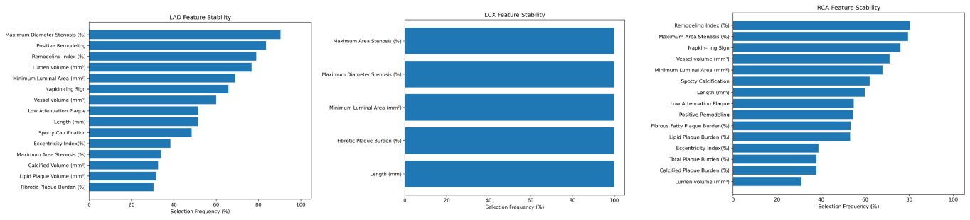
Supplementary figure 1. Stability of plaque feature selection across bootstrap resampling in LAD, LCX, and RCA vessels.

