SUPPLEMENTS
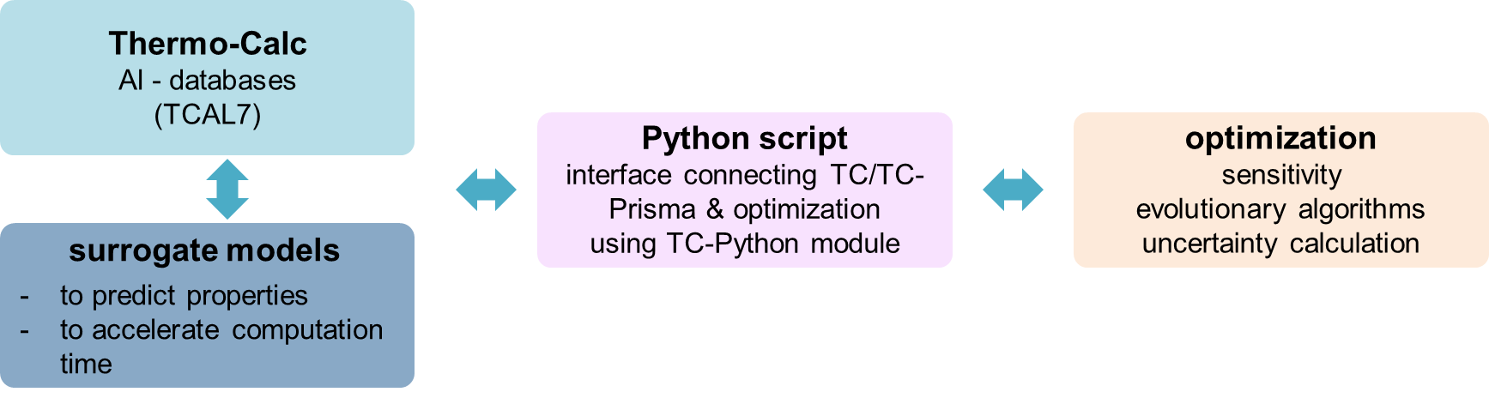
Fig. S1: General aapproach for high-throughput computational screening of alloys from scraps
Variable Description
Al | Aluminum content after mixing scraps (in wt.%)
Si | Silicon content after mixing scraps (in wt.%)
Cu | Copper content after mixing scraps (in wt.%)
Ni | Nickel content after mixing scraps (in wt.%)
Mg | Magnesium content after mixing scraps (in wt.%)
Mn | Manganese content after mixing scraps (in wt.%)
Fe | Iron content after mixing scraps (in wt.%)
Cr | Chromium content after mixing scraps (in wt.%)
Ti | Titanium content after mixing scraps (in wt.%)
Zr | Zirconium content after mixing scraps (in wt.%)
V | Vanadium content after mixing scraps (in wt.%)
P | Phosphor content after mixing scraps (in wt.%)
Vf_FCC_A1 | Volume fraction (in vol.%) of the α-Al-matrix phase
Vf_DIAMOND_A4 | Volume fraction (in vol.%) of the Si phase
Vf_AL15SI2M4 | Volume fraction (in vol.%) of the Al15(Fe,Mn)3Si2 phase
Vf_AL3X | Volume fraction (in vol.%) of the Al3(Ti,Zr) phase
Vf_AL6MN | Volume fraction (in vol.%) of the Al6Mn phase
Vf_ALP | Volume fraction (in vol.%) of the ALP phase
Vf_AL3NI2 | Volume fraction (in vol.%) of the δ-Al3(Cu,Ni)2 phase
Vf_AL3NI_D011 | Volume fraction (in vol.%) of the ε-Al3Ni phase
Vf_AL7CU4NI | Volume fraction (in vol.%) of the π-Al7Cu4Ni phase
Vf_AL2CU_C16 | Volume fraction (in vol.%) of the θ-Al2Cu phase
Vf_Q_ALCUMGSI | Volume fraction (in vol.%) of the Q-Al5Si6Cu2Mg8 phase
Vf_AL7CU2FE | Volume fraction (in vol.%) of the Al7Cu2Fe phase
Vf_MG2SI_C1 | Volume fraction (in vol.%) of the Mg2Si phase
Vf_AL9FE2SI2 | Volume fraction (in vol.%) of the β-Al5FeSi phase
Vf_AL18FE2MG7SI10 | Volume fraction (in vol.%) of the π- Al8FeMg3Si6 phase
eut. frac.[%] | fraction of eutectic after solidification (in %)
eut. T (°C) | temperature of eutectic formation (in C)
T_FCC_A1 | solidification temperature (in °C) of the α-Al-matrix phase
T_DIAMOND_A4 | solidification temperature (in °C) of the Si phase
T_AL15SI2M4 | solidification temperature (in °C) of the Al₁₅(Fe,Mn)₃Si₂ phase
T_AL3X | solidification temperature (in °C) of the Al₃(Ti,Zr) phase
T_AL6MN | solidification temperature (in °C) of the Al₆Mn phase
T_ALP | solidification temperature (in °C) of the ALP phase
T_AL3NI2 | solidification temperature (in °C) of the δ-Al₃(Cu,Ni)₂ phase
T_AL3NI_D011 | solidification temperature (in °C) of the ε-Al₃Ni phase
T_AL7CU4NI | solidification temperature (in °C) of the γ-Al₇Cu₄Ni phase
T_AL2CU_C16 | solidification temperature (in °C) of the θ-Al₂Cu phase
T_Q_ALCUMGSI | solidification temperature (in °C) of the Q-Al₅Si₆Cu₂Mg₈ phase
T_AL7CU2FE | solidification temperature (in °C) of the Al₇Cu₂Fe phase
T_MG2SI_C1 | solidification temperature (in °C) of the Mg₂Si phase
T_AL9FE2SI2 | solidification temperature (in °C) of the β-Al₅FeSi phase
T_AL18FE2MG7SI10 | solidification temperature (in °C) of the π- Al₈FeMg₃Si₆ phase
T(liqu) | liquidus temperature (in °C)
T(sol) | solidus temperature (in °C)
delta_T | Solidification interval (T(liqu) – T(sol), in °C)
delta_T_FCC | Solidification interval (T_FCC_A1 – T(sol), in °C)
delta_T_Al15Si2M4 | Solidification interval (T_Al15Si2M4 – T(sol), in °C)– T(sol), in °C)
delta_T_Si | Solidification interval (T_DIAMOND_A4 – T(sol), in °C)
CSC | hot crack susciptability coefficient
YS(MPa) | total yield strength (in MPa)
Hardness (Vickers) | total hardness (in Vickers)
CTEvol (1/K)(20.0-300.0°C) | volumetric thermal expansion coefficient (in 1/K, temperature range 20 - 300°C)
Density(g/cm3) | alloy density (in g/cm³)
Volume(m3/mol) | system volume (in m³/mol)
El.conductivity(S/m) | electrical conductivity (in S/m)
El. Resistivity (ohm m) | electrical resistivity (in ohm*m)
heat capacity (J/(mol K)) | heat capacity (in J/(mol*K))
Therm.conductivity (W/(mK)) | thermal conductivity (in W/(mK))
Therm. Diffusivity (m2/s) | thermal diffusivity (in m²/s)
Therm.resistivity (mK/W) | thermal resistivity (in mK/W)
Linear thermal expansion (1/K)(20.0-300.0°C) | linear thermal expansion coefficient (in 1/K, temperature range 20 - 300°C)
Technical thermal expansion (1/K)(20.0-300.0°C) | technical thermal expansion coefficient (in 1/K, temperature range 20 - 300°C)

Table S1: Output variables from Thermo-Calc calculations

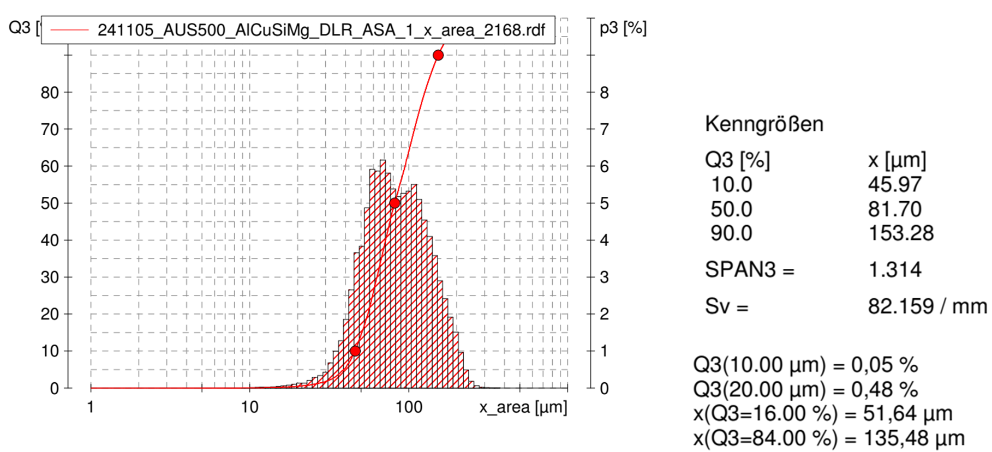
Fig. S2: Grain size analysis of the atomized scrap mixture for in-situ LPBF experiments

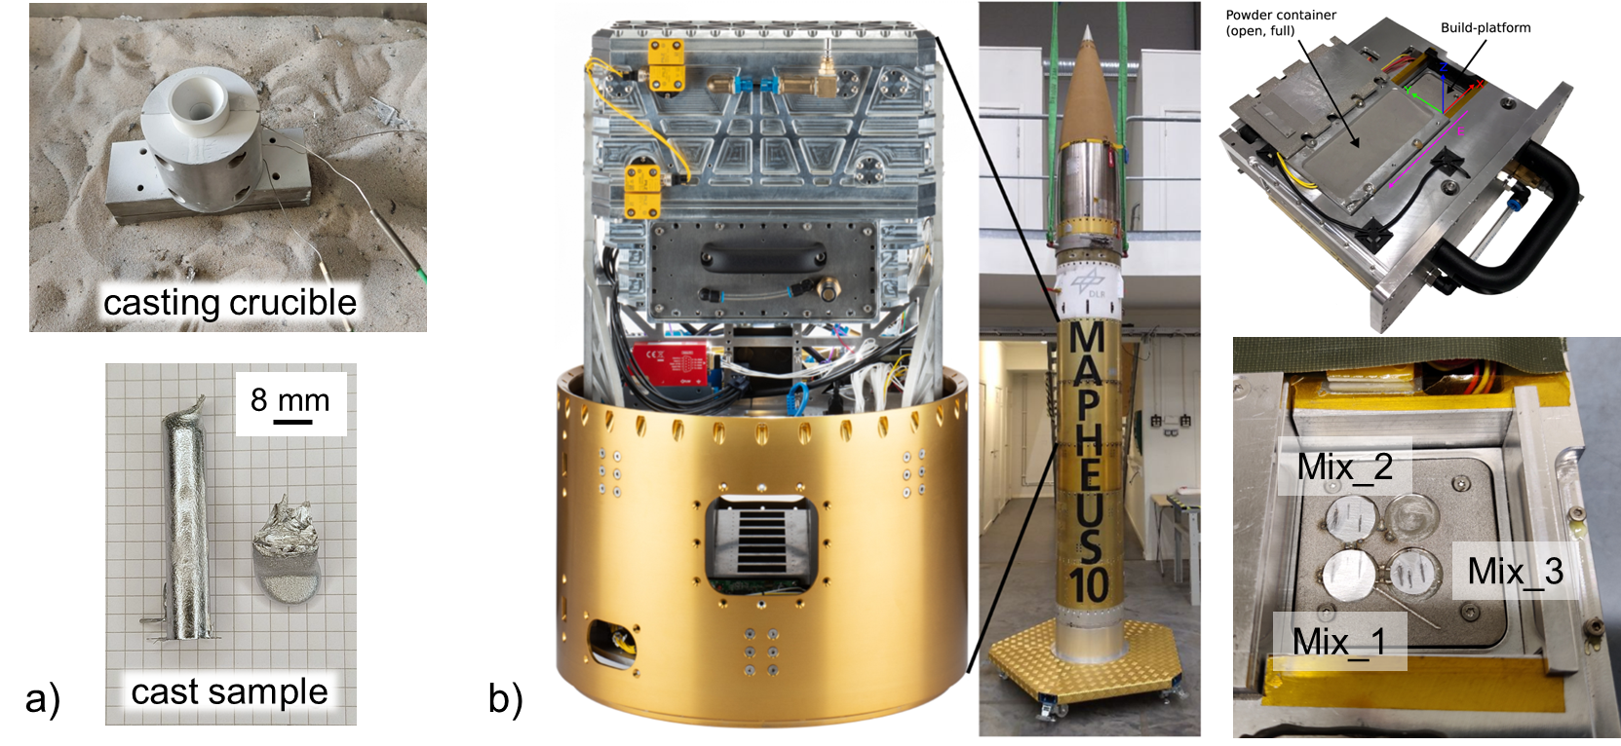
Fig. S3: a) casting crucible for sample production and cast sample, b) used LPBF machine (MARS-M) for laser line scan experiments and preliminary LPBF tests.

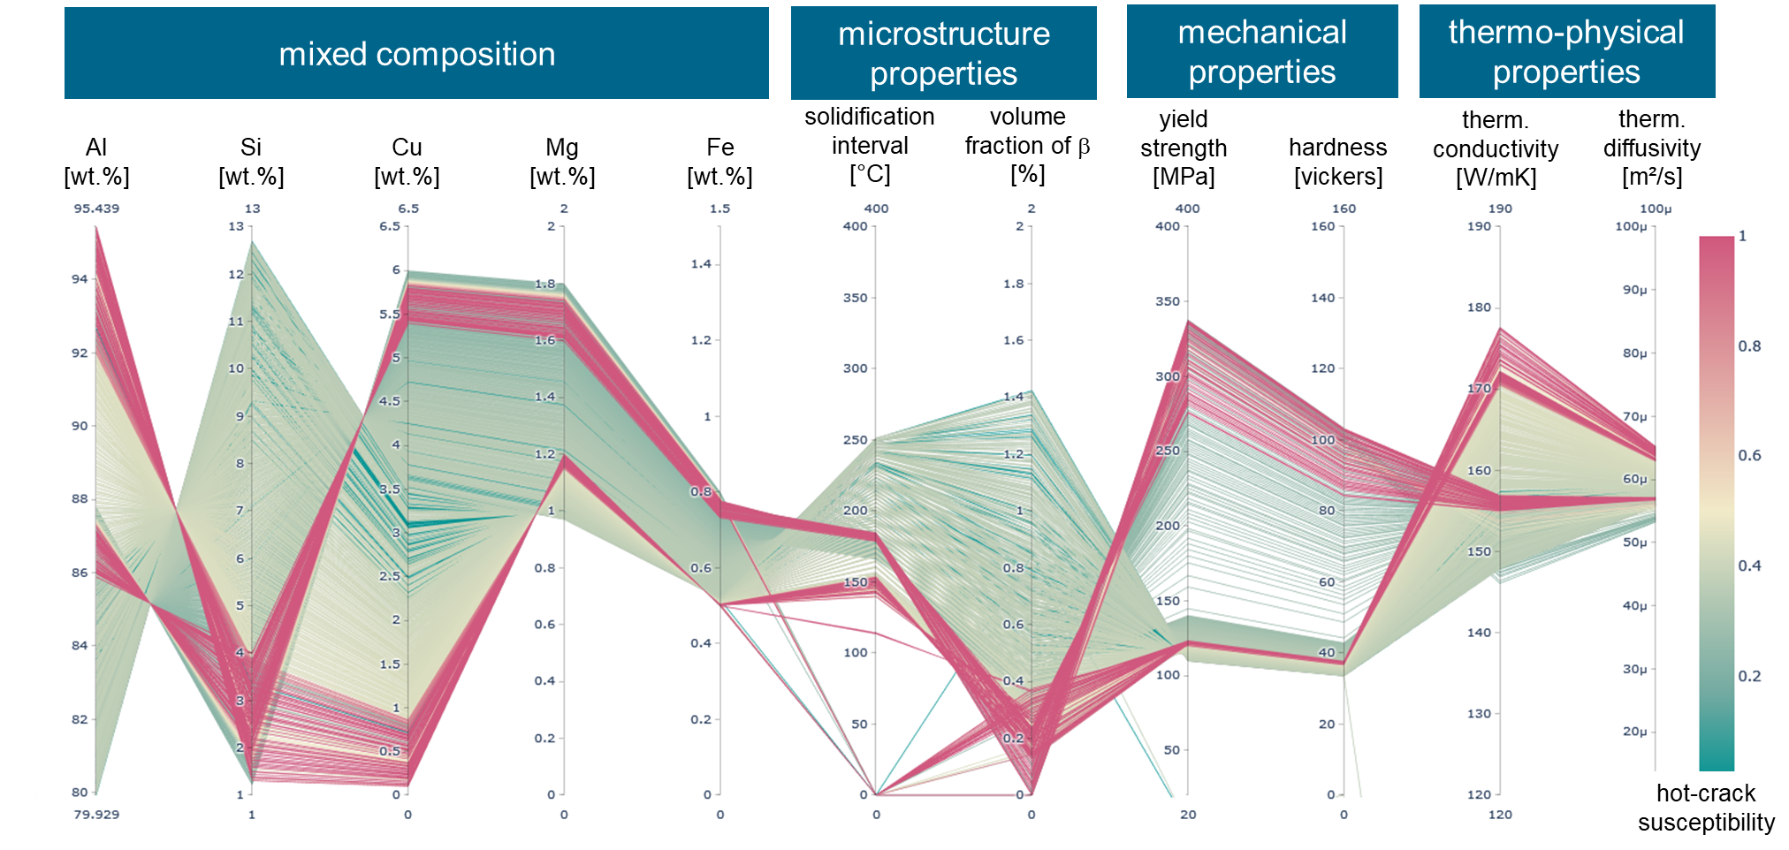
Fig. S4: Parallel coordinates plot showing representatively the information that can be gained from high-throughput thermodynamic calculations (on the example of ~ 1500 designs).
Fig. S4 shows selected input and output parameters for ~1500 designs in the form of a parallel plot where each line indicates one alloy design. This illustrates what kind of information can be gained from the conducted calculations, i.e. the chemical composition after mixing different scraps, microstructure properties, mechanical properties and thermo-physical properties.
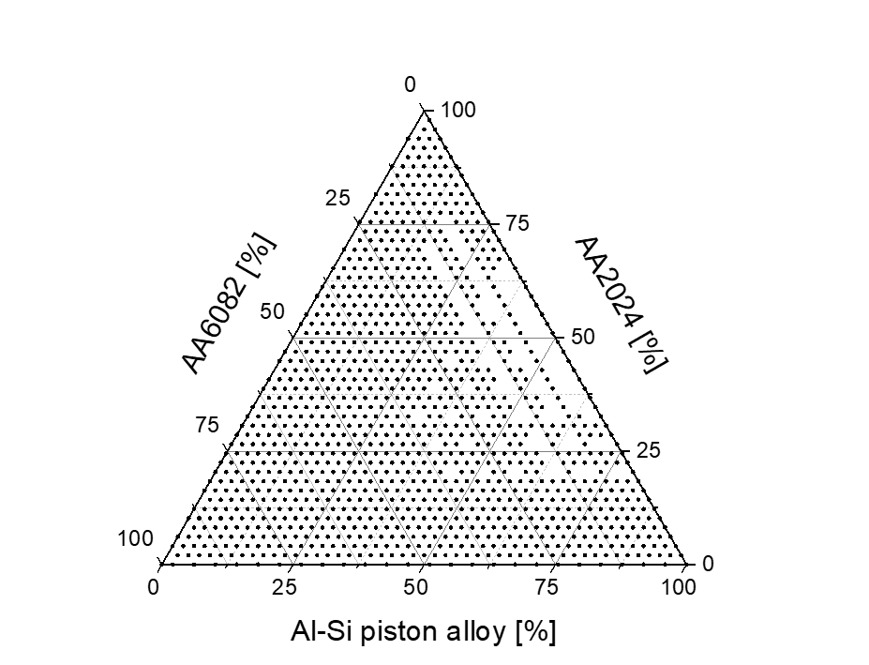
Fig. S5: Training dataset for the Random Forest surrogate model: ternary mixtures (Al-Si piston alloy + AA2024 + AA6082; 760 existing data points)

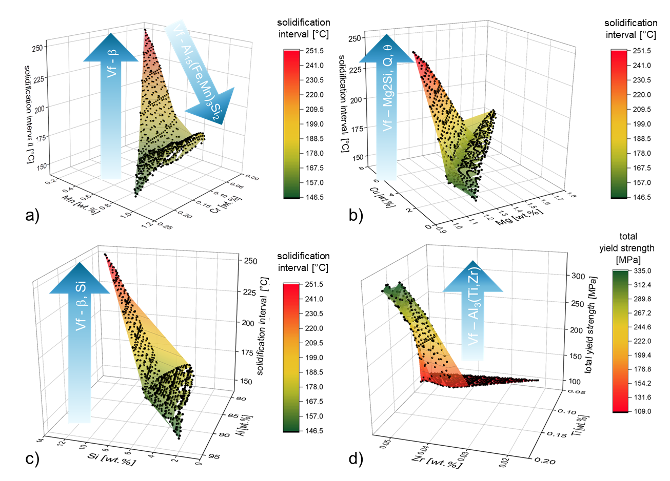
Fig. S7: Additional 3D sensitivity plots showing the influence of elements on phase volume fractions and relevant calculated alloy properties.

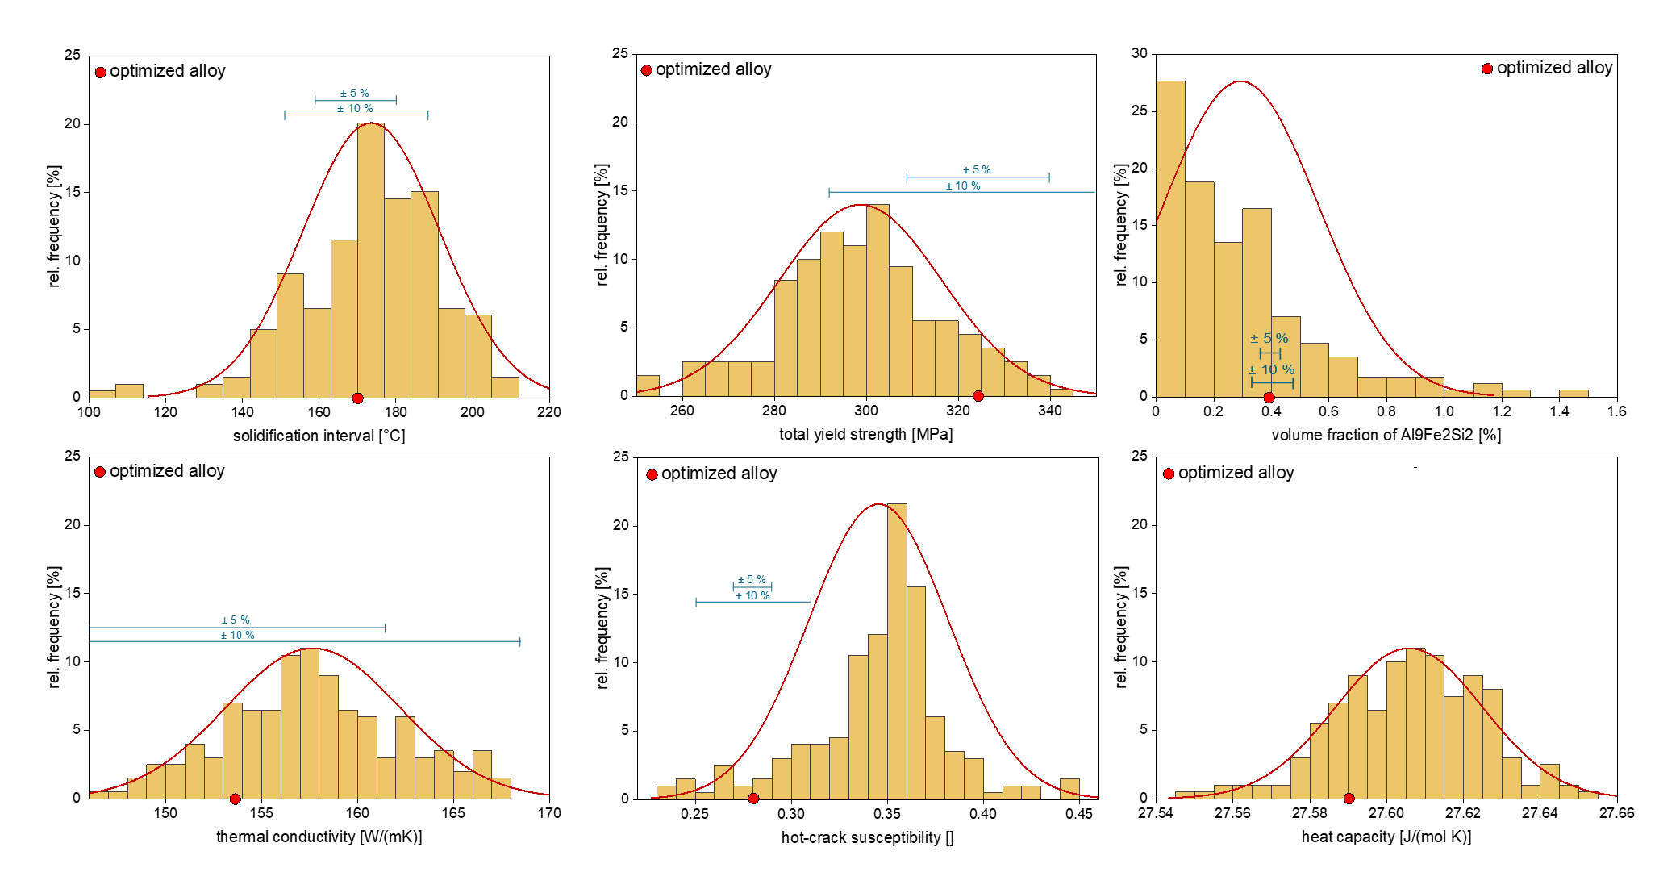
Fig. S8: Uncertainty histograms for the most relevant alloy properties within the defined element ranges in Fig. 8.
Phases identified in Mix1, Mix2 or Mix3 | Space group no. | Other names | Thermo-Calc designation
Al | 225 |  | FCC_A1
Si | 227 |  | DIAMOND_A4
Mg₂Si | 225 |  | MG2SI_C1
Al₂Cu | 140 |  | AL2CU_C16
Al_{17.1}Fe_{3.2}Mn_{0.8}Si_{1.9} * | 204 | Al₁₉(Fe,Mn)₅Si₂ | AL15SI2M4
Al₉FeMg₃Si₅ | 189 | Al₈FeMg₃Si₆ | AL18FE2MG7SI10
Al₄Cu₂Mg₈Si₇ | 174 | Al₅Cu₂Mg₈Si₆ | Q_ALCUMGSI
Al₃FeSi₂ | 140 |  | ALFESI_T4
Al₂CuNi | 221
Al-Ni-Cu rich phase | ?
* The phases Al_{17.1}Fe_{3.2}Mn_{0.8}Si₂ (space group 204) and Al₁₅(Fe,Mn)₃Si₂ (space group 200) with more than 130 atoms in the unit cell are very similar and cannot be easily distinguished from one another.
Table S2: Phase names, space group number and other common names of the phases identified in the as-cast alloy samples Mix-1, Mix-2 and Mix3 and the Thermo-Calc designations that most likely correspond to them.
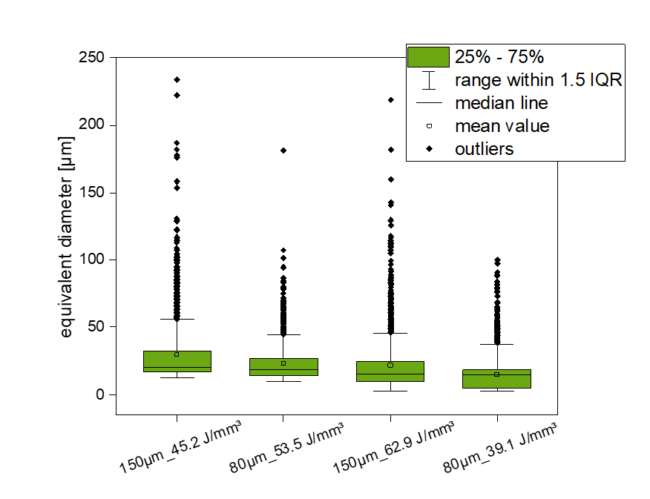
Fig. S9: Quantitative evaluation of the equivalent diameter of defects for the optimized alloy Mix-2 (AlSi5Ni0.7Cu4.4Mg1.5Fe0.5) comparing different print conditions.

