Supplementary Information

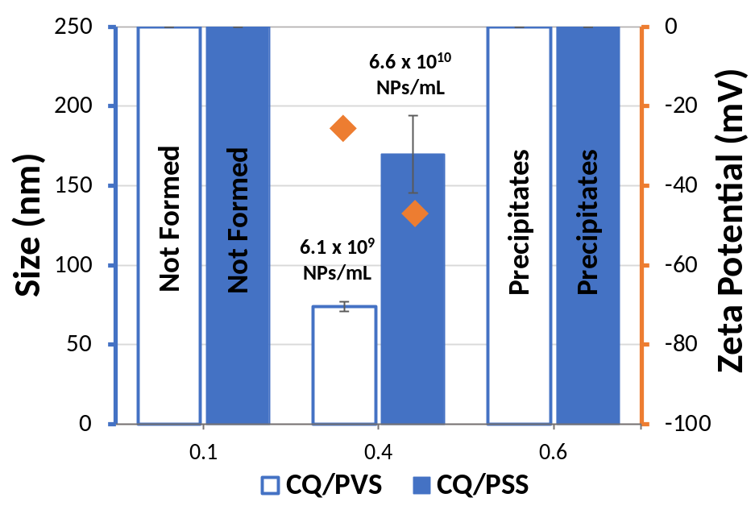
Figure S1. Size (bars), zeta potential (rhombuses) and NPs concentration (number) of tested CQ/polymer formulations at molar ratio 0.1, 0.4 and 0.6 (mean ± SD; n=3).

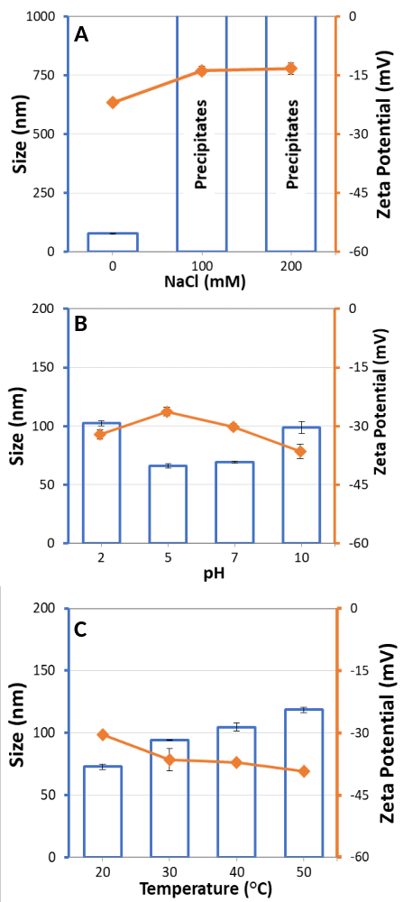
Figure S2. Stability study of NPs CQ/PVS 0.4 through evaluation of size (bars) and zeta potential (rhombuses), as a function of different NaCl concentrations (A), pH (B), and temperature (C) (mean ± SD, n=3).

Table S1. Diafiltration parameters of CQ/PSS formulations at different ratio (0.1 – 1.2) (mean ± SD, n=3).
[CQ]/[PSS]⁻ | [CQ]  (mM) | [PSS] (mM) | k^{m} | u^{m} | v | u | j | K^{diss} | KB % | TB % | EA %
0.1 | 0.33 | 3.3 | - | - | - | - | - | - | - | - | -
0.2 | 0.66 | 3.3 | - | - | - | - | - | - | - | - | -
0.3 | 0.99 | 3.3 | - | - | - | - | - | - | - | - | -
0.4 | 1.32 | 3.3 | 1.00 | 0.00 | 0.01 ± 0.00 | 0.99 ± 0.00 | 0.39 ± 0.31 | 0.7 ± 0.7 | 99.3 ± 0.3 | 0.5 ± 0.3 | 99.8 ± 0.1
0.5 | 1.65 | 3.3 | 1.00 | 0.00 | 0.18 ± 0.01 | 0.82 ± 0.01 | 0.76 ± 0.16 | 7.8 ± 9.7 | 81.7 ± 0.9 | 4.1 ± 2.6 | 85.8 ± 3.5
0.6 | 1.98 | 3.3 | 1.00 | 0.00 | 0.25 ± 0.04 | 0.75 ± 0.04 | 0.81 ± 0.07 | 3.2 ± 1.3 | 75.4 ± 3.6 | 4.2 ± 1.3 | 79.6 ± 4.8
0.7 | 2.31 | 3.3 | 1.00 | 0.00 | 0.25 ± 0.04 | 0.71 ± 0.03 | 0.84 ± 0.05 | 3.9 ± 1.6 | 70.5 ± 2.1 | 4.6 ± 1.3 | 75.1 ± 3.6
0.8 | 2.64 | 3.3 | 1.00 | 0.00 | 0.40 ± 0.11 | 0.60 ± 0.09 | 0.91 ± 0.09 | 12.5 ± 9.3 | 59.8 ± 9.1 | 3.7 ± 1.0 | 63.3 ± 10.3
0.9 | 2.97 | 3.3 | 1.03 | 0.00 | 0.47 ± 0.01 | 0.53 ± 0.00 | 0.88 ± 0.10 | 11.8 ± 4.1 | 53.4 ± 0.5 | 7.9 ± 5.5 | 61.3 ± 5.8
1 | 3.30 | 3.3 | 0.98 | 0.00 | 0.42 ± 0.18 | 0.58 ± 0.15 | 0.87 ± 0.06 | 7.2 ± 6.3 | 57.5 ± 15.1 | 4.2 ± 1.0 | 62.7 ± 12.4
1.1 | 3.60 | 3.3 | 0.98 | 0.00 | 0.54 ± 0.08 | 0.46 ± 0.07 | 0.92 ± 0.06 | 37.7 ± 7.7 | 45.7 ± 6.8 | 3.2 ± 1.7 | 48.8 ± 5.6
1.2 | 3.96 | 3.3 | 1.00 | 0.00 | 0.67 ± 0.02 | 0.33 ± 0.02 | 0.93 ± 0.03 | 9.1 ± 5.2 | 33.4 ± 1.6 | 4.5 ± 2.0 | 37.9 ± 1.5

Table S2. Values of CQ release data obtained from kinetic models for conventional dialysis and USP 4 apparatus at different conditions (Milli-Q water* and simulated biological conditions**.
 | Dialysis* |  |  |  | Dialysis** |  |  |  | USP apparatus 4*
Kinetics Model | R² | AIC | MSC | n | R² | AIC | MSC | n | R² | AIC | MSC | n
Zero Order | 0.634 | 55.23 | 0.88 | - | 0.103 | 112.23 | -0.21 | - | 0.237 | -94.24 | -0.88 | -
First Order | 0.637 | 54.98 | 0.90 | - | 0.560 | 100.17 | 0.79 | - | 0.237 | -94.24 | -0.88 | -
Higuchi | 0.668 | 52.13 | 1.04 | - | 0.713 | 96.00 | 1.14 | - | 0.230 | -94.15 | -0.88 | -
Korsmeyer-Peppas | 0.798 | 44.02 | 1.44 | 0.16 | 0.938 | 80.10 | 2.47 | 0.31 | 0.777 | -126.54 | 0.41 | 0.10

