Supplementary Materials:
- Northing result plots and Standard Deviations for Static Experiment (Section 3.3) for Leica AS10 Geodetic Antenna and U-blox F9P Low-cost Receiver for GPS, Galileo Beidou Satellite combination
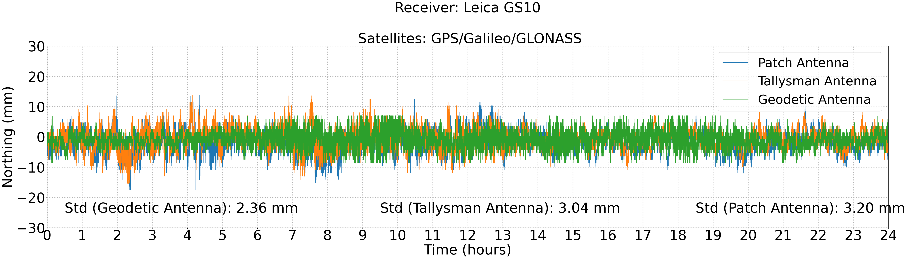
- Height result plots and Standard Deviations for Static Experiment (Section 3.3) for Leica AS10 Geodetic Antenna and U-blox F9P Low-cost Receiver for GPS, Galileo Beidou Satellite combination
