Supporting Information

Collagen Stimulating Activity of a Pentapeptide Conjugate and Self-Assembly into Micelles
Lucas de Mello,¹ Valeria Castelletto,¹ Jani Seitsonen,² Ian W Hamley¹
¹ School of Chemistry, Food Biosciences and Pharmacy, University of Reading, Whiteknights, Reading RG6 6AD, U.K.
² Nanomicroscopy Center , Aalto University, Puumiehenkuja 2, FIN-02150 Espoo, Finland

Table S1. Parameters extracted from the fitting of the SAXS data in Figure 2d, using the form the form factor for a spherical shell, together with the structure factor for a hard sphere.
 | 0.5 wt% FMDEG-KTTKS | 1 wt% FMDEG-KTTKS | 5 wt% FMDEG-KTTKS
R₁ / nm | 2.34 ± 0.64 | 2.40 ± 0.57 | 2.60 ± 0.52
R₂ / nm | 1.8 | 1.8 | 1.8
μ / cm⁻¹ | -4.8x10⁻² | -3.8x10⁻² | -3.8x10⁻²
τ / cm⁻¹ | 3.7x10⁻³ | 6.1x10⁻³ | 1.3x10⁻²
R_{HS} / nm | -- | 6.6 | 4.8
φ | -- | 6x10⁻² | 1.9x10⁻²
C | 5.7x10⁻⁴ | 1x10⁻³ | 4x10⁻³

Key. Spherical Shell Form Factor: overall radius of the spherical shell, R₁, radius of the core, R₂, scattering contrast of the inner core, μ, scattering contrast of the shell, τ. Hard Sphere Structure Factor: hard sphere radius, R_{HS}, volume fraction of hard spheres, φ. Background,

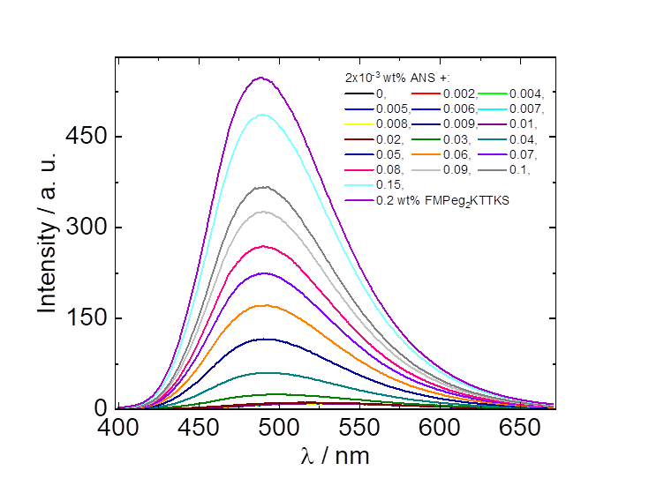
Figure S1. ANS fluorescence intensity curves used to construct the plot in Figure 1.

Figure S2. SAXS data for 1 wt% solutions of FMdEG-KTTKS at the pH values indicated.

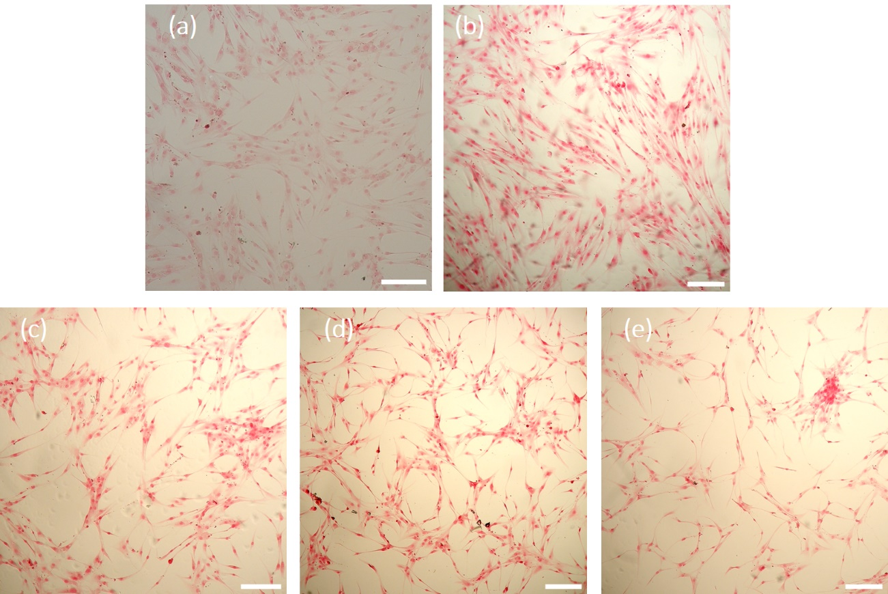
Figure S3. Bright field optical microscopy images of HDFa cells stained with Picrosirius red in the presence of (a) Basal media, (b) Conventional stimulants, (c) 0.00625 wt% FMdEG-KTTKS, (d) 0.0125 wt% FMdEG-KTTKS, (e) 0.025 wt% FMdEG-KTTKS. Scale bar = 200 µm.

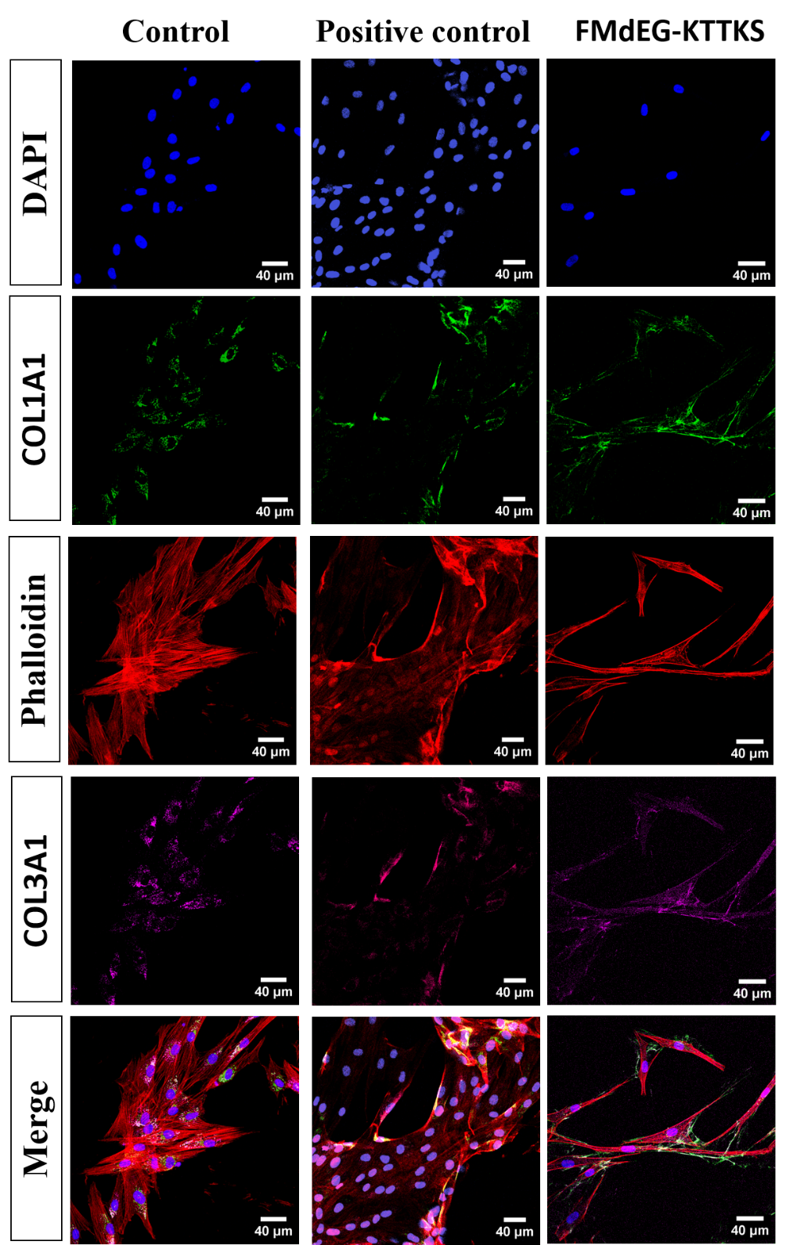
Figure S4. Immunocytochemistry images for (a) HDFa cells incubated only in basal DMEM media, (b) conventional stimulants containing TGF-β1, insulin and citric acid and (c) FMdEG-KTTKS 0.00625 wt%. Each row represents different labelling, with the nucleus stained with DAPI (blue), Phalloidin red staining actin in the cytoskeleton (red), Alexa Fluor 488 labelling for type I collagen (green) and Alexa Fluor 647 labelling for type III collagen (magenta). The last row shows a merge of all four channels.
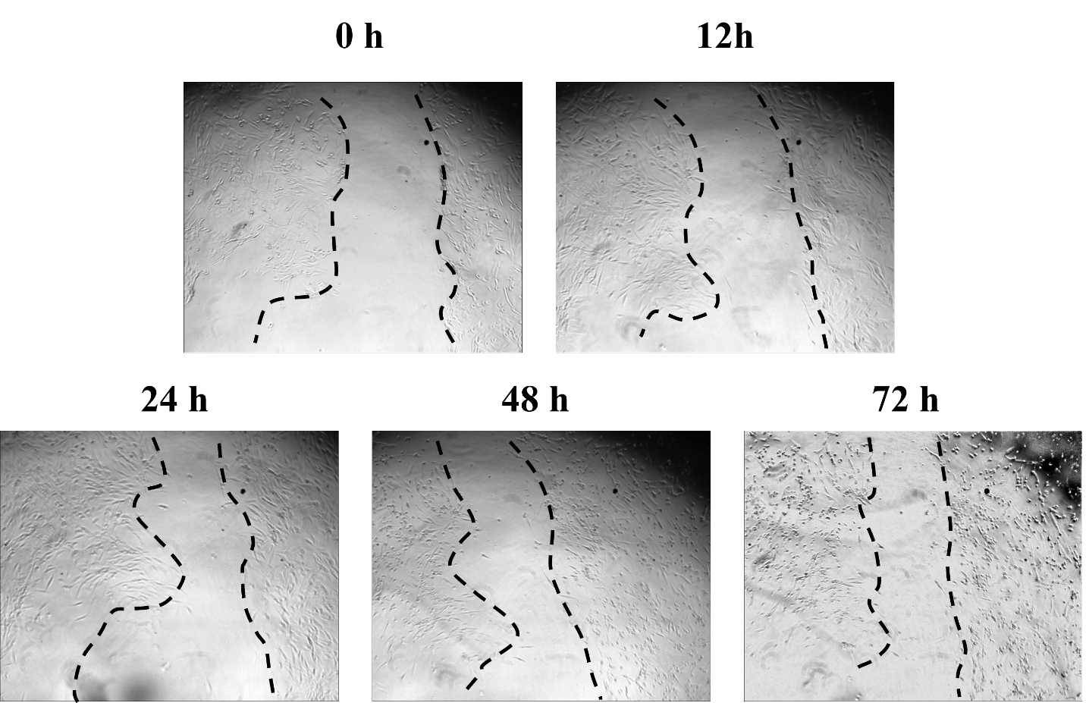

Figure S5. Scratch assay showing repopulation of scratched region shown on a plate surface by human dermal fibroblast cells as controls without FMdEG-KTTKS or collagen stimulants at the time points indicated. For better visualization, dashed lines are placed at the borders of the ‘wound’ in the cell monolayer.

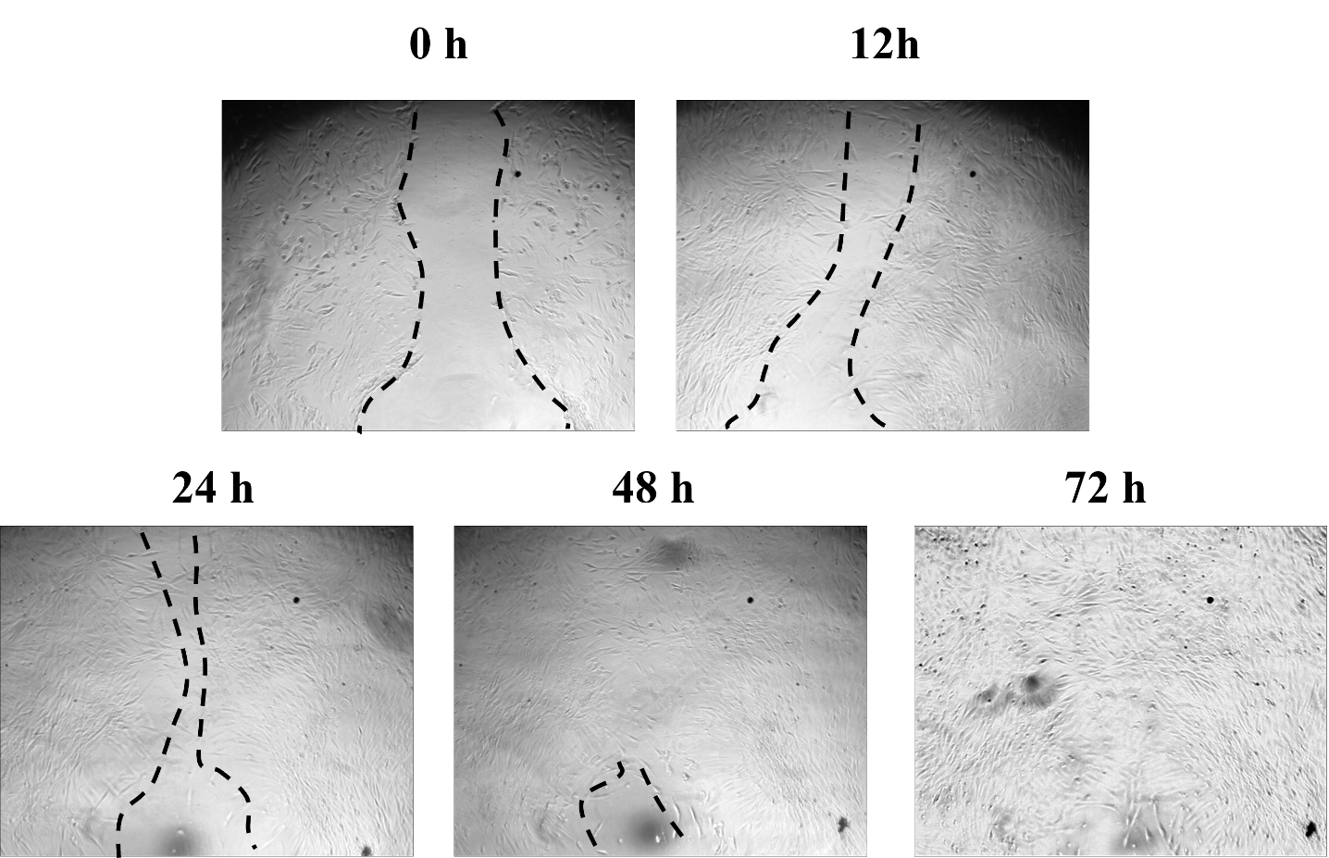

Figure S6. Positive control, scratch assays showing the repopulation of a scratched region by human dermal fibroblast cells incubated with conventional stimulants (TGF-β1, insulin and ascorbic acid) without FMdEG-KTTKS at the time points indicated. For better visualization, dashed lines are placed at the borders of the simulated wound in the cell monolayer.

