Additional File 1-Supporting Information
Decrease in Membrane Fluidity and Traction Force Induced by Silica-Coated Magnetic Nanoparticles

Tae Hwan Shin^{1,#}, Abdurazak Aman Ketebo^{2,#}, Da Yeon Lee¹, Seungah Lee³, Seong Ho Kang³, Shaherin Basith¹, Balachandran Manavalan¹, Sungsu Park^{2,*}, and Gwang Lee^{1,4,*}
¹Department of Physiology and Department of Biomedical Sciences, Ajou University School of Medicine, Suwon, Republic of Korea
²School of Mechanical Engineering, Sungkyunkwan University, Suwon, Republic of Korea
³Department of Chemistry, Graduate School, Kyung Hee University, Yongin-si, Republic of Korea
⁴Department of Molecular Science and Technology, Ajou University, Suwon, Republic of Korea
#These authors contributed equally to this work.

*Corresponding authors:
Sungsu Park, Professor, School of Mechanical Engineering, Sungkyunkwan University, Seobu-ro, Jangan-gu, Suwon-si, Gyeonggi-do, 16419, Republic of Korea. Phone: +82-31-290-7431, fax: +82-31-290-5889, e-mail: nanopark@skku.edu

Gwang Lee, Professor, Department of Physiology, Ajou University School of Medicine, 164, World cup-ro, Yeongtong-gu, Suwon-si, Gyeonggi-do 16499, Republic of Korea. Phone: +82-31-219-4554, fax: +82-31-219-5049, e-mail: glee@ajou.ac.kr
Materials and Methods
Cell culture. Human embryonic kidney 293 (HEK293) cells were obtained from American Type Culture Collection (ATCC). Briefly, the cells were cultured in Dulbecco’s high-glucose modified Eagle’s medium (DMEM, Gibco, USA) supplemented with 10% fetal bovine serum (Gibco, USA), 100 units/ml penicillin, and 100 µg/ml streptomycin (Gibco, USA) and incubated in a 5% CO₂ humidified chamber at 37°C.
Evaluation of intracellular ROS levels. Intracellular ROS levels were evaluated by DCFH-DA staining (Cell Biolabs, San Diego, CA, USA) according to the manufacturer’s protocol. Briefly, cells were resuspended in dye solution (10 µM DCFH-DA in PBS) and incubated in 37°C/5% CO₂ for 1 h. Samples were washed twice with PBS, and fluorescence was measured with a Gemini EM fluorescence microplate reader (Molecular Devices, Sunnyvale, CA, USA) at 480 nm excitation/530 nm emission.
Evaluation of lipid peroxidation. Peroxidized unsaturated lipids were quantified according to the manufacturer’s instructions with lipid peroxidation kit (Cayman Chemical, Ann Arbor, MI, USA). Briefly, for 12 h, 0.1 and 1.0 µg/µl of MNPs@SiO₂(RITC)-treated cells and non-treated control cells were detached from the culture dish and washed with PBS twice. The cells were transferred to glass test tubes. Lipids were extracted with methanol, which is saturated with crystalline solid and ice-cold chloroform. After centrifugation (1500g, 0ºC, 5-times), bottom chloroform layers were collected. The collected samples were 9:1 mixed with 2.25 mM ferrous sulfate, 0.1 M hydrochloric acid, and 1.5% ammonium thiocyanate in methanol and incubated in room temperature for 5 mins. Ferric ions were produced in the reaction with the mixture, and peroxidized unsaturated lipids were detected using thiocyanate as chromogen (absorbance at 500 nm). Absorbance were measured using quartz cuvette and microplate reader (Molecular Devices, USA).

Reverse transcription PCR (RT-PCR) analysis. For semi-quantitative RT-PCR, A cDNA library was synthesized using iScript Advanced cDNA Synthesis Kit (Bio-rad, CA). Reaction conditions were as follow: 46°C for 20 min, followed by 95°C for 1 min. cDNA were reverse transcribed and amplified using gene-specific primer pairs for genes related to transcriptomic network (Supplementary Table 2, Additional File 1). To remove template errors, PCR products were normalized relative to glyceraldehyde-3-phosphate dehydrogenase (GAPDH), and PCR products were amplified from the same cDNA. Amplified PCR products were separated on 2% agarose gels and stained with ethidium bromide.
Quantitative PCR analysis. The expression of transcriptomic network-related genes was detected by qPCR using the SYBR Green-based real-time PCR kit (Bio-Rad) with gene-specific primer pairs (Supplementary Table 2, Additional File 1) on a Rotor Gene-Q system (Qiagen, Valencia, CA, USA). Reaction conditions were as follow: 95°C for 5 min, followed by 50 cycles of 95°C for 5 s and 60°C for 30 s. The threshold/quantification cycle (Ct/Cq) value was determined at the point where the detected fluorescence was statistically higher than the background level. PCR products were analyzed based on a melting curve constructed using Rotor-Gene 1.7 software (Qiagen). PCR reactions were prepared as independent triplicate samples. The relative quantification of target gene expression was calculated by the 2^{−ΔΔCt} method.
Measurement of Adenosine Triphosphate (ATP) concentration. ATP concentration of MNPs@SiO₂(RITC)-treated HEK293 cells was measured using an ATP assay system (Promega, USA) according to the manufacturer's protocol. Briefly, HEK293 cells were seeded3 × 10⁴ on a 96 well plate and treated with MNPs@SiO₂(RITC) for 6, 12, and 24 h. HEK293 cells were trypsinized and counted. Luciferin reagent with cell lysis agent was mixed 1 × 10⁴ cells. The mixtures were resuspended and then cells were split in 384-well white plates. After 20 mins of incubation at room temperature, luminescence of each well was measured with luminometer (LMaxII³⁸⁴; Molecular Devices, USA). Luminescence was recorded using a 0.3–1-s integration on a Synergy 2 luminometer (BioTek, CA) and subsequently captured using a ChemiDoc™ Touch Gel Imaging System (Bio-Rad).

Supplementary Table 1. Ingenuity Pathway Analysis-based profiles of transcriptomic network-related genes in MNPs@SiO₂(RITC)-treated cells
Entrez gene name | Symbol | Affymetrix ID | Location | Signal fold changeª
 |  |  |  | 0.1 µg/µl | 1.0 µg/µl
acetylcholinesterase (Cartwright blood group) | ACHE | 205377_s_at | Plasma Membrane | -10.4 | -5.5
A-kinase anchoring protein 12 | AKAP12 | 1555395_at | Cytoplasm | 8.3 | 3.3
apolipoprotein B | APOB | 223579_s_at | Extracellular Space | -3.7 | -14.1
apolipoprotein E | APOE | 203382_s_at | Extracellular Space | 3.4 | 5.1
BCL2, apoptosis regulator | BCL2 | 203684_s_at | Cytoplasm | -7.3 | -10.5
complement C3a receptor 1 | C3AR1 | 209906_at | Plasma Membrane | -1.1 | -5.7
catalase | CAT | 215573_at | Cytoplasm | 13.4 | 17.4
CD44 molecule (Indian blood group) | CD44 | 234411_x_at | Plasma Membrane | -4.9 | 11.4
CDC42 binding protein kinase alpha | CDC42BPA | 214464_at | Cytoplasm | 1.3 | 5.2
complement C3d receptor 2 | CR2 | 244097_at | Plasma Membrane | 13.0 | 6.9
CRK like proto-oncogene, adaptor protein | CRKL | 206184_at | Cytoplasm | -1.4 | -3.6
cortactin | CTTN | 1567277_at | Plasma Membrane | 4.3 | 4.6
fibroblast growth factor receptor 2 | FGFR2 | 240913_at | Plasma Membrane | 6.0 | 17.0
fibronectin 1 | FN1 | 214702_at | Extracellular Space | 1.9 | -5.0
integrin subunit beta 1 | ITGB1 | 216190_x_at | Plasma Membrane | -19.4 | 29.3
integrin subunit beta 1 binding protein 1 | ITGB1BP1 | 228227_at | Plasma Membrane | -5.3 | -9.2
jagged 1 | JAG1 | 229924_s_at | Extracellular Space | -4.3 | -3.1
kinase insert domain receptor | KDR | 203934_at | Plasma Membrane | 8.7 | 7.4
klotho | KL | 205978_at | Extracellular Space | 22.0 | 5.3
low density lipoprotein receptor | LDLR | 217103_at | Plasma Membrane | -2.7 | -3.3
LIM zinc finger domain containing 1 | LIMS1 | 1566129_at | Plasma Membrane | 12.4 | 29.4
microtubule associated protein tau | MAPT | 203930_s_at | Plasma Membrane | -1.4 | -8.3
MCF.2 cell line derived transforming sequence | MCF2 | 208017_s_at | Cytoplasm | 8.3 | 7.2
NCK adaptor protein 1 | NCK1 | 229895_s_at | Cytoplasm | -1.8 | -8.5
nuclear factor, erythroid 2 like 2 | NFE2L2 | 1567013_at | Nucleus | 2.3 | 6.8
nitric oxide synthase 1 | NOS1 | 239132_at | Cytoplasm | 5.5 | 13.1
nitric oxide synthase 2 | NOS2 | 210037_s_at | Cytoplasm | 1.2 | -16.6
NADPH oxidase 4 | NOX4 | 236843_at | Cytoplasm | -8.5 | 6.2
3-phosphoinositide dependent protein kinase 1 | PDPK1 | 244630_at | Cytoplasm | -1.3 | -3.5
pseudopodium enriched atypical kinase 1 | PEAK1 | 234036_x_at | Plasma Membrane | 3.4 | 11.8
paraoxonase 1 | PON1 | 206344_at | Extracellular Space | -11.1 | -3.8
peroxisome proliferator activated receptor alpha | PPARA | 1560981_a_at | Nucleus | 6.6 | -4.8
protein kinase C alpha | PRKCA | 215195_at | Cytoplasm | 2.8 | 3.5
protein kinase C epsilon | PRKCE | 234089_at | Cytoplasm | 17.4 | 12.6
protein kinase C iota | PRKCI | 209678_s_at | Cytoplasm | 1.0 | 3.3
presenilin 1 | PSEN1 | 1559206_at | Plasma Membrane | 7.3 | 12.4
prostaglandin E receptor 3 | PTGER3 | 210833_at | Plasma Membrane | -78.4 | -17.8
prostaglandin E receptor 4 | PTGER4 | 204896_s_at | Plasma Membrane | -3.5 | -3.7
protein tyrosine kinase 2 beta | PTK2B | 203111_s_at | Cytoplasm | 1.2 | 7.6
protein tyrosine phosphatase, non-receptor type 1 | PTPN1 | 217689_at | Cytoplasm | -2.5 | 3.1
protein tyrosine phosphatase, non-receptor type 11 | PTPN11 | 205867_at | Cytoplasm | -1.9 | -17.6
protein tyrosine phosphatase, receptor type J | PTPRJ | 214137_at | Plasma Membrane | 5.1 | 4.7
paxillin | PXN | 211823_s_at | Cytoplasm | 1.1 | -4.0
ras homolog family member A | RHOA | 240337_at | Cytoplasm | 18.1 | 8.5
ras homolog family member B | RHOB | 1553963_at | Cytoplasm | -1.6 | 6.6
sphingosine-1-phosphate receptor 1 | S1PR1 | 204642_at | Plasma Membrane | -1.0 | -9.8
solute carrier family 9 member A1 | SLC9A1 | 1554728_at | Plasma Membrane | 1.7 | 7.8
SMAD family member 3 | SMAD3 | 205397_x_at | Nucleus | 1.1 | 5.0
synuclein alpha | SNCA | 236081_at | Cytoplasm | -1.9 | 3.2
superoxide dismutase 2 | SOD2 | 215078_at | Cytoplasm | 7.3 | 13.6
transforming growth factor beta 1 | TGFB1 | 203084_at | Extracellular Space | 3.2 | 12.0
transglutaminase 2 | TGM2 | 201042_at | Cytoplasm | -1.3 | -3.3
ªNormalized signal fold change of signal in treated groups with MNPs@SiO₂(RITC) to corresponding signal in non-treated control group.

Supplementary Table 2. RT-PCR and real-time PCR primer sequences for genes encoding transcriptomic network-related genes
Gene Name | Symbol | NCBI Ref. seq | Direction | Primer sequence (5’-3’)
Homo sapiens superoxide dismutase 2 | SOD2 | BC016934.1 | Forward | TGA GCC ACA TTC CGT TAC AC
Homo sapiens superoxide dismutase 2 | SOD2 | BC016934.1 | Reverse | GAC CAA ACA TTT CCC CAA AGC
Homo sapiens LIM zinc finger domain containing 1 | LIMS1 | NM_001193485 | Forward | TCA AGA ATG CTG GGA GAC AC
Homo sapiens LIM zinc finger domain containing 1 | LIMS1 | NM_001193485 | Reverse | GAA ATG GTC TGG ATG GTA GGG
Homo sapiens NCK adaptor protein 1 | NCK1 | NM_006153 | Forward | GAA CCA TCA CCT CCA CAG TG
Homo sapiens NCK adaptor protein 1 | NCK1 | NM_006153 | Reverse | AAT CCC CTT CAT GTC CTC TTT C
Homo sapiens complement component 3a receptor 1 | C3AR1 | BC020742 | Forward | AGG ATG AAG TGA TAT GGT GAG C
Homo sapiens complement component 3a receptor 1 | C3AR1 | BC020742 | Reverse | GGA TGC GGC TTG AGA ATT TG
Homo sapiens glyceraldehyde 3-phosphate dehydrogenase | GAPDH | NM_002046 | Forward | GAA GAC TGT GGA TGG CCC
Homo sapiens glyceraldehyde 3-phosphate dehydrogenase | GAPDH | NM_002046 | Reverse | CCA TGC CAG TGA GCT TCC
Ref. seq.: Reference sequence

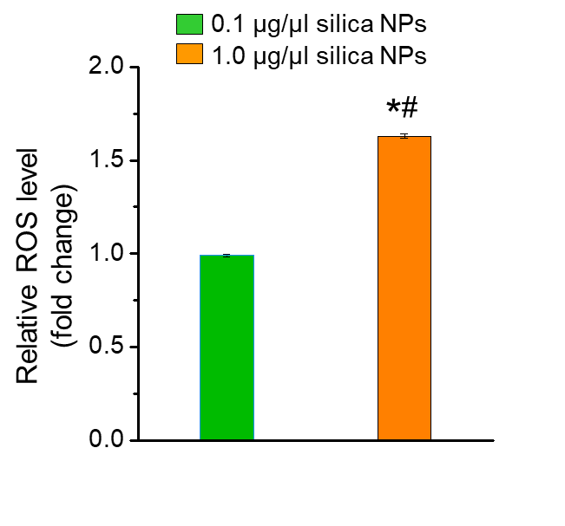
Supplementary Figure 1. ROS generation in silica nanoparticle-treated cells. Evaluation of intracellular ROS generation using DCFH-DA after 12 h silica NPs treatment in HEK293 cells. The intensity of non-oxidized DCFH-DA was used as a blank. Data represent mean ± SD of three independent experiments. *p < 0.05 vs non-treated control, #p < 0.05 compared between 0.1 and 1.0 µg/µl of silica NPs-treated cells.

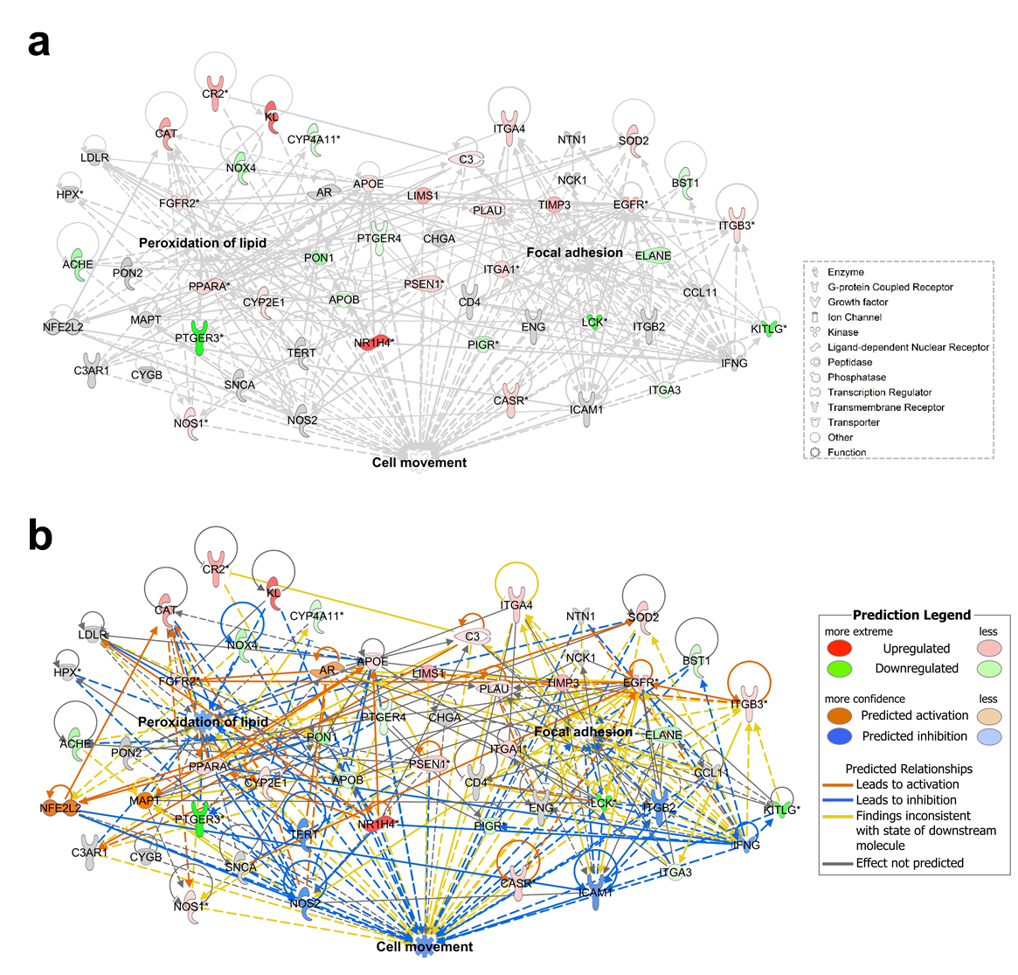
Supplementary Figure 2. Transcriptomic analysis of microarray in HEK293 cells treated with MNPs@SiO₂(RITC) for 12 h. Network of lipid peroxidation and focal adhesion related genes was constructed algorithmically by IPA. (a) Transcriptome network of 0.1 µg/µl MNPs@SiO₂(RITC)-treated cells were shown and (b) prediction analysis for the network. Red and green areas indicate up- and downregulated genes, respectively. Orange and blue color indicate activation and suppression. The lines indicate indirect (dotted) or direct (solid) relationship. Differentially expressed genes obtained from microarray data (genes with > 3-fold change) are shown.
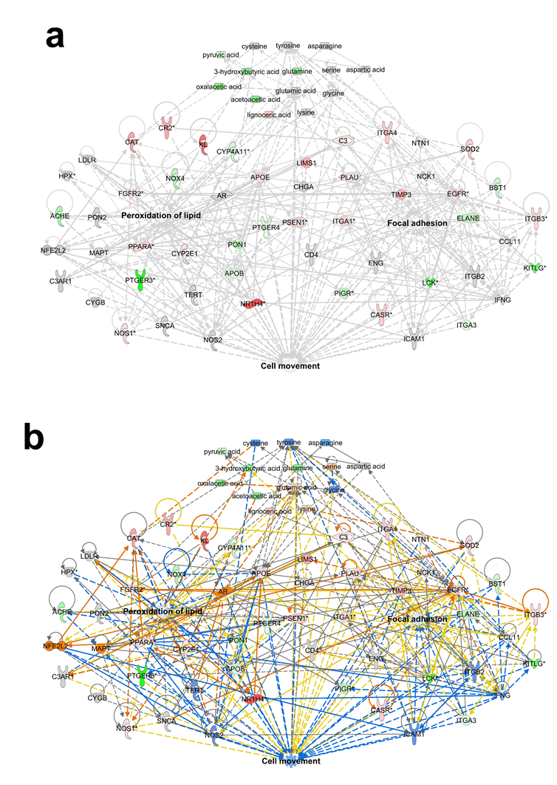
Supplementary Figure 3. Metabotranscriptomic analysis of microarray and metabolite profile in cells treated with 0.1 µg/µl MNPs@SiO₂(RITC) for 12 h. (a) Lipid peroxidation and focal adhesion related genes and metabolites network were constructed algorithmically by IPA in 0.1 µg/µl MNPs@SiO₂(RITC)-treated HEK293 cells and (b) prediction analysis for the network. Red and green areas indicate up- and downregulated genes, respectively. Orange and blue color indicate activation and suppression, respectively. The lines indicate indirect (dotted) or direct (solid) relationship. Differentially expressed genes obtained from microarray data (> 3-fold change) and disturbances in metabolic profile (> 20% change) are shown.

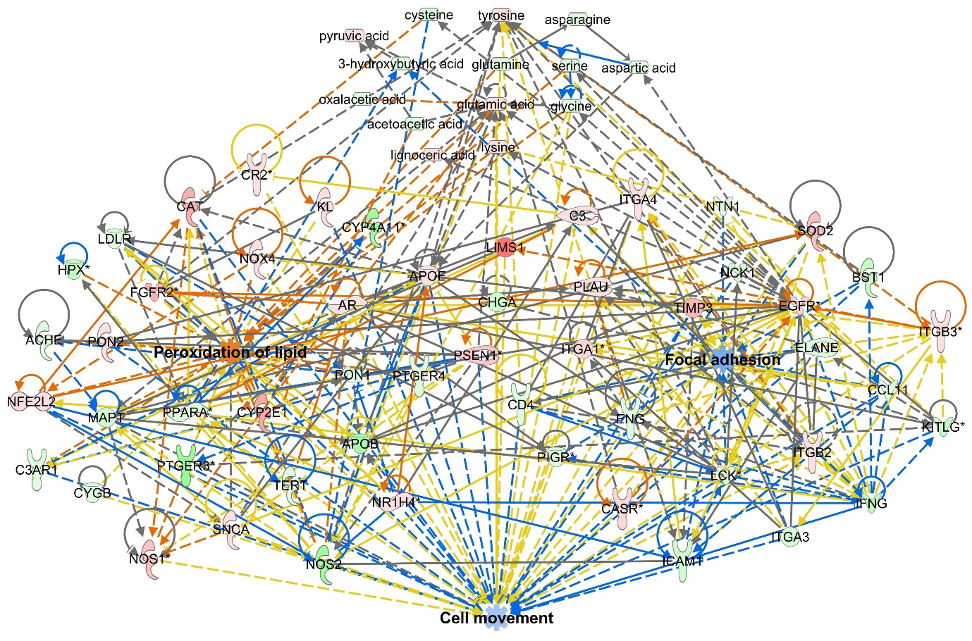
Supplementary Figure 4. Metabotranscriptomic analysis of microarray and metabolite profile in cells treated with 1.0 µg/µl MNPs@SiO₂(RITC) for 12 h. Lipid peroxidation and focal adhesion related genes and metabolites network were constructed algorithmically by IPA in 1.0 µg/µl MNPs@SiO₂(RITC)-treated HEK293 cells. Red and green areas indicate up- and downregulated genes, respectively. Orange and blue color indicate activation and suppression, respectively. The lines indicate indirect (dotted) or direct (solid) relationship. Differentially expressed genes obtained from microarray data (> 3-fold change) and disturbances in metabolic profile (> 20% change) are shown.

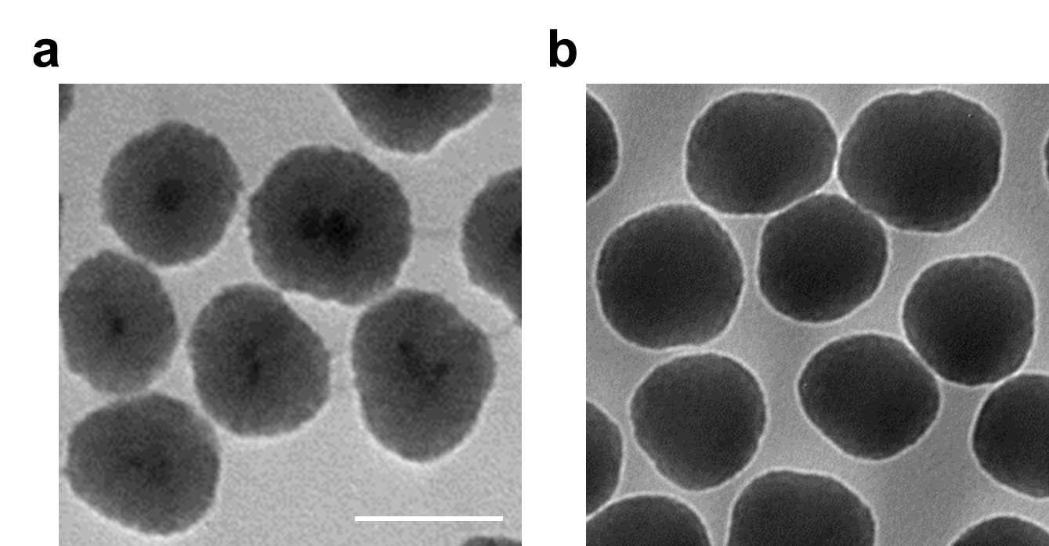
Supplementary Figure 5. Determination of Size for MNPs@SiO₂(RITC) and silica NPs using Transmission Electron Microscope (TEM) analysis. TEM images of MNPs@SiO₂(RITC) (a) and silica NPs (b). Scale bar = 50 nm.

