Association of Body Roundness Index with Cardiovascular Diseases in Middle-Aged and Older Chinese Adults with Cardiovascular-Kidney-Metabolic Syndrome Stage 0-3: Evidence from the CHARLS Study

Supplementary Materials

Table S1. Table S1. Specific definitions of health conditions and functional status.
Table S2. Framingham risk score for Men.
Table S3. Framingham risk score for Women.
Table S4. Methods for evaluating CKM stages 0-3.
Table S5. Baseline characteristics of the study participants.
Table S6. Collinearity Statistics.
Table S7. Exploratory subgroup analysis of the associations between BRI and the risk of CVD in a population with CKM stages 0-3.
Table S8: Sensitivity analyses of BRI levels and CVD events in the population with CKM stages 0-3.
Figure S1. Mediation analysis of the association between Body Roundness Index and heart disease.
Figure S2. Mediation analysis of the association between Body Roundness Index and stroke.
Figure S3. Association of Body Roundness Index with CVD across different CKM Stages.

Table S1. Specific definitions of health conditions and functional status.
Overweight/obesity | BMI ≥23 kg/m2.
Abdominal obesity | Waist circumference≥85/90 cm in female/male.
Diabetes (ADA) | Fasting blood glucose ≥ 126 mg/dL (≥7.0mmol/l) or HbA1c ≥ 6.5%; self-reported diagnosis of diabetes; use of insulin and oral hypoglycemic agents.
Prediabetes (ADA) | Fasting blood glucose: ≥110, <126 mg/dL (≥6.1, <7.0mmol/l) or HbA1c: 5.7%-6.4% and without self-reported diagnosis of diabetes, use of insulin, or oral hypoglycemic agents.
Hypertension | SBP ≥130 mmHg or DBP ≥85 mmHg; self-reported diagnosis of hypertension; use of antihypertensive medications.
chronic kidney disease | Any of the two criteria is met: Self-reported history of chronic kidney disease; eGFR < 60 ml/min/1.73m² (using CKD-EPI).
Hyperlipidemia | self-reported diagnosis of hyperlipidemia; use of lipid-lowing drugs; TC ≥200 mg/dl, TG≥150 mg/dl, LDL-C≥130 mg/dl, HDL-C <40 mg/dl.
metabolic syndrome | Meet any three or more of the five: 1) Waist circumference ≥ 85/90 cm in female/male; 2) HDL-C<40 mg/dL (1.04mmol/l); 3) TG ≥150 mg/dL (1.7 mmol/L); 4) Elevated blood pressure (SBP ≥130 mmHg or DBP ≥85mmHg; self-reported diagnosis of hypertension; use of antihypertensive medications); 5) Fasting blood glucose ≥110 mg/dL(≥6.1mmol/l); self-reported diagnosis of diabetes; use of insulin and oral hypoglycemic agents.
Clinical CVD | Any of the two criteria is met:1) Participants were asked "Have you been told by a doctor that you have been diagnosed with a heart disease, including angina, heart attack, congestive heart failure, and other heart problems?"; 2) "Have you been told by a doctor that you have been diagnosed with a stroke?"
Subclinical CVD | Any of the two criteria is met:1) Very high-risk CKD in KDIGO classification: eGFR < 30 ml/min/1.73m2; 2) Framingham risk score ≥18/15 in female/male.

Table S2. Framingham risk score for Men.
Points | Age, years | HDL | TC | SBP Not Treated | SBP Treated | Smoker | Diabetes
-2 |  | 60+ |  | <120
-1 |  | 50–59
0 | 30–34 | 45–49 | <160 | 120–129 | <120 | No | No
1 |  | 35–44 | 160–199 | 130–139
2 | 35–39 | <35 | 200–239 | 140–159 | 120–129
3 |  |  | 240–279 | 160+ | 130–139 |  | Yes
4 |  |  | 280+ |  | 140–159 | Yes
5 | 40–44 |  |  |  | 160+
6 | 45–49
7
8 | 50–54
9
10 | 55–59
11 | 60–64
12 | 65–69
13
14 | 70–74
15 | 75+

Table S3. Framingham risk score for Women.
Points | Age, years | HDL | TC | SBP Not Treated | SBP Treated | Smoker | Diabetes
-3 |  |  |  | <120
-2 |  | 60+
-1 |  | 50–59 |  |  | <120
0 | 30–34 | 45–49 | <160 | 120–129 |  | No | No
1 |  | 35–44 | 160–199 | 130–139
2 | 35–39 | <35 |  | 140–149 | 120–129
3 |  |  | 200–239 |  | 130–139 | Yes
4 | 40–44 |  | 240–279 | 150–159 |  |  | Yes
5 | 45–49 |  | 280+ | 160+ | 140–149
6 |  |  |  |  | 150–159
7 | 50–54 |  |  |  | 160+
8 | 55–59
9 | 60–64
10 | 65–69
11 | 70–74
12 | 75+

Table S4. Methods for evaluating CKM stages 0-3.
CKM stages | Threshold for CKM conditions
Stages 0 | All criteria are met：1) BMI< 23 kg/m2; 2) Waist circumference <85/90 cm in female/male; 3) Fasting blood glucose < 110 mg/dL and HbA1c < 5.7% and without self-reported diagnosis of diabetes, use of insulin, or oral hypoglycemic agents; 4) SBP <130 mmHg and DBP <85 mmHg without self-reported diagnosis of hypertension or use of antihypertensive medications; 5) HDL-C >40 mg/Dl; 6) TG < 150 mg/dL; 7) eGFR ≥ 60 ml/min/1.73m2 and without self-reported diagnosis of CKD; 8) No Subclinical CVD and clinical CVD.
Stages 1 | Any of the three criteria is met: 1) Overweight/obesity; 2) Abdominal obesity; 3) Prediabetes  All criteria are met：1) SBP <130 mmHg and DBP <85 mmHg without self-reported diagnosis of hypertension or use of antihypertensive medications; 2) HDL-C>40 mg/dL; 3) TG < 150 mg/dL; 4) eGFR ≥ 60 ml/min/1.73m2 and without self-reported diagnosis of CKD; 5) No Subclinical CVD and clinical CVD.
Stages 2 | Any of the five criteria is met: 1) Hypertriglyceridemia; 2) Hypertension; 3) Diabetes; 4) Metabolic syndrome; 5) eGFR：30-60 ml/min/1.73m2 and/or with self-reported diagnosis of CKD.  All criteria are met: No Subclinical CVD and clinical CVD.
Stages 3 | Any of the two criteria is met: 1) eGFR<30 ml/min/1.73m2; 2) Subclinical CVD.  Any of the eight criteria is met: 1) Overweight/obesity; 2) Abdominal obesity; 3) Prediabetes; 4) Hypertriglyceridemia; 5) Hypertension; 6) Diabetes; 7) Metabolic syndrome; 8) eGFR：30-60 ml/min/1.73m2 and/or with self-reported diagnosis of CKD.  The criterion is met：No clinical CVD.

Table S5. Baseline characteristics of the study participants.
Characteristics | Total | CVD group | Non-CVD group | P value
Participants, No. | 7566 | 1836 | 5730
Age, years | 59.3 (9.3) | 60.3 (8.6) | 58.9 (9.5) | <0.001
Sex, male | 3646 (48.2%) | 797 (43.4%) | 2849 (49.7%) | <0.001
Residence, urban | 2527 (33.4%) | 614 (33.4%) | 1913 (33.4%) | 0.987
Current married | 6675 (88.2%) | 1618 (88.1%) | 5057 (88.3%) | 0.915
Education |  |  |  | 0.248
Illiterate | 2191 (29.0%) | 554 (30.2%) | 1637 (28.6%)
Primary | 3137 (41.5%) | 764 (41.6%) | 2373 (41.4%)
Middle school | 1508 (19.9%) | 336 (18.3%) | 1172 (20.5%)
High school+ | 727 (9.6%) | 181 (9.9%) | 546 (9.5%)
Smoking | 3037 (40.1%) | 701 (38.2%) | 2336 (40.8%) | 0.052
Alcohol consumption | 2008 (26.5%) | 427 (23.3%) | 1581 (27.6%) | <0.001
Fuel for cooking |  |  |  | <0.001
Clean fuels | 1379 (18.2%) | 272 (14.8%) | 1107 (19.3%)
Solid fuels | 5657 (74.8%) | 1401 (76.3%) | 4256 (74.3%)
Fuel for hearting |  |  |  | 0.043
Clean fuels | 3138 (41.5%) | 721 (39.3%) | 2417 (42.2%)
Solid fuels | 4367 (57.7%) | 1093 (59.5%) | 3274 (57.1%)
BMI, kg/m2 |  |  |  | <0.001
Continuous | 23.4(3.7) | 24.1(4.0) | 23.2(3.6)
<23.9 | 4491 (59.4%) | 952 (51.9%) | 3539(61.8%)
24-27.9 | 2258 (29.8%) | 593(32.3%) | 1665(29.1%)
≥28 | 817 (10.8%) | 291(15.8%) | 526(9.2%)
Hypertension | 3533 (46.7%) | 1013 (55.2%) | 2520 (44.0%) | <0.001
GMS |  |  |  | <0.001
NGR | 4875 (64.4%) | 1101 (60.0%) | 3774 (65.9%)
Pre-diabetes | 1419 (18.8%) | 375 (20.4%) | 1044 (18.2%)
Diabetes | 1272 (16.8%) | 360 (19.6%) | 912 (15.9%)
Dyslipidemia | 549 (7.3%) | 226 (12.3%) | 323 (5.6%) | <0.001
Liver disease | 276 (3.6%) | 90 (4.9%) | 186 (3.2%) | 0.001
Kidney disease | 592 (7.8%) | 158 (8.6%) | 434 (7.6%) | 0.167
Metabolic Syndrome | 1183 (15.6%) | 355 (19.3%) | 828 (14.5%) | <0.001
Physical activity |  |  |  | <0.001
Low | 985 (13.0%) | 267 (14.5%) | 718 (12.5%)
Moderate | 941 (12.4%) | 232 (12.6%) | 709 (12.4%)
High | 1267 (16.7%) | 251 (13.7%) | 1016 (17.7%)
Total-C, mg/dl | 194.7 (38.7) | 198.2(38.6) | 193.5(38.6) | <0.001
LDL-C, mg/dl | 116.6 (35.1) | 120.2(35.7) | 115.5(34.8) | <0.001
HDL-C, mg/dl | 52.0 (15.3) | 50.8(15.3) | 52.4(15.3) | <0.001
TG, mg/dl | 104.4(74.3-155.8) | 112.4 (80.5-162.2) | 100.9 (72.6-153.1) | <0.001
HbA1c, % | 5.1 (4.9-5.4) | 5.2 (4.9-5.5) | 5.1 (4.9-5.4) | <0.001
hsCRP, mg/L | 1.0 (0.5-2.1) | 1.2 (0.6-2.3) | 1.0 (0.5-2.0) | <0.001
Uric acid, mg/dL | 4.3 (3.6–5.2) | 4.3 (3.6-5.2) | 4.3 (3.6-5.2) | 0.329
eGFR (ml/min/1.73 m²) | 98.9 (88.7–105.6) | 97.7 (87.2-104.0) | 99.3(89.1-106.3) | <0.001
CKM stage |  |  |  | <0.001
0 | 1051 (13.9%) | 161 (8.8%) | 890 (15.5%)
1 | 1098 (14.5%) | 236 (12.9%) | 862 (15.0%)
2 | 2832 (37.4%) | 723 (39.4%) | 2109 (36.8%)
3 | 2585 (34.2%) | 716 (39.0%) | 1869 (32.6%)
Data are presented as the mean±SD, median (IQR), or number (%), as appropriate. Abbreviations: SD, standard deviation; IQR, interquartile range; hs-CRP, high sensitivity C-reactive Protein; CKM, Cardio-Kidney-Metabolic Syndrome; BMI, body mass index; GMS, glycemic metabolic status; NGR, normal glucose regulation; HbA1c, glycated Hemoglobin, Total-C, total cholesterol, TG, triglyceride; LDL-C, low-density lipoprotein cholesterol; HDL-C, high-density lipoprotein cholesterol.

Table S6. Collinearity Statistics.
Variables | VIF
Age | 1.39
Sex | 1.25
Residence | 1.08
Current married | 1.07
Education | 1.05
Smoking | 1.44
Alcohol consumption | 1.17
Fuel for cooking | 1.09
Fuel for hearting | 1.13
BMI | 1.13
Hypertension | 1.09
GMS | 1.12
Dyslipidemia | 1.03
Liver disease | 1.01
Kidney disease | 1.04
Metabolic Syndrome | 1.37
Physical activity | 1.04
Total-C | 4.24
LDL-C | 3.80
HDL-C | 2.05
TG | 2.66
HbA1c | 1.15
hs-CRP | 1.01
eGFR | 1.25

Table S7. Exploratory subgroup analysis of the associations between BRI and the risk of CVD in a population with CKM stages 0-3.
 | CVD | P valve | Heart disease | P valve | Stroke | P valve
Overall | 1.154 (1.112-1.199) | <0.001 | 1.134 (1.086-1.184) | <0.001 | 1.187 (1.115-1.264) | <0.001
Age
45-59 | 1.201(1.135-1.272) | <0.001 | 1.177(1.104-1.256) | <0.001 | 1.283(1.166-1.413) | <0.001
60-69 | 1.189(1.120-1.262) | <0.001 | 1.175(1.097-1.257) | <0.001 | 1.188 1.074-1.313 | <0.001
>70 | 1.103(1.002-1.214) | 0.045 | 1.054(0.940-1.183) | 0.367 | 1.198 1.032-1.391 | 0.018
P _{interaction} |  | 0.083 |  | 0.029 |  | 0.587
Sex
Male | 1.225(1.146-1.308) | <0.001 | 1.190(1.098-1.289) | <0.001 | 1.298(1.179-1.429) | <0.001
Female | 1.126(1.074-1.179) | <0.001 | 1.116(1.059-1.176) | <0.001 | 1.111(1.023-1.207) | 0.012
P _{interaction} |  | 0.026 |  | 0.125 |  | 0.032
Education
Illiterate | 1.106(1.037-1.180) | 0.002 | 1.112(1.033-1.196) | 0.004 | 1.096(0.982-1.222) | 0.101
Primary | 1.176(1.111-1.246) | <0.001 | 1.155(1.080-1.235) | <0.001 | 1.174(1.067-1.291) | 0.001
Middle school | 1.167(1.058-1.286) | 0.002 | 1.103(0.984-1.235) | 0.092 | 1.351(1.149-1.589) | <0.001
High school+ | 1.307(1.130-1.512) | <0.001 | 1.263(1.073-1.485) | 0.005 | 1.441(1.145-1.812) | 0.002
P _{interaction} |  | 0.010 |  | 0.140 |  | 0.007
BMI
<23.9 | 1.104(1.025-1.190) | 0.009 | 1.069(0.981-1.165) | 0.128 | 1.236(1.092-1.399) | <0.001
24-27.9 | 1.065(0.958-1.183) | 0.245 | 1.019(0.901-1.151) | 0.769 | 1.107(0.932-1.315) | 0.246
≥28 | 1.061(0.945-1.190) | 0.315 | 1.034(0.909-1.176) | 0.611 | 1.030(0.839-1.265) | 0.780
P _{interaction} |  | 0.985 |  | 0.552 |  | 0.105
Residence
Urban | 1.204(1.124-1.289) | <0.001 | 1.197(1.108-1.294) | <0.001 | 1.219(1.089-1.363) | <0.001
Rural | 1.127(1.077-1.180) | <0.001 | 1.103(1.046-1.162) | <0.001 | 1.162(1.076-1.254) | <0.001
P _{interaction} |  | 0.036 |  | 0.103 |  | 0.070
Hypertension |  |  |  | 0.165 |  | 0.556
Yes | 1.150(1.095-1.207) | <0.001 | 1.123(1.061-1.189) | <0.001 | 1.184(1.097-1.278) | <0.001
No | 1.158(1.091-1.229) | <0.001 | 1.146(1.072-1.225) | <0.001 | 1.185(1.065-1.320) | 0.002
P _{interaction} |  | 0.197 |  | 0.165 |  | 0.556
Dyslipidemia
Yes | 1.136(1.023-1.260) | 0.017 | 1.118(0.996-1.256) | 0.059 | 1.045(0.876-1.246) | 0.628
No | 1.148(1.103-1.195) | <0.001 | 1.122(1.071-1.175) | <0.001 | 1.209(1.131-1.292) | <0.001
P _{interaction} |  | 0.523 |  | 0.739 |  | 0.041
Metabolic Syndrome
Yes | 1.113(1.020-1.214) | 0.016 | 1.084(0.980-1.199) | 0.118 | 1.117(0.972-1.283) | 0.120
No | 1.177(1.128-1.228) | <0.001 | 1.151(1.096-1.208) | <0.001 | 1.238(1.153-1.329) | <0.001
P _{interaction} |  | 0.165 |  | 0.342 |  | 0.113
GMS
NGR | 1.147(1.091-1.206) | <0.001 | 1.117(1.054-1.183) | <0.001 | 1.212(1.114-1.319) | <0.001
Pre-diabetes | 1.091(1.003-1.186) | 0.042 | 1.079(0.979-1.188) | 0.124 | 1.158(1.009-1.329) | 0.037
Diabetes | 1.237(1.141-1.341) | <0.001 | 1.235(1.125-1.355) | <0.001 | 1.159(1.019-1.318) | 0.025
P _{interaction} |  | 0.283 |  | 0.107 |  | 0.550
HR (95% CIs) of CVD risk per 1 unit increase in BRI. The model was adjusted for age, marital status, educational level, residence, smoking, drinking, household fuel use, LDL-c, HbA1c, hs-CRP, hypertension, and diabetes.

Table S8: Sensitivity analyses of BRI levels and CVD events in the population with CKM stages 0-3.
 | Sensitivity analyses 1 |  | Sensitivity analyses 2 |  | Sensitivity analyses 3
 | HR (95% CI) | P value | HR (95% CI) | P value | HR (95% CI) | P value
CVD
BRI (per 1 unit) | 1.154 (1.112-1.199) | <0.001 | 1.122 (1.07-1.177) | <0.001 | 1.218 (1.147-1.294) | <0.001
Q1 | 1(Ref.) |  | 1(Ref.) |  | 1(Ref.)
Q2 | 1.297 (1.111-1.514) | 0.001 | 1.253 (1.052-1.493) | 0.012 | 1.299 (1.018-1.657) | 0.035
Q3 | 1.522 (1.306-1.773) | <0.001 | 1.338 (1.122-1.595) | 0.001 | 1.653 (1.305-2.093) | <0.001
Q4 | 1.796 (1.535-2.100) | <0.001 | 1.483 (1.238-1.776) | <0.001 | 1.978 (1.549-2.525) | <0.001
Heart disease
BRI (per 1 unit) | 1.134 (1.086-1.184) | <0.001 | 1.103 (1.044-1.165) | <0.001 | 1.191 (1.111-1.276) | <0.001
Q1 | 1(Ref.) |  | 1(Ref.) |  | 1(Ref.)
Q2 | 1.215 (1.017-1.451) | 0.03 | 1.250 (1.023-1.527) | 0.029 | 1.148 (0.866-1.522) | 0.337
Q3 | 1.406 (1.180-1.675) | <0.001 | 1.256 (1.026-1.539) | 0.028 | 1.524 (1.164-1.995) | 0.002
Q4 | 1.673 (1.399-1.999) | <0.001 | 1.388 (1.128-1.708) | 0.002 | 1.861 (1.411-2.454) | <0.001
Stroke
BRI (per 1 unit) | 1.186 (1.115-1.263) | <0.001 | 1.173 (1.081-1.272) | <0.001 | 1.207 (1.092-1.333) | <0.001
Q1 | 1(Ref.) |  | 1(Ref.) |  | 1(Ref.)
Q2 | 1.448 (1.112-1.886) | 0.006 | 1.329 (0.975-1.811) | 0.072 | 1.584 (1.048-2.393) | 0.029
Q3 | 1.798 (1.388-2.331) | <0.001 | 1.685 (1.244-2.282) | <0.001 | 2.030 (1.360-3.030) | <0.001
Q4 | 2.081 (1.591-2.72) | <0.001 | 1.837 (1.338-2.521) | <0.001 | 1.988 (1.297-3.046) | 0.002
Abbreviations: HR, hazard ratio; CI, confidence interval; BRI, body roundness index; CVD, cardiovascular disease. The model was adjusted for age, marital status, educational level, residence, smoking, drinking, household fuel use, LDL-c, HbA1c, hs-CRP, hypertension, and diabetes. Sensitivity analysis1 was performed among 6973 participants without any missing data (except for physical activity); Sensitivity Analysis 2 was performed by excluding participants (n=6052) with a baseline history of medication use for hypertension, diabetes, and dyslipidemia; Sensitivity analysis 3 was conducted among 3193 participants without any missing data, with additional adjustment for physical activity in the model;

Figure S1. Mediation analysis of the association between Body Roundness Index and heart disease.
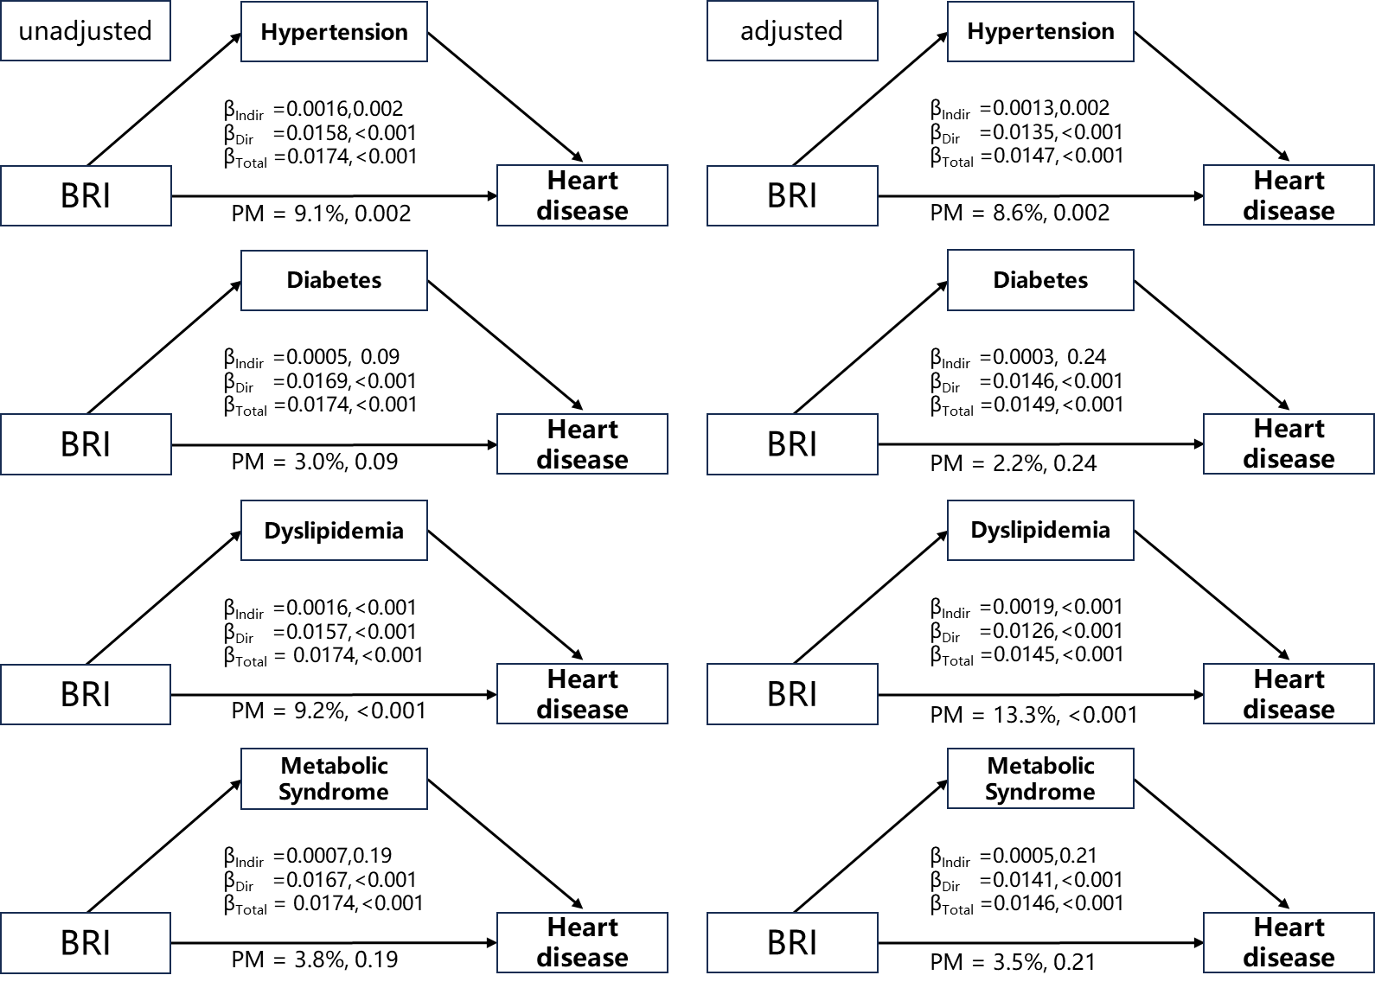
The model was adjusted for age, marital status, educational level, residence, smoking, drinking, household fuel use, LDL-c, HbA1c, hs-CRP, hypertension, and diabetes.

Figure S2. Mediation analysis of the association between Body Roundness Index and stroke.
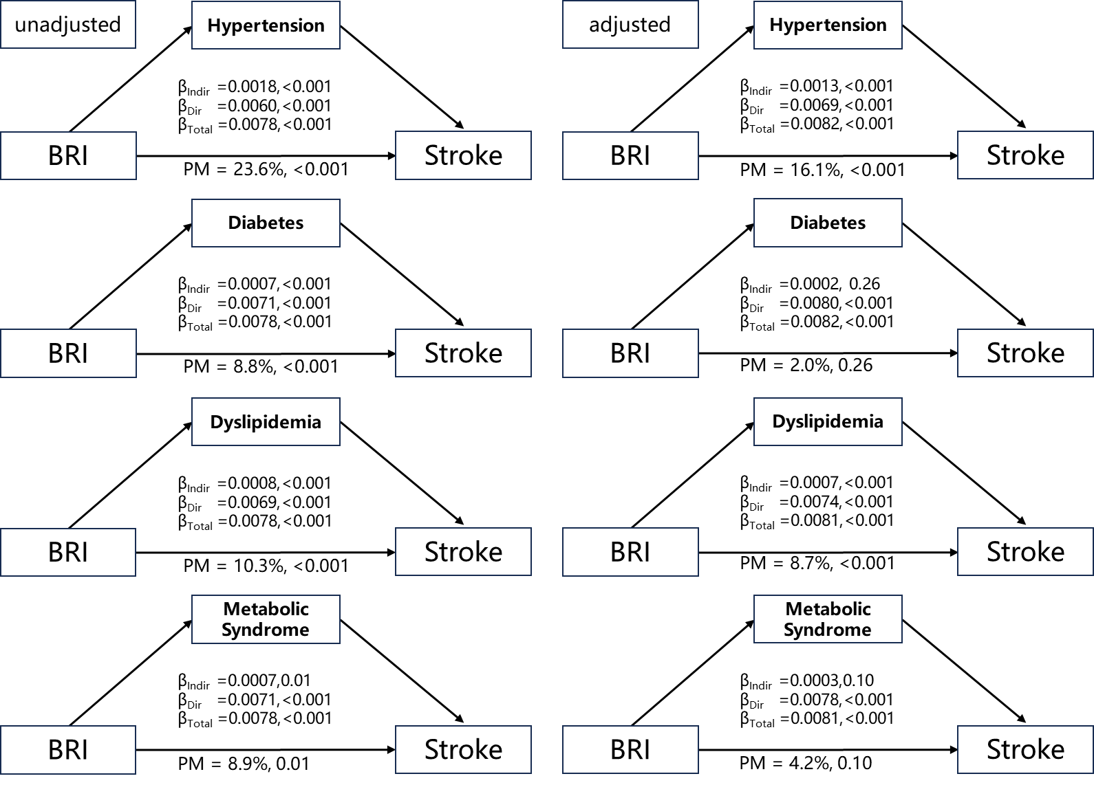
The model was adjusted for age, marital status, educational level, residence, smoking, drinking, household fuel use, LDL-c, HbA1c, hs-CRP, hypertension, and diabetes.

Figure S3. Association of Body Roundness Index with CVD across different CKM Stages.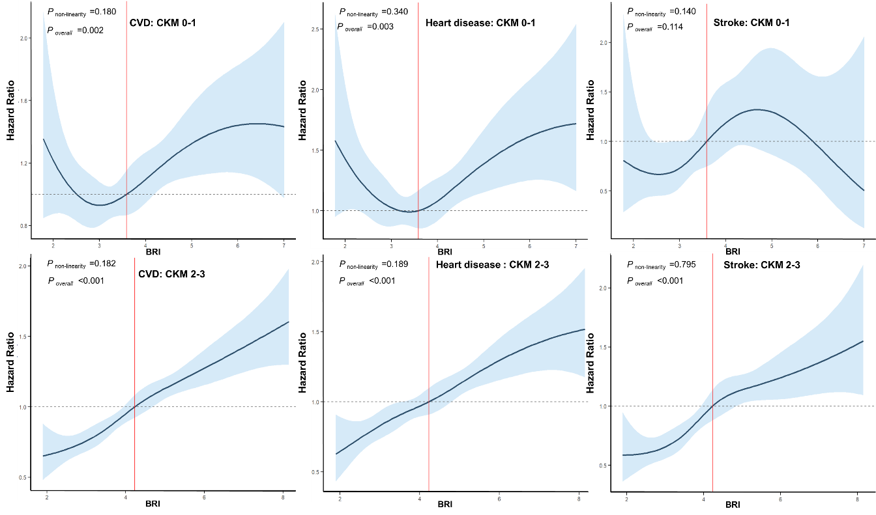
The model was adjusted for age, marital status, educational level, residence, smoking, drinking, household fuel use, LDL-c, HbA1c, hs-CRP, hypertension, and diabetes.

