Physics-Informed Machine Learning for Predicting Buckling Performance and Damage Evolution in Graphene Reinforced Basalt/Epoxy Composites

Fabrication of Samples
Electrophoretic deposition (EPD) of graphene on fiber –

Initially, graphene oxide (GO) was deposited onto the basalt fibers using electrophoretic deposition (EPD). A homogeneous aqueous dispersion of GO is critical for EPD; however, achieving stable dispersion is generally challenging for graphene-based materials due to their tendency to agglomerate. GO creates a highly stable colloidal suspension in water due to the presence of numerous oxygen-containing functional groups, including epoxide, hydroxyl, and carbonyl groups, which contribute to its pronounced hydrophilicity. Given that EPD setup necessitates a conductive substrate and basalt fiber is a non-conductive substance composed of molten lava rocks, the basalt fabric was mounted above a copper sheet serving as an electrode. The EPD setup comprised 2 liters of a GO bath solution at a concentration of 2 mg/mL in a 2-liter beaker, which was continuously agitated with a magnetic stirrer during the deposition process. Copper plates with a purity of 99.96% and dimensions of 10 × 15 × 0.2 mm were utilized as positive and negative electrodes The basalt fabric was affixed to the anode, as GO nanoparticles migrate toward the positively charged electrode due to their intrinsic negative zeta potential. The separation between the electrodes was approximately 2 cm. In the experiment, a DC bench power supply was utilized to apply a voltage of 5 V for a duration of 5 minutes. Subsequent to deposition, the coated basalt fiber was rinsed by submerging it twice in deionized water to eliminate weakly adhered GO (merely by immersion in the GO solution). Subsequently, the GO-coated basalt fiber was subjected to drying for 12 hours at a temperature of 50°C. The resultant basalt fiber was designated as GO-Basalt.

The reduction of GO-Basalt was conducted using thermochemical reduction. GO-Basalt was maintained for 24 hours at 100°C in a glass Petri dish containing a tissue saturated with hydrazine hydrate (about 2–3 mL). As a potent reducing agent, hydrazine hydrate reduced the GO sheets grafted onto Basalt, resulting in a fabric material designated as rGO-Basalt. The graphene coating content (0.3 wt.%) was determined based on the mass increase of the basalt fibers prior to and following EPD and reduction, presuming that all additional mass represents the deposited rGO. Figure 2 (a) shows the schematic diagram of the process.

Mechanism of rGO Adhesion to fibers –

Negatively charged GO nanosheets move toward the positively charged electrode during electrophoretic deposition, uniformly depositing basalt fibers at the anode. Electrostatic attraction, hydrogen bonding, and mechanical interlocking with surface hydroxyl groups hold GO sheets to the desized basalt surface. After thermochemical reduction with hydrazine vapor, the sp² carbon network is partially restored, resulting in rGO with oxygen-containing functional groups for epoxy compatibility. Graphitic domains and residual oxygen functions improve surface roughness, wettability, and interfacial reactivity, ensuring efficient stress transfer during infusion and loading. Electrophoretically produced rGO coatings remain fixed on fiber surfaces, preventing nanoparticle aggregation in the resin phase and strengthening interfacial bonds.

Dispersion of rGO in epoxy –

A uniform nanoscale dispersion of rGO is important because graphene sheets that stick together can act as stress concentrators and delay resin flow during VARTM. The rGO concentration was 0.75wt.%. A detailed optimization investigation found that 0.75 wt.% rGO provides the best mechanical, thermal, and viscoelastic properties without rGO agglomeration [30]. To guarantee proper exfoliation, rGO powder was combined with acetone and ultrasonicated for 30 minutes at 40 kHz. After that, 3000 rpm high-shear mixing lasted 20 minutes. A hybrid dispersion approach separates stacked rGO sheets and prevents them from stacking again during mixing. Swirling constantly combined the rGO-solvent combination with epoxy resin. To evaporate the acetone, the mixture was heated to 80 °C for 1 hour and vacuum-dried at 60 °C for 12 hours. The stable nanosheets were shown by the smooth, particle-free rGO-epoxy mixture. The hybrid dispersion method exfoliated hydrophobic rGO nanosheets and prevented restacking. Ultrasonication (30 min) delaminated rGO multilayers by cavitation, while high-shear mixing (3000 rpm, 20 min) separated nanosheets and stabilized dispersion. Commonly, the combined high-energy approach produces homogenous rGO dispersions in epoxy without chemical surface modification. Figure 2 (b) displays the process schematic.

Fabrication of composite –
The composite was manufactured utilizing Vacuum-Assisted Resin Transfer Molding (VARTM). Basalt fibres fabric were oven-dried at 90 °C for 1 h to remove surface moisture and ensure consistent fibre matrix wetting. The pre-coated basalt fiber fabric (300 mm × 300 mm) were positioned in a mold, sealed with a vacuum bag, and exposed to a vacuum pressure of 0.85 bar to eliminate air and guarantee homogeneous resin infusion. The rGO-epoxy resin and hardener mixture (100:50 ratio) was infused into the mold under vacuum to ensure complete fiber impregnation, cured at 25°C for 24 hours, and subsequently post-cured at 60°C for 4 hours. The flow front speed of the resin was kept at about 1–2 cm/min to reduce micro-voids forming. This procedure made composite panels with a thickness of roughly 3.0 mm and a fiber volume fraction of 55%, enhancing void reduction and mechanical uniformity relative to conventional hand lay-up techniques. Figure 2 (c) shows the schematic representation of the process.
The developed CBREC composite having dual-phase funtionalization had a total rGO concentration of 1.05 wt.%, comprising 0.75 wt.% rGO incorporated within the epoxy matrix and 0.30 wt.% rGO coated on the basalt fibers. 0.75 wt.% was optimal for reinforcing the matrix without inducing aggregation or excessively increasing viscosity as proven in our previous work [1]. The additional 0.30 wt.% rGO coated fiber does not function as a bulk nanofiller; rather, it forms a thin, conformal interphase layer that increases surface roughness, enhances wettability, and improves the interfacial bonding between the fiber and the matrix. The effective nanofiller loading remains comfortably within the permissible range specified in graphene–epoxy literature (<1 wt.%), as only the matrix-phase fraction influences rheology and dispersion [1, 2]. The final composite consisted of approximately 51.4 wt.% fiber, 47.6 wt.% epoxy, and 1.05 wt.% total rGO, reflecting a well-balanced and scientifically supported reinforcement level that promotes both processability and interfacial improvement.

Figure F1 shows the fabricated samples. The experimental specimens have been cut from the panels using a laser cutting apparatus to match the specified form and dimensions specified by the standards employed for the mechanical analysis.

Prepared samples
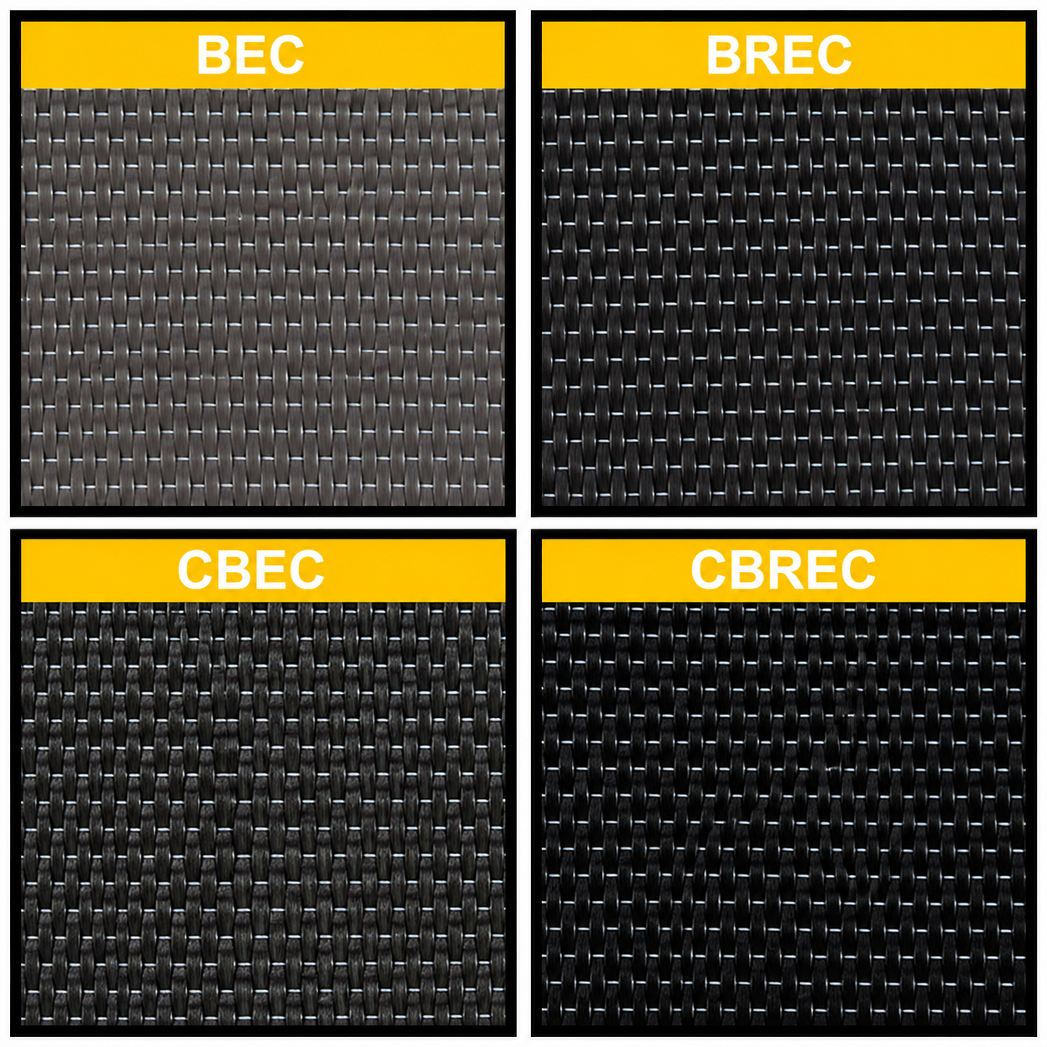

Figure F1: Prepared samples

Mechanical Properties

Properties of CBREC –

Table T1: Results of mechanical characterization.

Sample | Tensile Strength  (MPa) | Tensile Modulus  (GPa) | Compression Strength  (MPa) | Compression Modulus  (GPa) | Interlaminar Shear Strength  (MPa) | Shear Modulus  (GPa)
BEC | 410.2 ± 16.26 | 19.3 ± 3.02 | 252.8 ± 11.76 | 5.3 ± 0.21 | 59.3 ± 0.34 | 1.7 ± 0.02
BREC | 446.7 ± 17.16 | 21.2 ± 2.13 | 264.6 ± 13.36 | 5.7 ± 0.26 | 63.7 ± 0.21 | 1.9 ± 0.19
CBEC | 481.7 ± 18.19 | 22.1 ± 2.66 | 281.2 ± 13.49 | 7.2 ± 0.36 | 67.6 ± 0.39 | 2.02 ± 0.76
CBREC | 506.4 ± 22.22 | 24.9 ± 3.33 | 292.1 ± 15.62 | 7.8 ± 0.82 | 72.4 ± 0.72 | 2.1 ± 0.23

Stress-Strain curve obtained in mechanical characterization:
Tensile strength –

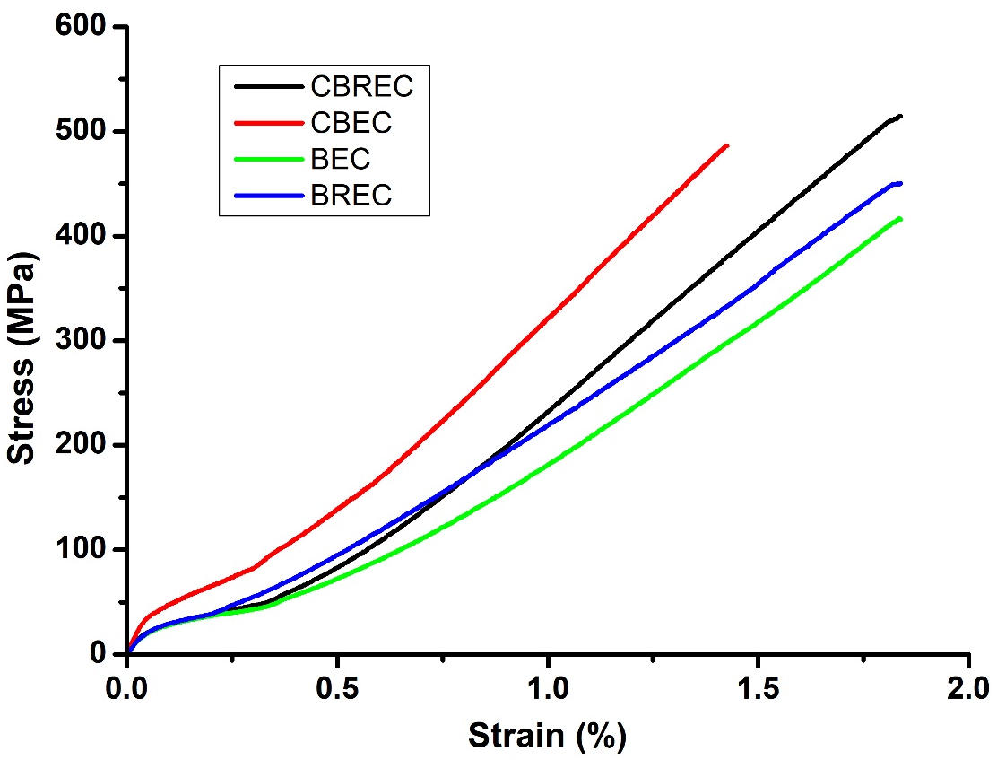
Figure F2. The stress-strain contours of all samples in tensile strength test.

Compression Strength –

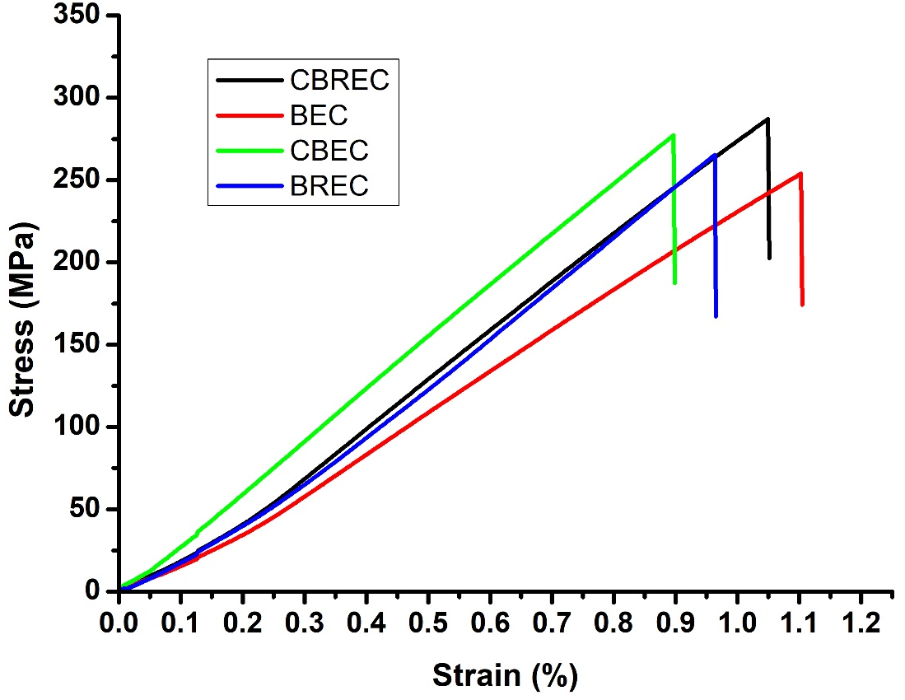
Figure F3. The stress-strain contours of all samples in compression strength test.

Interlaminar Shear Strength –
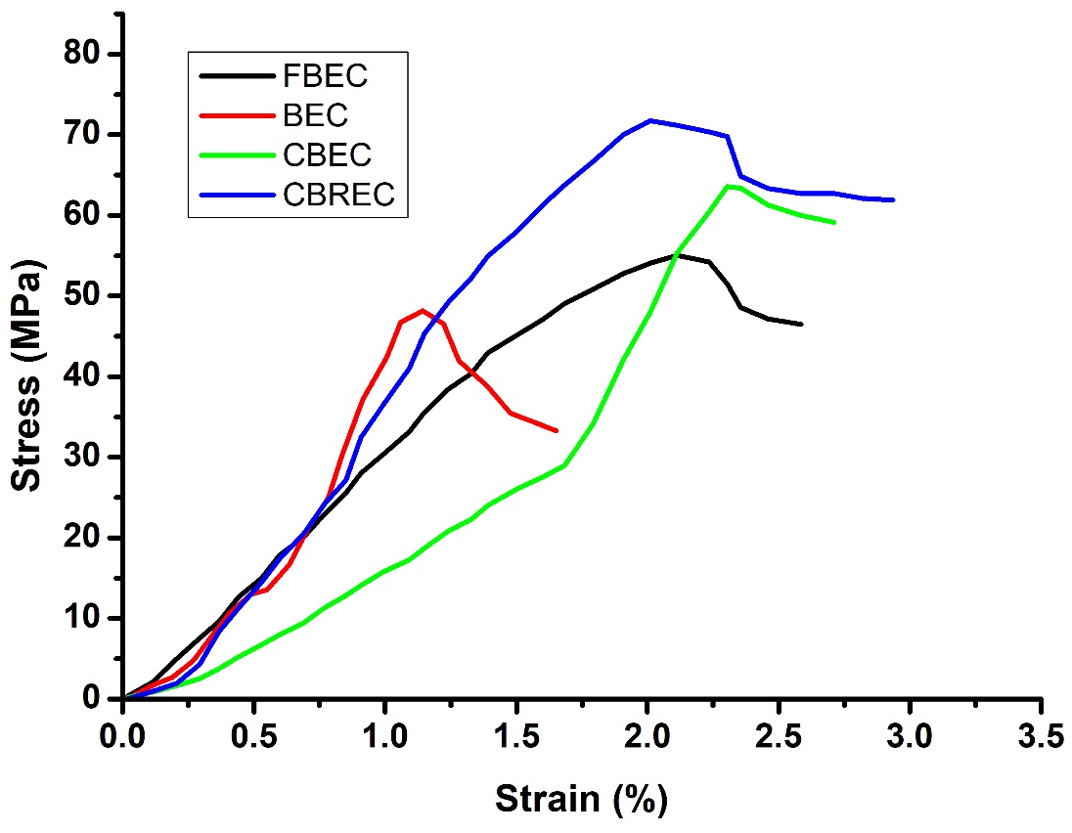
Figure F4. The stress-strain contours of all samples in Interlaminar Shear strength test.

References
- Ge, Qi, Jingwen Chu, Weiqi Cao, Fenglian Yi, Zhou Ran, Zhan Jin, Boyang Mao, Zheling Li, and Kostya S. Novoselov. "Graphene‐based textiles for thermal management and flame retardancy." Advanced Functional Materials 32, no. 42 (2022): 2205934.
- Dubey, Umang, and Panneerselvam K. "Low-combustible, high-strength, and thermally stable bio-blended epoxy-based bio-nanocomposite using reduced graphene oxide as a strengthening agent." Journal of Reinforced Plastics and Composites (2024) ;0(0). doi:10.1177/07316844241279013.

