Design, Synthesis, and Mechanism of Novel Coumarin-Based Inhibitors of the Tryptophan-Kynurenine Pathway for Neuroinflammatory Depression

The ¹H-NMR, ¹³C-NMR, and HRMS spectra of the target compound.
N-pentyl-2-oxo-2H-chromene-3-carboxamide (3a)
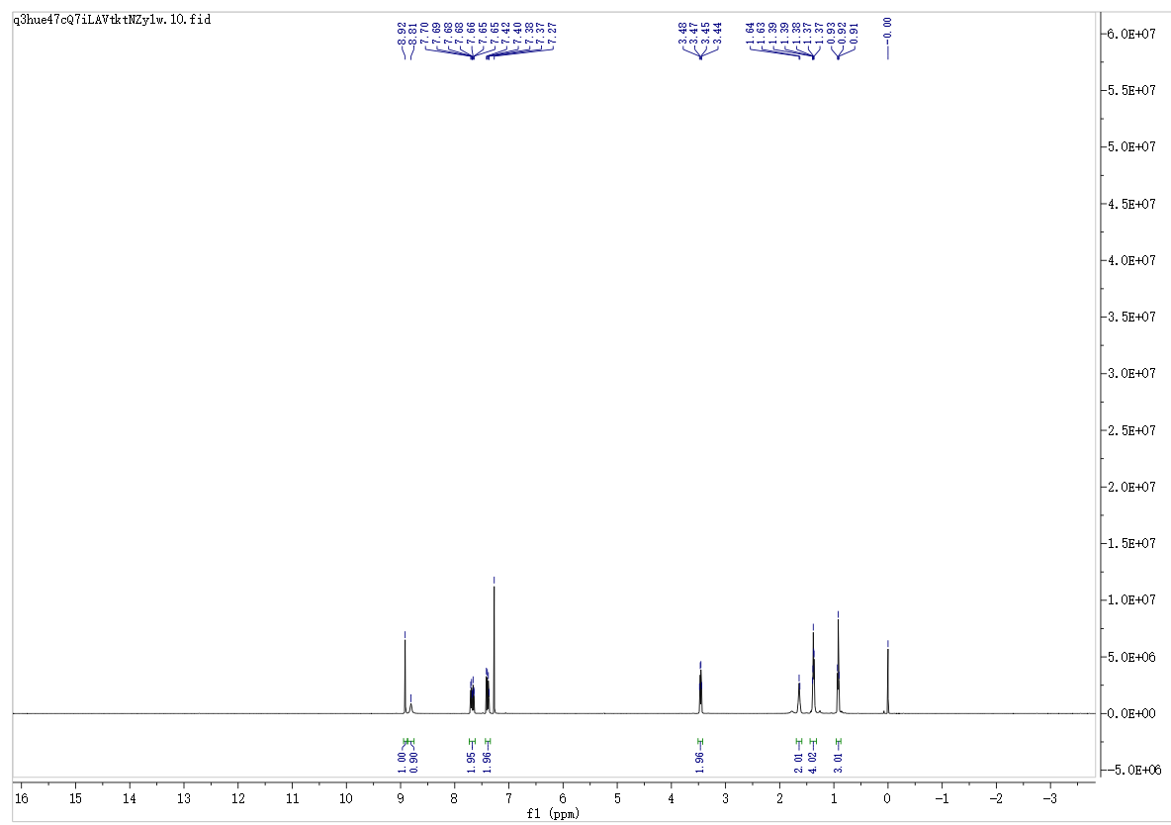
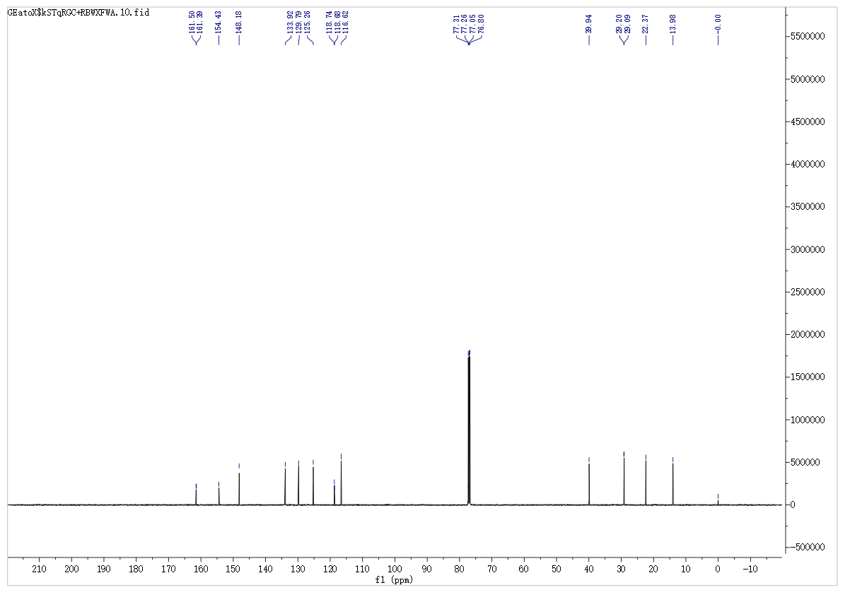
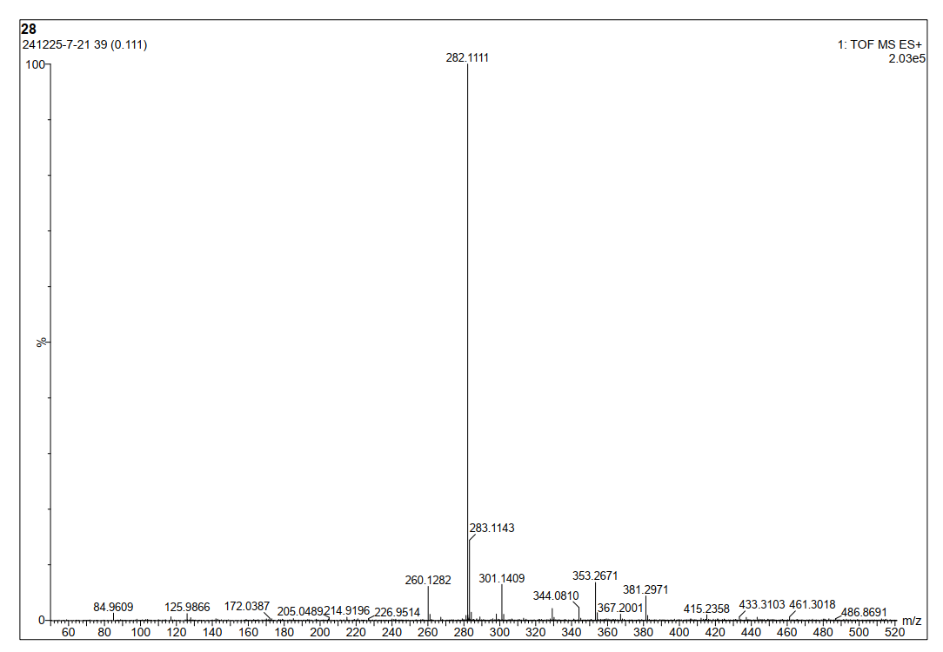
N-hexyl-2-oxo-2H-chromene-3-carboxamide (3b)
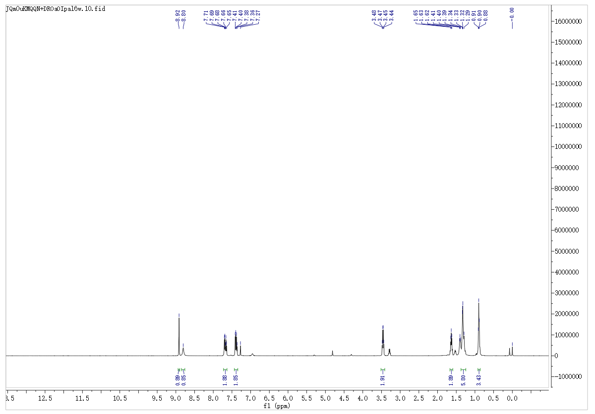
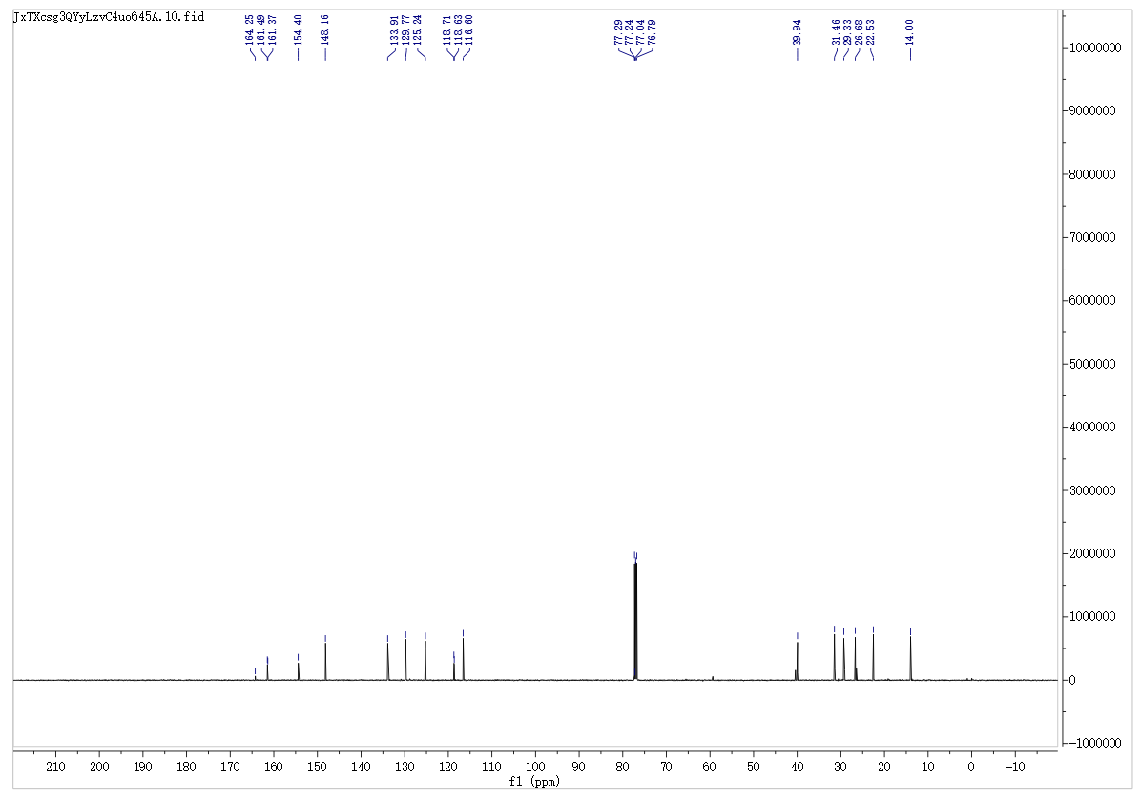
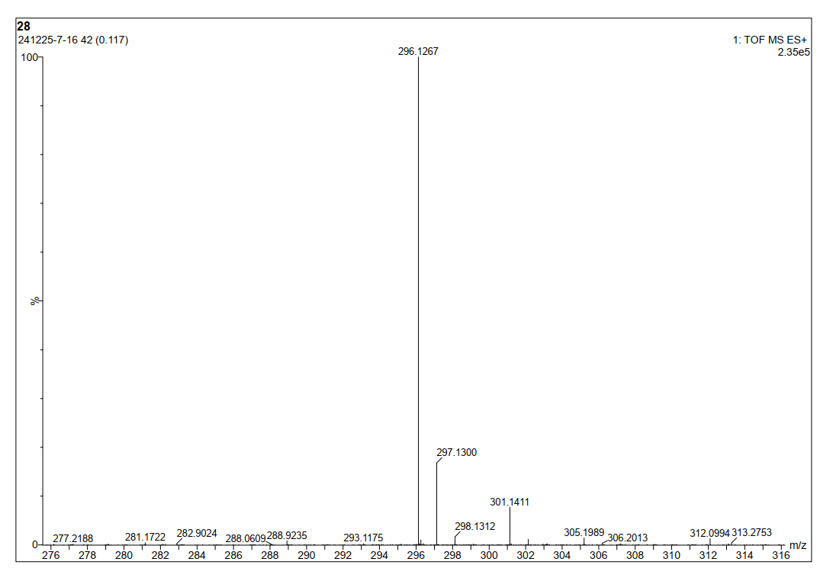
N-heptyl-2-oxo-2H-chromene-3-carboxamide (3c)
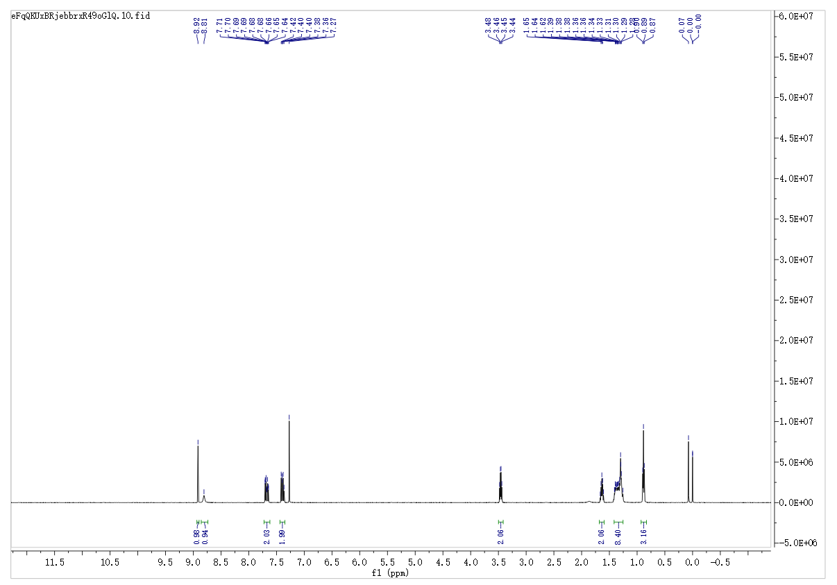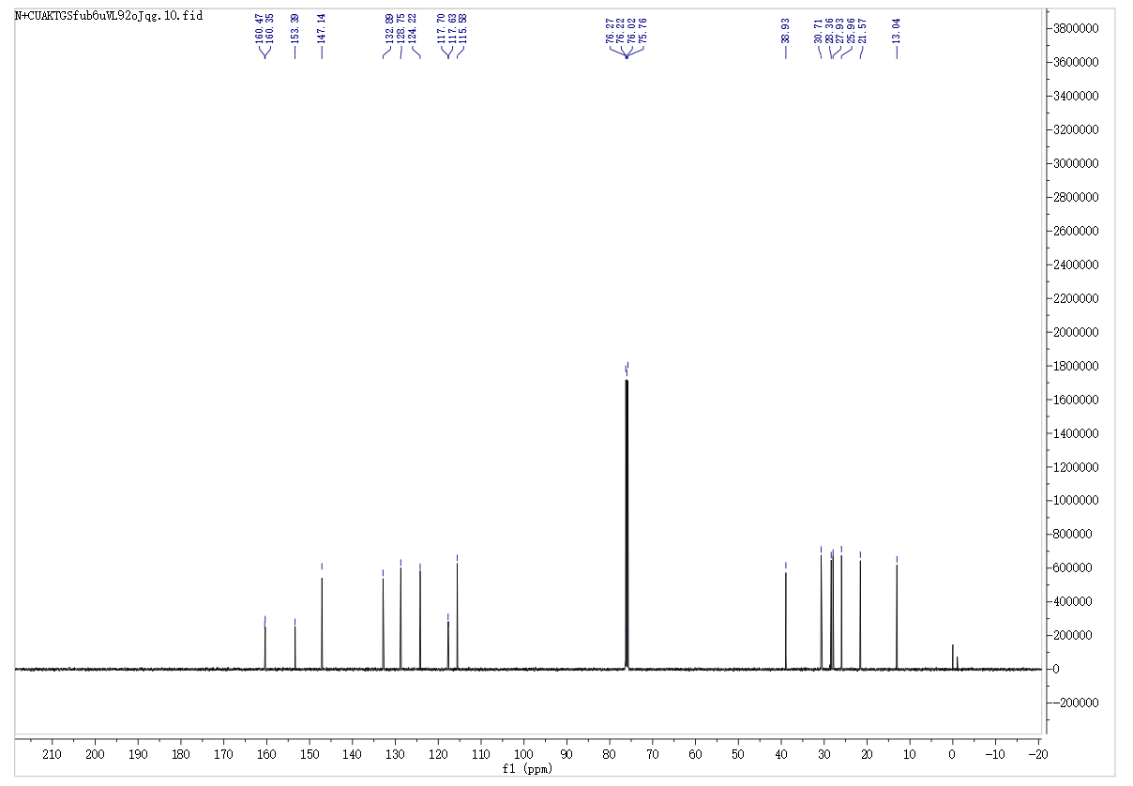
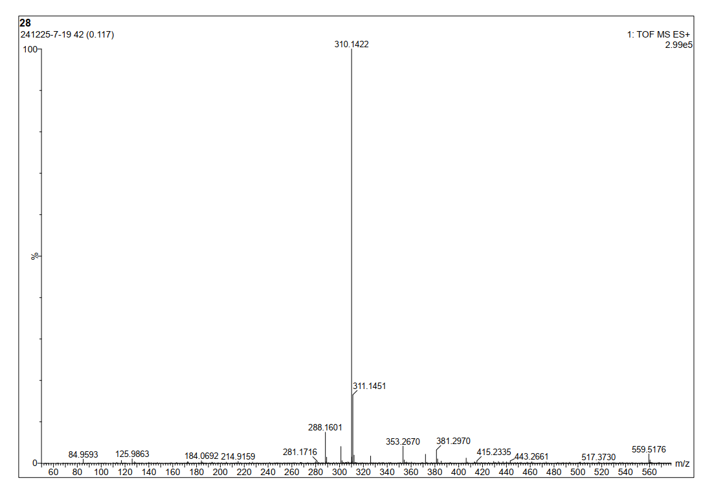

N,N-diethyl-2-oxo-2H-chromene-3-carboxamide (3d)
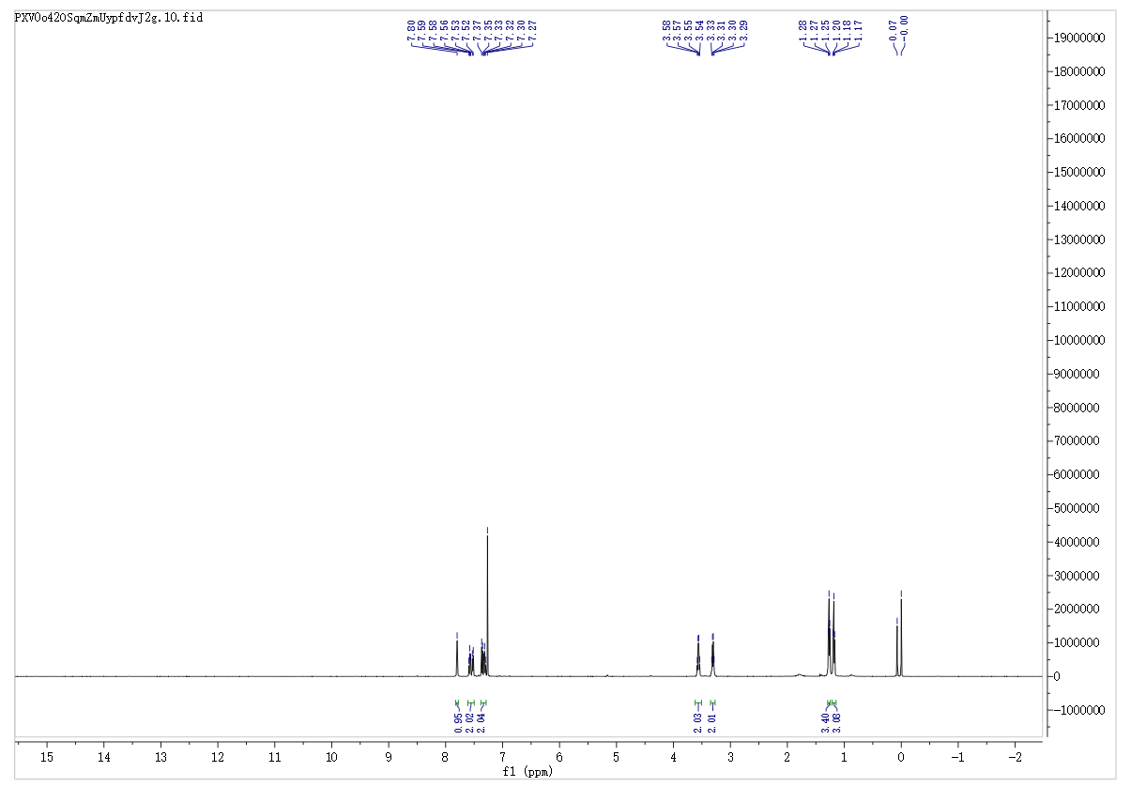
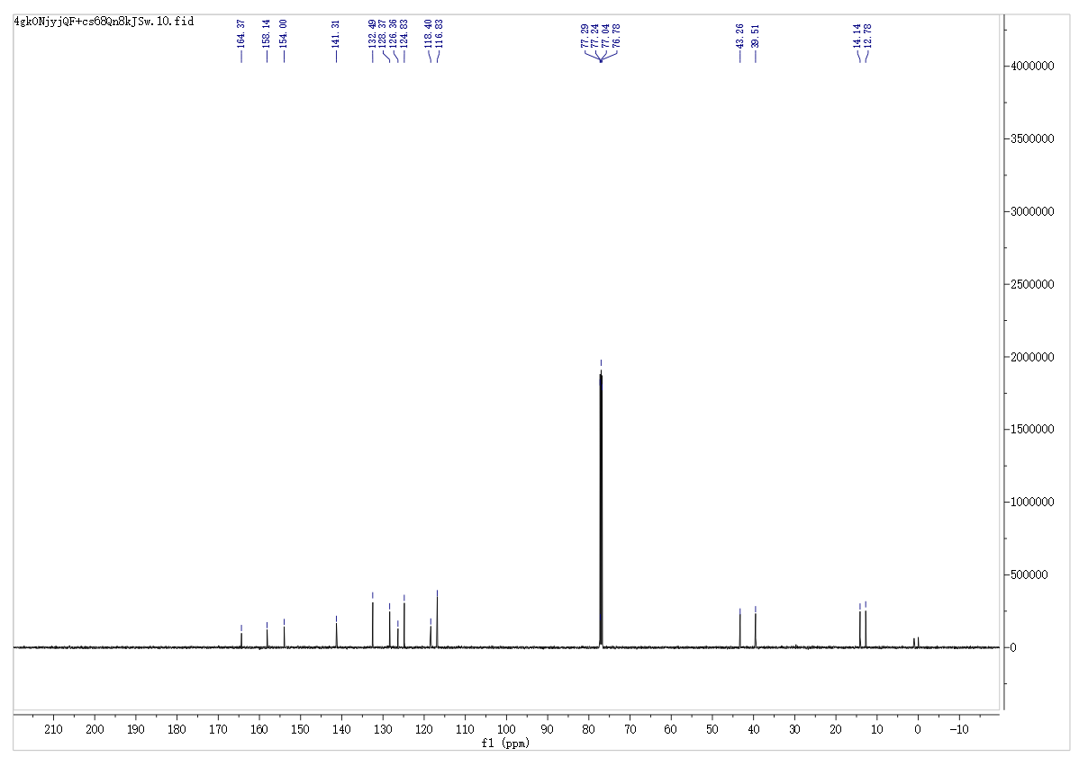
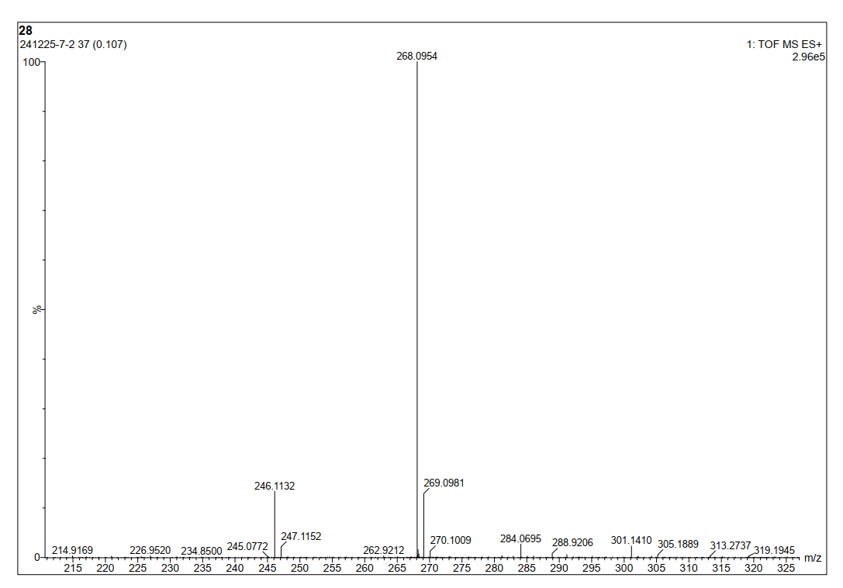
2-Oxo-N-phenyl-2H-chromene-3-carboxamide (3e)
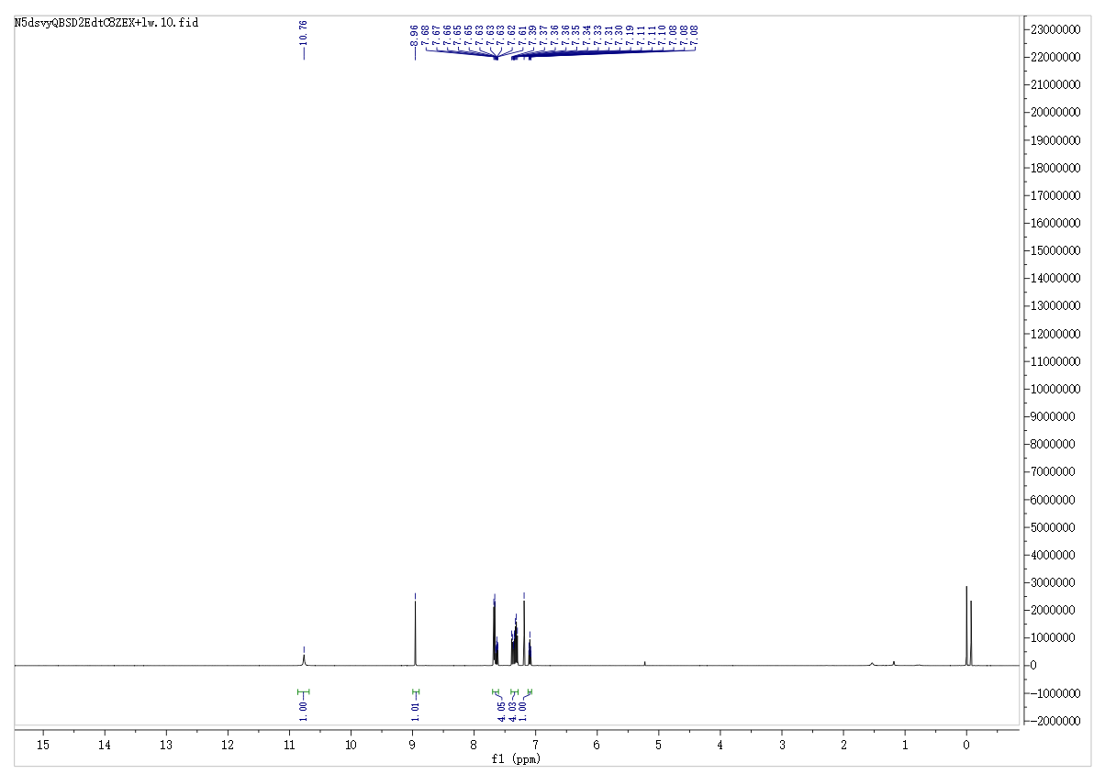
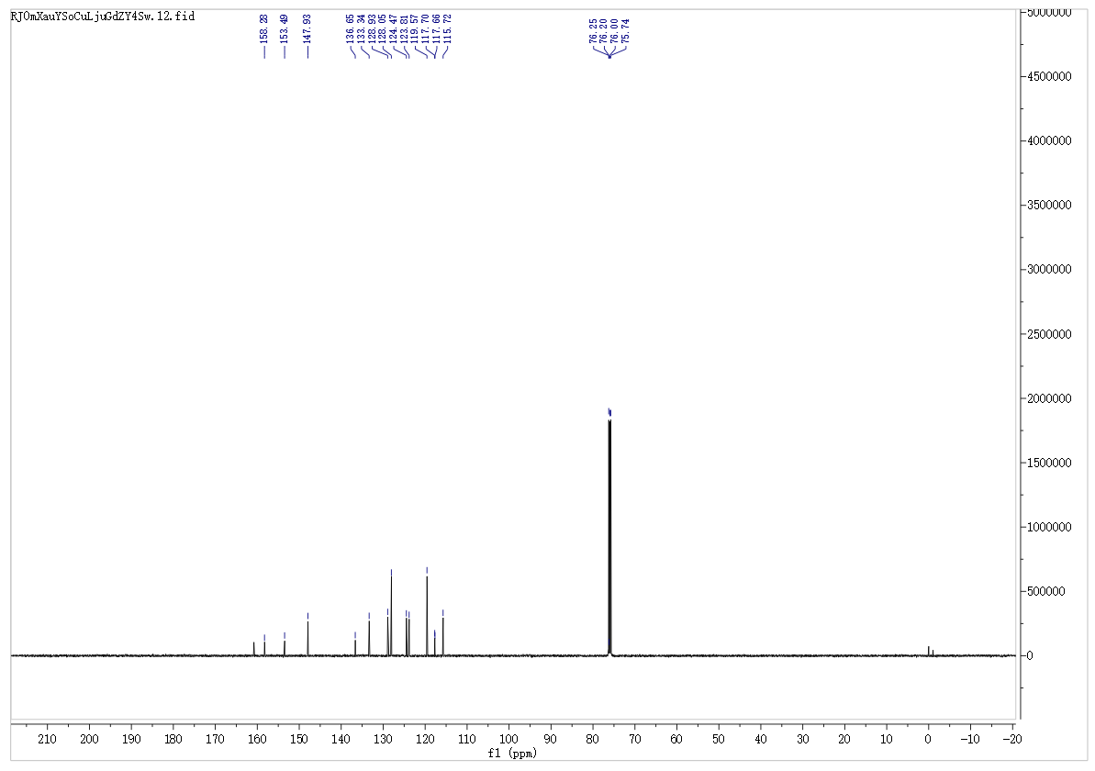

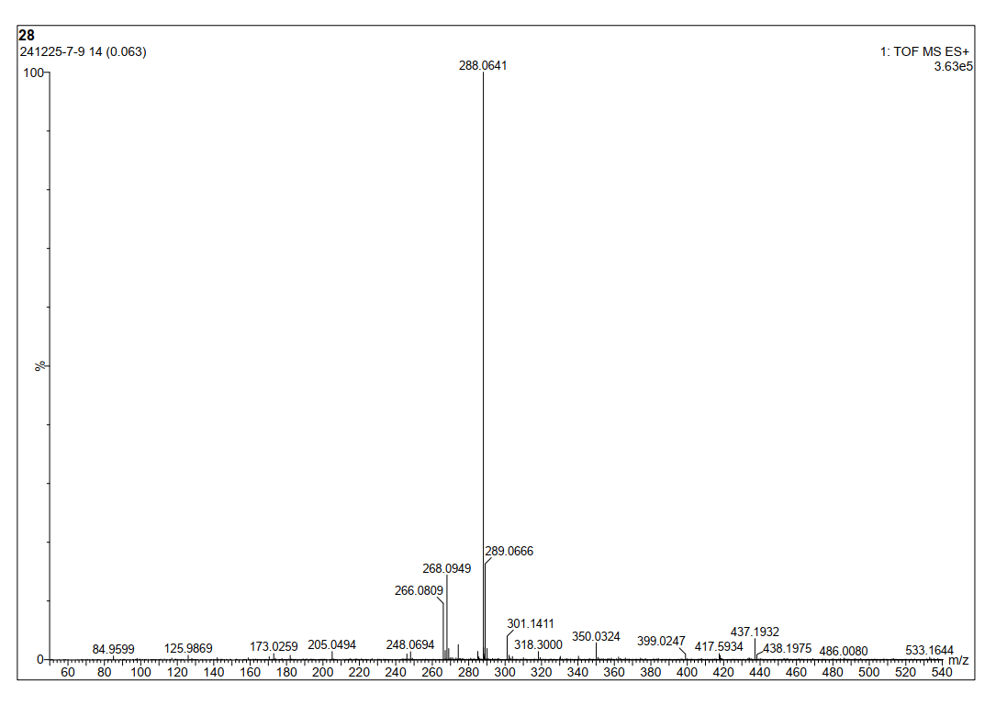

N-Benzyl-2-oxo-2H-chromene-3-carboxamide (3f)
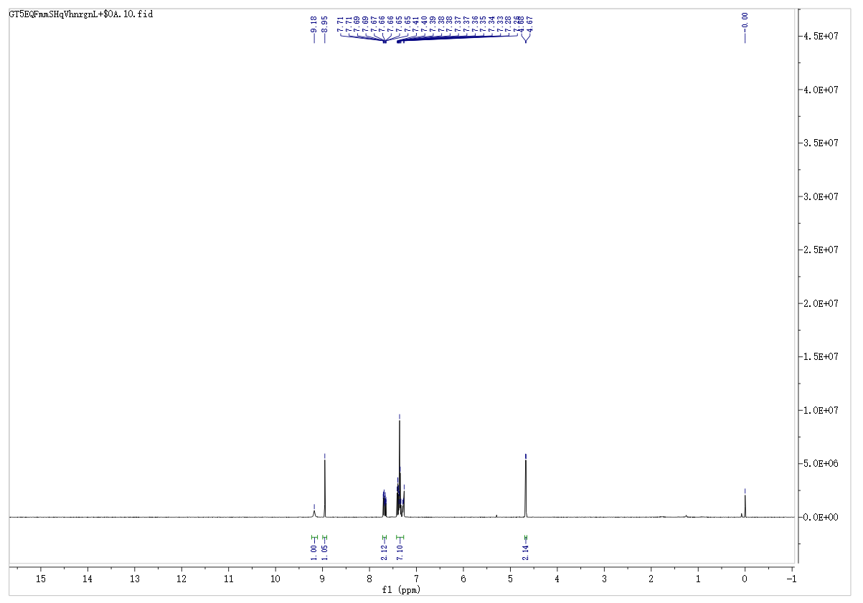
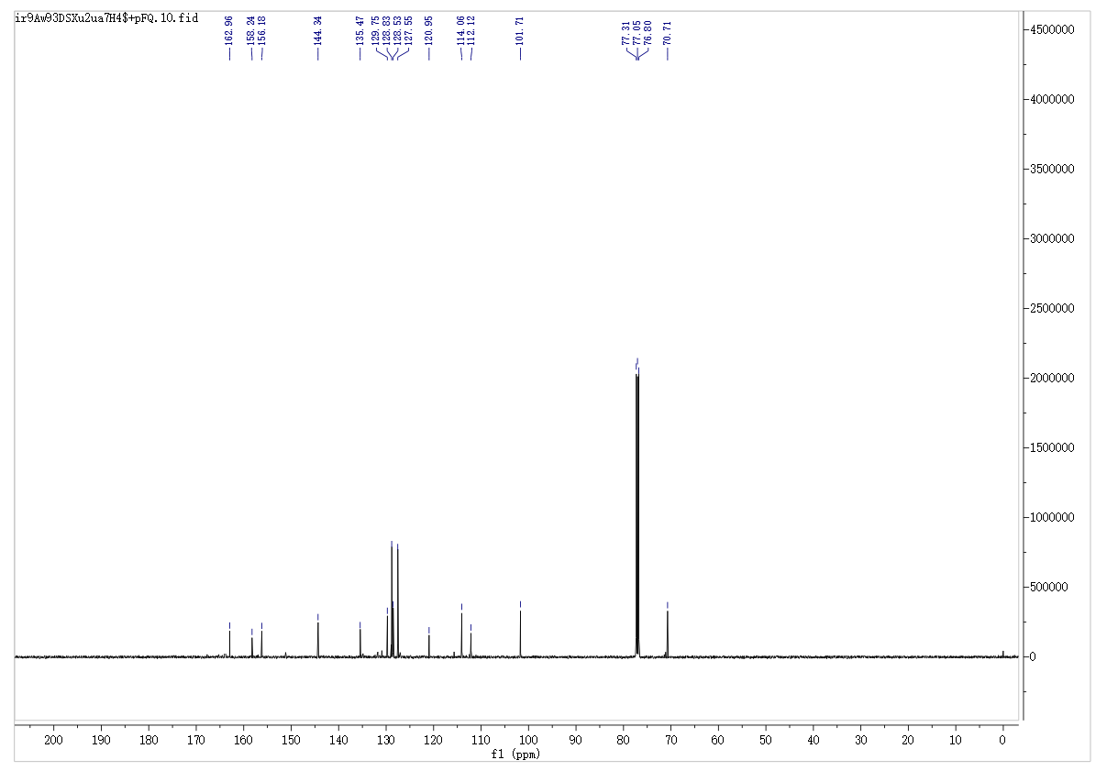
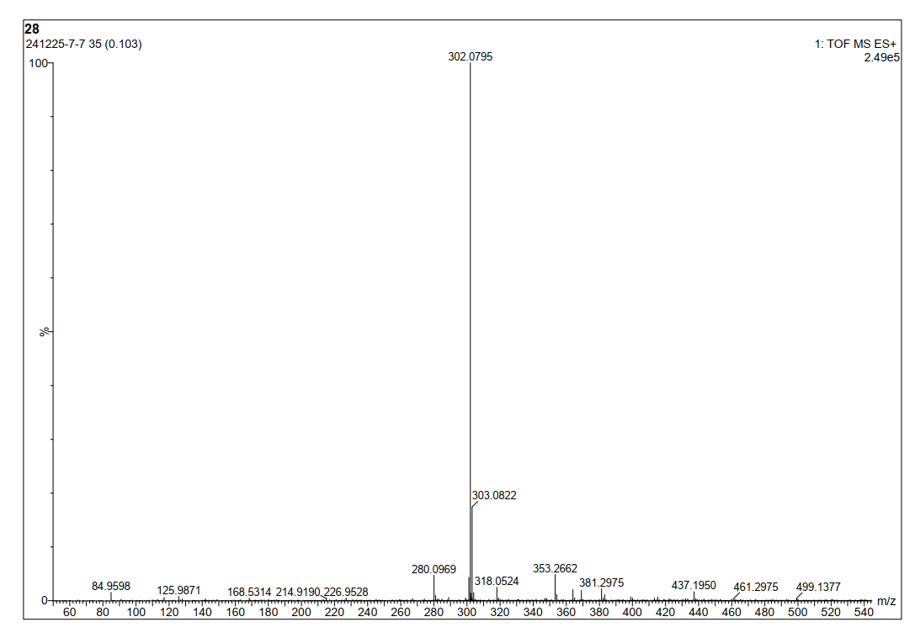
2-Oxo-N-phenethyl-2H-chromene-3-carboxamide (3g)
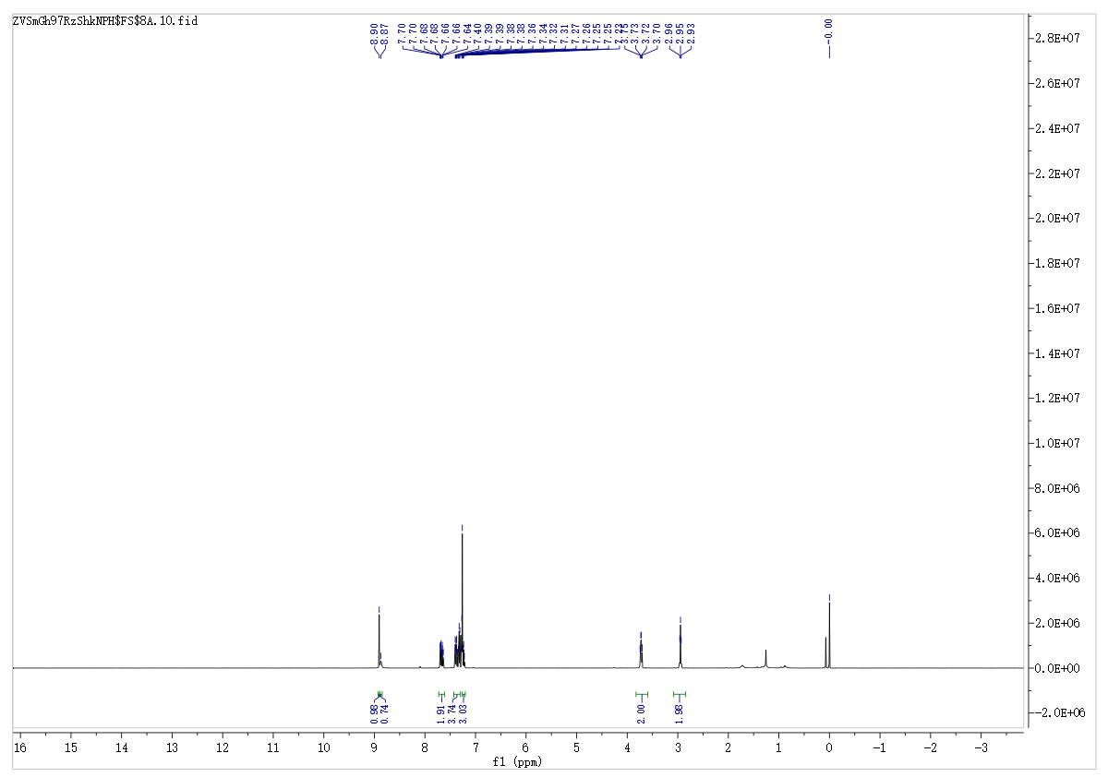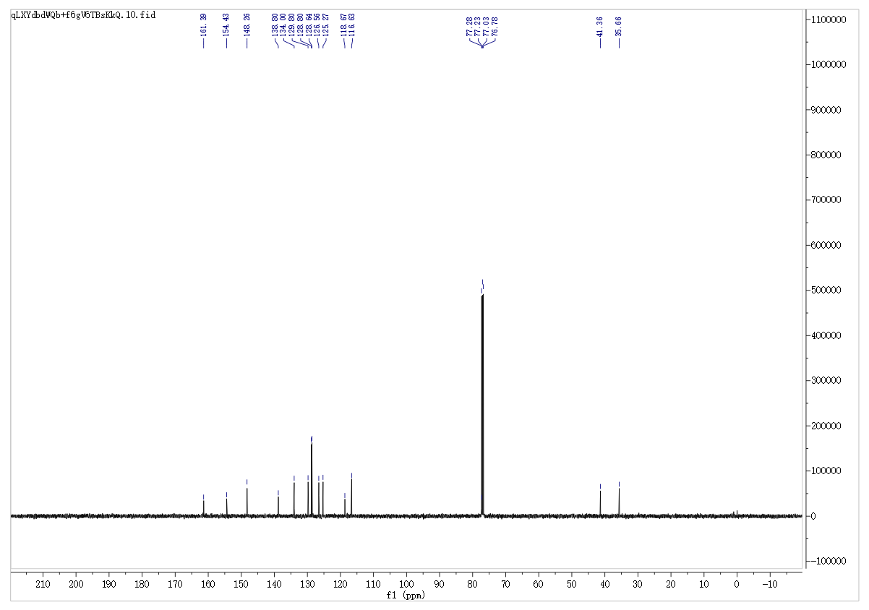
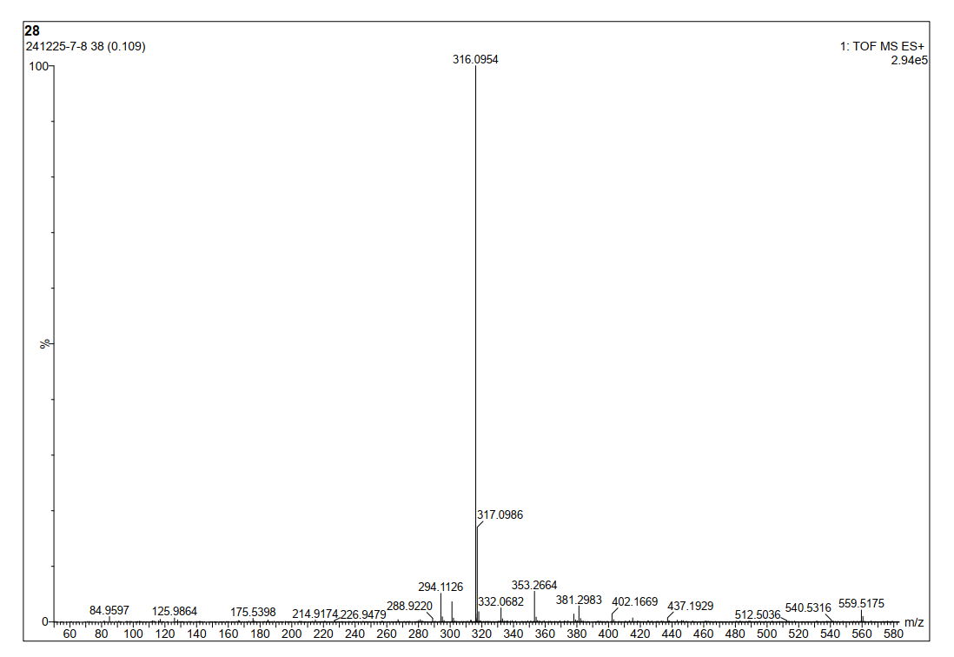
- (4-chlorophenyl)-2-oxo-2H-chromene-3-carboxamide (3h)

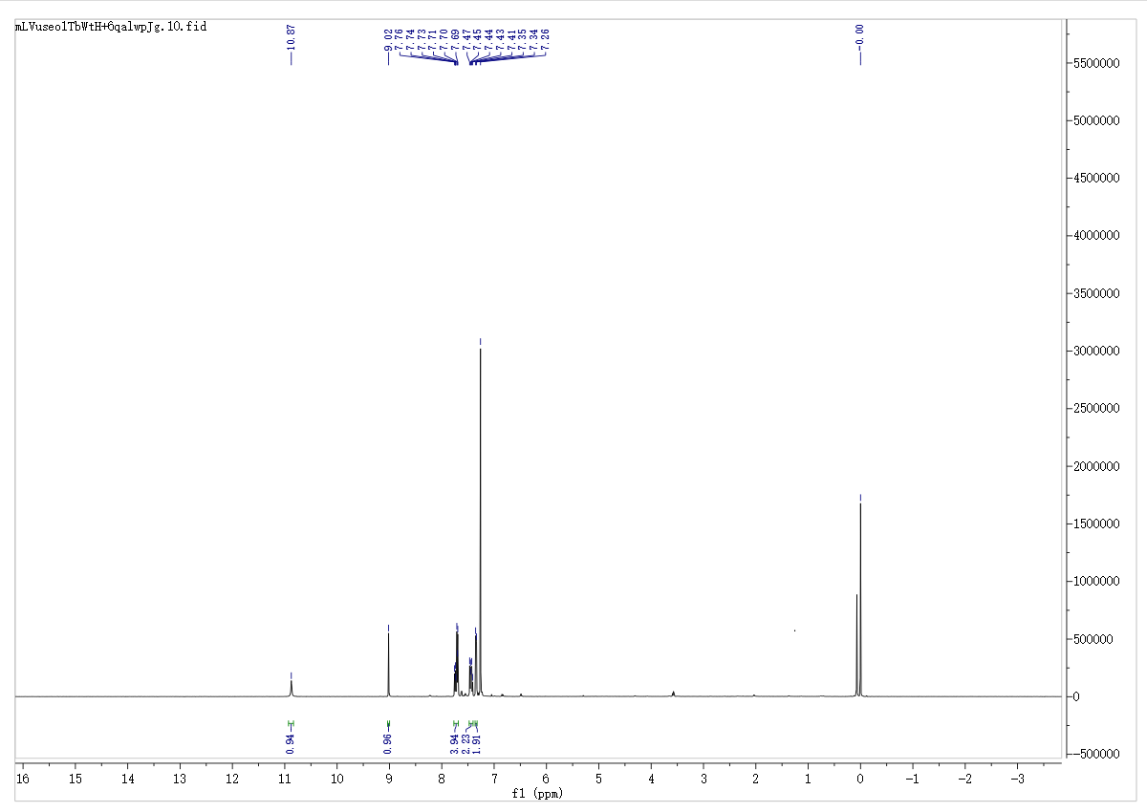
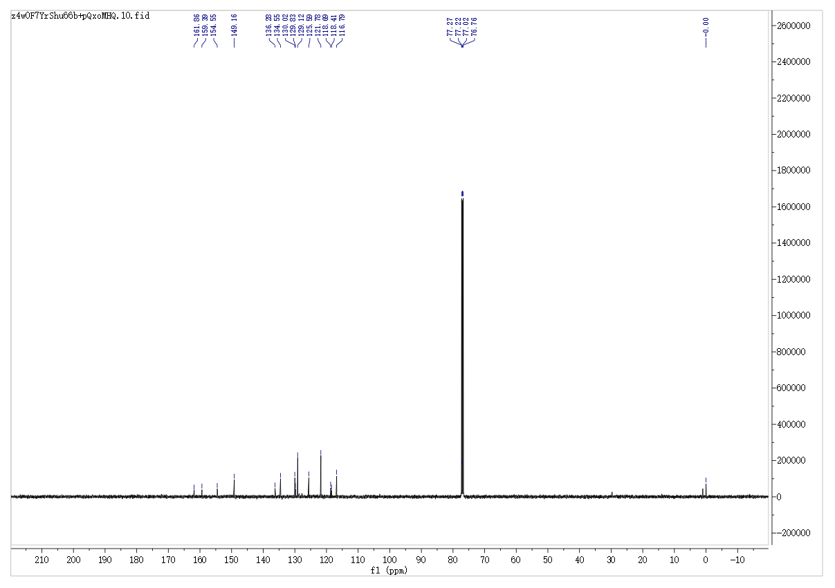

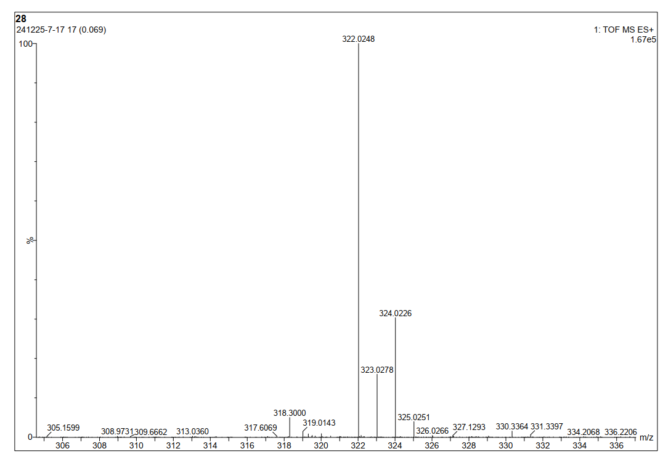
3-(Piperidine-1-carbonyl)-2H-chromen-2-one (3i)
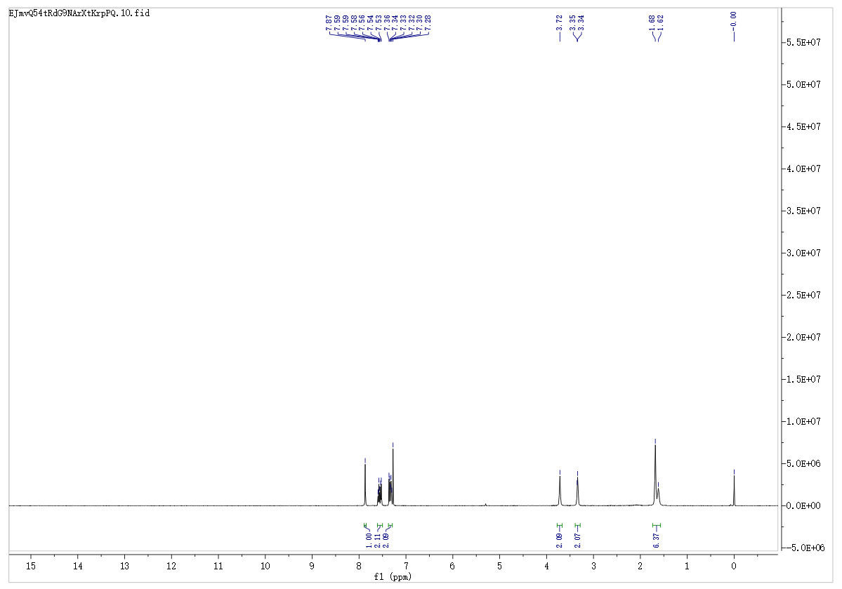
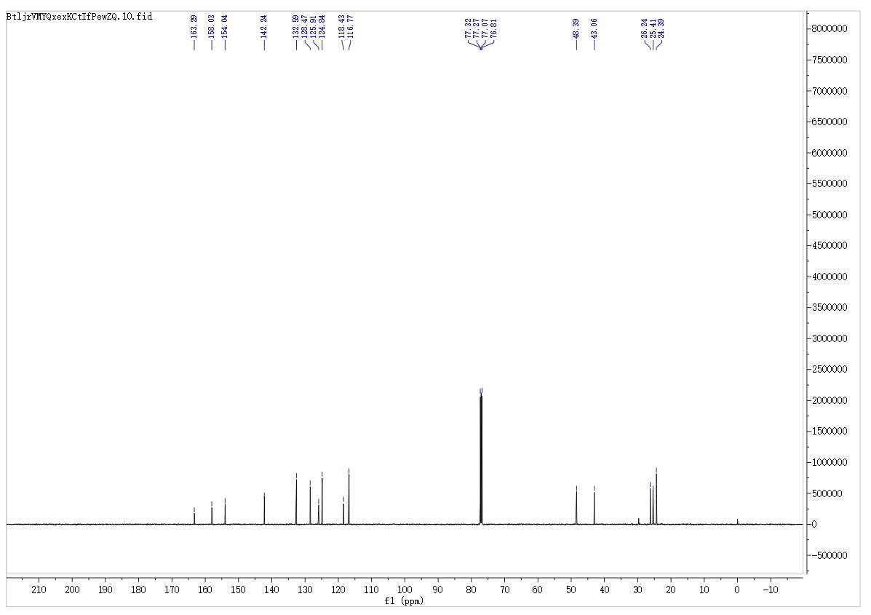
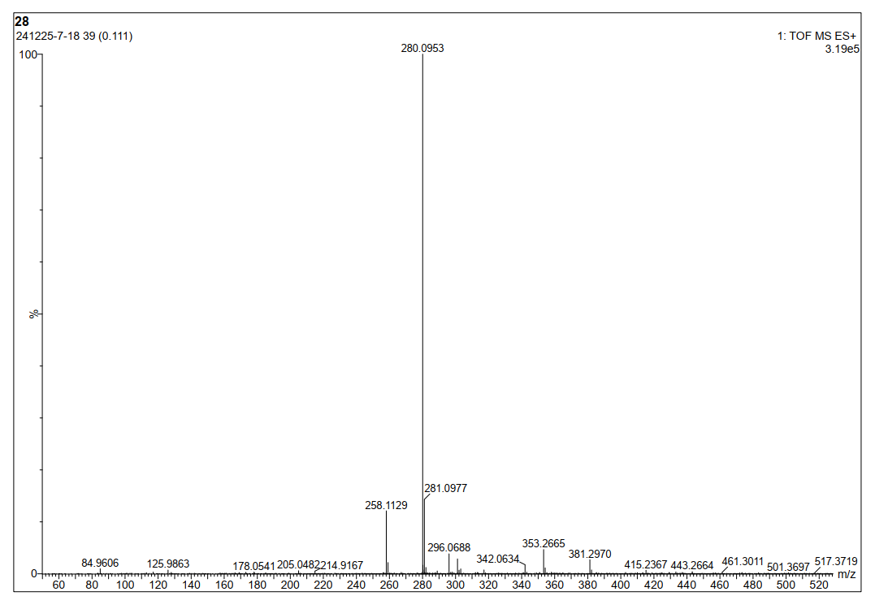
3-(4-Methylpiperazine-1-carbonyl)-2H-chromen-2-one (3j)
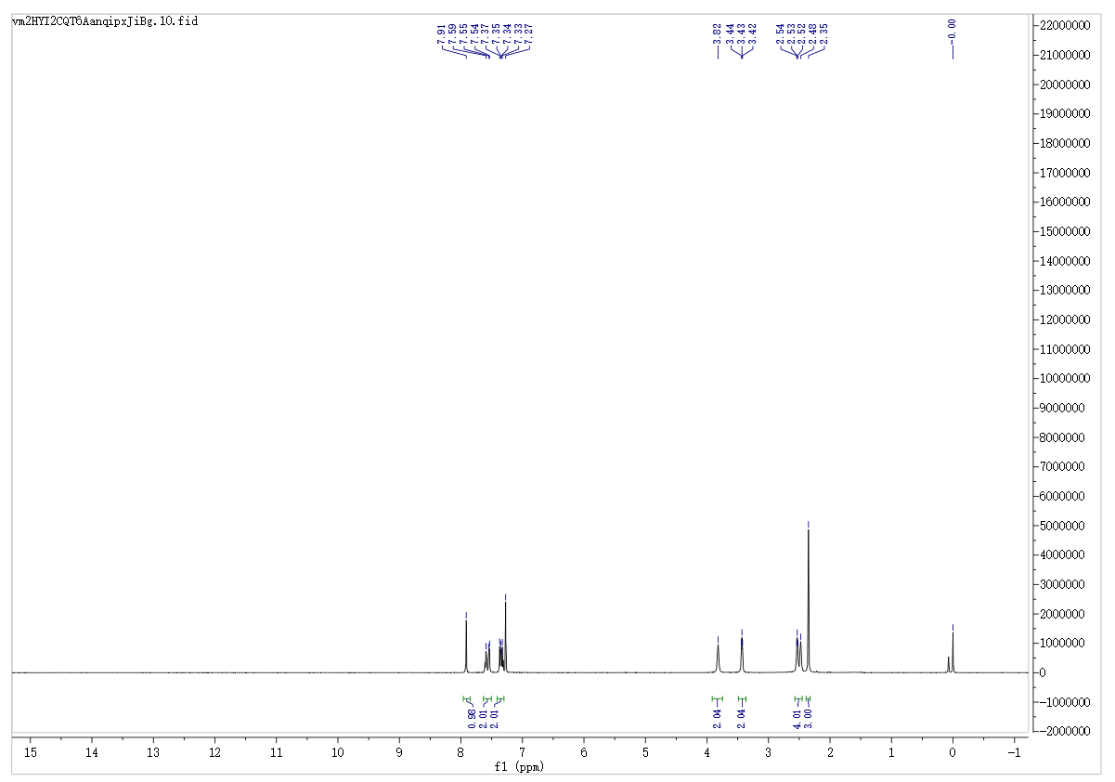
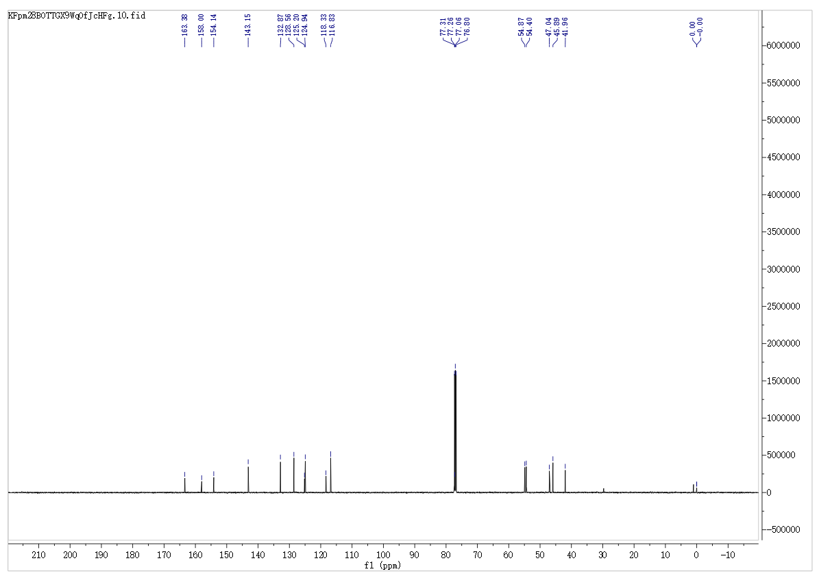
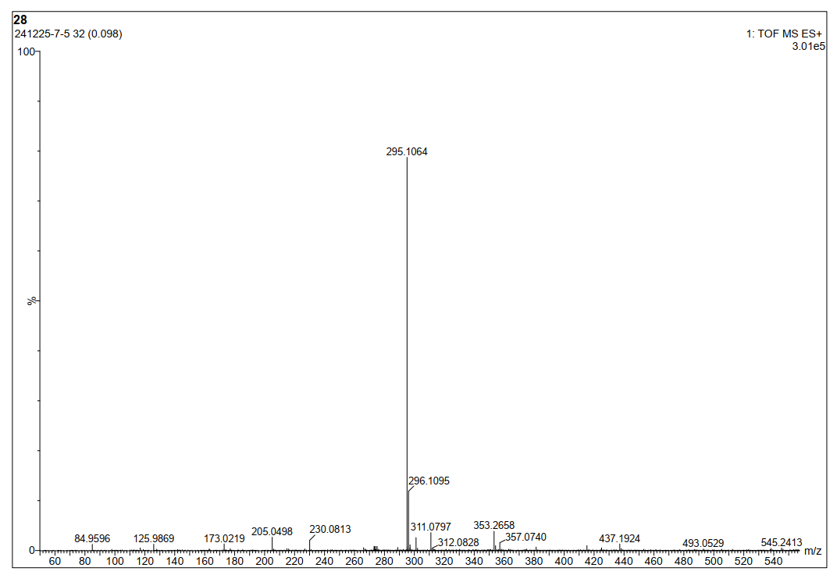
N-Cyclohexyl-2-oxo-2H-chromene-3-carboxamide (3k)
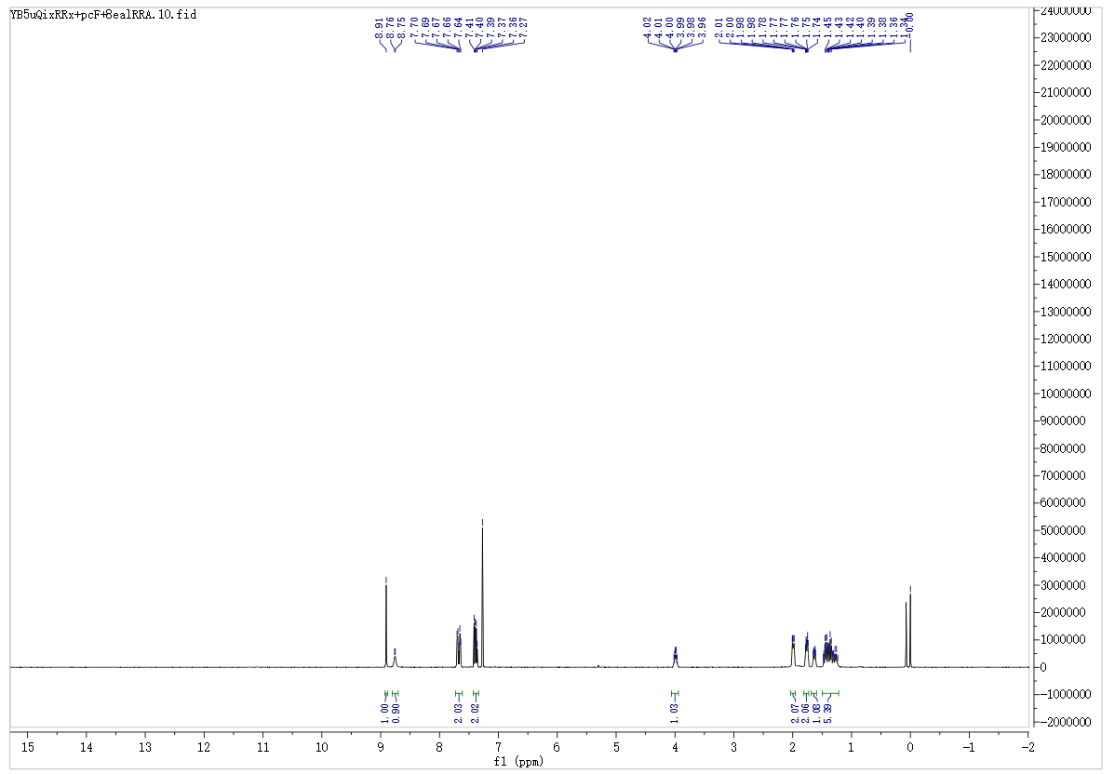
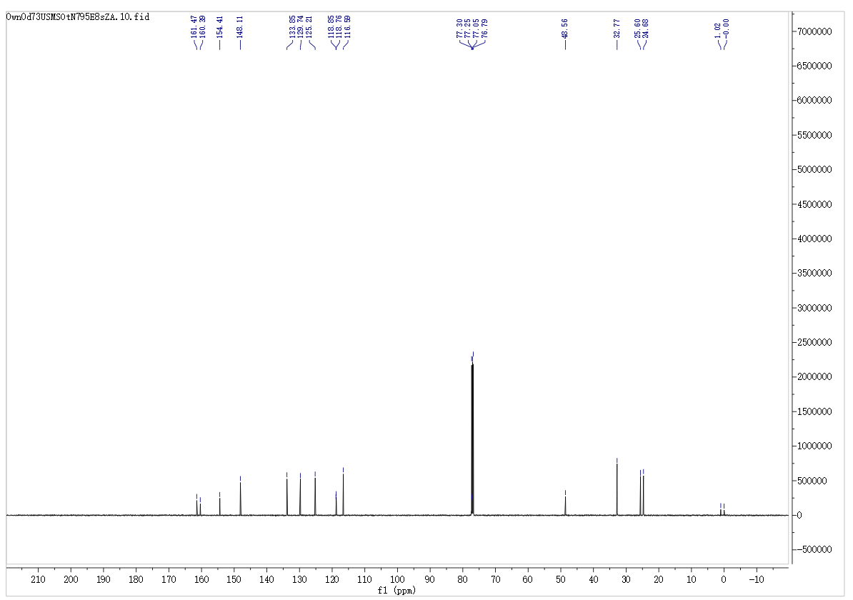
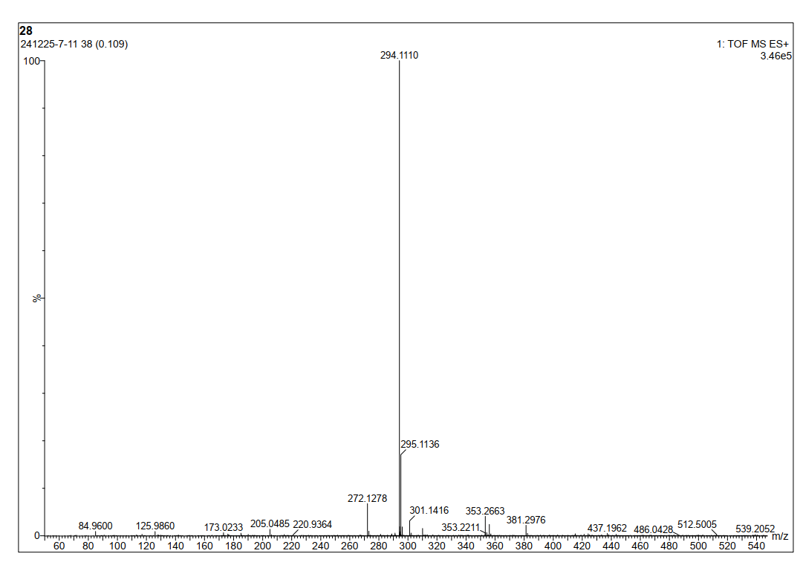
2-Oxo-N-(2-(piperidin-1-yl)ethyl)-2H-chromene-3-carboxamide (3l)
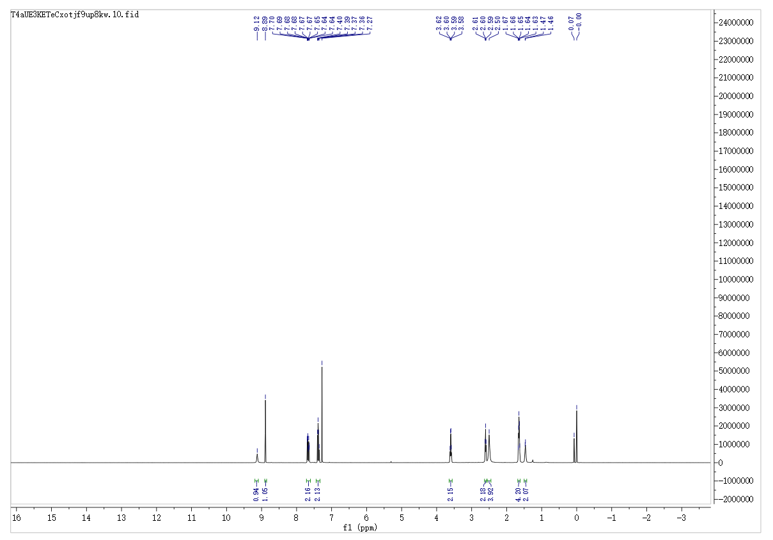
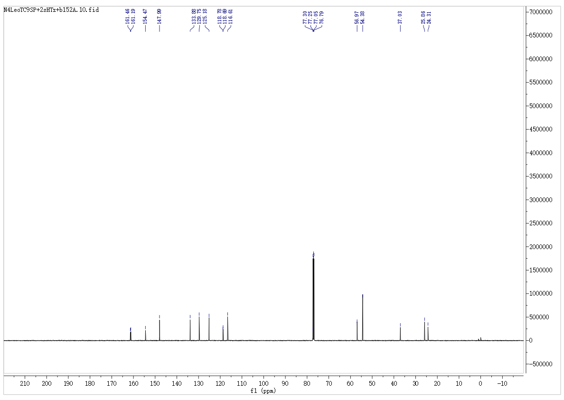
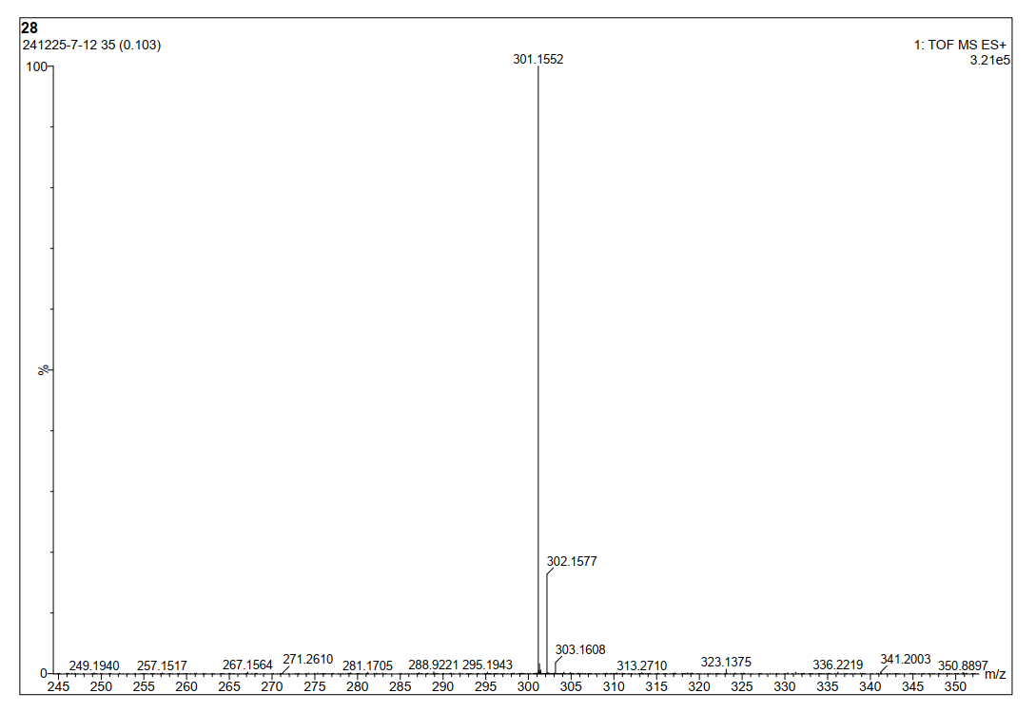
7-(Benzyloxy)-N-butyl-2-oxo-2H-chromene-3-carboxamide (8a)
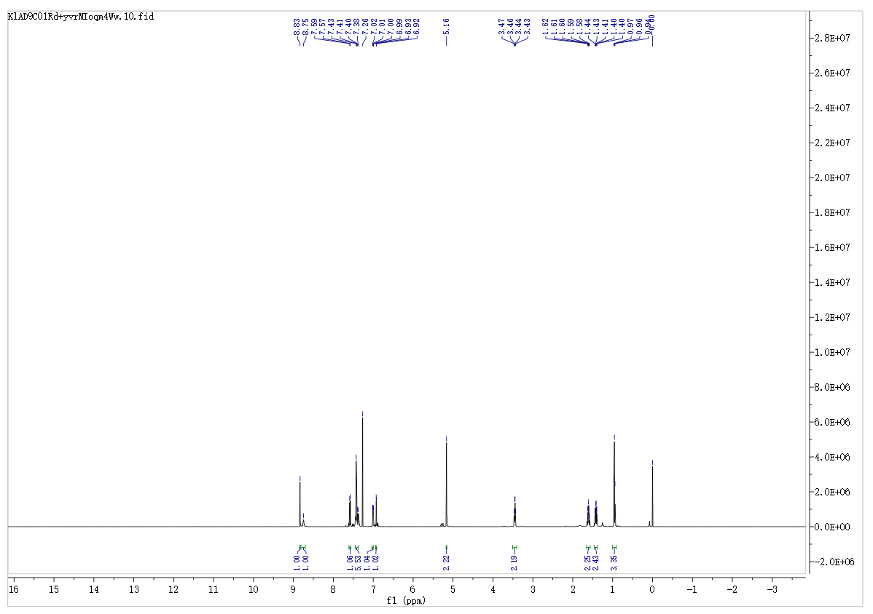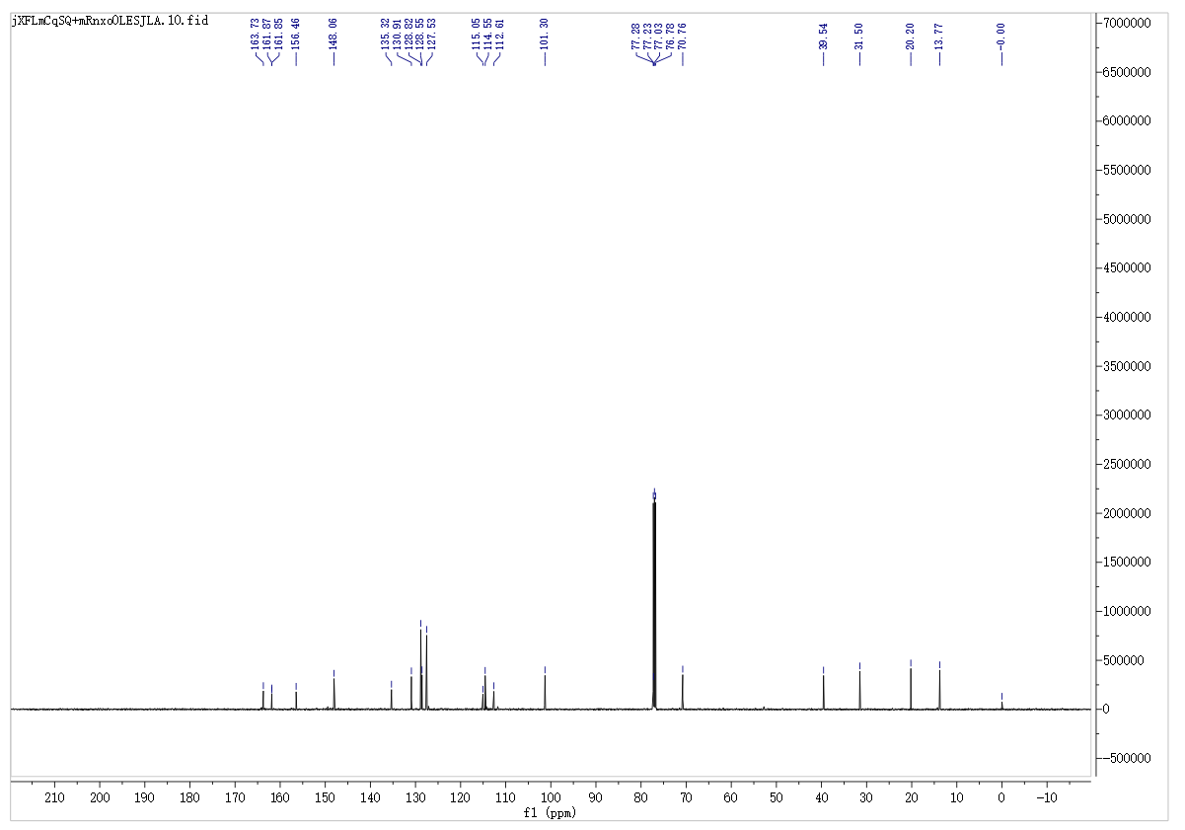
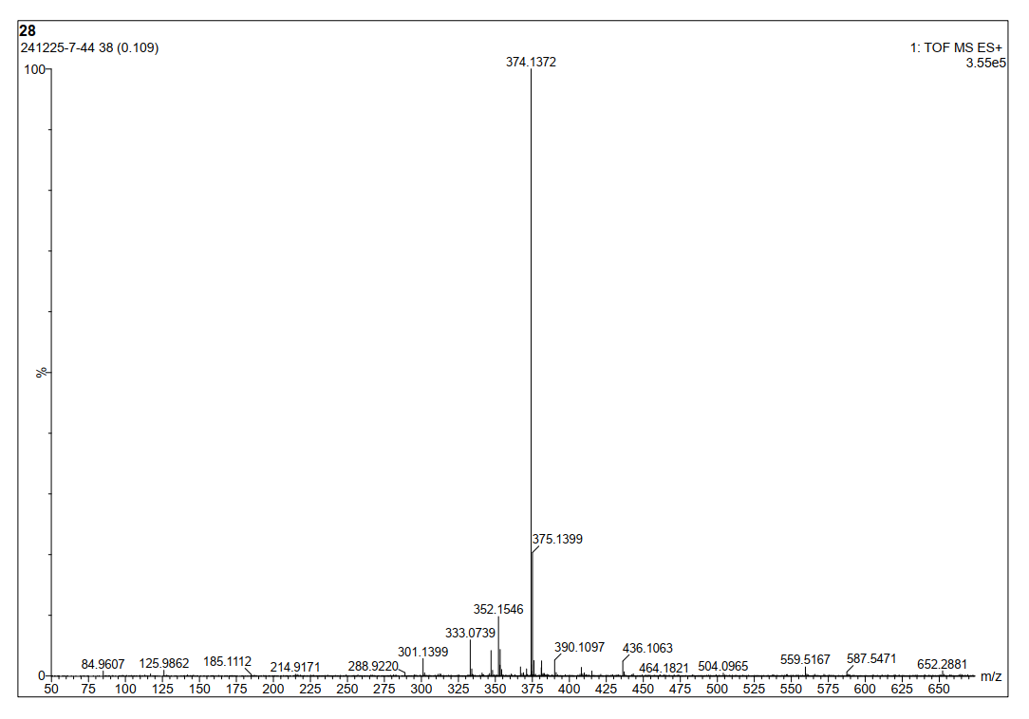
7-(Benzyloxy)-2-oxo-N-pentyl-2H-chromene-3-carboxamide (8b)
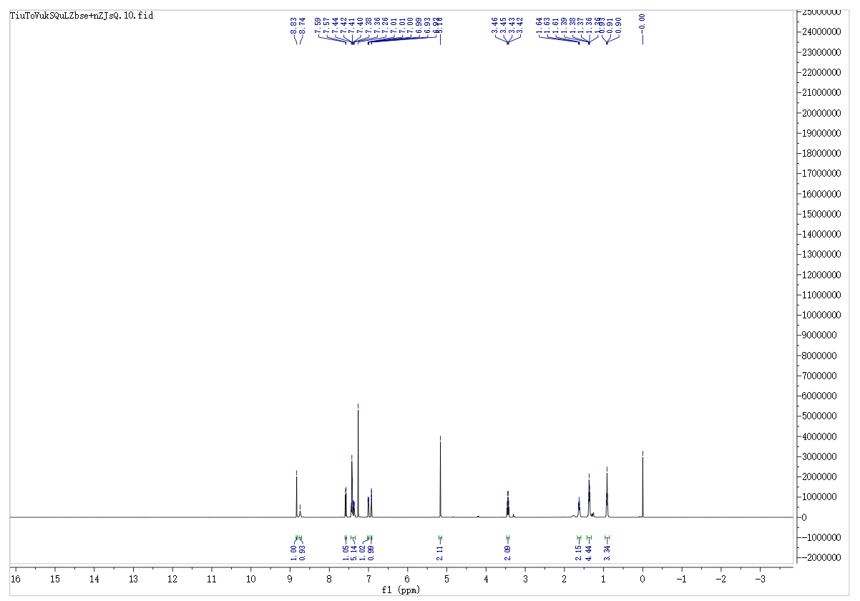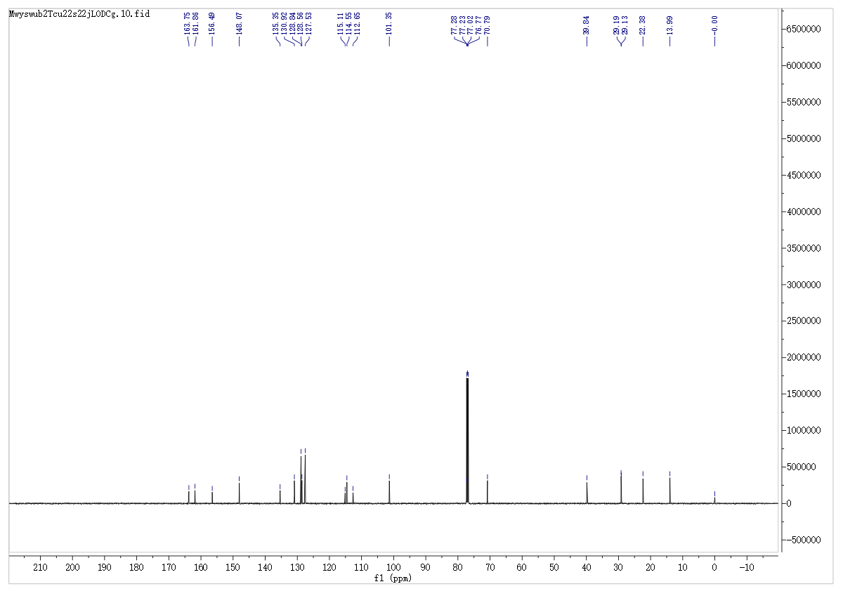
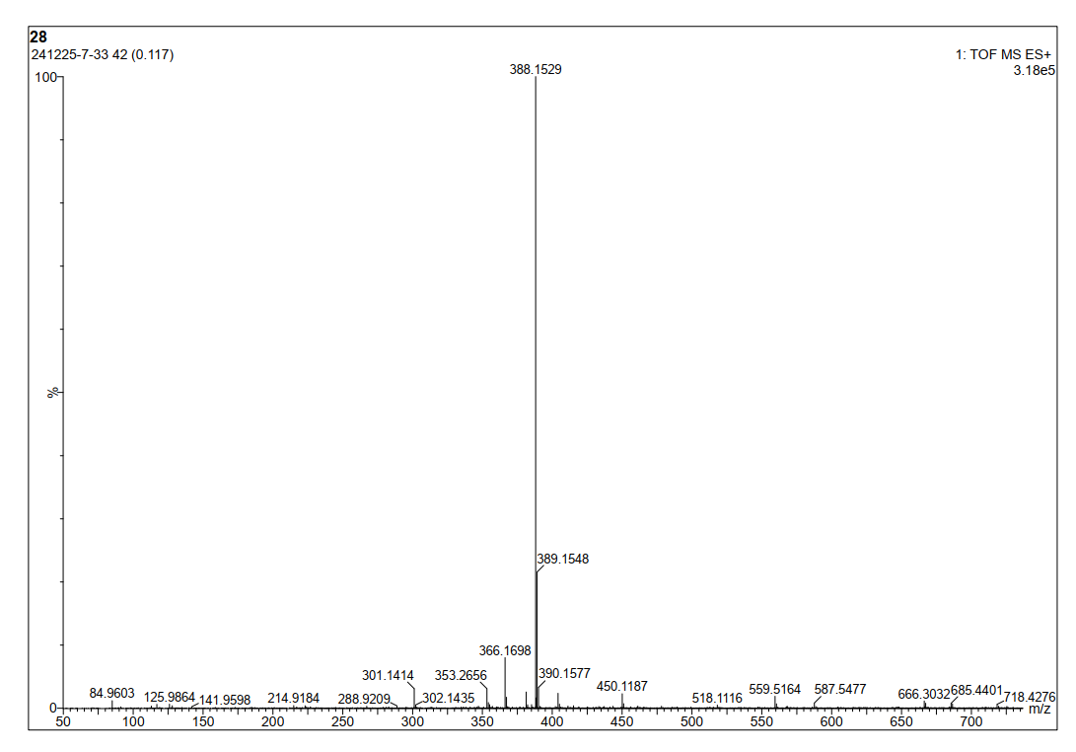
7-(Benzyloxy)-N-hexyl-2-oxo-2H-chromene-3-carboxamide (8c)
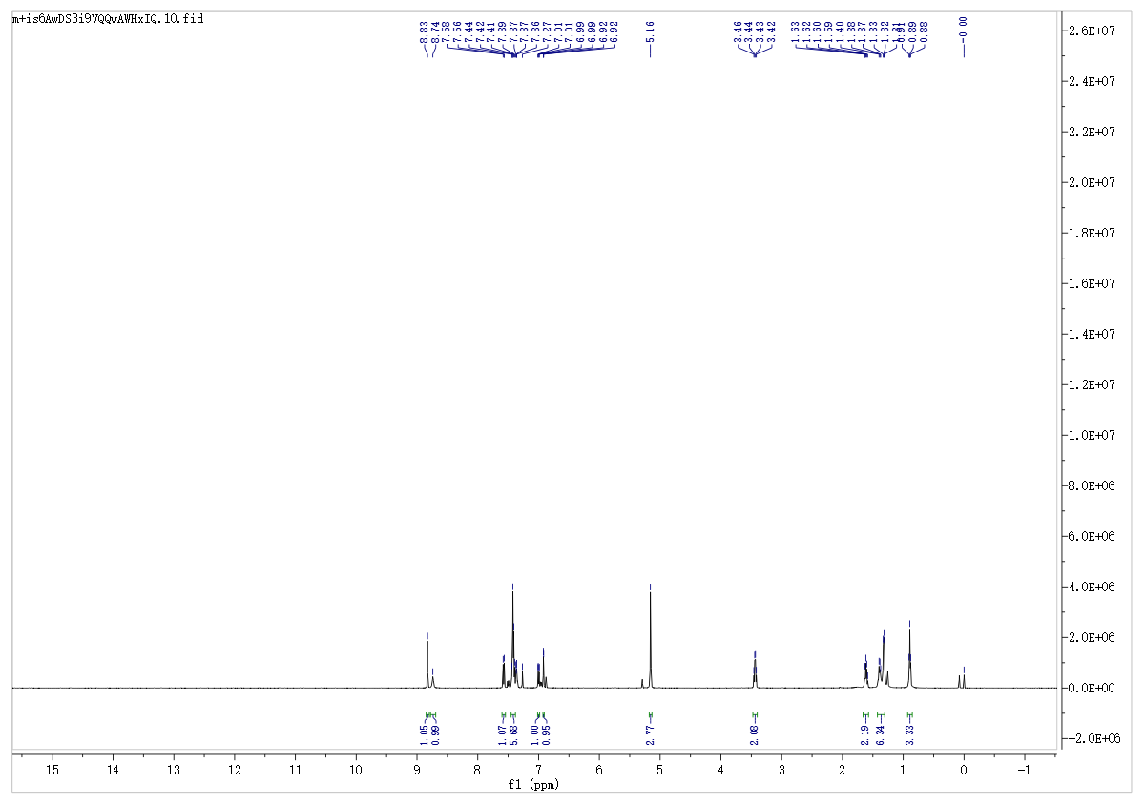
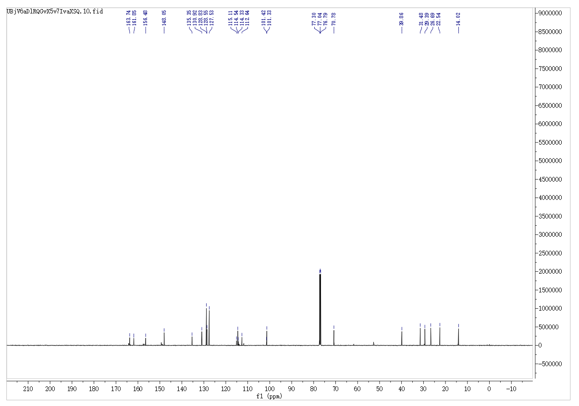
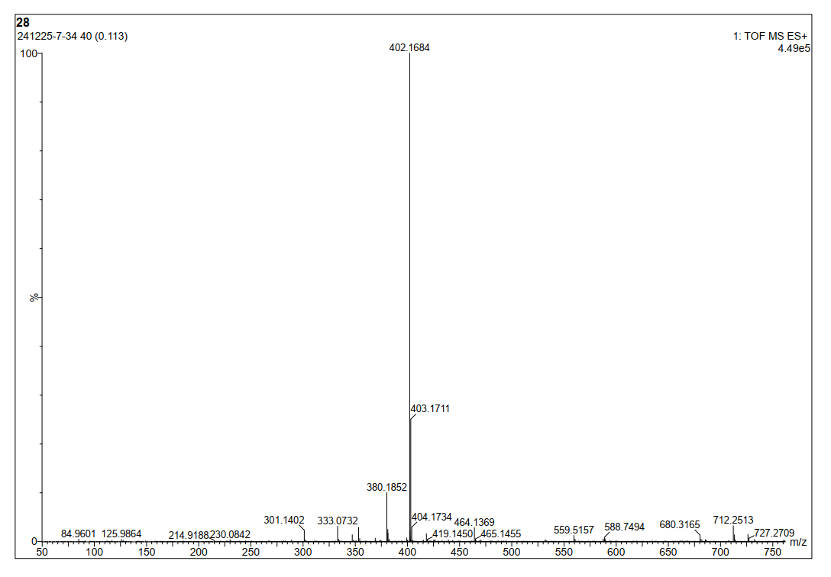
7-(Benzyloxy)-N-heptyl-2-oxo-2H-chromene-3-carboxamide (8d)
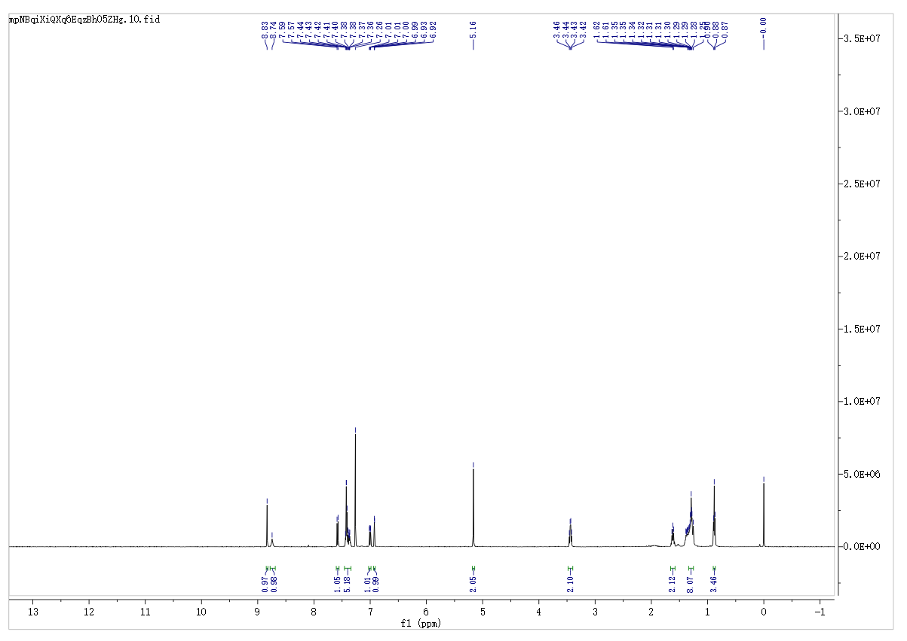
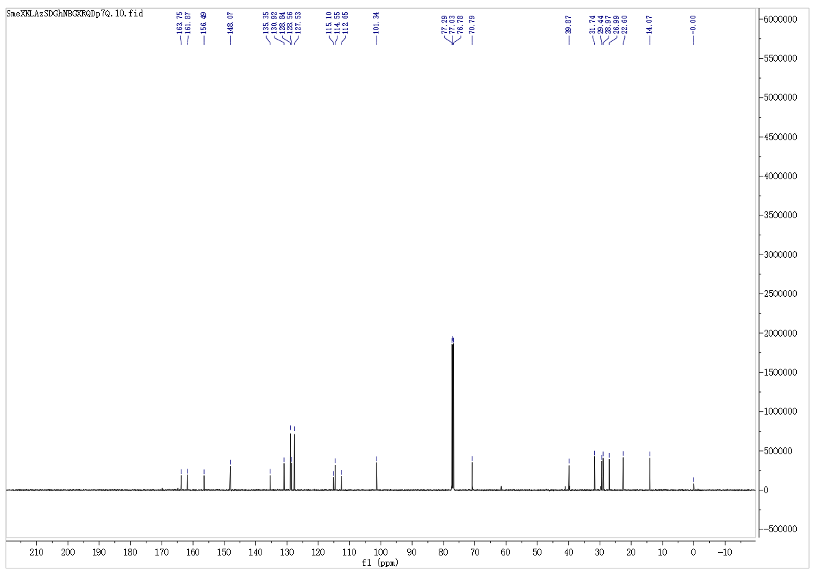
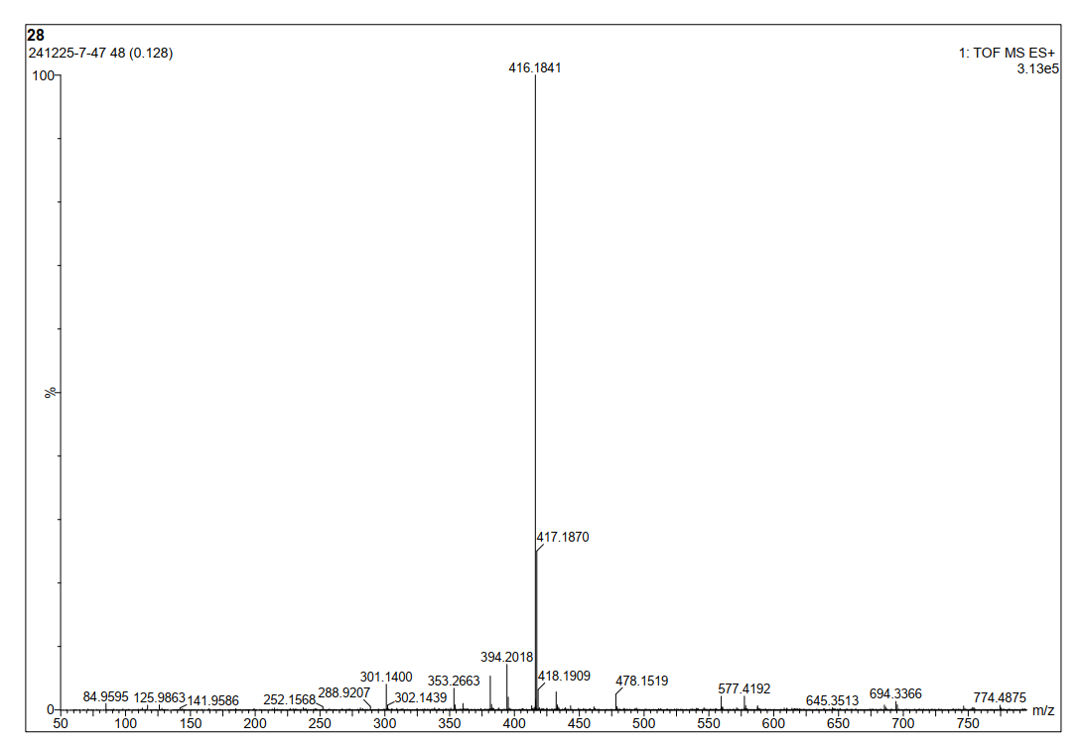
7-(Benzyloxy)-N,N-diethyl-2-oxo-2H-chromene-3-carboxamide (8e)
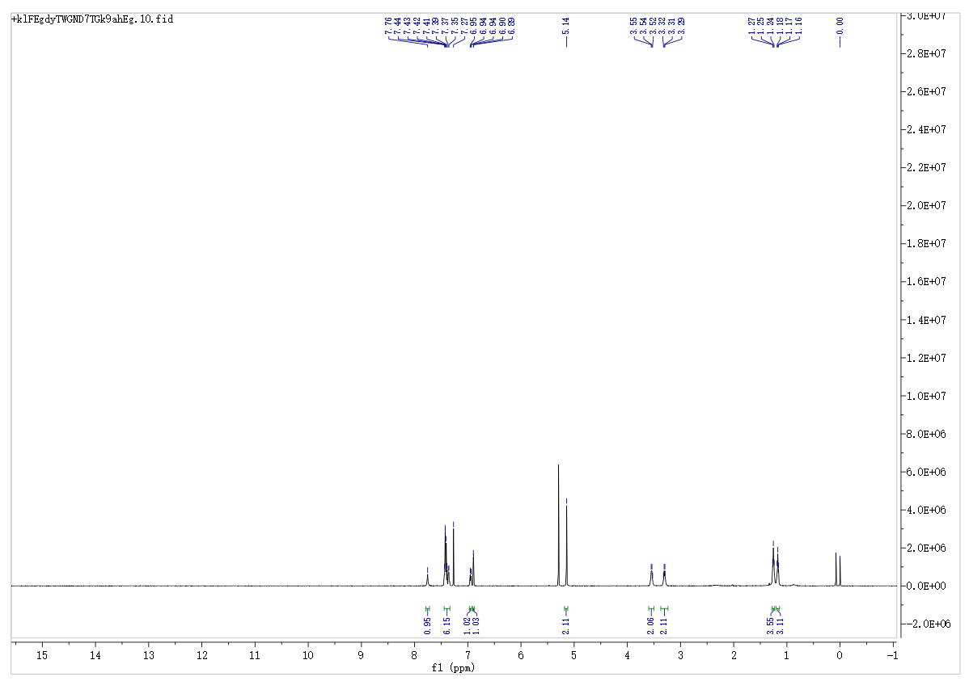
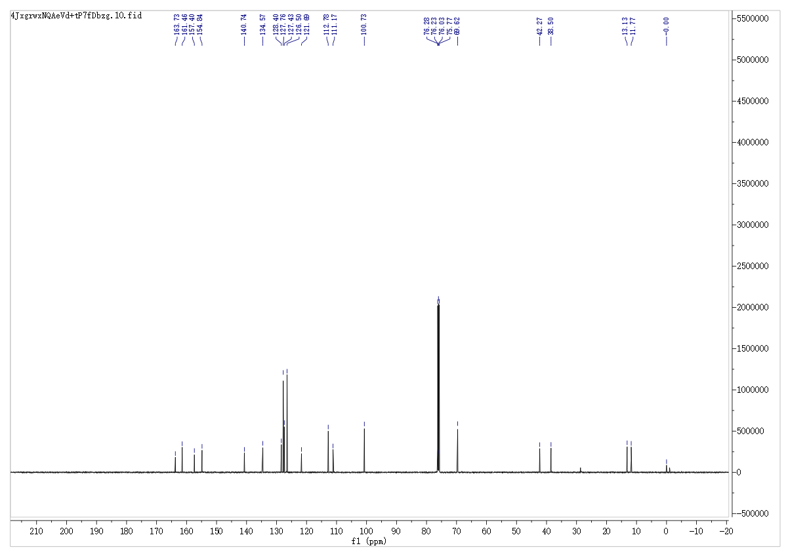
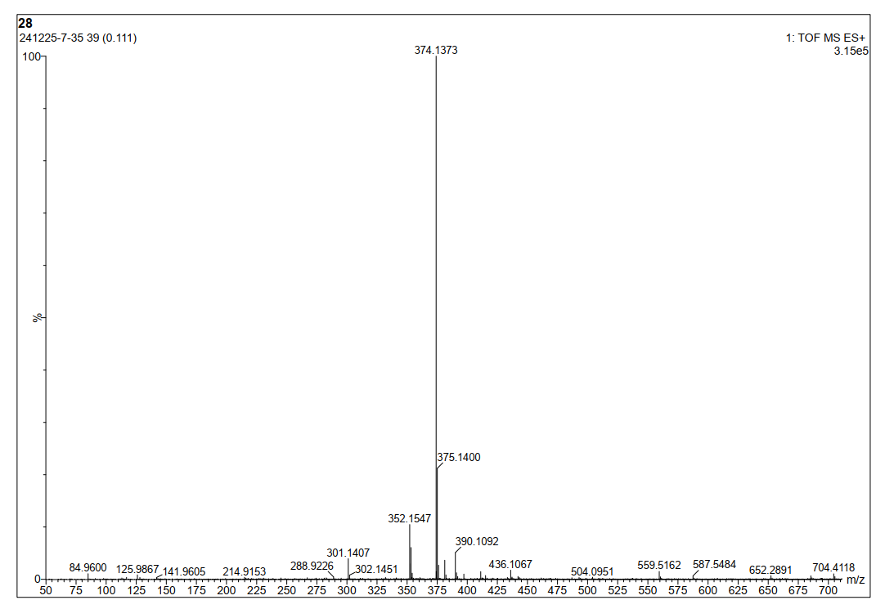
7-(Benzyloxy)-2-oxo-N-phenyl-2H-chromene-3-carboxamide (8f)
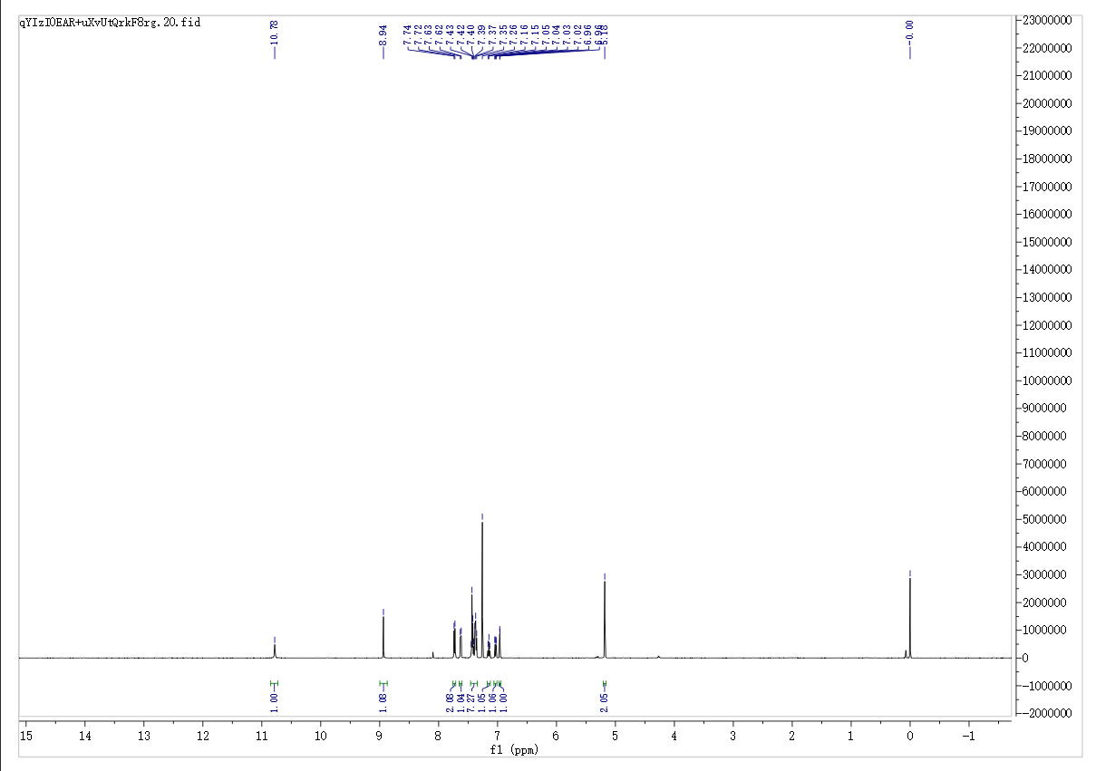
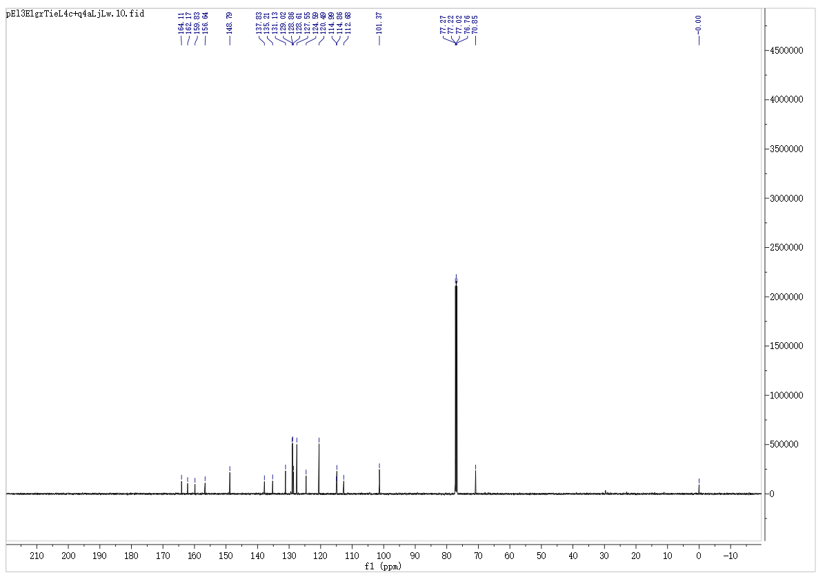
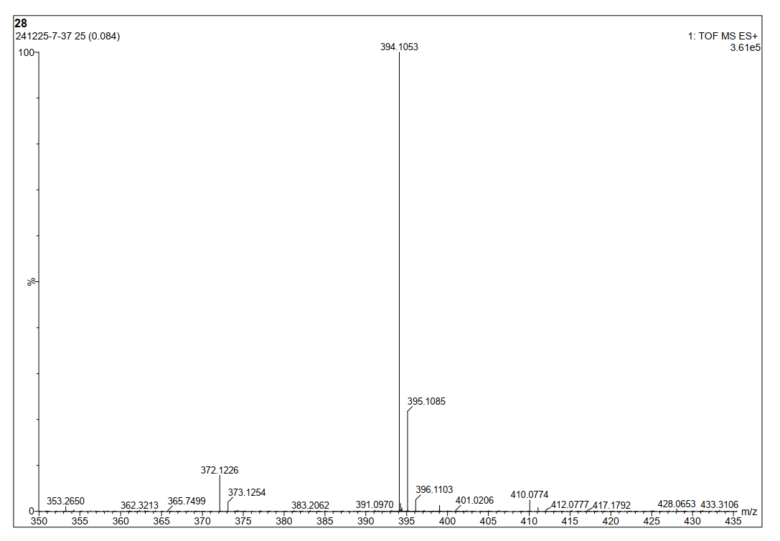
N-Benzyl-7-(benzyloxy)-2-oxo-2H-chromene-3-carboxamide (8g)
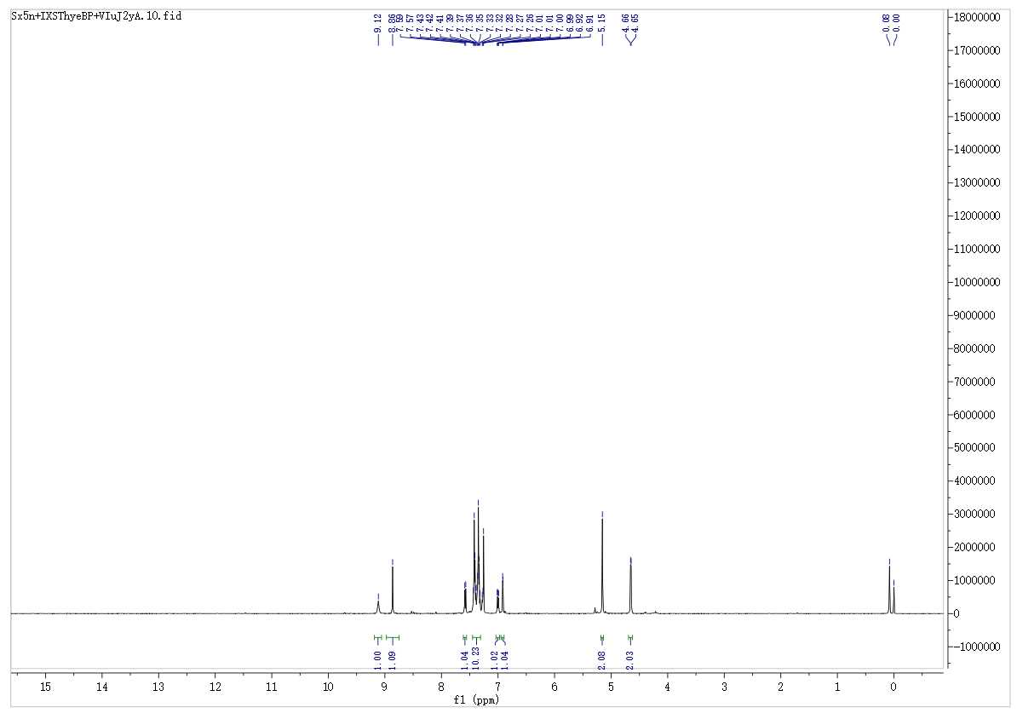
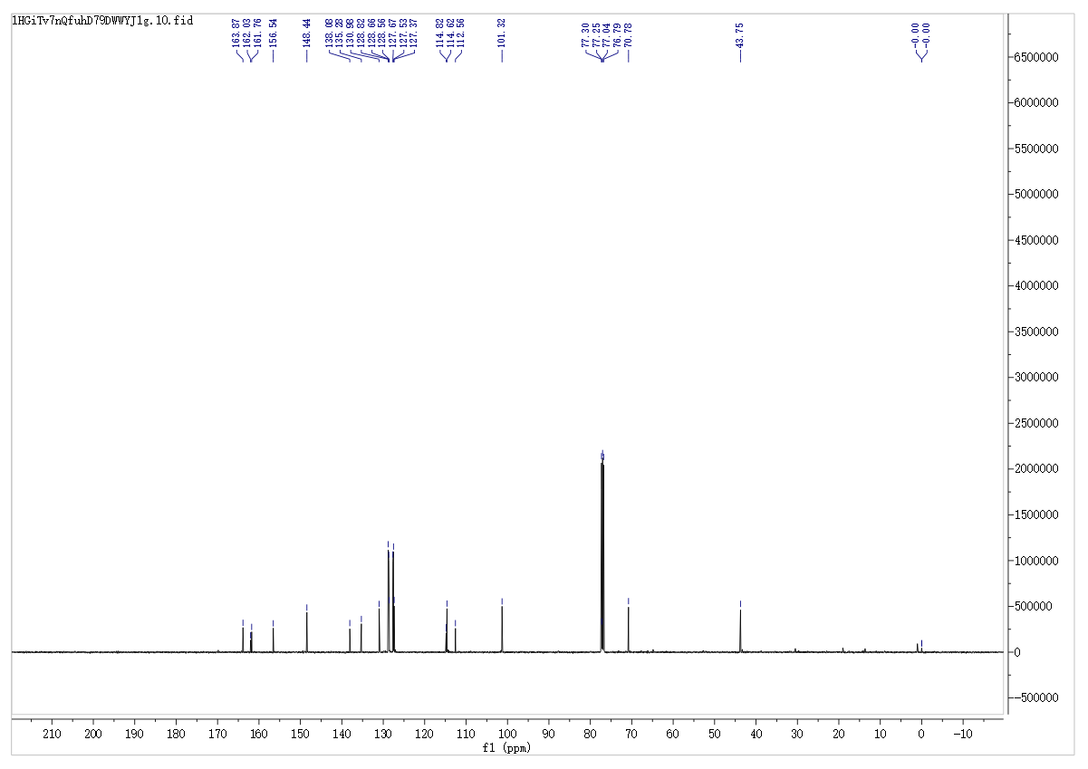
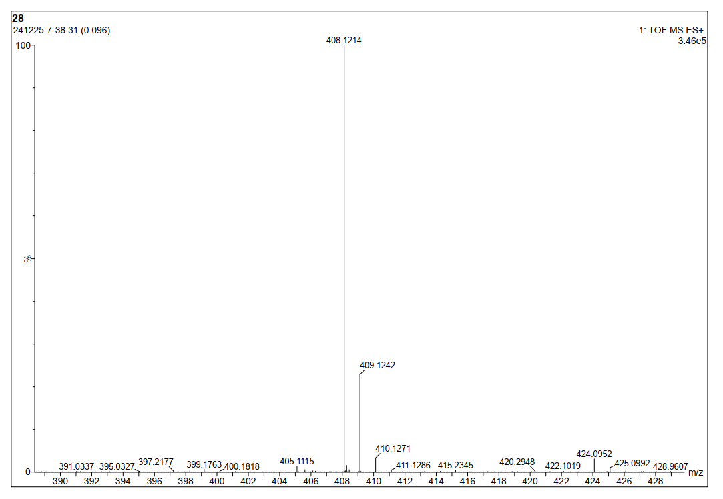
7-(Benzyloxy)-2-oxo-N-phenethyl-2H-chromene-3-carboxamide (8h)
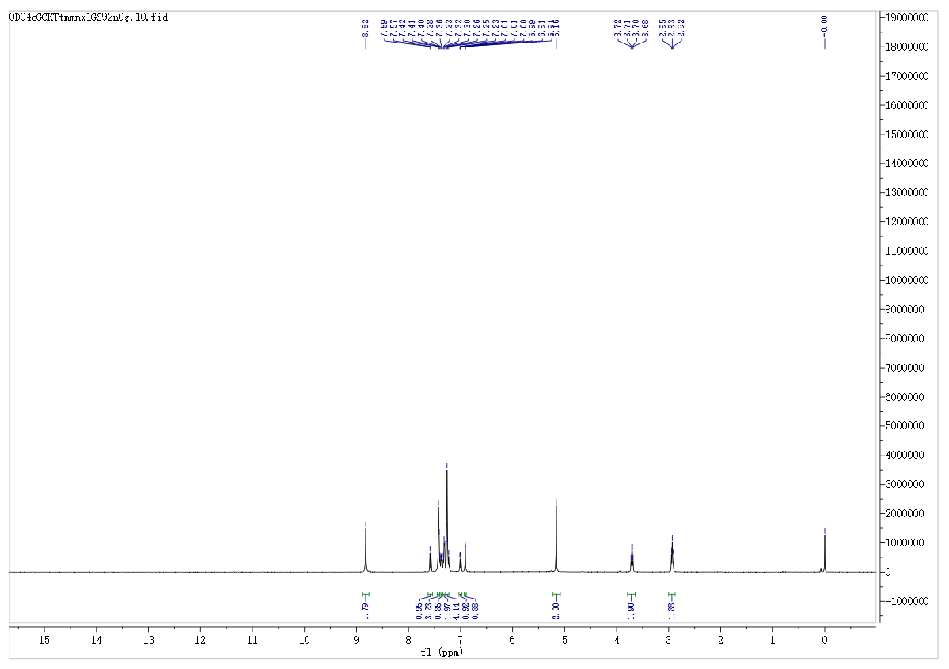
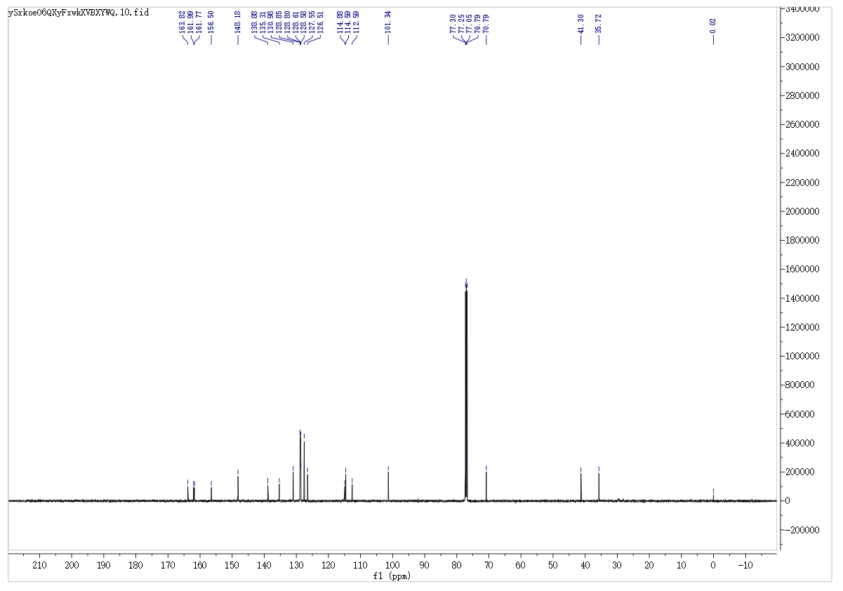
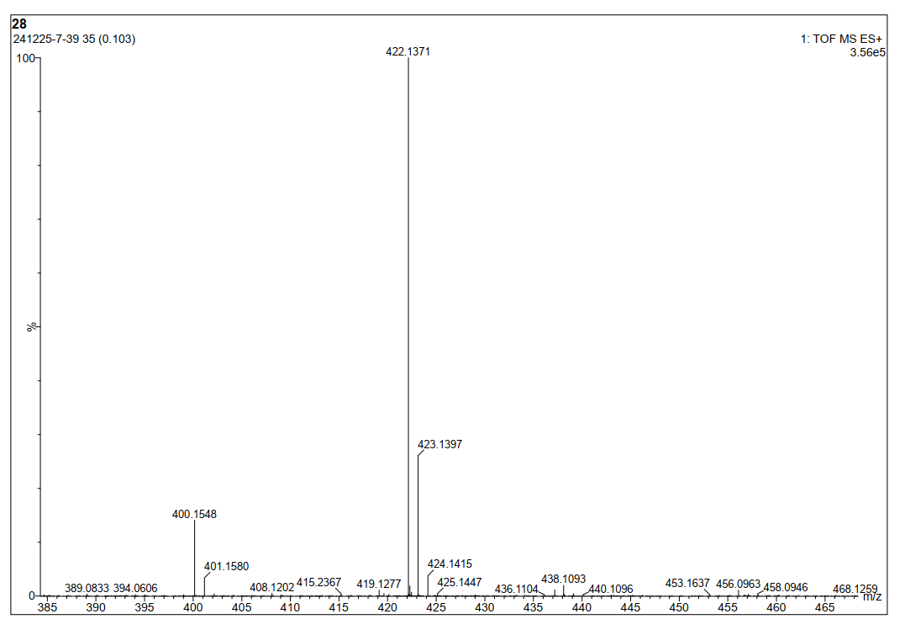
7-(Benzyloxy)-N-(4-chlorophenyl)-2-oxo-2H-chromene-3-carboxamide (8i)
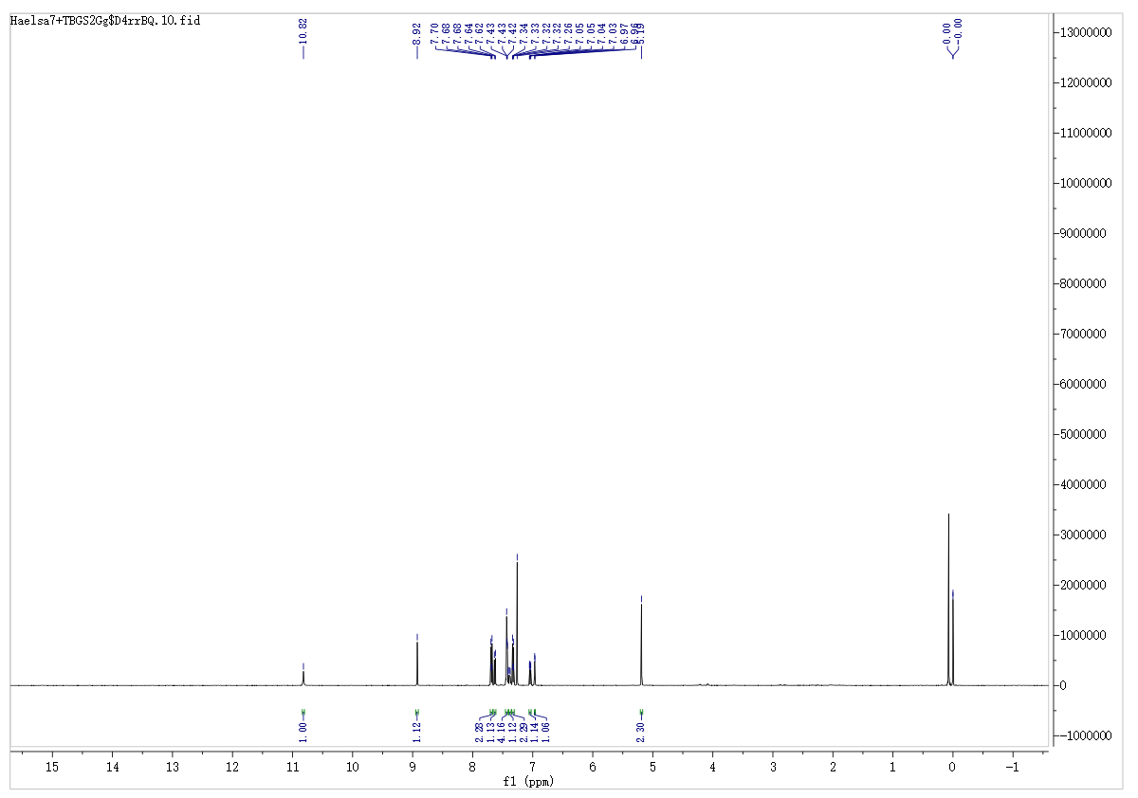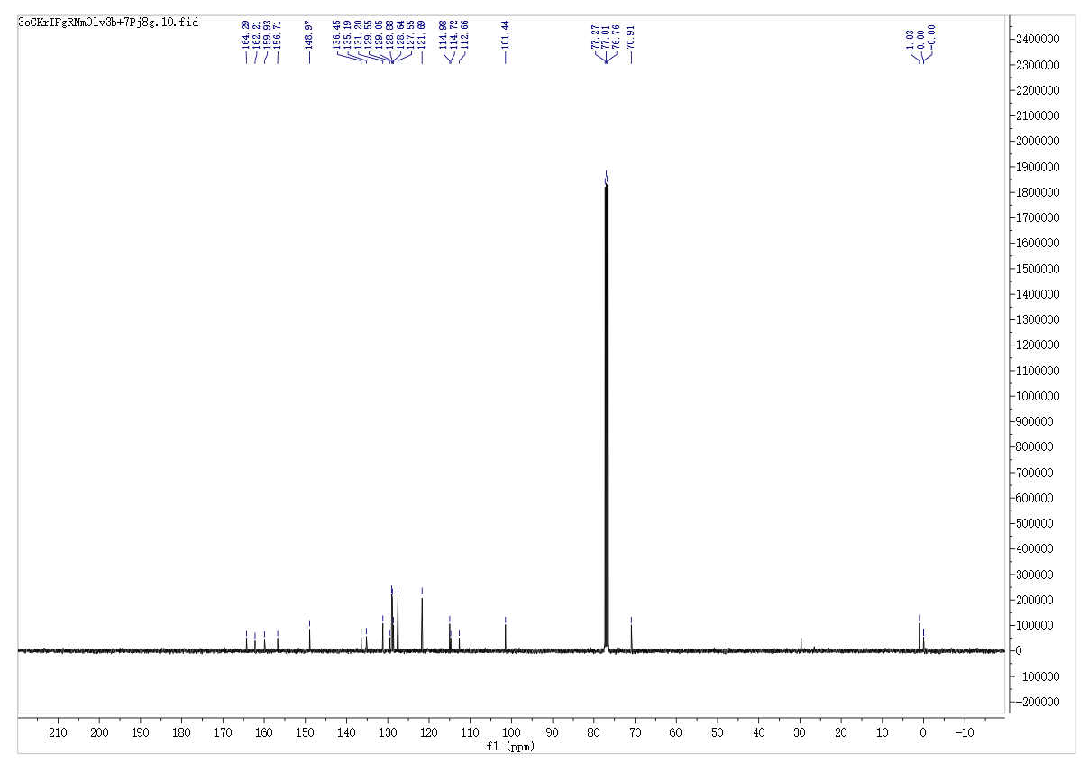
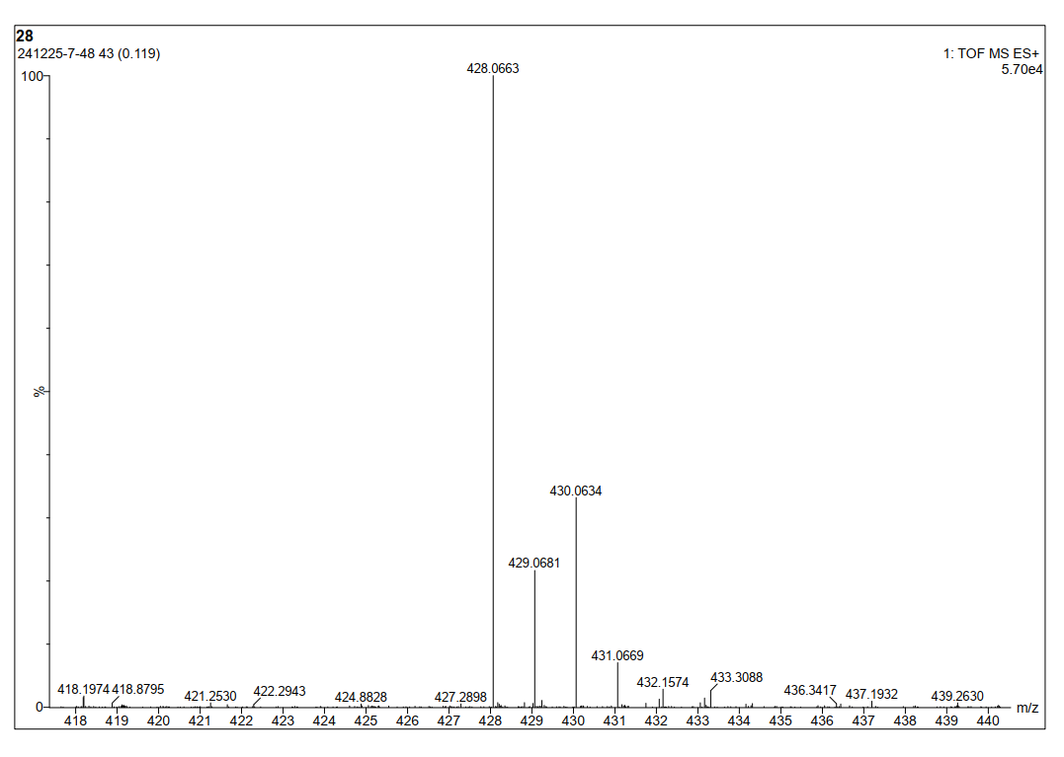
7-(Benzyloxy)-3-(pyrrolidine-1-carbonyl)-2H-chromen-2-one (8j)
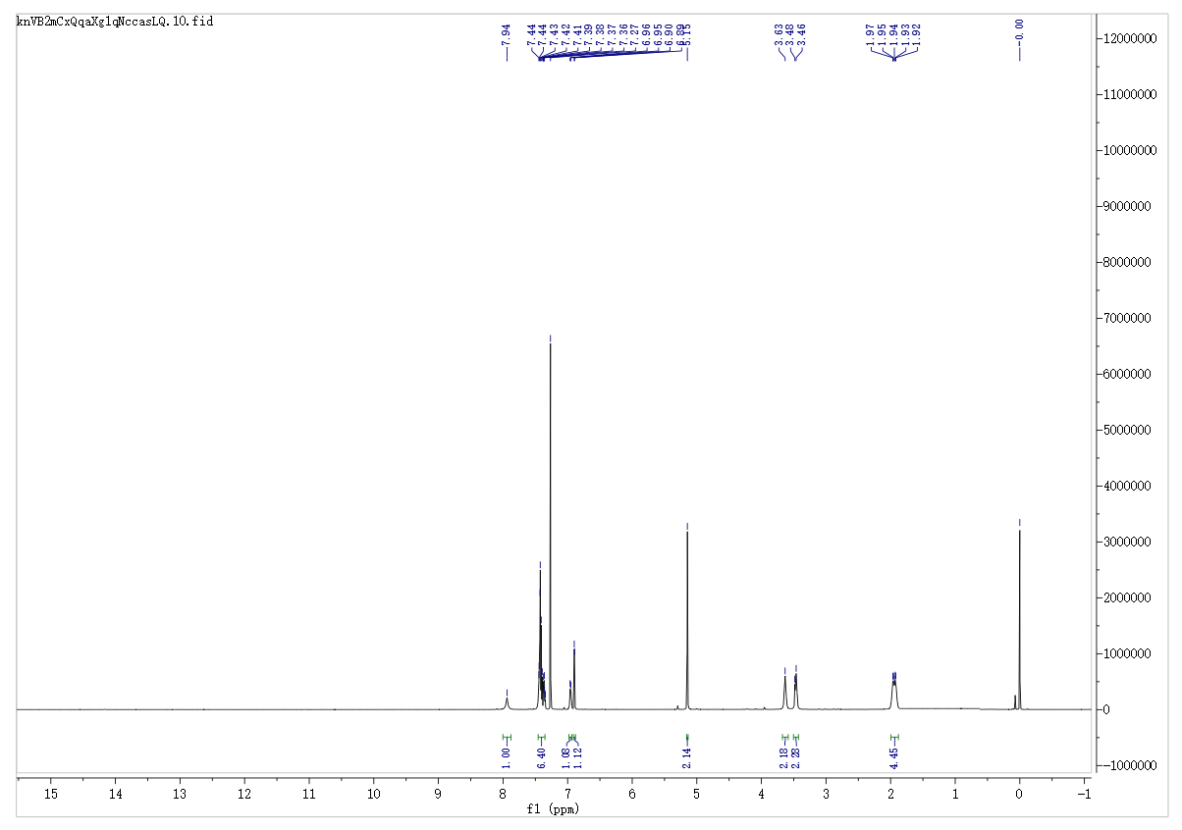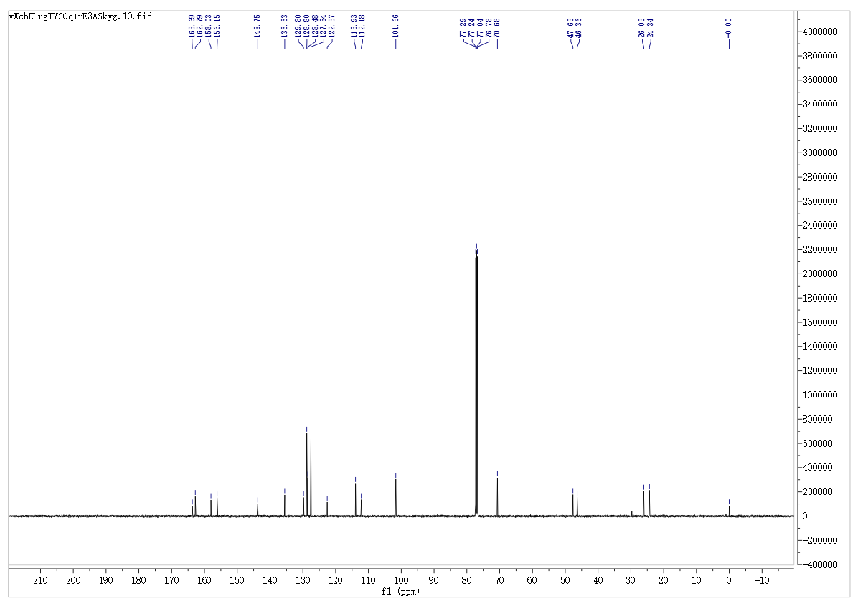
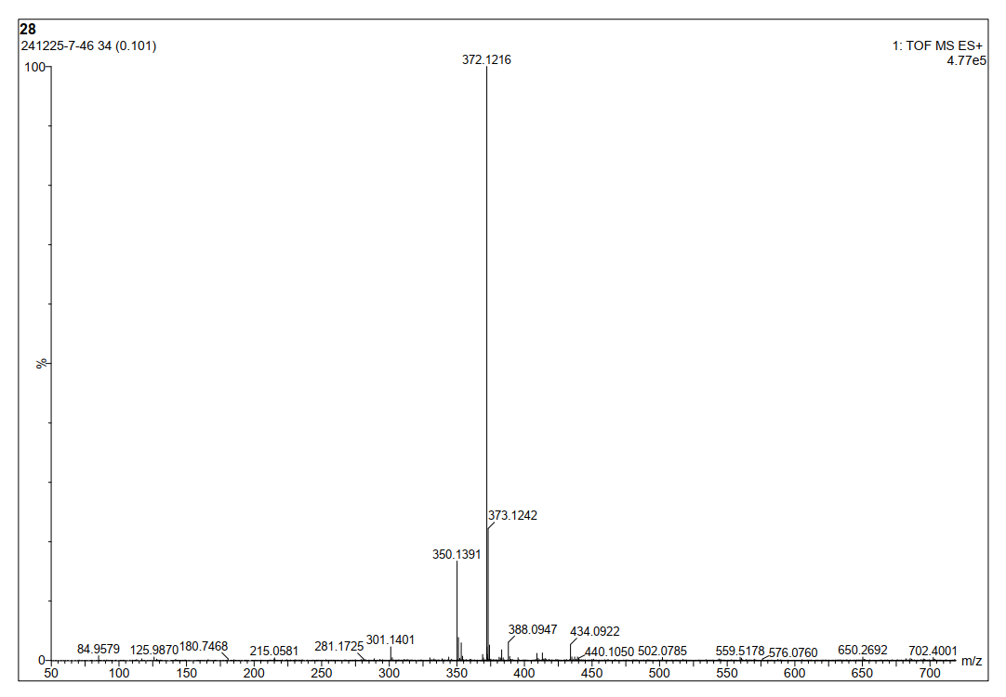
7-(Benzyloxy)-3-(piperidine-1-carbonyl)-2H-chromen-2-one (8k)
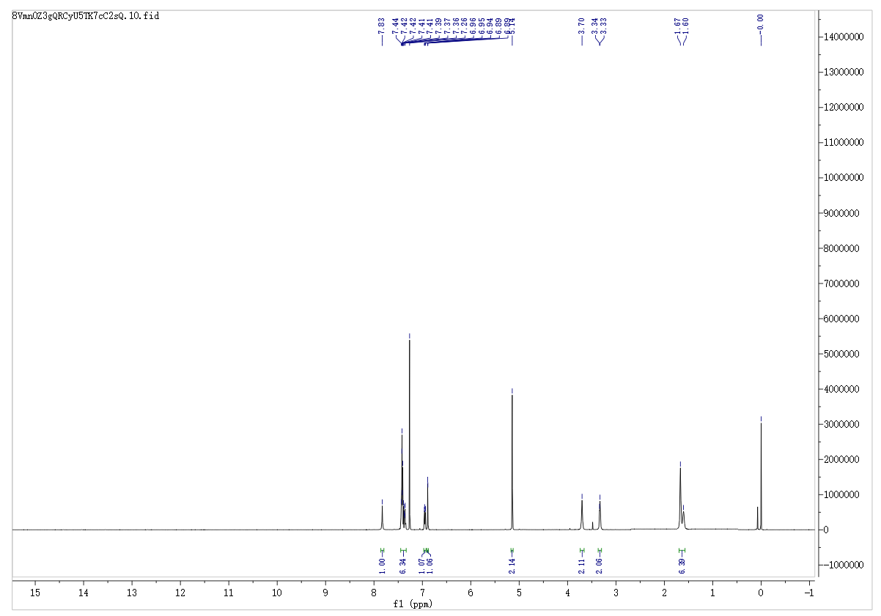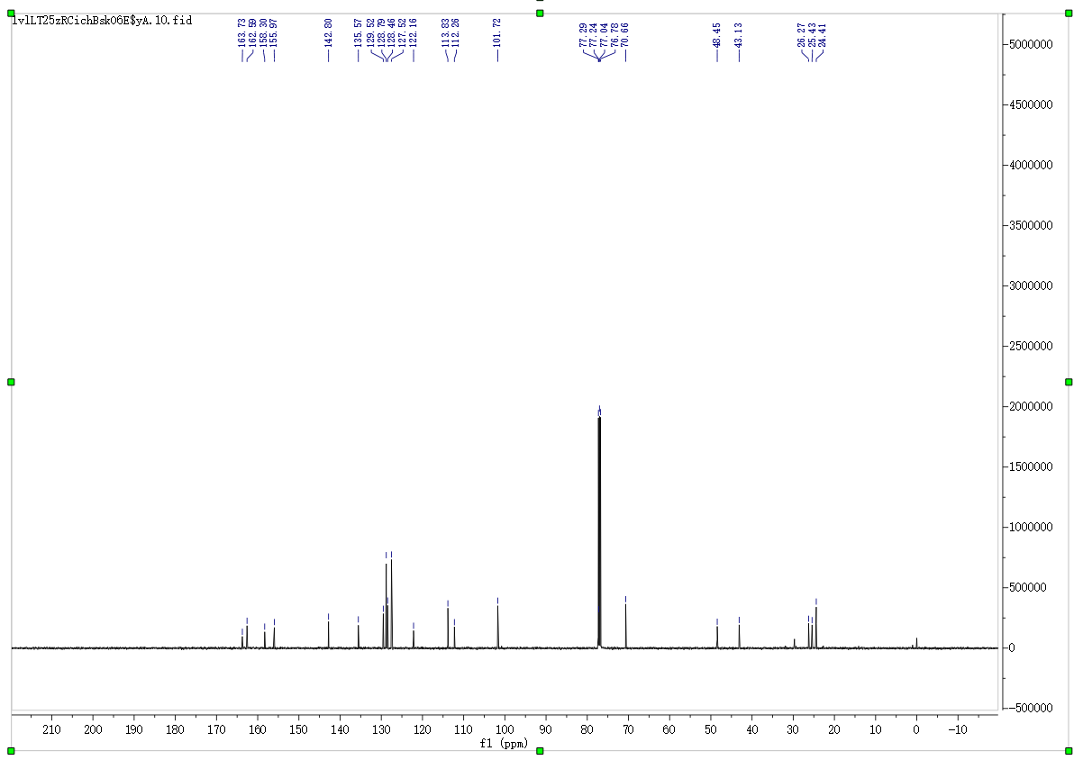
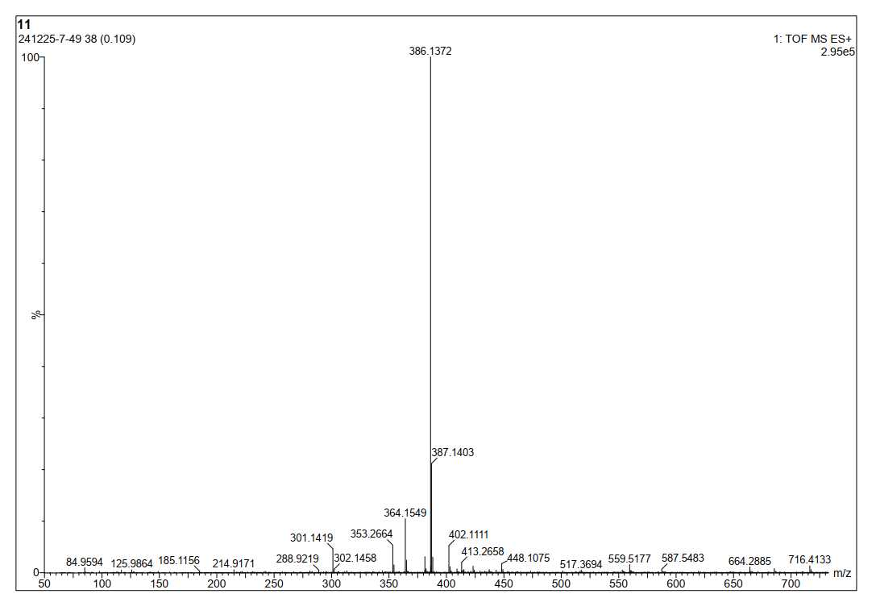
7-(Benzyloxy)-3-(morpholine-4-carbonyl)-2H-chromen-2-one (8l)
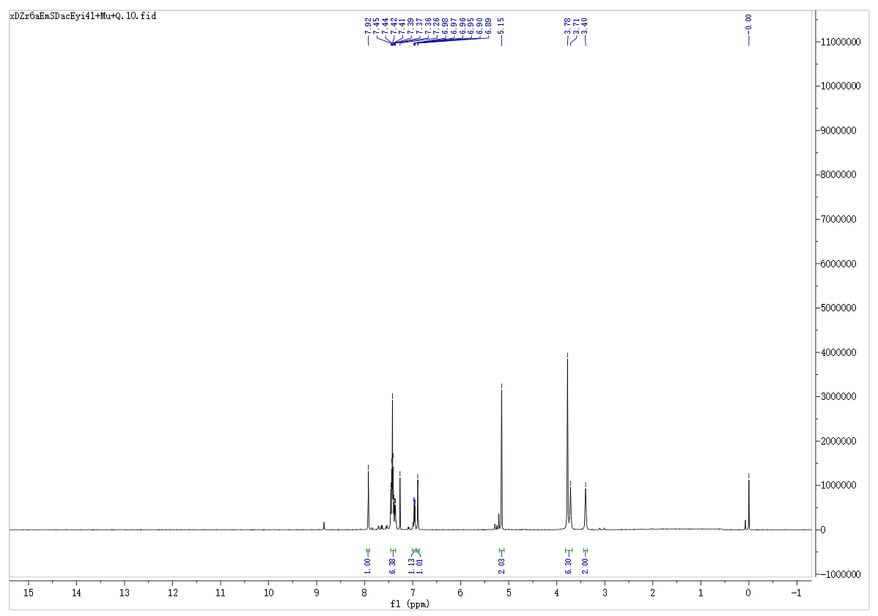
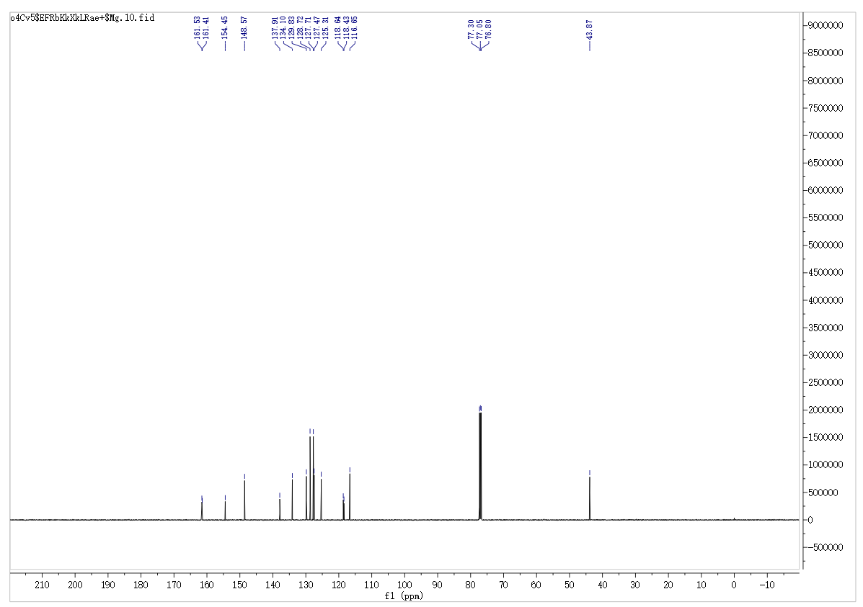
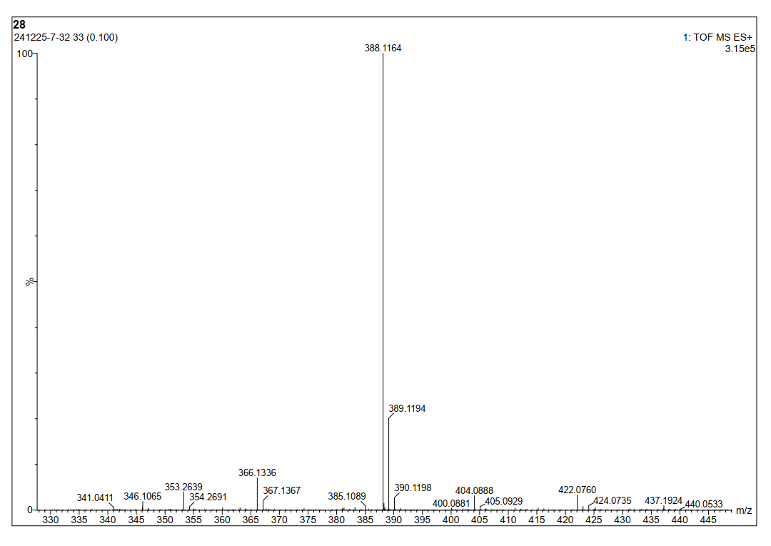
7-(Benzyloxy)-3-(4-methylpiperazine-1-carbonyl)-2H-chromen-2-one (8m)
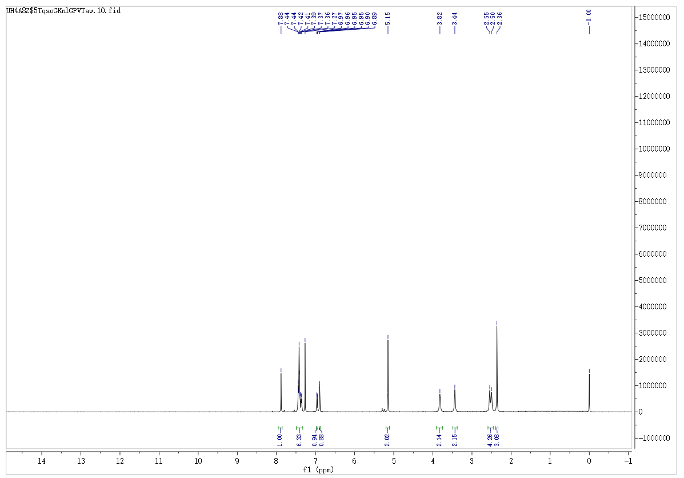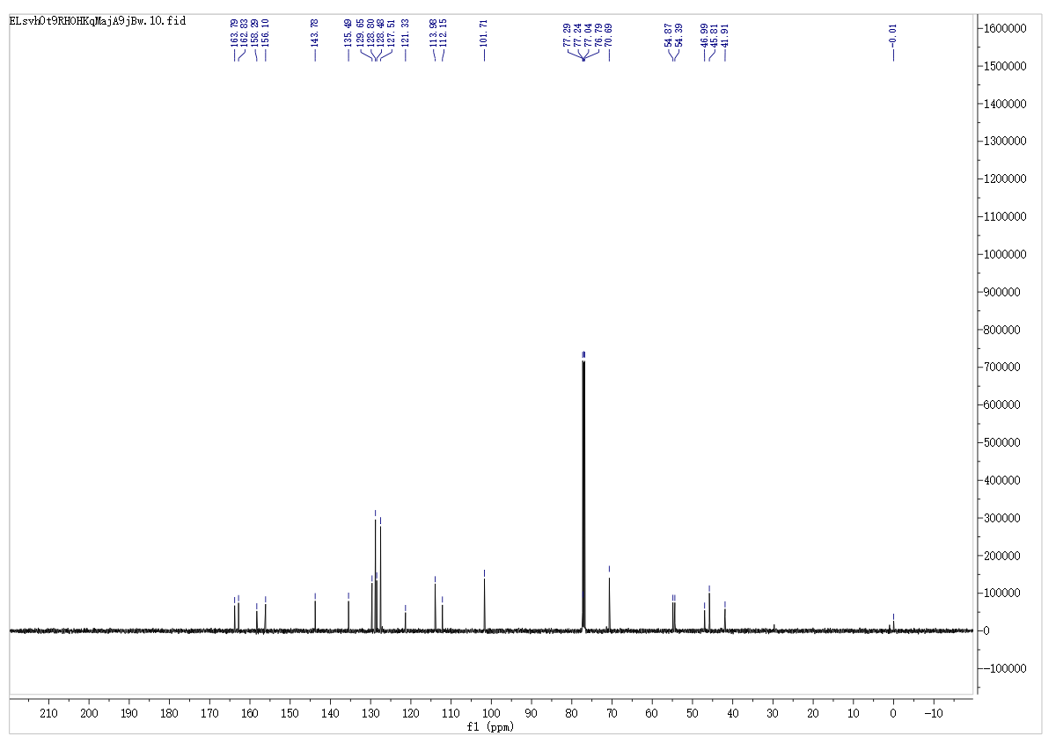
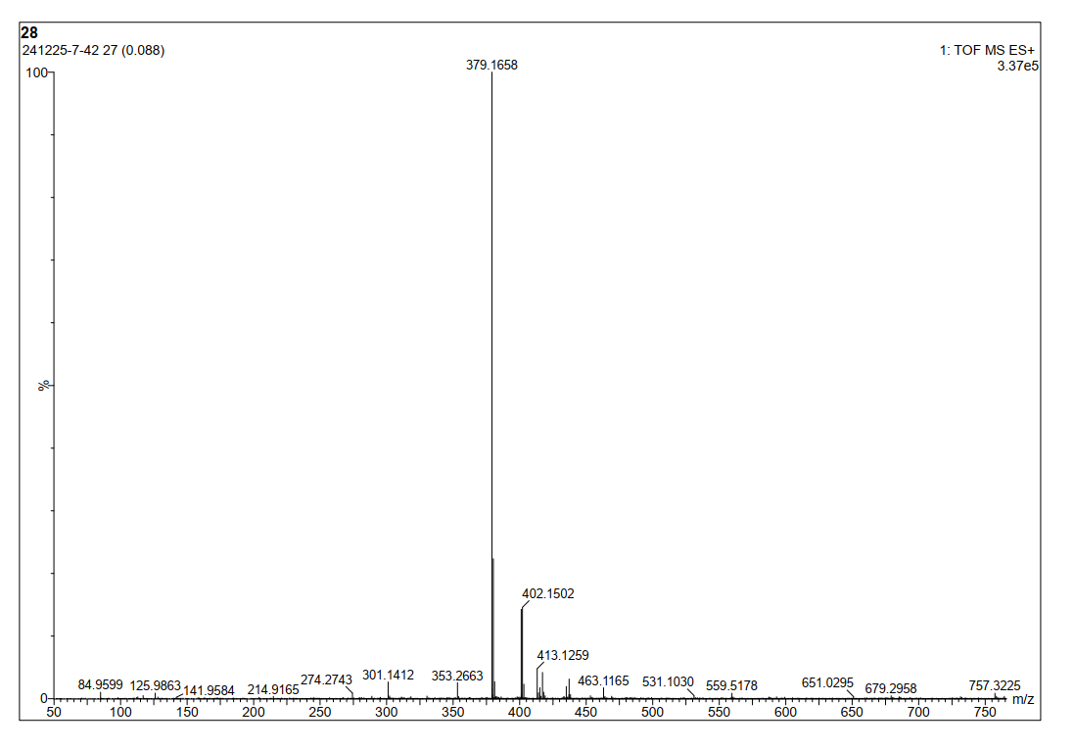
7-(Benzyloxy)-N-cyclopentyl-2-oxo-2H-chromene-3-carboxamide (8n)
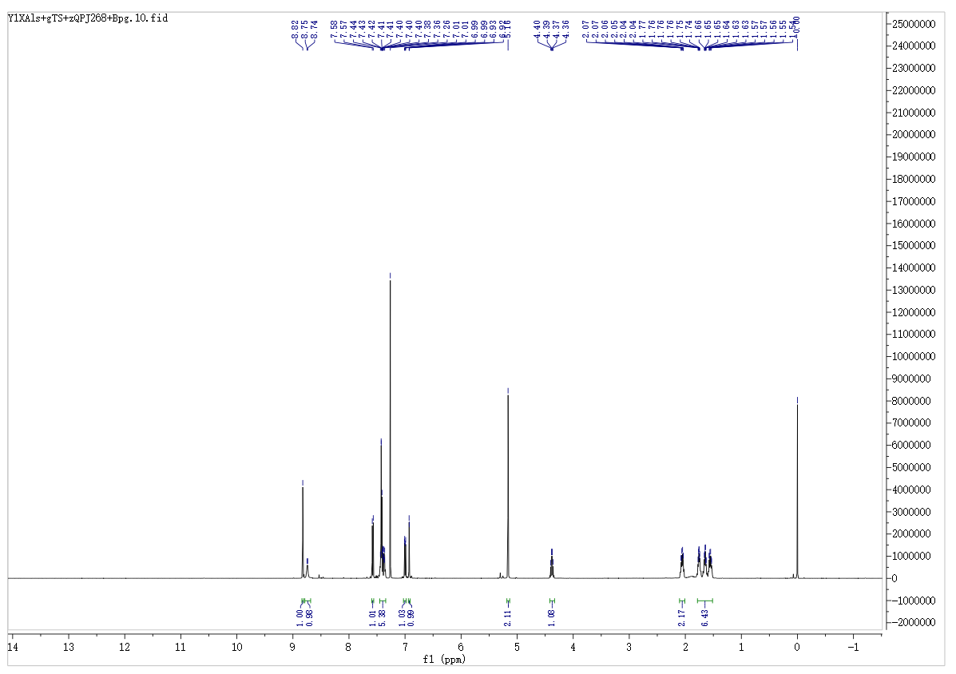
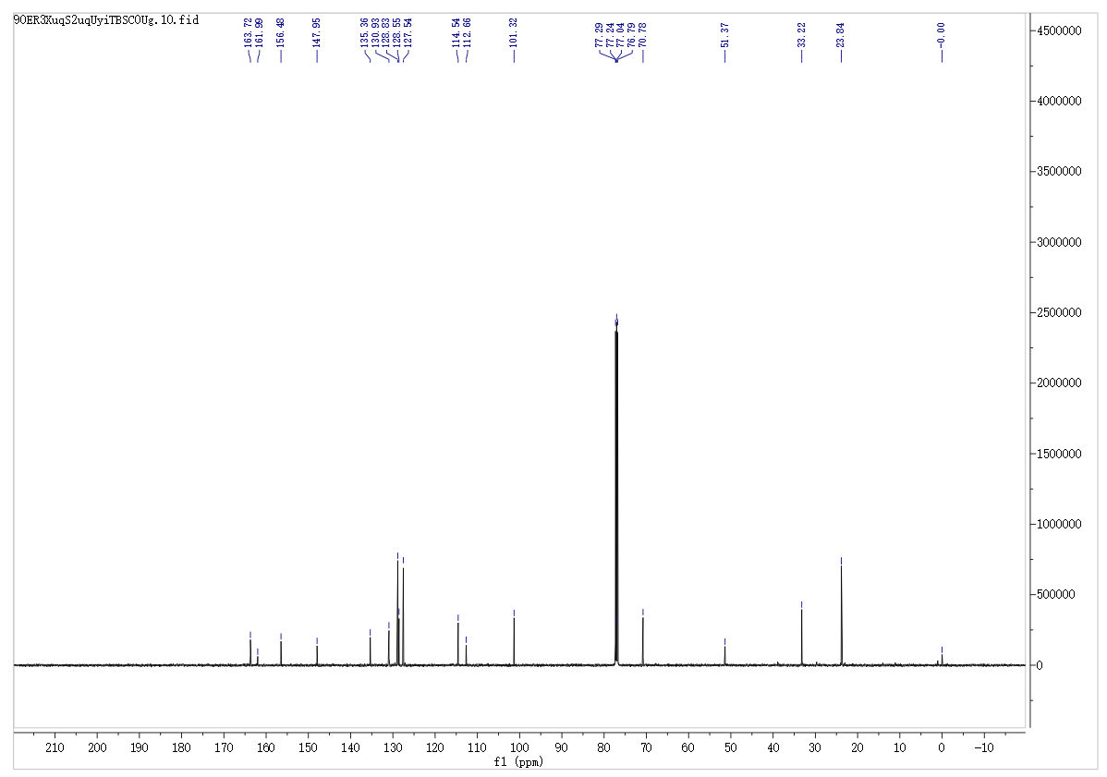
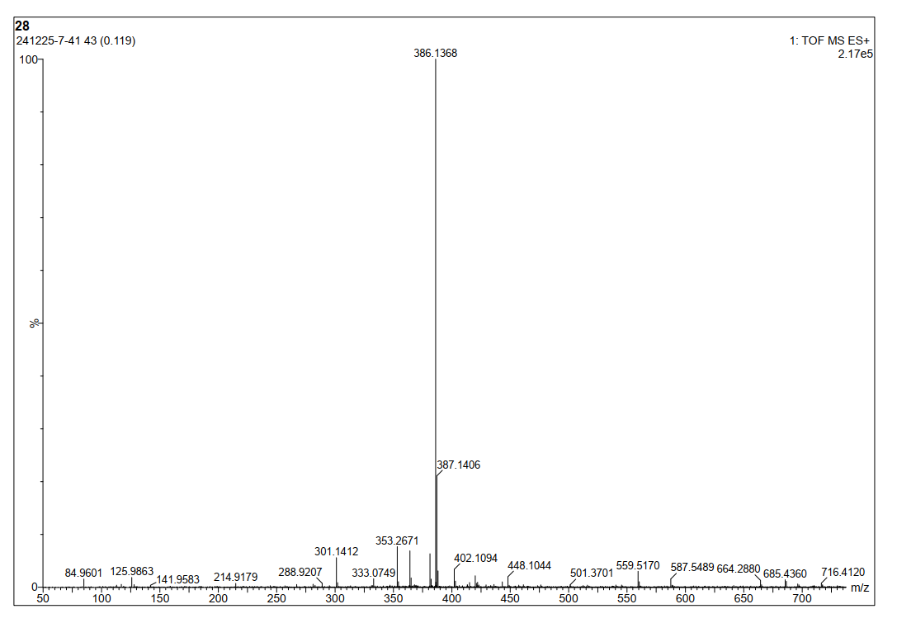
7-(Benzyloxy)-N-cyclohexyl-2-oxo-2H-chromene-3-carboxamide (8o)
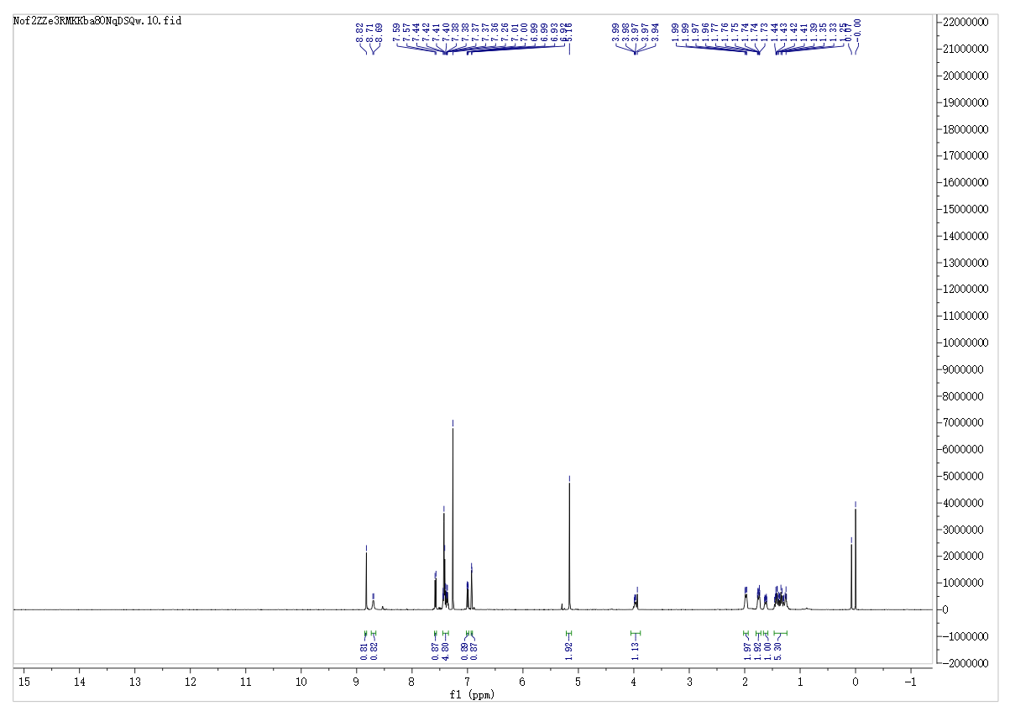
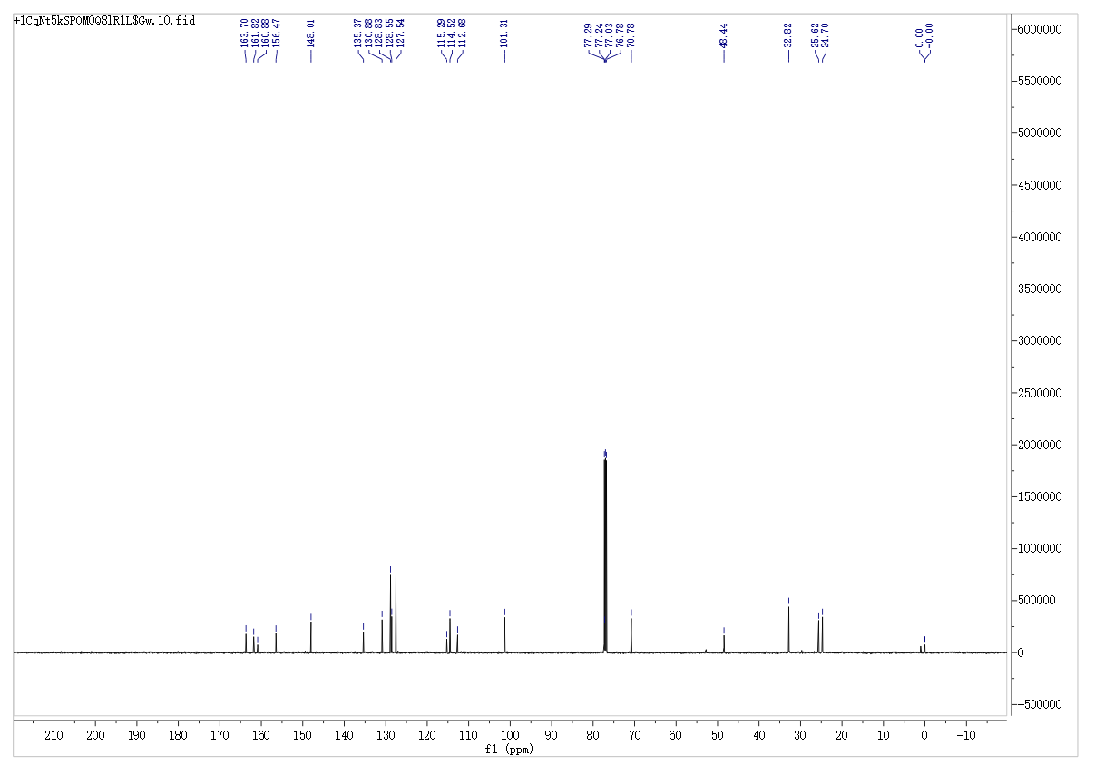
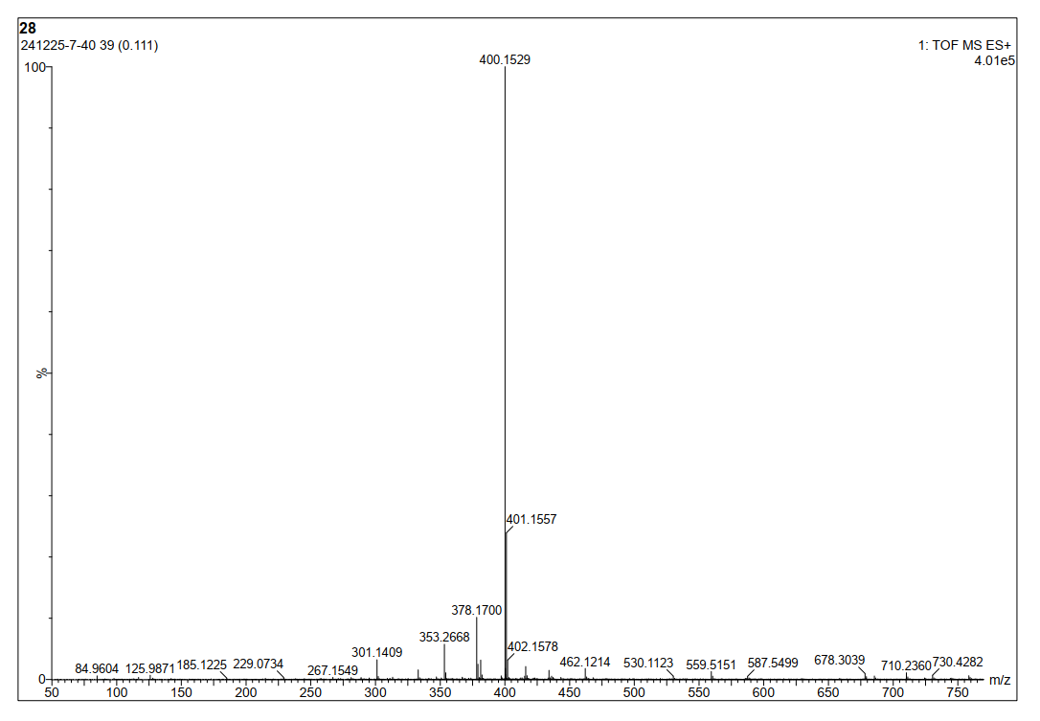
7-(Benzyloxy)-2-oxo-N-(2-(piperidin-1-yl)ethyl)-2H-chromene-3-carboxamide (8p)
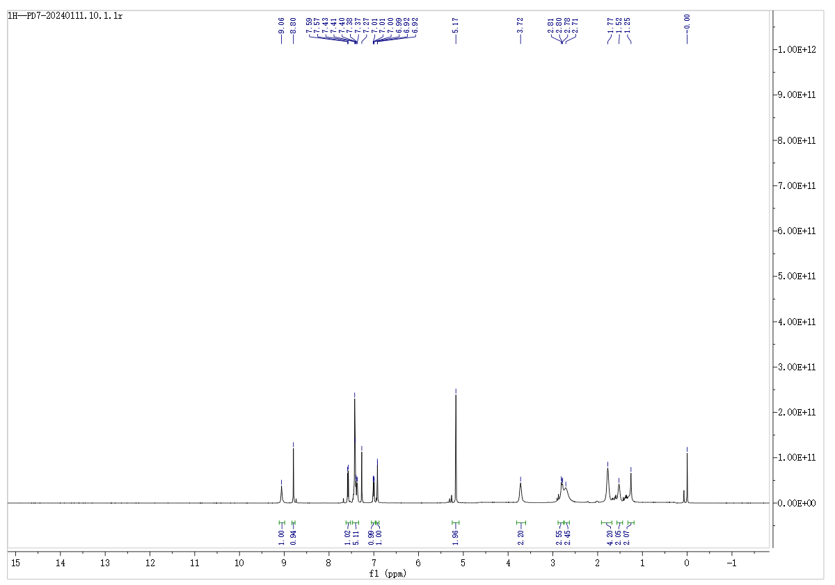
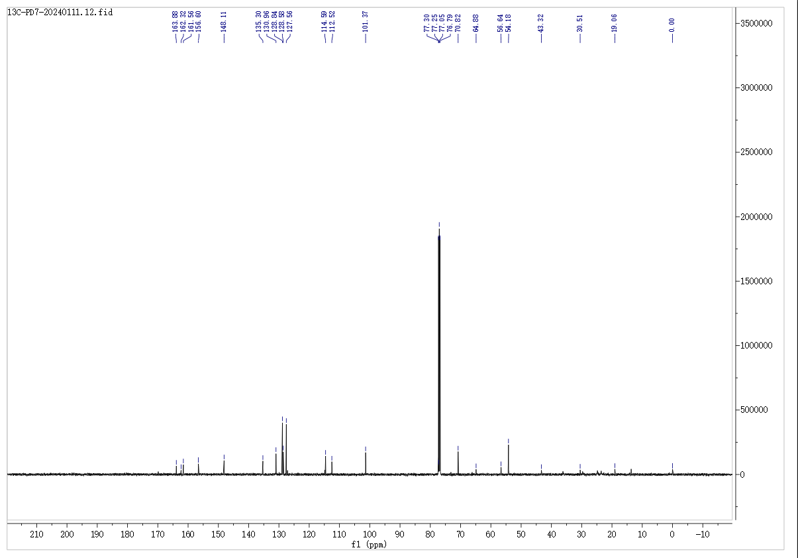
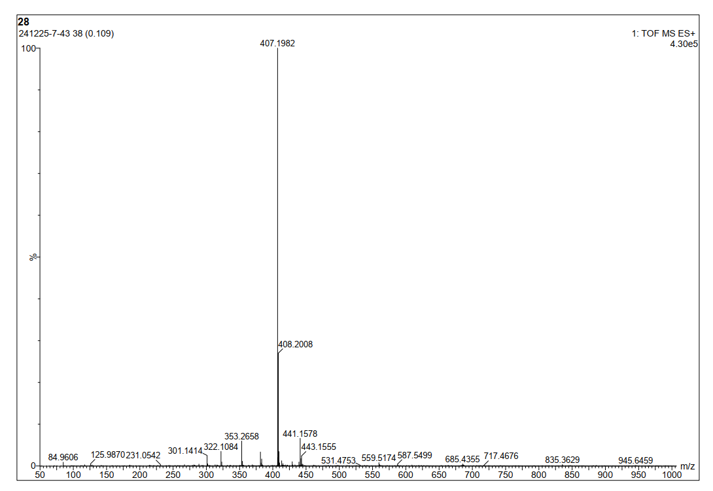
7-(Benzyloxy)-3-(piperazine-1-carbonyl)-2H-chromen-2-one (10)
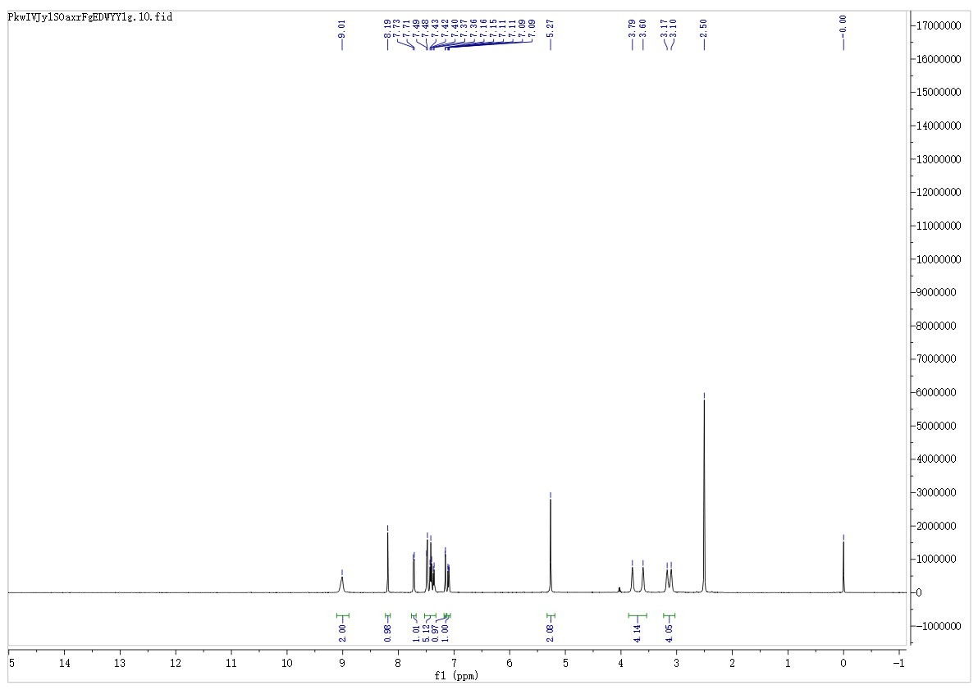
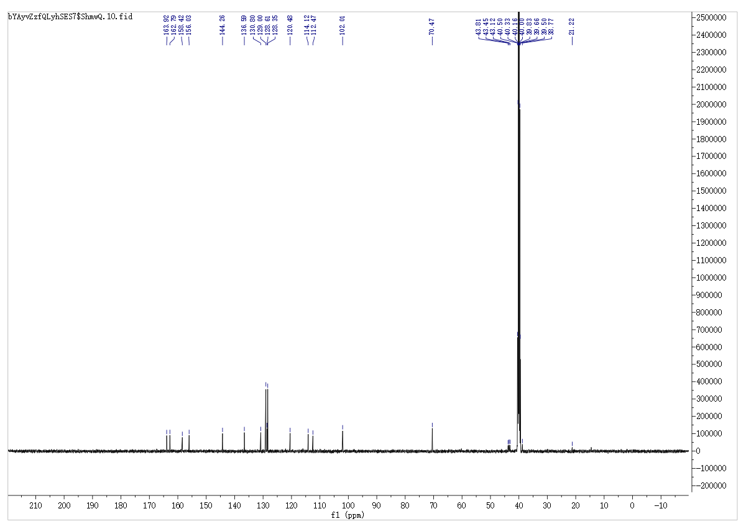
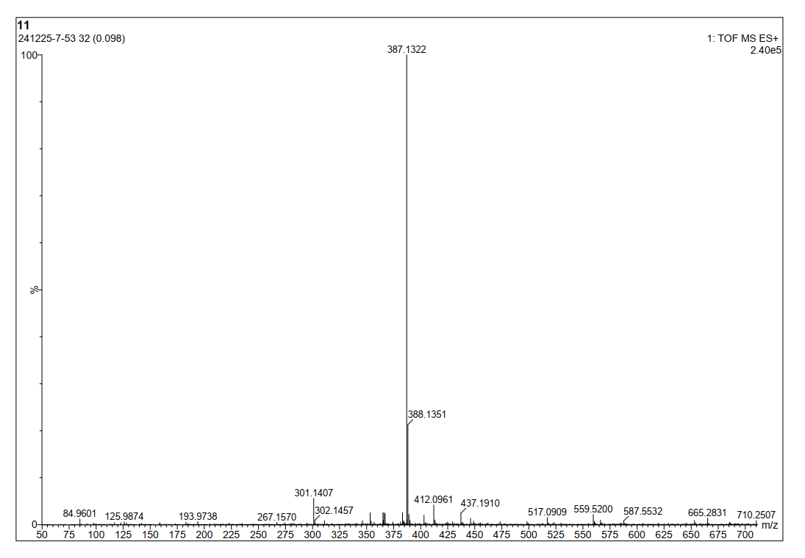
7-(Benzyloxy)-3-(4-benzylpiperazine-1-carbonyl)-2H-chromen-2-one (11)
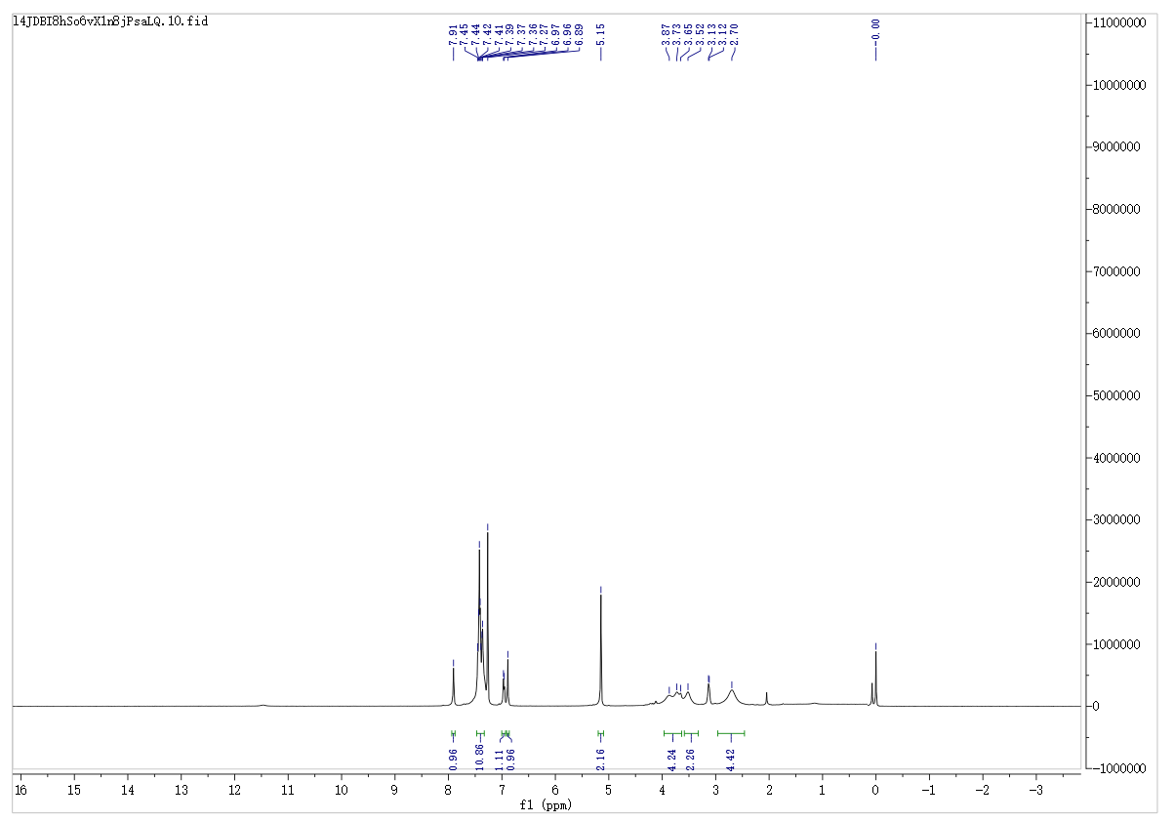
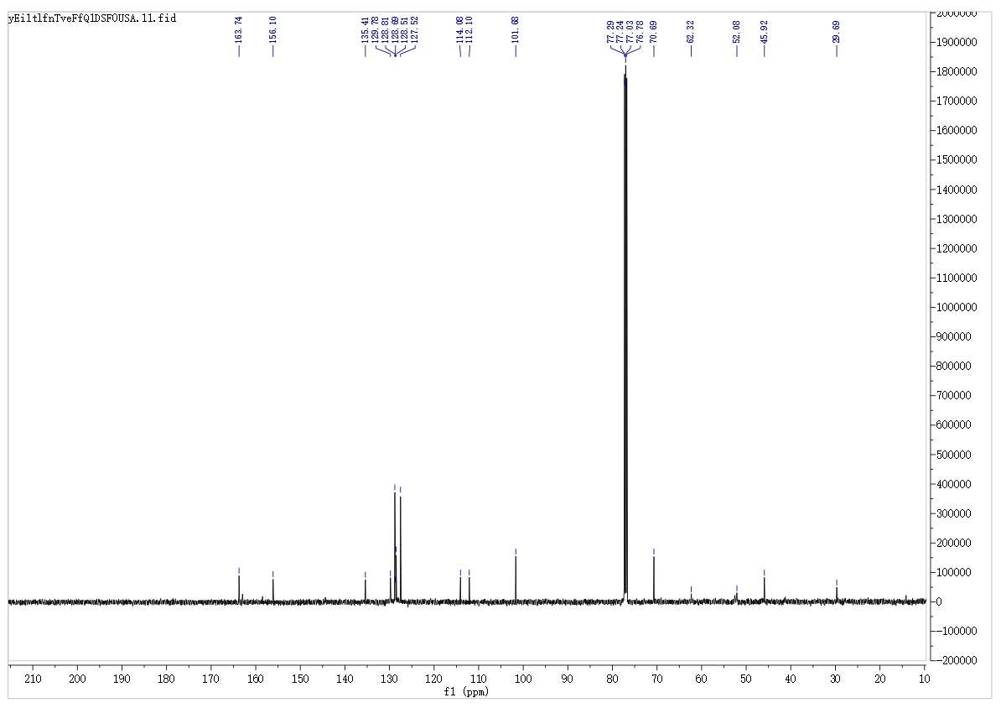
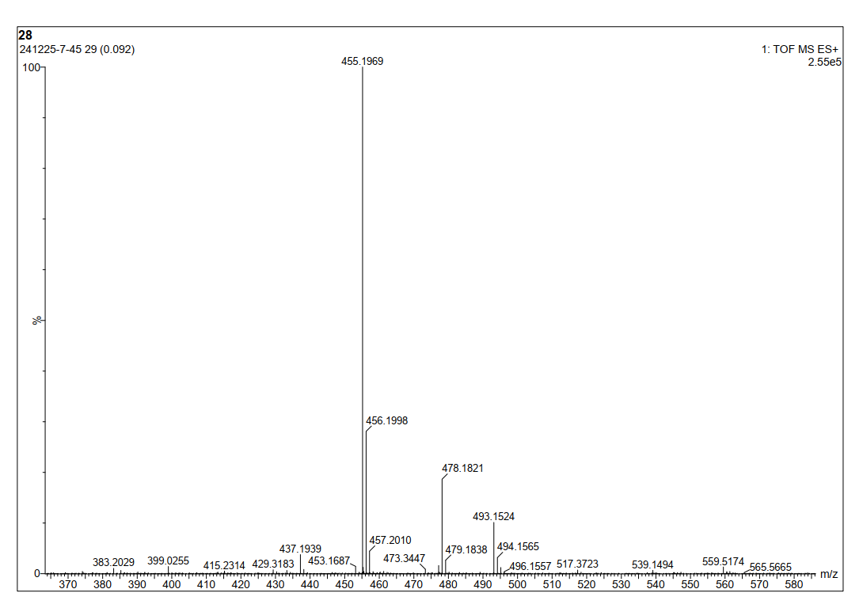
7-(Benzyloxy)-2-oxo-N-(2-(piperazin-1-yl)ethyl)-2H-chromene-3-carboxamide (13)
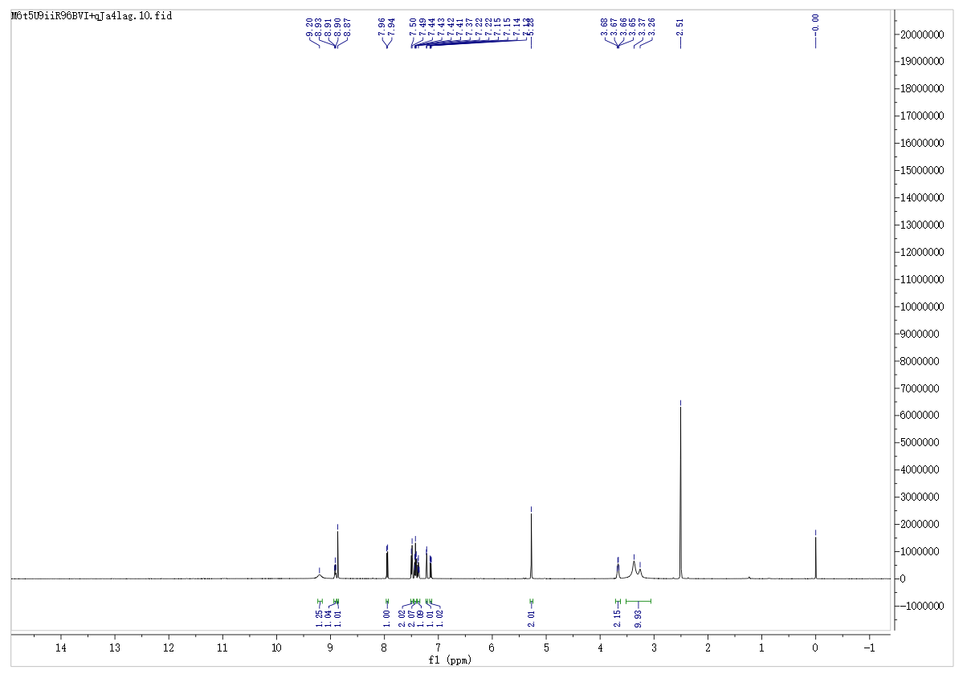
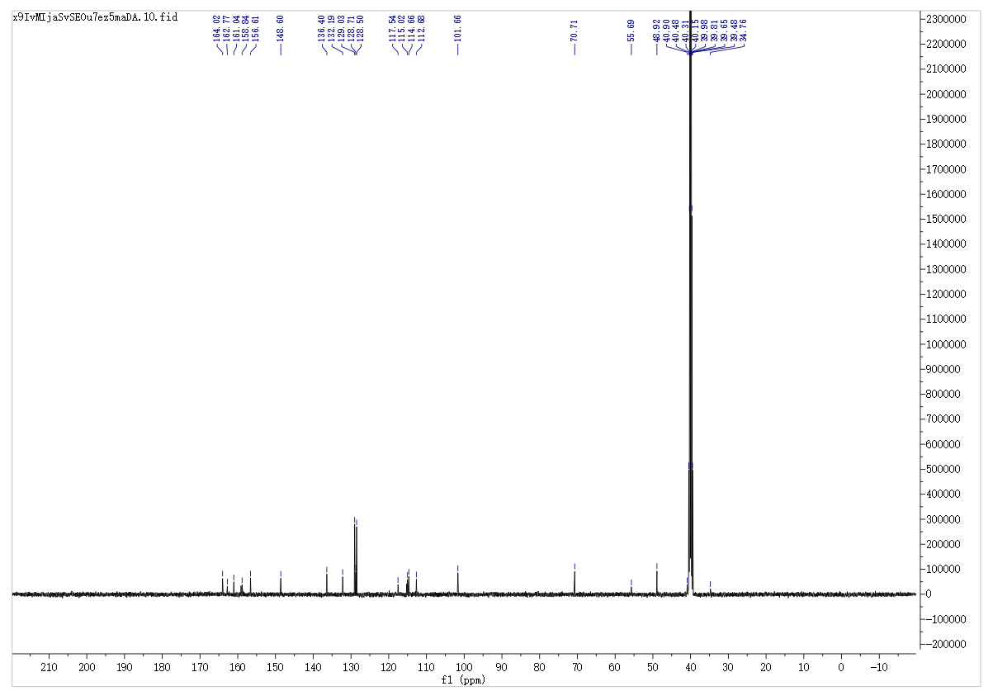
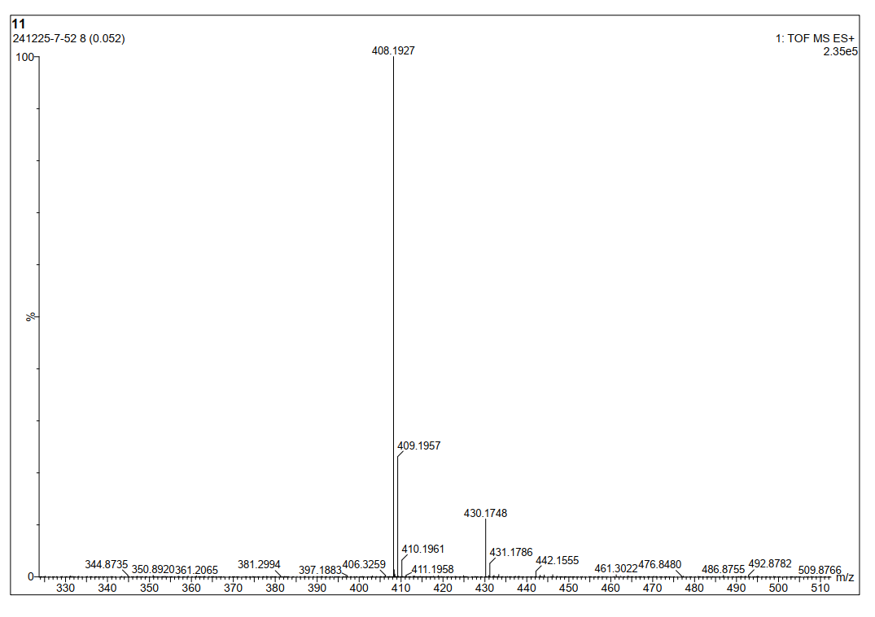
7-(Benzyloxy)-N-(2-(4-benzylpiperazin-1-yl)ethyl)-2-oxo-2H-chromene-3-carboxamide (14)
