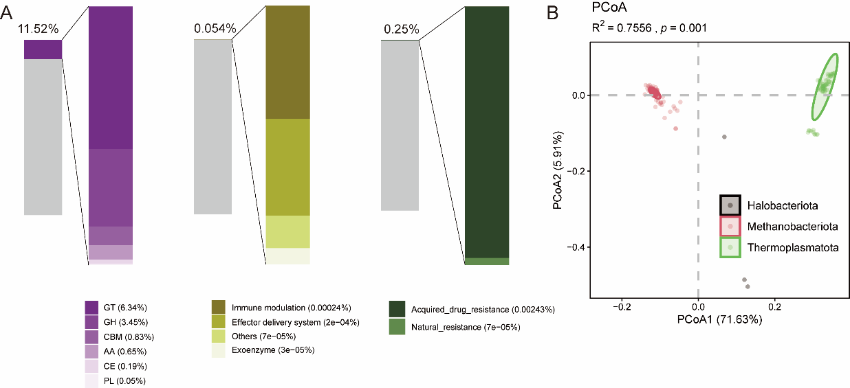
Figure S1. Functional characterization of gut archaea. (A) Protein annotation rates for archaeal genomes using various functional databases. The left and right bar charts represent the proportions of unannotated (gray) and module-assigned proteins, respectively. (B) PCoA based on Bray-Curtis dissimilarity for archaeal phyla.

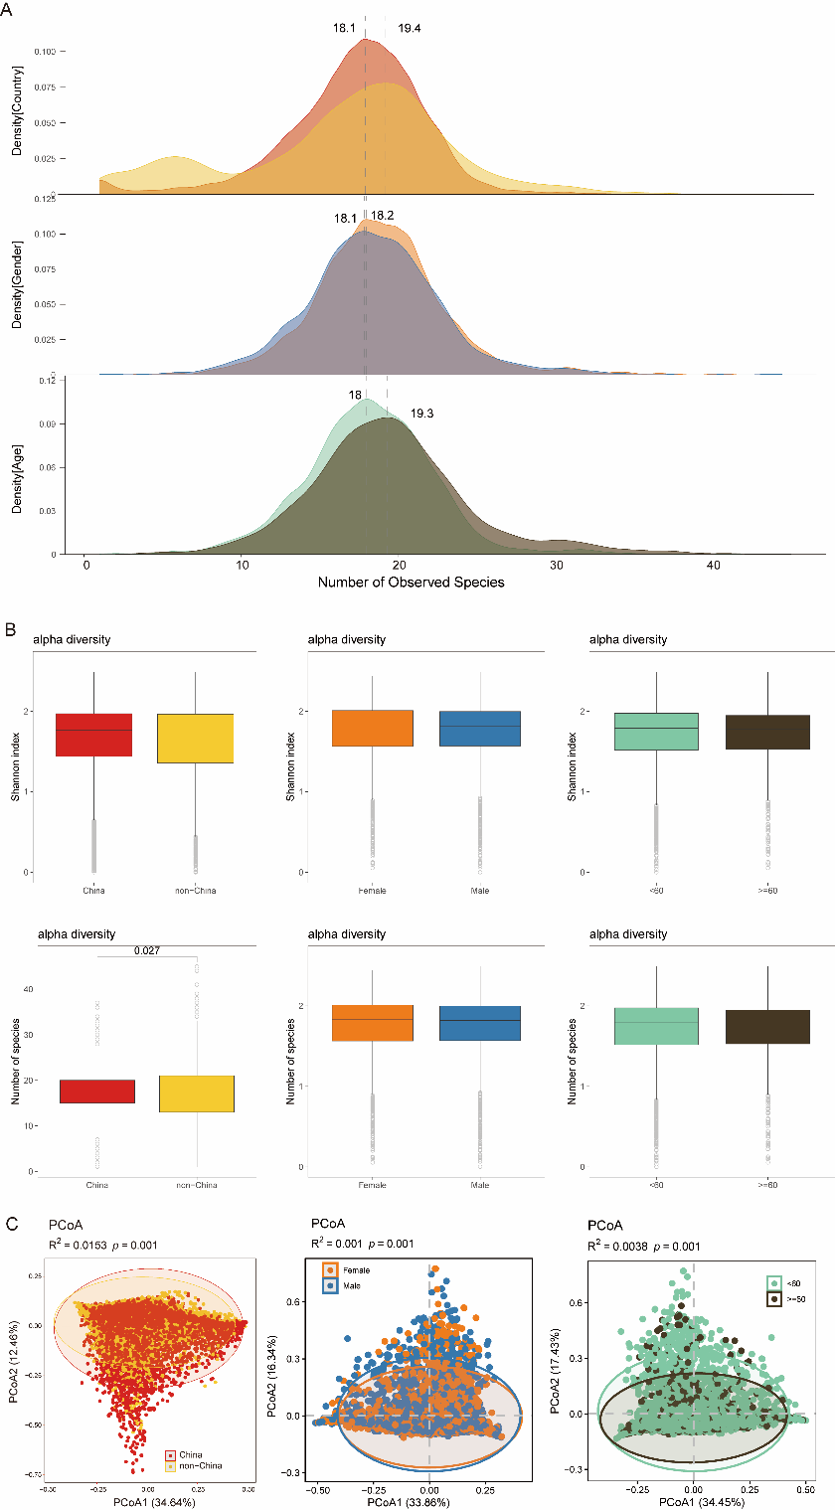
Figure S2. Influence of geographic location, host sex, and age on gut archaeal communities. (A) Frequency distribution of archaeal species richness by geography, sex, and age. (B) Archaeal alpha-diversity comparisons across geography, sex, and age cohorts. (C) PCoA based on Bray-Curtis dissimilarity for geography, sex, and age. PERMANOVA (adonis) was applied to calculate effect sizes (R²) and significance.

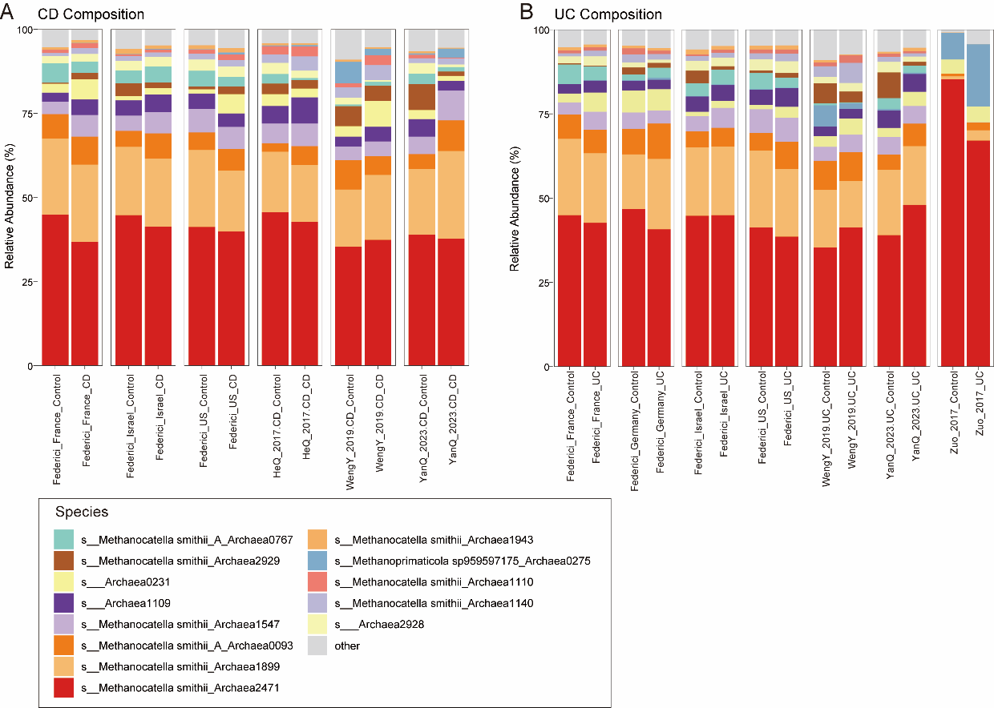
Figure S3. Species-level composition of gut archaea across IBD cohorts. (A–B) Taxonomic profiles of gut archaeal species comparing patients and healthy controls within the CD (A) and UC (B) cohorts.

