Supplementary Materials
Agreement and device-specific calibration of a single-frequency and a multi-frequency segmental bioelectrical impedance analyzer against dual-energy X-ray absorptiometry for appendicular skeletal muscle mass: a two-center method-comparison study with external validation

Contents
Fig. S1. Flow diagram of participant inclusion in the analytical sample.
Fig. S2. Residual plots in the external validation cohort before and after device-specific calibration.
Table S1. Passing–Bablok regression as a sensitivity analysis for continuous-value agreement.
Table S2. Sensitivity analyses for the calibration model.
Table S3. Low-muscle-mass classification under EWGSOP2 ASM/height² cutoffs in the ≥50-y subgroup.
Table S4. Low-muscle-mass classification under EWGSOP2 absolute ASM cutoffs in the ≥50-y subgroup.
Table S5. Positive and negative predictive values for the AWGS 2025 low-muscle-mass classification under ASM/height² and ASM/BMI normalization
Table S6. Subgroup-specific bias before and after calibration, with subgroup × device interaction tests.
Table S7. Low-muscle-mass classification under AWGS 2025 ASM/BMI cutoffs

Fig. S1. Flow diagram of participant inclusion in the analytical sample
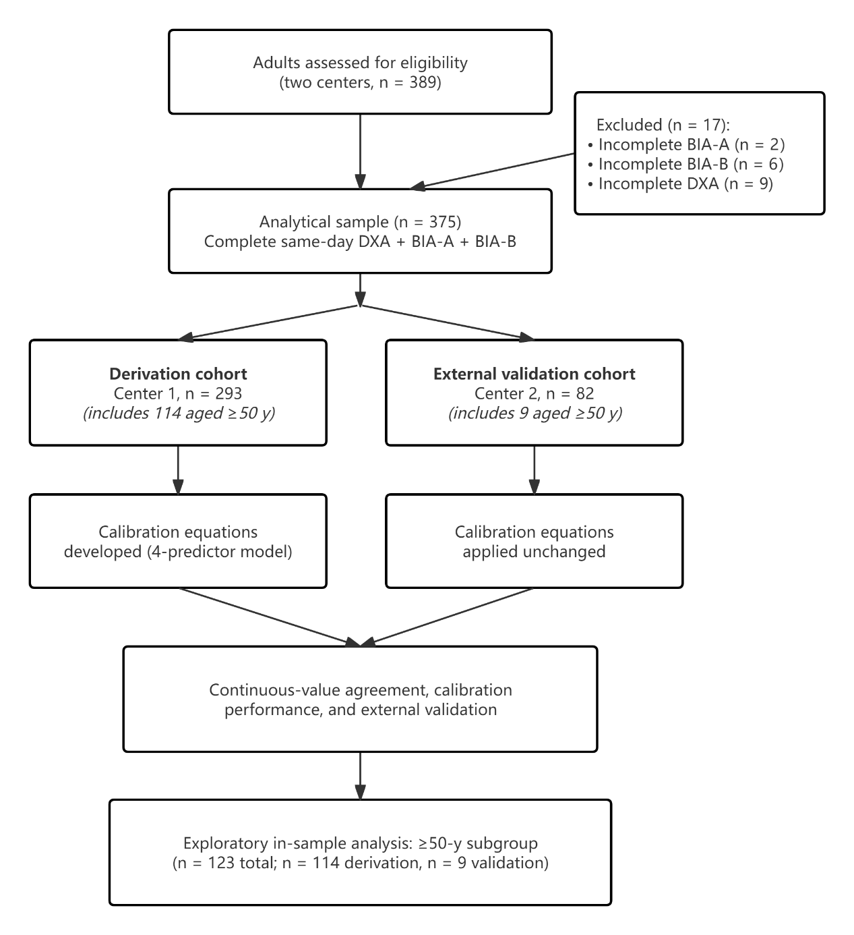
Fig. S1. Flow diagram of participant inclusion. Of 389 adults assessed for eligibility, 17 were excluded for incomplete same-day assessments (incomplete BIA-A in 2, BIA-B in 6, DXA in 9), leaving 375 participants with complete same-day DXA, BIA-A, and BIA-B measurements (293 derivation, 82 external validation).

Fig. S2. Residual plots in the external validation cohort before and after device-specific calibration.
Fig. S2. Residual plots in the external validation cohort (n = 82) before and after device-specific calibration. (A) BIA-A uncalibrated. (B) BIA-A calibrated. (C) BIA-B uncalibrated. (D) BIA-B calibrated. The red line shows the LOWESS smoother; dotted grey lines show mean ± 1.96 × SD of residuals. Calibration equations were fitted on the derivation cohort (n = 293) and applied unchanged to the external validation cohort.

Table S1. Passing–Bablok regression as a sensitivity analysis for continuous-value agreement (n = 375)
Statistic | BIA-A (95% CI) | BIA-B (95% CI)
Intercept | 0.20 (−0.15 to 1.01) | −1.57 (−2.59 to −1.16)
Slope | 0.914 (0.874 to 0.932) | 1.064 (1.042 to 1.117)
Passing–Bablok regression with bootstrap 95% CIs (2,000 replicates). Abbreviations: BIA, bioelectrical impedance analysis.

Table S2. Sensitivity analyses for the calibration model
Panel A. Incremental contribution of mid-calf circumference
Device | Model | Adjusted R² | Δ Adjusted R² | Nested-F P
BIA-A | 4-predictor (primary) | 0.952 | — | —
 | 5-predictor (+ mid-calf) | 0.952 | <0.001 | ≥0.10
BIA-B | 4-predictor (primary) | 0.970 | — | —
 | 5-predictor (+ mid-calf) | 0.970 | <0.001 | ≥0.10
Mid-calf circumference did not improve adjusted R² for either device. The 4-predictor model was retained as primary. Abbreviations: BIA, bioelectrical impedance analysis.

Panel B. Calibration coefficients across alternative model specifications
Device | Predictor | Primary OLS (n = 293) | OLS excluding |stud. res.| > 3 | OLS excluding any influence-flagged | Huber M-estimator
BIA-A | Intercept | 1.227 | 0.880 | 0.672 | 0.960
 | BIA-A-derived ASM, kg | 0.741 | 0.742 | 0.770 | 0.754
 | Age, years | −0.032 | −0.029 | −0.030 | −0.030
 | Female sex | −0.619 | −0.591 | −0.429 | −0.565
 | BMI, kg/m² | 0.180 | 0.189 | 0.171 | 0.174
BIA-B | Intercept | −2.032 | −2.059 | −2.419 | −2.316
 | BIA-B-derived ASM, kg | 0.785 | 0.783 | 0.787 | 0.789
 | Age, years | −0.020 | −0.018 | −0.017 | −0.018
 | Female sex | −1.438 | −1.453 | −1.415 | −1.415
 | BMI, kg/m² | 0.312 | 0.312 | 0.321 | 0.316
Influence-flagged: observations identified by externally studentized residuals (|>3|), Cook's distance (>4/n), or DFFITS (>2√[p/n]). Abbreviations as in Tables 1–2 of the main manuscript. Abbreviations: BMI, body mass index; BIA, bioelectrical impedance analysis; OLS, ordinary least squares; ASM, appendicular skeletal muscle mass.

Table S3. Low-muscle-mass classification under EWGSOP2 ASM/height² cutoffs in the ≥50-y subgroup
Method | Low n (%) | TP | FP | FN | TN | Sensitivity (95% CI) | Specificity (95% CI) | κ (95% CI)
DXA (reference) | 17 (13.8) | — | — | — | — | — | — | —
Uncalibrated BIA-A | 0 (0.0) | 0 | 0 | 17 | 106 | 0.0 (0.0 to 18.4) | 100.0 (96.5 to 100.0) | 0.00 (—)
Calibrated BIA-A | 17 (13.8) | 13 | 4 | 4 | 102 | 76.5 (52.7 to 90.4) | 96.2 (90.7 to 98.5) | 0.73 (0.54 to 0.88)
Uncalibrated BIA-B | 7 (5.7) | 5 | 2 | 12 | 104 | 29.4 (13.3 to 53.1) | 98.1 (93.4 to 99.5) | 0.37 (0.10 to 0.62)
Calibrated BIA-B | 13 (10.6) | 10 | 3 | 7 | 103 | 58.8 (36.0 to 78.4) | 97.2 (92.0 to 99.0) | 0.62 (0.39 to 0.81)
EWGSOP2 cutoffs: < 7.0 kg/m² (men) and < 5.5 kg/m² (women). McNemar's tests for paired correctness change: BIA-A P = 0.049; BIA-B P = 0.29 (exact binomial). Abbreviations: ASM, appendicular skeletal muscle mass; BIA, bioelectrical impedance analysis; DXA, dual-energy X-ray absorptiometry; TP, true positive; FP, false positive; FN, false negative; TN, true negative.

Table S4. Low-muscle-mass classification under EWGSOP2 absolute ASM cutoffs in the ≥50-y subgroup
Method | Low n (%) | TP | FP | FN | TN | Sensitivity (95% CI) | Specificity (95% CI) | κ (95% CI)
DXA (reference) | 32 (26.0) | — | — | — | — | — | — | —
Uncalibrated BIA-A | 10 (8.1) | 10 | 0 | 22 | 91 | 31.2 (17.7 to 48.7) | 100.0 (96.0 to 100.0) | 0.40 (0.20 to 0.59)
Calibrated BIA-A | 27 (22.0) | 21 | 6 | 11 | 85 | 65.6 (47.8 to 79.7) | 93.4 (87.0 to 96.8) | 0.62 (0.45 to 0.78)
Uncalibrated BIA-B | 27 (22.0) | 22 | 5 | 10 | 86 | 68.8 (51.4 to 82.0) | 94.5 (88.5 to 97.4) | 0.67 (0.51 to 0.81)
Calibrated BIA-B | 29 (23.6) | 25 | 4 | 7 | 87 | 78.1 (61.2 to 89.0) | 95.6 (89.9 to 98.1) | 0.76 (0.61 to 0.88)
EWGSOP2 absolute cutoffs: < 20 kg (men) and < 15 kg (women). Abbreviations: ASM, appendicular skeletal muscle mass; BIA, bioelectrical impedance analysis; DXA, dual-energy X-ray absorptiometry; TP, true positive; FP, false positive; FN, false negative; TN, true negative.

Table S5. Positive and negative predictive values for the AWGS 2025 low-muscle-mass classification under ASM/height² and ASM/BMI normalization
Panel A. ASM/height²
Method | PPV, % (95% CI) | NPV, % (95% CI)
Uncalibrated BIA-A | 100.0 (61.0 to 100.0) | 87.2 (79.7 to 92.2)
Calibrated BIA-A | 75.0 (53.1 to 88.8) | 94.2 (87.9 to 97.3)
Uncalibrated BIA-B | 60.9 (40.8 to 77.8) | 93.0 (86.3 to 96.6)
Calibrated BIA-B | 82.4 (59.0 to 93.8) | 93.4 (87.0 to 96.8)

Panel B. ASM/BMI
Method | PPV, % (95% CI) | NPV, % (95% CI)
Uncalibrated BIA-A | 30.4 (15.6 to 50.9) | 94.0 (87.5 to 97.2)
Calibrated BIA-A | 57.1 (25.0 to 84.2) | 92.2 (85.9 to 95.9)
Uncalibrated BIA-B | 22.8 (13.8 to 35.2) | 100.0 (94.5 to 100.0)
Calibrated BIA-B | 57.1 (32.6 to 78.6) | 95.4 (89.7 to 98.0)

Predictive values are conditional on the observed DXA-positive proportion in this subgroup (17.1% under ASM/height²; 10.6% under ASM/BMI). Uncalibrated BIA classified by AWGS 2025 BIA-specific cutoffs; calibrated BIA by AWGS 2025 DXA cutoffs. Abbreviations: PPV, positive predictive value; NPV, negative predictive value; ASM, appendicular skeletal muscle mass; BIA, bioelectrical impedance analysis; BMI, body mass index; AWGS, Asian Working Group for Sarcopenia.
Table S6. Subgroup-specific bias before and after calibration, with subgroup × device interaction tests
Panel A. Bias by chronic-disease status (n = 373)
Device | Calibration | No NCD (n = 289)ª | Has NCD (n = 84)ª | Difference (95% CI), kg | P
BIA-A | Uncalibrated | 1.44 ± 1.33 | 2.14 ± 1.59 | 0.69 (0.32 to 1.07) | <0.001
 | Calibrated | 0.12 ± 1.17 | 0.12 ± 1.14 | 0.00 (−0.28 to 0.28) | 0.98
BIA-B | Uncalibrated | 0.39 ± 1.35 | 0.19 ± 1.21 | −0.20 (−0.51 to 0.10) | 0.19
 | Calibrated | 0.15 ± 0.96 | 0.13 ± 0.94 | −0.02 (−0.25 to 0.21) | 0.86

Panel B. Bias by BMI category (n = 375)
Device | Calibration | BMI < 24 (n = 170)ª | BMI ≥ 24 (n = 205)ª | Difference (95% CI), kg | P
BIA-A | Uncalibrated | 1.39 ± 1.07 | 1.78 ± 1.63 | 0.39 (0.11 to 0.67) | 0.006
 | Calibrated | 0.21 ± 0.96 | 0.04 ± 1.29 | −0.17 (−0.40 to 0.06) | 0.14
BIA-B | Uncalibrated | 1.09 ± 1.05 | −0.28 ± 1.21 | −1.38 (−1.61 to −1.15) | <0.001
 | Calibrated | 0.20 ± 0.82 | 0.09 ± 1.05 | −0.11 (−0.30 to 0.08) | 0.25

Panel C. Bias by sex (n = 375)
Device | Calibration | Male (n = 188)ª | Female (n = 187)ª | Difference (95% CI), kg | P
BIA-A | Uncalibrated | 2.22 ± 1.47 | 0.98 ± 1.04 | −1.24 (−1.50 to −0.99) | <0.001
 | Calibrated | 0.01 ± 1.24 | 0.23 ± 1.06 | 0.23 (−0.01 to 0.46) | 0.06
BIA-B | Uncalibrated | −0.13 ± 1.38 | 0.82 ± 1.08 | 0.95 (0.70 to 1.20) | <0.001
 | Calibrated | 0.04 ± 1.01 | 0.25 ± 0.89 | 0.21 (0.02 to 0.41) | 0.03

Panel D. Bias by age category (n = 375)
Device | Calibration | Age < 50 (n = 252)ª | Age ≥ 50 (n = 123)ª | Difference (95% CI), kg | P
BIA-A | Uncalibrated | 1.42 ± 1.26 | 1.99 ± 1.63 | 0.57 (0.24 to 0.90) | <0.001
 | Calibrated | 0.13 ± 1.15 | 0.10 ± 1.18 | −0.04 (−0.29 to 0.22) | 0.78
BIA-B | Uncalibrated | 0.40 ± 1.40 | 0.22 ± 1.18 | −0.18 (−0.45 to 0.09) | 0.19
 | Calibrated | 0.20 ± 0.95 | 0.03 ± 0.96 | −0.17 (−0.38 to 0.04) | 0.11

Panel E. Subgroup × device interaction tests on residual bias (n = 375; n = 373 for chronic disease)
Subgroup | State | Interaction coefficient (95% CI), kg | P
Chronic disease | Uncalibrated | −0.90 (−1.27 to −0.52) | <0.001
 | Calibrated | −0.02 (−0.21 to 0.16) | 0.81
BMI ≥ 24 | Uncalibrated | −1.77 (−2.05 to −1.48) | <0.001
 | Calibrated | 0.06 (−0.12 to 0.24) | 0.51
Female sex | Uncalibrated | 2.20 (1.94 to 2.45) | <0.001
 | Calibrated | −0.01 (−0.19 to 0.16) | 0.88
Age ≥ 50 | Uncalibrated | −0.75 (−1.09 to −0.42) | <0.001
 | Calibrated | −0.13 (−0.30 to 0.04) | 0.13
ªmean ± SD. Bias = (uncalibrated or calibrated) ASM − DXA-derived ASM. In Panels A–D, between-subgroup differences (comparison minus reference category) and 95% confidence intervals are from Welch t-tests. In Panel E, the interaction coefficient is the subgroup × device (BIA-B minus BIA-A) term for residual bias, estimated by long-format linear regression with subject-clustered robust standard errors. Chronic disease coded yes vs no; BMI ≥ 24 vs < 24 kg/m²; female vs male; age ≥ 50 vs < 50 years. Abbreviations: NCD, any self-reported non-communicable chronic disease; ASM, appendicular skeletal muscle mass; BIA, bioelectrical impedance analysis; BMI, body mass index.

Table S7. Low-muscle-mass classification under AWGS 2025 ASM/BMI cutoffs
Method | Low n (%) | TP | FP | FN | TN | Sensitivity, % (95% CI) | Specificity, % (95% CI) | κ (95% CI)
DXA (reference) | 13 (10.6) | — | — | — | — | — | — | —
Uncalibrated BIA-A | 23 (18.7) | 7 | 16 | 6 | 94 | 53.8 (29.1 to 76.8) | 85.5 (77.7 to 90.8) | 0.29 (0.06 to 0.51)
Calibrated BIA-A | 7 (5.7) | 4 | 3 | 9 | 107 | 30.8 (12.7 to 57.6) | 97.3 (92.3 to 99.1) | 0.35 (0.02 to 0.60)
Uncalibrated BIA-B | 57 (46.3) | 13 | 44 | 0 | 66 | 100.0 (77.2 to 100.0) | 60.0 (50.7 to 68.7) | 0.24 (0.13 to 0.36)
Calibrated BIA-B | 14 (11.4) | 8 | 6 | 5 | 104 | 61.5 (35.5 to 82.3) | 94.5 (88.6 to 97.5) | 0.54 (0.26 to 0.76)
Uncalibrated BIA classified by AWGS 2025 BIA-specific ASM/BMI cutoffs (≥65 y: men <0.83, women <0.57; 50–64 y: men <0.90, women <0.63); calibrated BIA by AWGS 2025 DXA ASM/BMI cutoffs (≥65 y: men <0.73, women <0.52; 50–64 y: men <0.80, women <0.55). κ 95% CIs are from 2,000-resample percentile bootstrap; sensitivity and specificity 95% CIs are Wilson intervals. McNemar test of calibration-related change in classification correctness (gains vs losses, exact binomial): BIA-A 13 vs 3, P = 0.02; BIA-B 38 vs 5, P < 0.001. PPV and NPV with 95% CIs are reported in Supplementary Table S5. Abbreviations: AWGS, Asian Working Group for Sarcopenia; ASM, appendicular skeletal muscle mass; BMI, body mass index; DXA, dual-energy X-ray absorptiometry; TP, true positive; FP, false positive; FN, false negative; TN, true negative.

