Supporting Information for “Can Southeast Asia continue to be a major rice bowl?” by Yuan et al.

CONTENTS

- Historical yield trends …………..……………………..........……….…….. 2

- Site selection ……………………………………………………….……….. 2

- Weather and soil data source…………………………………………….... 3

- Crop management and actual yield ………………………………………. 3

- Yield potential simulation ……………………………………....….…....… 4

Supplementary Figures 1-4…………………………………………………... 6-9
Supplementary Tables 1-6 …………………………………………………… 10-15
Additional references associated with Supplementary Information ……… 16

1. Historical yield trends
During the 2017-2019 period, global annual rice production and harvested rice area averaged 757 million tons (Mt paddy rice) and 164 million hectares (M ha), respectively¹. The six selected major rice-producing countries in Southeast Asia, including Cambodia, Indonesia, Myanmar, Philippines, Thailand, and Vietnam, together accounted for 27% and 25% of the global total rice harvested area and rice production, respectively¹ (Supplementary Table 1). To assess historical rates of yield gain during the past 30 years (1990-2019) in each of the six countries, average rice yields at national level were regressed against years using five parsimonious regression models: linear model, piecewise model (with up to three phases), linear-plateau, quadratic model, and exponential model^{2,3}. The ‘best model’ was chosen depending on the best fit for each country, as determined based on Akaike’s Information Criterion (AIC), coefficient of determination (R²), and statistical significance and confidence intervals of model coefficients (Fig. 1 and Supplementary Table 2).

2. Site selection
Following protocols established by the Global Yield Gap Atlas (www.yieldgap.org), a geospatial Spatial Production Allocation Model map (SPAM 2010; www.mapspam.info) was used to identify the major rice-producing regions in each of the six selected countries (Supplementary Fig. 4). In the case of Thailand, while the reported total rice area by SPAM map was fairly accurate, it exhibited important discrepancies in relation to the fraction of rice area that is irrigated based on expert opinion from local researchers. Hence, we modified the SPAM map using data on fraction of irrigated rice land reported in previous studies to better portray the spatial distribution of irrigated and rainfed lowland rice⁴. Southern Thailand was not included in our analysis as this region accounts for less than 2% of total rice production in the country, including areas of deep-water rice (MOAC; www.moac.go.th). Similarly, rainfed lowland rice in Vietnam was not included in the analysis as it accounts for less than 10% of the national rice harvested rice area⁵.
Reference weather station (RWS) buffers and climate zones (CZ) were selected by following previous studies^{6,7}. In total, 69 RWS buffers were identified for irrigated rice, with five buffers located in Cambodia, 31 in Indonesia, eight in Myanmar, 12 in Philippines, six in Thailand, and seven in Vietnam (Supplementary Fig. 4 and Table 3). For rainfed lowland rice, a total of 61 RWS buffers were selected, including six in Cambodia, 24 in Indonesia, 10 in Philippines, 12 in Thailand, and nine in Myanmar. The proportion of national irrigated rice harvested area located within selected RWS buffers and CZs was 77% and 95% in Cambodia, 50% and 99% in Indonesia, 64% and 67% in Myanmar, 59% and 87% in Philippines, 40% and 65% in Thailand, and 69% and 81% in Vietnam, respectively (Supplementary Table 3). The proportion of national rainfed lowland rice harvested area located within selected RWS buffers and CZs was 56% and 73% in Cambodia, 24% and 92% in Indonesia, 51% and 62% in Myanmar, 32% and 74% in Philippines, and 32% and 75% in Thailand, respectively. We noted that area coverage was lower for rainfed lowland than irrigated rice at both RWS buffer and CZ levels because areas planted with rainfed lowland rice tend to be more spread out within countries in comparison with irrigated rice.

3. Weather and soil data source
Meteorological variables required for simulation of yield potential (Yp) included solar radiation and maximum and minimum temperatures (Tmax and Tmin, respectively). In the case of water-limited yield potential, simulations also required precipitation, wind speed and vapor pressure deficit⁸. Long-term (most recent 10 years) measured daily weather data required by yield potential simulation were available for all buffers in Cambodia, Myanmar, Philippines, and Vietnam, 28 out of the 36 selected buffers in Indonesia, and 15 of 18 buffers in Thailand (Supplementary Table 4). Following Allen et al.⁹, vapor pressure deficit for RWS in Cambodia, Myanmar, and Thailand were computed from Tmax, Tmin, and relative humidity. In the case of Indonesia, reported sunshine hours were converted to incident solar radiation using the Angstrom equation. Because daily solar radiation, wind speed, and relative humidity were not available for RWS in Cambodia, Myanmar, and Thailand, we retrieved these variables from the NASA-POWER Agro-climatic database¹⁰. Similarly, daily weather data records were not available for the remaining 11 buffers, including eight in Indonesia and three in Thailand. For these 11 buffers, we also used gridded weather data from the NASA-POWER Agro-climatic database as a suitable substitute for Yp simulations^{10,11}.

4. Crop management and actual yield
For each RWS buffer, the dominant rice cropping system(s) was (were) identified. A rice cropping system is defined as a unique combination of ecosystem (lowland, upland), water regime (irrigated, rainfed), and rice cropping intensity (single, double, triple) as defined by the number, type, and temporal cycle of crops planted on the same piece of land over a 12-month period (Supplementary Fig. 1). Structured questionnaires completed by local agronomists and extension personnel in each country were used to collect data on water regime (irrigated, rainfed), crop establishment method (direct-seeded, transplanted), sowing or transplanting (for transplanted rice only) window, maturity window, probability of drought, and rice variety name of each rice crop cycle in each cropping system, as well as the percentage of rice area under this cropping system to total rice area.. For direct-seeded rice, crop emergence was assumed to occur seven days after direct seeding. The date of crop establishment (either direct-seeded or transplanted rice) used in yield potential simulation corresponds to the mid-point of the reported establishment window (10-day) reported by local agronomists and extension personnel. Data on average farmer rice yields and rice harvested area were retrieved from national statistics reported at the finest level of spatial resolution available (Supplementary Table 5). Data on farmer yields were adjusted to a standard moisture content of 140 g H₂O kg⁻¹ rice grain.

5. Yield potential simulation
We attempted to simulate varieties with broad adaptability that are (or were) widely grown in each of the six selected countries as determined based on previous reports¹²⁻¹⁵. For example, Inpari 32 is a high-yielding inbred rice variety, which becomes one of the predominant varieties across major rice-producing areas in Indonesia¹². OM1490 is a high-yielding rice variety widely cultivated by farmers in Cambodia and Vietnam¹⁶. Similarly, although PSBRc80 is a fairly old, short duration high-yielding rice variety released in 1999, it is still grown in the Philippines and similar to other modern varieties^{17,18}. KDML105 is a widely grown aromatic rice variety in rainfed lowland environments in northern and northeastern Thailand, also known as Jasmine rice, or Thai Hom Mali Rice^{19,20}. Genetic coefficients derived from well-managed experiments were not available for rice varieties in Myanmar. In this case, we simulated the variety that more closely represents the current varieties grown in this country as determined via expert opinion, which was PSBRc10.
Given the range of possible scenarios and associated uncertainties, we simulated water-limited yield potential for rainfed lowland rice for three different scenarios of groundwater depth during the entire rice season: shallow (10 cm), medium (75 cm), and deep (150 cm). These three scenarios represent non-water limitation (shallow), moderate-drought (medium) and drought-prone (deep) environments. For these simulations, we assumed a puddled clay loam soil and bund height of 25 cm. We also assumed that each groundwater scenario accounts for an equal share of the rainfed lowland rice area in each buffer. Given the sandy soils and high probability of water deficit of rainfed lowland rice in northern and northeastern Thailand, two different scenarios of groundwater depth during the entire crop cycle (favorable [75 cm] and no groundwater) were simulated, using a puddled sandy loam in both cases²¹⁻²³. Each groundwater scenario was assumed to account for an equal (50:50) share of the rainfed lowland rice area in each buffer in northeastern Thailand. In the case of rainfed lowland rice in northern Thailand, separate simulations were performed for white rice and aromatic rice (because both rice types are grown widely in this area) and the overall water-limited yield potential was computed by averaging the water-limited yield potential for each rice type, after weighting by harvested area. In the case of Cambodia, considering the predominance of both clay loam and sandy loam soil types in rice growing area²⁴, we simulated water-limited yield potential for rainfed lowland rice separately for both soil types. In the case of clay loam soils, we simulated three scenarios of groundwater depth (shallow [10 cm], medium [75 cm], and deep [150 cm]), while two scenarios of groundwater depth (favorable [75 cm] and no groundwater) were simulated for the sandy loam soil. We assumed that each groundwater scenario accounts for an equal share (33:33:33 for clay loam soil and 50:50 for sandy loam soil) within each soil type, and each soil type accounts for an equal share (50:50) of rice harvested area in each buffer.

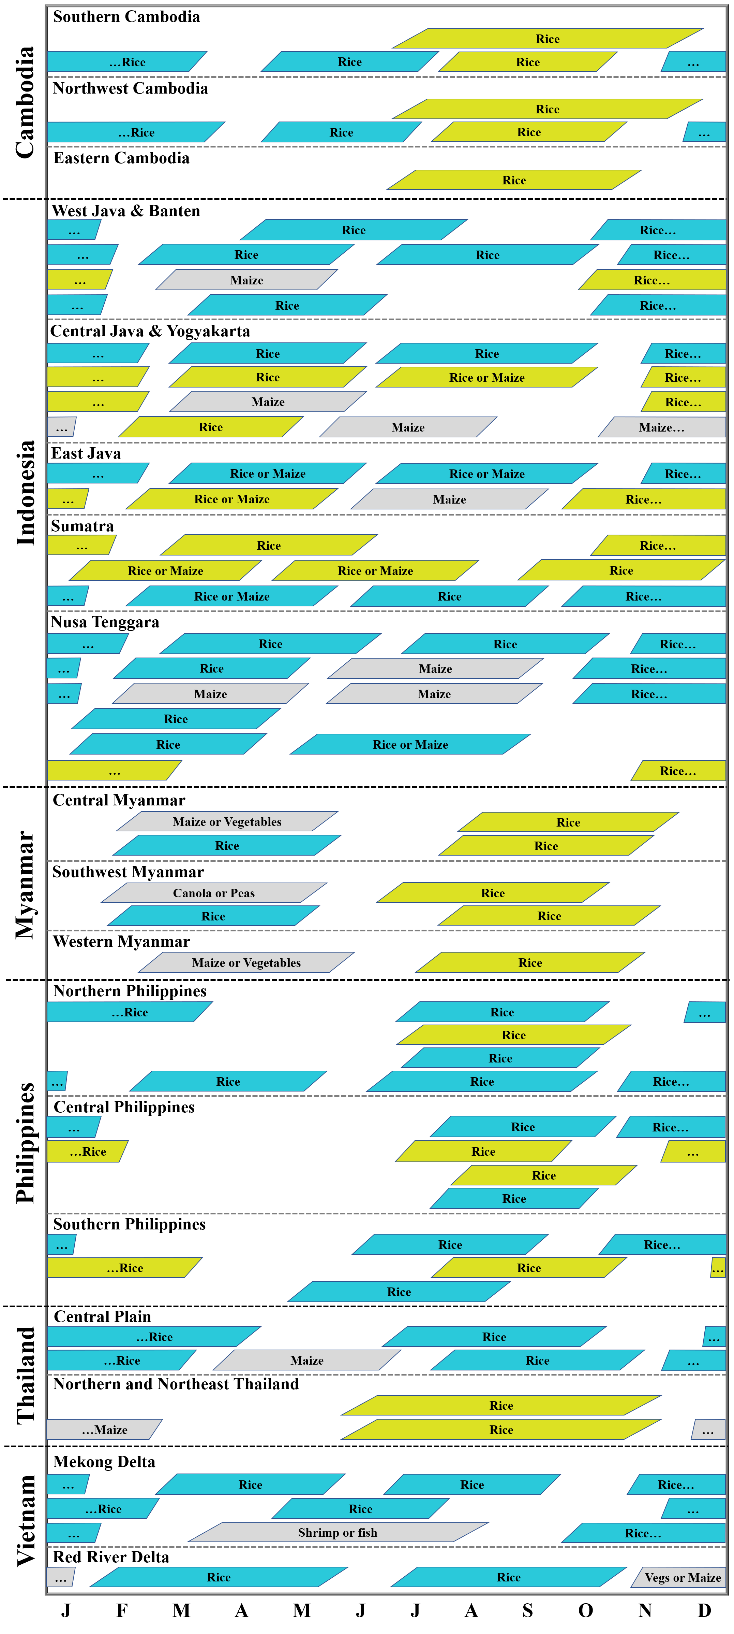
Supplementary Figure 1 Dominant rice cropping systems in each country. Boxes show approximate crop cycle length (from establishment to harvest maturity). Blue and yellow colors indicate irrigated and rainfed lowland rice, respectively. Gray color represents other crops grown within each sequence.
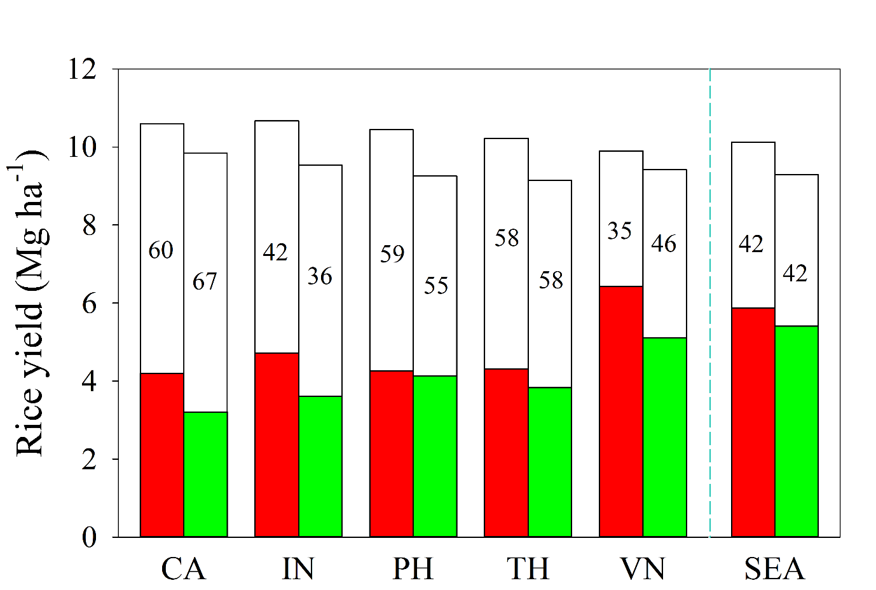
Supplementary Figure 2 Average yield potential for irrigated rice in dry (red) and wet season (green), respectively, for five countries in Southeast Asia (CA: Cambodia, IN: Indonesia, PH: Philippines, TH: Thailand, and VN: Vietnam). Solid and empty portions of bars indicate the average farmer yield and the yield gap, respectively. Values inside the empty portion of the bars indicate the average yield gap as a percentage of yield potential. Also shown are the regional averages of Southeast Asia (SEA) for each season. Yield potential for irrigated rice during the dry and wet seasons is not shown for Myanmar as all irrigated and rainfed rice is grown in the dry and wet season, respectively.

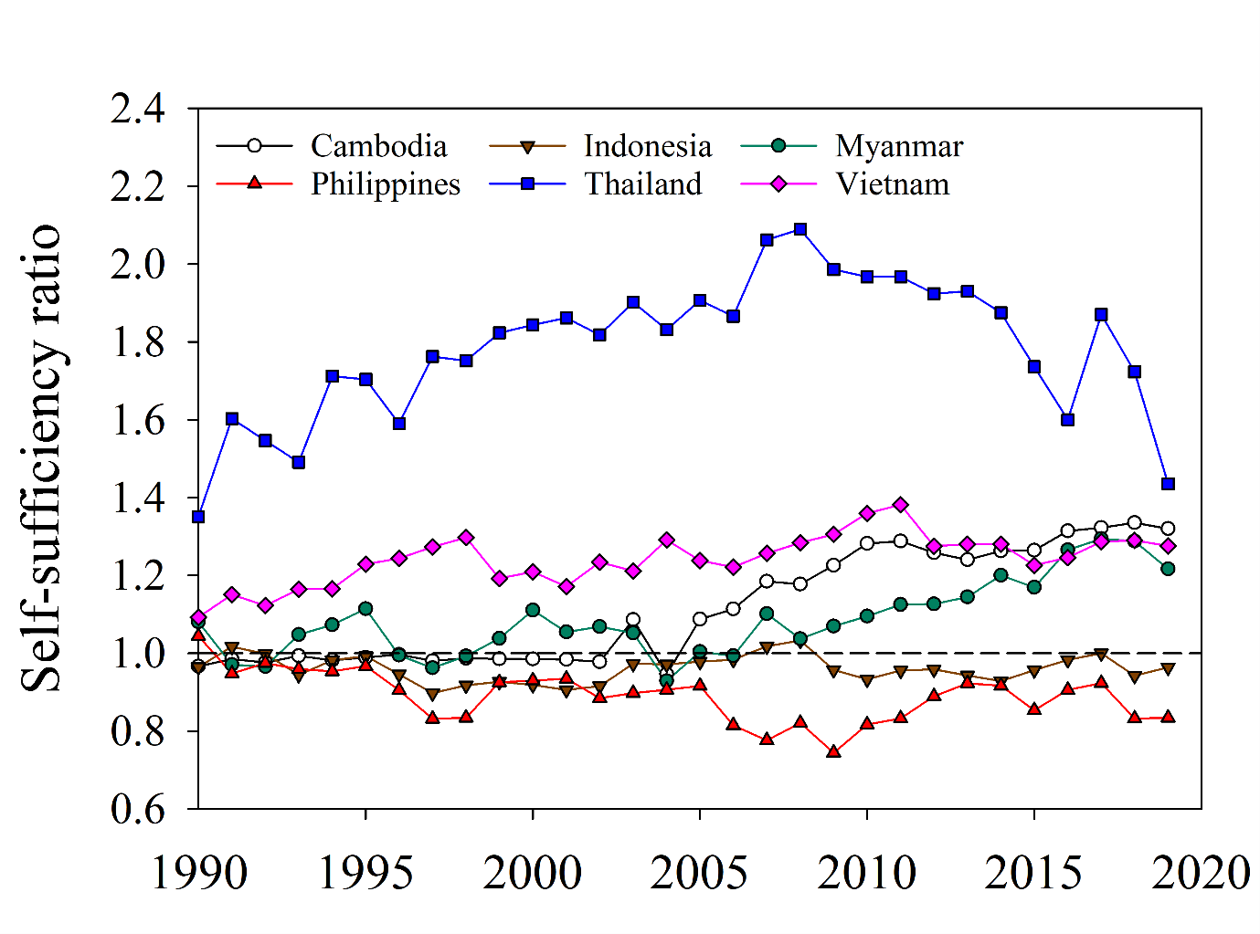
Supplementary Figure 3 Trends in rice self-sufficiency ratio, which was estimated as the ratio of rice production to domestic rice consumption (calculated as rice production plus import amount minus export amount) in six selected major rice-producing countries in Southeast Asia: Cambodia, Indonesia, Myanmar, Philippines, Thailand, and Vietnam during the past 30 years (1990-2019). Source: USDA²⁵.

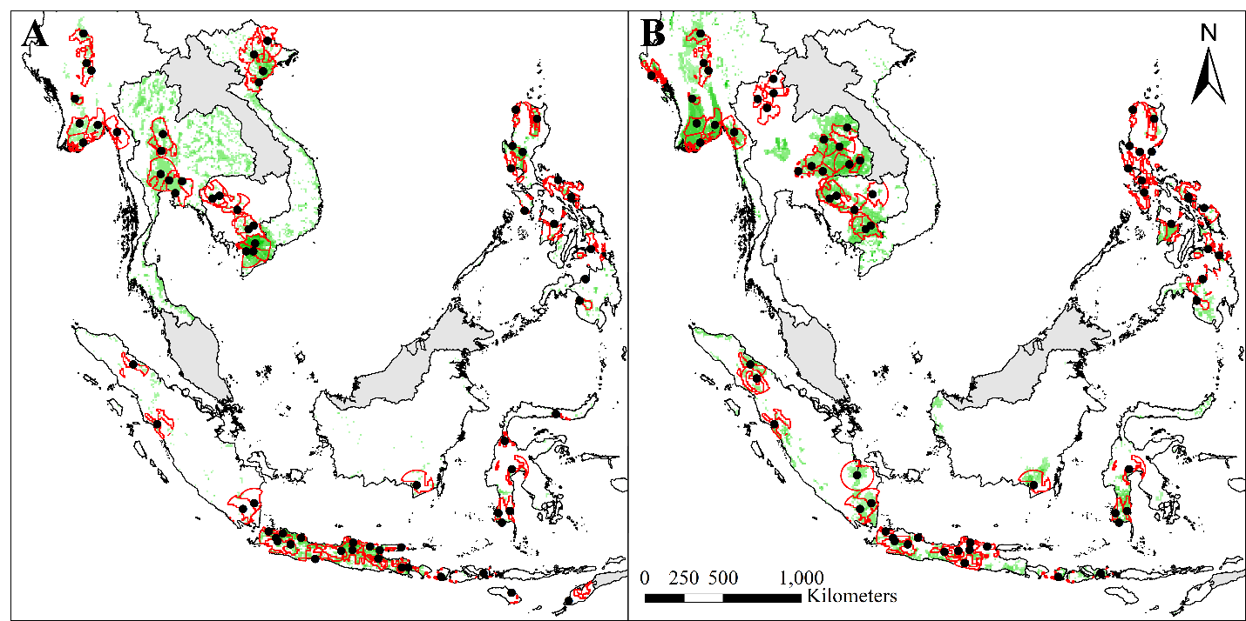
Supplementary Figure 4 Selected buffers (red polygons) for (A) irrigated and (B) rainfed lowland rice. Reference weather stations (black circles) and SPAM crop harvested area distribution (green) are shown (SPAM 2010; www.mapspam.info) in six major rice-producing countries in Southeast Asia: Cambodia, Indonesia, Myanmar, Philippines, Thailand, and Vietnam. Other countries in Southeast Asia not included in our yield-gap analysis (but included for our rice self-sufficiency assessment) are shown in gray (Brunei, Laos, Malaysia, Singapore, and Timor-Leste).

Supplementary Table 1. Data on annual harvested rice area (and percentage of global total), rice production (and percentage of global total), population, national total gross domestic product (GDP), per-capita GDP, percentage of agricultural GDP to national total GDP, and net rice export (calculated as the difference between rice export and rice import) in Cambodia (CA), Indonesia (IN), Myanmar (MY), Philippines (PH), Thailand (TH), and Vietnam (VN) during the 2017-2019 period. Sources: FAOSTAT¹, UN²⁶, World Bank²⁷.
Country | Rice area (M ha) | % of global area | Rice production (Mt) † | % of global production | Population (million) | Total GDP (billion US$) | GDP per capita (US$) | Agriculture share of total GDP (%) | Net rice exports (Mt) †
CA | 3.0 | 1.8 | 10.8 | 1.4 | 16 | 25 | 1514 | 22 | 0.8
IN | 11.2 | 6.8 | 57.7 | 7.6 | 268 | 1059 | 3956 | 13 | -1.5
MY | 7.0 | 4.3 | 26.8 | 3.5 | 54 | 74 | 1373 | 22 | 2.8
PH | 4.8 | 2.9 | 19.1 | 2.5 | 107 | 351 | 3287 | 10 | -2.8
TH | 10.4 | 6.3 | 31.2 | 4.1 | 69 | 502 | 7232 | 8 | 14.7
VN | 7.6 | 4.6 | 43.4 | 5.7 | 96 | 244 | 2549 | 15 | 8.0
SE Asia | 43.9 | 26.8 | 189.0 | 25 | 609 | 2254 | 3700 | 12 | 22.0
† Rice production and net rice exports were reported in paddy rice.

Supplementary Table 2. Coefficient of determination (R²), breakpoint indicating the year when a change in the slope occurred and 95% confidence interval (CI), slopes, 95% CI, and 95% CI of each segment of regression models fitted to the relationship between rice yield and years for six rice-producing countries in Southeast Asia: Cambodia (CA), Indonesia (IN), Myanmar (MY), Philippines (PH), Thailand (TH), and Vietnam (VN) during the past 30 years (1990-2019).
Country | R² | Year and 95% CI of breakpoint |  |  | Slope, 95% CI, and stand error of each segment
 |  | 1st breakpoint | 2nd breakpoint |  | 1st segment | 2nd segment | 3rd segment
CA | 0.98 | 2003 [1996, 2009] |  |  | 68 [52, 85] (8)* | 95 [84, 106] (6)*
IN | 0.97 | 2000 [1999, 2002] | 2015 [2013, 2016] |  | 0 (7) | 67 [58, 77] (5)* | 0 (22)
MY | 0.97 | 1997 [1995, 1999] | 2008 [2006, 2009] |  | 0 (10) | 81 [68, 95] (6)* | 0 (6)
PH | 0.97 | 1998 [1997, 1999] | 2005 [2003, 2007] |  | 0 (10) | 117 [79, 155] (18)* | 30 [20, 39] (5)*
TH | 0.91 | 2005 [2003, 2008] |  |  | 66 [54, 78] (6)* | 0 (7)
VN | 0.99 | 2012 [2010, 2013] |  |  | 115 [110, 120] (3)* | 0 (12)
Values in square brackets and brackets represent 95% CI and stand error, respectively.
Asterisks indicate significance at * p<0.05.

Supplementary Table 3. The number of selected reference weather stations (RWS), associated buffer and climate zone (CZ) coverage as percentage of national harvested area for irrigated and rainfed lowland rice in six rice-producing countries in Southeast Asia: Cambodia (CA), Indonesia (IN), Myanmar (MY), Philippines (PH), Thailand (TH), and Vietnam (VN). Note that the rainfed lowland rice in Vietnam was not included in the analysis as it accounts for less than 10% of national harvested rice area⁵.
Country | Irrigated |  |  |  | Rainfed
 | RWS number | Buffer coverage | CZ coverage |  | RWS number | Buffer coverage | CZ coverage
CA | 5 | 77 | 95 |  | 6 | 56 | 73
IN | 31 | 50 | 99 |  | 24 | 24 | 92
MY | 8 | 64 | 67 |  | 9 | 51 | 62
PH | 12 | 59 | 87 |  | 10 | 32 | 74
TH | 6 | 40 | 65 |  | 12 | 32 | 75
VN | 7 | 69 | 81 |  | - | - | -

Supplementary Table 4. Time span, climatic variables, and data sources of daily weather data for six rice-producing countries in Southeast Asia: Cambodia (CA), Indonesia (IN), Myanmar (MY), Philippines (PH), Thailand (TH), and Vietnam (VN).
Country | Time span | Climatic variables † | Data source
CA | 2010-2019 | Tmax, Tmin, and precipitation ‡ | Ministry of Water Resources and Meteorology of Cambodia (MOWRAM)
MY | 2010-2019 | Tmax, Tmin, and precipitation ‡ | Department of Meteorology and Hydrology of Myanmar (DMH)
IN | 2000-2015 | Sunshine hours, Tmax, Tmin, relative humidity, and precipitation ⸸ | Indonesian Agency for Meteorological, Climatological and Geophysics (BMKG)
PH | 2008-2017 | Solar radiation, Tmax, Tmin, precipitation, vapor pressure deficit, and wind speed | Philippine Atmospheric, Geophysical and Astronomical Services Administration (PAGASA))
TH | 2009-2018 | Tmax, Tmin, and precipitation ‡, ⸸ | Thai Meteorological Department (TMD)
VN | 2009-2018 | Solar radiation, Tmax, Tmin, precipitation, vapor pressure deficit, and wind speed | Vietnam Institute of Meteorology, Hydrology and Climate Change (IMHEN)
† Tmax and Tmin represent the maximum and minimum temperature, respectively.
‡ Other climatic variables including daily solar radiation, wind speed, and relative humidity were retrieved from the NASA-POWER Agro-climatic database⁹.
⸸ Measure daily weather data were available for 28 out of the 36 buffers in Indonesia and 15 of 18 buffers in Thailand. Hence, for the additional 11 buffers created for Thailand and Indonesia, gridded weather data from the NASA-POWER Agro-climatic database⁹ were used for yield potential simulation.

Supplementary Table 5. Time span, level of administrative unit for data, and data sources of farmer yield data for six rice-producing countries in Southeast Asia: Cambodia (CA), Indonesia (IN), Myanmar (MY), Philippines (PH), Thailand (TH), and Vietnam (VN).
Country | Time span | Administrative unit of data | Data source
CA | 2013-2017 | Province | Ministry of Agriculture, Forestry and Fisheries of Cambodia (MAFF)
MY | 2015-2018 | Region/state | Central Statistical Organization of Myanmar (CSO)
IN | 2010-2015 | Regency | Central Bureau of Statistics of Indonesia (BPS)
PH | 2014-2018 | Province | Philippine Statistics Authority (PSA)
TH | 2009-2017 | Province | Ministry of Agriculture and Cooperatives of Thailand (MOAC)
VN | 2007-2016 | Province | General Statistics Office of Vietnam (GSO)

Supplementary Table 6. Current (2019-2020) and future (2040) population, per-capita rice demand (in kg paddy rice), and total annual national rice demand (in Mt paddy rice) at national level in the six selected major rice-producing countries including Cambodia (CA), Indonesia, (IN), Myanmar (MY), Philippines (PH), Thailand (TH), and Vietnam (VN) and for the entire Southeast Asia (SEA).
Country | Population (million) † |  |  | Per-capita demand (kg) ‡ |  |  |  |  | Total demand (Mt) ⸸
 | Baseline (2019-2020) | Year 2040 |  | Baseline (2019-2020) | Year 2040 |  |  |  | Baseline (2019-2020) | Year 2040
 |  |  |  |  | IGRM | IMPACT | RECC |  |  | IGRM | IMPACT | RECC
CA | 17 | 21 |  | 435 | 425 | 426 | 434 |  | 7 | 9 | 9 | 9
IN | 271 | 319 |  | 209 | 186 | 208 | 212 |  | 57 | 59 | 66 | 68
MY | 55 | 61 |  | 300 | 292 | 313 | 353 |  | 16 | 18 | 19 | 22
PH | 109 | 136 |  | 210 | 203 | 207 | 213 |  | 23 | 28 | 28 | 29
TH | 69 | 69 |  | 273 | 250 | 274 | 277 |  | 19 | 18 | 19 | 19
VN | 98 | 108 |  | 347 | 303 | 325 | 360 |  | 34 | 33 | 35 | 39
SEA § | 666 | 769 |  | 246 | 223 | 241 | 252 |  | 163 | 172 | 185 | 194
† Current (2019-2020) and future (2040) population are from the UN Population Dyanmics²⁶ and medium fertility variant of the UN population projections²⁸, respectively.
‡ Current per-capita rice demand was calculated by dividing total domestic rice consumption based on USDA²⁵ by current population²⁶. Future per-capita rice demand was estimated based on current per-capita rice demand baseline and the projected relative change in per-capita rice demand as predicted separately by the IGRM²⁹, IMPACT (SSP2 scenario)³⁰, and RECC³¹, see Methods for details. Per-capita rice demand in the current and in the future were expressed in paddy rice by dividing originally reported milled rice from the USDA database and the three models by the rice milling rate of 0.610, 0.635, 0.640, 0.630, 0.660, and 0.625 for CA, IN, MY, PH, TH, and VN, respectively²⁵.
⸸ Current national total rice demand was estimated as the average annual national rice production, imports, exports, and stock change during 2019-2020. Future national total rice demand by 2040 was estimated as the product of future population and future per-capita rice demand by 2040 for each projection.
§ Current total rice demand in Southeast Asia was estimated as the average of annual regional rice production, import, export, and stock variation during 2019-2020. Future total rice demand in Southeast Asia was estimated by multiplying the future total rice demand from the six countries by 1.05, see Methods for details.

Additional references associated with Supplementary Information
- FAO. FAOSTAT production data. (accessed 2 May 2021); www.fao.org/faostat/en/#data.
- Grassini, P., Eskridge, K. M. & Cassman, K. G. Distinguishing between yield advances and yield plateaus in historical crop production trends. Nat. Commun. 4, 2918 (2013).
- Rondanini, D. P., Gomez, N. V., Agosti, M. B. & Miralles, D. J. Global trends of rapeseed grain yield stability and rapeseed-to-wheat yield ratio in the last four decades. Eur. J. Agron. 37, 56-65 (2012).
- Varinruk, B. Thailand rice production and rice research and development on climate change, Workshop on strengthening APEC cooperation on food security and climate change (Ha Noi, Vietnam, 2017).
- FAO. AQUASTAT Database. (accessed 5 Aug 2021); www.fao.org/aquastat/statistics.
- van Bussel, L. G. et al. From field to atlas: upscaling of location-specific yield gap estimates. Field Crops Res. 177, 98-108 (2015).
- van Wart, J. et al. Use of agro-climatic zones to upscale simulated crop yield potential. Field Crops Res. 143, 44-55 (2013).
- Bouman, B. A. M. et al. ORYZA2000: Modeling Lowland Rice (International Rice Research Institute, Los Baños, Philippines, 2001).
- Allen, R. G., Pereira, L. S., Raes, D. & Smith, M. Crop evapotranspiration. Guidelines for computing crop water requirements, FAO Irrigation and Drainage paper 56 (FAO, Rome, Italy, 1998).
- NASA-POWER. POWER Data Methodology. (accessed 25 June 2020). http://power.larc.nasa.gov/docs.
- Bai, J., Chen, X., Dobermann, A., Yang, H., Cassman, K. G. & Zhang, F. Evaluation of NASA satellite‐and model‐derived weather data for simulation of maize yield potential in China. Agron. J. 102, 9-16 (2010).
- Agustiani, N. et al. Simulating rice and maize yield potential in the humid tropical environment of Indonesia. Eur. J. Agron. 101, 10-19 (2018).
- Bouman, B. A. M. Developing a system of temperate and tropical aerobic rice in Asia (STAR), CPWF Project Report (CGIAR Challenge Program on Water and Food, Colombo, Sri Lanka, 2008).
- Asian Development Bank. Regional: development and dissemination of climate-resilient rice varieties for water-short areas of South Asia and Southeast Asia (Asian Development Bank, Metro Manila, Philippines, 2016).
- Nguyen, V. N. & Tran, D. V. Rice in producing countries, FAO Rice Information (FAO, Rome, Italy, 2002).
- Anh, D. T. & Tinh, T. V. The cross-border trade in rice from Cambodia to Vietnam, White Gold: the commercialisation of rice farming in the Lower Mekong Basin (Palgrave Macmillan, Singapore, 2020).
- Launio, C. C., Redondo, G. O., Beltran, J. C. & Morooka, Y. Adoption and spatial diversity of later generation modern rice varieties in the Philippines. Agron. J. 100, 1380-1389 (2008).
- Laza, M. R. C., Peng, S., Akita, S. & Saka, H. Effect of panicle size on grain yield of IRRI-released indica rice cultivars in the wet season. Plant Prod. Sci. 7, 271-276 (2004).
- Win, K. M. et al. Breeding the Thai jasmine rice variety KDML105 for non-age-related broad-spectrum resistance to bacterial blight disease based on combined marker-assisted and phenotypic selection. Field Crops Res. 137, 186-194 (2012).
- Vanavichit, A., et al. Thai Hom Mali Rice: Origin and breeding for subsistence rainfed lowland rice system. Rice 11, 20 (2018).
- Khunthasuvon, S. et al. Lowland rice improvement in northern and northeast Thailand: 1. Effects of fertiliser application and irrigation. Field Crops Res. 59, 99-108 (1998).
- Naklang, K., Harnpichitvitaya, D., Amarante, S. T., Wade, L. J. & Haefele, S. M. Internal efficiency, nutrient uptake, and the relation to field water resources in rainfed lowland rice of northeast Thailand. Plant Soil 286, 193-208 (2006).
- Roy, R. N., Finck, A., Blair, G. J. & Tandon, H. L. S. Plant nutrition for food security-A guide for integrated nutrient management, FAO Fertilizer and Plant Nutrition Bulletin 16 (FAO, Rome, Italy, 2006).
- White, P. F., Oberthür, T. & Sovuthy, P. The soils used for rice production in Cambodia: a manual for their identification and management (International Rice Research Institute, Los Baños, Philippines, 1997).
- USDA. Foreign Agricultural Service. (accessed 2 May 2021); https://apps.fas.usda.gov/psdonline/app/index.html#/app/advQuery.
- UN. Population Dynamics. (accessed 2 May 2021); https://population.un.org/wup/DataQuery.
- World Bank. DataBank. (accessed 2 May 2021); www.databank.worldbank.org/home.aspx.
- UN. World Population Prospects (Department of Economic and Social Affairs, Population Division, UN, New York, USA, 2019). Online Edition. Rev. 1. 2019.
- Balié, J. & Valera, H. G. Domestic and international impacts of the rice trade policy reform in the Philippines. Food Policy 92, 101876 (2020).
- Robinson, S. et al. The International Model for Policy Analysis of Agricultural Commodities and Trade (IMPACT)-Model Description for Version 3, IFPRI Discussion Paper 1483 (International Food Policy Research Institute, Washington DC, USA, 2015).
- Koizumi, T., Gay, S. H. & Furuhashi, G. Reviewing Indica and Japonica rice market developments (OECD Publishing, Paris, France, 2021).

