Decoding the precipitation dynamics at an East Himalayan glacier using Spectral Bin Classification and Boosted Regression Trees
Nilamoni Barman^{*1,2}
¹ Central Ground Water Board, Northeastern Region, Guwahati, Assam, India
² Centre for Atmospheric Science and Hydrometeorology, (Research initiative) Nalbari, Assam, India

*e-mail: neelspinor@gmail.com, ORCID: 0000-0003-3288-8131

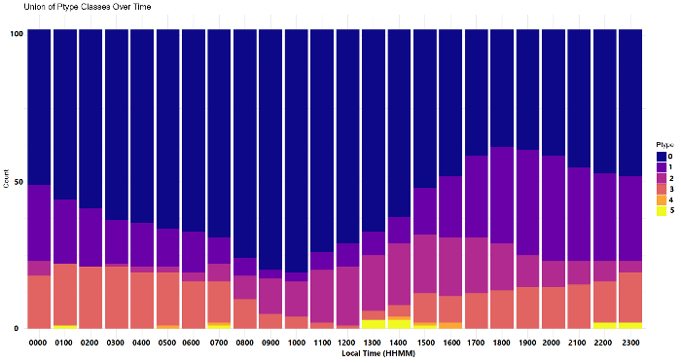
a) Pre-monsoon
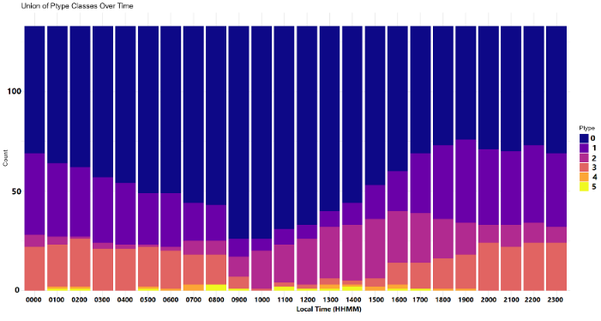
b) Monsoon

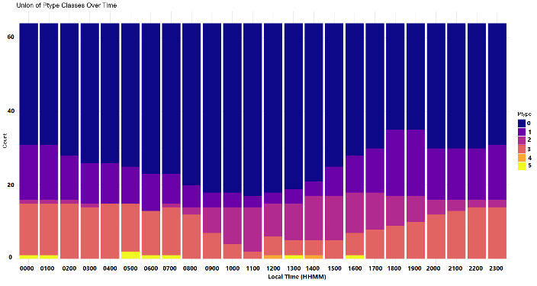
c) Post-monsoon
Fig.S1 The diurnal frequency distribution of ptype during a) Pre-monsoon, b) monsoon and c) Post-monsoon. No precipitation (in dark blue, 0), Snow (in purple,1), rain (salmon red, 2), freezing rain (in magenta, 3), orange freezing rain-ice pellet (in orange, 4), and rain-snow mixed (in yellow, 5)

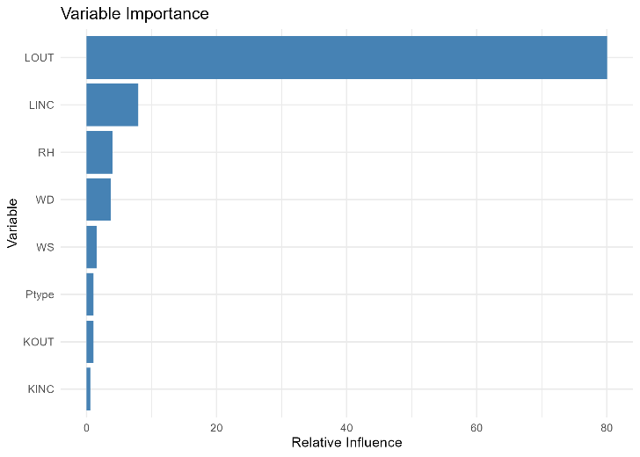
- Pre-monsoon
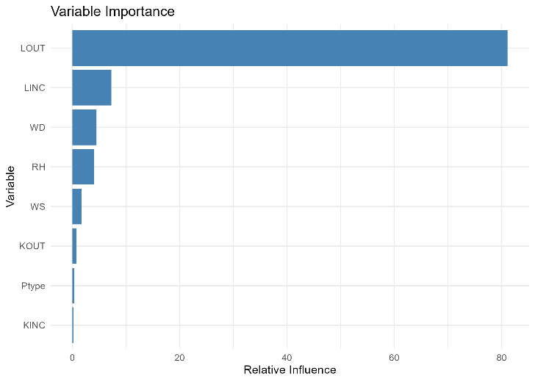
- Monsoon
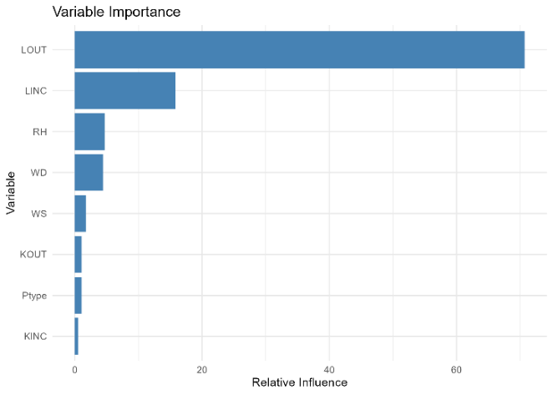
- Post-monsoon
Fig.S2 Relative influence of meteorological parameters on T during a) pre-monsoon, b) monsoon and c) post-monsoon.

