Graphical abstract
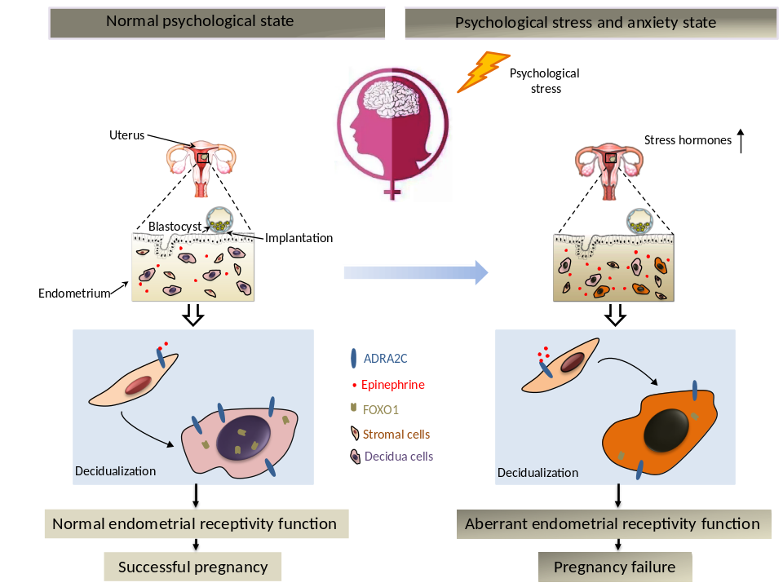

Supplementary Table 1
Table 1 Basal information for control group(n=35) and infertility group(n=35)
Variable | control group | infertility group | P
Average ages(years)of the patients | 31.2±4.6 | 30.9±4.3 | 0.782
Average infertility duration(years) | / | 5.5±2.9 | 0
BMI | 22.4±3.9 | 21.5±2.6 | 0.425
Tobacco smoking | 2.86% | 8.57% | 0.614
Alcohol consumption | 5.70% | 0% | 0.493
BMI, body mass index; values are shown as the mean± standard. t tests and χ² tests were used to analyze the diﬀerences in parameters.

Supplementary Table 2
Table 1 Basal information for pregnancy group(n=43) and pregnant failure group(n=45)
Variable | pregnancy group | pregnant failure group | P
Average ages(years)of the patients | 30.5±3.6 | 29.7±3.3 | 0.844
Average infertility duration(years) | 4.5±2.6 | 4.7±2.8 | 0.889
BMI | 22.6±5.3 | 21.3±6.1 | 0.235
Endometrial thickness on the day of embryo transfer | 10.3±2.4 | 9.7±2.3 | 0.808
Alcohol consumption | 9.30% | 11.11% | 0.78
Tobacco smoking | 4.60% | 6.67% | 0.683
Number of oocytes retrieved | 9.9±5.0 | 9.4±4.5 | 0.998
MIIoocyte rate(n) | 86.6 %(393/454) | 87.4 %(387/443) | 0.766
Fertilization rate(n) | 83.5 %(328/393) | 82.4 %(319/387) | 0.705
2PN rate(n) | 74.0 %(291/393) | 73.1 %(273/387) | 0.298
High-quality embryo rate(n) | 52.2 %(152/291) | 52.4 %(143/273) | 0.972
Embryo transfer number(D5) | 1.21（52/43） | 1.27（57/45） | 0.929
2PN, two pro-nucleate; HCG, human chorionic gonadotropin; D5, Embryos on day 5; values are shown as the mean± standard. t tests and χ² tests were used to analyze the diﬀerences in parameters.

Supplementary Table 3
Table 2 Basal patient information for human endometrial biopsy
Variable | control (n=6) | RIF (n=7) | P
Average ages(years)of the patients | 28.7±2.9 | 30.7±4.6 | 0.373
BMI | 21.4±2.7 | 20.8±2.3 | 0.681
Alcohol consumption | 0% | 0% | /
Tobacco smoking | 0% | 0% | /
Endometrial thickness in Mid-secretory stage | 9.3±1.1 | 9.0±1.5 | 0.707
Basic FSH level (mIU/ml) | 5.15±1.1 | 5.4±0.7 | 0.673
Basic LH level (mIU/ml) | 2.16±0.42 | 2.50±0.85 | 0.363
Basic E2 level (pg/ml) | 31.57±5.8 | 29.67±6.7 | 0.595
The level of LH peak (mIU/ml) | 35.0±5.1 | 33.67±7.7 | 0.717
FSH, Follicle-stimulating hormone; E2, estradiol; LH, Luteinizing hormone; values are shown as the mean± standard. t tests and χ² tests were used to analyze the diﬀerences in parameters.

Supplementary Table 4
Table 4. Quantitative real-time PCR primer sequences
Genes | Primer sequence5’–3’ |  | GenBank accession no.
ADRA1A | Forward | TTCTGCAACATCTGGGCGG | NM_000680.4
ADRA1A | Reverse | GCTGCCTCCAGCCGAACA
ADRA1B | Forward | GACCTGCTGTTGAGCTTCA | NM_000679.4
ADRA1B | Reverse | AGAGGCCCGATGGAGATGA
ADRA1D | Forward | GTCACCAACTATTTCATCG | NM_000678.4
ADRA1D | Reverse | GAGATGGTGCAGAGGCT
ADRA2A | Forward | GAGGAAGAGGAGGACCCA | NM_000681.4
ADRA2A | Reverse | TCGGTCCCGTTCCAGCT
ADRA2C | Forward | CAGAACCTCTTCCTGGTGT | NM_000683.4
ADRA2C | Reverse | TGCGTCACCGACCAGTAGC
ADRA2B | Forward | CTGGCCAACGAGCTGCTG | NM_000682.7
ADRA2B | Reverse | GTGCGCTTGGAGTTGTACT
ADRB1 | Forward | GTGCTGGTGATCGTGGCCAT | NM_000684.3
ADRB1 | Reverse | GCAGAAGAAGGAGCCGTACTC
ADRB2 | Forward | ATCGTCCTGGCCATCGTG | NM_000024.5
ADRB2 | Reverse | ATCACGCACAGGGTCTC
ADRB3 | Forward | ACCAACGTGTTCGTGACTTC | NM_000025.3
ADRB3 | Reverse | CACCACTGGCTCATGATGG
PNMT | Forward | CTCCGCAACAACTACGCG | NM_002686.4
PNMT | Reverse | TCTGTCATGGTGATGTCC | NM_002686.4
TH | Forward | GACTGCTGCCACGAGCTG | XM_011520335.2
TH | Reverse | TCTTGGTAGGGCTGCAC | XM_011520335.2
GAPDH | Forward | ATTTGGCTACAGCAACAGG | NM_002046.7
GAPDH | Reverse | TTGAGCACAGGGTACTTTATT | NM_002046.7

Supplementary Figure S1.
Figure S1. (A) The expression of TH and PNMT in endometrial at different menstrual stages; (B) The expression of TH and PNMT before and after HESCs differentiation; (C) Immunohistochemistry showed ADRA2C protein expression in endometrium from proliferative stage to late secretory phase of the menstrual cycle. Scale bars, 500 μM. Pos, positive; Neg, negative; MP, Mid-proliferation phase; MS, Mid -secretion phase; ES, ES, early secretory phase; LS, late secretory phase; S, stroma; GE, glandular epithelium; Scale bars, 500 μm.

Supplementary Figure S2.

Figure S2.Effects of adrenergic receptor signaling on proliferation of HESCs during in vitro culture.(A) MTS assay monitored the proliferation of human endometrial stromal cells in vitro culture; (B) Ki67 immunofluorescence assay analyzed the proliferation of human endometrial stromal cells in vitro culture; (C) The positive rate of Ki67 positive cells; Ctr, control; NS, No significance. Scale bars, 100 μm.
Supplementary FigureS3.
Figure S3. (A) Immunofluorescence detected the knockdown efficiency of ADRA2C in HESCs; (B) Expression and localization of FOXO1 by cellular immunofluorescence assay after ADRA2C knockdown; Scale bars, 50 μm.
Supplementary Figure S4.
FigureS4.(A) The subcellular localization of ADRA2C, FOXO1 and PR in endometrial tissue from fertile women was analyzed by immunohistochemistry. (B) The subcellular localization of ADRA2C, FOXO1 and PR in Mid-secretory endometrial tissues from RIF patients was analyzed by immunohistochemistry. Scale bars, 200 μm. Ctr, control; RIF, repeated implantation failure; S, stroma; GE, glandular epithelium;

