Graphic Abstract

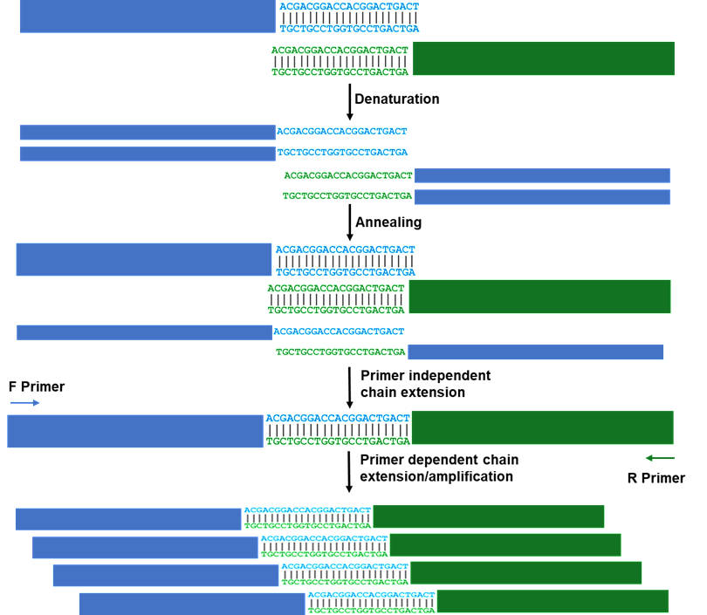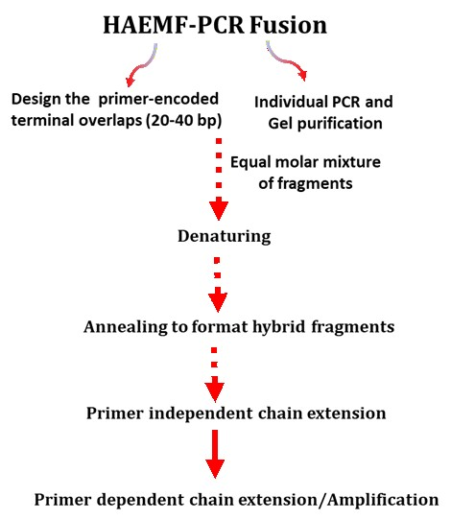
Homology-annealing extension-mediated fusion PCR (HAEMF-PCR) allows for the seamless assembly of multiple DNA fragments into a single amplicon using a single
DNA polymerase

