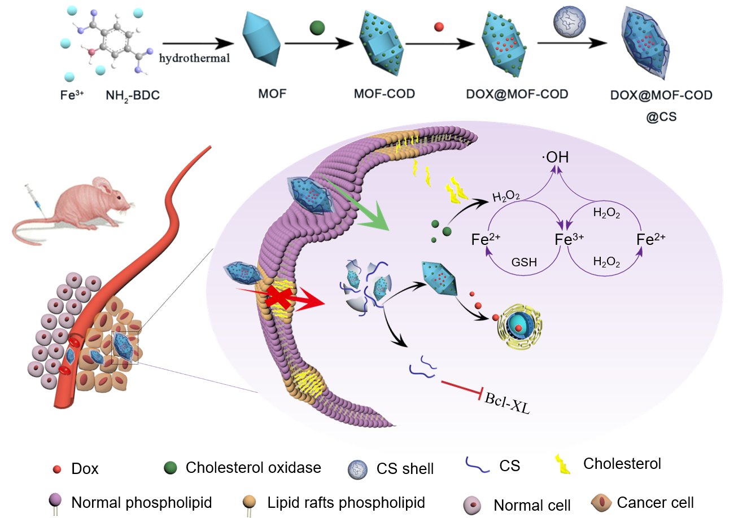

Preparation of nanocarriers based on cascade catalysis and tumor region specific targeting for efficient delivery and reversal of multidrug resistance

