Supporting Information
Nanozyme-natural enzymes cascade catalyze cholesterol consumption and reverse cancer multidrug resistance
Bin Du ^{a,b}, Mei Zheng ª, Jingshu Huang ª, Qingqing Jiao ª, Yimeng Bai ª, Mengmeng Zhao ª, Jie Zhou ^{a,b,*}
ª School of Pharmaceutical Sciences, Zhengzhou University, 100 Science Road, Zhengzhou 450001, P. R. China
^{b} Key Laboratory of Targeting Therapy and Diagnosis for Critical Diseases, Henan Province, 100 Science Road, Zhengzhou 450001, P. R. China
*Corresponding author.
E-mail address: zhj_paper@sina.com
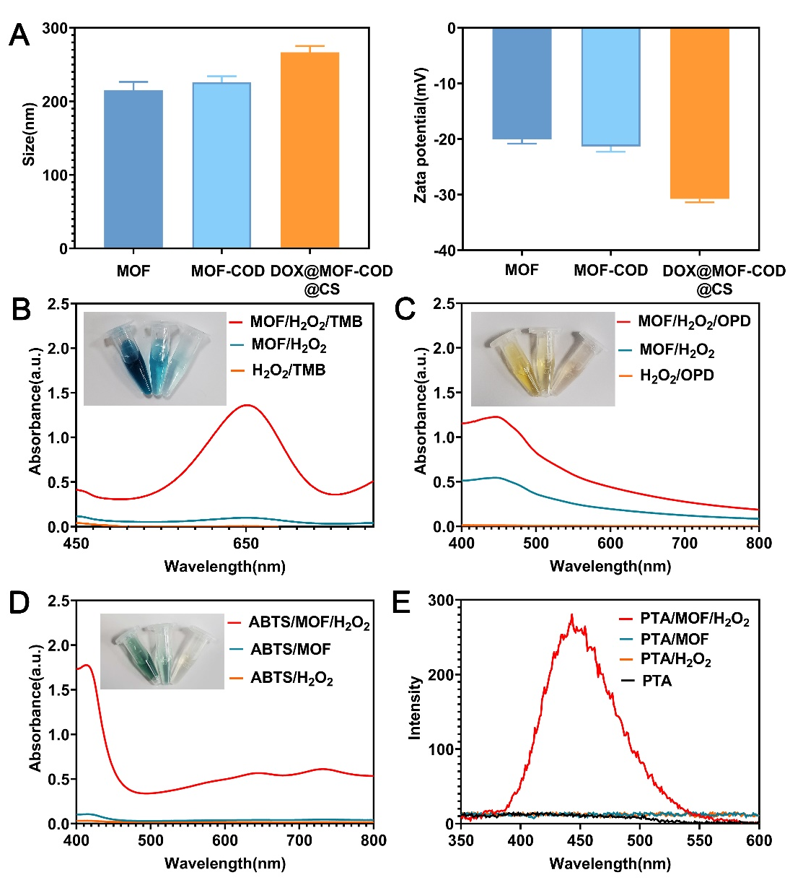
Figure S1. Characterizations of the different nanosystems. (A) Particle sizes and zeta potentials of MOF, MOF-COD, DOX@MOF-COD@CS nanoparticles. (B-E) Peroxidase-like properties of MOF. ([MOF] = 40 μg·mL⁻¹, [H₂O₂] = 200 μM, pH = 4, [TMB] = 1mM, [ABTS] = 1mM, [OPD] = 1mM, [PTA] = 1 mM, temperature: 37℃)
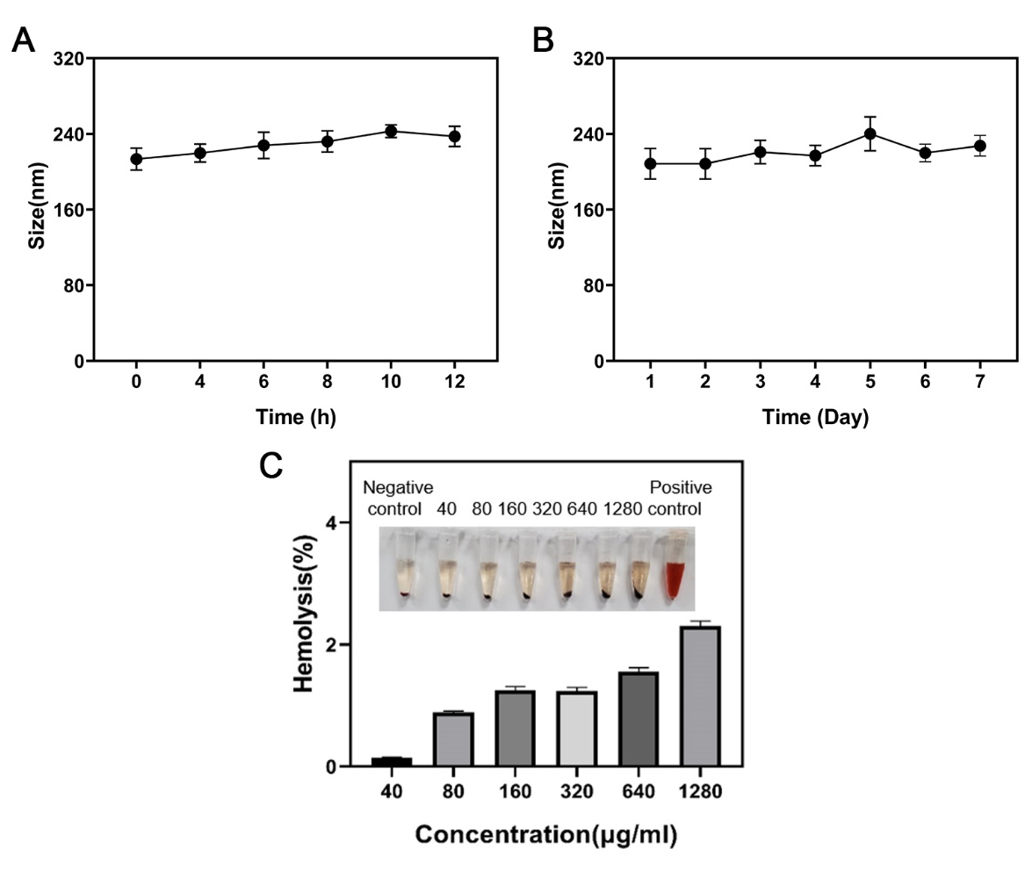
Figure S2. Researches on the stability and security of DOX@MOF-COD@CS nanoparticles. (A) Changes in the sizes of DOX@MOF-COD@CS nanoparticles incubated in serum for 24 h. (B) Changes in the sizes of DOX@MOF-COD@CS nanoparticles incubated in PBS for 7 days. (C) Hemolysis test of DOX@MOF-COD@CS nanoparticles.
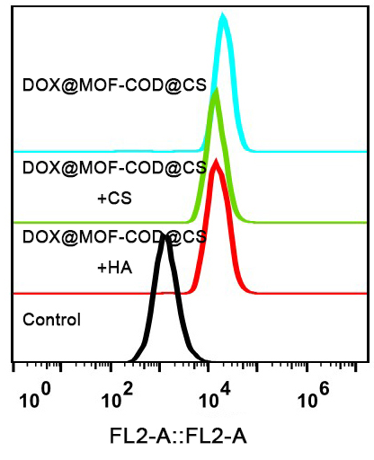
Figure S3. Flow cytometry analysis of the targeting effect of different nanoparticles on CD44.

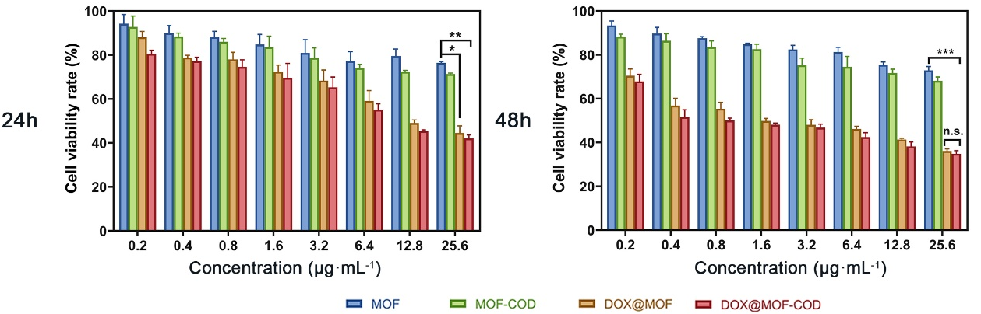
Figure S4. Cell viability rates of MCF-7 cells incubated with MOF, MOF-COD, DOX@MOF, DOX@MOF-COD for 24 and 48 h (n = 6), *P <0.05, **P <0.01, ***P <0.001.
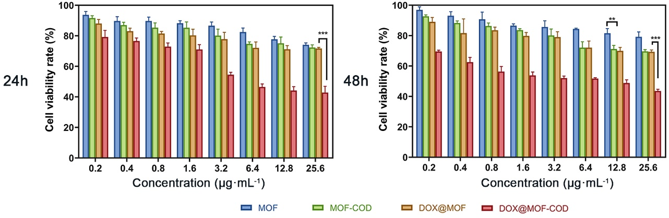
Figure S5. Cell viability of MCF-7/ADR cells incubated with MOF, MOF-COD, DOX@MOF, DOX@MOF-COD nanoparticles for 24 and 48 h (n = 6), data are expressed as means ± SD, **P <0.01, ***P <0.001.
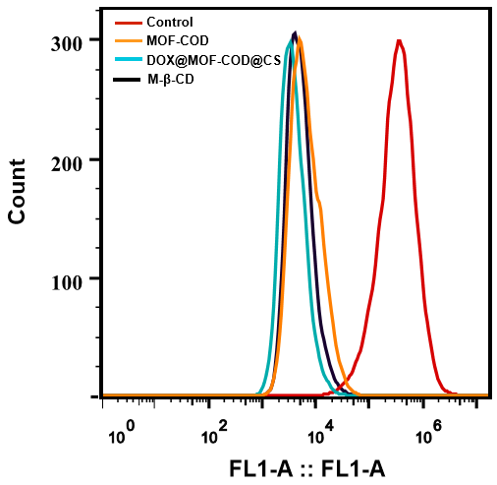
Figure S6. Fluorescence intensity of lipid rafts was analyzed by flow cytometry.
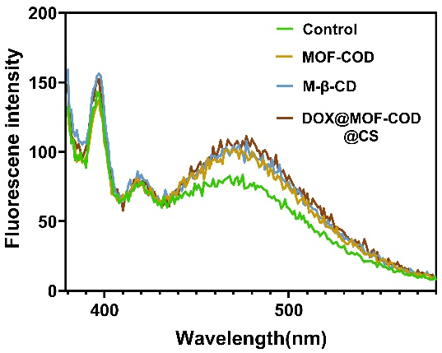
Figure S7. Fluorescence emission spectra of 1-pyrenedodecanoic acid.
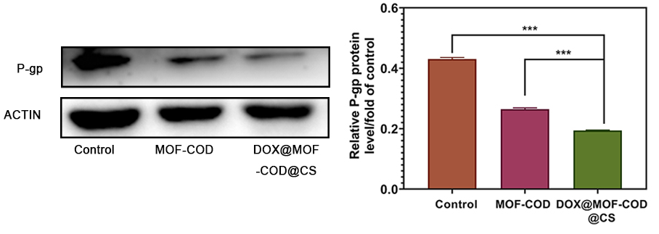Figure S8. Western blot to study the content of P-gp and gray-scale analysis of P-gp protein (n = 3), ***P <0.001.
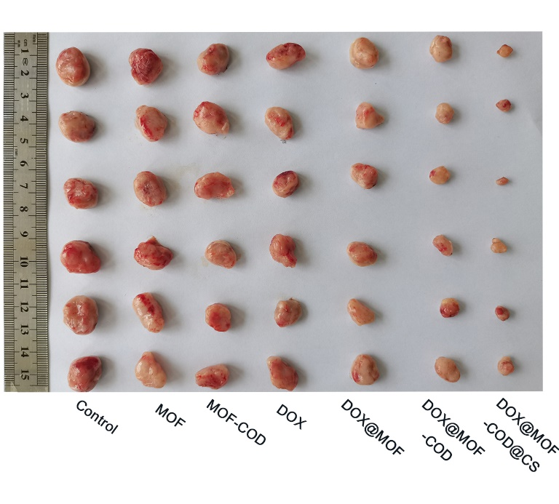
Figure S9. Photographic records of nude mice tumors in each group.

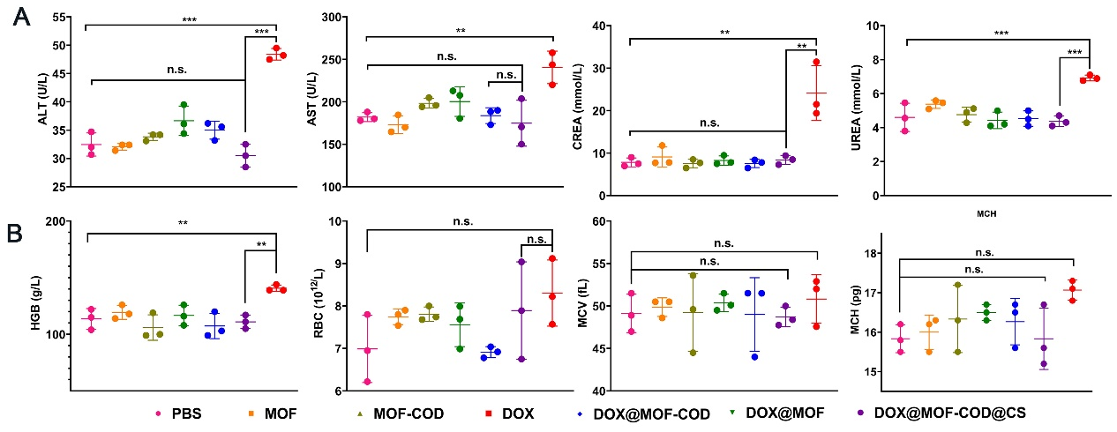
Figure S10. In vivo safety evaluation. (A) Detection of liver and kidney function in each group. alanine aminotransferase (ALT), aspartate aminotransferase (AST), creatinine (CREA). (B) Blood routine test, hemoglobin (HGB), red blood cell (RBC), mean corpuscular volume (MCV), mean corpuscular hemoglobin (MCH) (n= 3), **P <0.01, ***P <0.001.
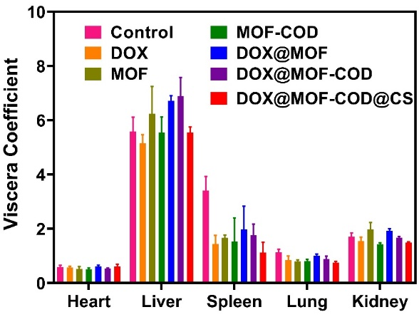
Figure S11. Investigation of organ index in each group (n= 6).
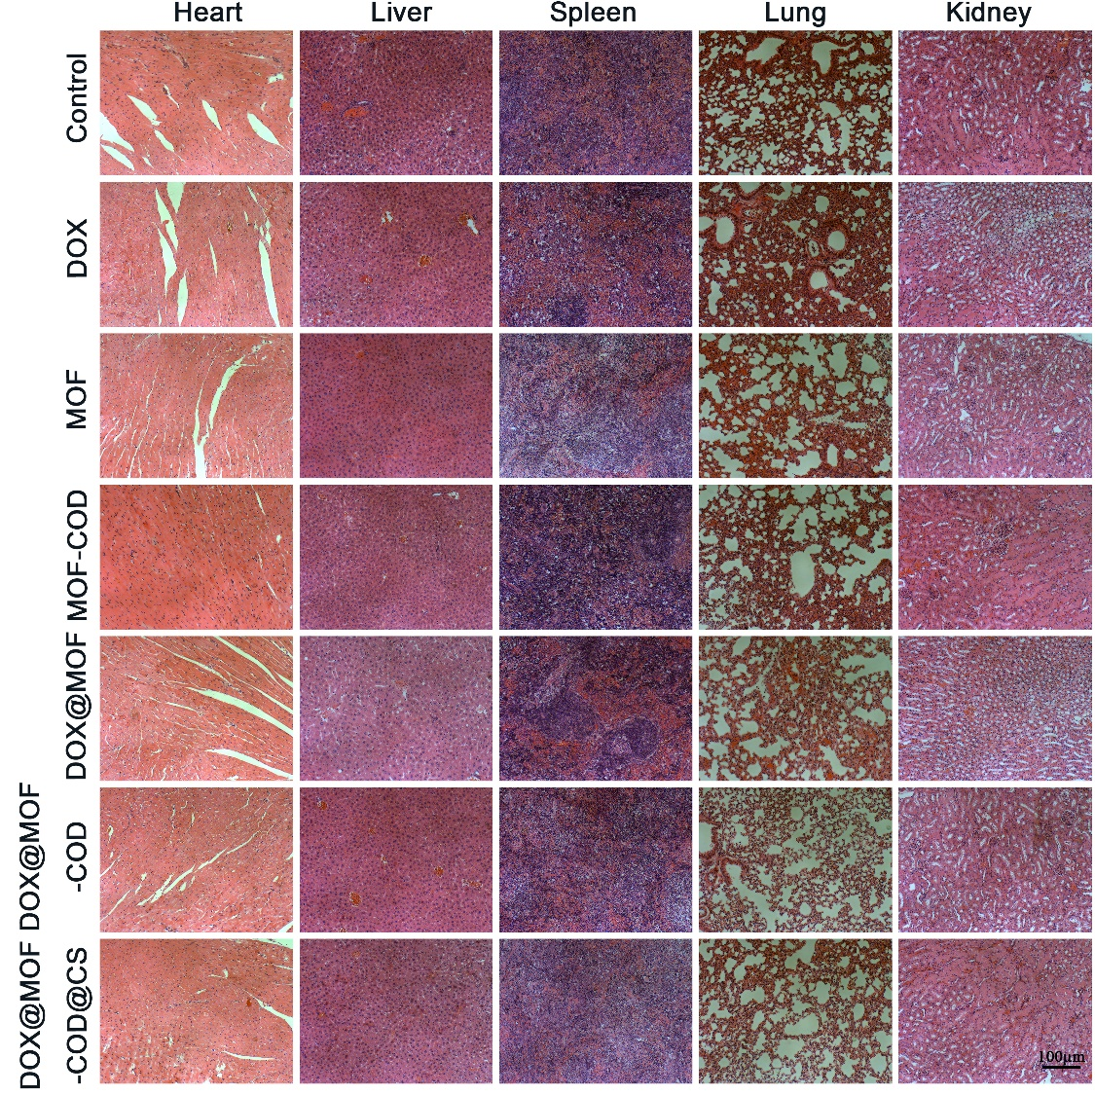
Figure S12. H&E staining study on major organs (Heart, Liver, Spleen, Lung, Kidney).

