Supplementary Material – Appendix 1
Local procedure for esophageal pressure monitoring.

The esophageal catheter was positioned according to our local protocol, as described below (1,2):
- Insert the esophageal catheter (Nutrivent®, Sidam, Modena, Italy) into the stomach through the mouth. Confirm correct gastric placement by observing an increase in gastric pressure during gentle external epigastric compression.
- Inflate the balloon with 4 mL of air, as recommended by the manufacturer. Withdraw the catheter slowly until cardiac artifacts appear on the esophageal pressure (P_{es}) waveform.
- Optimize balloon inflation using the method described by Mojoli et al. (3). Briefly, inflate the balloon with 10 mL of air and then deflate it stepwise in 1-mL increments. Select the balloon volume that produces the greatest change in Pes (ΔP_{es}) during tidal ventilation.
- Verify correct catheter positioning by applying gentle external chest compressions during an expiratory occlusion and measure the absolute changes in airway and esophageal pressures (ΔP_{aw} and ΔP_{es}). A ΔP_{es}/ΔP_{aw} ratio close to 1 (±10%) during the occlusion confirms accurate pleural pressure measurement.
- Measure end-expiratory and end-inspiratory esophageal pressures (P_{es,e} and P_{es,i}) during occlusion. To correct for esophageal wall pressure artifacts, subtract 1 cmH₂O for each milliliter of balloon volume above 1 mL (3).

- Mauri T, Yoshida T, Bellani G, Goligher EC, Carteaux G, Rittayamai N, et al. Esophageal and transpulmonary pressure in the clinical setting: meaning, usefulness and perspectives. Intensive Care Med. sept 2016;42(9):1360‑73.
- Piquilloud, L., Beitler, J.R. & Beloncle, F.M. Monitoring esophageal pressure. Intensive Care Med. June 2024;50:953–956.
- Mojoli F, Iotti GA, Torriglia F, Pozzi M, Volta CA, Bianzina S, et al. In vivo calibration of esophageal pressure in the mechanically ventilated patient makes measurements reliable. Crit Care. 11 avr 2016;20:98.

Supplementary Material – Appendix 2
Calculated variables used in the study

End-expiratory transpulmonary pressure: P_{L,e} = PEEP – P_{es,e}
End-inspiratory transpulmonary pressure, direct method: P_{L,i} = P_{plat} – P_{es,i}
End-inspiratory transpulmonary pressure, elastance-derived method: P_{L,i} = P_{plat} x (E_{L} / E_{rs})
Respiratory system compliance: C_{rs} = V_{T} / (P_{plat} – PEEP)
Lung compliance: C_{L} = V_{T} / [(P_{plat} – P_{es,i}) – (PEEP – P_{es,e})]
Non-dependent lung compliance: C_{L,ND} = (V_{T} x %V_{T,ND}) / [(P_{plat} – P_{es,i}) – (PEEP – P_{es,e})]
Dependent lung compliance: C_{L,D} = (V_{T} x %V_{T,D}) / [(P_{plat} – P_{es,i}) – (PEEP – P_{es,e})]

E_{L}: lung elastance, E_{rs}: respiratory system elastance, PEEP: positive end-expiratory pressure, P_{es,e}: end-expiratory esophageal pressure, P_{es,i}: end-inspiratory esophageal pressure, P_{plat}: plateau pressure, V_{T}: tidal volume, %V_{T,D}: fraction of tidal distribution of impedance signal in the dependent lung, %V_{T,ND}: fraction of tidal distribution of impedance signal in the non-dependent lung.
Supplementary Material – Appendix 3
Contraindications to Study Procedures

Esophageal balloon catheter
Active upper gastrointestinal bleeding, including bleeding esophageal varices
Recent esophageal trauma
Esophageal tumor
Esophageal diverticulum or ulceration
Recent esophageal surgery
Platelet count < 10,000 cells/µL
Prothrombin time < 30%
Electrical impedance tomography
Pacemakers
Implantable cardiac defibrillators
Unstable rib or spinal fractures
Inability to correctly position the EIT belt (e.g., chest burns, chest drains)
Decremental PEEP trial
Pneumothorax, pneumomediastinum, or bronchopleural fistula
Severe hemodynamic instability (>30% increase in vasopressorsrequirements within the last 6 hours or norepinephrine > 0.5 µg/kg/min)
Severe hypoxemia (PaO2/FiO2 ratio < 80 mmHg)
Severe or very severe chronic obstructive pulmonary disease according to GOLD criteria (stage III: FEV1 30-50% predicted; stage IV: FEV1 < 30% predicted)
Known or highly suspected elevated intracranial pressure (>18 mmHg)

EIT: electrical impedance tomography, FiO₂: fraction of inspired oxygen, PaO₂: arterial partial pressure of oxygen, GOLD: global initiative for chronic obstructive lung disease, FEV1: forced expiratory volume in 1 second.

Supplementary Material – Table e1
Spearman’s and repeated measures correlation between transpulmonary pressures, alveolar collapse and overdistension.

Analysis |  |  | Spearman’s correlation |  |  |  | Repeated measures correlation
Analysis |  |  | ρ | 95% CI | p value |  | rmcorr | 95% CI | p value
P_{L,e} vs. collapse
All PEEP levels |  |  | -0.68 | -0.74 to -0.62 | <0.001 |  | −0.85 | −0.88 to −0.81 | <0.001
Excluding PEEP 20 cmH₂O |  |  | -0.63 | -0.70 to -0.56 | <0.001 |  | −0.87 | −0.90 to −0.84 | <0.001
P_{L,i} vs. overdistension
All PEEP levels |  |  | 0.60 | 0.52 to 0.67 | <0.001 |  | 0.89 | 0.86 to 0.91 | <0.001
Excluding PEEP 4 cmH₂O |  |  | 0.55 | 0.47 to 0.63 | <0.001 |  | 0.89 | 0.86 to 0.91 | <0.001

CI: confidence interval, P_{L,e}: end-expiratory transpulmonary pressure, P_{L,i}: end-inspiratory transpulmonary pressure (elastance-derived method), PEEP: positive end-expiratory pressure, r: Spearman coefficient, rmcorr: repeated-measures correlation.
Supplementary Material – Table e2
Linear mixed-effects models.

Analysis | β | 95% CI | p value
P_{L,e} vs. collapse
All PEEP levels | -2.99 | -3.22 to -2.77 | <0.001
Excluding PEEP 4 cmH₂O | -2.56 | -2.79 to -2.32 | <0.001
P_{L,i} vs. overdistension
All PEEP levels | 1.93 | 1.81 to 2.05 | <0.001
Excluding PEEP 20 cmH₂O | 1.80 | 1.67 to 1.93 | <0.001

CI: confidence interval, P_{L,e}: end-expiratory transpulmonary pressure, P_{L,i}: end-inspiratory transpulmonary pressure (elastance-derived method), PEEP: positive end-expiratory pressure.
Supplementary Material – Table e3
Fisher’s z comparison of Spearman according to the obesity status, respiratory system compliance, oxygenation, and recruitability.

Comparison | Obese vs. non-obese |  |  |  |  | Low vs. high C_{rs} |  |  |  |  | Low vs. high P_{a}O₂/F_{i}O₂ ratio |  |  |  |  | Low vs. high recruitability
Comparison | r₁ | r₂ | Z score | p value |  | r₁ | r₂ | Z score | p value |  | r₁ | r₂ | Z score | p value |  | r₁ | r₂ | Z score | p value
Correlation between collapse and P_{L,e} | -0.73 | -0.64 | -1.50 | 0.134 |  | -0.64 | -0.73 | -1.53 | 0.126 |  | -0.69 | -0.68 | -0.17 | 0.865 |  | -0.61 | -0.72 | -0.56 | 0.577
Correlation between overdistension and P_{L,i} | 0.74 | 0.55 | 2.92 | 0.004 |  | 0.65 | 0.65 | 0 | >0.99 |  | 0.56 | 0.65 | 1.27 | 0.204 |  | 0.67 | 0.71 | 0.22 | 0.830

C_{rs}: respiratory system compliance, P_{a}O₂/F_{i}O₂: ratio of arterial oxygen partial pressure to fractional inspired oxygen, P_{L,e}: end-expiratory transpulmonary pressure, P_{L,i}: end-inspiratory transpulmonary pressure (elastance-derived method), r: Spearman coefficient, Z: Fisher-transformed correlation coefficient.
Supplementary Material – Table e4
Performance of transpulmonary pressures in predicting critical alveolar collapse and overdistension (i.e. 10% out of the total lung imaged by electrical impedance tomography) in ARDS patients.

Parameters | AUC  [95% CI] | p value | Optimal cut-off (cmH₂O) | Se (%) | Sp (%) | Youden Index | Gray zone  (cmH₂O)
P_{L,e} to predict collapse >10% | 0.84  [0.80-0.88] | <0.001 | 2.1 | 75 | 80 | 0.55 | 2.0-9.0
P_{L,i} to predict overdistension >10% | 0.80  [0.75-0.84] | <0.001 | 17.5 | 73 | 78 | 0.50 | 9.2-18.4

AUC: area under the ROC curve, P_{L,e}: end-expiratory transpulmonary pressure (direct method), P_{L,i}: end-inspiratory transpulmonary pressure (elastance-derived method), Se: sensitivity, Sp: specificity. The gray zone values indicate the PEEP level to predict collapse or overdisension >10% and the absence of collapse or overdistension >10%, with a specificity of at least 80%.

Supplementary Material – Figure e1
Ability of end-inspiratory transpulmonary pressure to detect critical value (i.e. 10% out of the total lung imaged by electrical impedance tomography) of alveolar overdistension.

Panel A: evolution of end-inspiratory transpulmonary pressures (grey circle) and alveolar collapse (blue bar) across the decremental PEEP titration. Data are expressed as mean ± SD. The horizontal dashed lines indicate P_{L,i} of 20 cmH₂O. panel B: scatterplots depicting the correlation (and 95% confidence interval) between P_{L,i} and the percentage of alveolar overdistension. Solid line shows linear regression. Dashed vertical line shows 10% of overdistension lung units out of the total lung imaged by EIT. Dashed horizontal line shows P_{L,i} at 20 cmH₂O – the theorical threshold value above which the risk of alveolar overdistension increase. Panel C: receiver operating characteristic (ROC) curves for P_{L,i} predicting alveolar overdistension higher than 10%. Panel D: Specificity of P_{L,i} to predict alveolar overdistension lung units higher than 10% (blue circles) or lower than (grey circles) 10% out of the total lung imaged by EIT. Pre-determined thresholds of interest (targeted specificity of 80% for both outcomes) are plotted. AUC: area under the ROC curve, P_{L,i}: end-inspiratory transpulmonary pressure (direct method), PEEP: positive end-expiratory transpulmonary pressure.
Supplementary Material – Figure e2
Repeated measures correlations between transpulmonary pressures, alveolar collapse and overdistension.
Within-subject (repeated-measures) correlations between transpulmonary pressures and the percentage of alveolar collapse and overdistension across decremental PEEP titration. Each coloured dot represents a single PEEP level for an individual patient, and same-coloured points belong to the same patient; parallel lines show the common within-subject slope fitted for each patient by repeated-measures correlation (rmcorr). Panel A: correlation between end-expiratory transpulmonary pressure (P_{L,e}) and collapse using all PEEP levels. Panel B: correlation between end-inspiratory transpulmonary pressure (P_{L,i}) and overdistension using all PEEP levels. Panel C: correlation between P_{L,e} and collapse after exclusion of PEEP 20 cmH₂O. Panel D: correlation between P_{L,i} and overdistension after exclusion of PEEP 4 cmH₂O.
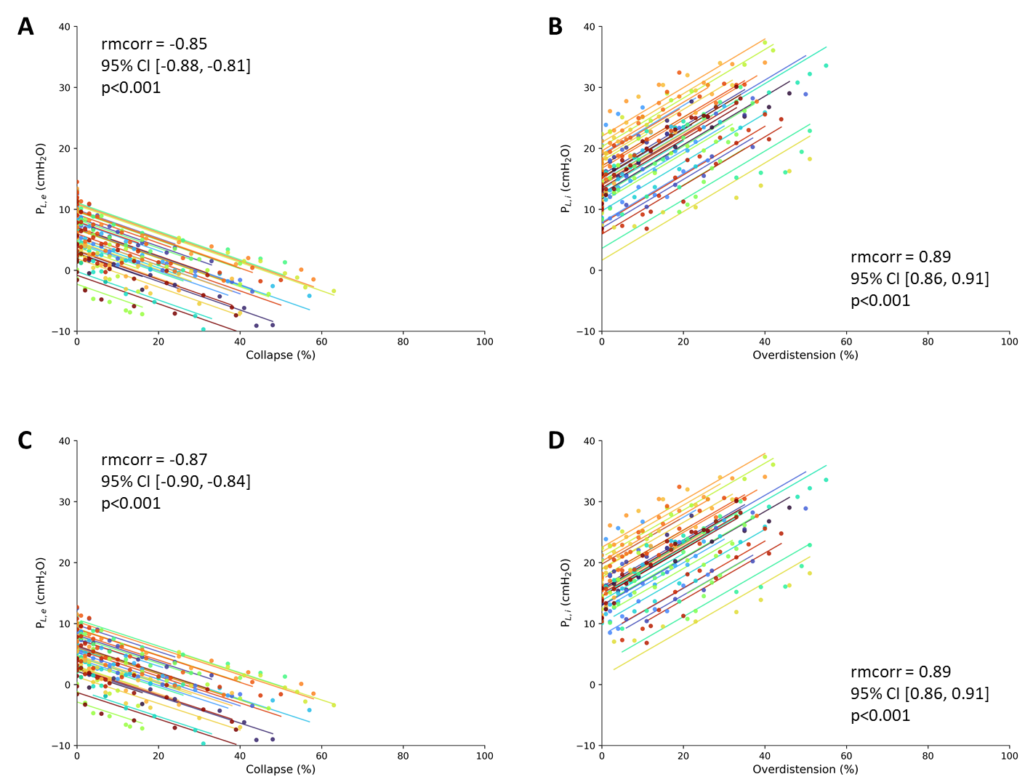
Supplementary Material – Figure e3
Correlation between collapse and end-expiratory transpulmonary pressure according to the obesity status, respiratory system compliance, oxygenation, and recruitability.
Scatterplots depicting the correlation (and 95% confidence interval) between P_{L,e} and the percentage of alveolar collapse according to [Panel A] obesity status (30 < BMI ≥ 30 Kg/m²), [Panel B] C_{rs} (35 < C_{rs} ≥ 35 cmH₂O/L), [Panel C] P_{a}O₂/F_{i}O₂ ratio (153 < P_{a}O₂/F_{i}O₂ ≥ 153 mmHg), and [Panel D] potential for lung recruitment (33 < Δcollapse ≥ 33 %). Solid line shows linear regression. Dashed vertical line shows 10% of collapse lung units out of the total lung imaged by EIT. Dashed horizontal line shows P_{L,e} at 0 cmH₂O – the theorical threshold value beyond which the risk of alveolar collapse increase. Δcollapse: absolute reduction in collapse, C_{rs}: respiratory system compliance, P_{a}O₂/F_{i}O₂: ratio of arterial oxygen partial pressure to fractional inspired oxygen, P_{L,e}: end-expiratory transpulmonary pressure.

A | B | C | D
Supplementary Material – Figure e4
Correlation between overdistension and end-inspiratory transpulmonary pressure according to the obesity status, respiratory system compliance, oxygenation, and recruitability.
Scatterplots depicting the correlation (and 95% confidence interval) between P_{L,i} and the percentage of alveolar overdistension according to [Panel A] obesity status (30 < BMI ≥ 30 Kg/m²), [Panel B] E_{rs} (35 < C_{rs} ≥ 35 cmH₂O/L), [Panel C] P_{a}O₂/F_{i}O₂ ratio (153 < P_{a}O₂/F_{i}O₂ ≥ 153 mmHg), and [Panel D] potential for lung recruitment (33 < Δcollapse ≥ 33 %). Solid line shows linear regression. Dashed vertical line shows 10% of overdistension lung units out of the total lung imaged by EIT. Dashed horizontal line shows P_{L,i} at 20 cmH₂O – the theorical threshold value above which the risk of alveolar overdistension increase. Δcollapse: absolute reduction in collapse, C_{rs}: respiratory system compliance, P_{a}O₂/F_{i}O₂: ratio of arterial oxygen partial pressure to fractional inspired oxygen, P_{L,i}: end-inspiratory transpulmonary pressure (elastance-derived method).

A | B | C | D

Supplementary Material – Figure e5
Optimal positive end-expiratory pressure according to titration strategies.

Panel A: Cumulative distribution of PEEP values determined by EIT-guided and esophageal pressure-guided strategy (PEEP_{EIT} and PEEP_{Peso}, respectively). Panel B: Correlation between PEEP_{EIT} and PEEP_{Peso}. Each dot represents one patient; the solid line indicates the linear regression with 95% confidence interval (shaded area). Panel C: Bland–Altman analysis showing agreement between PEEP_{EIT} and PEEP_{Peso}. The solid horizontal line represents the mean bias, and dashed lines indicate the 95% limits of agreement. PEEP: positive end-expiratory pressure, SD: standard deviation.

Supplementary Material – Figure e6
Comparisons of positive end-expiratory pressure titration strategies on respiratory mechanics, collapsus and alveolar overdistension.

Effect of EIT-guided strategy (PEEP_{EIT}) on (Panels A and D) transpulmonary pressures, (Panels B and E) percentages of collapse and/or overdistension, and (Panels C, F) lung compliances compared to esophageal pressure-guided strategy (PEEP_{Peso}). C_{L,D}: dependent lung compliance, C_{L,ND}: non-dependent lung compliance, P_{L,e}: end-expiratory transpulmonary pressure (direct method), P_{L,i}: end-inspiratory transpulmonary pressure (elastance-derived method).

