Supplementary Material

Figure S1. Linear regression plots of ERG b-wave amplitude during the scotopic luminescent response (SLR) stage comparing subconjunctival (SbC) and intravitreal (ITV) administration at 5 days. No statistically significant differences between regression slopes were detected (p ≥ 0.05). Grey circles represent pre-treatment recordings and black squares represent post-treatment recordings.
R² = 0.82
R² = 0.78
R² = 0.80
R² = 0.82
Figure S2. Linear regression of a-wave amplitude before and after CM administration (SLR stage, 5 days post-injection). Left: SbC route; right: ITV route.

R² = 0.21
R² = 0.58
R² = 0.57
R² = 0.23

Figure S3. Linear regression of b-wave amplitude before and after CM administration (PLR stage, 5 days post-injection). Left: SbC route; right: ITV route.
R² = 0.52
R² = 0.43
R² = 0.62
R² = 0.35
Figure S4. Linear regression of b-wave amplitude before and after CM administration (PF stage, 5 days post-injection). Left: SbC route; right: ITV route.

Figure S5. Linear regression of b-wave amplitude before and after CM administration (SLR stage, 28 days post-injection). Left: SbC route; right: ITV route.
R² = 0.47
R² = 0.23
R² = 0.63
R² = 0.28
R² = 0.76
R² = 0.79
R² = 0.82
R² = 0.73
Figure S6. Linear regression of a-wave amplitude before and after CM administration (SLR step, 28 days post-injection). Left: SbC route; right: ITV route.

Figure S7. Linear regression of a-wave amplitude before and after CM administration (SA step, 28 days post-injection). Left: SbC route; right: ITV route.
R² = 0.08
R² = 0.11
R² = 0.28
R² = 0.28
R² = 0.28
R² = 0.28
R² = 0.12
R² = 0.17
Figure S8. Linear regression of a-wave amplitude before and after CM administration during the SA stage, at 5- and 28-days post-injection. Left: SbC route 5 days; right: SbC route 28 days.

Figure S9. Linear regression of b-wave amplitude before and after CM administration during the SLR stage, at 5- and 28-days post-injection. Left: ITV route 5 days; right: ITV route 28 days.
R² = 0.80
R² = 0.82
R² = 0.82
R² = 0.73
R² = 0.41
R² = 0.58
R² = 0.63
R² = 0.28
Figure S10. Linear regression of a-wave amplitude before and after CM administration during the SLR stage, at 5- and 28-days post-injection. Left: ITV route 5 days; right: ITV route 28 days.

Figure S11. Linear regression of b-wave amplitude before and after CM administration during the PLR stage, at 5- and 28-days post-injection. Left: ITV route 5 days; right: ITV route 28 days.
R² = 0.62
R² = 0.35
R² = 0.22
R² = 0.50
R² = 0.57
R² = 0.23
R² = 0.29
R² = 0.40
Figure S12. Linear regression of b-wave amplitude before and after CM administration during the PF step, at 5- and 28-days post-injection. Left: ITV route 5 days; right: ITV route 28 days.

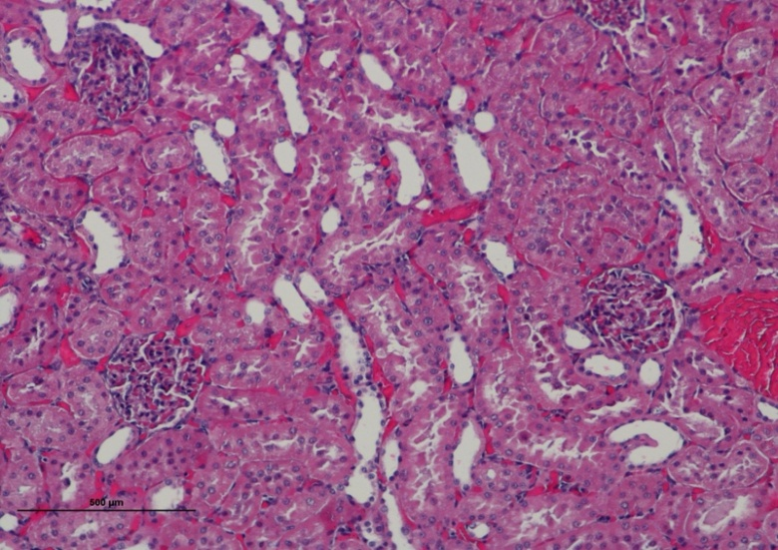
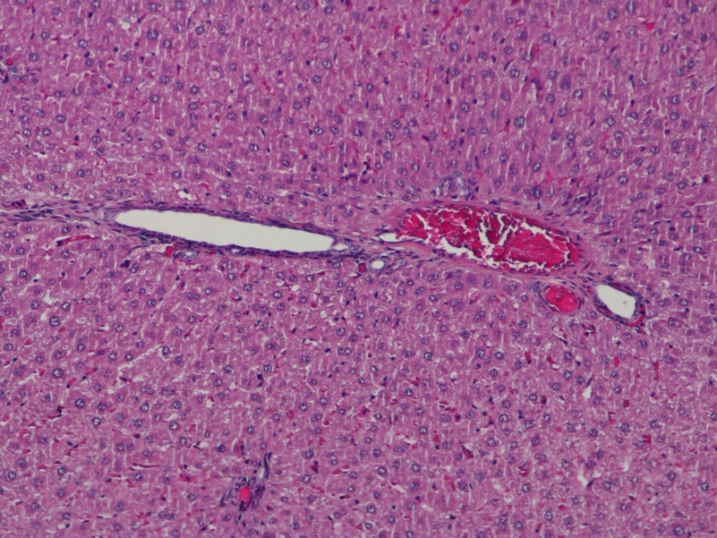
Figure S13. Representative photomicrograph of the kidney showing preserved overall organ morphology and intact structural organization. Mild histological alterations were observed, including generalized vascular congestion, rare hyaline casts within renal tubules, and occasional mild inflammatory infiltrates compatible with mild multifocal chronic interstitial nephritis. No additional lesions of pathological significance were identified. Hematoxylin and Eosin staining; 100× magnification.
Figure S14. Representative photomicrograph of the liver showing preserved overall organ architecture, with emphasis on the hepatic triad region. No necrosis, fibrosis, or significant inflammatory infiltration is present. Hematoxylin and Eosin staining; 100× magnification.
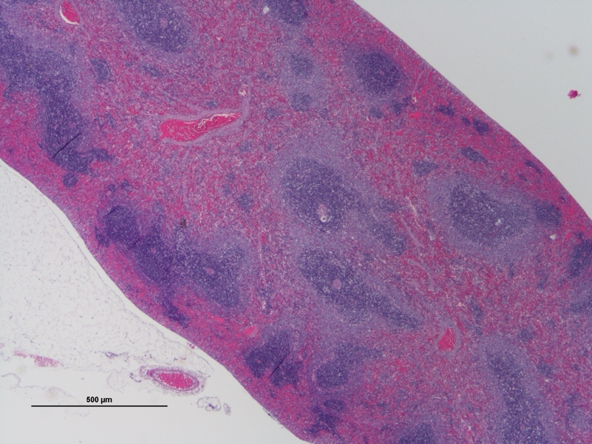
Figure S15. Representative photomicrograph of the spleen showing overall preservation of organ architecture. Mild histological alterations were observed, including areas of follicular lympholysis consistent with white pulp depletion, interspersed with regions of lymphoid hyperplasia and mild vascular congestion. Hematoxylin and Eosin staining; 20× magnification.

