Supplemental Figures

Granzyme A-expressing Terminal Effector T Cells Dedifferentiate into Long-lived Memory T Cells

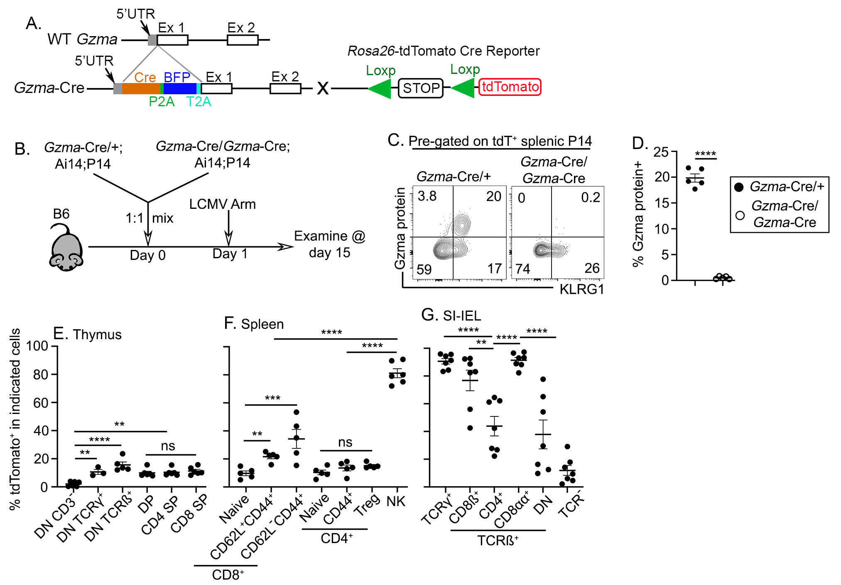
Figure S1. Generation of Gzma-fate mapping (Gzma-FM) mice. (A) Design of the Gzma-Cre allele and the breeding strategy to generate Gzma-FM mice. (B) Experimental design for (C) and (D). (C) and (D), Gzma protein expression was measured by flow cytometry in pre-gated P14 CD8⁺ T cells isolated from the spleen of infected mice. Two subsets of P14 T cells with different genotypes are shown, i.e., Gzma-Cre/+ and Gzma-Cre/Gzma-Cre. (E-H) Naïve Gzma-FM/+ mice were analyzed by flow cytometry at 8-12 weeks. The percentage of tdTomato⁺ cells in indicated subsets of lymphocytes isolated from (E) thymus, (F) spleen, and (G) small intestine intraepithelial lymphocytes (SI-IEL) is shown. Each symbol represents the results from one mouse. Pooled results from 3-4 independent experiments are shown. One-way ANOVA or t-test, ns, not significant, **, p<0.01, ***, p<0.001, and ****, p<0.0001.

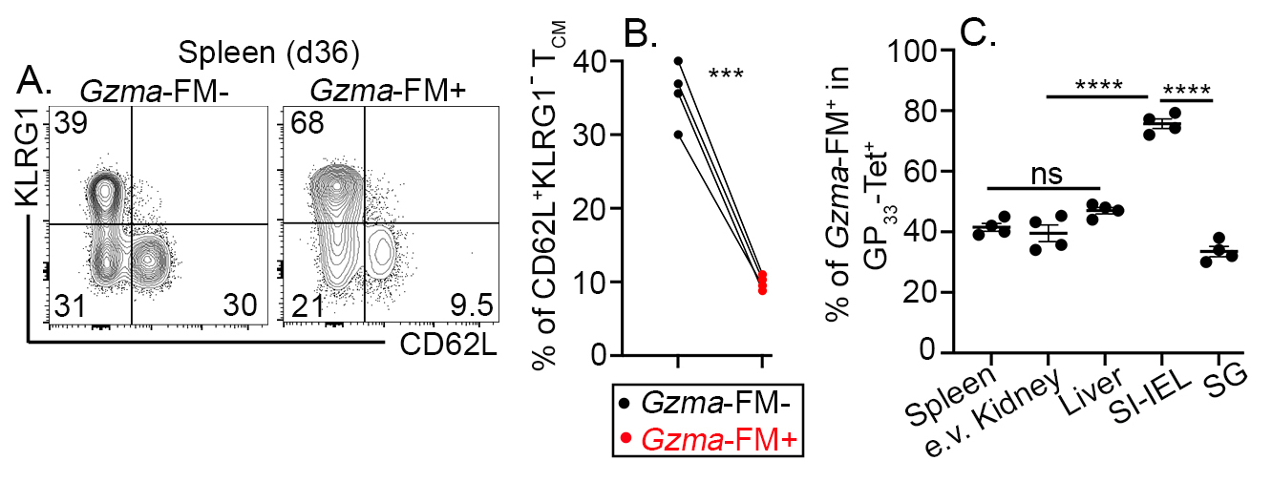
Figure S2. The distribution and characterization of Gzma-FM⁺ cells in polyclonal CD8⁺ T cells post LCMV infection. Gzma-FM mice were directly infected with LCMV Arm. Day 36 post-infection, representative FACS profiles of Gzma-FM⁻ and Gzma-FM⁺ cells among pre-gated H2-D^{b}-GP₃₃₋₄₁ tetramer⁺ subsets are shown in (A). (B) The percentage of CD62L⁺KLRG1⁻ T_{CM} cells in Gzma-FM⁻ and Gzma-FM⁺ H2-D^{b}-GP₃₃₋₄₁ tetramer⁺ CD8⁺ T cells in the spleen. (C) The percentage of Gzma-FM⁺ cells in H2-D^{b}-GP₃₃₋₄₁ tetramer⁺ CD8⁺ T cells isolated from the indicated tissues. e.v., extravascular, defined by intravascular CD8 staining in vivo. Each symbol in (C) and each pair of symbols in (B) represents the results from one mouse. Paired Student t-test or one-way ANOVA, ns, not significant, ***, p<0.001, and ****, p<0.0001.
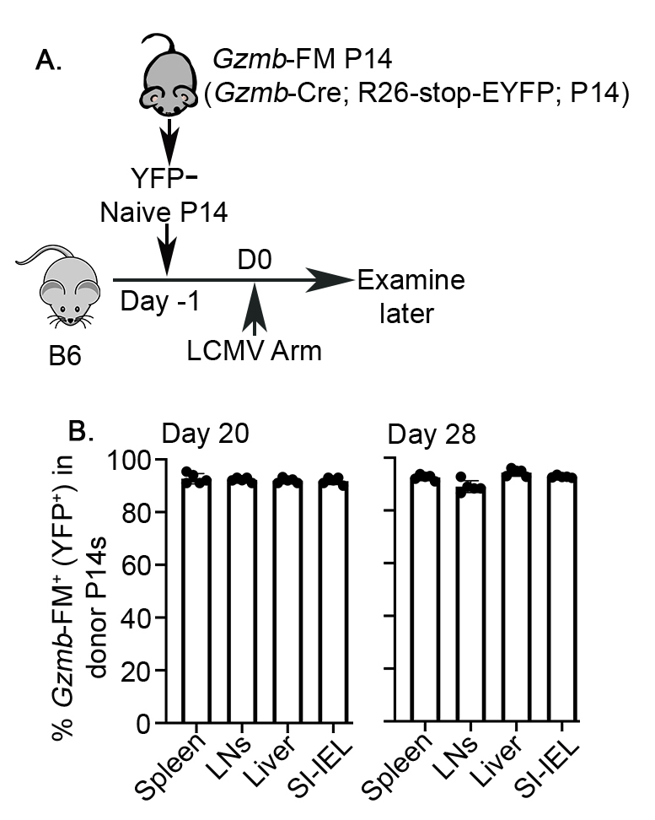

Figure S3. Gzmb-FM labels activated CD8⁺ T cells. (A) Experimental design. YFP⁻naïve P14 T cells were sorted from Gzmb-FM-P14 mice. 5,000 sorted cells were adoptively transferred into each B6 recipient, followed by LCMV Arm infection. (B) At day 20 (left) and day 28 (right) post-infection, the percentage of YFP⁺ (Gzmb-FM⁺) cells in donor P14 T cells isolated from the indicated tissues is shown. Each symbol represents the results from one B6 recipient. Pooled results from two repeats.

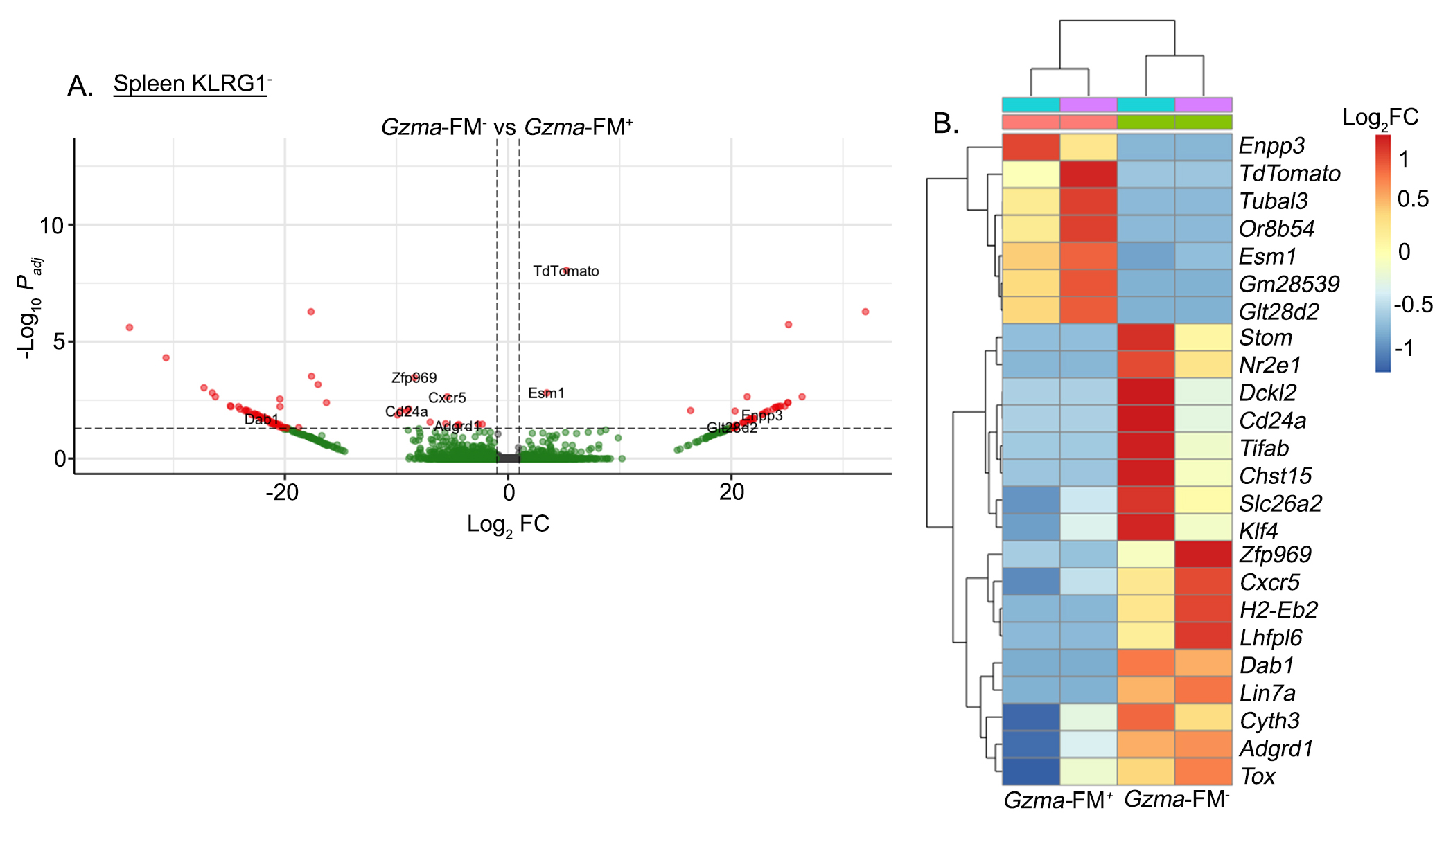
Figure S4. Transcriptional profiles of Gzma-FM⁻ and Gzma-FM⁺ memory T cells. Similar experimental design as in Fig. 2A. Day 36 post-infection, KLRG1⁻Gzma-FM⁻ and KLRG1⁻Gzma-FM⁺ P14 T cells were FACS sorted from the spleen. Sorted cells were subjected to RNA-seq analyses. (A), volcano plot, and (B), heatmap to show differentially expressed genes. Each column in (B) represents a biologically independent replicate.
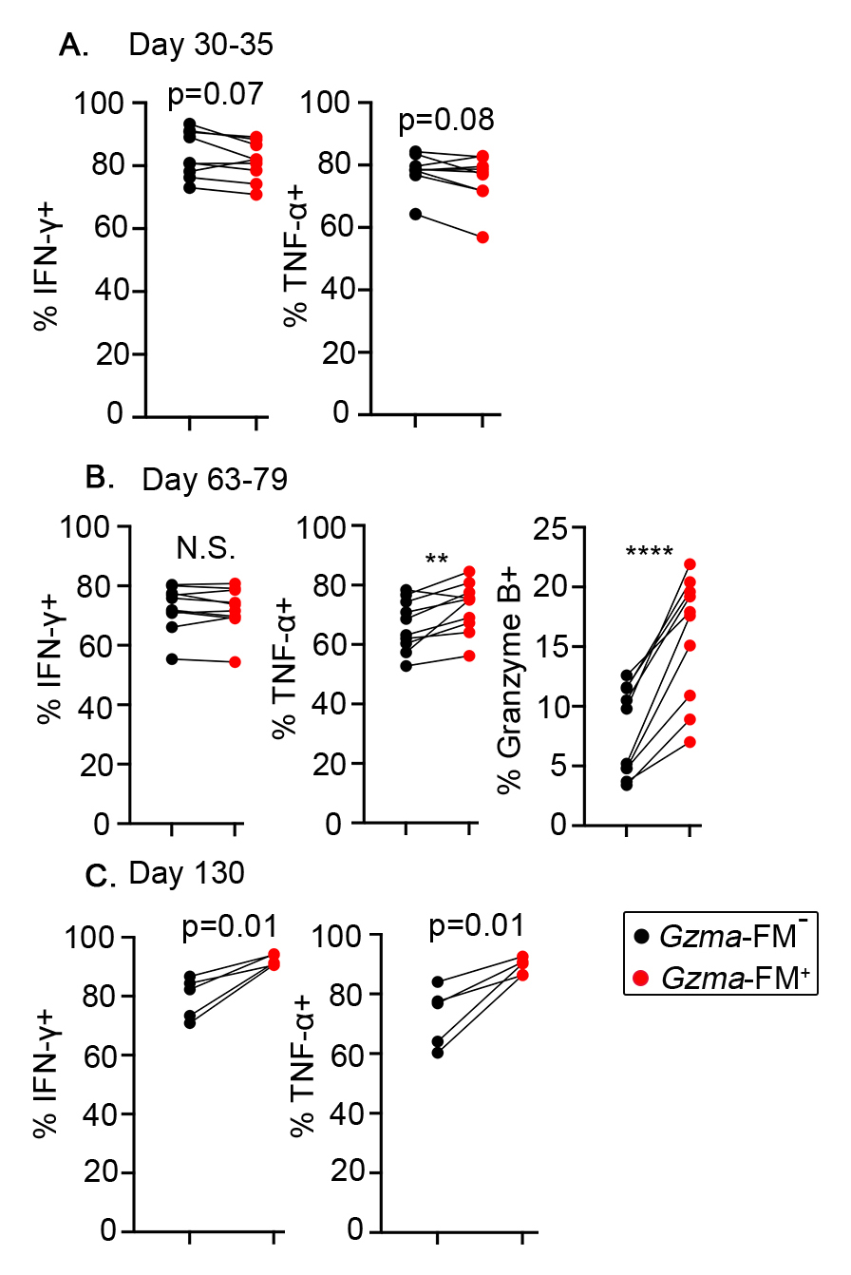
Figure S5. Enhanced effector cytokine production in Gzma-FM⁺ long-term memory T cells. Similar experimental design as in Fig. 2A. At (A) day 30-35, (B) day 63-79 and (C) day 130 post LCMV Arm infection, cytokine production from Gzma-FM⁻ and Gzma-FM⁺ donor P14 memory T cells was measured by intracellular FACS staining after 4-hour ex vivo peptide stimulation. Each pair of symbols represents the results from one recipient. Pooled results from 3 independent repeats are shown. Paired Student t-test, N.S., not significant, **, p<0.01 and ****, p<0.0001.

