S1. Canonical Correlation Analysis (exploratory)
CCA was used to explore the association between immune-related variables (IgM, mucus protein, LYZ gene, IL-1β, and TNF-α) and antioxidant-related variables (SOD activity, GPx activity, CAT activity, MDA, SOD gene, and GPx gene). The first and second canonical correlations were high (r = 1.000, p < 0.001; r = 0.984, p = 0.021), suggesting a coordinated relationship between the two variable sets under the present experimental conditions. However, these results should be interpreted cautiously given the limited sample size (n = 12 tank means) and the exploratory nature of the analysis.
Supplementary Fig. S1. Canonical Correlation Analysis (CCA) biplot showing the relationship between immune parameters (IgM, mucus protein, LYZ gene, IL-1β, TNF-α) and antioxidant parameters (SOD, GPx, CAT, MDA, SOD gene, GPx gene). The first canonical correlation was very high (r = 1.000, p < 0.001), and the second was also strong (r = 0.984, p = 0.021), indicating a coordinated biological response between immune and antioxidant systems after WCF treatment.

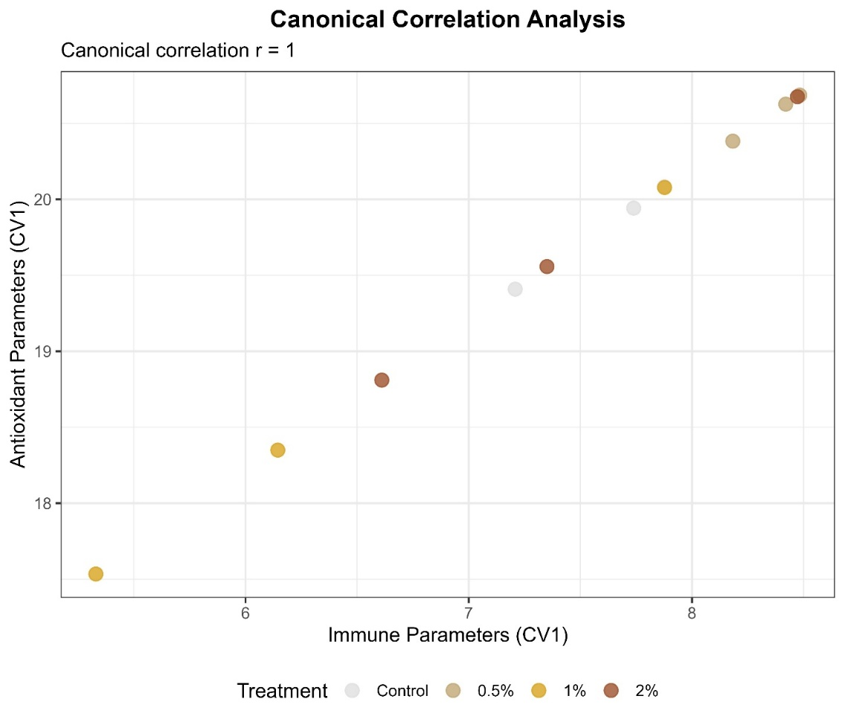

S2. Redundancy Analysis (exploratory)
RDA was used to examine the proportion of biomarker variation explained by dietary treatment. Treatment dose explained 23.1% of the total variance (permutation test, F = 3.005, p = 0.042). The ordination plot suggested partial separation of the 1% and 2% groups along the first RDA axis, with MDA, ALT, and LDH associated more strongly with the 2% group, whereas IgM and TNF-α were more closely associated with the 1% group. These patterns are exploratory and should be interpreted cautiously.
Supplementary Fig. S2. Redundancy Analysis (RDA) triplot showing the relationship between treatment dose and all measured biomarkers. Dose significantly explained 23.1% of the total variance (permutation test, F = 3.005, p = 0.042). The 1% and 2% treatment groups are clearly separated along the first RDA axis. MDA, ALT and LDH load strongly toward the 2% group, while IgM and TNF-α load toward the 1% group.
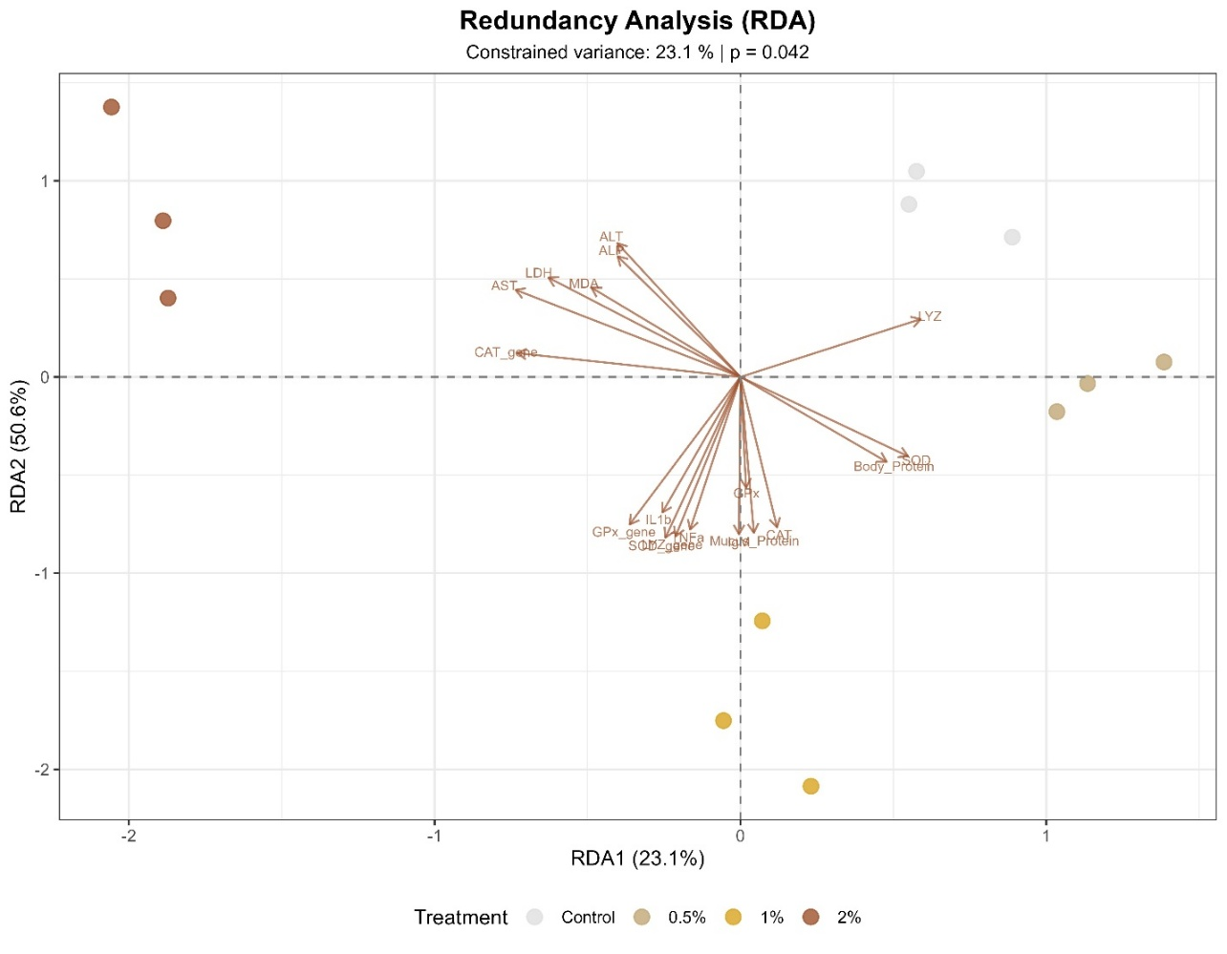

S3. Partial Least Squares Regression (exploratory)
PLSR was used to explore which biomarkers contributed most strongly to discrimination among WCF doses. The first two components explained 75.6% of the variance in the predictors, and the cross-validated R² was 0.761. The highest loading weights were observed for MDA (0.56), total protein (0.55), SOD gene expression (0.54), ALT (0.52), and LDH (0.51), suggesting that oxidative stress markers, liver enzymes, and antioxidant gene expression contributed most strongly to dose separation. Because of the limited sample size, these findings should be interpreted as exploratory.
Supplementary Fig. S3. Partial Least Squares Regression (PLSR) loading plot showing the most important predictors of WCF dose. The first two components explained 75.6% of the variance in the predictors (cross-validated R² = 0.761). MDA, body protein, SOD gene, ALT and LDH showed the strongest loading weights, confirming that oxidative stress, liver enzymes and antioxidant gene expression are the dominant drivers of dose prediction.
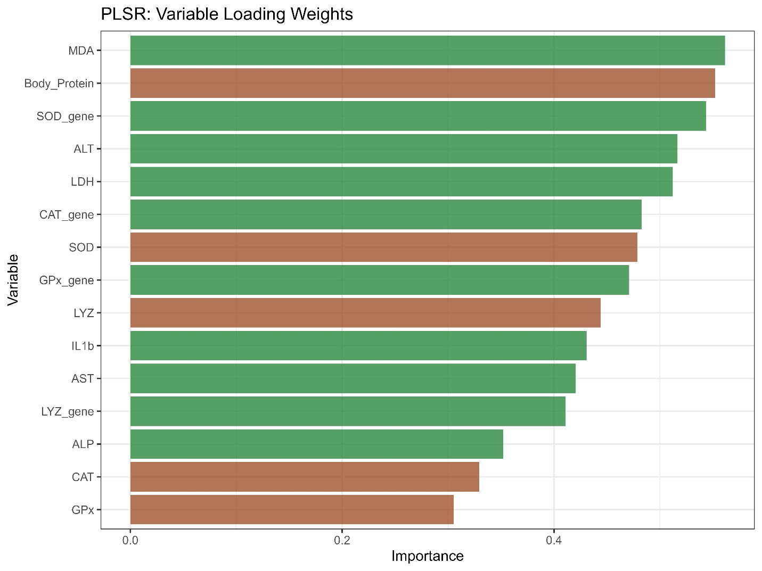

S4. Benchmark Dose (BMD) and optimal dose estimation
Benchmark dose modelling for a 10% increase in adverse endpoints (MDA and ALT) yielded a BMD₁₀ of approximately 1.2% WCF under the present experimental conditions. This value suggests that adverse responses begin to emerge above the moderate inclusion range. A desirability function combining beneficial and adverse endpoints indicated that 1% WCF had the highest overall desirability score (0.85), suggesting that this was the most favorable inclusion level in the present study.
Supplementary Fig. S4.1. Benchmark dose (BMD) analysis for MDA (malondialdehyde) as an adverse endpoint. The horizontal dashed line represents a 10% increase over the control value (BMD₁₀). The vertical dashed line indicates the calculated BMD₁₀ of approximately 1.2% WCF, defining the safe upper limit for dietary supplementation.
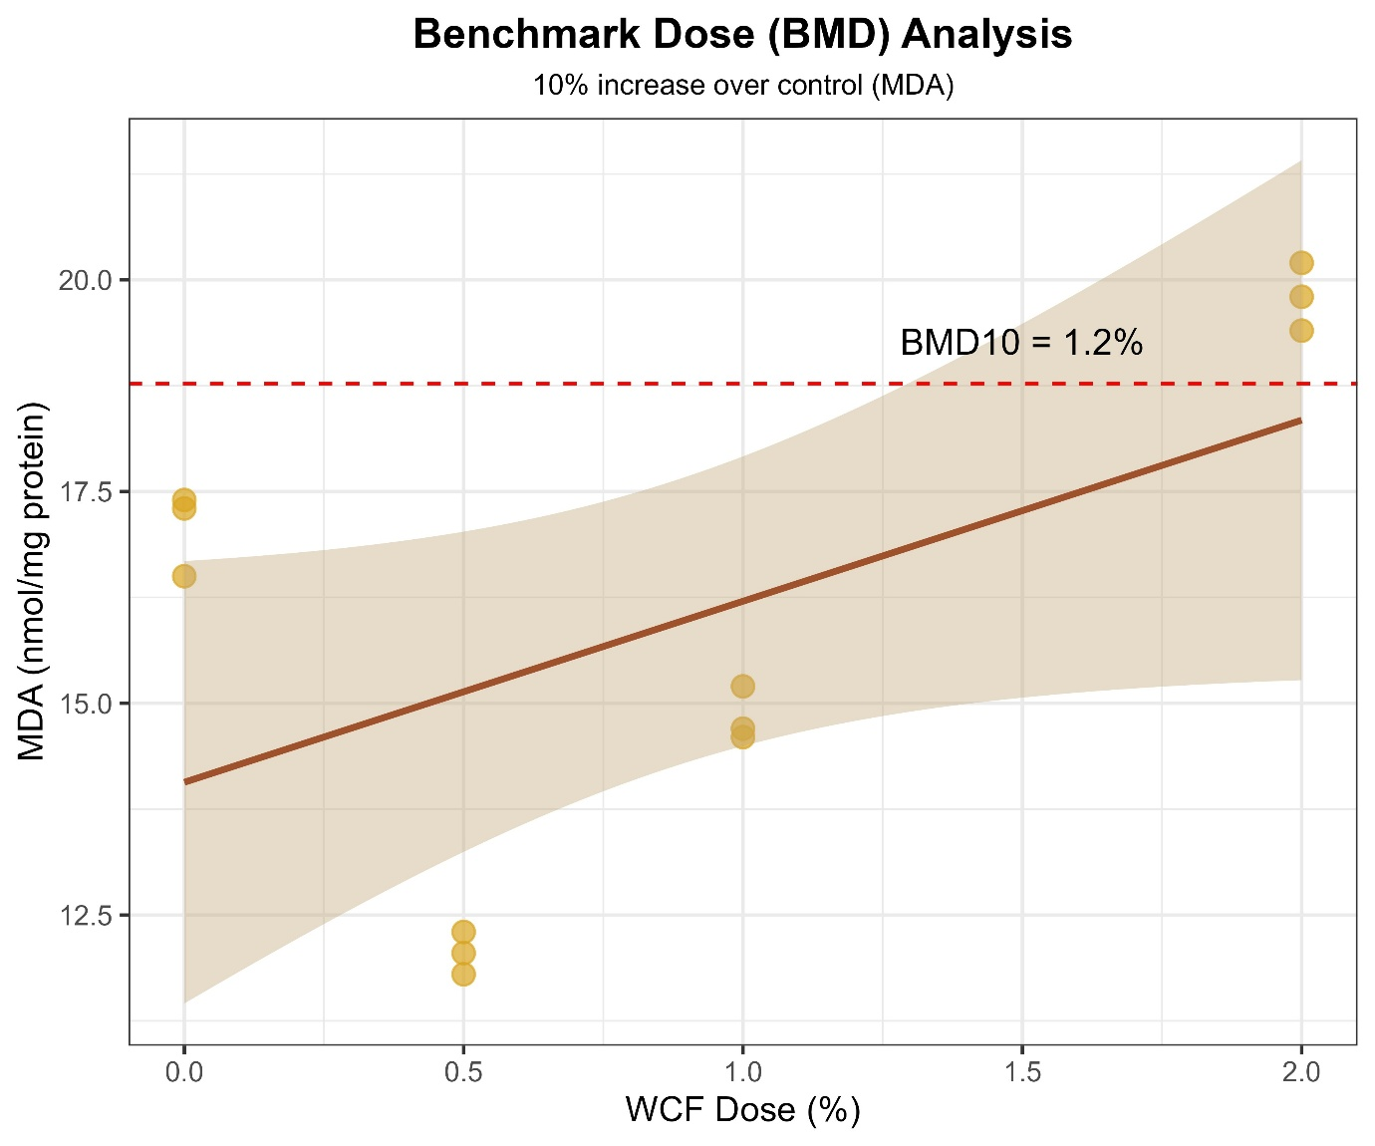

Supplementary Fig. S4.2. Desirability function analysis combining all beneficial and adverse outcomes to identify the mathematically optimal WCF dose. The peak desirability score (0.85) occurs at 1% WCF, confirming this as the optimal supplementation level. Scores range from 0 (undesirable) to 1 (highly desirable).
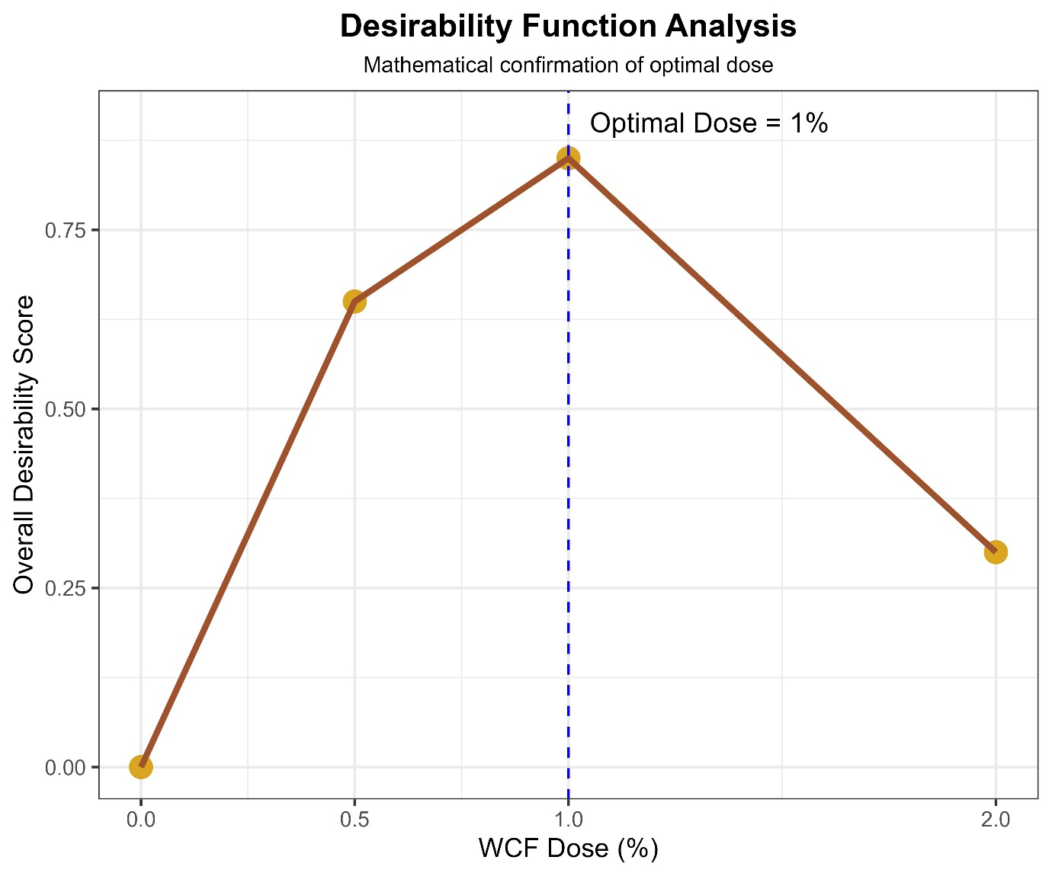

S5. Bootstrap validation
Key estimates (IgM, TNF-α, and MDA at 1% and 2% WCF) were assessed by 1000-iteration bootstrap resampling. Bias was minimal and the confidence intervals were relatively narrow, supporting the stability of the observed trends. However, these results should be interpreted as supportive rather than confirmatory because of the limited number of independent tanks.
Supplementary Fig. S5. Bootstrap validation of key biomarkers in zebrafish fed diets containing different levels of Withania coagulans fruit powder. Bootstrap resampling (1000 iterations) was performed for representative immune and oxidative stress biomarkers, including total immunoglobulin (IgM), TNF-α expression, and malondialdehyde (MDA), at 1% and 2% WCF inclusion levels relative to the control group. 