Supporting Information

Effect of activated carbon on the production selectivity of Ni/MoC catalyst for methanol steam reforming
Yawen Qi,ª Xinxin Zhao,ª Rong Zhang,ª Ling Cao,^{b,}* Fufeng Cai,^{a,b,}*
ª Faculty of Chemical Engineering and Energy Technology, Shanghai Institute of Technology, Shanghai 201418, PR China
^{b} College of Chemistry and Chemical Engineering, Changji University, Changji, 831100, PR China
E-mail addresses: caiff@sit.edu.cn (F. Cai), caolinggirl@126.com (L. Cao).
Tel./Fax: +86 21 60877223.

This file includes:
Fig. S1-S2.

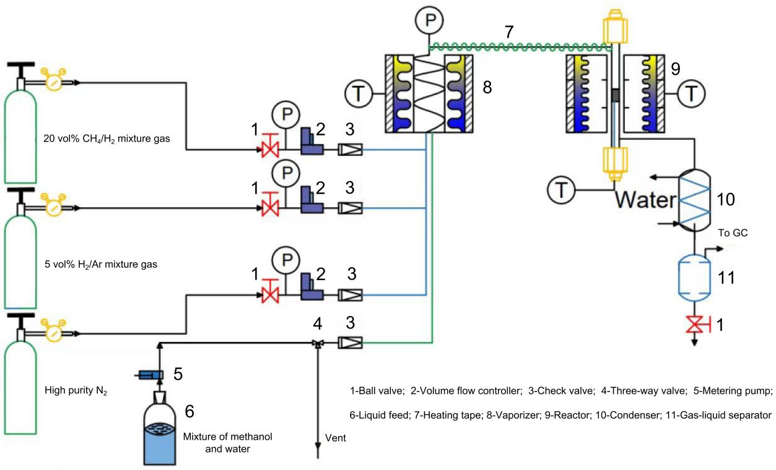
Fig. S1. Schematic diagram of the experimental apparatus for methanol steam reforming (MSR) reaction. The MSR experiment was performed in a vertical fixed-bed flow reactor. The experimental apparatus mainly contained the reactor, vaporizer, condenser, gas chromatograph, etc. The reactor and vaporizer were an electric heating furnace. The condenser was a gas–liquid separator. The flow range of metering pump was from 0.001ml/min to 0.500 ml/min. The gas chromatograph (GC9790Ⅱ, China) was equipped with two thermal conductivity detectors, and the chromatographic columns were respectively Plot Q (analysis of CO₂) and 5A molecular sieve (analysis of H₂, N₂, CH₄ and CO). The carrier gas for the GC was high-purity Ar.

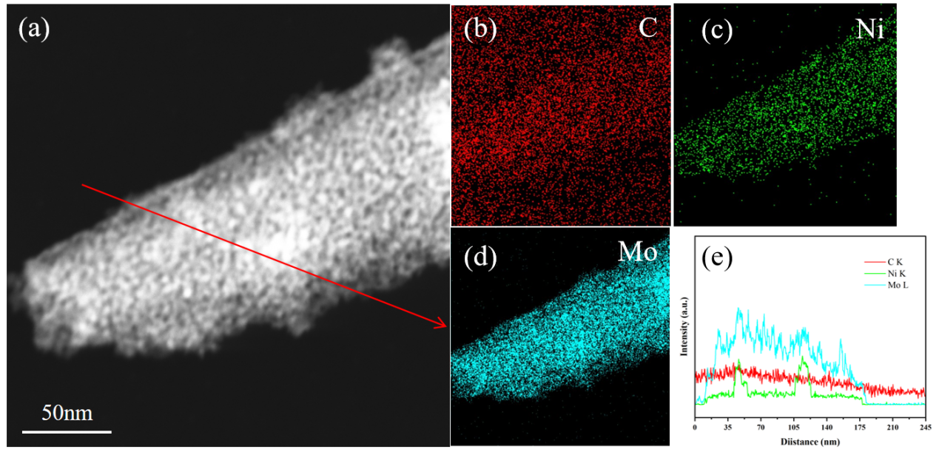
Fig. S2. (a) TEM image of 5CNi/MoC catalyst; (b-d) corresponding EDX element mappings of 5CNi/MoC catalyst; (e) EDX line spectra along the red arrow in (a).

