Appendix A
Table A1. Mean values of nine hydrological signature metrics across five sub-basins for six calibration methods. Bold values indicate the best-performing method in each (station, metric) cell.
Station | Method | KGE | RMSE | PBIAS (%) | Peak Ratio | Low Flow Ratio | BFI Bias (%) | Peak Timing Bias (d) | Peak Mag. Bias (%) | Recession K Ratio
XX | SADR (G) | 0.653 | 165.8 | -3.1 | 0.812 | 1.41 | 0.5 | -0.20 | 18.8 | 2.01
XX | MADR (G) | 0.817 | 127.2 | 4.3 | 0.908 | 1.52 | 4.8 | -0.07 | 23.4 | 1.50
XX | SADR (C) | 0.817 | 131.6 | 6.1 | 0.942 | 1.42 | -3.5 | -0.12 | 31.0 | 2.10
XX | MADR (C) | 0.843 | 125.7 | -0.5 | 0.960 | 1.12 | -8.5 | -0.09 | 32.0 | 2.30
XX | NSGA-III | 0.853 | 117.8 | -4.8 | 0.933 | 1.03 | -1.6 | -0.07 | 24.6 | 1.48
XX | SCE-UA | 0.860 | 116.7 | -7.4 | 0.941 | 0.79 | -2.7 | 0.05 | 24.7 | 1.37
WJB | SADR (G) | 0.878 | 156.3 | 1.0 | 0.957 | 1.70 | 3.1 | 0.03 | 3.7 | 1.14
WJB | MADR (G) | 0.847 | 170.0 | 6.6 | 0.977 | 2.18 | 7.3 | 0.10 | 5.7 | 0.87
WJB | SADR (C) | 0.852 | 168.8 | 5.7 | 1.016 | 1.89 | 1.8 | 0.05 | 10.5 | 1.08
WJB | MADR (C) | 0.864 | 165.5 | 4.4 | 0.972 | 2.00 | 6.4 | 0.14 | 5.5 | 0.88
WJB | NSGA-III | 0.857 | 165.5 | 1.8 | 0.874 | 2.17 | 17.6 | -0.02 | -5.0 | 0.44
WJB | SCE-UA | 0.852 | 162.7 | 5.7 | 0.889 | 2.18 | 19.5 | 0.00 | -3.4 | 0.37
JJJ | SADR (G) | 0.376 | 118.9 | -31.7 | 0.507 | 1.47 | 0.7 | -0.12 | -29.5 | 1.25
JJJ | MADR (G) | 0.526 | 106.3 | -19.8 | 0.662 | 2.17 | -4.7 | -0.07 | -8.6 | 1.19
JJJ | SADR (C) | 0.402 | 116.7 | -30.3 | 0.533 | 1.52 | -1.4 | -0.10 | -26.5 | 1.32
JJJ | MADR (C) | 0.533 | 106.7 | -18.1 | 0.667 | 2.17 | -5.1 | -0.04 | -7.7 | 1.20
JJJ | NSGA-III | 0.533 | 104.8 | -22.4 | 0.688 | 1.85 | -6.3 | 0.13 | -4.5 | 0.92
JJJ | SCE-UA | 0.520 | 106.5 | -23.9 | 0.670 | 1.58 | -14.1 | 0.11 | -6.6 | 1.26
ZK | SADR (G) | 0.728 | 127.2 | 8.7 | 0.866 | 12.70 | 20.6 | -0.18 | 21.3 | 0.62
ZK | MADR (G) | 0.688 | 127.3 | 13.5 | 0.834 | 15.08 | 24.5 | -0.21 | 18.5 | 0.55
ZK | SADR (C) | 0.714 | 127.7 | 11.7 | 0.865 | 13.44 | 22.5 | -0.19 | 22.0 | 0.59
ZK | MADR (C) | 0.777 | 112.5 | 3.7 | 0.834 | 11.57 | 22.0 | -0.28 | 13.1 | 0.63
ZK | NSGA-III | 0.841 | 112.6 | 9.2 | 0.939 | 17.20 | 17.8 | -0.24 | 22.8 | 0.34
ZK | SCE-UA | 0.758 | 110.8 | 19.5 | 0.926 | 20.72 | 25.9 | -0.24 | 22.1 | 0.29
BB | SADR (G) | 0.569 | 618.0 | 42.2 | 1.192 | 4.93 | 13.5 | -0.68 | 25.4 | 0.40
BB | MADR (G) | 0.608 | 591.9 | 36.9 | 1.121 | 4.69 | 12.7 | -0.32 | 19.6 | 0.41
BB | SADR (C) | 0.579 | 618.2 | 41.0 | 1.177 | 4.81 | 13.5 | -0.24 | 24.5 | 0.40
BB | MADR (C) | 0.616 | 591.9 | 37.4 | 1.181 | 4.44 | 12.2 | 0.08 | 26.5 | 0.41
BB | NSGA-III | 0.627 | 559.3 | 36.4 | 1.184 | 4.90 | 14.4 | 0.05 | 24.7 | 0.26
BB | SCE-UA | 0.516 | 618.7 | 48.0 | 1.184 | 5.14 | 13.6 | 0.03 | 25.6 | 0.32

Appendix B

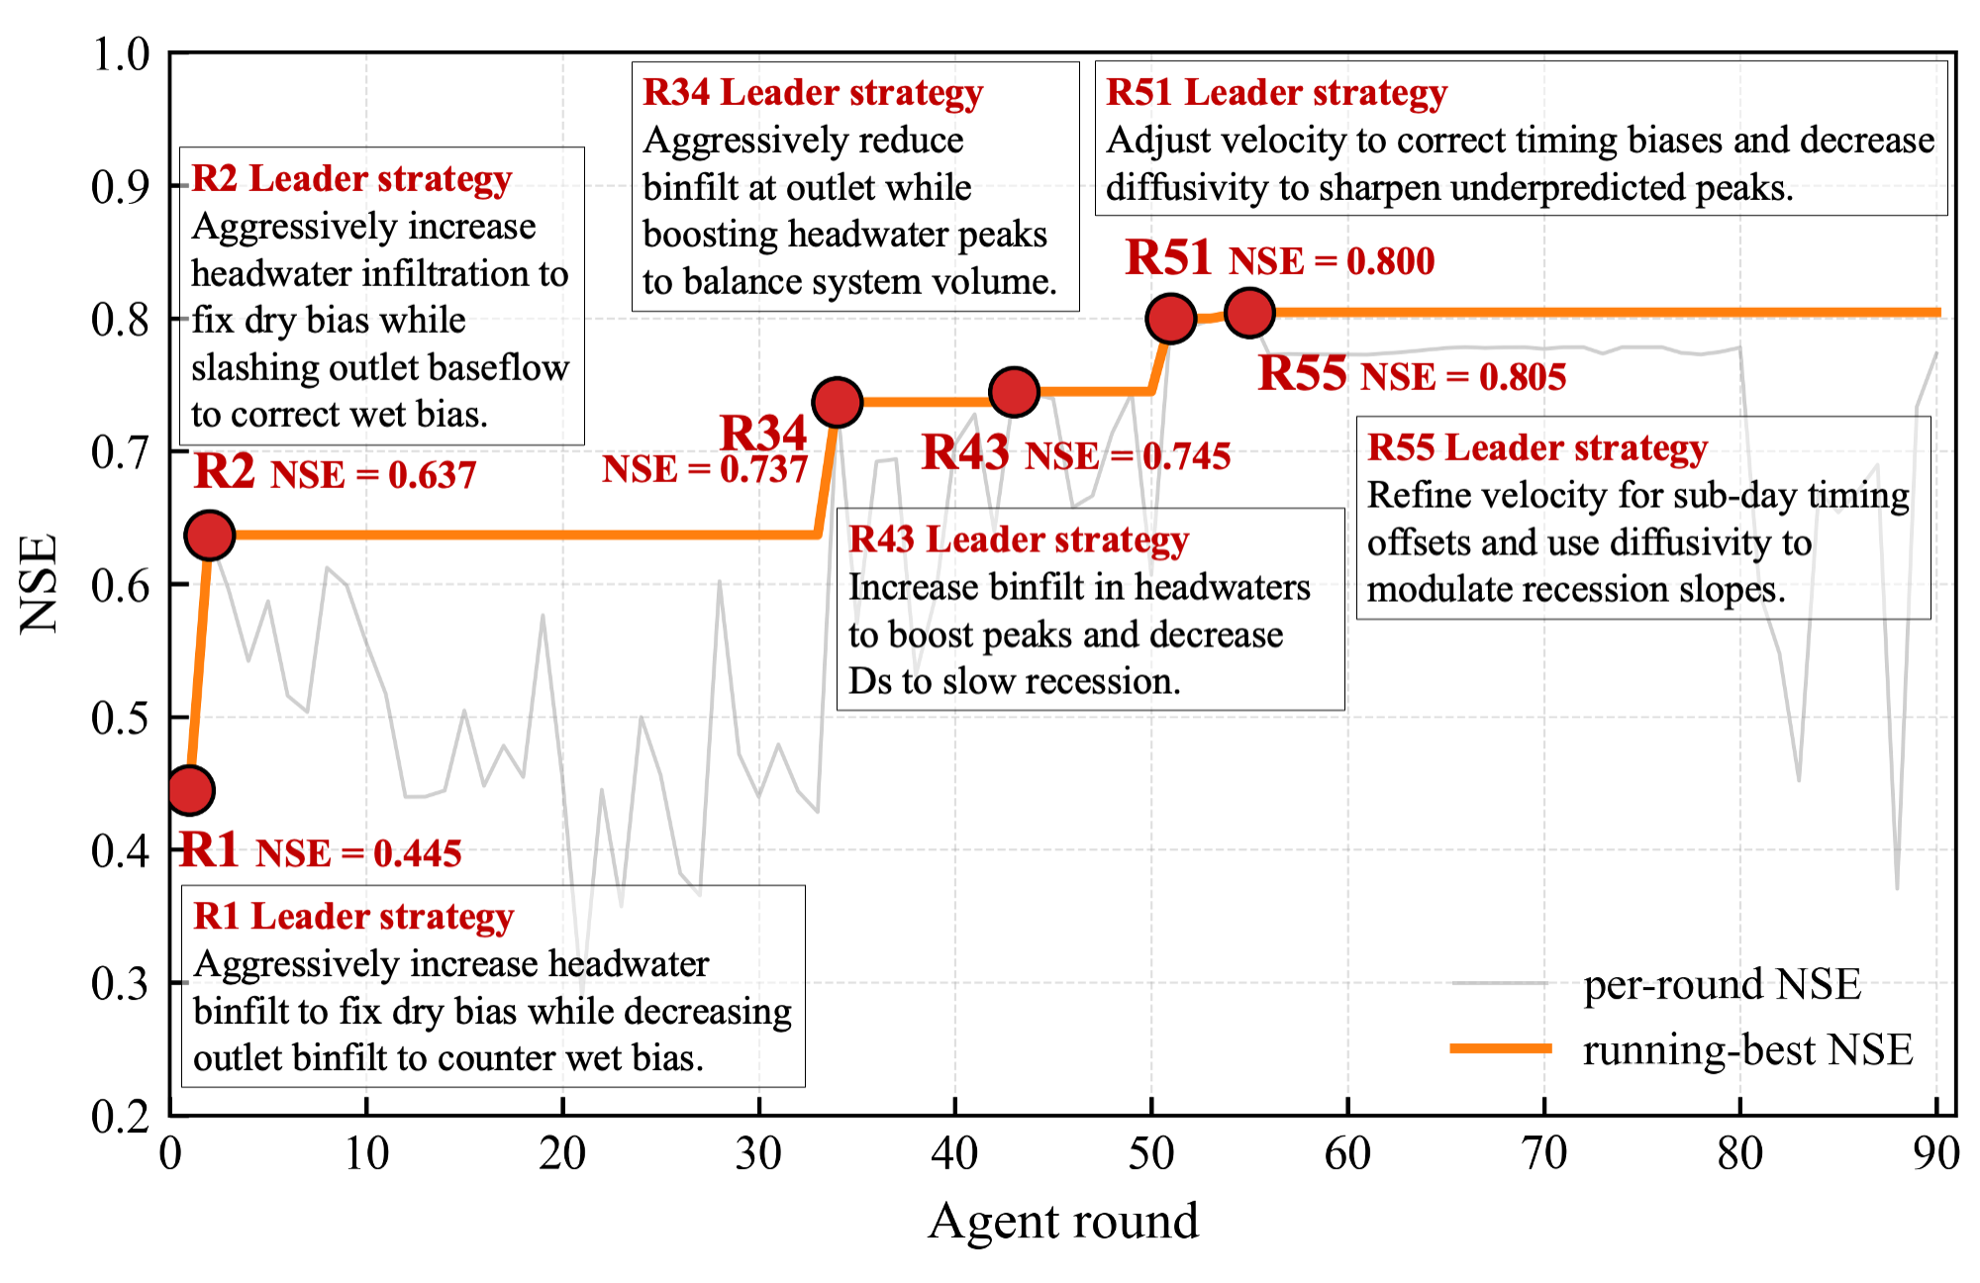
Figure B1. Evolution of the Leader's diagnostic strategy across calibration rounds for a representative MADR (Gemini) run, with the NSE evaluated at the outlet station BB whose response integrates parameter adjustments across all five upstream sub-basins.

Appendix C

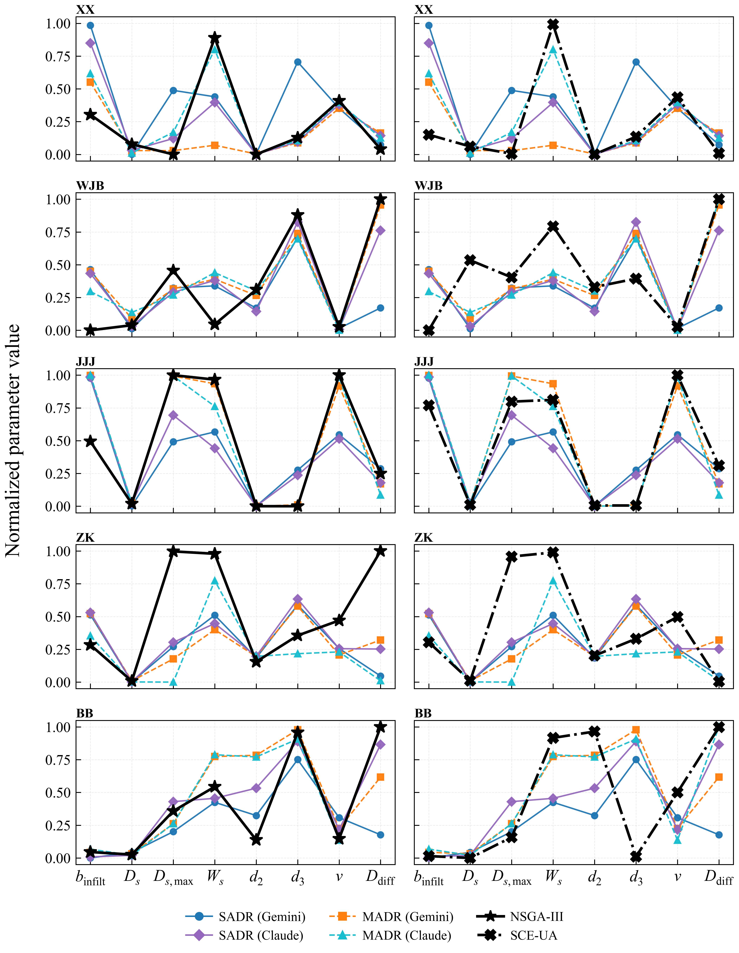
Figure C1. Calibrated parameter regions for MADR and SADR versus NSGA-III (left) and SCE-UA (right) across the five sub-basins.

