Bidirectional modifying effects of PM_{2.5} pollution and non-optimal temperatures on cardiovascular diseases
Jiahui Zhou^{a, 1}, Yueyue Zhu ^{a, 1}, Yingru Gongª, Meng Cheng^{b}, Haisheng Wu^{c}, Yanlong Xu ^{d, *}, Yuhui Wan^{a, *}, Jinping Ou^{a, *}
ª The Department of Health Promotion and Behavioral Sciences, School of Public Health, Anhui Medical University, Hefei 230032, China
^{b} Environmental Health, School of Public Health, Anhui Medical University
^{c} School of Public Health, LKS Faculty of Medicine, The University of Hong Kong, Hong Kong Special Administrative Region, China.
^{d} Anhui Provincial Center for Disease Control and Prevention, Hefei 230601, China.

Table S1 The modification effect of PM_{2.5} on the relationship between non-optimal temperature and CVD mortality risk under different definitions of extreme temperature (P_{2.5}, P_{97.5}; P₁₀, P₉₀).
Subgroup | PM_{2.5}  level | EHT |  | ELT
Subgroup | PM_{2.5}  level | OR (95% CI) | P for Z test | OR (95% CI) | P for Z test
P_{2.5}、P_{97.5} | Low | 1.47 (0.98, 2.19) | 0.90 | 1.53 (0.97, 2.43) | 0.91
P_{2.5}、P_{97.5} | Medium | 1.06 (0.98, 1.14) * | <0.01 | 1.07 (0.99, 1.17) * | <0.01
P_{2.5}、P_{97.5} | High | 1.51 (1.30, 1.76) |  | 1.58 (1.35, 1.84)
P₁₀、P₉₀ | Low | 0.96 (0.87, 1.06) * | <0.01 | 1.41 (1.00, 2.01) | 0.97
P₁₀、P₉₀ | Medium | 1.04 (0.98, 1.11) * | <0.01 | 1.04 (0.98, 1.12) * | <0.01
P₁₀、P₉₀ | High | 1.74 (1.36, 2.22) |  | 1.43 (1.23, 1.66)
Abbreviations: PM_{2.5}, particulate matter with aerodynamic diameter ≤ 2.5 μm; EHT, extreme high temperature (above the 95th percentile); ELT, extreme low temperature (below the 5th percentile). *: P < 0.05.
Notes: PM_{2.5} levels were categorized as low (< 25th percentile), medium (25th–75th percentile), and high (> 75th percentile). Two-sample Z-tests were conducted to compare the effects of EHT and ELT across PM_{2.5} strata, with the high PM_{2.5} level serving as the reference. P-values from Z-tests indicate inter-stratum differences.

Table S2 The modification effect of PM_{2.5} on the relationship between non-optimal temperature and CVD mortality risk after adjusting for other pollutants (PM₁₀, O₃, SO₂, NO_{2,} CO) in the model.
Subgroup | PM_{2.5}  level | EHT |  | ELT
Subgroup | PM_{2.5}  level | OR (95% CI) | P for Z test | OR (95% CI) | P for Z test
Add PM_{10,} O_{3,} SO_{2,} NO_{2,} CO | Low | 1.12 (1.00, 1.26) * | <0.01 | 1.02 (0.91, 1.15) * | <0.01
Add PM_{10,} O_{3,} SO_{2,} NO_{2,} CO | Medium | 1.11 (1.00, 1.23) * | <0.01 | 1.09 (1.00, 1.19) * | <0.01
Add PM_{10,} O_{3,} SO_{2,} NO_{2,} CO | High | 2.41 (1.67, 3.49) |  | 2.13 (1.55, 2.94)
Abbreviations and notes: Same as Table S1. Models were additionally adjusted for co-pollutants including PM₁₀, ozone (O₃), sulfur dioxide (SO₂), nitrogen dioxide (NO₂), and carbon monoxide (CO). *: P < 0.05.

Table S3 The modification effect of PM_{2.5} on the relationship between non-optimal temperature and CVD mortality risk when the lag period of PM_{2.5} is adjusted to lag02–lag07.
Subgroup | PM_{2.5}  level | EHT |  | ELT
Subgroup | PM_{2.5}  level | OR (95% CI) | P for Z test | OR (95% CI) | P for Z test
PM_{2.5}_lag02 | Low | 1.12 (1.01, 1.24) * | <0.01 | 1.03 (0.93, 1.14) * | <0.01
PM_{2.5}_lag02 | Medium | 1.03 (0.93, 1.13) * | <0.01 | 1.02 (0.94, 1.11) * | <0.01
PM_{2.5}_lag02 | High | 1.79 (1.30, 2.46) |  | 1.64 (1.24, 2.16)
PM_{2.5}_lag03 | Low | 1.15 (1.04, 1.28) * | 0.04 | 1.05 (0.95, 1.16) * | 0.01
PM_{2.5}_lag03 | Medium | 1.06 (0.96, 1.18) * | 0.01 | 1.05 (0.97, 1.14) * | 0.01
PM_{2.5}_lag03 | High | 1.62 (1.19, 2.21) |  | 1.51 (1.15, 1.98)
PM_{2.5}_lag04 | Low | 1.15 (1.04, 1.28) | 0.08 | 1.06 (0.96, 1.17) * | 0.03
PM_{2.5}_lag04 | Medium | 1.02 (0.92, 1.13) * | 0.01 | 1.02 (0.93, 1.11) * | 0.01
PM_{2.5}_lag04 | High | 1.56 (1.13, 2.15) |  | 1.46 (1.11, 1.92)
PM_{2.5}_lag05 | Low | 1.16 (1.05, 1.28) * | <0.01 | 1.06 (0.97, 1.17) * | <0.01
PM_{2.5}_lag05 | Medium | 1.02 (0.92, 1.13) * | <0.01 | 1.02 (0.93, 1.10) * | <0.01
PM_{2.5}_lag05 | High | 1.98 (1.42, 2.76) |  | 1.79 (1.34, 2.39)
PM_{2.5}_lag06 | Low | 1.13 (1.03, 1.25) * | <0.01 | 1.04 (0.95, 1.15) * | <0.01
PM_{2.5}_lag06 | Medium | 1.09 (0.98, 1.20) * | <0.01 | 1.07 (0.98, 1.16) * | <0.01
PM_{2.5}_lag06 | High | 1.82 (1.33, 2.47) |  | 1.68 (1.28, 2.19)
PM_{2.5}_lag07 | Low | 1.14 (1.03, 1.25) * | <0.01 | 1.04 (0.95, 1.14) * | <0.01
PM_{2.5}_lag07 | Medium | 1.05 (0.95, 1.16) * | <0.01 | 1.04 (0.95, 1.13) * | <0.01
PM_{2.5}_lag07 | High | 1.70 (1.26, 2.31) |  | 1.59 (1.22, 2.07)
Abbreviations and notes: Same as Table S1. Lag periods refer to the days prior to the event (e.g., lag02 indicates a 2-day lag). Each panel represents a separate model with PM_{2.5} exposure at different lag structures.

Table S4 The modification effect of PM_{2.5} on the relationship between non-optimal temperature and CVD mortality risk when the lag period of temperature is adjusted to lag01, lag02, and lag04–lag07.
Subgroup | PM_{2.5}  level | EHT |  | ELT
Subgroup | PM_{2.5}  level | OR (95% CI) | P for Z test | OR (95% CI) | P for Z test
T_lag01 | Low | 0.59 (0.19, 1.87) * | 0.02 | 0.55 (0.18, 1.72) * | 0.03
T_lag01 | Medium | 0.75 (0.50, 1.13) * | <0.01 | 0.73 (0.49, 1.10) * | 0.01
T_lag01 | High | 4.10 (1.22, 13.79) |  | 3.55 (1.09, 11.59)
T_lag02 | Low | 1.14 (1.03, 1.27) * | <0.01 | 1.05 (0.94, 1.16) * | <0.01
T_lag02 | Medium | 1.11 (1.01, 1.22) * | <0.01 | 1.09 (1.01, 1.18) * | <0.01
T_lag02 | High | 2.43 (1.73, 3.41) |  | 2.13 (1.59, 2.86)
T_lag04 | Low | 1.09 (0.97, 1.22) * | <0.01 | 0.99 (0.89, 1.11) * | <0.01
T_lag04 | Medium | 1.02 (0.92, 1.13) * | <0.01 | 1.01 (0.93, 1.10) * | <0.01
T_lag04 | High | 2.26 (1.63, 3.13) |  | 2.01 (1.52, 2.67)
T_lag05 | Low | 1.06 (0.95, 1.19) * | <0.01 | 0.97 (0.87, 1.08) * | <0.01
T_lag05 | Medium | 0.98 (0.88, 1.09) * | <0.01 | 0.98 (0.90, 1.07) * | <0.01
T_lag05 | High | 2.10 (1.52, 2.91) |  | 1.90 (1.43, 2.51)
T_lag06 | Low | 1.05 (0.93, 1.18) * | <0.01 | 0.96 (0.86, 1.08) * | <0.01
T_lag06 | Medium | 0.94 (0.85, 1.05) * | <0.01 | 0.95 (0.87, 1.04) * | <0.01
T_lag06 | High | 1.90 (1.39, 2.62) |  | 1.75 (1.32, 2.30)
T_lag07 | Low | 1.06 (0.94, 1.18) * | <0.01 | 0.98 (0.88, 1.09) * | <0.01
T_lag07 | Medium | 0.91 (0.82, 1.02) * | <0.01 | 0.93 (0.85, 1.01) * | <0.01
T_lag07 | High | 1.83 (1.34, 2.51) |  | 1.69 (1.29, 2.23)
Abbreviations and notes: Same as Table S1. Temperature exposure was modeled using different lag structures to assess sensitivity of the modification effect.

Table S5 The modification effect of PM_{2.5} on the relationship between non-optimal temperature and CVD mortality risk when the degrees of freedom for temperature are adjusted to 4–6.
Subgroup | PM_{2.5}  level | EHT |  | ELT
Subgroup | PM_{2.5}  level | OR (95% CI) | P for Z test | OR (95% CI) | P for Z test
T_df 4 | Low | 1.12 (1.01, 1.25) | 0.72 | 1.02 (0.92, 1.13) | 0.47
T_df 4 | Medium | 1.07 (0.96, 1.19) | 0.57 | 1.06 (0.97, 1.15) | 0.57
T_df 4 | High | 1.22 (0.77, 1.93) |  | 1.19 (0.80, 1.76)
T_df 5 | Low | 1.11 (0.99, 1.24) | 0.70 | 1.01 (0.91, 1.13) | 0.93
T_df 5 | Medium | 1.09 (0.98, 1.22) | 0.73 | 1.06 (0.97, 1.15) | 0.79
T_df 5 | High | 0.99 (0.56, 1.75) |  | 0.99 (0.61, 1.62)
T_df 6 | Low | 1.11 (0.98, 1.25) | 0.97 | 1.02 (0.91, 1.14) | 0.79
T_df 6 | Medium | 1.11 (0.99, 1.23) | 0.97 | 1.04 (0.95, 1.13) | 0.84
T_df 6 | High | 1.12 (0.55, 2.27) |  | 1.10 (0.60, 2.02)
Abbreviations and notes: Same as Table S1. Degrees of freedom for the temperature spline were varied to assess the robustness of the modification effect.

Table S6 The modification effect of PM_{2.5} on the relationship between non-optimal temperature and CVD mortality risk when the degrees of freedom for humidity are adjusted to 4–6.
Subgroup | PM_{2.5}  level | EHT |  | ELT
Subgroup | PM_{2.5}  level | OR (95% CI) | P for Z test | OR (95% CI) | P for Z test
RH_df 4 | Low | 1.12 (1.01, 1.25) * | <0.01 | 1.03 (0.92, 1.14) * | <0.01
RH_df 4 | Medium | 1.06 (0.96, 1.17) * | <0.01 | 1.05 (0.97, 1.14) * | <0.01
RH_df 4 | High | 2.16 (1.53, 3.05) |  | 1.93 (1.43, 2.61)
RH_df 5 | Low | 1.12 (1.01, 1.25) * | <0.01 | 1.03 (0.92, 1.14) * | <0.01
RH_df 5 | Medium | 1.06 (0.96, 1.17) * | <0.01 | 1.05 (0.97, 1.14) * | <0.01
RH_df 5 | High | 2.26 (1.60, 3.20) |  | 2.01 (1.49, 2.71)
RH_df 6 | Low | 1.12 (1.01, 1.25) * | <0.01 | 1.03 (0.92, 1.14) * | <0.01
RH_df 6 | Medium | 1.07 (0.97, 1.18) * | <0.01 | 1.06 (0.98, 1.15) * | <0.01
RH_df 6 | High | 2.28 (1.61, 3.22) |  | 2.02 (1.50, 2.73)
Abbreviations and notes: Same as Table S1. Degrees of freedom for the humidity spline were varied to assess sensitivity.
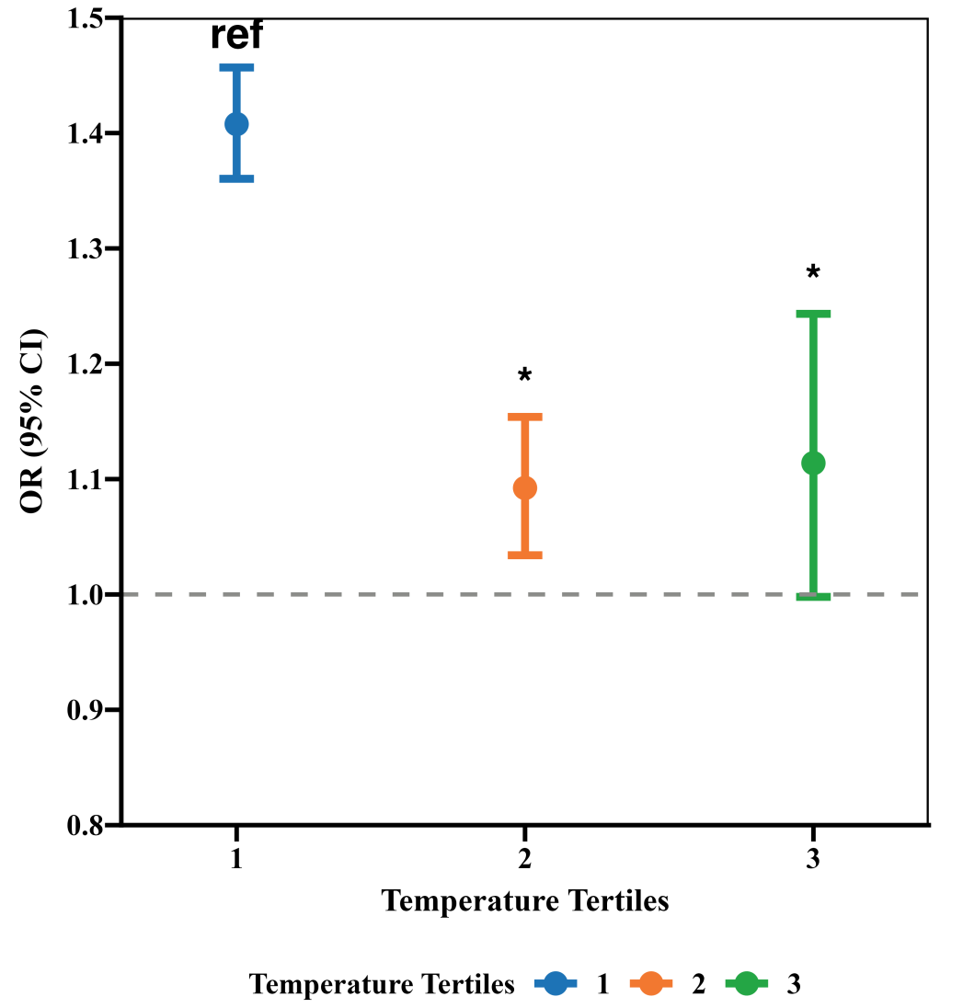
Figure S1 The modification effect of non-optimal temperature on PM_{2.5}-related CVD mortality risk after adjusting for other pollutants (PM₁₀、O₃、SO₂、NO₂、CO) in the model.

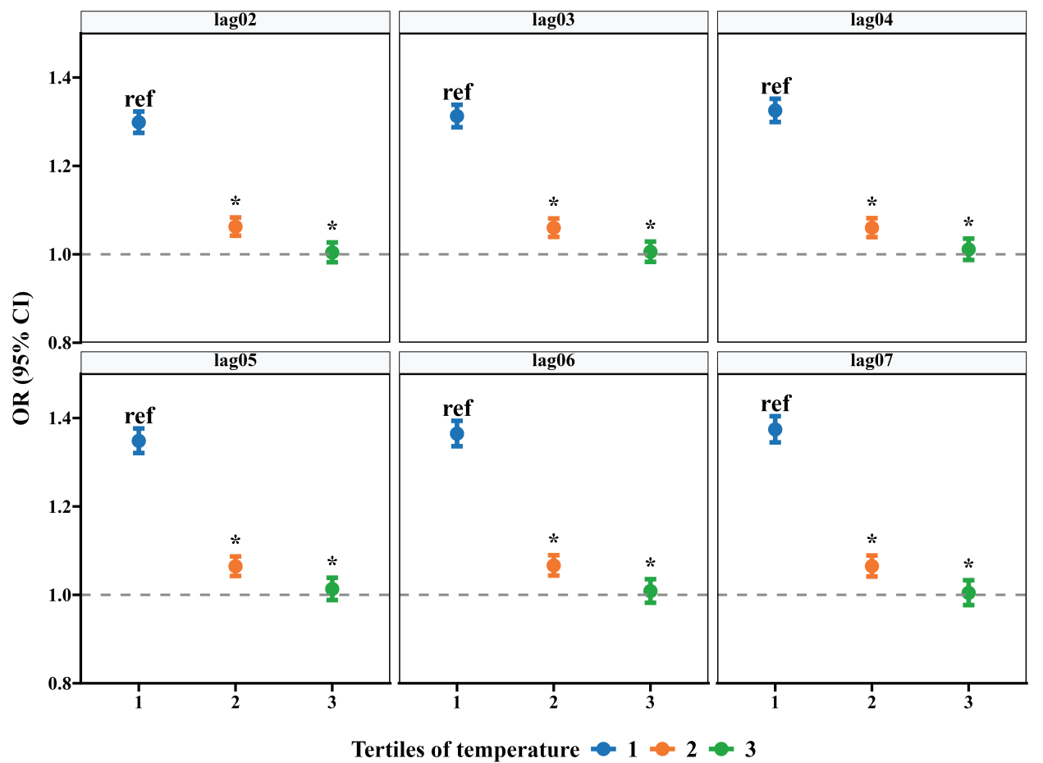
Figure S2 The modification effect of non-optimal temperature on PM_{2.5}-related CVD mortality risk when the lag period of PM_{2.5} is adjusted to lag02–lag07.

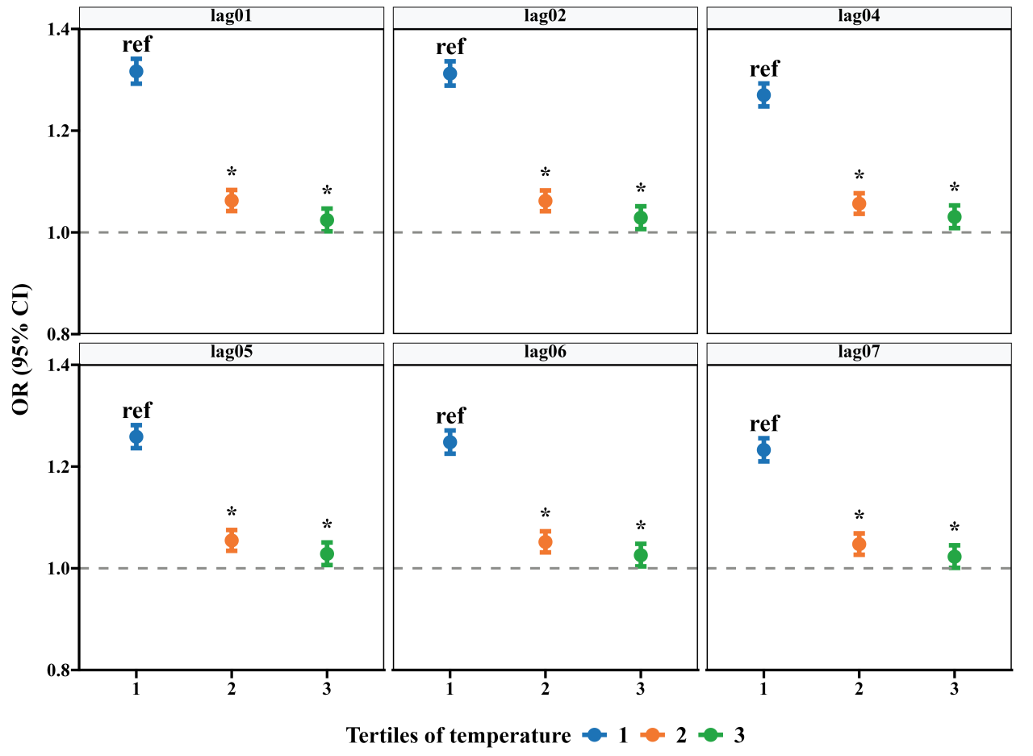
Figure S3 The modification effect of non-optimal temperature on PM_{2.5}-related CVD mortality risk when the lag period of temperature is adjusted to lag01, lag02, and lag04–lag07.

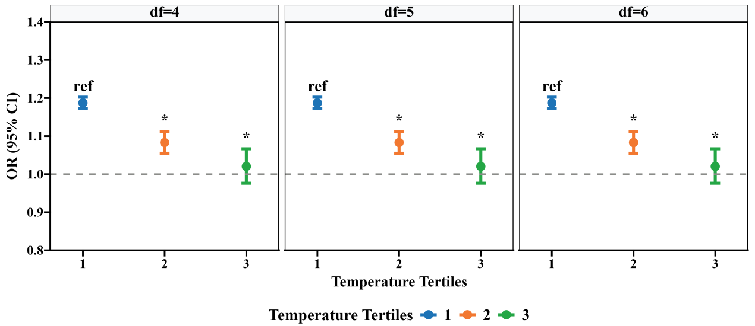
Figure S4 The modification effect of non-optimal temperature on PM_{2.5}-related CVD mortality risk when the degrees of freedom for temperature are adjusted to 4–6.

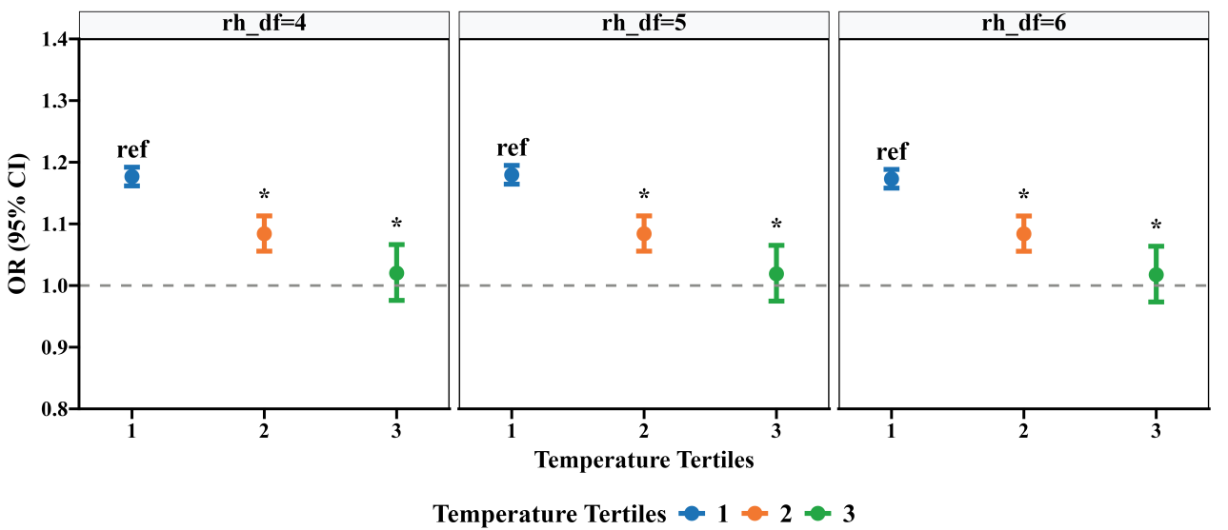
Figure S5 The modification effect of non-optimal temperature on PM_{2.5}-related CVD mortality risk when the degrees of freedom for humidity are adjusted to 4–6.

