Supplementary Information

Electrically driven mid-submicron pixelation of InGaN micro-LED displays for AR glasses
Jinjoo Park^{1†}, Jun Hee Choi^{1†*}, Kiho Kong¹, Joo Hun Han¹, Jung Hun Park¹, Nakhyun Kim¹, Eunsung Lee¹, Dongho Kim¹, Joosung Kim¹, Deukseok Chung¹, Miyoung Kim², Euijoon Yoon², Jaikwang Shin¹, Sungwoo Hwang¹

¹ Samsung Advanced Institute of Technology, Suwon 443-803, Republic of Korea
²Department of Materials Science and Engineering, Seoul National University, Seoul 151–744, Republic of Korea
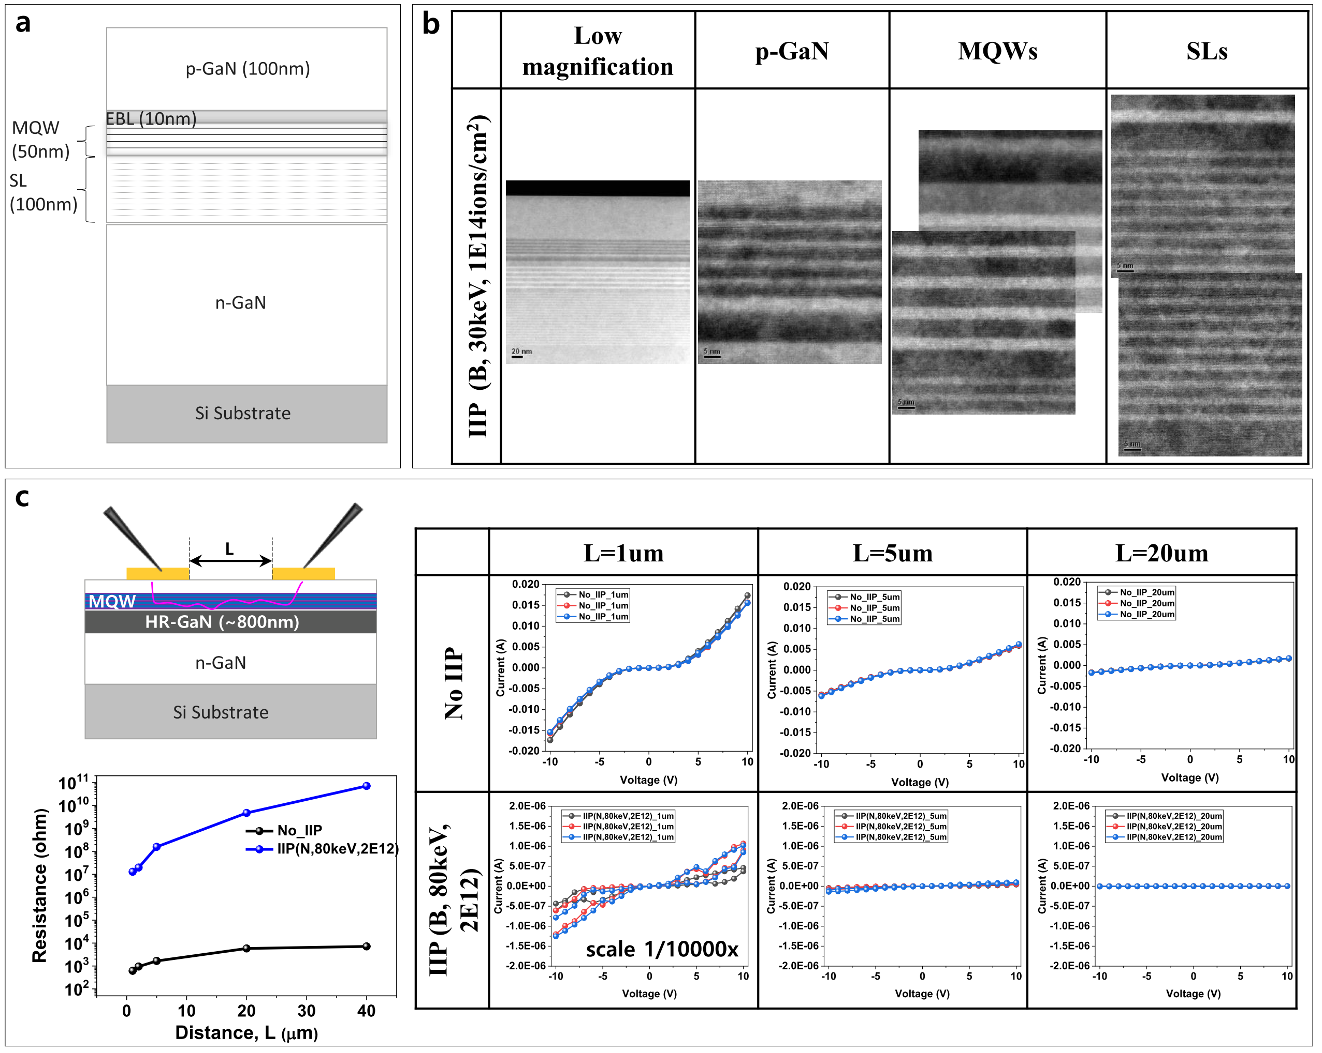
Fig. S1. a InGaN-based LED epi-layer structure on Si (111) substrate. b Dark field TEM images of B⁺ implanted under energy of 30 keV, and fluence of 1×10¹⁴ cm⁻². c Resistance change of LED epi-layers (p-GaN/MQW/high-resistance carbon doped GaN) before and after
B⁺ implanted under energy of 80 keV, and fluence of 2×10¹² cm⁻². The LED epi-layers is electrically isolated in vertical direction by using carbon doped GaN.

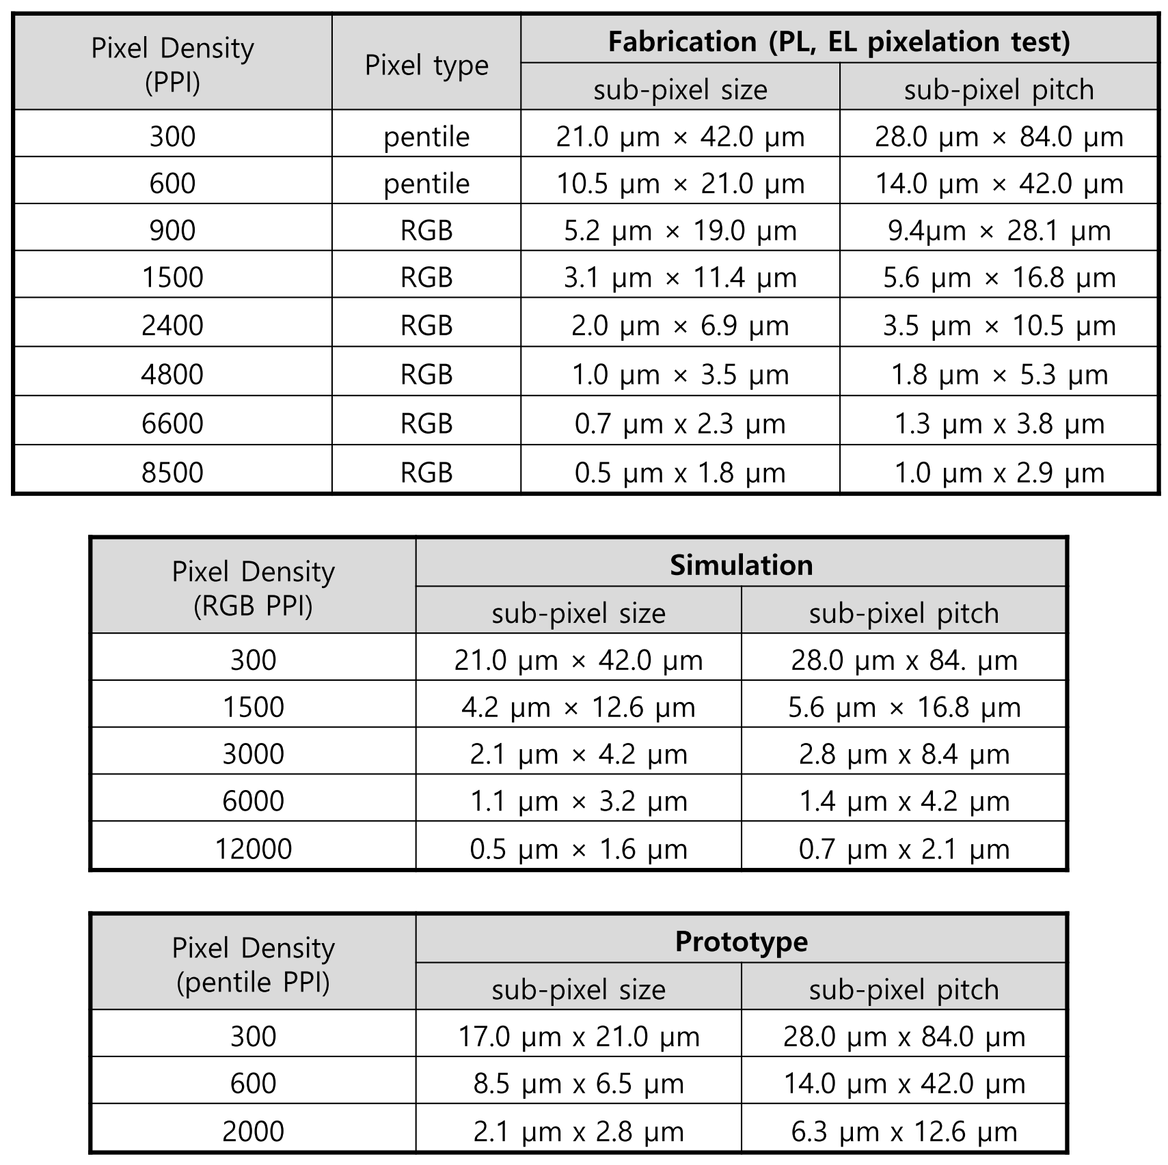
Table S1. The used pixel density and its corresponding subpixel size used for pixelataion test, simulation and display prototype. The two different color pixel structures of RGB and pentile are shown on the bottom. It should be noted that the subpixel pitch of pentile is 1.5 time larger than that of RGB for the same pixel density (PPI).

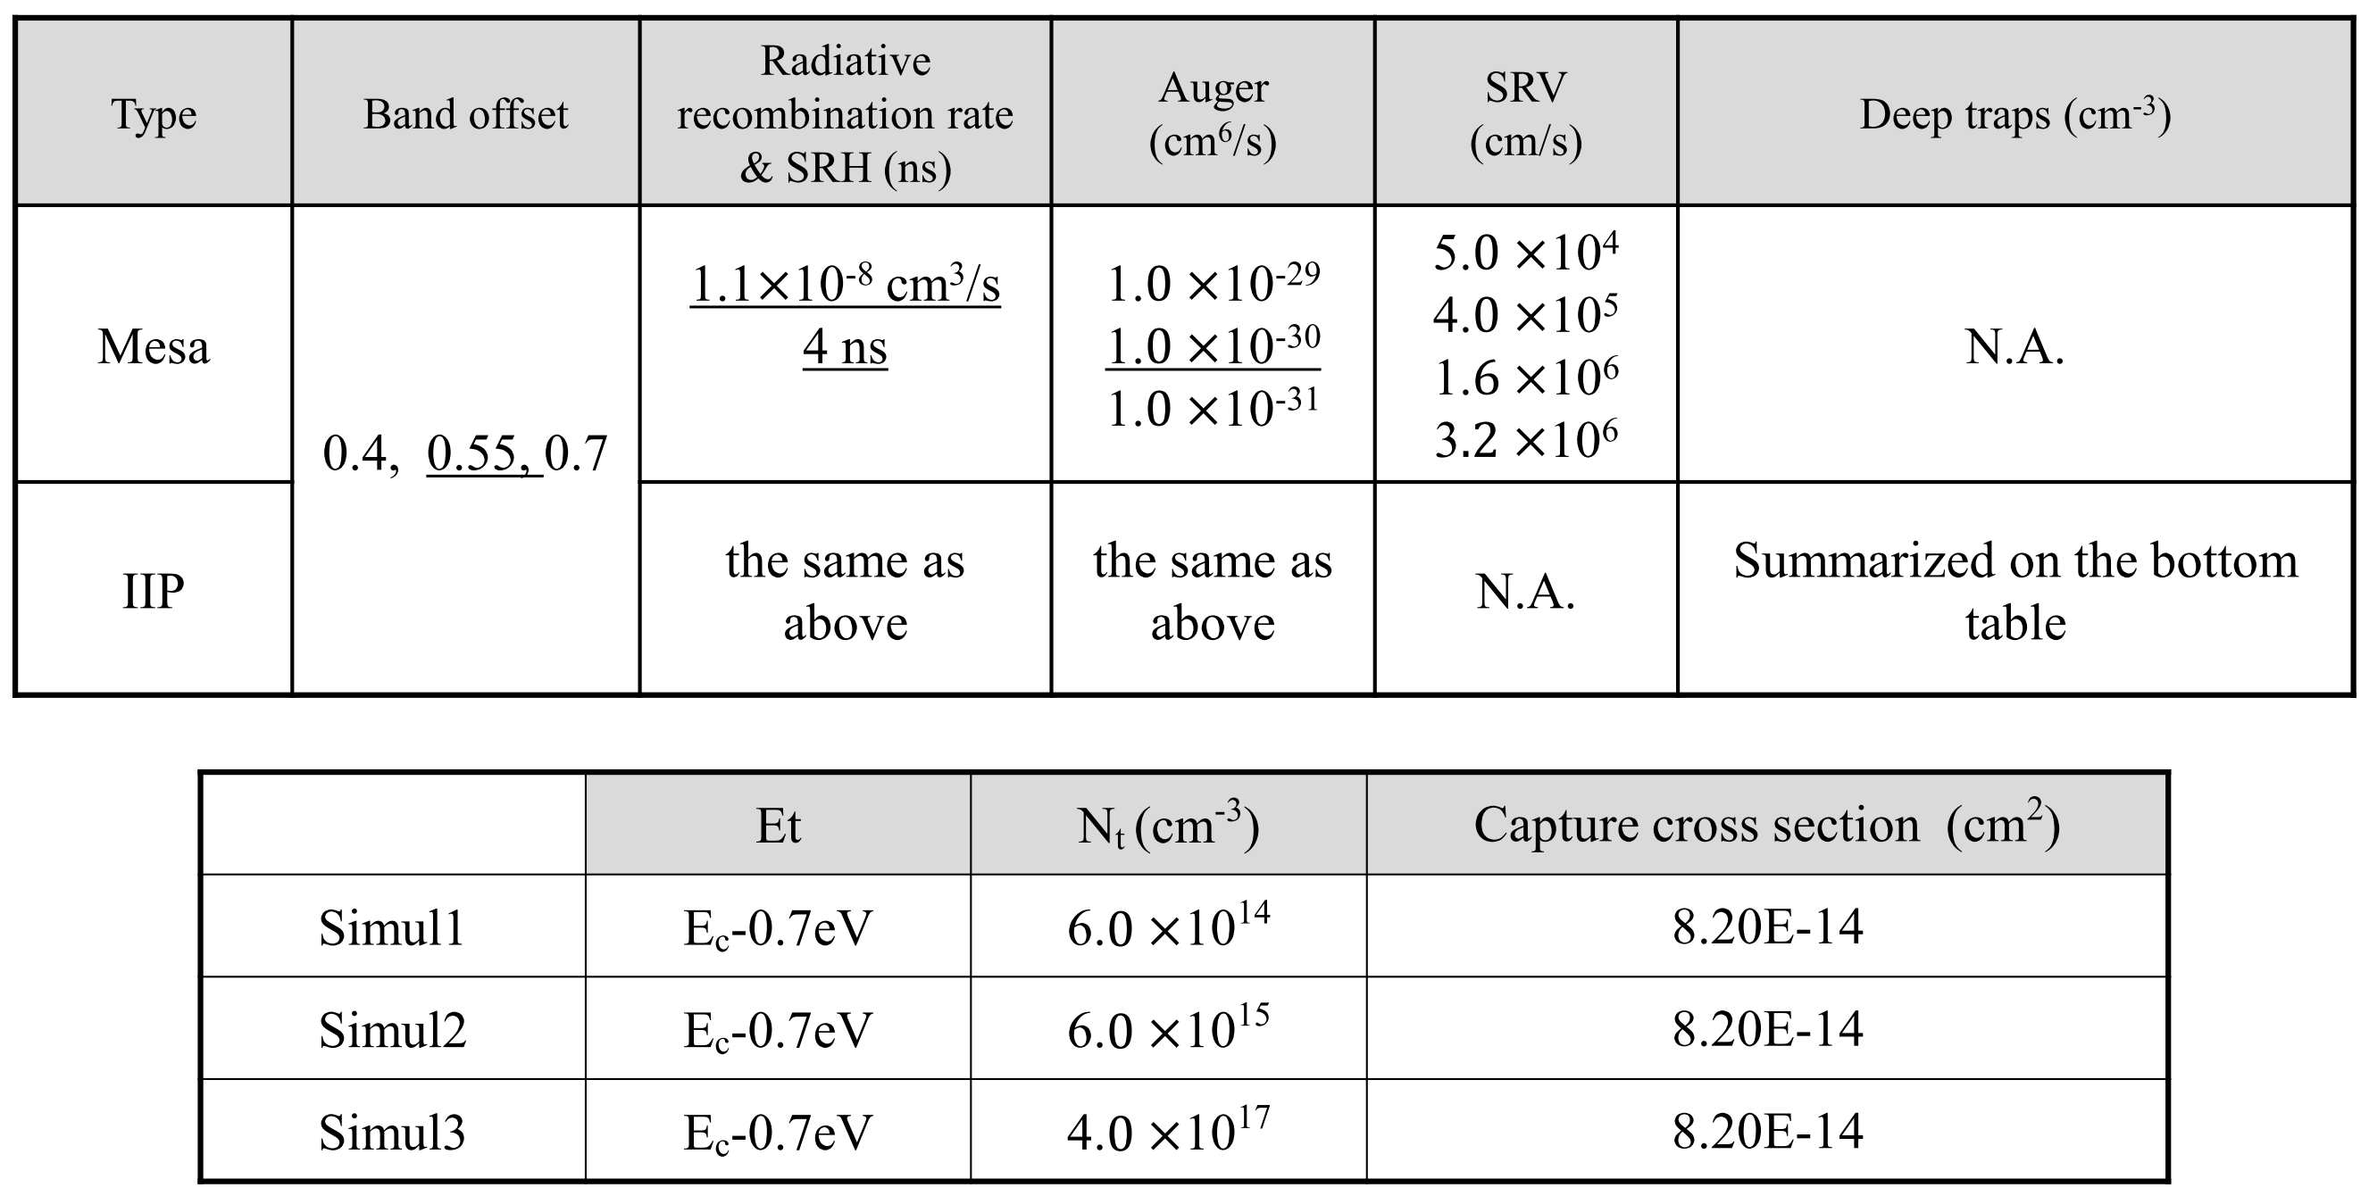
Table S2. The parameters used in the TCAD simulation. The optimum value is underlined.

Fig. S2. Screening experiment for finding TIIP condition. PL images using fluorescence microscopes for different ionic species including N ⁺, Ar⁺ , As ⁺, Kr⁺, Xe⁺ with different mask thicknesses, incident angles, ion energies, and fluences. The implantation is performed at room temperature (a-x) and various temperatures in y and z. (a-f, m-o : 1um-thick PR mask, 2400 & 4800 ppi, g-l, p-r : 1um-thick PR mask, 6700 & 8500 ppi, s,t,u : 200 nm-thick Ti mask, 2400 & 4800 ppi, v,w,x : 200 nm-thick Ti mask, 6700 & 8500 ppi, y: 200 nm-thick Ti mask, temperature split, 2400 & 4800 ppi, z: 200 nm-thick Ti mask, temperature split, 6700 & 8500 ppi)

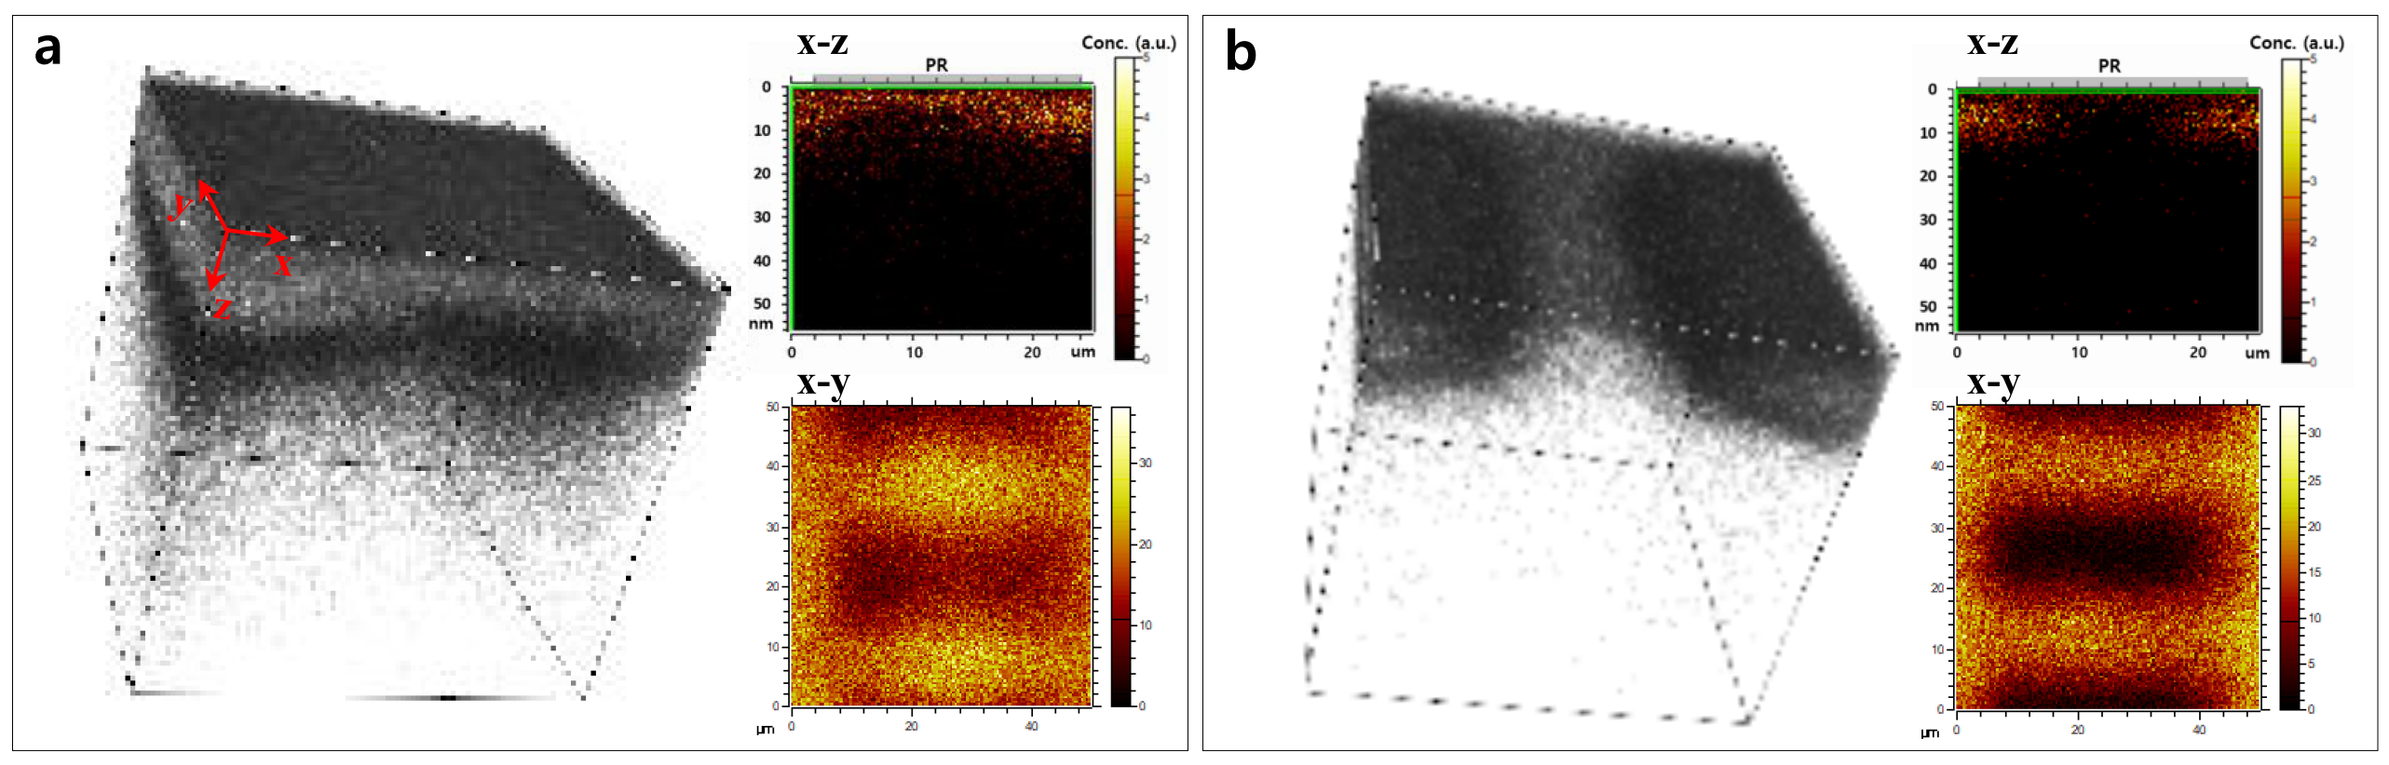
Fig. S3. Corrseponding time-of-flight (TOF) SIMS images of a, Fig. 2a and b, Fig. 2b.

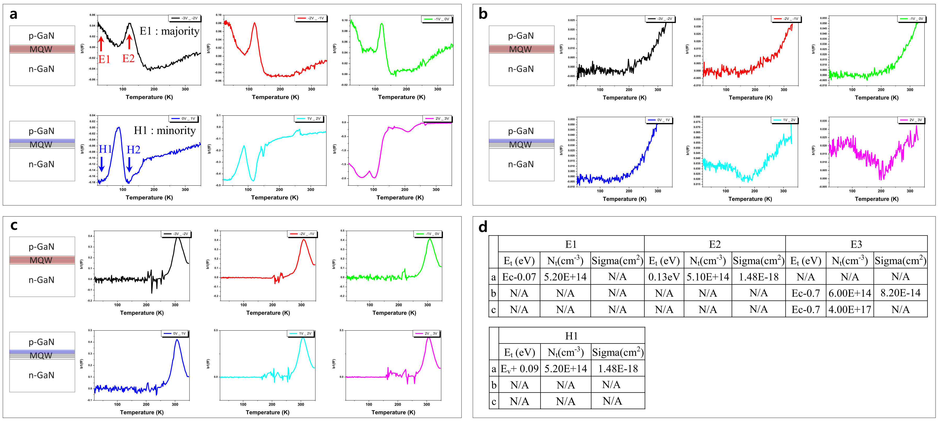
Fig. S4. DLTS data swept from -2.5V to 3V with small voltage interval in Fig. 2d. a, as-made epi layer without implantation, and epi layers implanted with b, As+/0°/8keV/$2×{10}^{12}$ at/cm² and with c, As⁺/0°/8keV/$1×{10}^{14}$at/cm². d, The obtained electron and hole trap levels with trap density and capture cross section.

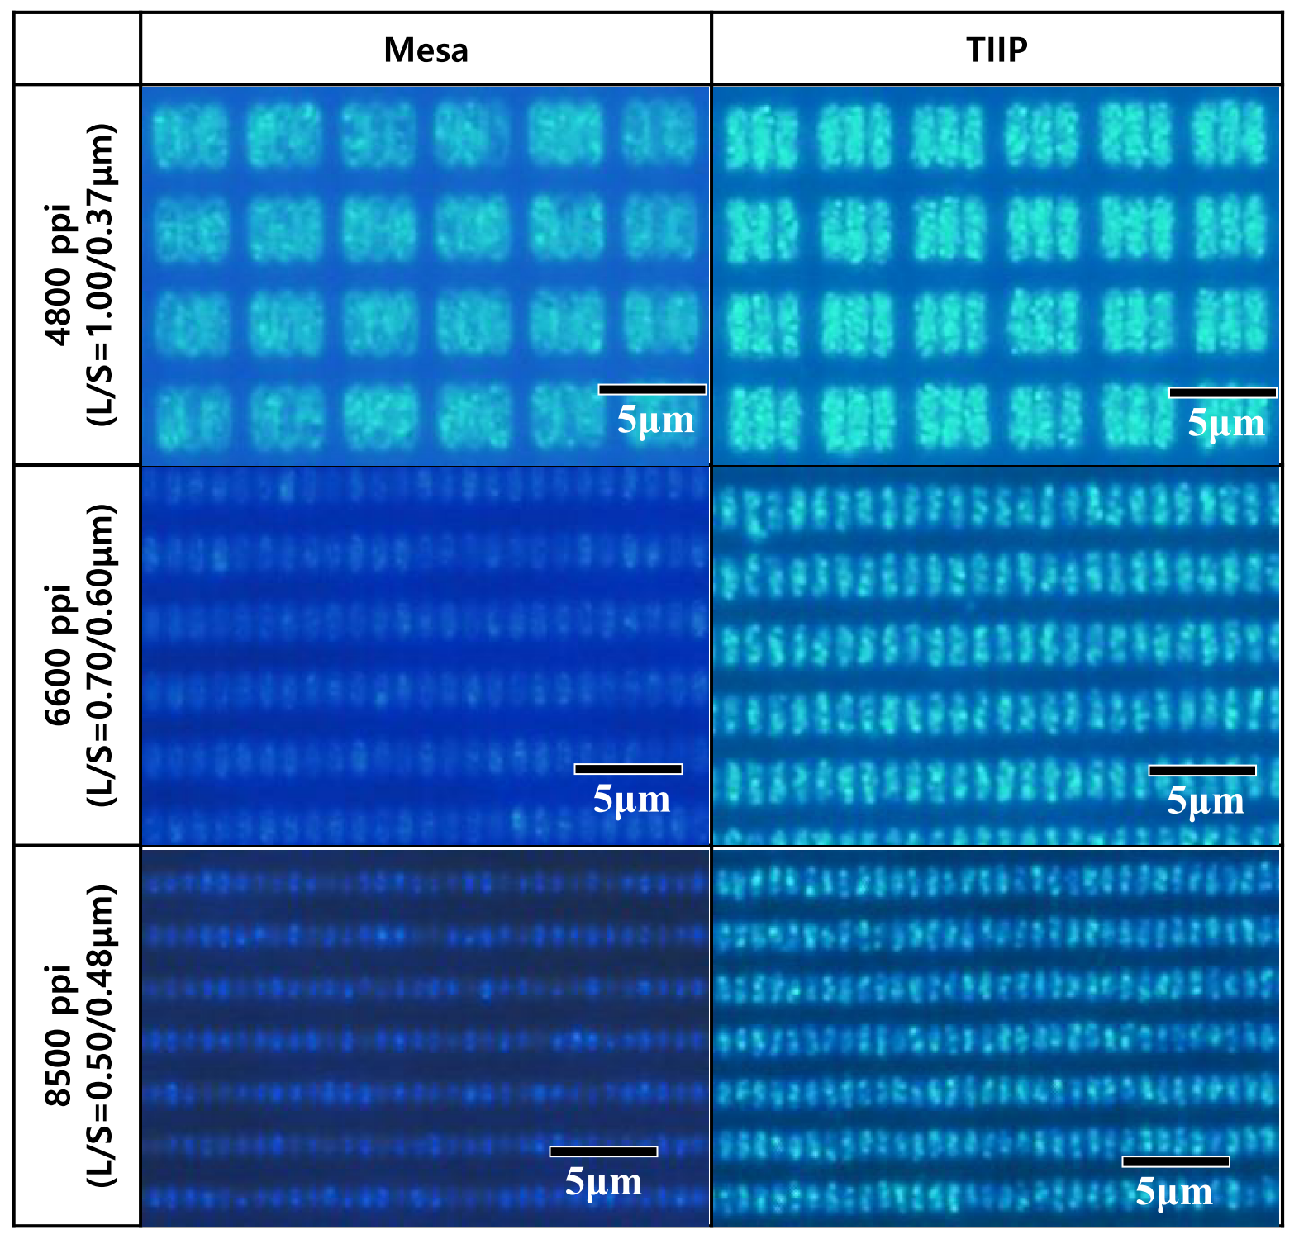
Fig. S5. Detailed comparison between TIIP and mesa pixelation. Photoluminescence (PL) microscopy, magnified images of different high-density pixel sizes (4800, 6600, 8500 ppi).

Comparison of defect density between TIIP and mesa pixelation
To explain superiority of TIIP over mesa pixelation, we estimate the effective defect density around a pixel. For TIIP pixelation, assuming uniform distribution of point defects, the effective surface-defect density per unit area (N_{s}) is expressed by the peak volume concentration (N_{pv}) as follows:
$N_{es}=\sqrt[3]{{{(N}_{pv})}^{2}}$ (1)
Using N_{pv} of 4$×$10¹⁷ cm^{–3} from our DLTS measurements, equation (1) yields N_{es} of 5.41 $×$ 10⁻³ nm⁻². In mesa pixelation, we approximate the number of dangling bonds on the exposed mesa surface as the number of single point defects. Then, N_{es} is the dangling-bond density per exposed unit surface. For example, $\left\{0001\right\}$,$\left\{1\overline{1}00\right\}$, $\left\{1\overline{1}01\right\}$, and $\left\{11\overline{2}2\right\}$ have defect densities of 11.4, 12.1, 16.0, and 17.8 nm⁻², respectively.^{[ref.1]} Therefore, the defect density of TIIP pixelation is at least three orders of magnitude less than that of mesa pixelation, exhibiting high IQE even for small-sized subpixels.
[ref.1] Hiramatsu, K., Nishiyama, K., Motogaito, A., Miyake, H., Iyechika, Y. & Maeda, T. Recent Progress in Selective Area Growth and Epitaxial Lateral Overgrowth of III‐Nitrides: Effects of Reactor Pressure in MOVPE Growth. Phys. Stat. Sol. (a) 176, 535 (1999).

Details of Numerical calculation
The flipped architecture (FA) EL structures by mesa and IIP pixelation are used for simulation (Fig. S6a and Fig. S7a), in which EL devices are flipped (p-GaN side down) for efficient light extraction. Three well-known recombination mechanisms of charge carriers are considered; radiative band-to-band recombination, non-radiative SRH, and Auger recombination. The recombination relationship is approximated as so-called ABC model in which coefficients A (SRH), B (radiative), and C (Auger) are proportional to free-carrier concentration, the square, and the cube of the concentration, respectively. Radiative recombination rate and SRH recombination time were fixed as 1.1$×$10⁻⁸ cm³/s and 4 ns, respectively.
In case of pixelated μLEDs, specific defects generated during each pixelation should be further considered. For the mesa pixelation, SRV is a main measure of non-radiative surface recombination, expressed by (2), (2-1), and (2-2).
$R_{surf}=\frac{pn-{n_{i}}^{2}}{\begin{aligned}{τ_{p}}^{eff}\left[n+n_{i}\exp\left(\frac{E_{T}}{kT}\right)\right]+{τ_{n}}^{eff}\left[p+n_{i}\exp\left(\frac{{-E}_{T}}{kT}\right)\right]\end{aligned}} \left(2\right)$
$\frac{1}{{τ_{p}}^{eff}}=\frac{1}{{τ_{p}}^{i}}+\frac{d_{i}}{A_{i}}SRV.N$ (2-1), $\frac{1}{{ τ_{n}}^{eff}}=\frac{1}{{τ_{n}}^{i}}+\frac{d_{i}}{A_{i}}SRV.P$ (2-2)
,where, $τ_{p0}$, $τ_{n0}$, $E_{T}$, $C_{p}$, $n_{i}$, $SRV.N$, and $SRV.P$ represents lifetimes at equilibrium hole and electron concentration, trap energy level, Auger constant, intrinsic concentration, surface recombination velocities for electron and holes, respectively. The d_{i} and A_{i} parameters are the length and area of the interface for node i. The mesa-pixelated FA EL device is shown in Fig. S6a, where the mesa thickness is 0.4 μm including an epi-layer stack (p-GaN/p-AlGaN/ MQWs/part of n-GaN).
We use conduction band offset (BO) of 0.55 both for mesa and IIP pixel simulation, at which gradual increase or decrease of electron and hole concentrations from the nearest quantum well beneath AlGaN electron blocking layer (EBL) to neighboring wells was observed (See Fig. S6c).
Both for mesa and IIP pixelation, it should be noted that IQE is strongly decreased at higher Auger recombination coefficients, i.e., C_{p} and C_{n} of 10⁻²⁹ cm⁶/s, compared to the value of 10⁻³⁰ cm⁶/s or less (lower panel of Fig. 4 c), which is more evident in large pixel size , For a relatively large pixel size of 300 ppi, the strong IQE droop is observed at C_{p} and C_{n} of 10⁻²⁹ cm⁶/s, whereas such droop behavior is much reduced with a sharp increase in peak IQE with the Auger recombination coefficients of 10⁻³⁰ cm⁶/s or less,. This might be due to existence of much higher local current density region for large-size pixel, where Auger recombination becomes significant. Inspection of Fig. S6b and Fig. S7 b, c clearly reveals that local current density fluctuation of 300ppi pixel is much larger than small-size (3000, 12000 ppi) pixels.
We use conduction band offset (BO) of 0.55 both for mesa and IIP pixel simulation, at which gradual increase or decrease of electron and hole concentrations from the nearest quantum well beneath AlGaN electron blocking layer (EBL) to neighboring wells was observed (See Fig. S6c).

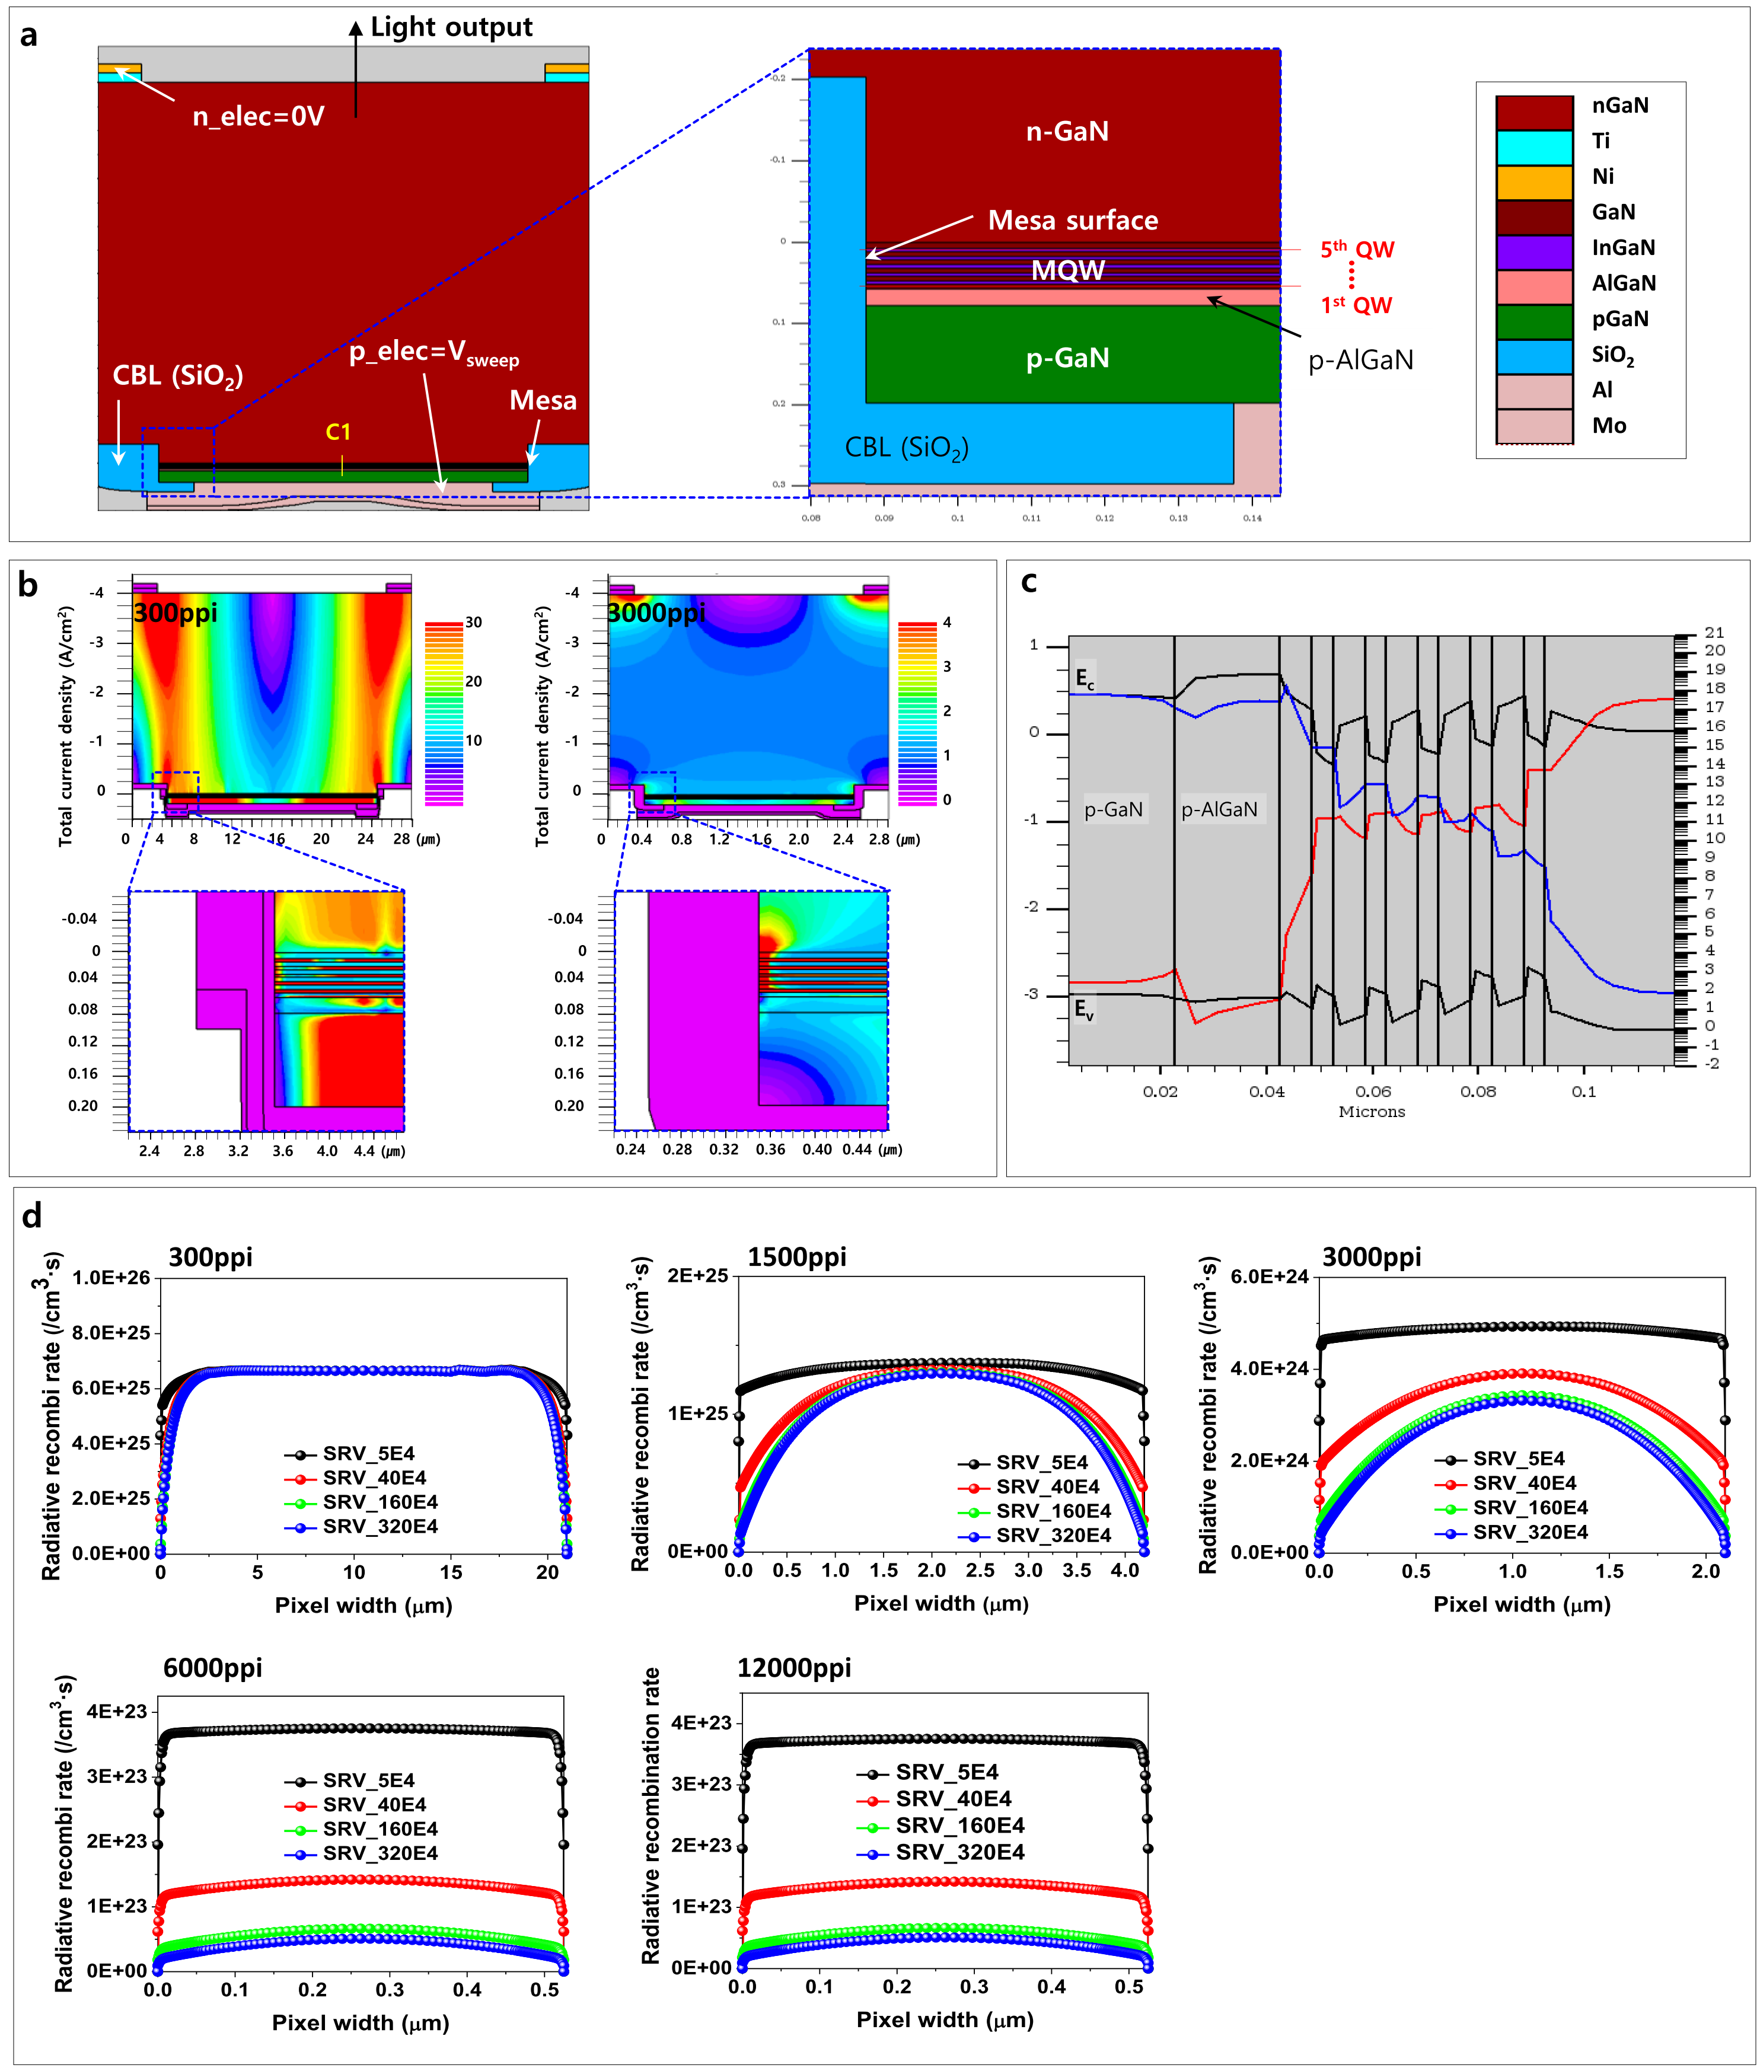
Fig. S6. TCAD simulation of a FA-EL structure by mesa pixelation at current density of 0.1A/cm². a (left) Overall device structure at 12000 ppi and (right) a magnified view of dotted rectangle in left panel of a. b (upper) Total current density contours at 300 and 3000 ppi, and (lower) their magnified images of dotted rectangles in upper panels. c Electron/hole concentrations with band diagrams (E_{c} and E_{v}) at cutline 1 (c1) in a. d Radiative recombination rates at QW1 in right panel of a for different pixel densities. SRH recombination time of 4ns, Auger coefficient of 1×10⁻³⁰ cm⁶/s, and SRV of 4×10⁵ cm/s were used in the simulation.

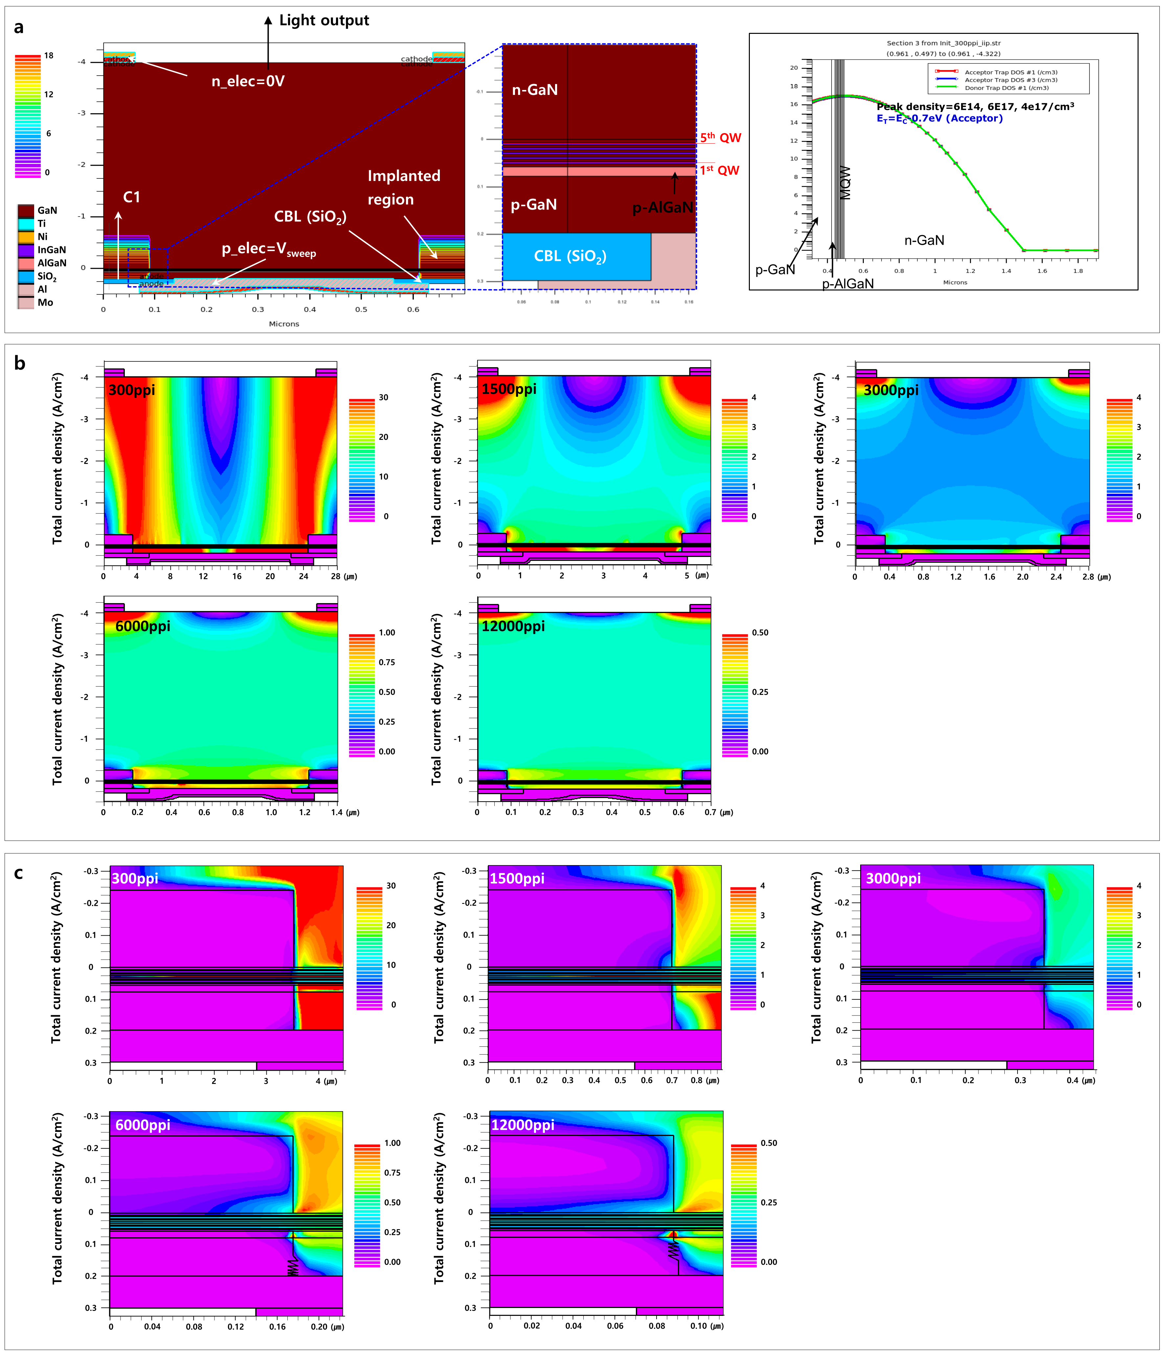
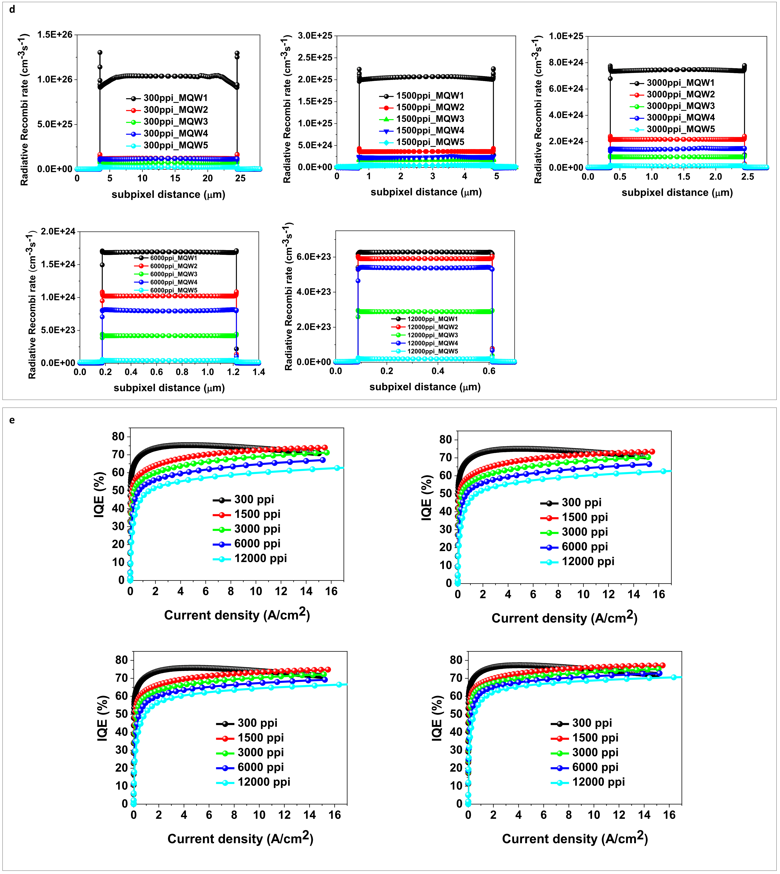Fig. S7. TCAD simulation of a FA-EL structure by IIP pixelation at current density of 0.1A/cm². a (left) Overall device structure at 12000 ppi, (center) a magnified view of dotted rectangle in left panel, and (right) Gaussian defect distribution of cutline C1 in left panel. b Total current density contours for different pixel densities, and c their magnified images of dotted rectangles in b. d Radiative recombination rates at QW1-QW5 for different pixel densities. e IQEs vs. current density for various pixel densities at different deep-level- trap densities.

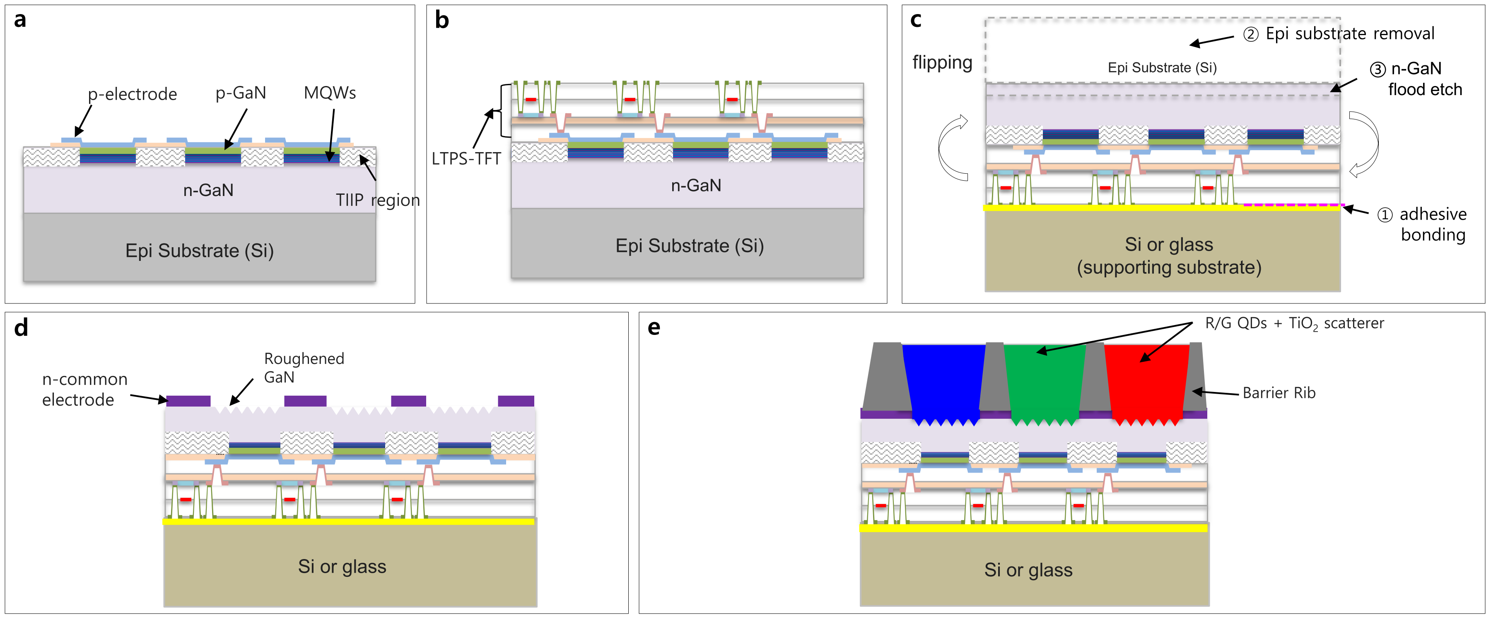
Fig. S8. Fabrication of μLED displays with flipped architecture: a Fabrication of μLED with IIP pixelation and a charge blocking layer (CBL). b Monolithic integration of LTPS-TFTs on μLED. c Flipping LED+TFT and bonding to supporting substrate via adhesive bonding, epi substrate removal, and n-GaN flood etch. d Common n-electrode formation, GaN wet roughening, and data pad opening. e Barrier rib and R/G/B QD C/F formation.

Additionally, in Fig. S9, we observe that p-GaN is deactivated when exposed to fluorine-based plasmas; hence, only wet etching can be used for the SiO₂ CBL. The enlargement of CBL diameter during wet etching is more significant in the mesa structure, which again limits the leakage characteristics.
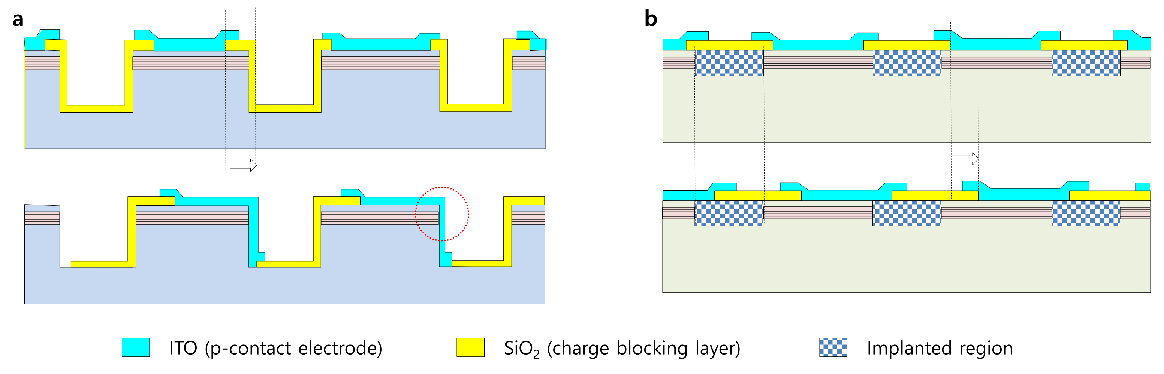
Fig. S9. The basic EL device structure by a TIIP pixelation and b mesa pixelation. Upper and lower panels represent well-aligned and misaligned states, respectively.
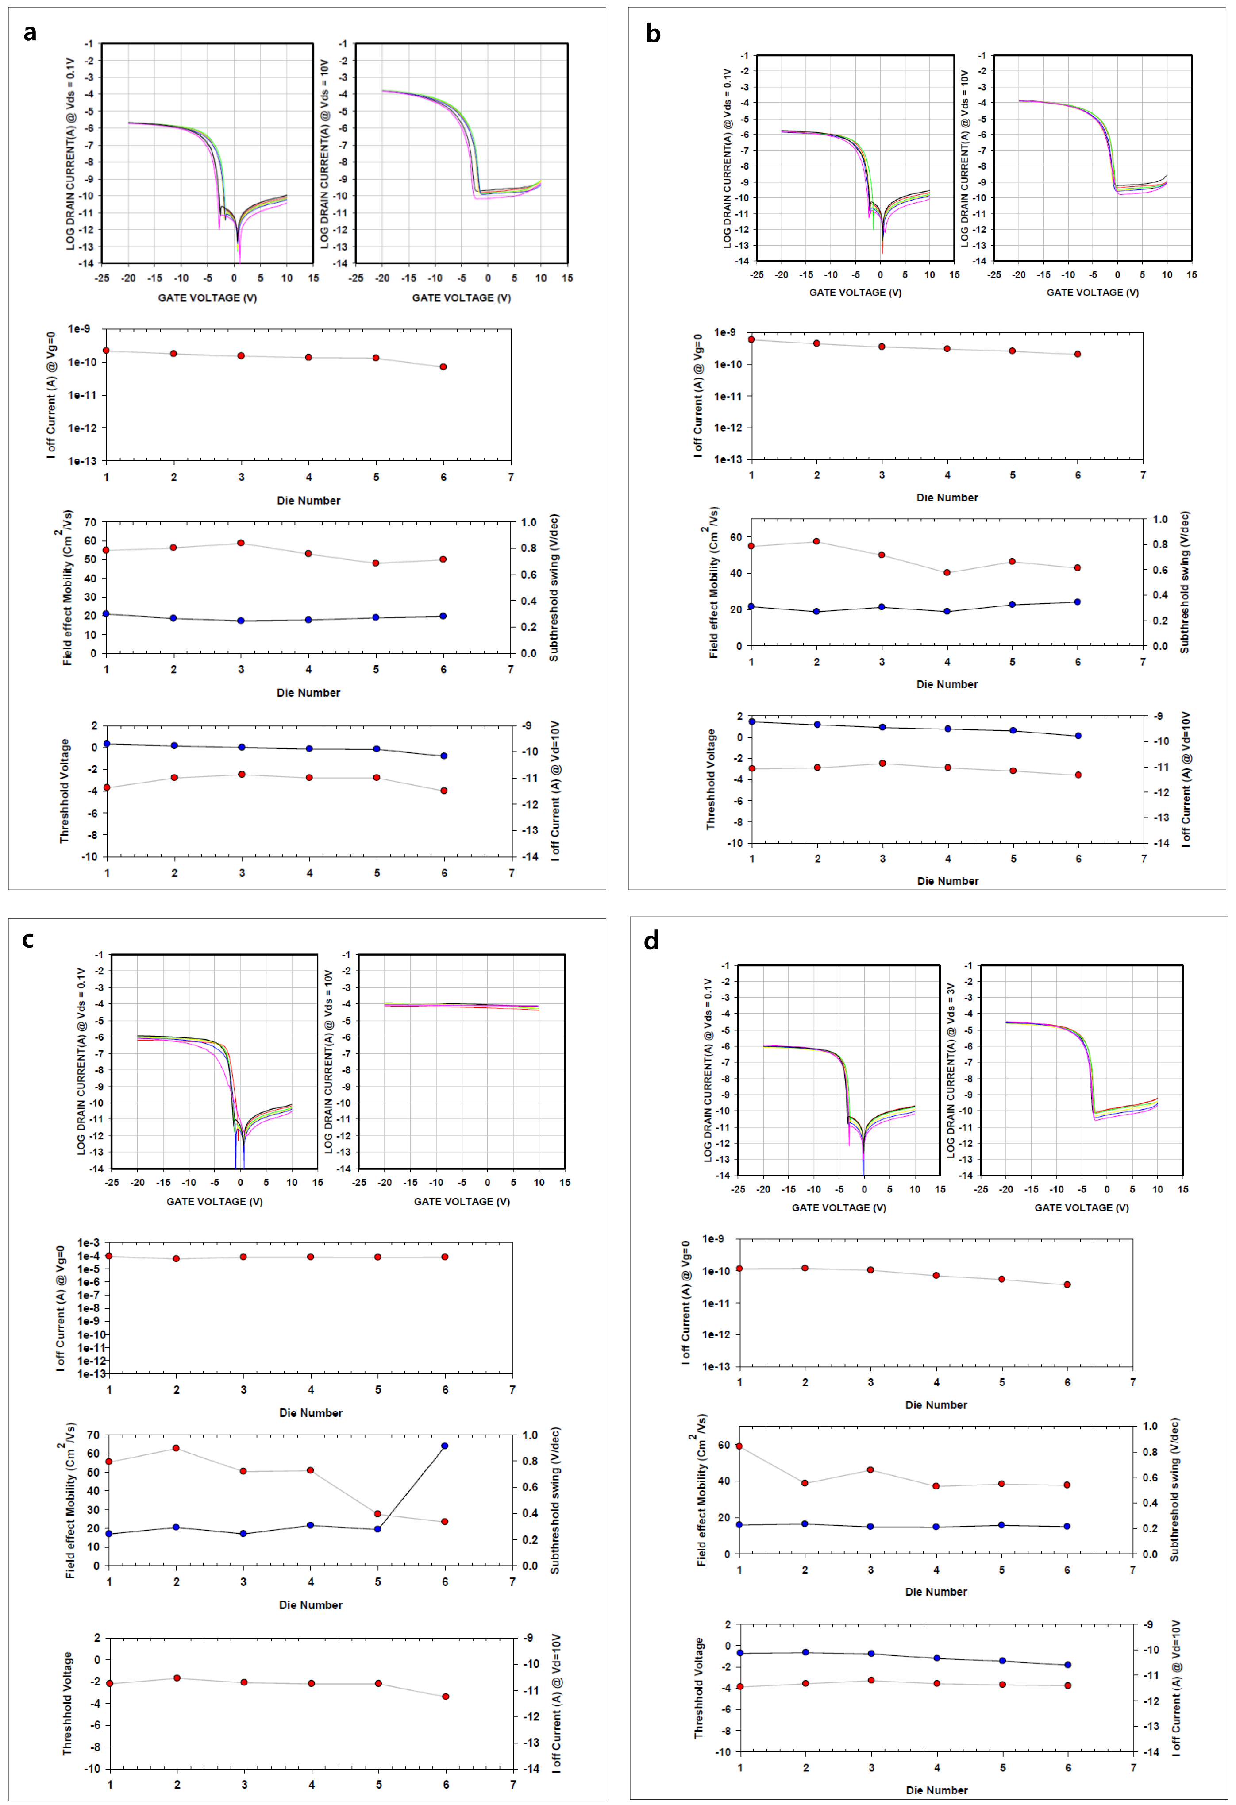
Fig. S10. Transfer curves of p-Si TFT with a W/L=2/2 μm, b W/L=1/1 μ m, c and d W/L=0.5/0.5 μ m. For a-c and d, V_{ds}=-0.1/-10V and -0.1/-3V, respectively.
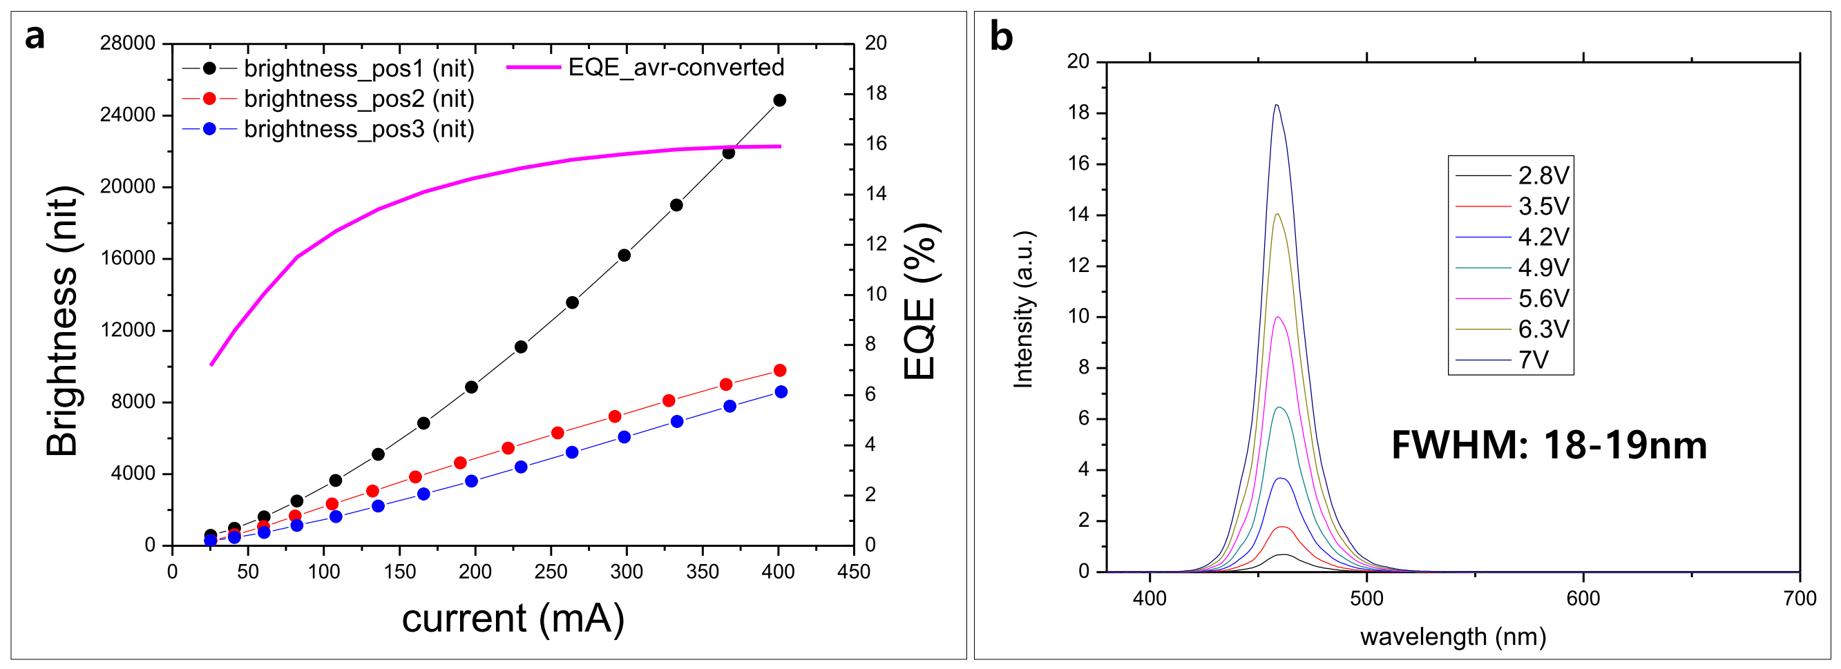
Fig. S11. a Brightness-average EQE-current curves for 3 different TFT-integrated devices. b EL emission spectrum

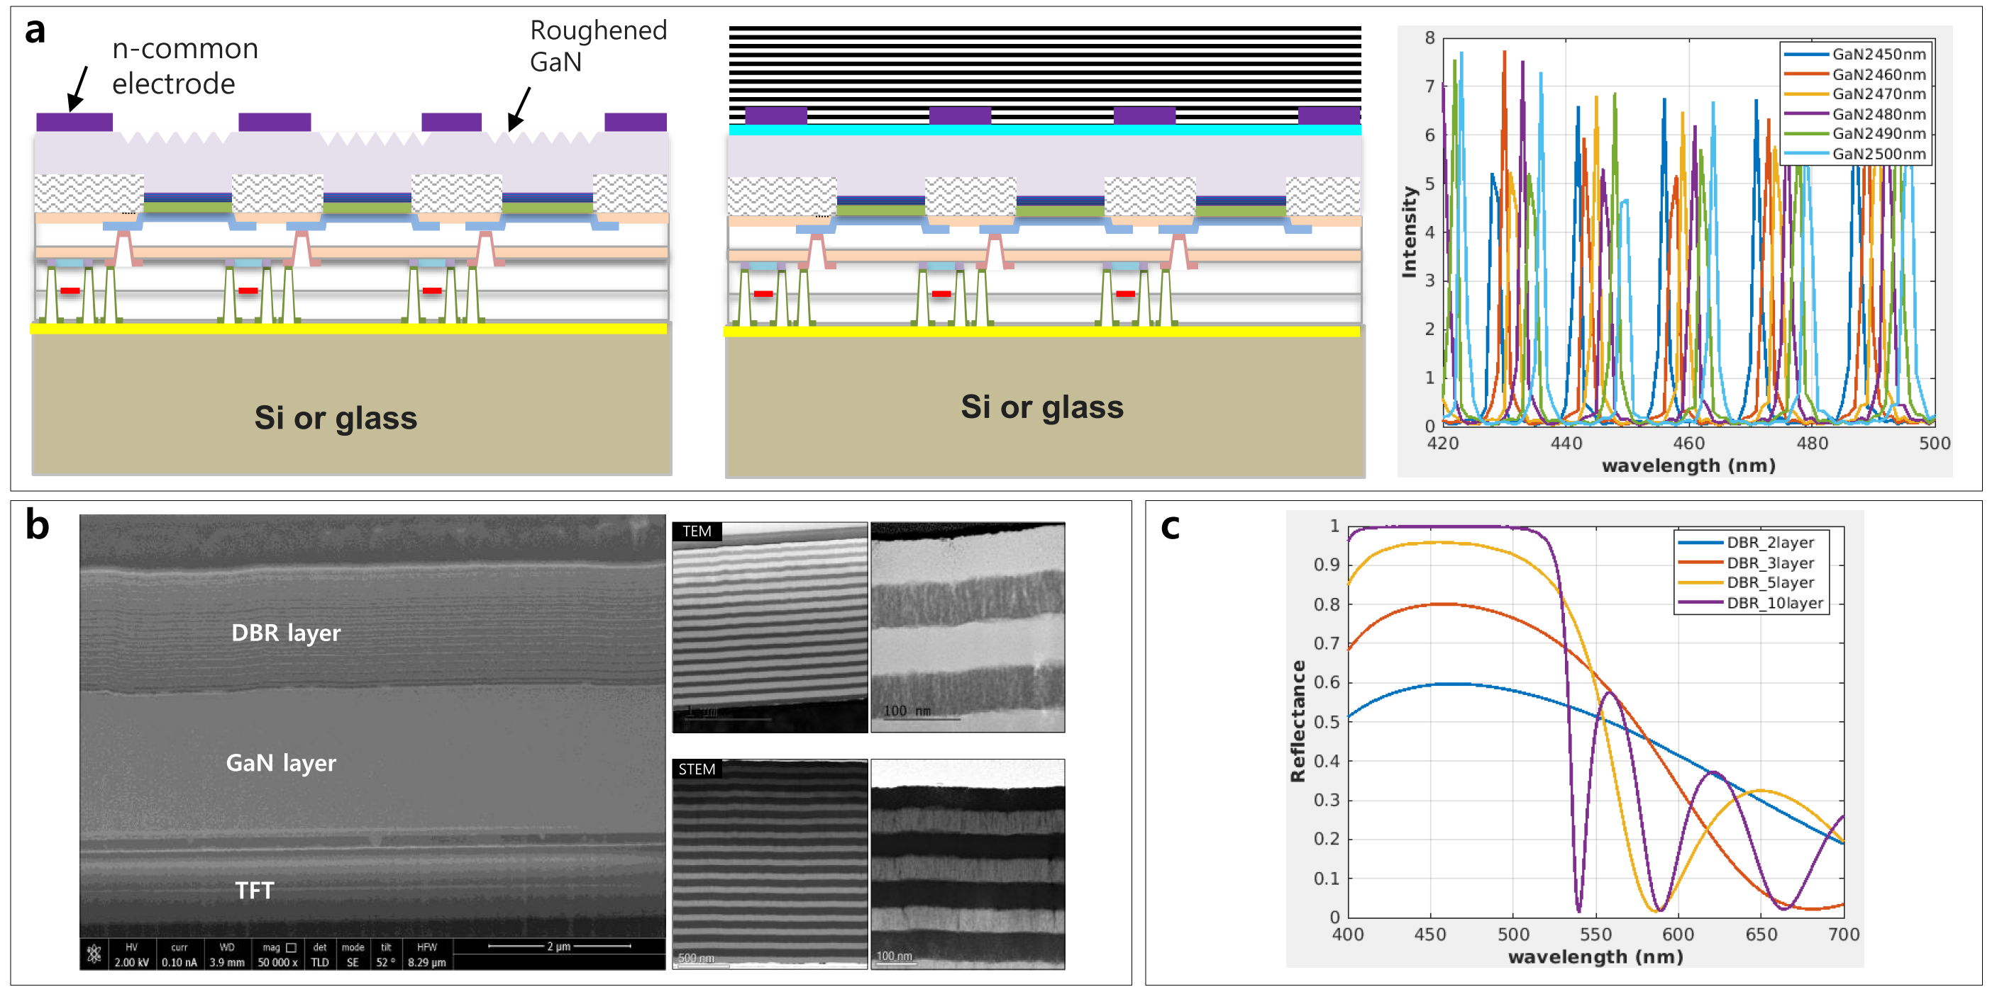
Fig. S12. a flipped architecture with roughened GaN (left) and with resonant cavity (right). b SEM and TEM images of resonant cavity flipped architecture. c Reflectance and TiO₂/SiO₂ DBR depending on the number of DBR pair.

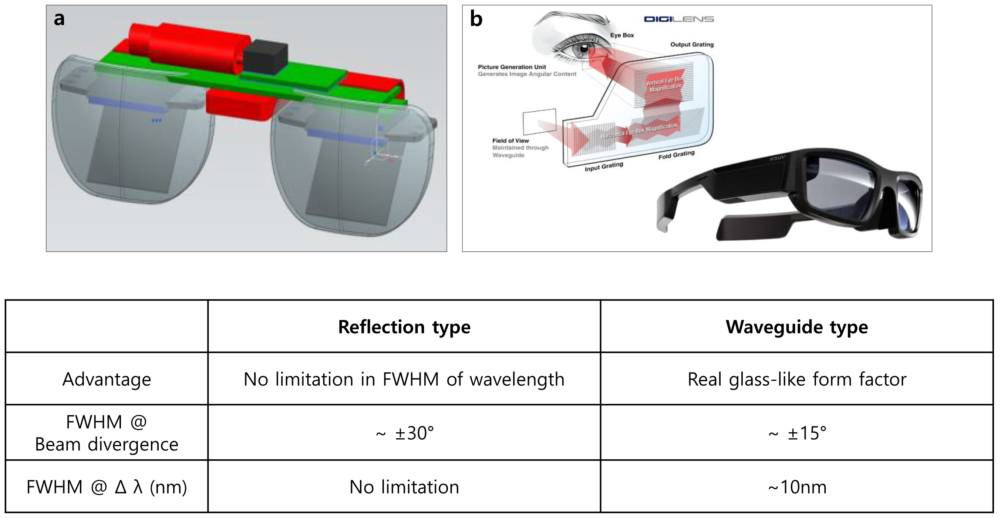
Fig. S13. AR glasses of a reflection-type and b Waveguide-type using diffractive optical element (DOE) by courtesy of DIGILENS, LTD.

Table S3. Comparison of AR glasses
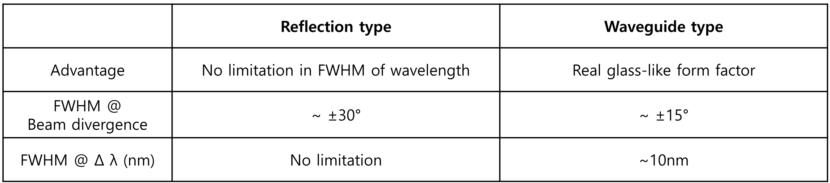

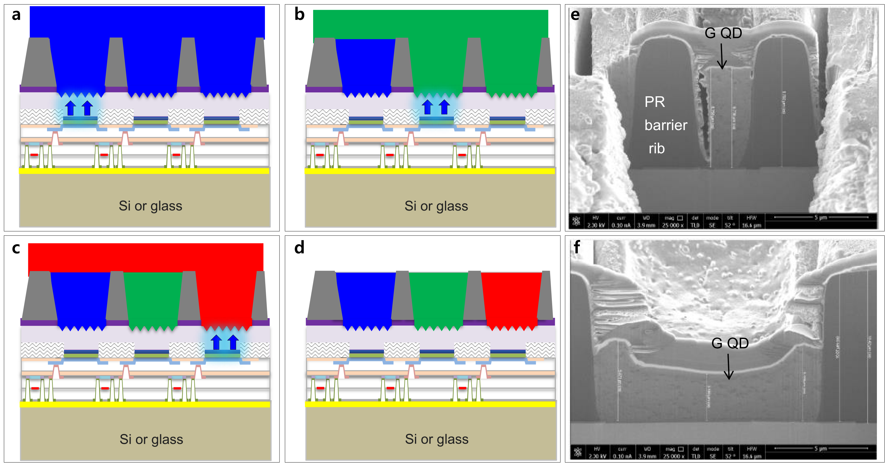
Fig. S14. Schematics of back-side exposure techniques for high-resolution patterning for QD C/C patterning. a Blue QD coating and backside exposure, b development of blue QD and coating of green QD, c development of green QD and coating of red QD coating, d development of red QD, and e,f backside-exposed and developed green QD C/C with aspect ratio (H/L) of 6.5/2.5 μm (e) and of 4/12 μm (f).

