Supplementary Table 1 Robustness of movement-state segmentation (BALM) and temporary-habitat detection (DBSCAN) to temporal coarsening, across five species. For each species the rate mark (step speed), the flight-onset threshold (c), the habitat radius (eps) and the minimum-residence duration were estimated once at full resolution and held fixed; fixes were then thinned by retaining every 2nd, 3rd, and 5th fix per individual (1× = analysis-resolution baseline; the Lesser Kestrel and Greater Snow Goose were pre-aggregated to 2 h). c, eps, and the minimum residence are therefore constant within each species, whereas minPts is the residence duration re-expressed as a fix count at each level’s median interval and so decreases as the interval grows. BALM agreement is the percentage of shared fixes (matched by individual and timestamp) assigned the same movement state (H-H, L-L, H-L, L-H); DBSCAN ARI is the per-individual Adjusted Rand Index between the original and coarsened habitat partitions over their shared points.
Species | Coarsening | Median interval (h) | Fixes retained, n (%) | minPts | BALM agreement (%) | DBSCAN ARI
Black-tailed Godwit | 1× | 3 | 61,410 (100) | 15 | 100.0 | 1.000
 | 2× | 6 | 30,709 (50.0) | 8 | 99.6 | 0.981
 | 3× | 9 | 20,473 (33.3) | 5 | 99.5 | 0.961
 | 5× | 15 | 12,286 (20.0) | 3 | 99.2 | 0.951
Greater Snow Goose | 1× | 2 | 365,702 (100) | 13 | 100.0 | 1.000
 | 2× | 4 | 182,858 (50.0) | 6 | 98.6 | 0.976
 | 3× | 6 | 121,911 (33.3) | 4 | 98.2 | 0.948
 | 5× | 10 | 73,155 (20.0) | 3 | 97.8 | 0.930
Pied Avocet | 1× | 2 | 53,097 (100) | 12 | 100.0 | 1.000
 | 2× | 4 | 26,555 (50.0) | 6 | 99.2 | 0.938
 | 3× | 6 | 17,708 (33.4) | 4 | 99.0 | 0.911
 | 5× | 10 | 10,629 (20.0) | 2 | 98.7 | 0.905
Eurasian Oystercatcher | 1× | 1 | 49,561 (100) | 7 | 100.0 | 1.000
 | 2× | 2 | 24,781 (50.0) | 4 | 100.0 | 0.962
 | 3× | 3 | 16,521 (33.3) | 2 | 100.0 | 0.827
 | 5× | 5 | 9,913 (20.0) | 2 | 99.9 | 0.599
Lesser Kestrel | 1× | 2 | 23,868 (100) | 9 | 100.0 | 1.000
 | 2× | 4 | 11,935 (50.0) | 4 | 95.5 | 0.904
 | 3× | 6 | 7,958 (33.3) | 3 | 93.8 | 0.960
 | 5× | 10 | 4,777 (20.0) | 2 | 91.8 | 0.859
* For the Greater Snow Goose and Lesser Kestrel, the high-frequency data were down-sampled to a common analysis resolution before the test, so their baseline counts differ from the native fix totals in Table 1.
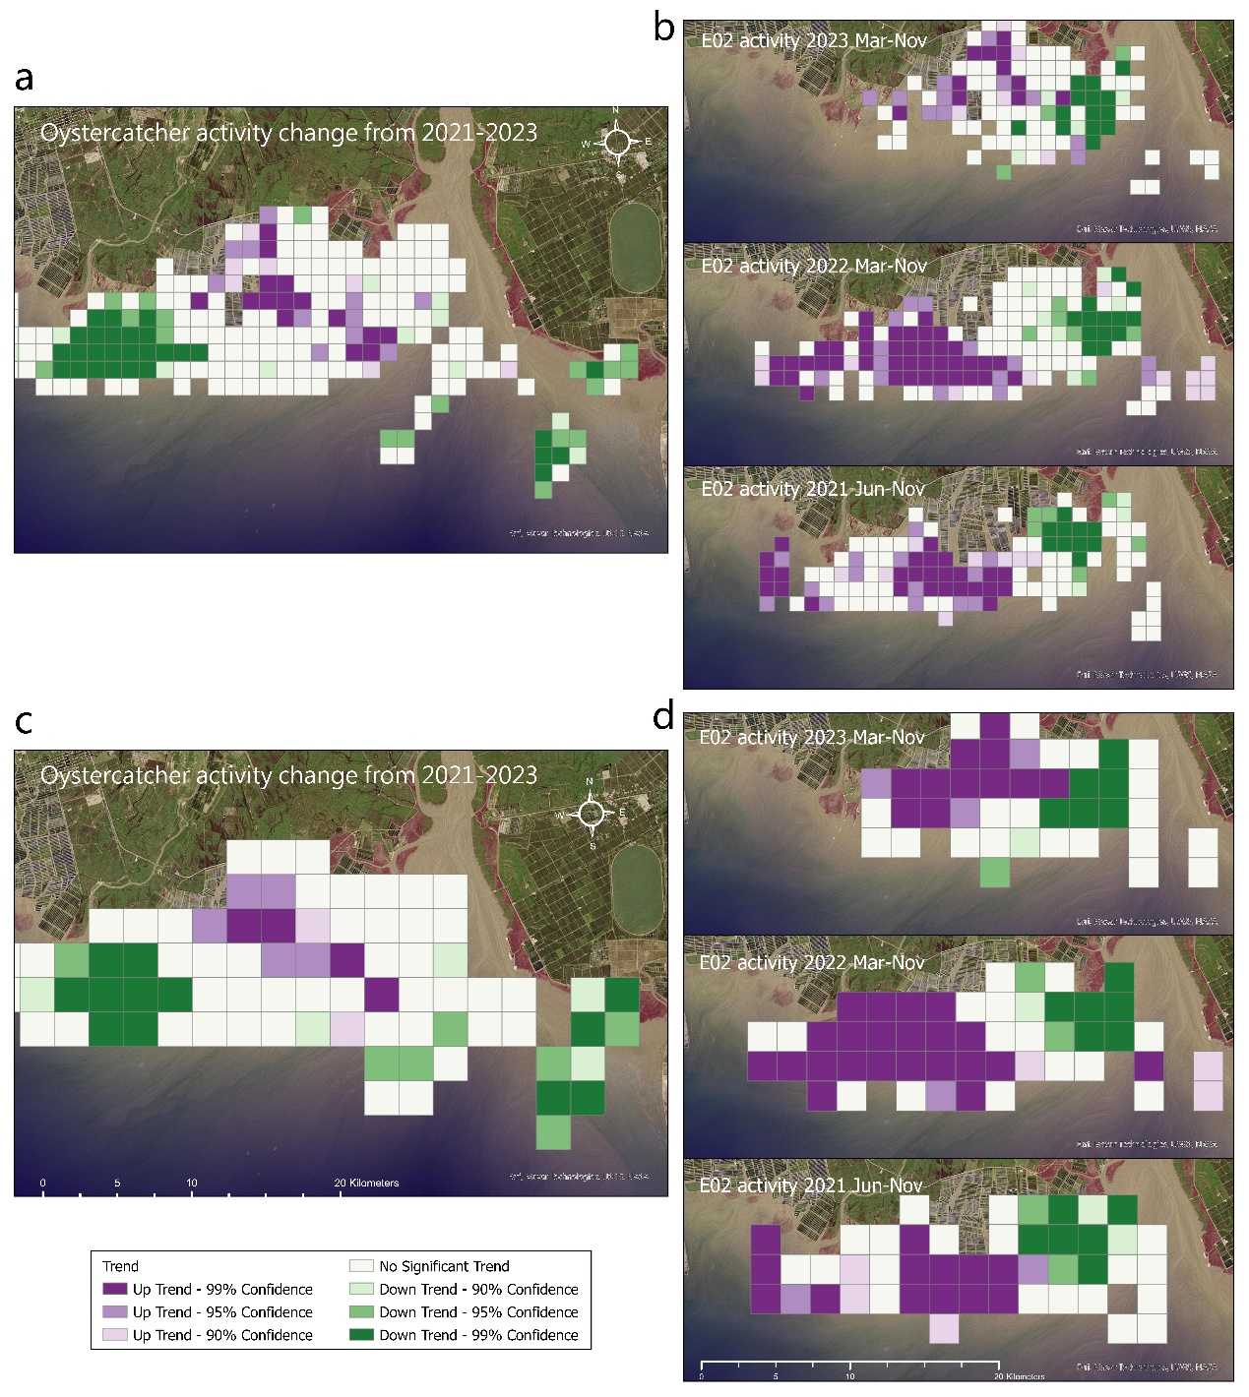
Supplementary Figure 1 Robustness of the space–time cube trends to spatial grid resolution. The population-scale annual analysis (three Eurasian Oystercatchers, 2021–2023; a, c) and the individual-scale seasonal analysis (bird E02, by year; b, d) were each repeated at 1 km (a, b) and 2 km (c, d) grid resolution.

