Supplementary information
SI-1. FITC labeling of nanocarrier
In order to be able to trace the nanocarriers inside the cells, they were labeled with FITC according to the supplier protocol. Briefly, FITC was dissolved in DMSO in concentration of 5 mM. 0.1 mg of nano-carrier was dispersed in 1 ml of carbonate-bicarbonate buffer (pH 9.2) under bath sonication. 10 µL of FITC was added to nano-carrier dispersion and shaked for 2 hrs at room temperature. The FITC-labeled nano-carrier was separated from the free FITC by several washing steps. The Uv-vis spectrum of FITC-labeled GPPF nanocarrier is depicted above. Both FITC and FA characteristic peaks were also visible.

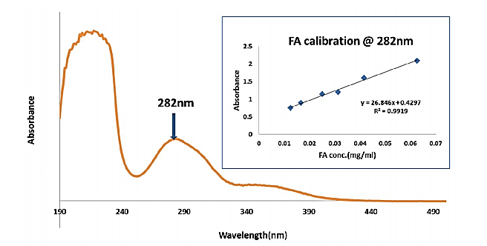
SI-2. Folic acid calibration curve
Uv-vis spectrum and calibration curve of FA were prepared based on absorption at 282 nm for various FA concentrations (12.5-250 μg/mL in MES buffer).
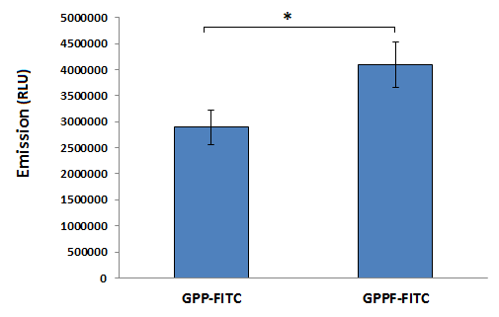
SI-3. Quantitative internalization efficacy of GPP and GPPF nanocarrier after 24 hrs

SI. 4 TEM image of non-treated MCF-7 cells
E, M, V, L, G and N represent endosome compartment, mitochondria, vacuole, lysosomes, golgi apparatus and nucleus. Scale bare represents 2µm (left image) and 500 nm (right image).

4.5 | 7.4 | 11 | Incubation pH
95.3 | 9.6 | 3.2 | Estimated Release %

SI. 5 CQ Calibration curve
Calibration curve of CQ concentration (X) versus illumination density (Y), estimated by Image J® calibration wizard. The concentration of released CQ at different pH was estimated based on the optical densitometry of gel electrophoresis image, compared to the prepared calibration curve.
SI.6 zeta potential and particle size analysis
Zeta potential and particle size analyses of functionalized nanocarriers complexed with plasmid compared to bare functionalized nanocarriers (GPPF/CQ)
Sample | Zeta potential value (mv) | Particle size analysis
Sample | Zeta potential value (mv) | Effective diameter (nm) | PDI
GPPF/CQ | +35.97±2.05 | 245±3.0 | 0.18±0.01
GPPF/CQ + pEGFP | +22.43±2.05 | 218±4.15 | 0.21±0.005

