Supplementary information

Fast charging stabilizes lithium-rich cathodes in all-solid-state batteries

Liang Shen^{1,2}, Chen-Zi Zhao^{1,2*}, Yi-Cheng Le^{1,2}, Wei-Jin Kong^{1,2}, Zhong-Yuan Huang^{1,2}, Jun-Dong Zhang^{1,2}, Zi-Xuan Wang³, Cheng-Long Liu^{1,2}, Qiang Zhang^{1,2,4,5,6*}

¹ Beijing Key Laboratory of Complex Solid-State Batteries, Department of Chemical Engineering, Tsinghua University, Beijing 100084, China.
² State Key Laboratory of Chemical Engineering and Low-Carbon Technology, Tsinghua University, Beijing 100084, China.
³ Advanced Research Institute of Multidisciplinary Science, Beijing Institute of Technology, Beijing 100081, China.
⁴ AI Solid-State Battery Innovation Center, Yibin 644002, China.
⁵ Institute for Carbon Neutrality, Tsinghua University, Beijing 100084, China.
⁶ Shanxi Research Institute for Clean Energy, Tsinghua University, Taiyuan 030032, China
* Corresponding author. Email: zcz@mail.tsinghua.edu.cn (C.-Z.Z.); zhang-qiang@mails.tsinghua.edu.cn (Q.Z.)

Supplementary Figures
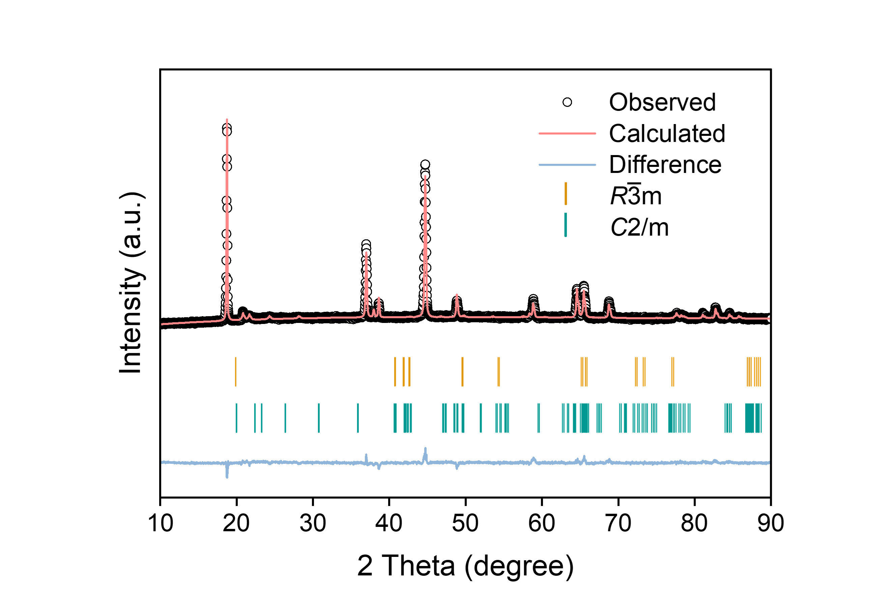
Supplementary Fig. 1 | X-ray diffraction (XRD) pattern and Rietveld refinements of the lithium-rich manganese-based oxide (LRMO).

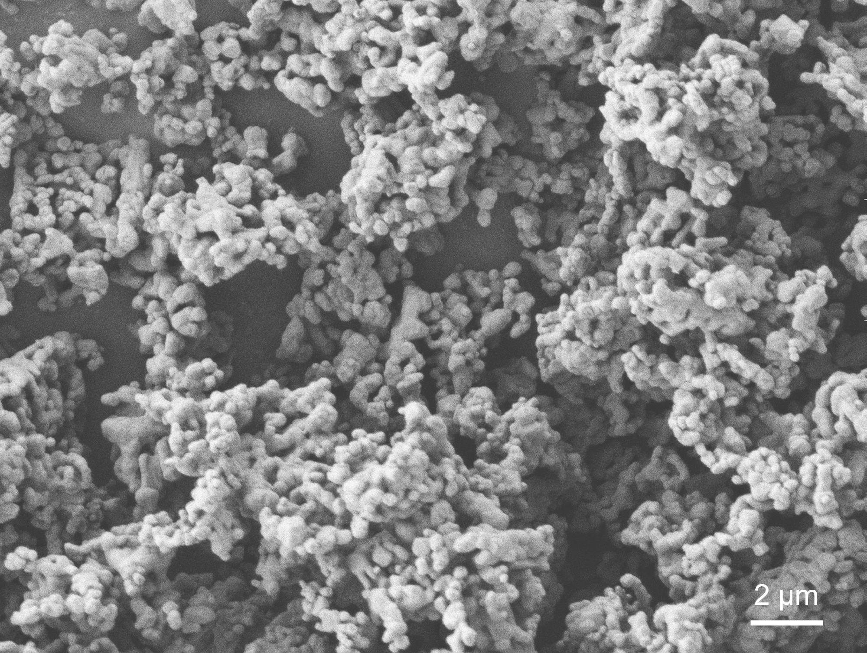
Supplementary Fig. 2 | Scanning electron microscopy (SEM) image of the LRMO.

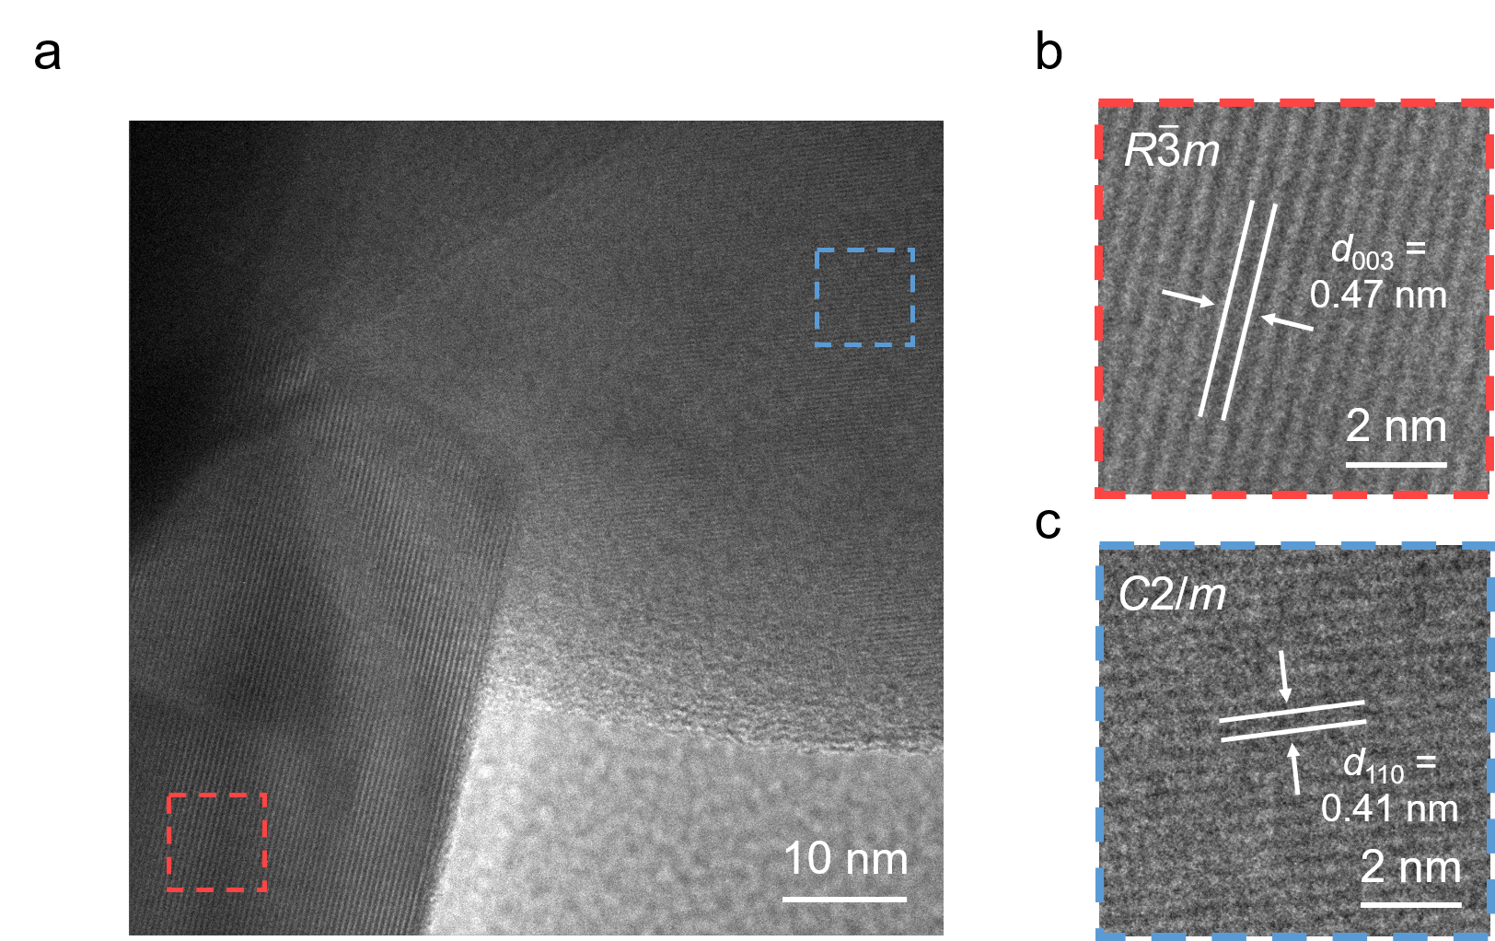
Supplementary Fig. 3 | Transmission electron microscopy (TEM) image of the LRMO, showing the two-phase feature.

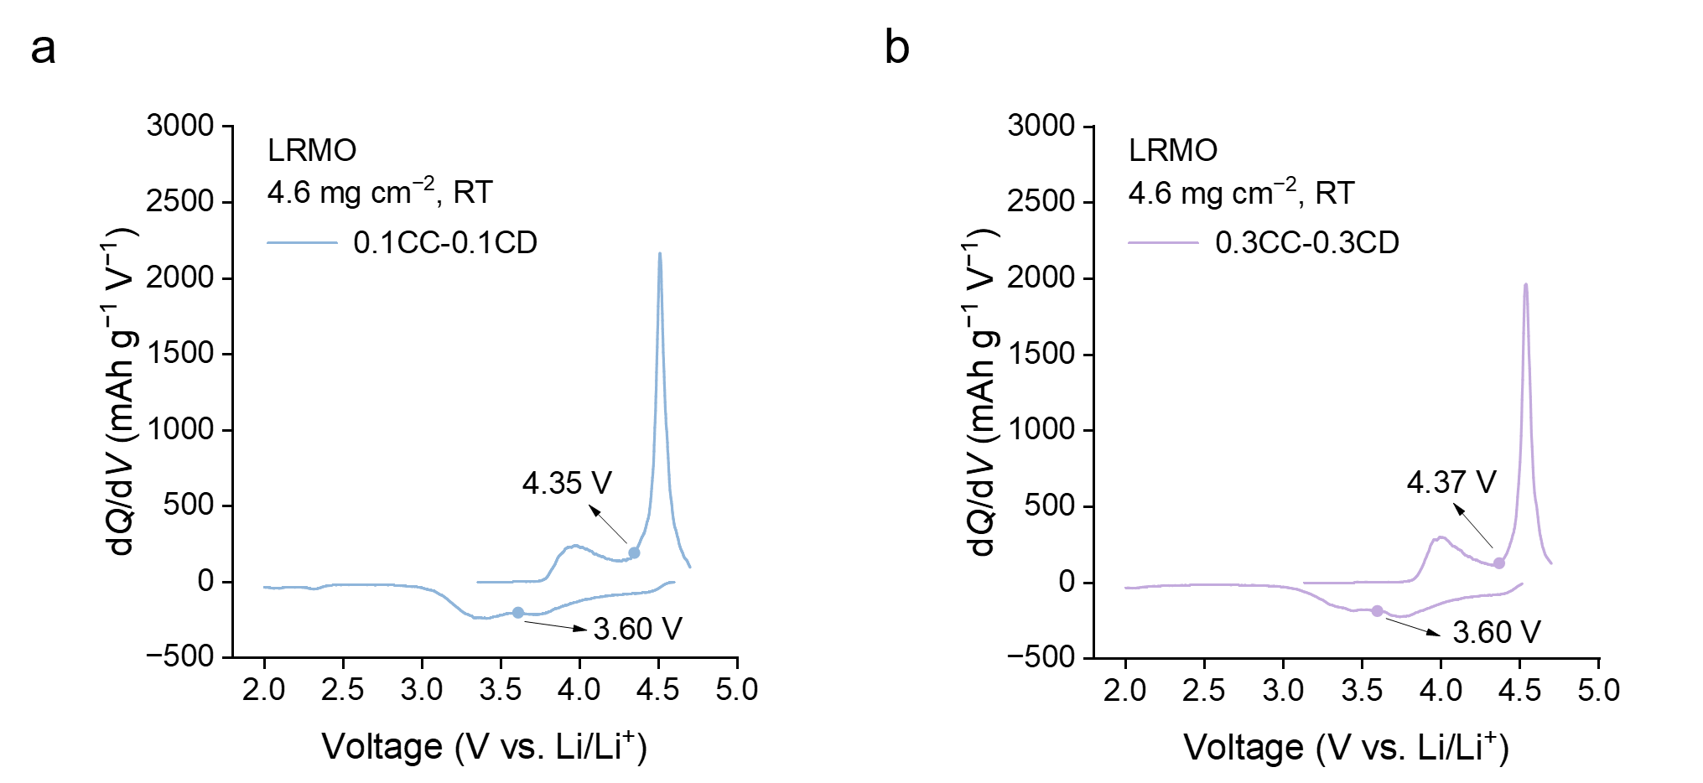
Supplementary Fig. 4 | Differential capacity (dQ/dV) curve of the LRMO with symmetric a, 0.1 C, and b, 0.3 C charge and discharge. dQ/dV curves display 4.35 V for 0.1 C and 4.37 V for 0.3 C as the division between cationic and anionic dominant region during charging, and 3.60 V during discharging.

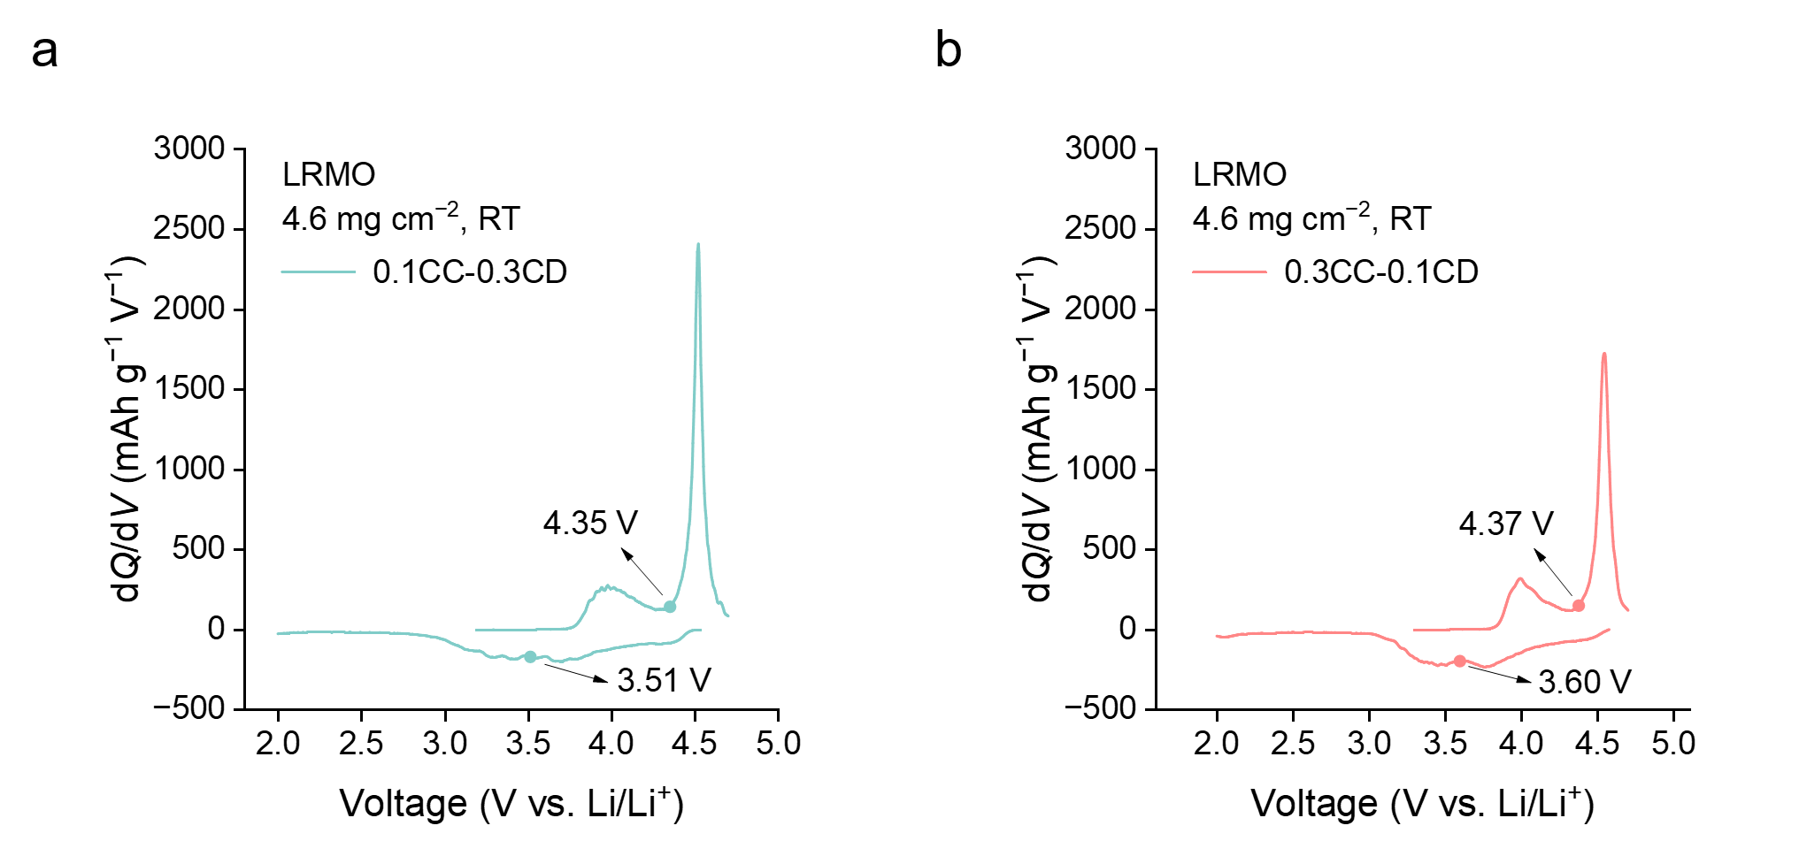
Supplementary Fig. 5 | dQ/dV curve of the LRMO with asymmetric a, 0.1 C charge and 0.3 C discharge, and b, 0.3 C charge and 0.1 C discharge. For 0.1 C charge and 0.3 C discharge, dQ/dV curves display 4.35 V as the division between cationic and anionic dominant region during charging, and 3.51 V during discharging. For 0.3 C charge and 0.1 C discharge, dQ/dV curves display 4.37 V as the division between cationic and anionic dominant region during charging, and 3.60 V during discharging.

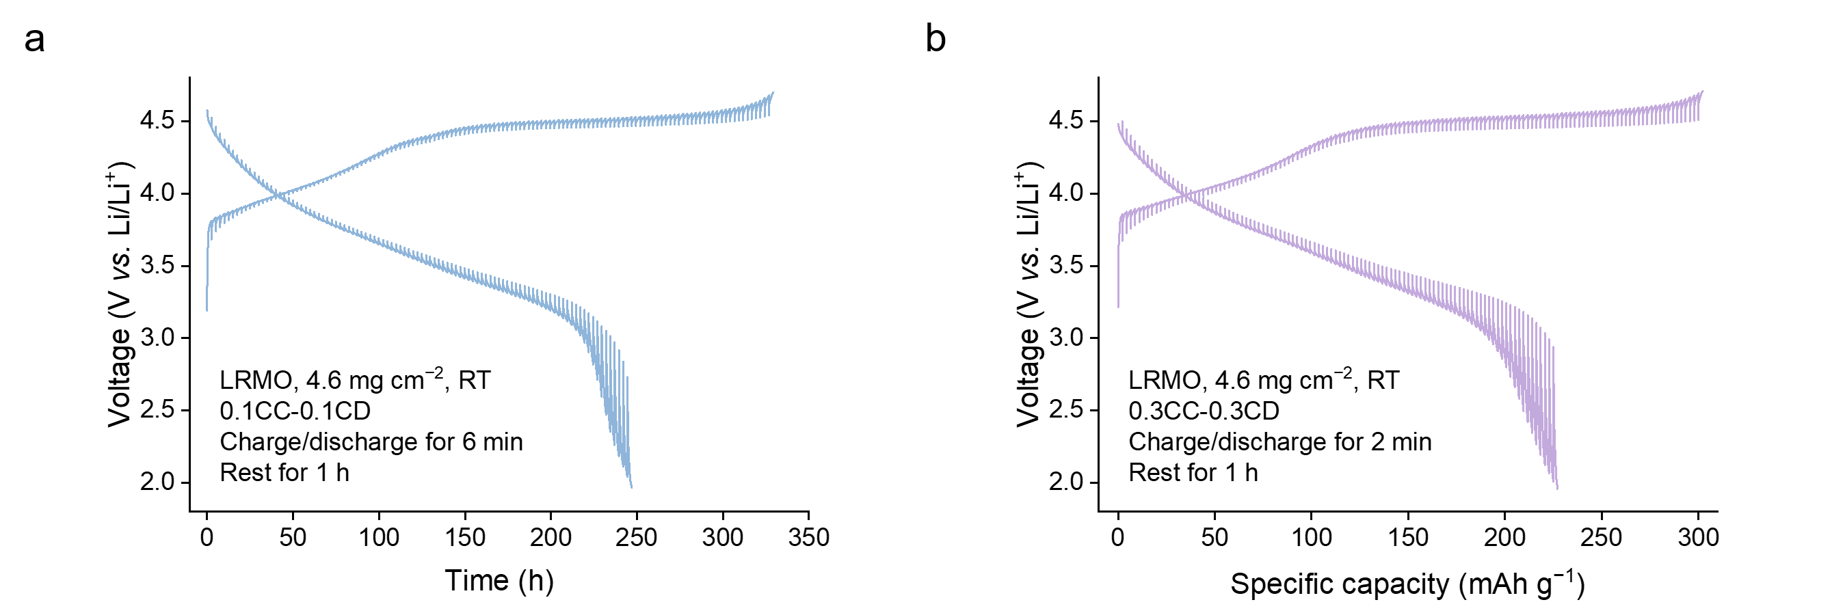
Supplementary Fig. 6 | Galvanostatic intermittent titration technique (GITT) curves of a, 0.1 C, and b, 0.3 C.

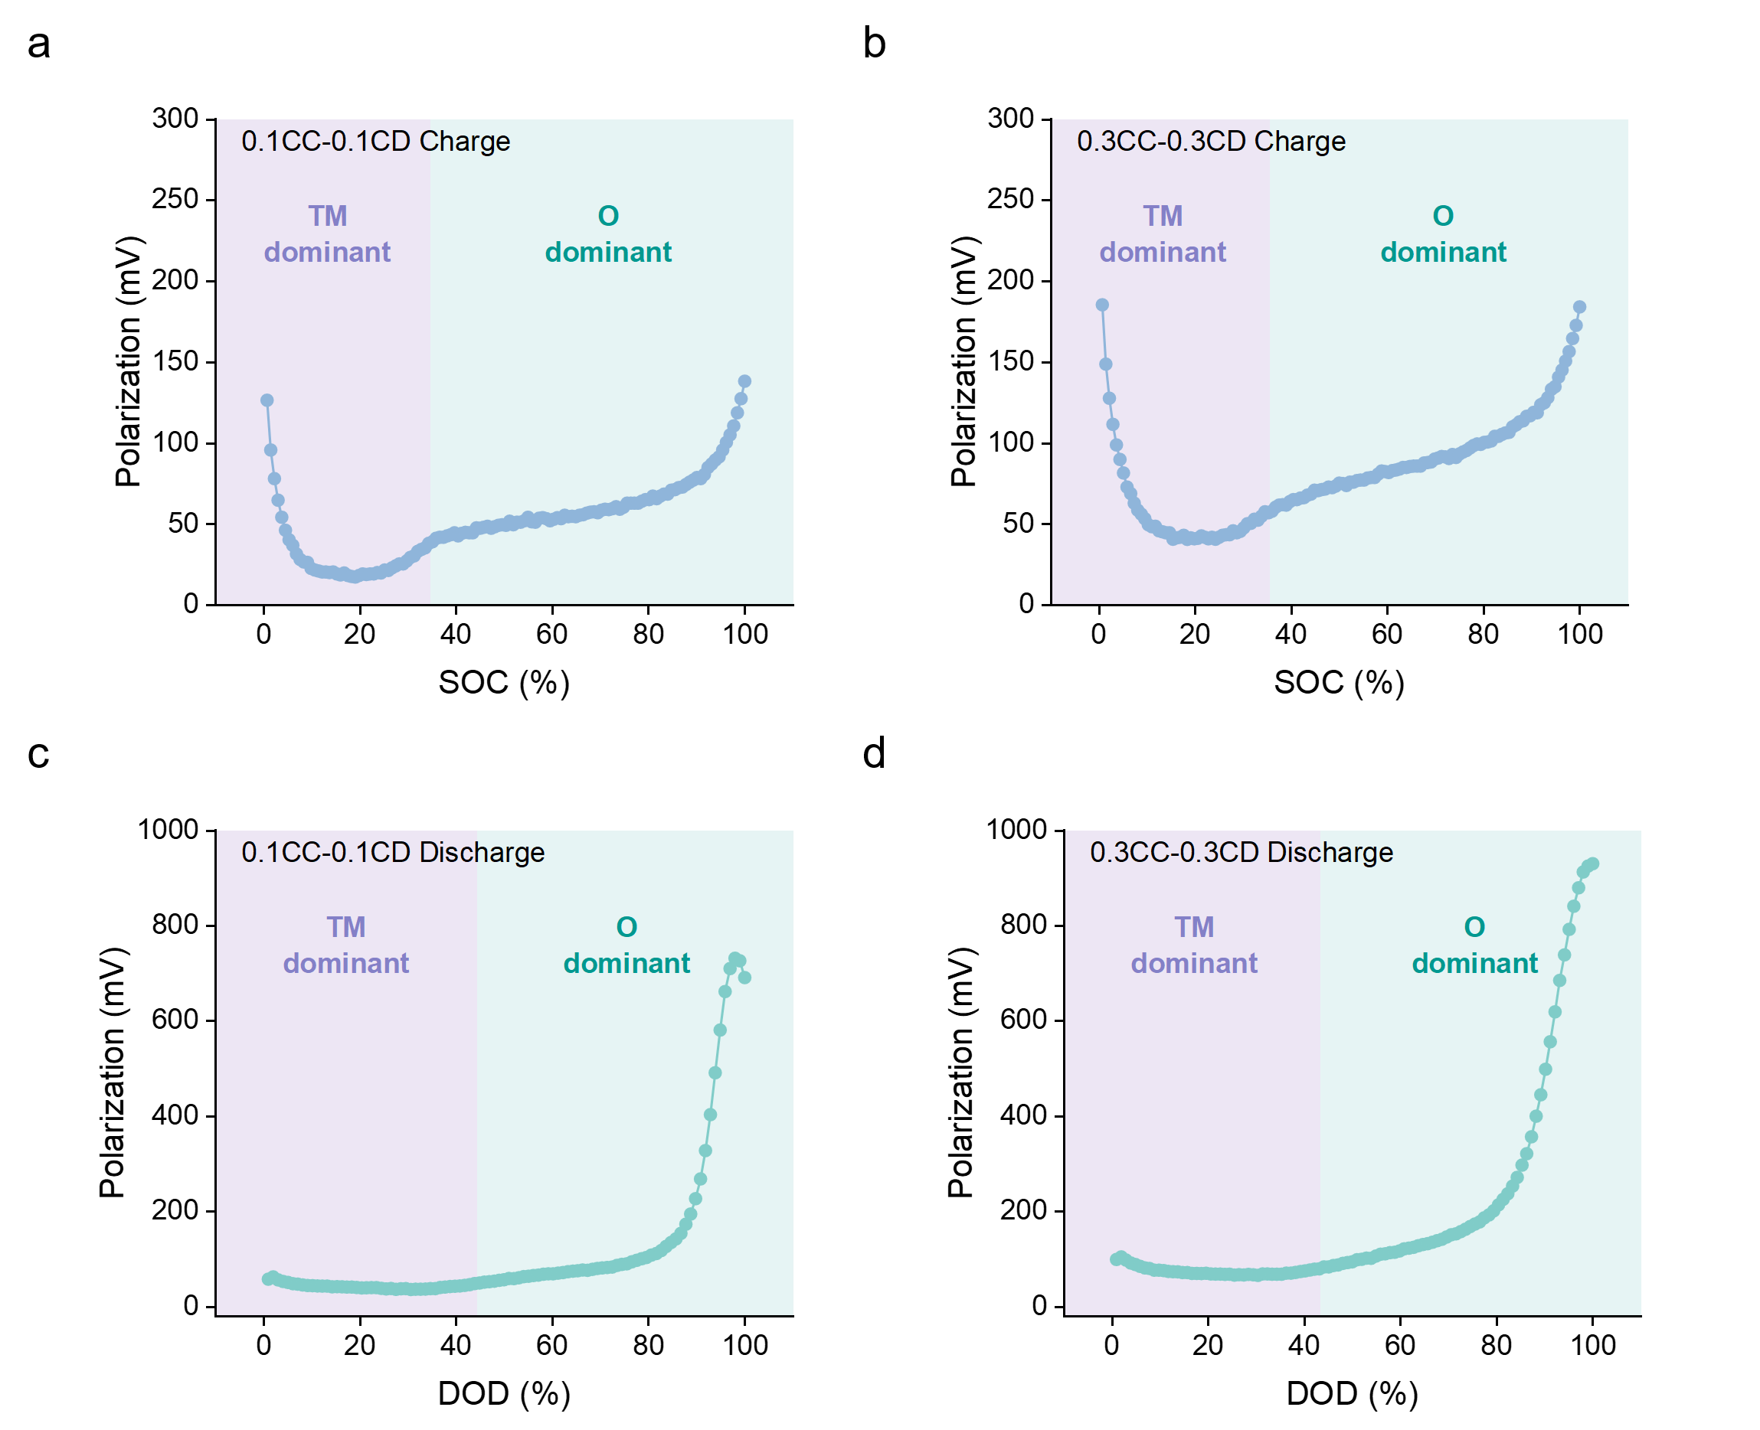
Supplementary Fig. 7 | Decoupled polarization of symmetric and asymmetric charge and discharge.

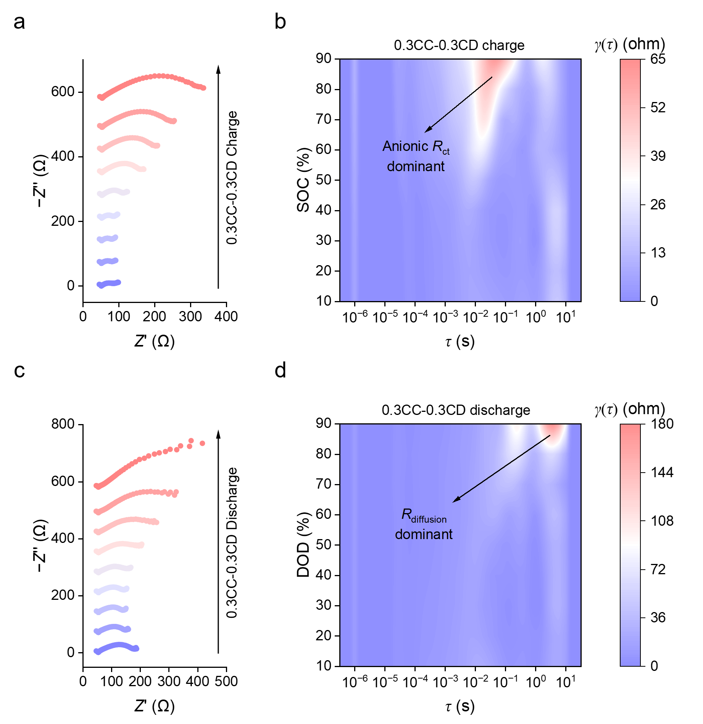
Supplementary Fig. 8 | Nyquist plot of in situ electrochemical impedance spectroscopy (EIS) and distribution of relaxation times (DRT) analysis for 0.3 C symmetric cycling. Similarly with 0.1 C symmetric cycling, at the end of charging, the impedance increase originates primarily from anionic charge transfer resistance, whereas at the end of discharging, the response is dominated by an exceptionally large Li⁺ diffusion resistance.

Supplementary Fig. 9 | dQ/dV curve of discharge process for the LRMO with 6 hours potentiostatic relaxation at 4.70 V. The cationic and anionic reduction peaks shift to lower voltages with decreased intensity, indicating that the structure of LRMO has degraded and that lithium-ion (Li⁺) diffusion is suppressed.

Supplementary Fig. 10 | dQ/dV curve of discharge process for the NCM811 with 6 hours potentiostatic relaxation at 4.70 V.

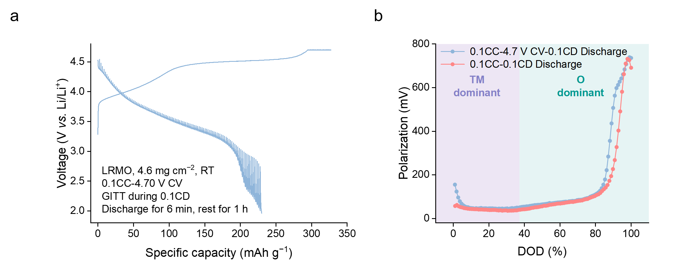
Supplementary Fig. 11 | a, GITT curve and b, decoupled polarization for the LRMO with 6 hours potentiostatic relaxation at 4.70 V.

Supplementary Fig. 12 | Nyquist plot of in situ EIS of the LRMO during discharging with 6 hours potentiostatic relaxation at 4.70 V.

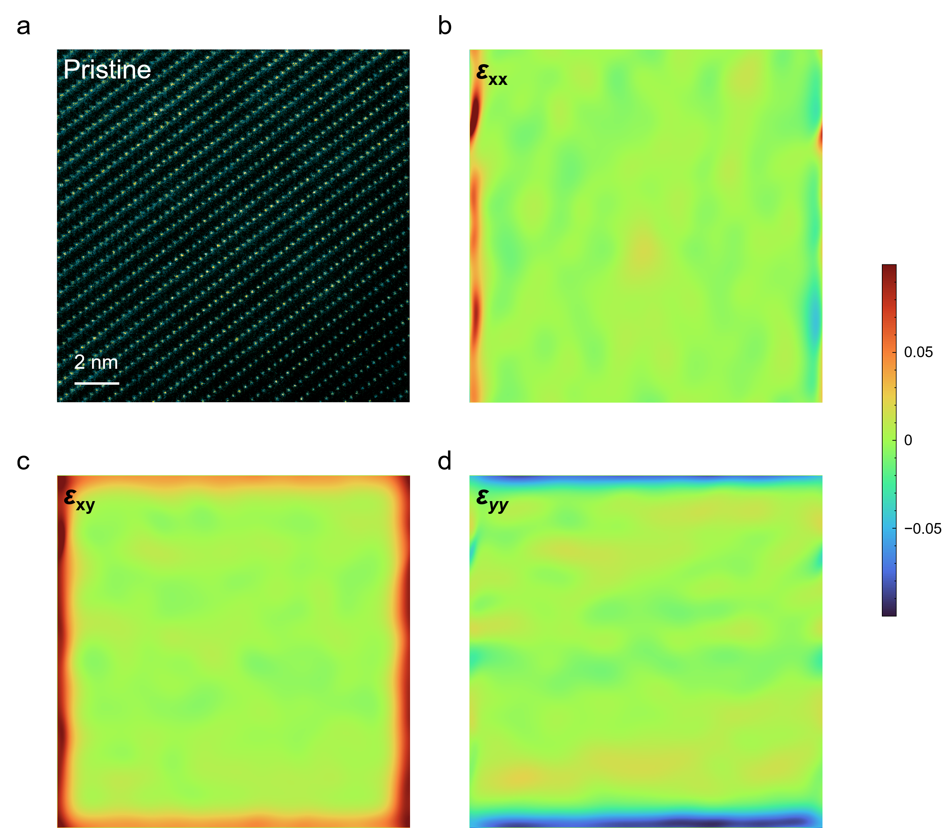
Supplementary Fig. 13 | Atomic arrangement and geometric phase analysis (GPA) of pristine LRMO. a, High-angle annular dark-field scanning transmission electron microscopy (HAADF-STEM) image of pristine LRMO. b–d, GPA strain analysis of the pristine LRMO.

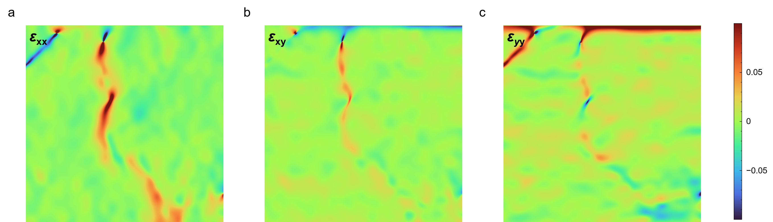
Supplementary Fig. 14 | GPA strain mapping of LRMO charging to 4.70 V at 0.1 C. Nano-cracks cause intense local mechanical strain and driving mechanical failure.

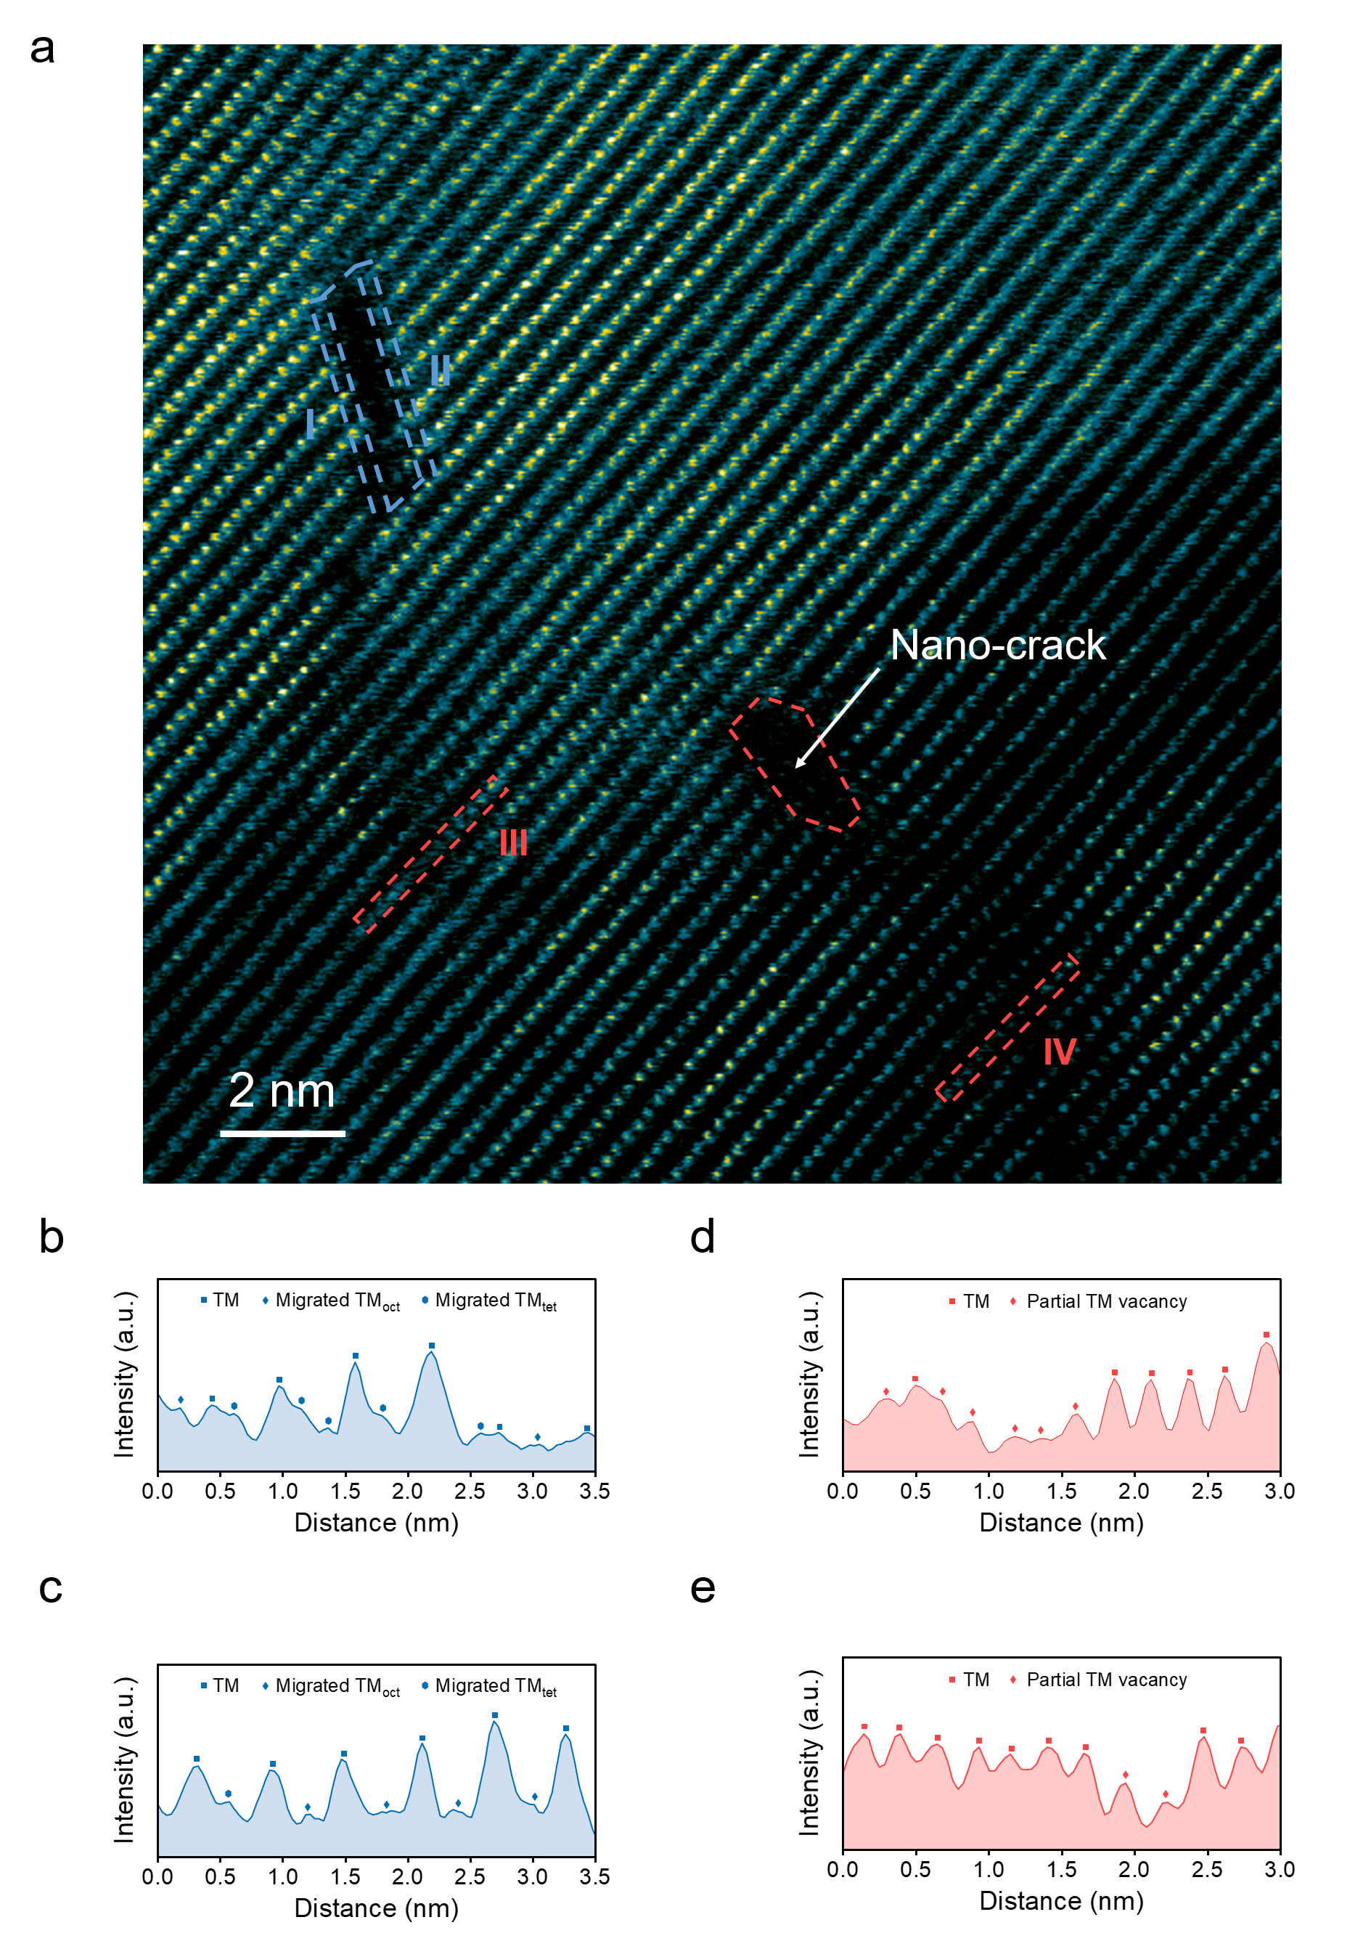
Supplementary Fig. 15 | Atomic arrangement of the LRMO charging to 4.70 V at 0.1 C at another position. a, HAADF-STEM image of the LRMO. b–e, Atomic intensity line scans of nano-cracks and TM vacancy.

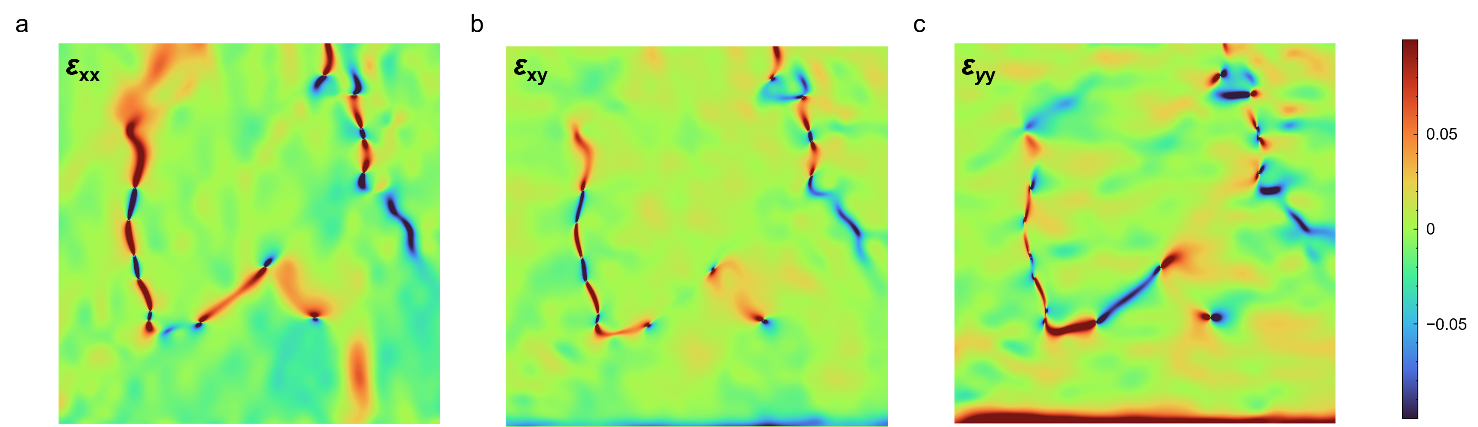
Supplementary Fig. 16 | GPA strain mapping of LRMO charging to 4.70 V at 0.1 C at another position. Nano-cracks cause intense local mechanical strain and driving mechanical failure.

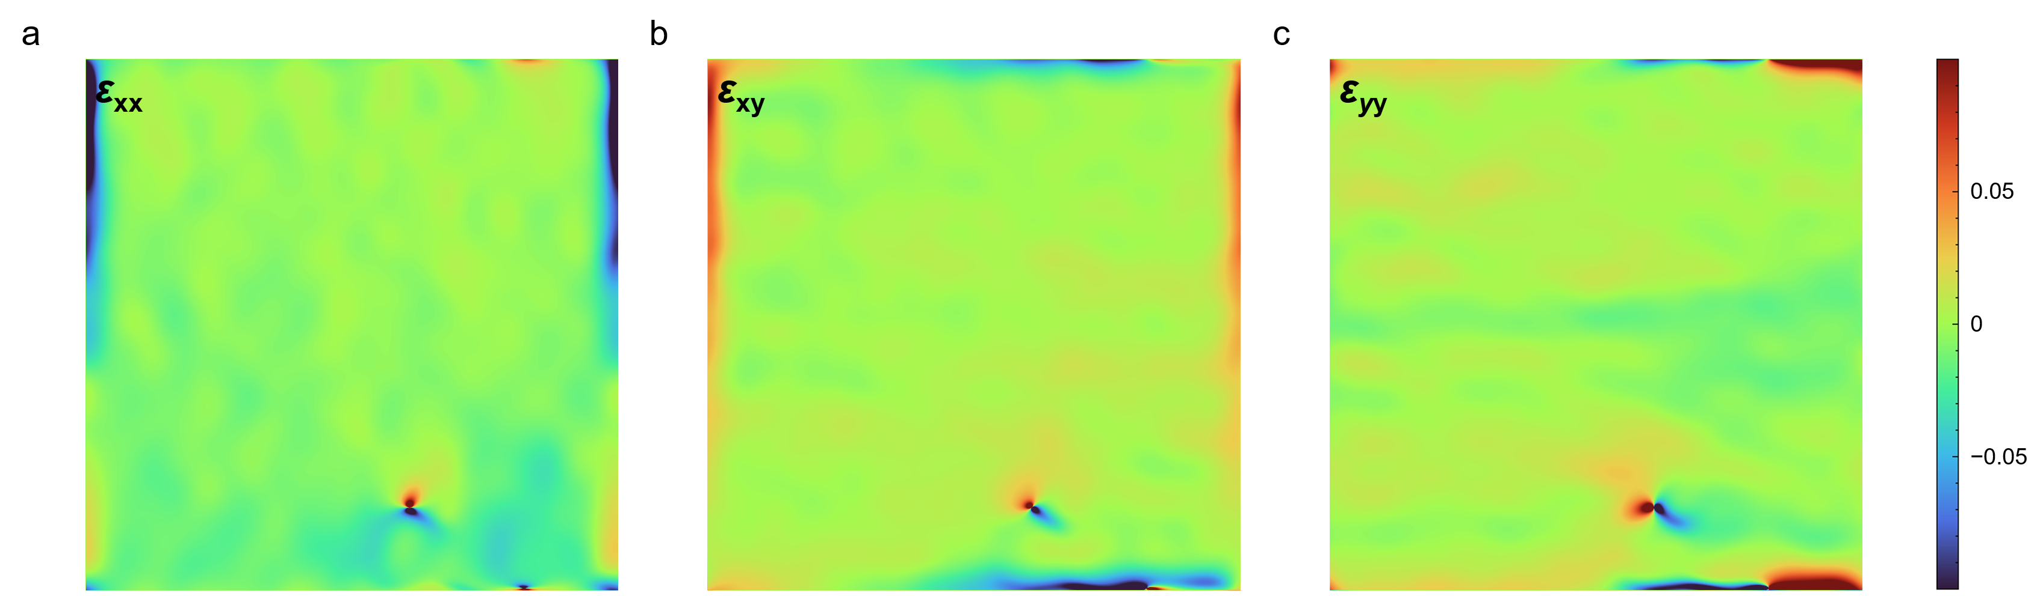
Supplementary Fig. 17 | GPA strain mapping of LRMO charging to 4.70 V at 0.3 C. Fast charging LRMO retain remarkable atomic structural integrity and uniform internal stress distribution than slow charging LRMO.

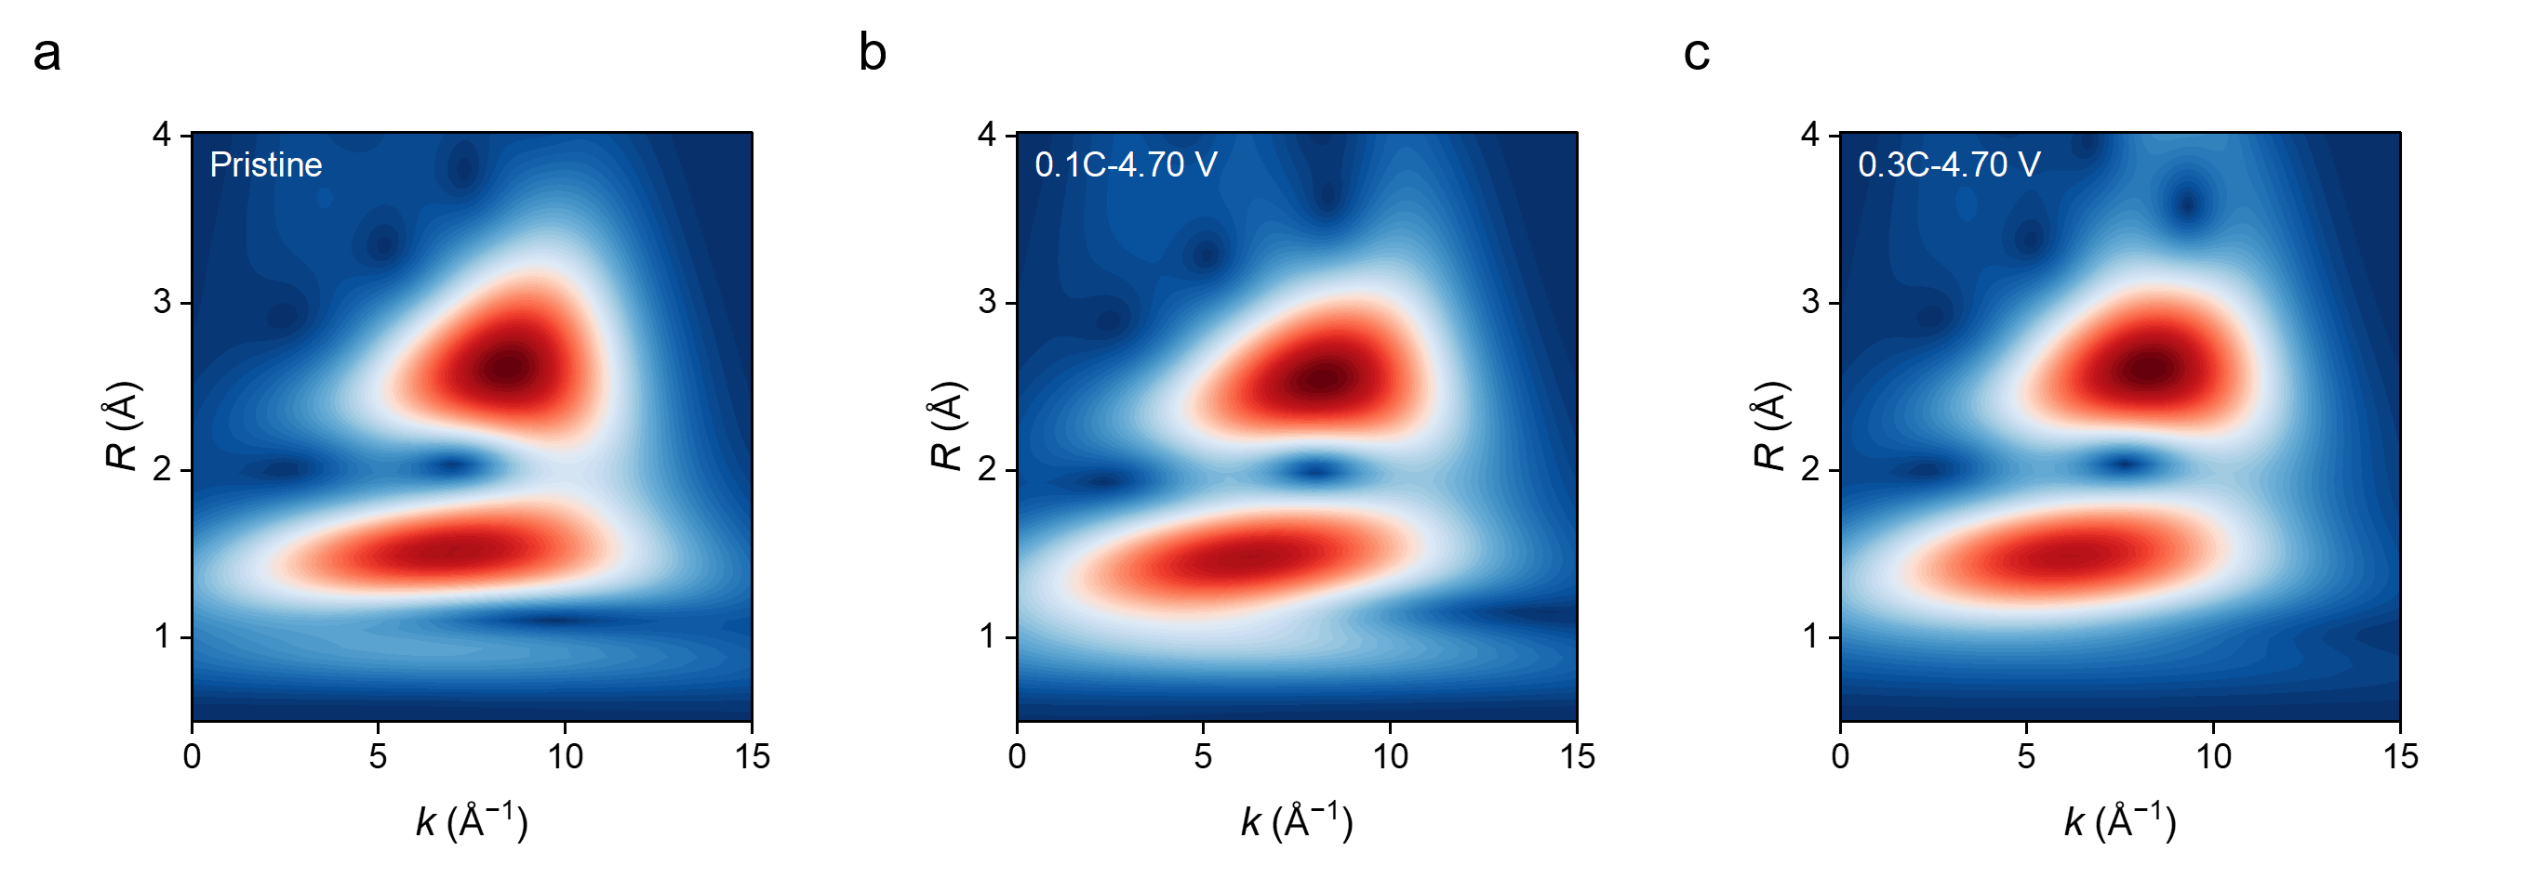
Supplementary Fig. 18 | Wavelet transform-extended X-ray absorption fine structure (WT-EXAFS) of the a, Pristine LRMO, b, LRMO charging to 4.70 V at 0.1 C, and c, LRMO charging to 4.70 V at 0.3 C.

Supplementary Fig. 19 | Rate performance of LRMO all-solid-state batteries (ASSBs).

Supplementary Fig. 20 | Cycling performance of the symmetric protocols. Asymmetric fast charging and slow discharging protocol exhibits the highest capacity retention of 94.6%.

Supplementary Fig. 21 | Voltage decay of the symmetric protocols. Asymmetric fast charging and slow discharging protocol exhibits the lowest voltage decay rate of 2.19 mV/cycle.

Supplementary Fig. 22 | Cycling performance and voltage decay of the duration-matched symmetric protocols (0.15 C). Asymmetric fast charging and slow discharging protocol still displays highest capacity retention and lowest voltage decay.

Supplementary Fig. 23 | Initial charge and discharge curves of the asymmetric 0.5 C–0.2 C combination.

Supplementary Fig. 24 | Cycling performance of the asymmetric 0.5 C–0.2 C combination.

Supplementary Fig. 25 | Voltage decay of the asymmetric 0.5 C–0.2 C combination.

Supplementary Fig. 26 | Cycling performance and voltage decay of the duration-matched symmetric protocols (0.286 C). Asymmetric fast charging and slow discharging protocol displays highest capacity retention and lowest voltage decay.

Supplementary Fig. 27 | Voltage decay of the asymmetric 1 C–0.33 C combination.

Supplementary Fig. 28 | Cycling performance and voltage decay of the duration-matched symmetric protocols (0.5 C). Asymmetric fast charging and slow discharging protocol displays highest capacity retention and lowest voltage decay.

Supplementary Fig. 29 | HAADF-STEM image of the LRMO cycled at 0.1 C charge and 0.3 C discharge for 100 cycles. Nano-cracks and 10-nm level nanovoids severely hinder the Li⁺ transfer within the LRMO cathode.

Supplementary Fig. 30 | GPA strain mapping of the nanovoid of the LRMO cycled at 0.1 C charge and 0.3 C discharge for 100 cycles.

Supplementary Fig. 31 | GPA strain mapping of the nano-cracks of the LRMO cycled at 0.1 C charge and 0.3 C discharge for 100 cycles.

Supplementary Fig. 32 | GPA strain mapping of the LRMO cycled at 0.3 C charge and 0.1 C discharge for 100 cycles. Fast charging and slow discharging cycled LRMO displays lower strain than slow charging and fast discharging LRMO, evidencing more stable lattice during cycling.

Supplementary Fig. 33 | Wavelet transform-extended X-ray absorption fine structure (WT-EXAFS) of the a, Pristine LRMO, b, LRMO cycled at 0.1 C charge and 0.3 C discharge for 100 cycles, and c, LRMO cycled at 0.3 C charge and 0.1 C discharge for 100 cycles

Supplementary Fig. 34 | Cl 2p X-ray photoelectron spectroscopy (XPS) spectra with 0 s sputtering of a, LRMO cycled at 0.1 C charge and 0.3 C discharge for 100 cycles, and b, LRMO cycled at 0.3 C charge and 0.1 C discharge for 100 cycles.

Supplementary Fig. 35 | Cl 2p X-ray photoelectron spectroscopy (XPS) spectra with 60 s sputtering of a, LRMO cycled at 0.1 C charge and 0.3 C discharge for 100 cycles, and b, LRMO cycled at 0.3 C charge and 0.1 C discharge for 100 cycles.

Supplementary Fig. 36 | Cl 2p X-ray photoelectron spectroscopy (XPS) spectra with 120 s sputtering of a, LRMO cycled at 0.1 C charge and 0.3 C discharge for 100 cycles, and b, LRMO cycled at 0.3 C charge and 0.1 C discharge for 100 cycles.

Supplementary Fig. 37 | Content analysis of Cl 2p XPS with different sputtering time. Fast charging and slow discharging LRMO maintain less oxidated Cl, showing less oxygen evolution of LRMO and more stable cathode–solid electrolyte interface.

Supplementary Fig. 38 | Intensity analysis of time-of-flight secondary ion mass spectrometry for a, ClO⁻, b, ClO²⁻, c, InO⁻, and d, InO²⁻ fragment signals.

Supplementary Fig. 39 | Post-cycling a, EIS and b, DRT analysis for LRMO cycled at 0.1 C charge and 0.3 C discharge and 0.3 C charge and 0.1 C discharge.

