Supplementary Information

Future population exposures to unprecedented climatic risks

Taichi Sano¹, Taikan Oki^{1,2*}

¹Department of Civil Engineering
Graduate School of Engineering
The University of Tokyo
7-3-1 Hongo, Bunkyo-ku
Tokyo 113-8656, Japan

²Rector’s Office
United Nations University
5–53–70 Jingumae, Shibuya-ku
Tokyo 150-8925, Japan

*Corresponding author
Telephone: +81 3 5841-0504
Email: oki@civil.t.u-tokyo.ac.jp

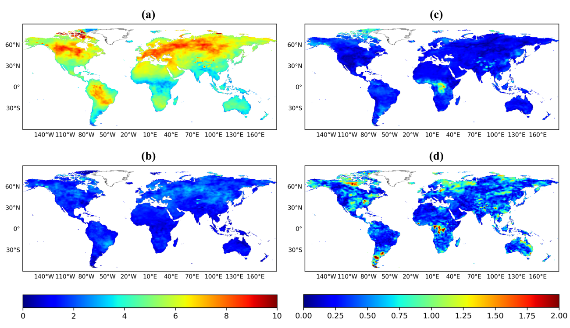
Supplementary Figure 1 | Projected multi-model average change in the 20-year temperature from 1980–2009 to 2070–2099 and coefficients of variation. (a) The change under the RCP8.5-SSP5 scenario. (b) The change under the RCP2.6-SSP1 scenario. (c) The coefficient of variation under the RCP8.5-SSP5 scenario. (d) The coefficient of variation under the RCP2.6-SSP1 scenario.

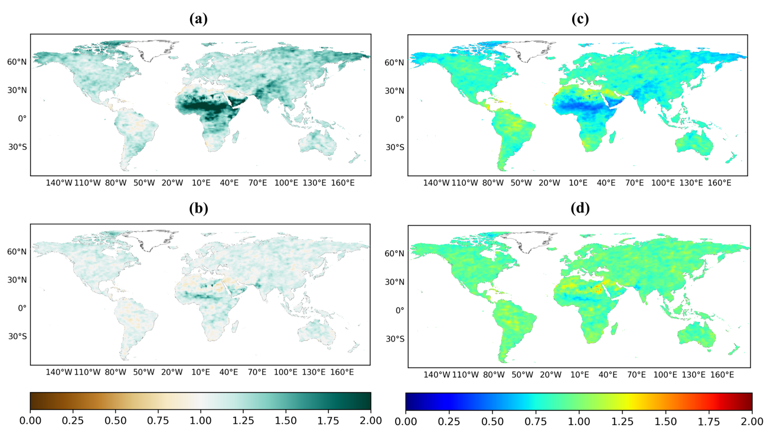
Supplementary Figure 2 | Projected multi-model average change in the 20-year precipitation from 1980–2009 to 2070–2099 and coefficients of variation. (a) The change under the RCP8.5-SSP5 scenario. (b) The change under the RCP2.6-SSP1 scenario. (c) The coefficient of variation under the RCP8.5-SSP5 scenario. (d) The coefficient of variation under the RCP2.6-SSP1 scenario.

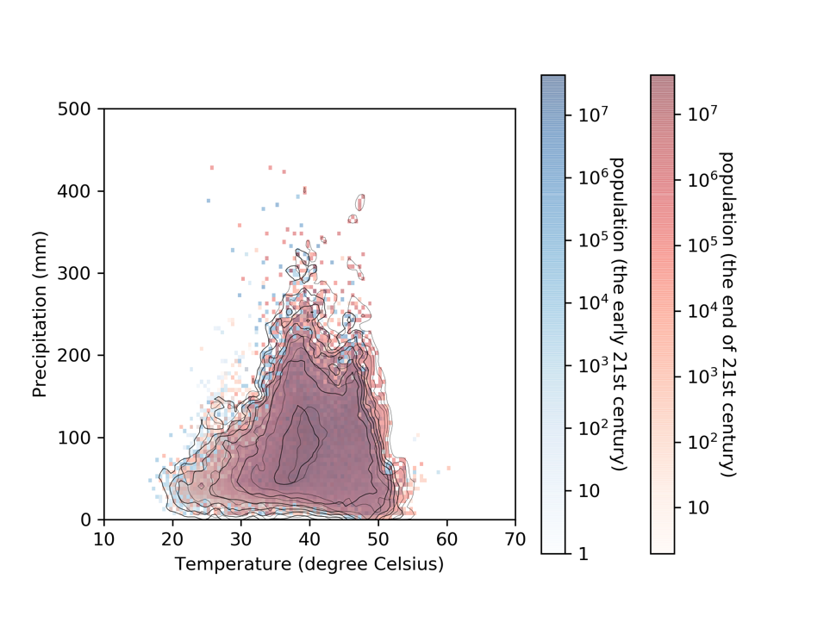
Supplementary Figure 3 | Projected change in the population exposed to extreme weather risks. Two-dimensional histogram representing the population exposed to the combination extreme weather risks, calculated based on the 20-year temperature and precipitation data, divided by intervals of 0.5 °C and 10 mm, respectively. The blue and red histograms show the results for 1980–2009 and 2070–2099, respectively. These data were obtained under the RCP2.6-SSP1 scenario.

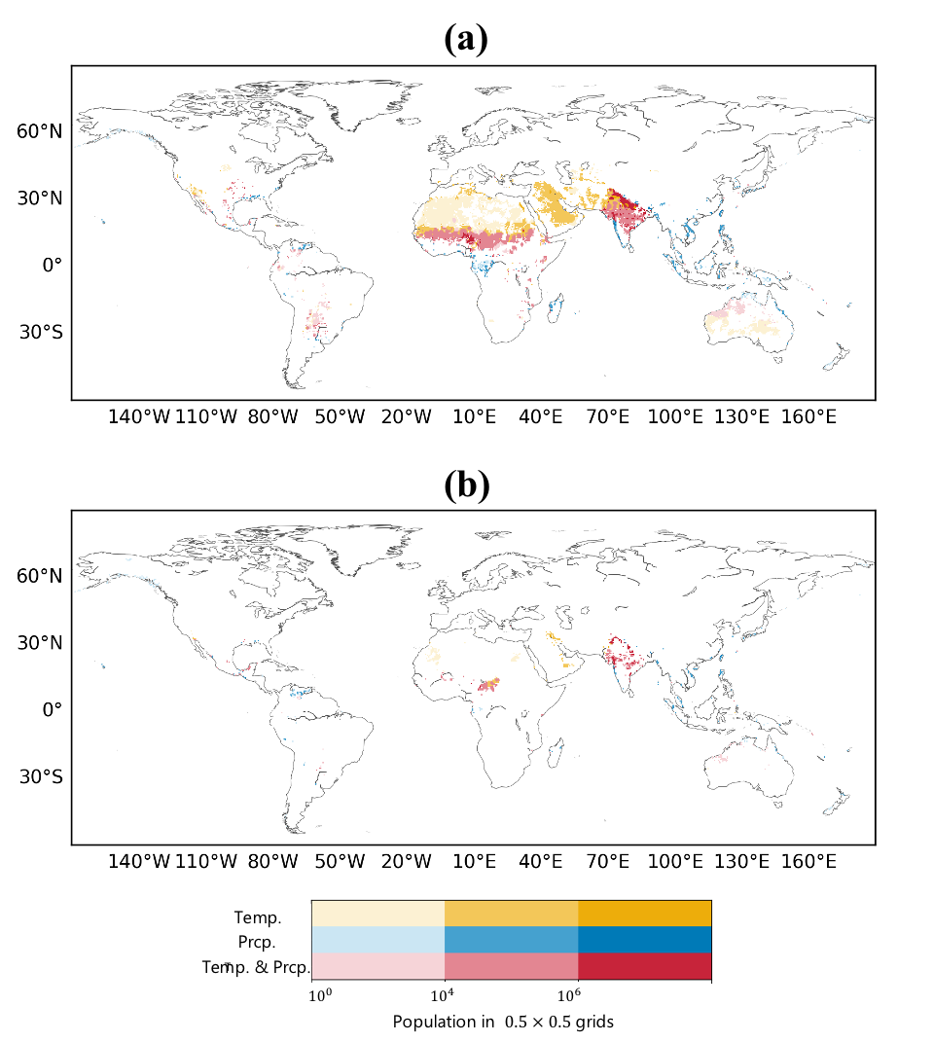
Supplementary Figure 4 | Projected population expected to overstep the climatic risk boundaries and be exposed to unprecedented extreme climatic risks, and its geographic distribution. People in the yellow grid will be exposed to unprecedented extreme temperature risks, people in the blue grid will be exposed to unprecedented extreme precipitation risks, and people in the red grid will be exposed to unprecedented extreme climatic risks (both extreme temperature and extreme precipitation). The deepest color represents the grids in which more than ${10}^{6}$ people live, the second-deepest color represents the grids in which more than ${10}^{4}$ people live, and the lightest color represents the grids in which at least 1 person lives. The resolution of a grid is 0.5° longitudinally and latitudinally, i.e. approximately 50 km × 50 km. (a) Map for the RCP8.5-SSP5 scenario. (b) Map for the RCP2.6-SSP1 scenario.

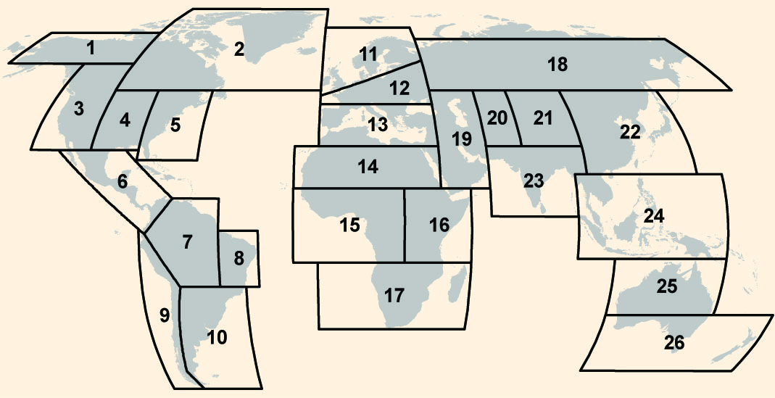

Supplementary Figure 5 | Map showing the ‘SREX’ regions (Figure3-1) for the regional climatic risk boundaries. (IPCC, 2012)

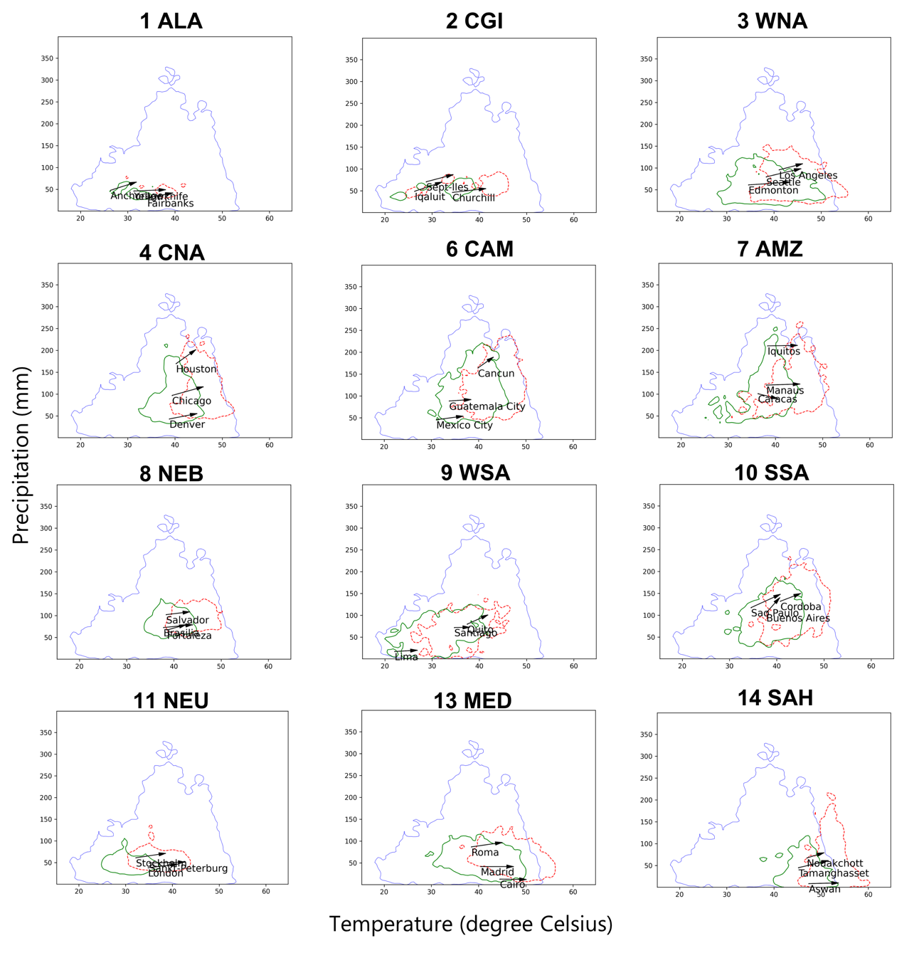
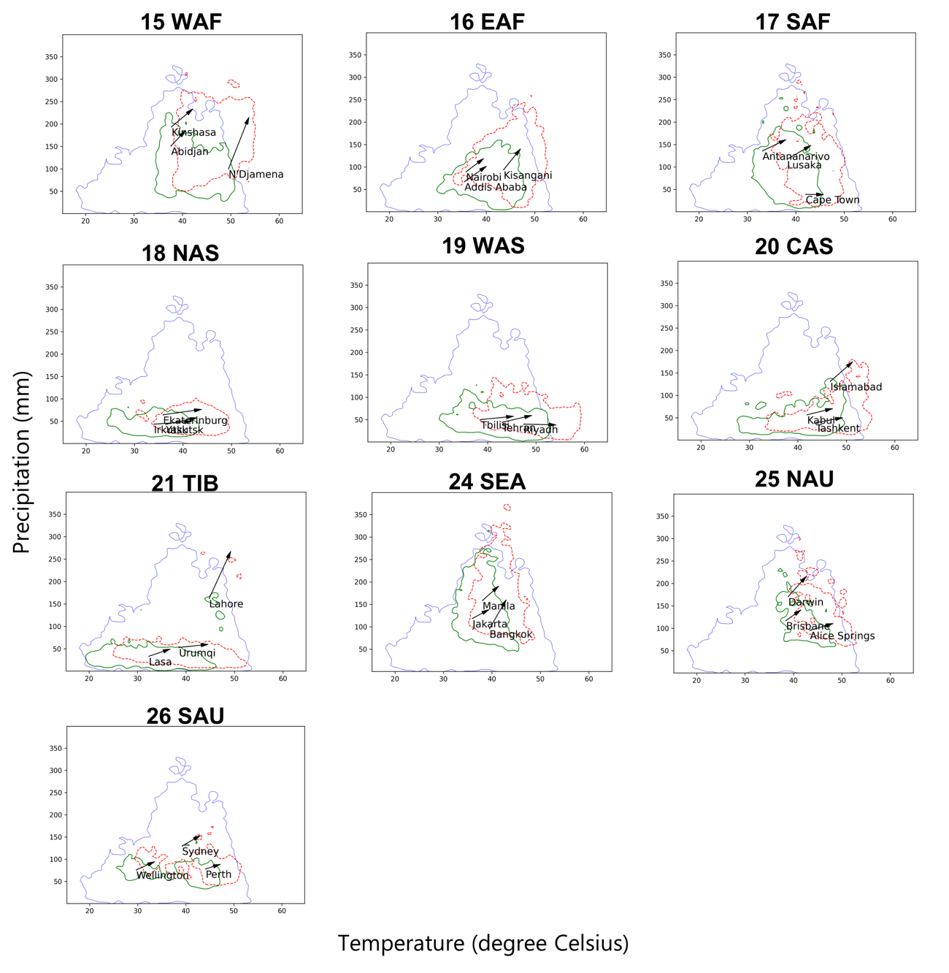
Supplementary Figure 6 | Projected regional climatic risk boundaries. The numbers in the figure correspond to the IPCC SREX regional classification. The blue, green, and red lines represent a climatic risk boundary for humanity as a whole, a current regional climatic risk boundary, and a future regional climatic risk boundary, respectively.
Supplementary Table 1 | The correspondence relation among region ID, abbreviation and regional representation.
Region ID | Abbreviation | Regional representation
1 | ALA | Alaska/Northwest Canada
2 | CGI | East Canada, Greenland, Iceland
3 | WNA | West North America
4 | CNA | Central North America
5 | ENA | East North America
6 | CAM | Central America and Mexico
7 | AMZ | Amazon
8 | NEB | Northeastern Brazil
9 | WSA | West coast of South America
10 | SSA | Southeastern South America
11 | NEU | Northern Europe
12 | CEU | Central Europe
13 | MED | Southern Europe and Mediterranean
14 | SAH | Sahara
15 | WAF | West Africa
16 | EAF | East Africa
17 | SAF | Southern Africa
18 | NAS | North Asia
19 | WAS | West Asia
20 | CAS | Central Asia
21 | TIB | Tibetan Plateau
22 | EAS | East Asia
23 | SAS | South Asia
24 | SEA | Southeast Asia
25 | NAU | North Australia
26 | SAU | South Australia/New Zealand

Supplementary Table 2 | Total population and population (million) under unprecedented extreme climatic risks at the end of 21st century under each scenario.
Scenario | RCP8.5-SSP5 | RCP2.6-SSP1
Under unprecedented extreme temperature risk | $$367$$ | $$42.7$$
Under unprecedented extreme precipitation risk | $$265$$ | $$51.8$$
Under unprecedented extreme combination (T & P) risk | $$1.09×{10}^{3}$$ | $$306$$
Total | $$1.72×{10}^{3}$$ | $$401$$
World population | $$7.39×{10}^{3}$$ | $$6.90×{10}^{3}$$
Ratio of people under unprecedented extreme climatic risk | $$23.3\%$$ | $$5.81\%$$

Supplementary Table 3 | Total population and population (million) under unprecedented extreme climatic risks at the end of 21st century under RCP8.5- SSP 5 scenario.
Region ID | T | P | T & P | Total | Population | Ratio
1 ALA | 0 | 0.0127 | 0 | 0.0127 | 1.30 | 0.973%
2 CGI | 0 | 0 | 0 | 0 | 2.97 | 0%
3 WNA | 0 | 0.864 | 0 | 0.864 | 389 | 0.222%
4 CNA | 0.157 | 4.75 | 12.1 | 17.0 | 242 | 7.01%
5 ENA | 11.4 | 0.0265 | 0.465 | 11.9 | 187 | 6.35%
6 CAM | 0.266 | 1.15 | 3.37 | 4.79 | 168 | 2.85%
7 AMZ | 0.0861 | 0.836 | 0.893 | 1.81 | 56.8 | 3.20%
8 NEB | 0.0497 | 0.0451 | 0 | 0.0948 | 48.8 | 0.194%
9 WSA | 0 | 0.189 | 0 | 0.189 | 30.7 | 0.616%
10 SSA | 0.148 | 2.03 | 1.99 | 4.16 | 122 | 3.41%
11 NEU | 0 | 0 | 0 | 0 | 219 | 0%
12 CEU | 0 | 0 | 0 | 0 | 440 | 0%
13 MED | 33.7 | 0 | 0.146 | 33.8 | 401 | 8.45%
14 SAH | 47.6 | 0 | 11.2 | 58.8 | 94.9 | 61.9%
15 WAF | 16.2 | 59.8 | 288 | 364 | 876 | 41.6%
16 EAF | 10.4 | 3.65 | 31.1 | 45.2 | 569 | 7.94%
17 SAF | 0.0483 | 3.91 | 4.56 | 8.53 | 226 | 3.76%
18 NAS | 0 | 0.000270 | 0 | 0.000270 | 62.0 | 0.000436%
19 WAS | 104 | 0 | 0 | 104 | 244 | 42.8%
20 CAS | 63.6 | 0 | 86.4 | 150 | 242 | 62.0%
21 TIB | 2.18 | 1.88 | 29.7 | 33.8 | 52.9 | 63.9%
22 EAS | 0 | 52.6 | 0.817 | 53.4 | 842 | 6.35%
23 SAS | 7.64 | 73.6 | 619 | 769 | 1360 | 56.4%
24 SEA | 0.0293 | 57.0 | 0.215 | 57.3 | 401 | 14.3%
25 NAU | 0.0646 | 1.58 | 0.116 | 1.76 | 11.9 | 14.8%
26 SAU | 0.0417 | 0.481 | 0 | 0.522 | 59.5 | 0.878%

