Diamine-templated crystal engineering of an anionic Co(II) bis(phthalate) based coordination polymer with promising antimicrobial activity
Sujesh Baby¹*. Alex P Andrews². M. Padmanabhan³
¹Department of chemistry, Christian College Chengannur, Affiliated to University of Kerala, Thiruvananthapuram, Kerala, India; ²School of Chemistry IISER Thiruvananthapuram, Kerala, India; ³School of Chemical Sciences, Mahatma Gandhi University, Kottayam, Kerala, India
corresponding author: *e-mail: sujeshbaby@gmail.com (Sujesh Baby)

Supplementary materials
- IR Spectra of complex (1)
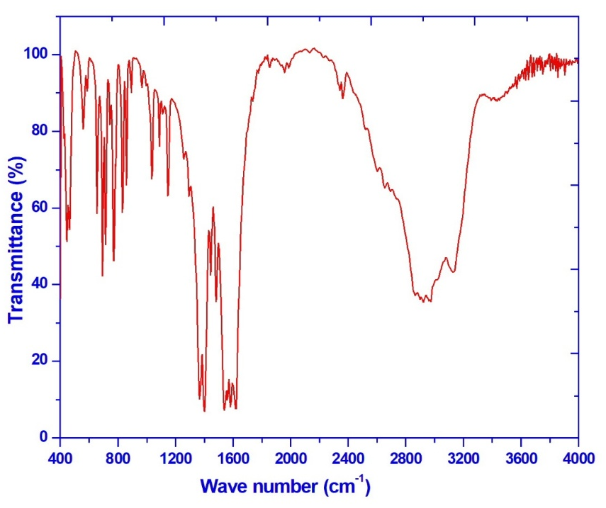
Fig. S1 IR Spectra of complex (1)
- UV-VIs Spectra of complex (1)
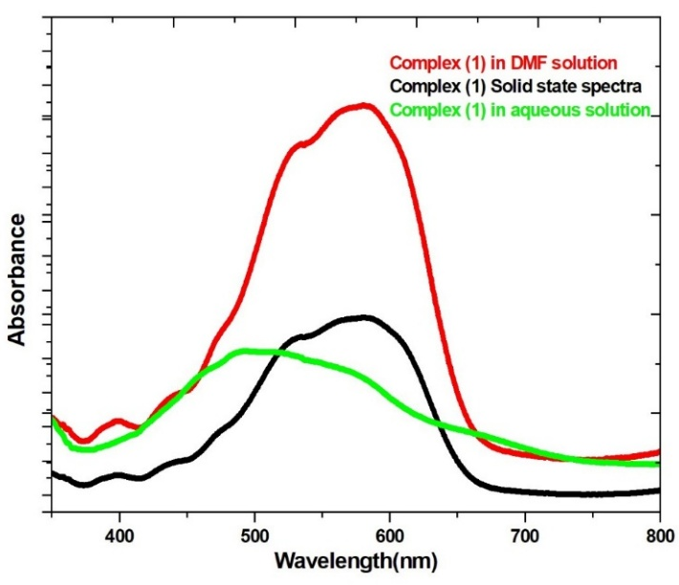
Fig. S2 UV-VIs Spectra of complex (1)
- Experimentally obtained and simulated PXRDs
Fig. S3 PXRD (a), experimental and (b), simulated
- Inter and intra molecular chain distances
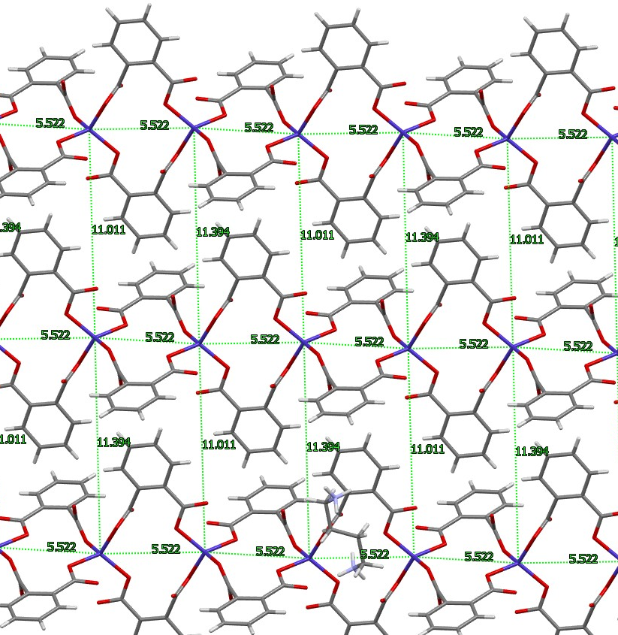
Fig. S4 Intra and intermolecular chain distances

- TGA of complex (1)

Fig. S5 TGA plot of complex(1)

