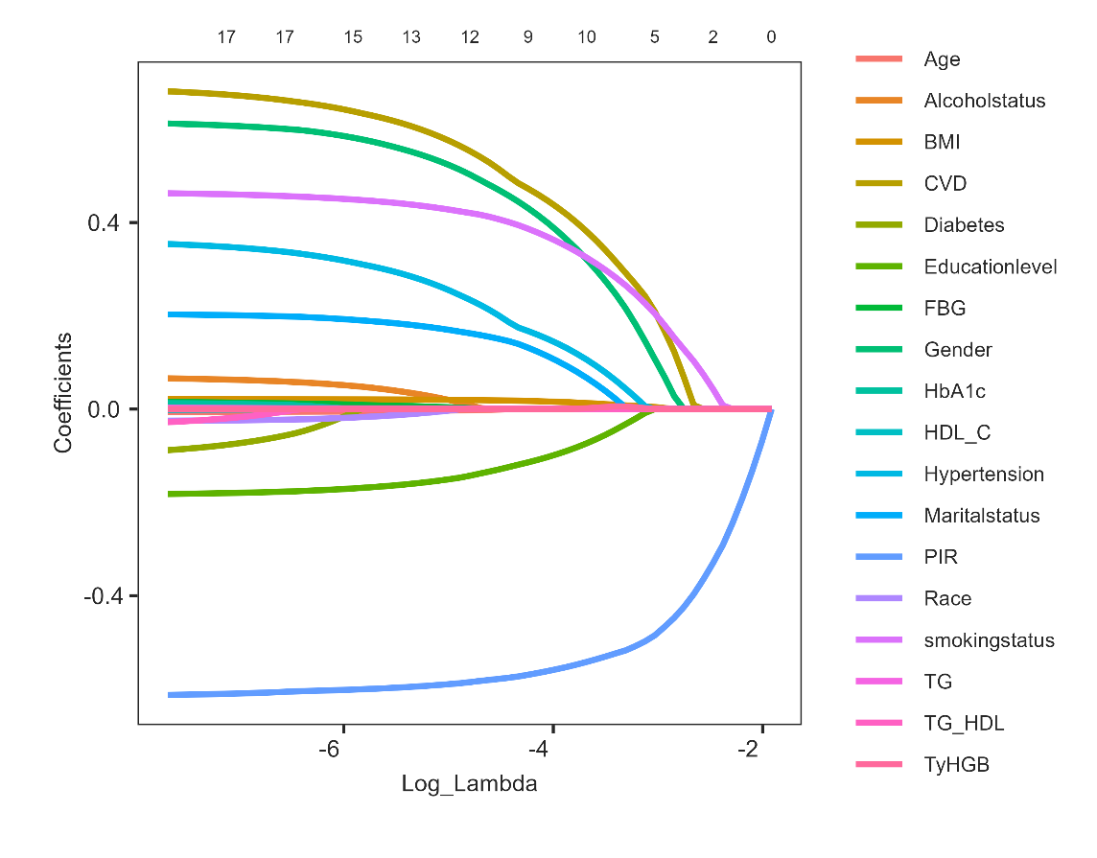
Supplementary Figure S1. Lasso coefficient of 18 variables.
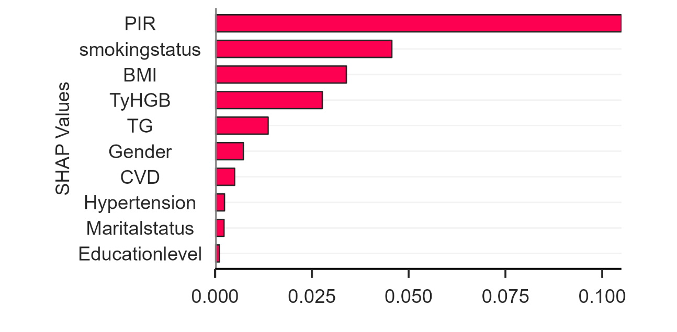
Supplementary Figure S2. Relative importance of the selected variables derived from the Random Forest model, along with their corresponding importance scores. The X-axis represents the importance score, defined as the relative frequency with which a variable is used to split (i.e., distribute) the data. The Y-axis lists the selected variables.
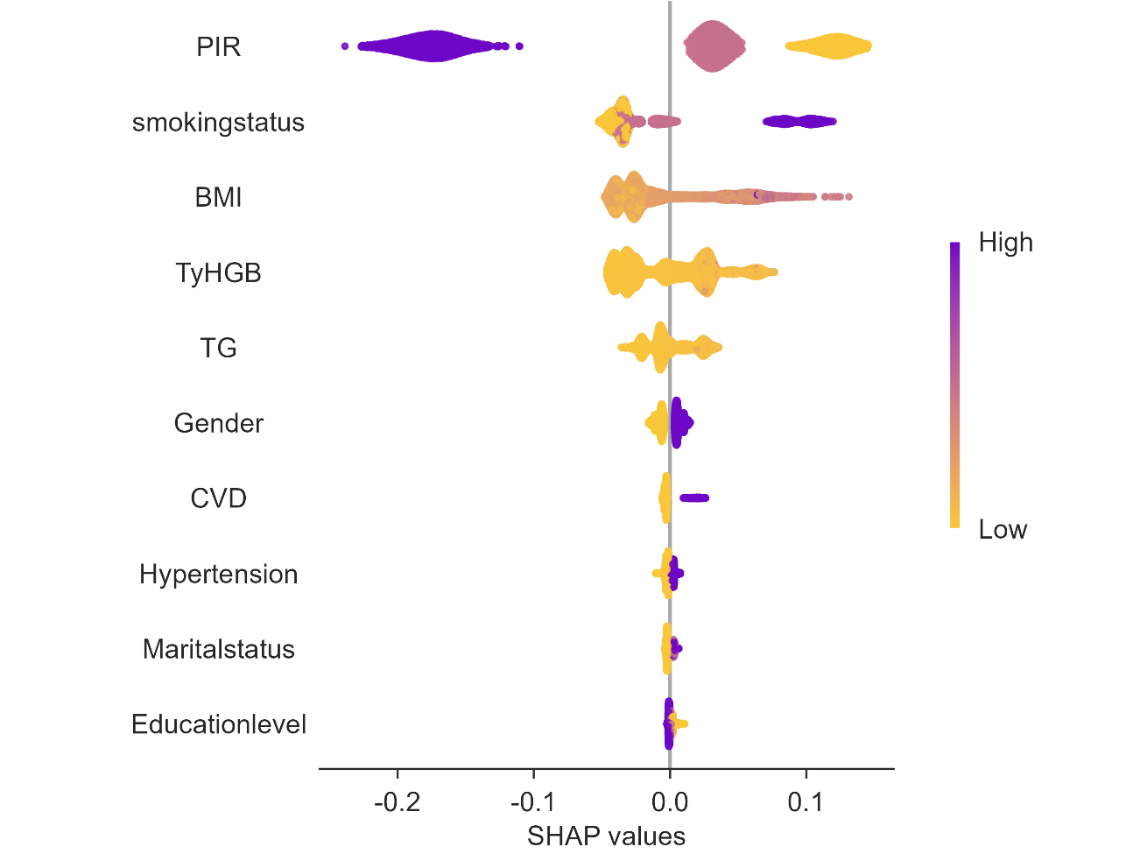
Supplementary Figure S3. This beeswarm plot shows the SHAP value distribution for each selected variable. The X-axis denotes the SHAP value (direction and magnitude of contribution to the model output), and the Y-axis presents the variables ranked by decreasing mean absolute SHAP value, from most important at the top to least important at the bottom.
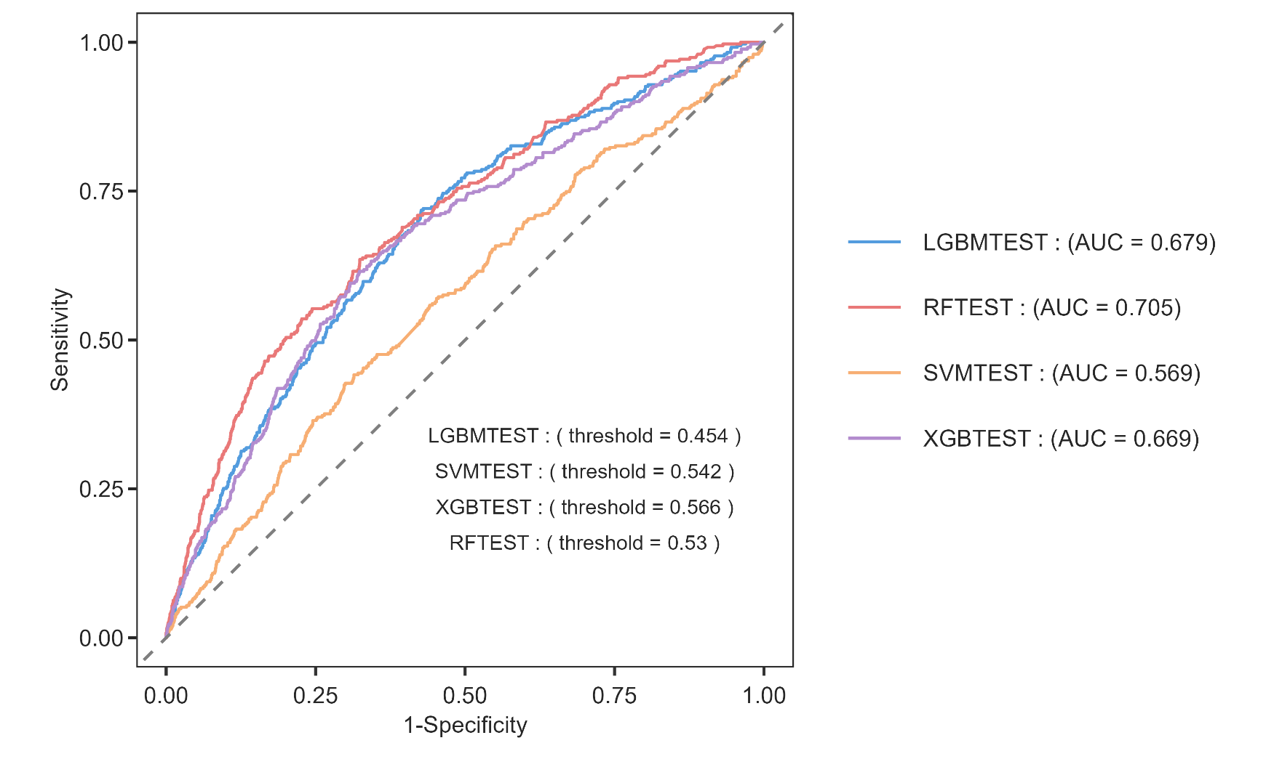
Supplementary Figure S4. Receiver operating characteristic (ROC) curves of the four machine-learning models.

Supplementary Table S1 Sensitivity analyses.
 | Model I  OR (95%CI), P | Model II  OR (95%CI), P | Model III  OR (95%CI), P
TyHGB continuous | 1.03(1.02,1.04),<0.001 | 1.04(1.03,1.05),<0.001 | 1.02(1.01,1.03),0.002
TyHGB quartile
Q1 | Ref | Ref | Ref
Q2 | 1.00(0.81,1.23),0.988 | 1.11(0.90,1.37),0.322 | 1.00(0.80,1.25),0.995
Q3 | 1.41(1.12,1.77),0.004 | 1.63(1.27,2.08),<0.001 | 1.32(1.03,1.69),0.028
Q4 | 1.75(1.45,2.10),<0.001 | 2.17(1.77,2.66),<0.001 | 1.52(1.22,1.91),<0.001
Model 1: no covariates were adjusted.
Model 2: age, gender and race were adjusted.
Model 3: age, gender, race, marital status, education level, PIR, smoking status, alcohol status, cardiovascular disease, hypertension and diabetes were adjusted.
P for trend was derived by modeling the quartiles as a continuous variable.

