Supplementary
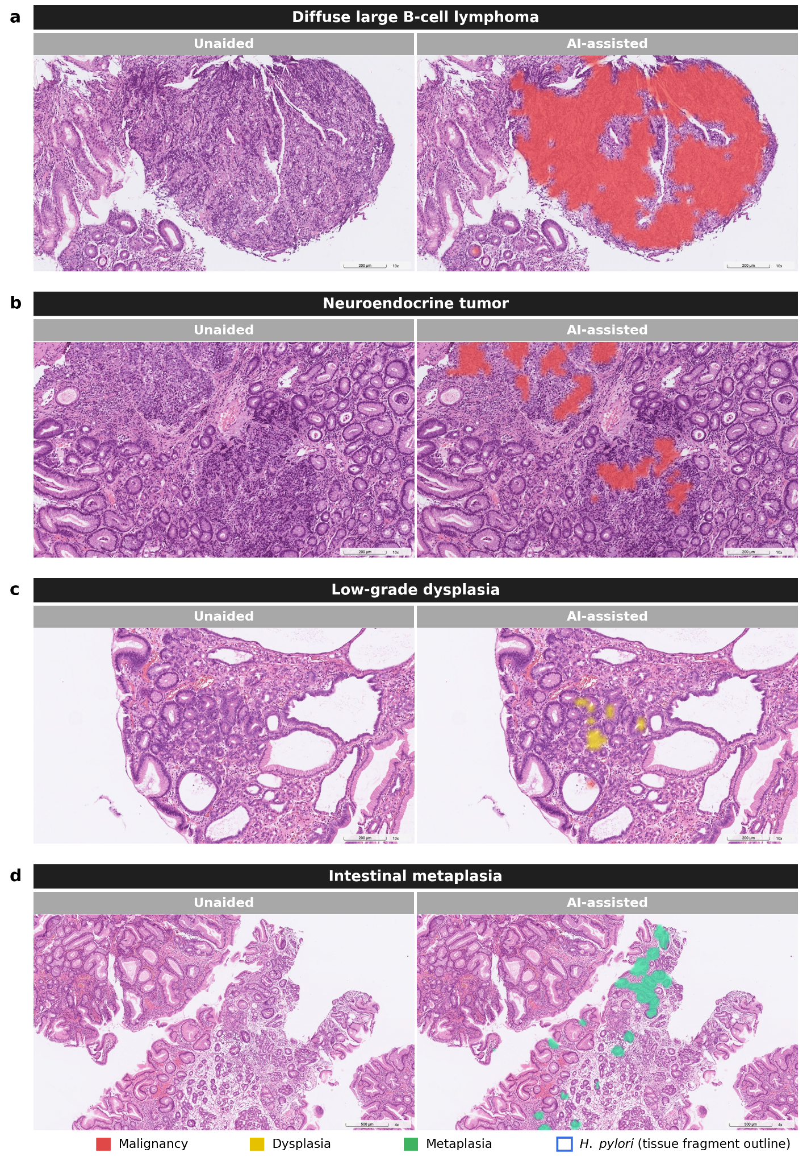
Supplementary Figure 1 | Representative localization examples of additional gastric diseases not shown in Fig. 2. Each case is shown without (left) and with (right) AI inference: a, diffuse large B-cell lymphoma; b, neuroendocrine tumor; c, low-grade dysplasia; and d, intestinal metaplasia. Heatmaps are color-coded by lesion category (red, malignancy; yellow, dysplasia; green, metaplasia). All overlays were produced by CAM using only slide-level supervision; no pixel- or region-level annotations were used during training.

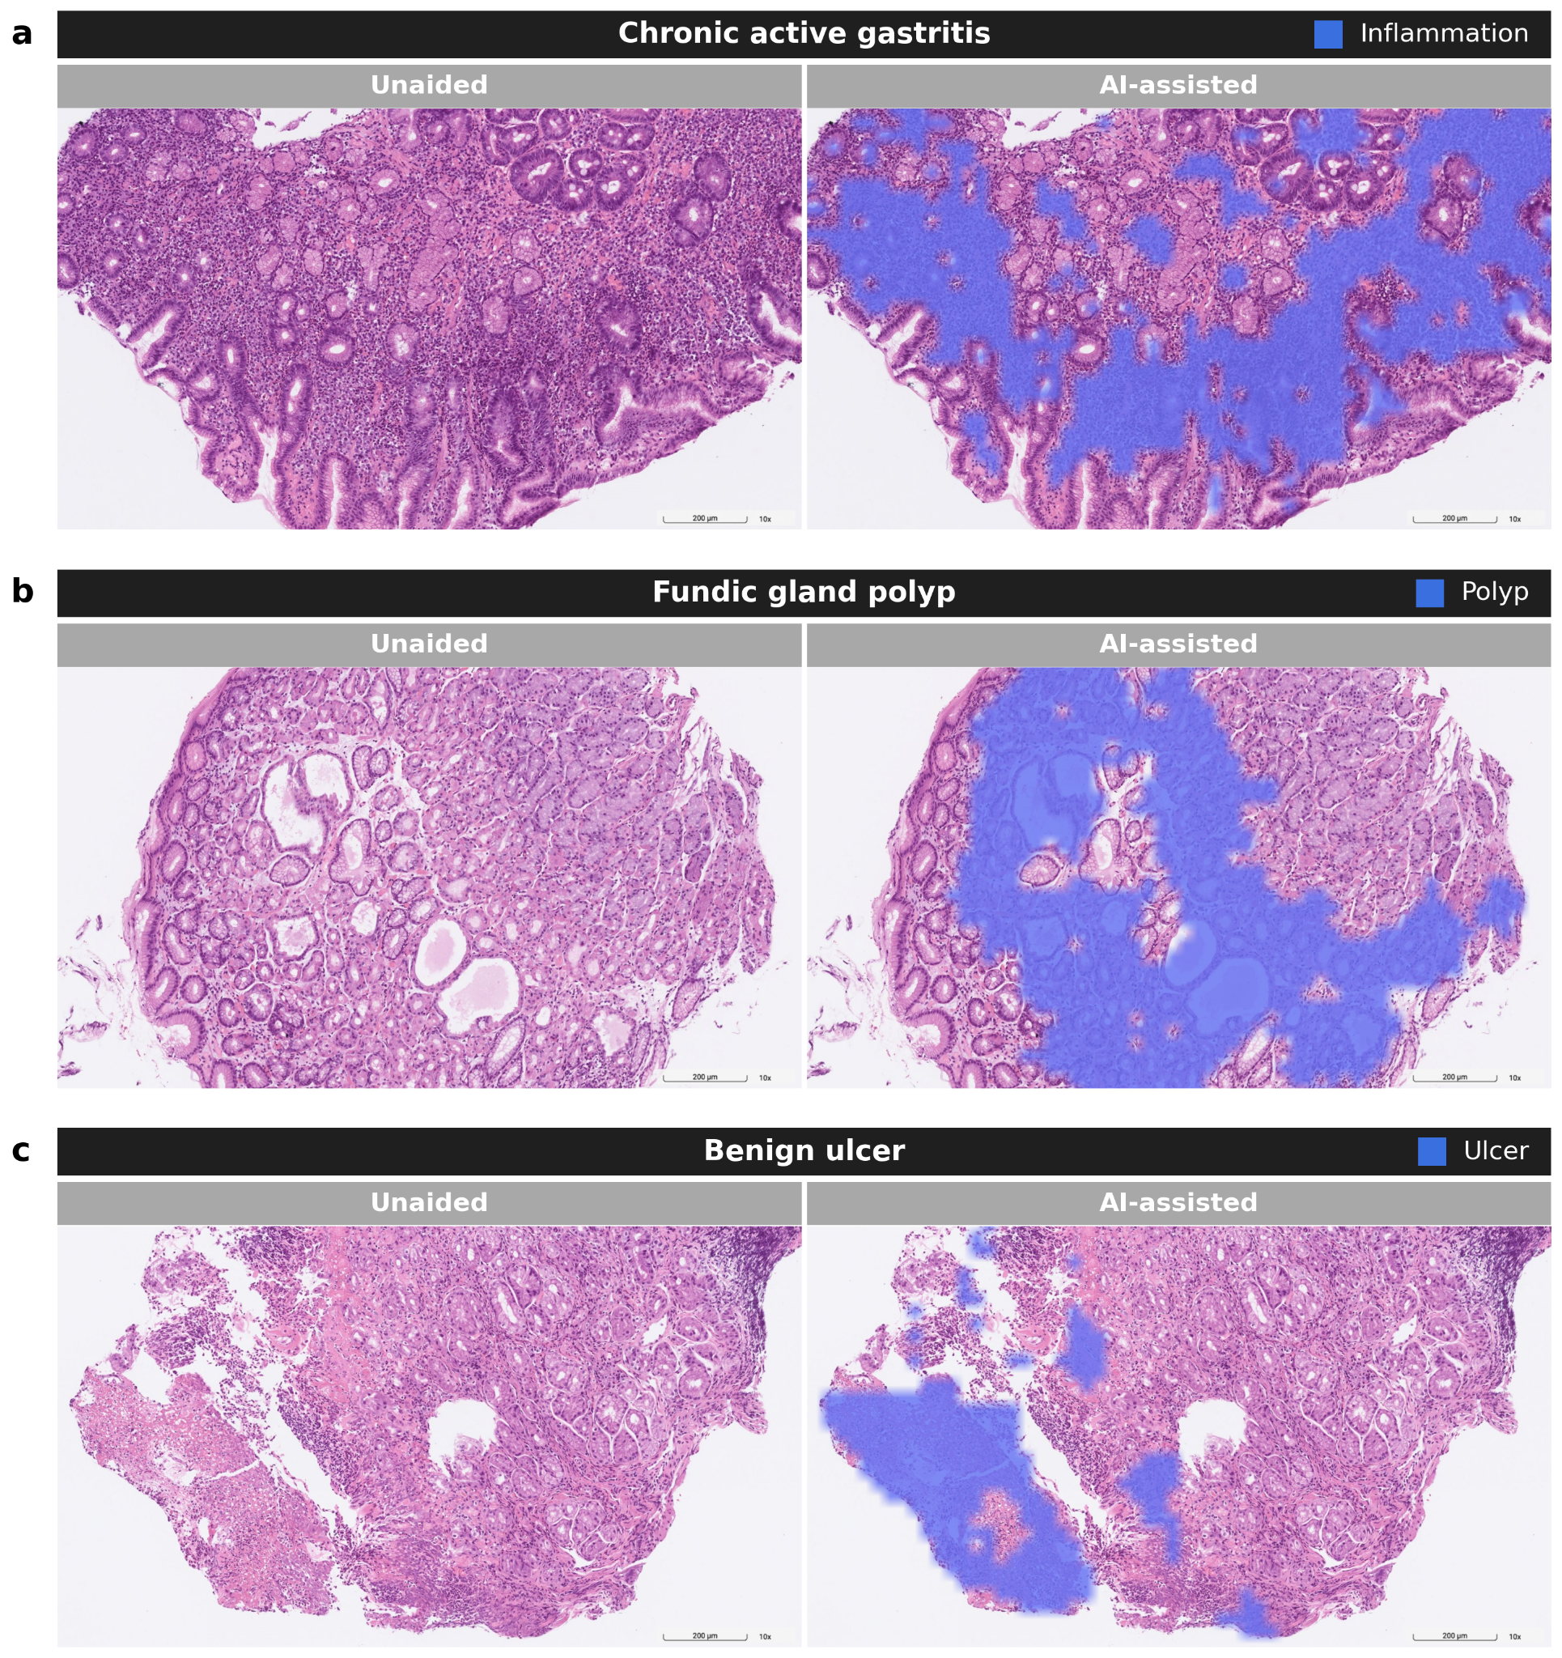
Supplementary Figure 2 | Representative localization examples of additional non-neoplastic gastric diseases not shown in Fig. 2, with and without inference. Each case is shown without (left) and with (right) AI inference: a, chronic active gastritis (model category: inflammation); b, fundic gland polyp (model category: polyp); and c, benign ulcer (model category: ulcer). For visual distinction from the four primary heatmap colors in Fig. 2, overlays for these categories are rendered in a single blue tone, with the corresponding model category labeled in each panel header. All overlays were produced by CAM using only slide-level supervision; no pixel- or region-level annotations were used during training.

