Supplementary Materials:
Title: Serum thyroid hormone concentrations and breast cancer risk: an extended cohort study with time-varying exposure analysis

Authors list: Chang Ik Yoon, Hyung Suk Kim, Soong June Bae, Jang-Hee Lee, Eun Young Kim, Chan Heun Park, Yong Lai Park, Ji-Sup Yun, Yun Tae Kim, Kwan Ho Lee
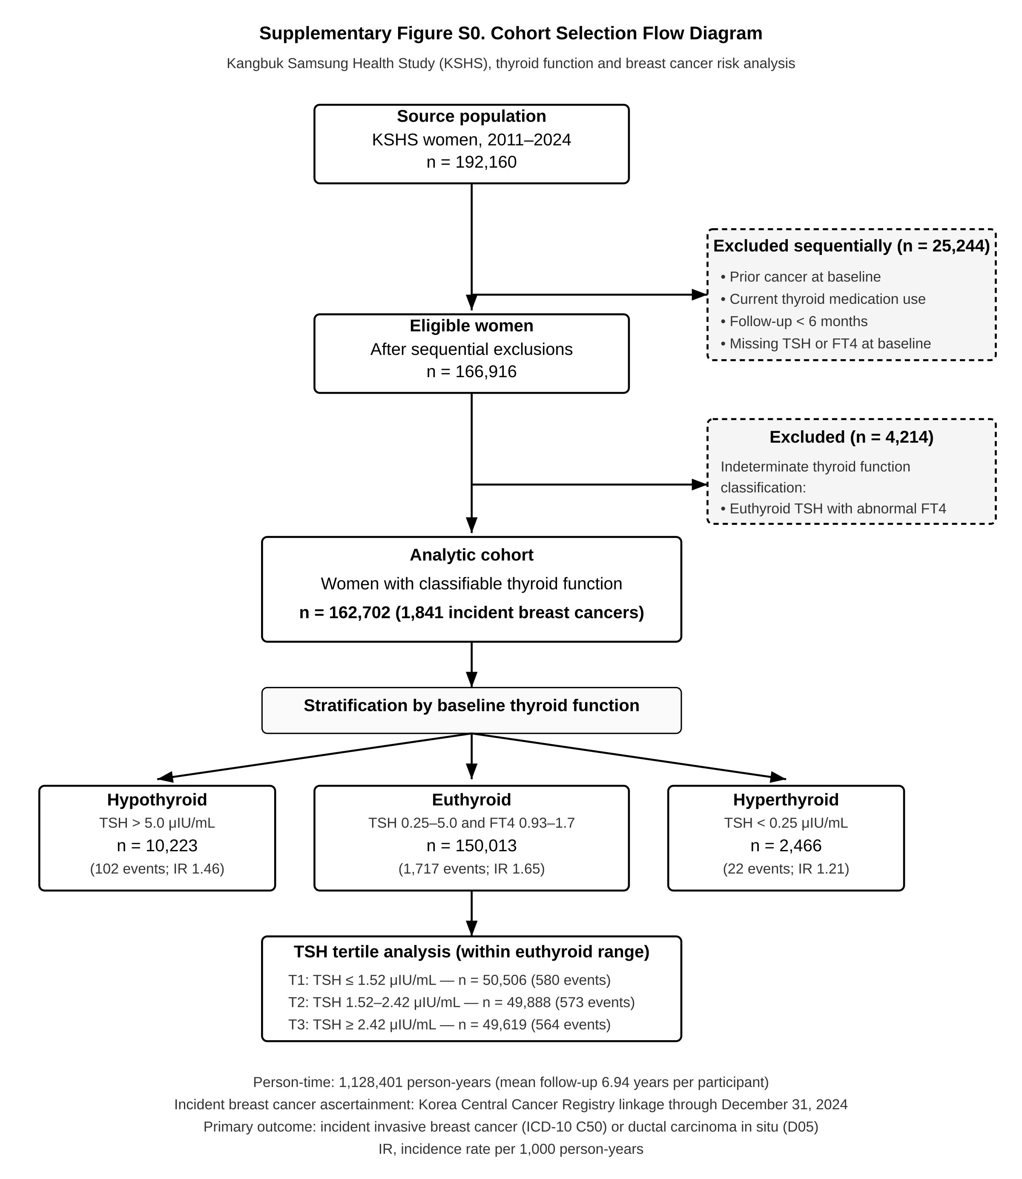
Supplementary Figure S0. CONSORT-style flow diagram of cohort selection. Cohort flow from the source KSHS population to the final analytic cohort. Sequential exclusions (prior cancer at baseline, current thyroid medication use, follow-up <6 months, missing baseline TSH or FT4) yielded 166,916 eligible women. An additional 4,214 women with indeterminate thyroid function classification (euthyroid TSH with abnormal FT4, or discordant TSH/FT4) were excluded for primary analyses, yielding 162,702 women in the analytic cohort. The cohort accumulated 1,128,401 person-years of follow-up with 1,841 incident breast cancers (1,347 invasive [C50] + 494 ductal carcinoma in situ [D05]).
Abbreviations: FT4, free thyroxine; IR, incidence rate; KSHS, Kangbuk Samsung Health Study; TSH, thyroid-stimulating hormone.
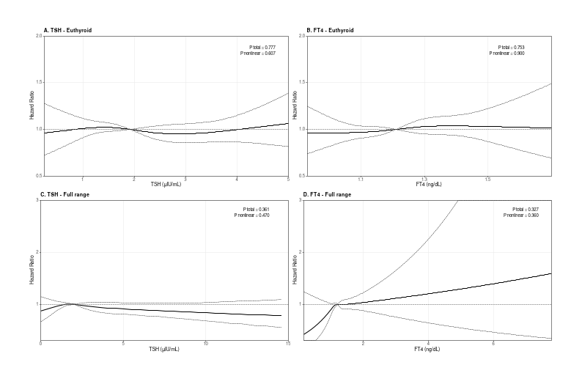
Supplementary Figure S1. Restricted cubic spline analyses of TSH and FT4 in relation to breast cancer risk. Four-panel restricted cubic spline (RCS) analysis with knots placed at the 10th, 50th, and 90th percentiles. Solid line: estimated hazard ratio; dashed lines: 95% confidence interval. (A) TSH within the euthyroid range; (B) FT4 within the euthyroid range; (C) TSH across the full measurement range; (D) FT4 across the full measurement range. All p values for non-linearity > 0.30, supporting linear modeling of TSH and FT4 in primary analyses. Adjusted for: age, examination center, examination year, body mass index, menopausal status, parity, age at menarche, hormone use, family history of breast cancer.
Supplementary Table S1. C50-only outcome sensitivity analysis (1,347 invasive events): hazard ratios for breast cancer by thyroid function exposure.
Exposure | Category | N (C50-only) | Events (C50-only) | C50+D05 Primary HR (95% CI) | C50-only Sensitivity HR (95% CI)
TSH tertile (Euthyroid) | T1 (≤1.52) | 50,531 | 438 | 1.00 (Ref) | 1.00 (Ref)
 | T2 (1.52–2.42) | 49,908 | 415 | 0.96 (0.85–1.09) | 0.93 (0.81–1.07)
 | T3 (≥2.42) | 49,629 | 396 | 0.95 (0.84–1.07) | 0.88 (0.76–1.01), p = .068
Continuous (Euthyroid) | TSH per 1 SD | 150,068 | 1,249 | 0.95 (0.80–1.12) | 0.88 (0.72–1.07)
 | FT4 per 1 SD | 150,068 | 1,249 | 0.97 (0.88–1.07) | 0.96 (0.86–1.08)
Elevated FT4 | FT4 > 1.7 ng/dL | 1,197 | 11 | 0.62 (0.28–1.39) | 0.86 (0.38–1.91)
Postmenopausal subgroup | TSH T3 vs T1 (postmeno) | 7,815 | 44 | 0.69 (0.47–1.02), p = .061 | 0.65 (0.42–0.99), p = .049
 | p interaction (menopause × T3) | — | — | .086 | .143
Note: All HRs adjusted with Model 2 covariates (age, examination center, examination year, body mass index, menopausal status, parity, age at menarche, hormone use, family history of breast cancer). Event counts for the C50-only sensitivity column reflect the invasive-only outcome (1,347 events total in the C50-only sensitivity cohort [n = 162,758]; 1,249 within the euthyroid range). The systematic attenuation observed under the primary outcome (C50+D05) relative to the sensitivity outcome (C50-only) is consistent with non-differential dilution of an invasive-specific signal by ductal carcinoma in situ events (Discussion §4.1). The N and Events columns describe the C50-only sensitivity cohort; the corresponding primary-outcome (C50+D05) event counts (580, 573, and 564 across TSH tertiles T1–T3) are those reported in Table 2.
Abbreviations: CI, confidence interval; FT4, free thyroxine; HR, hazard ratio; SD, standard deviation; TSH, thyroid-stimulating hormone.
Supplementary Table S2. Five-category thyroid function classification with Firth penalized Cox regression (C50-only outcome).
Category | N | Events | IR / 1,000 PY | Standard Cox HR (95% CI), p | Firth Penalized HR (95% CI), p
Euthyroid (Ref) | 150,068 | 1,249 | 1.20 | 1.00 (Ref) | 1.00 (Ref)
Subclinical Hypothyroidism | 8,914 | 78 | 1.29 | 1.03 (0.81–1.32), p = .797 | 1.04 (0.81–1.31), p = .756
Overt Hypothyroidism | 1,310 | 4 | 0.42 | 0.35 (0.13–0.94), p = .037 | 0.40 (0.13–0.89), p = .021
Subclinical Hyperthyroidism | 1,269 | 5 | 0.54 | 0.30 (0.10–0.94), p = .040 | 0.35 (0.10–0.87), p = .020
Overt Hyperthyroidism | 1,197 | 11 | 1.22 | 0.99 (0.53–1.85), p = .980 | 1.04 (0.53–1.81), p = .897
Note: Firth penalized Cox regression applied to sparse cells (events < 10) to correct for small-sample bias in maximum likelihood estimation. C50-only outcome shown because sparse-cell event counts (n = 4–5 for Overt Hypothyroidism and Subclinical Hyperthyroidism) are most pronounced under this outcome definition; C50+D05 estimates were directionally consistent but did not reach statistical significance for any category. Model 2 covariate adjustment.
Abbreviations: CI, confidence interval; HR, hazard ratio; IR, incidence rate; PY, person-years.

Supplementary Table S3. Time-varying Cox sensitivity analysis: 12-month exposure lag versus primary 6-month lag (TSH tertile, euthyroid range).
TSH tertile | Outcome | 6-month lag HR (95% CI), p (primary) | 12-month lag HR (95% CI), p
T1 (≤1.52) | C50+D05 | 1.00 (Ref) | 1.00 (Ref)
T2 (1.52–2.42) | C50+D05 | 0.99 (0.87–1.11), p = .825 | 0.98 (0.87–1.11), p = .765
T3 (≥2.42) | C50+D05 | 0.90 (0.80–1.02), p = .096 | 0.91 (0.80–1.03), p = .147
T1 (≤1.52) | C50-only | 1.00 (Ref) | 1.00 (Ref)
T2 (1.52–2.42) | C50-only | 0.97 (0.84–1.12), p = .696 | 0.95 (0.82–1.10), p = .475
T3 (≥2.42) | C50-only | 0.89 (0.77–1.03), p = .104 | 0.91 (0.78–1.05), p = .184
Note: Time-varying Cox models with counting-process data structure. The 6-month exposure lag (primary specification) was extended to 12 months as a sensitivity analysis to assess robustness to reverse-causation concerns. Estimates were essentially unchanged. Model 2 covariate adjustment.
Abbreviations: CI, confidence interval; HR, hazard ratio.
Supplementary Table S4. Sensitivity analysis including thyroid-medication users (excluded a priori in primary analyses).
TSH tertile | Outcome | Primary excl. (n=139,324) | Incl. thyroid med (n=141,211) | Difference
T2 (1.52–2.42) | C50-only | 0.93 (0.81–1.07), p = .298 | 0.94 (0.81–1.08), p = .348 | Negligible
T3 (≥2.42) | C50-only | 0.88 (0.76–1.01), p = .068 | 0.89 (0.77–1.02), p = .091 | Negligible
T2 (1.52–2.42) | C50+D05 | 0.96 (0.85–1.09), p = .542 | 0.96 (0.85–1.08), p = .510 | Negligible
T3 (≥2.42) | C50+D05 | 0.95 (0.84–1.07), p = .403 | 0.95 (0.84–1.07), p = .372 | Negligible
Note: Primary analyses excluded participants on thyroid medications (levothyroxine, antithyroid agents, iodine preparations); this sensitivity analysis re-included 1,887 such participants. Effect estimates were essentially unchanged, indicating that the principal exposure-outcome estimates are not materially affected by the medication-exclusion criterion. Model 2 covariate adjustment. Column header N values (139,324 with thyroid-medication users excluded; 141,211 with them included) denote the complete-case participant counts contributing to the respective time-varying TSH-tertile models; their difference equals the 1,887 re-included medication users.
Abbreviations: CI, confidence interval; HR, hazard ratio.
Supplementary Table S5. TSH and FT4 distributions by examination center.
Center | N | TSH (μIU/mL) — Mean ± SD; Median (IQR) | FT4 (ng/dL) — Mean ± SD; Median (IQR)
Seoul | 70,571 | 2.36 ± 2.70; 1.92 (1.30–2.84) | 1.22 ± 0.23; 1.20 (1.11–1.31)
Suwon | 92,187 | 2.52 ± 2.96; 2.05 (1.36–3.03) | 1.24 ± 0.23; 1.22 (1.12–1.33)
Note: TSH and FT4 distributions are nearly identical between the two KSHS examination centers, supporting pooled analyses with examination center retained as a stratification covariate (see Methods §2.5).
Abbreviations: IQR, interquartile range; SD, standard deviation.
Supplementary Table S6. Schoenfeld residual tests of proportional hazards assumption (Model 2).
Variable | χ² | df | p value
Model A: Thyroid function (3-category)
thyroid_3cat (exposure) | 0.11 | 2 | .945 ✓
age | 25.93 | 1 | <.001
examination center | 0.14 | 1 | .710
examination year | 0.00 | 1 | .956
body mass index | 1.14 | 1 | .285
postmenopausal status | 0.30 | 1 | .585
parity | 10.45 | 1 | .001
age at menarche | 2.89 | 1 | .089
hormone use | 1.17 | 1 | .279
family history of breast cancer | 2.44 | 1 | .119
GLOBAL | 43.46 | 11 | <.001
Model B: TSH tertile (Euthyroid)
TSH tertile (exposure) | 0.27 | 2 | .875 ✓
age | 27.10 | 1 | <.001
parity | 7.40 | 1 | .007
family history of breast cancer | 4.59 | 1 | .032
GLOBAL | 45.51 | 11 | <.001
Note: Schoenfeld residual tests evaluate whether the proportional hazards (PH) assumption holds for each variable in the Cox model. The principal exposure variables (thyroid 3-category and TSH tertile) showed strong PH compliance (p = .945 and p = .875 respectively, marked ✓). Variable-specific tests indicated PH violation for age and parity (and, in Model B, family history of breast cancer); consequently, the global test of proportional hazards was significant. The principal hazard ratio estimates for the exposure variables are therefore considered unbiased, although residual time-dependent confounding by age and parity cannot be entirely excluded (Discussion §4.4). For each model, only the exposure term and the covariates with notable departures from proportional hazards are displayed; the GLOBAL row (df = 11) reflects all terms in the model—the exposure plus the nine covariates specified in Methods §2.5.
Abbreviations: df, degrees of freedom.

