SUPLIMENTARY MATERIALS
- Crystallographic Data

Table S1. The crystallographic data and experimental parameters for compounds 5, 6, 9 and 10.
Parameter | 5 | 6 | 9 | 10
Unit cell  a, Å | 8.9709(7) | 9.8082(9) | 4.6812(11) | 7.857(4)
b, Å | 14.5709(11) | 16.0576(14) | 12.741(3) | 5.944(3)
c, Å | 8.6991(7) | 5.9193(6) | 22.125(6) | 18.567(9)
α, deg | 90.0 | 90.0 | 90.0 | 90.0
β, deg | 115.526(5) | 95.051(7) | 91.477(17) | 93.76(4)
γ, deg | 90.0 | 90.0 | 90.0 | 90.0
V, Å³ | 1026.10(14) | 928.65(15) | 1319.2(5) | 865.3(8)
F(000) | 600 | 464 | 648 | 432
Crystal system | Monoclinic | Monoclinic | Monoclinic | Monoclinic
Space group | P2₁/c | P2₁/c | Pc | P2₁/c
Z | 4 | 4 | 6 | 4
T, K | 173(2) | 173(2) | 173(2) | 173(2)
μ, mm⁻¹ | 4.222 | 0.359 | 0.355 | 0.361
D_{calc}, g/cm³ | 2.001 | 1.647 | 1.603 | 1.629
2Θ_{max}, grad | 60.0 | 50.0 | 50.0 | 50.0
Measured reflections | 9226 | 6428 | 18990 | 11141
Independent reflections | 2993 | 1626 | 3874 | 1519
R_{int} | 0.0569 | 0.0333 | 0.1381 | 0.0907
Reflections with F>4σ(F) | 1854 | 1325 | 2455 | 1008
Parameters | 145 | 136 | 379 | 127
R₁ [I>2σ(I)] | 0.0508 | 0.0378 | 0.0688 | 0.0464
wR₂ [I>2σ(I)] | 0.1035 | 0.0826 | 0.1086 | 0.0999
R₁ [all data] | 0.0987 | 0.0498 | 0.1268 | 0.0800
wR₂ [all data] | 0.1151 | 0.0885 | 0.1267 | 0.1153
S | 1.059 | 1.048 | 1.040 | 1.013
CCDC number | 2543375 | 2543374 | 2543377 | 2543376

- NMR- Specra
19F NMR specta of reaction mixture (compounds 5-8) before separation
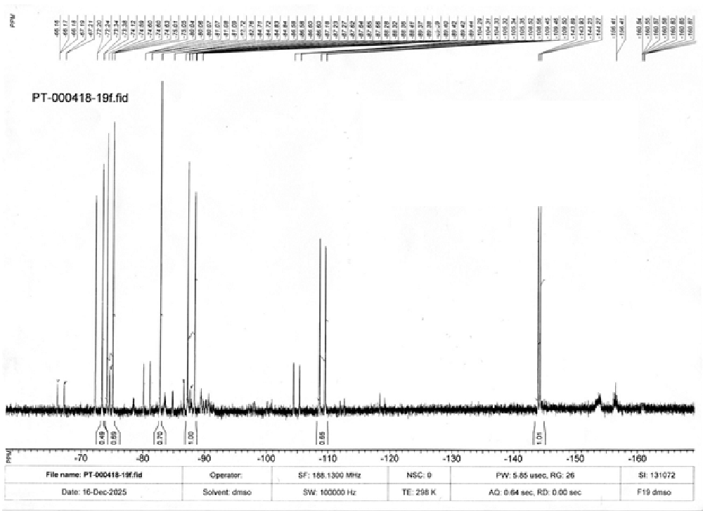

1H NMR specta of compound 5
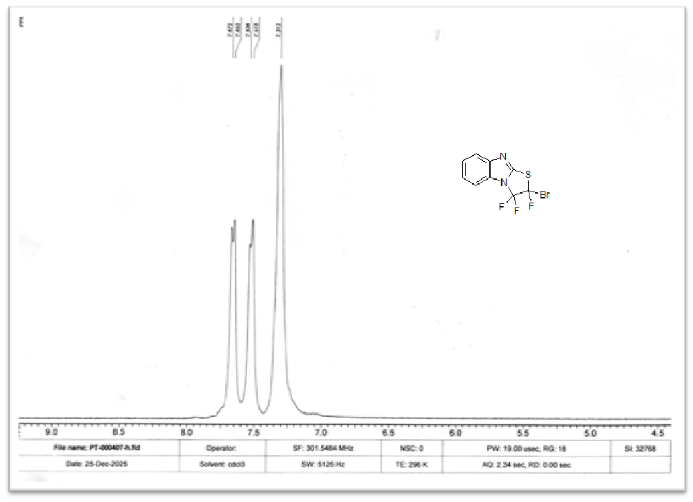
19F NMR specta of compound 5
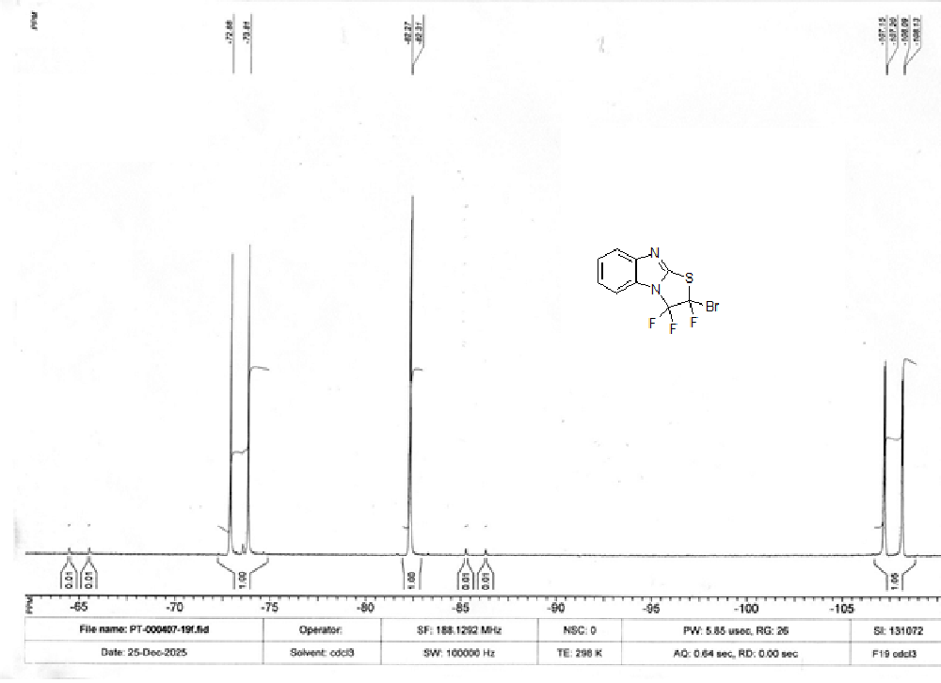
13C NMR specta of compound 5
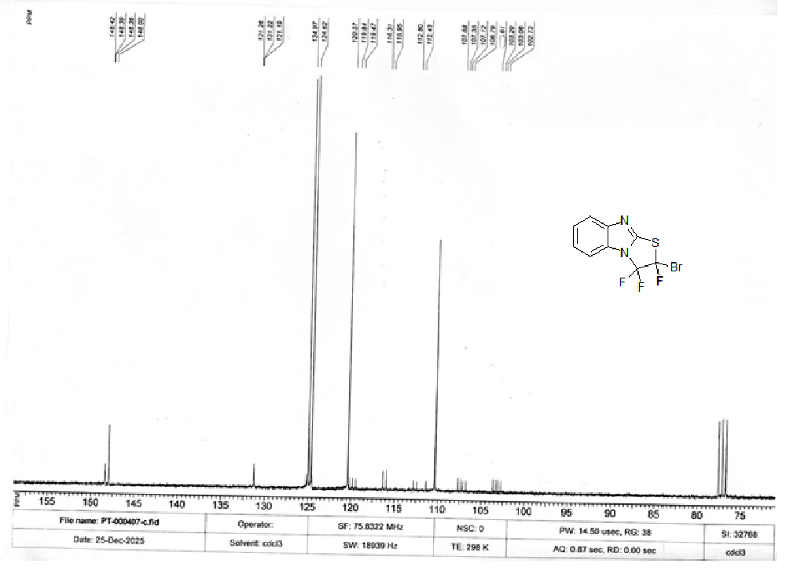
1H NMR specta of compound 6
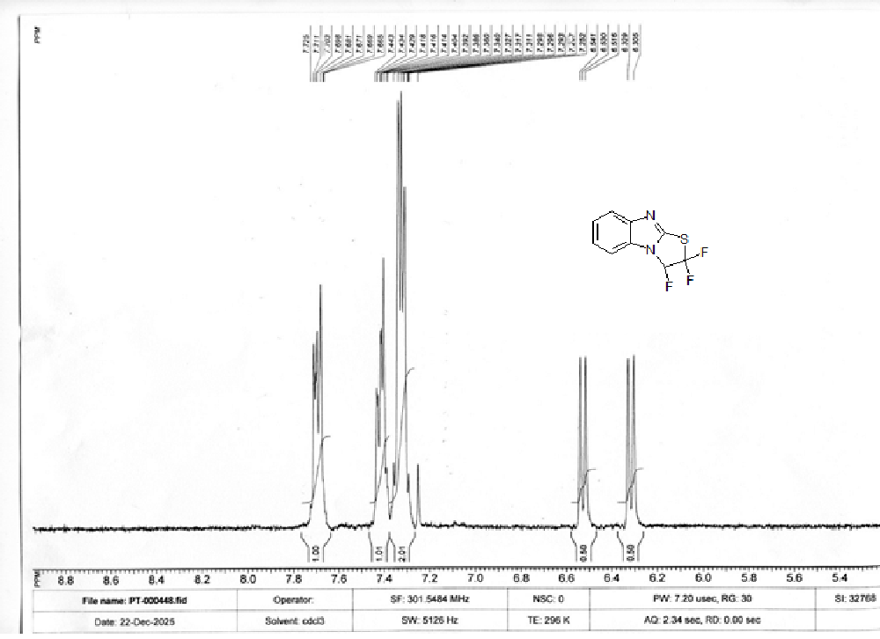
19F NMR specta of compound 6
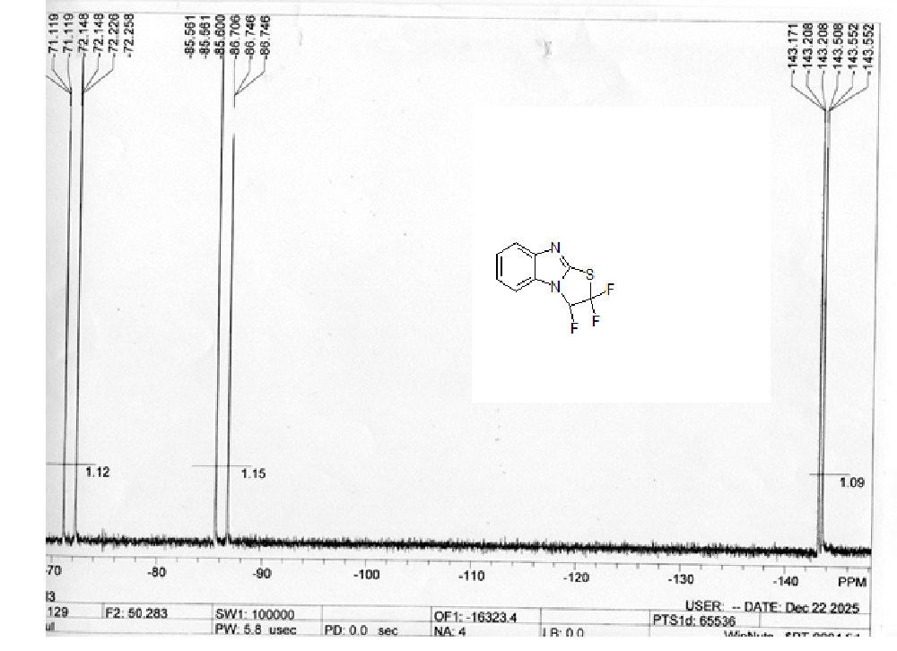
13C NMR specta of compound 6
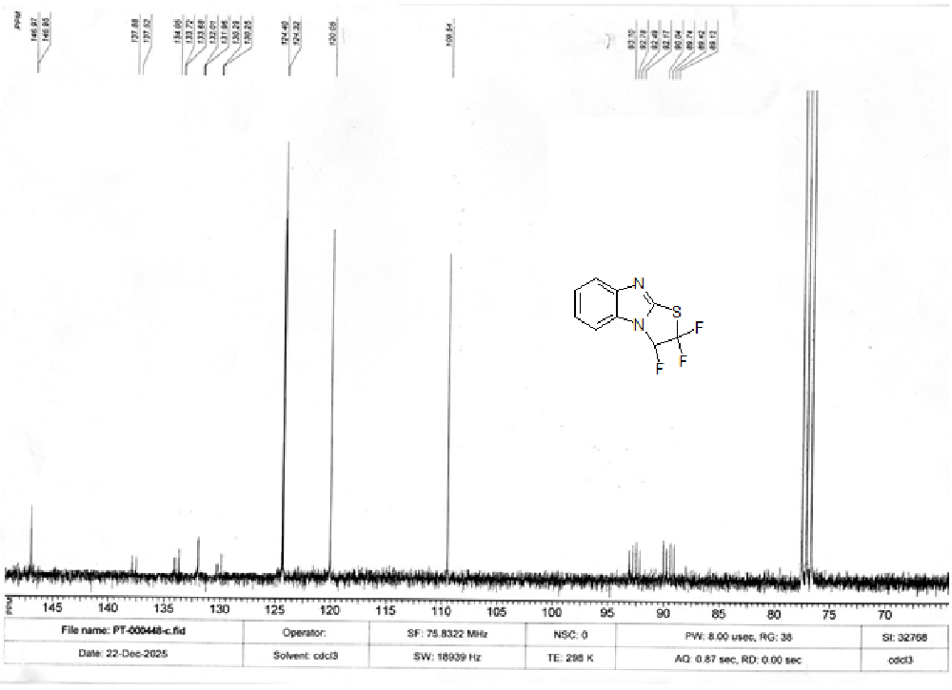
1H NMR specta of compound 7
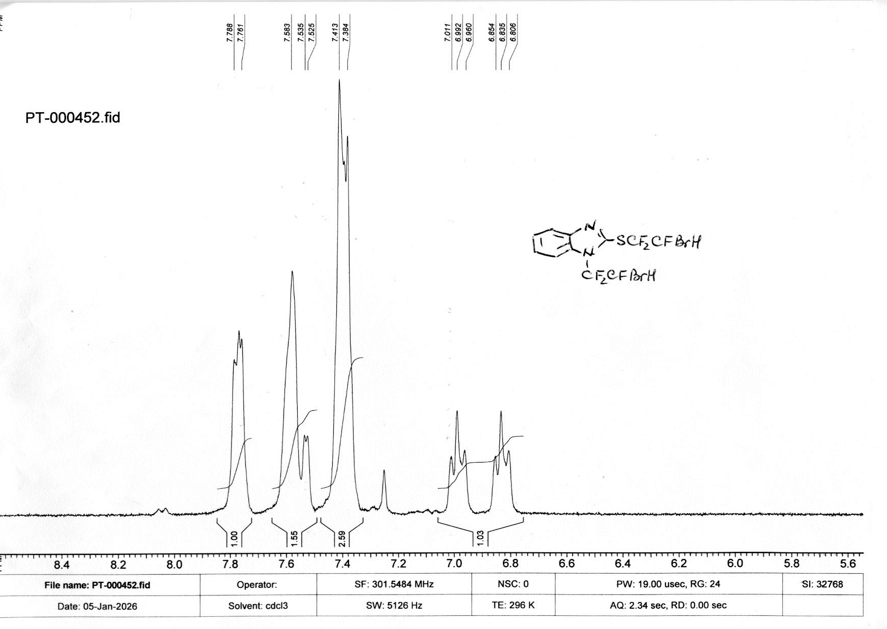
19F NMR specta of compound 7
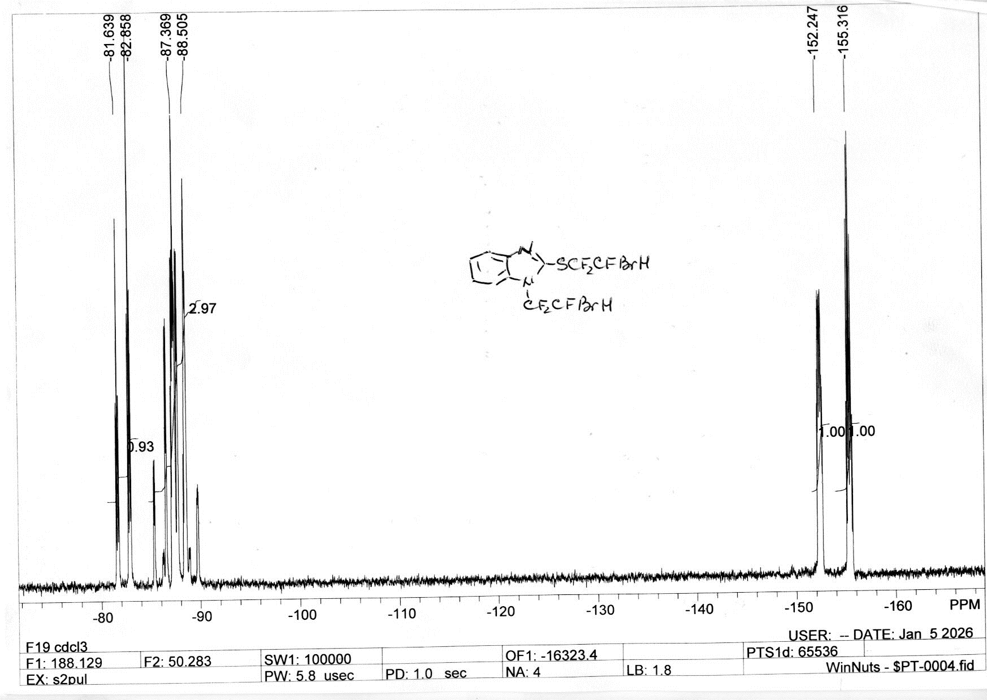
13C NMR specta of compound 7
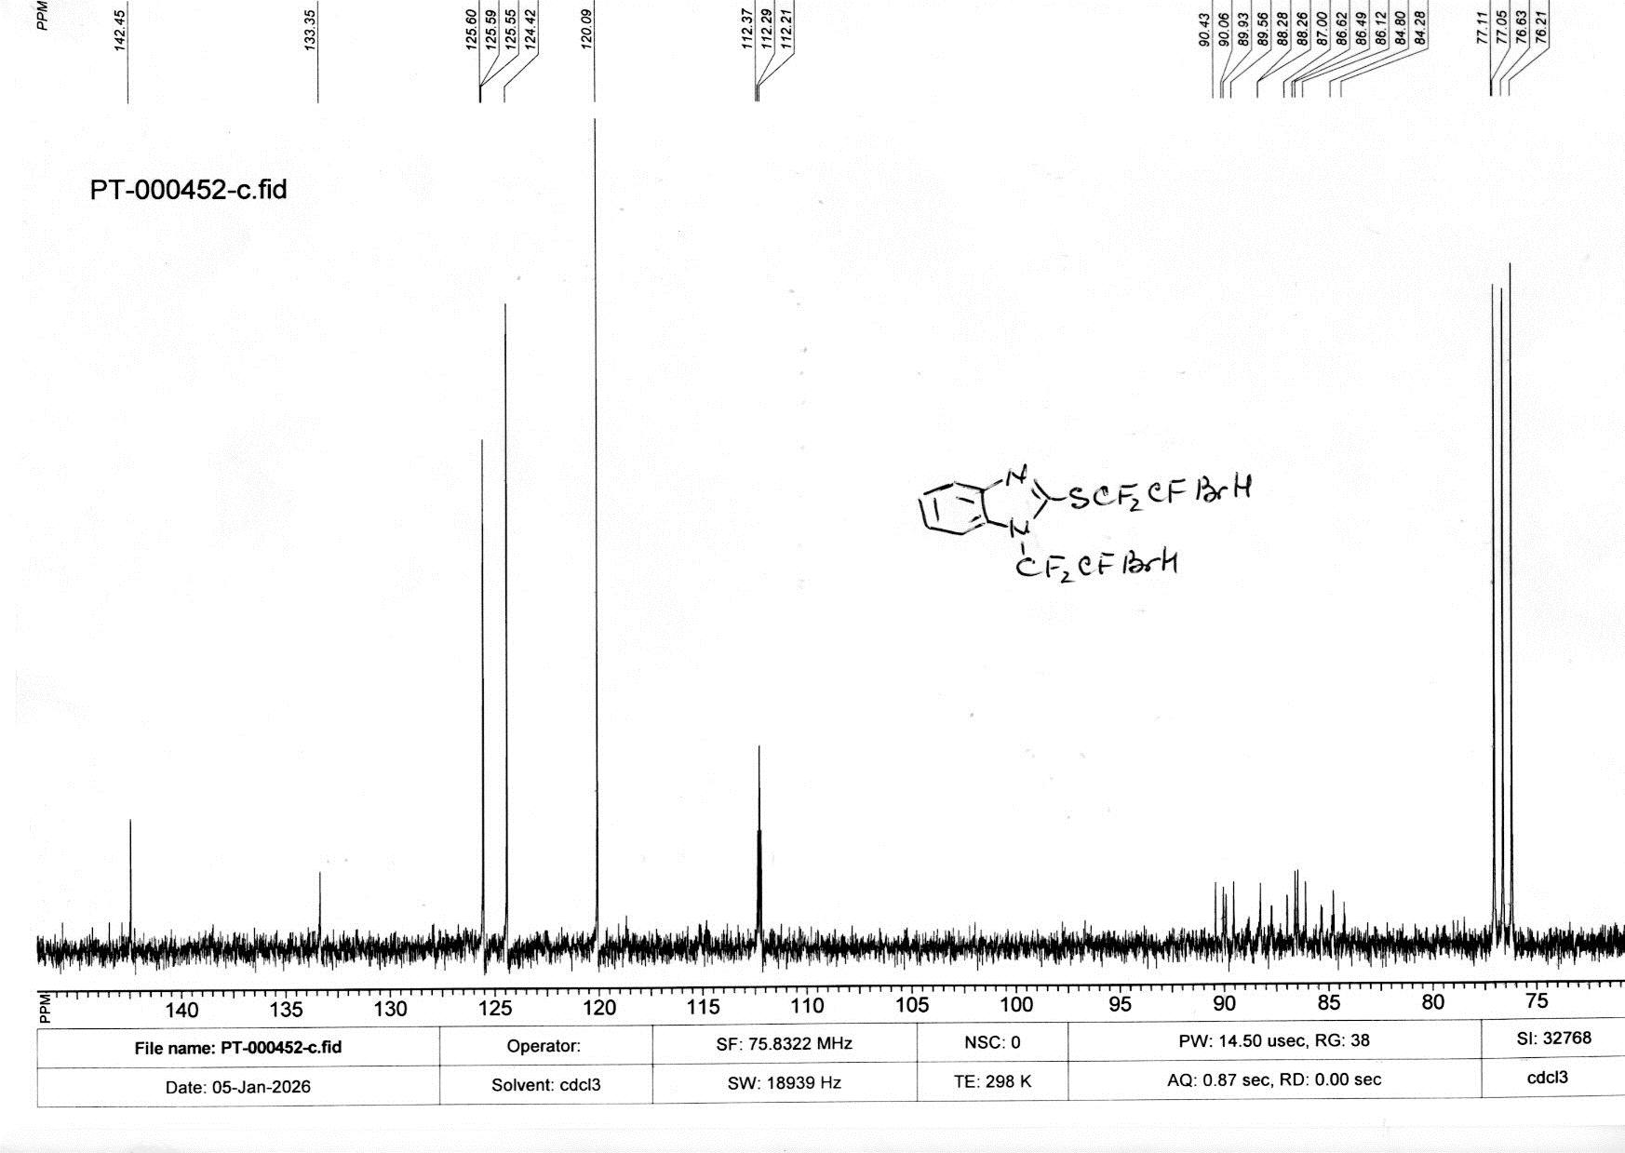
Mass specnta of compound 7
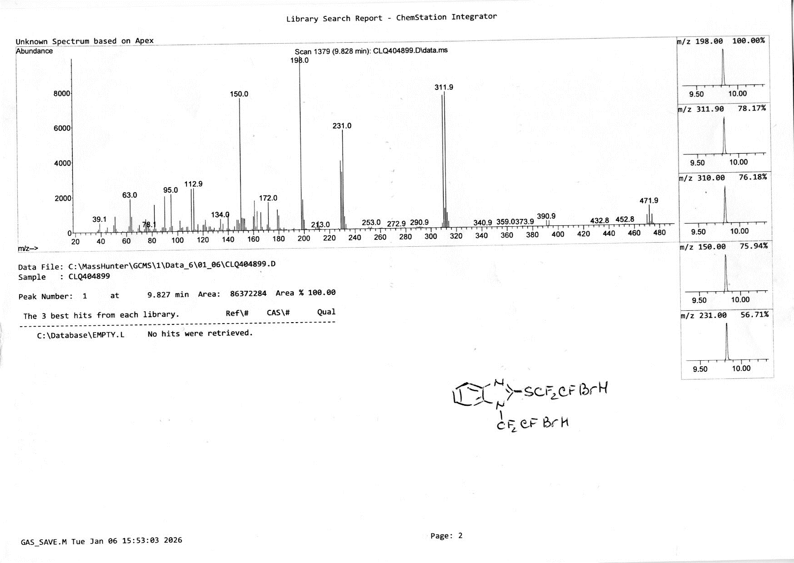
19 F 70 % compound 8
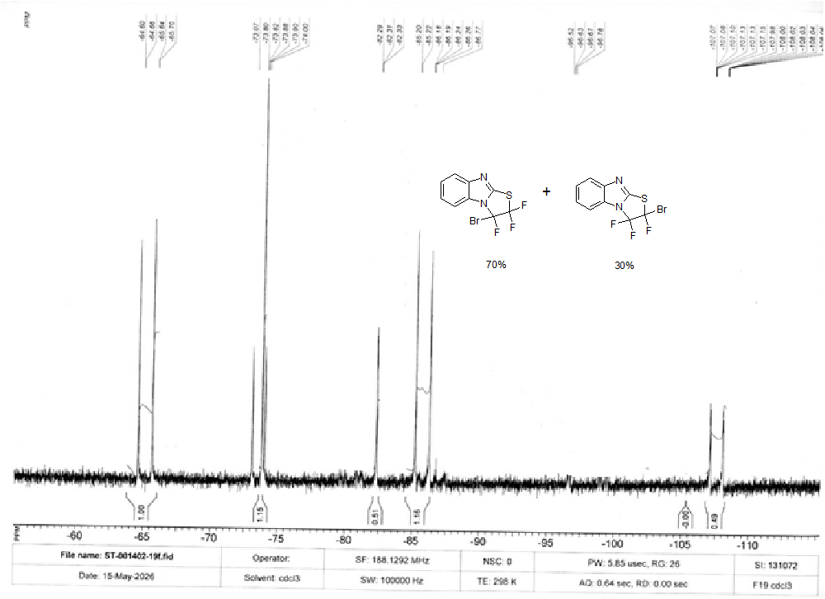
19F NMR specta of compound 9 and 10
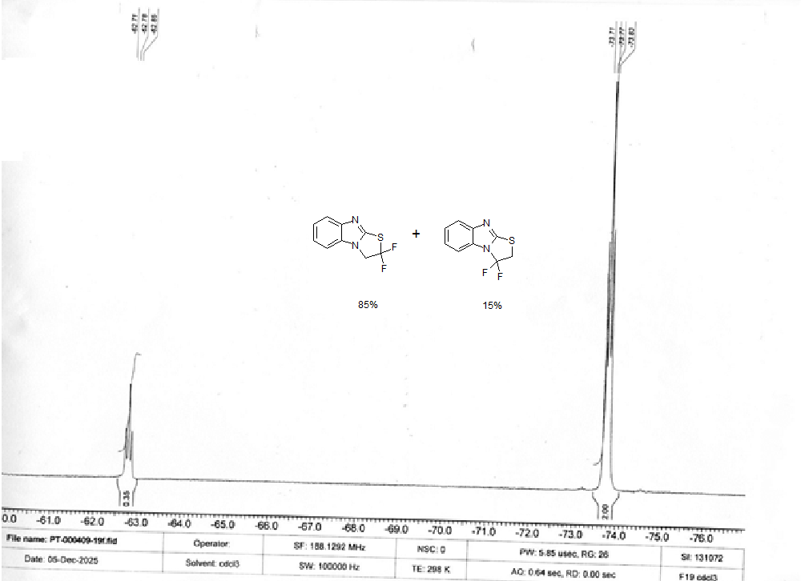

1H NMR specta of compound 9
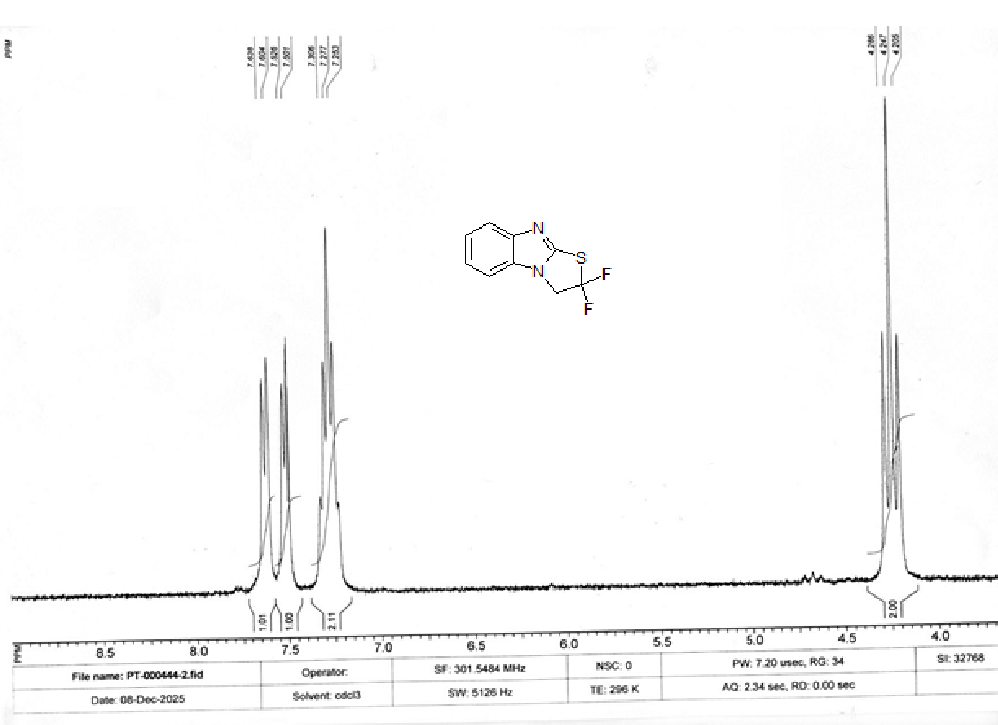
13C NMR specta of compound 9
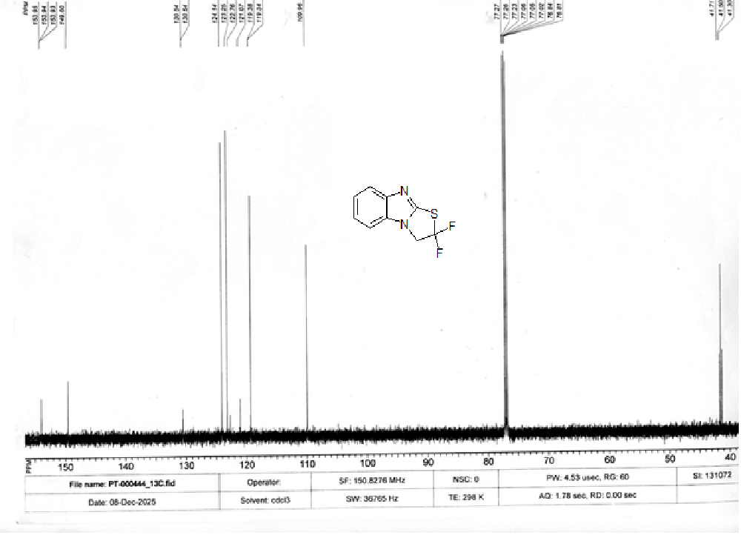
1H NMR specta of compound 10
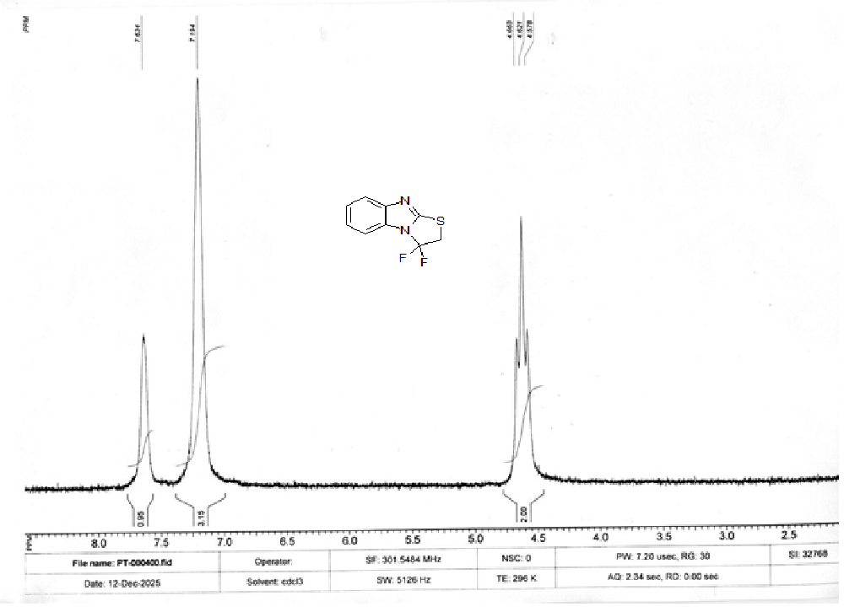
13C NMR specta of compound 10
\

