Supplementary Figures to

Persistence of the coral Porites harrisoni in the Persian/Arabian Gulf is underpinned by strong selection on few genomic loci

Anna Fiesinger*, Rachel Alderdice, Luigi Colin, Gabriela Perna, Hannah Manns, Samantha Goyen, Line K. Bay, Nitin S. Baliga, Jacob J. Valenzuela, Daniel J. Barshis, Iliana B. Baums, John A. Burt, Christian R. Voolstra*

*Correspondence to Anna Fiesinger, fiesinger.anna@gmail.com, and Christian R. Voolstra, christian.voolstra@uni-konstanz.de

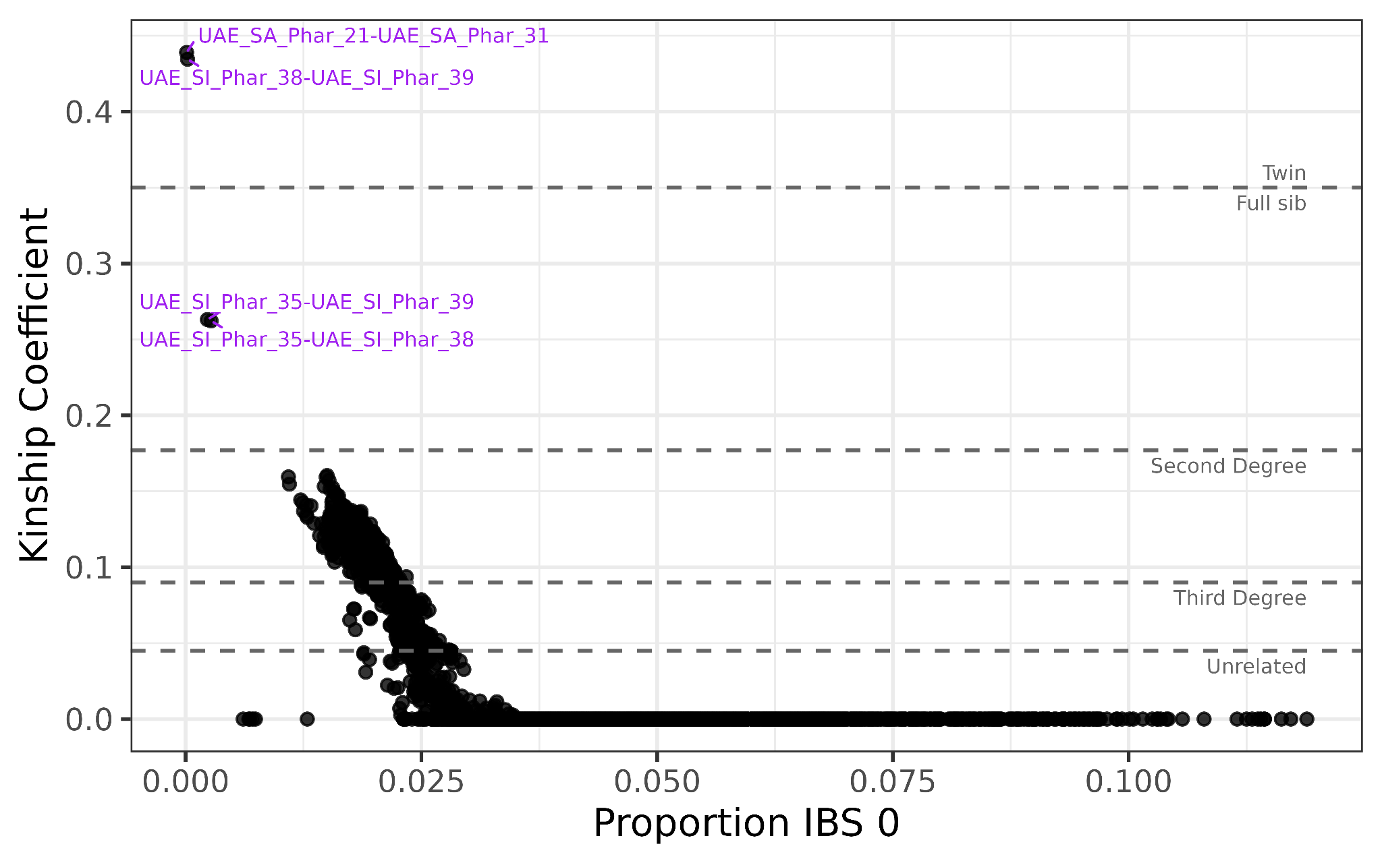
Supplementary Figure S1. Kinship analysis of Porites harrisoni colonies. The program KING identified two sets of clone mates (i.e., twins) through kinship analysis (kinship coefficient > 0.354) and three full siblings (kinship coefficient > 0.177). Several colonies are distantly related (i.e., second or third degree), while many individuals are unrelated.

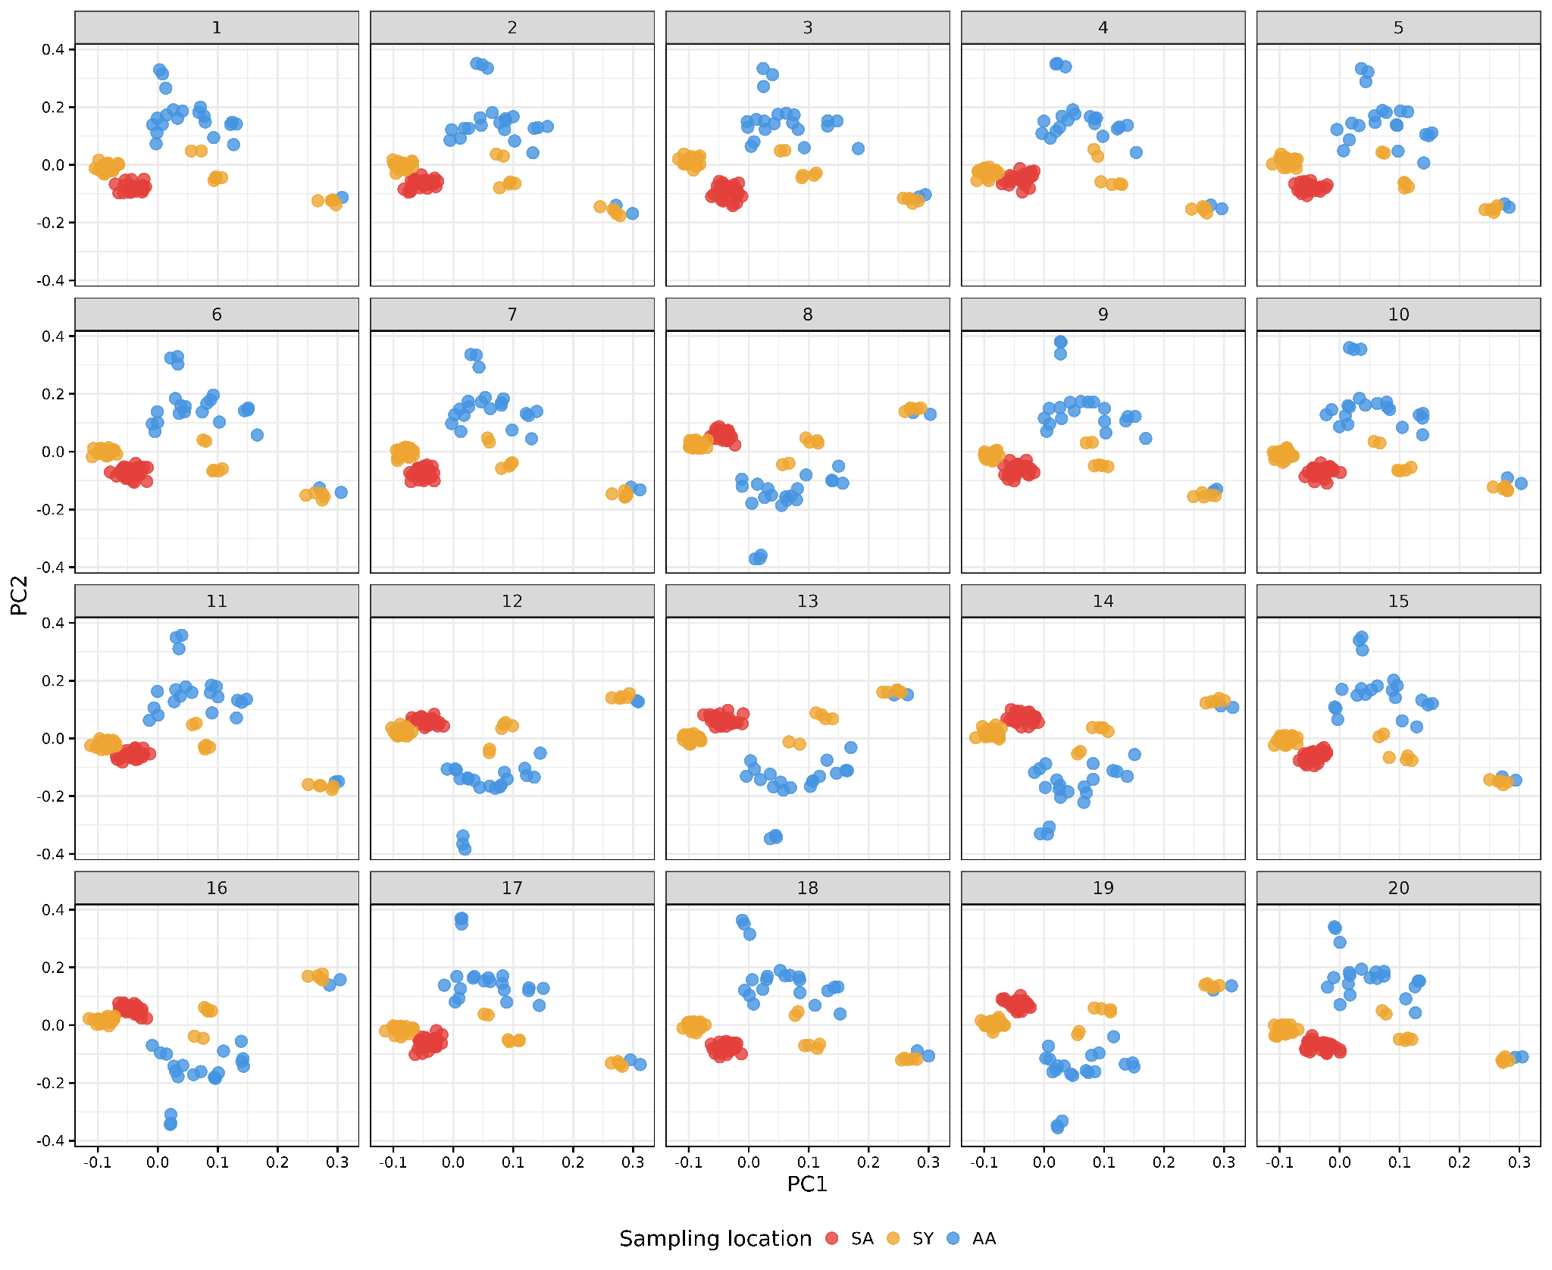
Supplementary Figure S2. PCAs of randomly resampled 10,000 SNPs in 20 replicates from the whole dataset. The clustering patterns apparent in the whole dataset are also evident when random SNPs are resampled, suggesting a true population structure signal rather than a few specific SNPs driving these patterns.

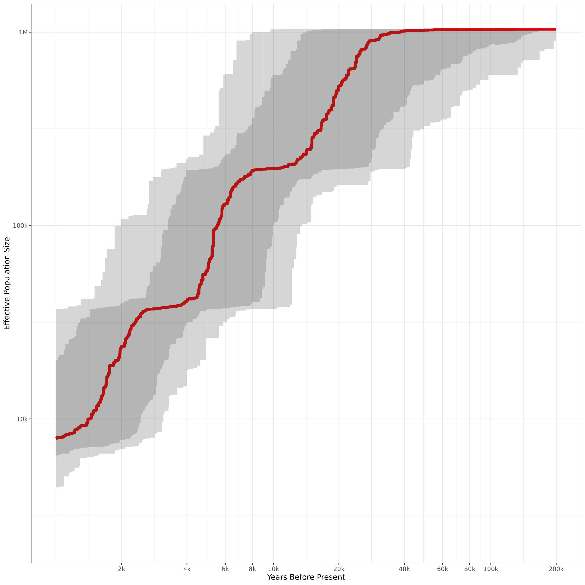
Supplementary Figure S3. Stairway Plot of southern PAG Porites harrisoni. The stairway plot shows historic changes in effective population size of southern PAG P. harrisoni (sites SA and SY, n = 79). The red line shows the median estimated effective population size, with the 75% and 95% confidence intervals shown in light and dark grey, respectively.

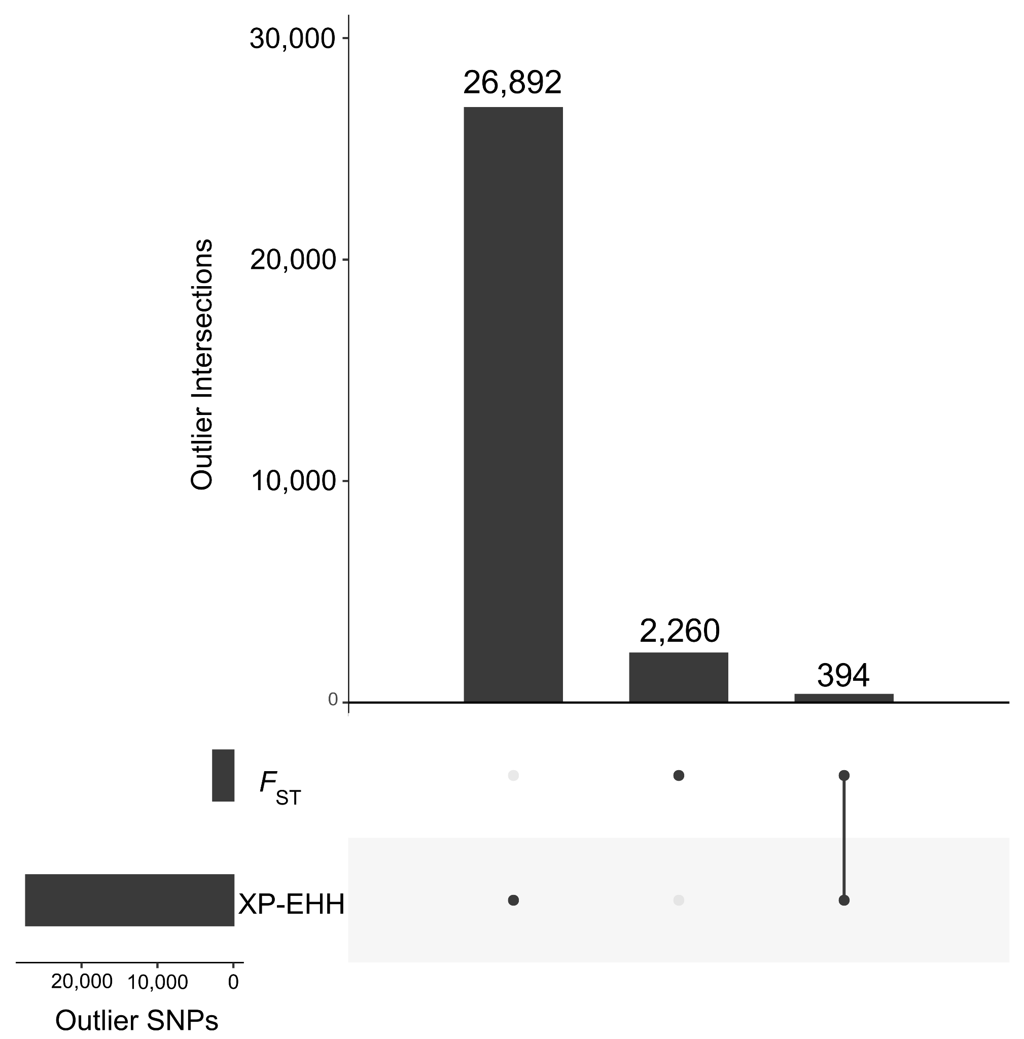
Supplementary Figure S4. Outlier SNPs in candidate regions of selection in both measures examined (F_{ST} and XP-EHH). A total of 394 outlier SNPs were identified in both approaches.

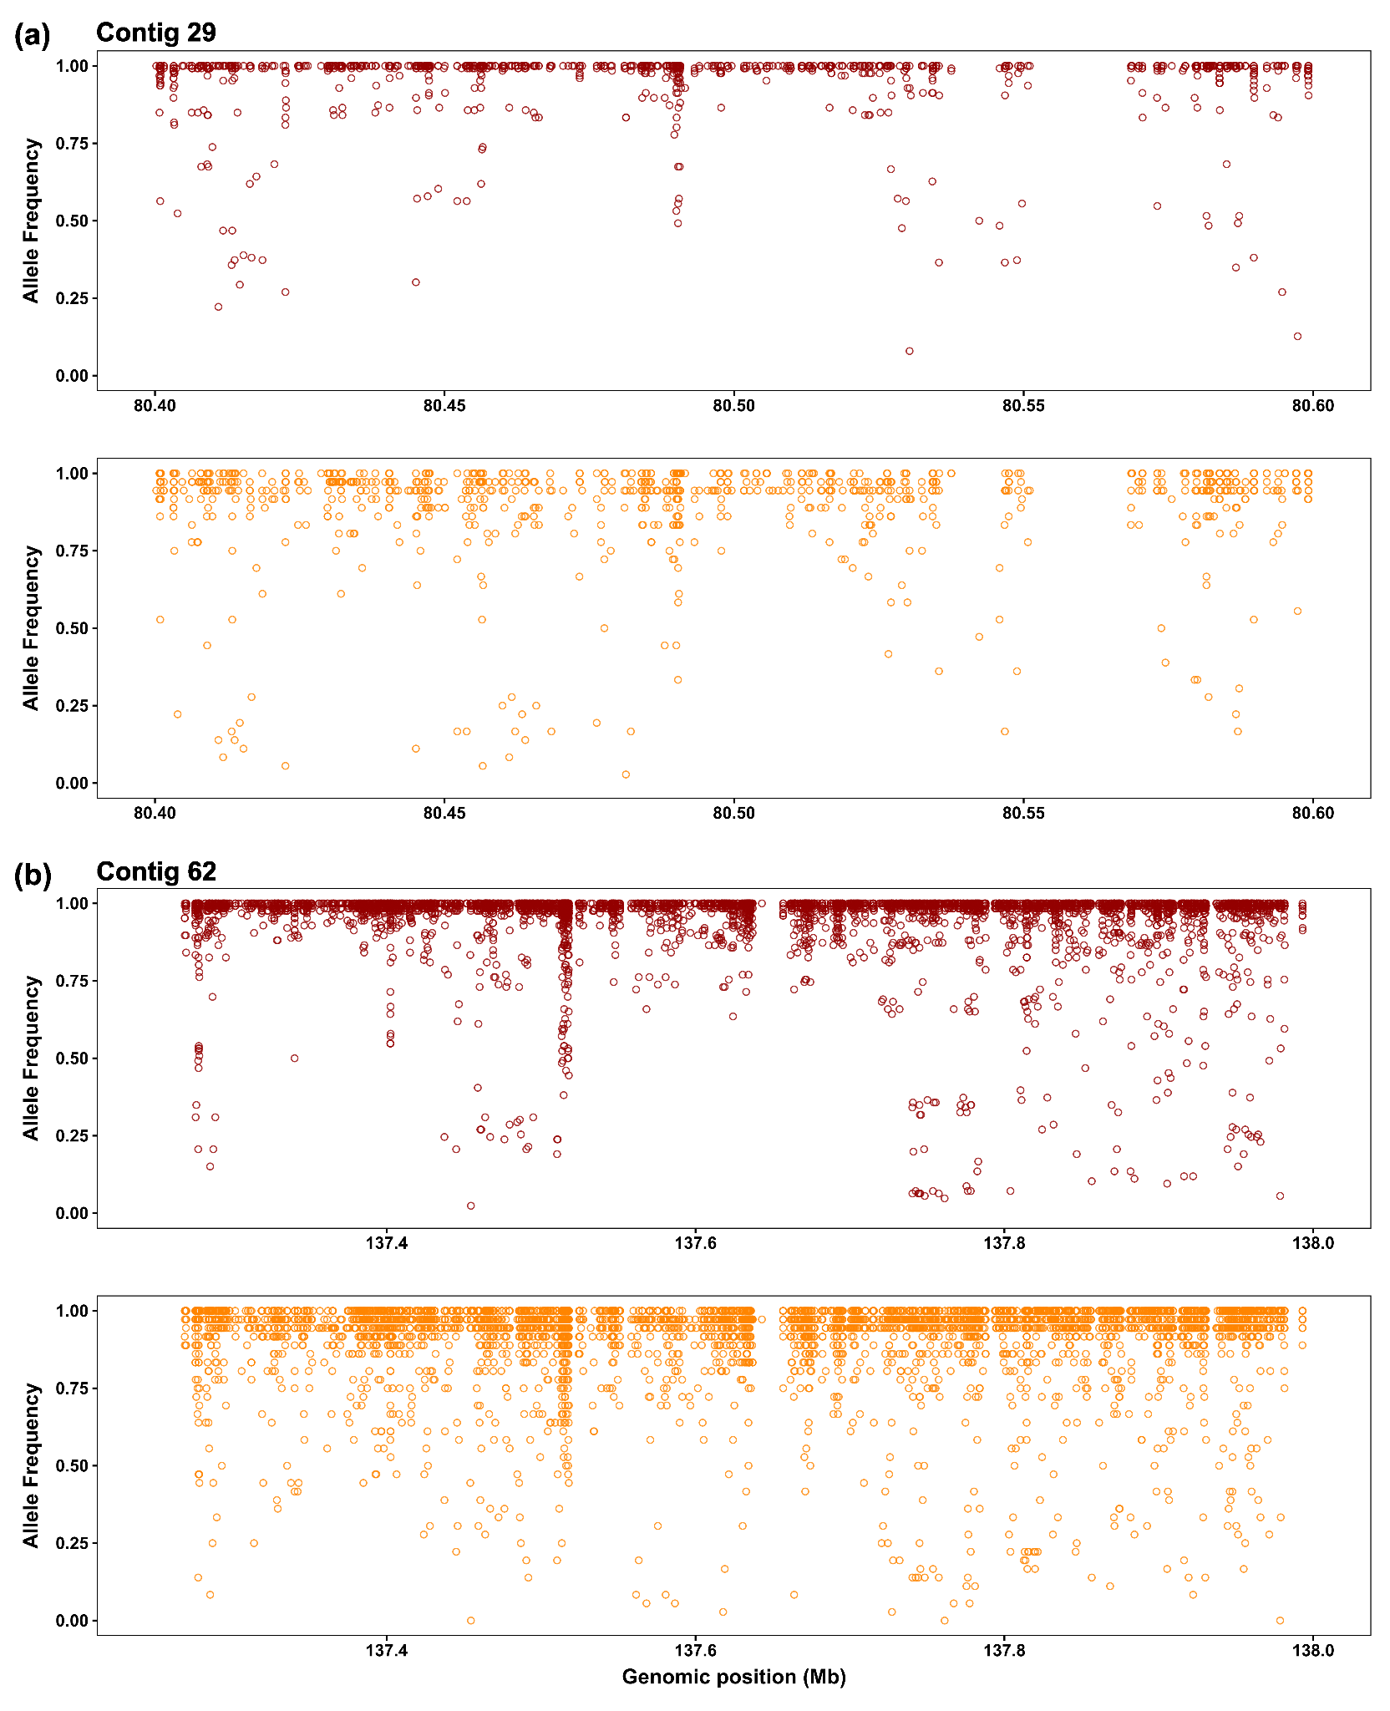
Supplementary Figure S5. Allele frequency for the candidate regions of positive selection. Allele frequency is plotted in dark red for PAG corals and orange for GO corals on (a) contig 29 and (b) contig 62. Each contig is displayed for the region of each potential sweep, i.e., on contig 29 between 80.4–80.6 Mb, where F_{ST} values reached 0.93, and for contig 62 between 137.25–138 Mb where normalized XP-EHH values reached up to 10.47.

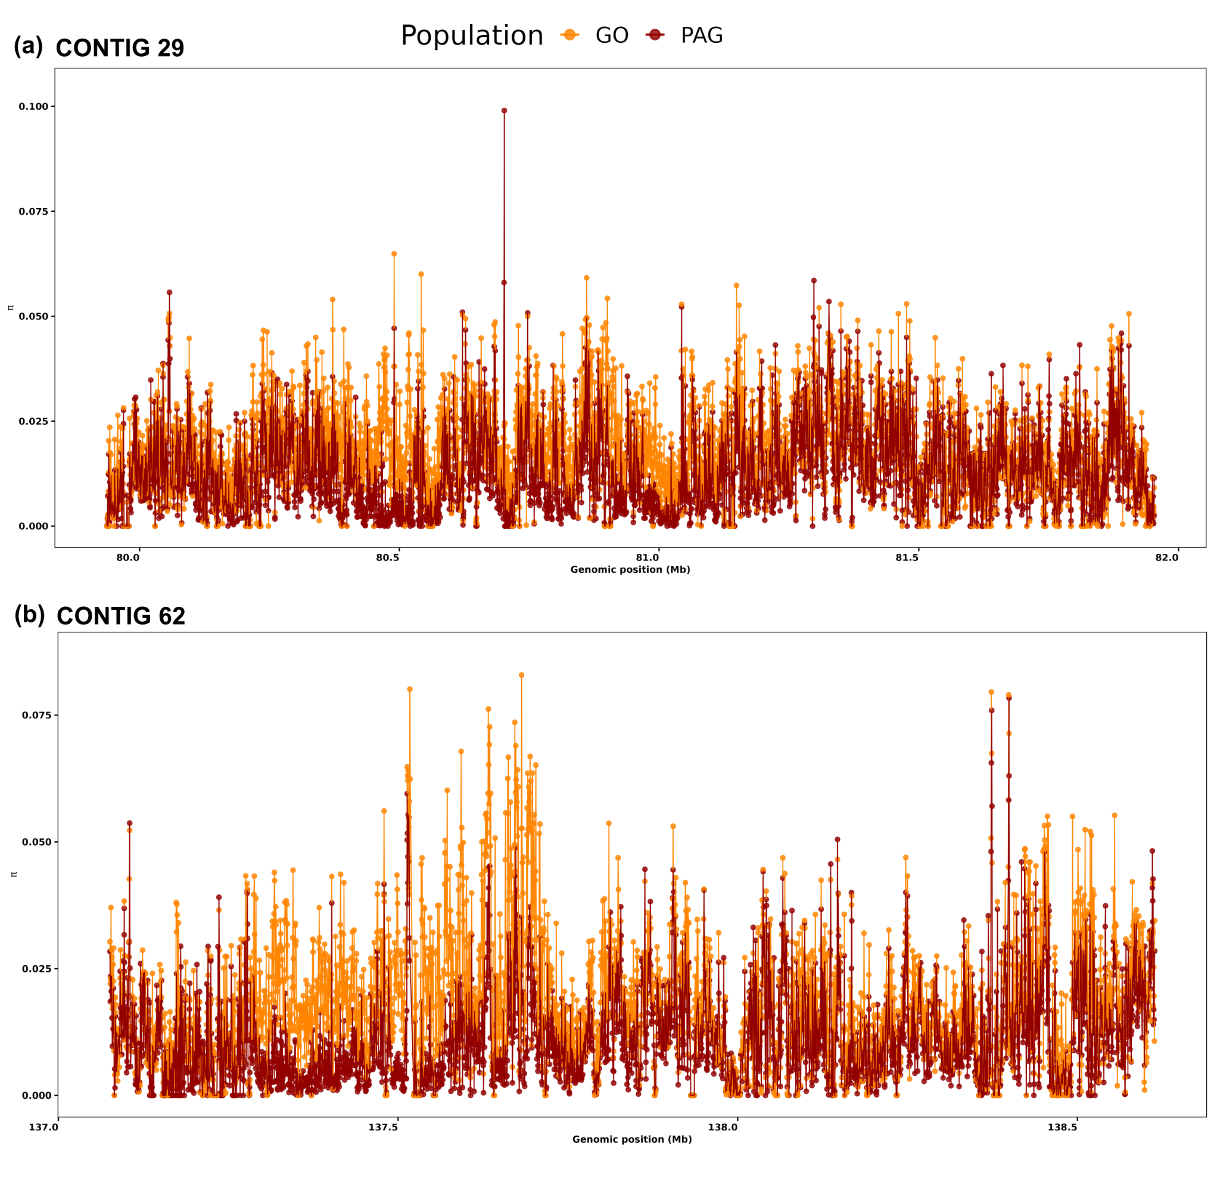
Supplementary Figure S6. Nucleotide diversity (π) in candidate regions of selection. Nucleotide diversity is plotted for PAG corals in dark red and GO corals in orange on (a) contig 29 and (b) contig 62.
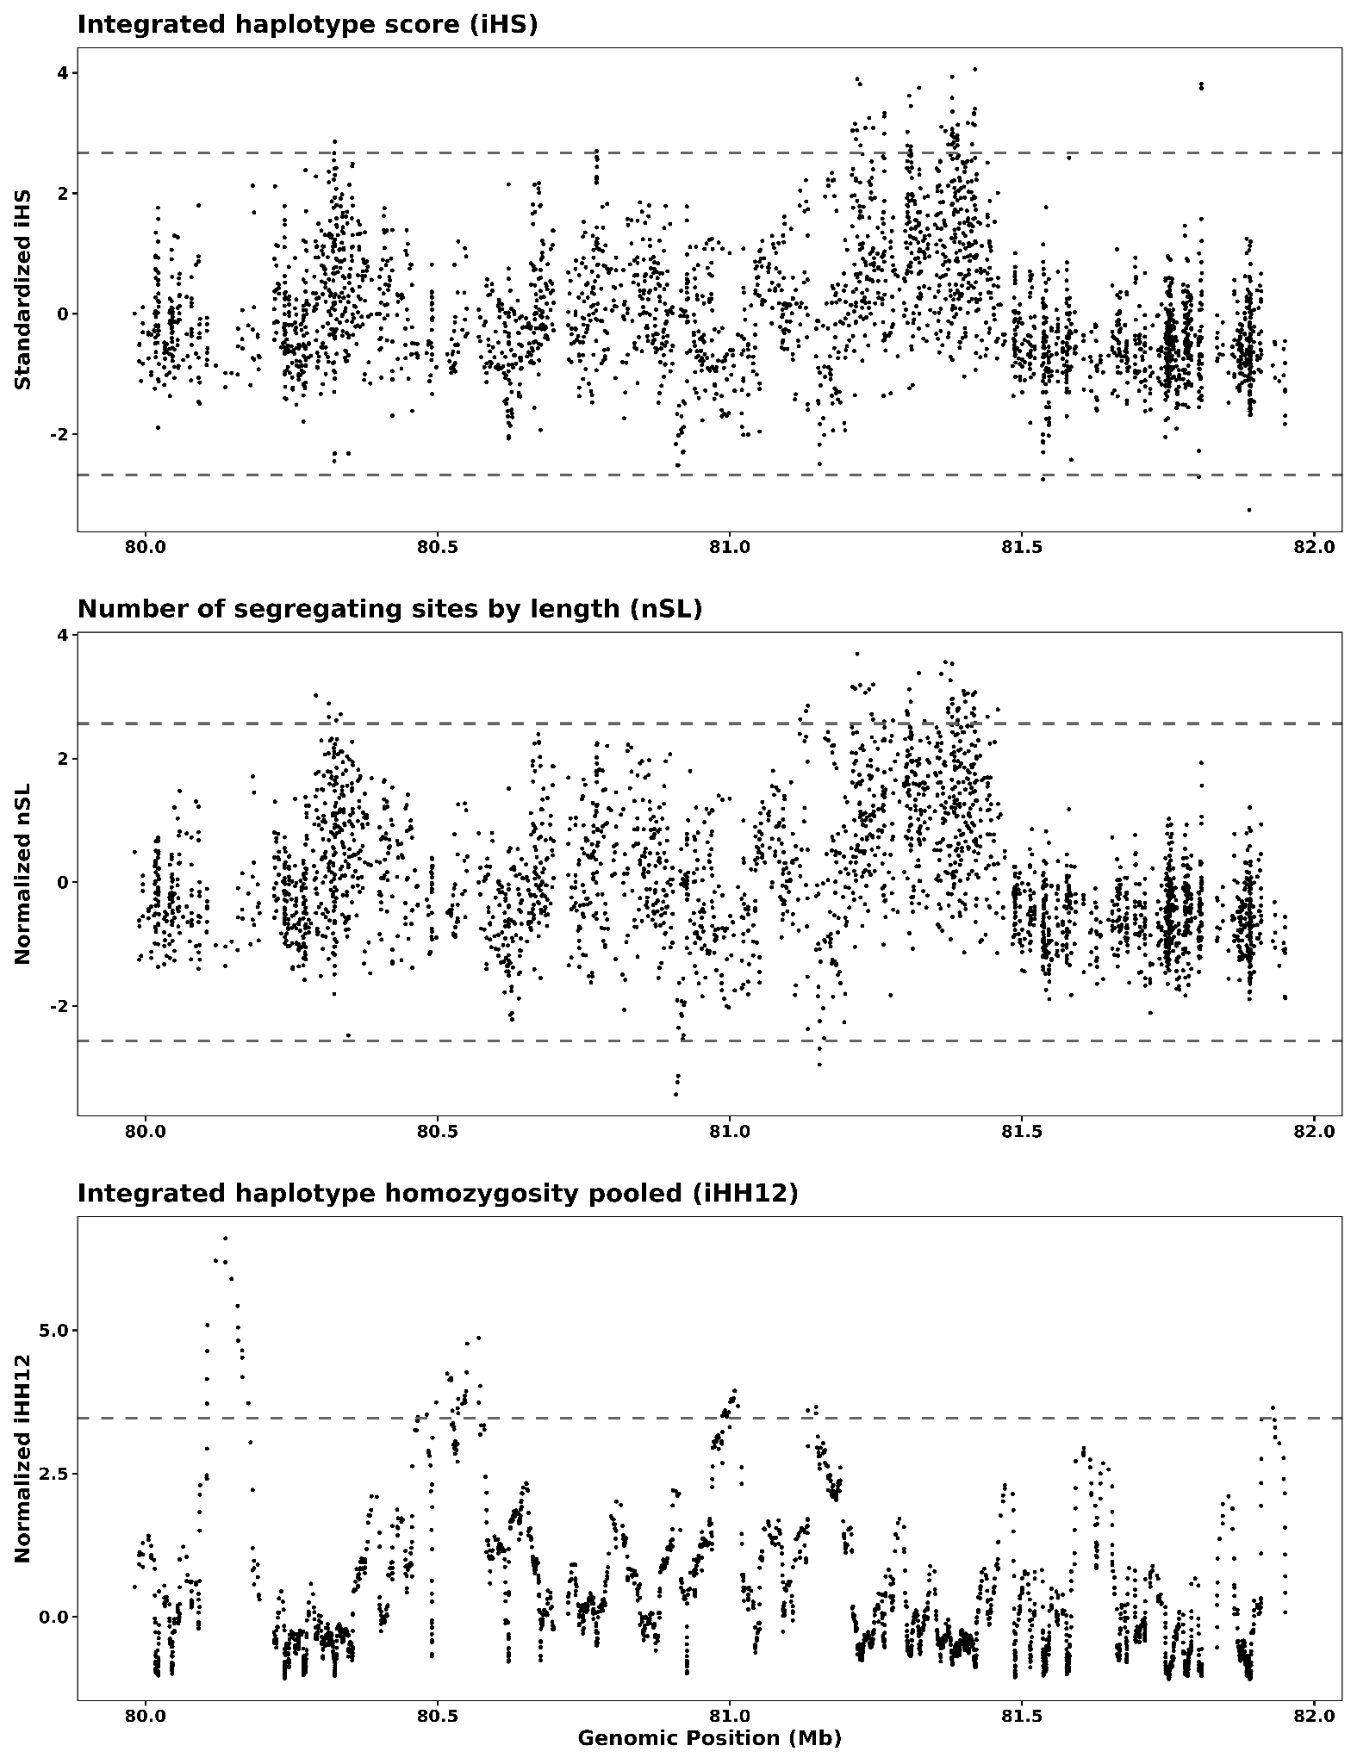
Supplementary Figure S7. Soft sweep detection in PAG corals on contig 29. Haplotype homozygosity measures on contig 29 with outlier thresholds in grey dashed lines. Top: integrated haplotype score, iHS; middle: number of segregating sites by length, nSL; bottom: integrated haplotype homozygosity pooled, iHH12.

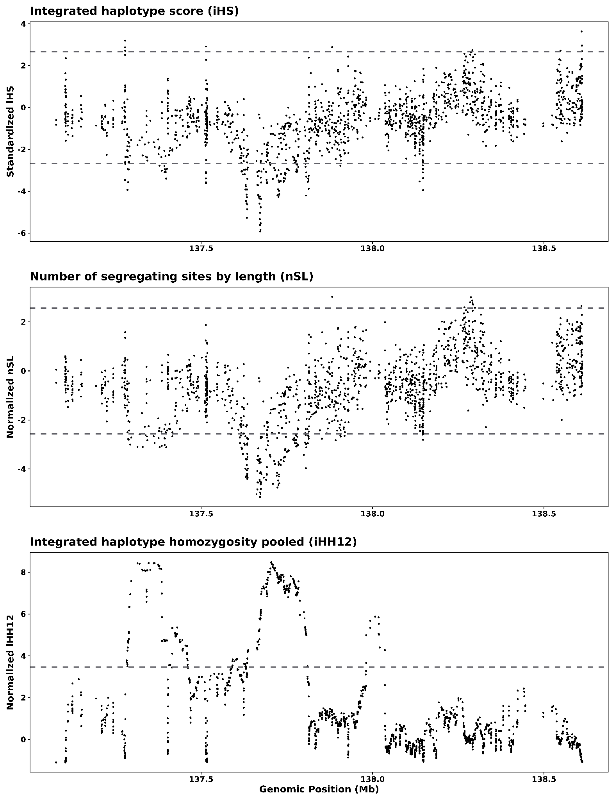
Supplementary Figure S8. Soft sweep detection in PAG corals on contig 62. Haplotype homozygosity measures on contig 62 with outlier thresholds in grey dashed lines. Top: integrated haplotype score, iHS; middle: number of segregating sites by length, nSL; bottom: integrated haplotype homozygosity pooled, iHH12.

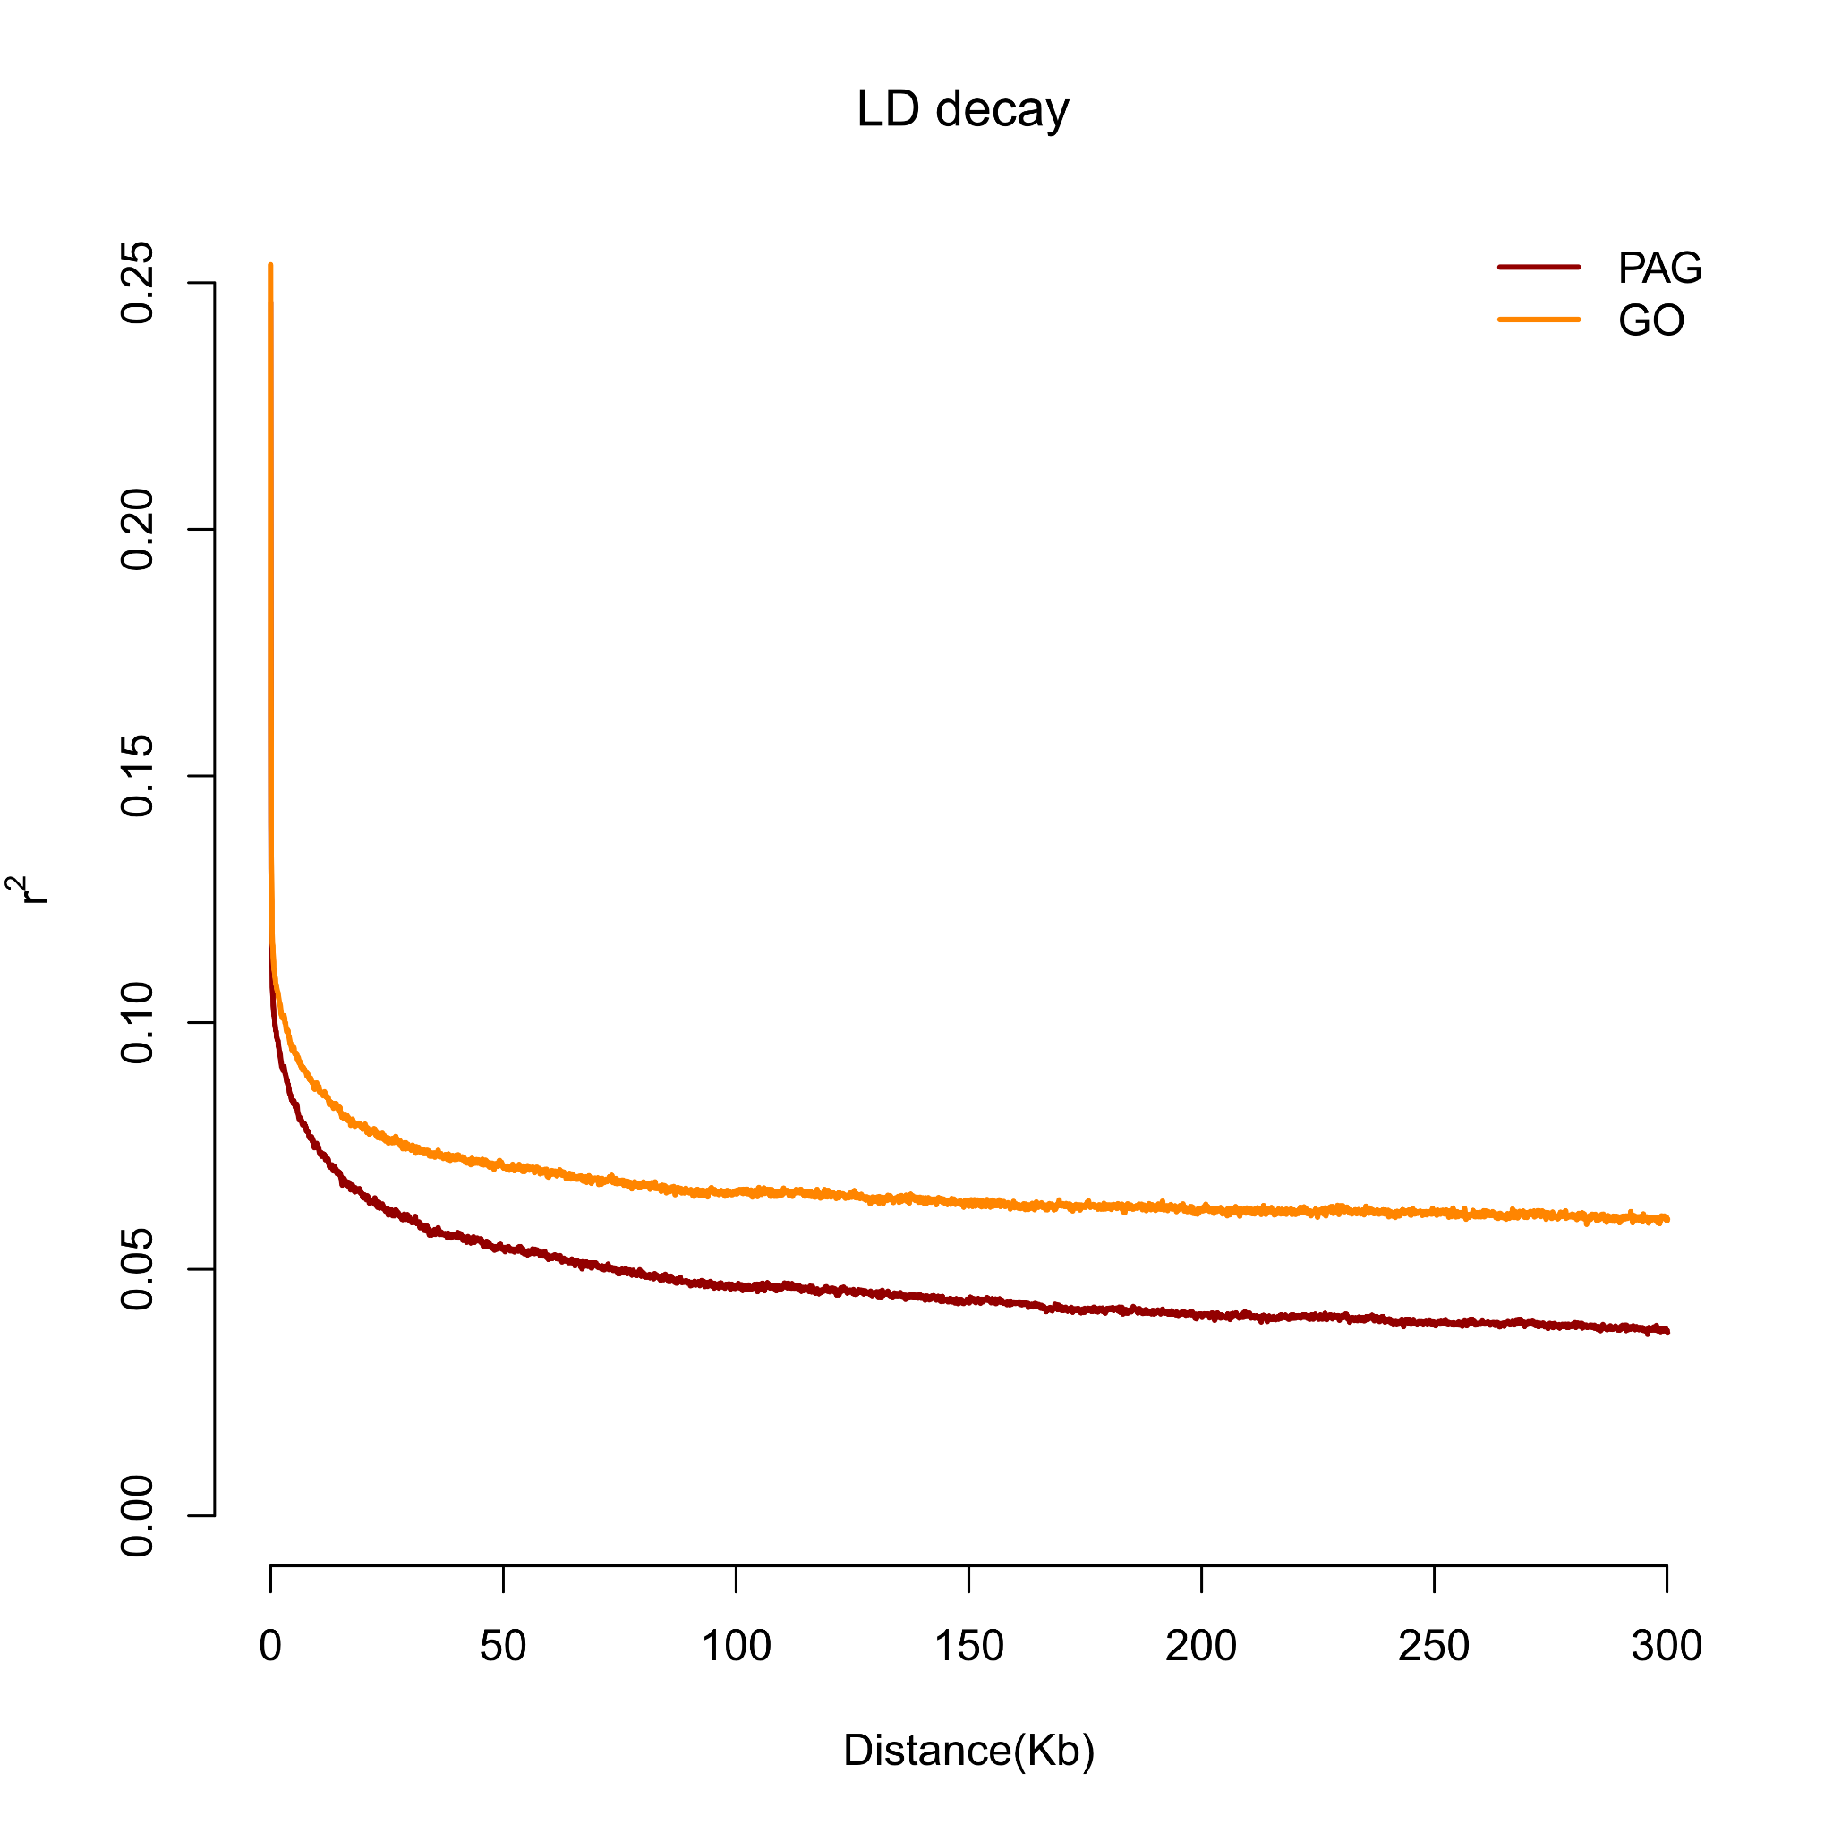
Supplementary Figure S9. Linkage disequilibrium (LD) decay in PAG and GO Porites harrisoni. A total of 1,140,169 SNPs from the population structure VCF file before LD pruning informed the LD decay analysis, showing a slower rate of LD decay in the PAG corals (dark red) compared to the GO corals (orange).

