Supplementary Materials
Nocturnal UTCI Heat Duration and Next-Day Active-Mobility Use: A Behavior-Day Monitoring Framework
International Journal of Biometeorology
Authors: Kang Li, Kui Ma, Huitian Shao, Zongli Xu, and Hao Ding
Corresponding author: Kang Li
Dongshin University, Naju-si, Jeollanam-do, Republic of Korea
Email: likang3645@gmail.com

Supplementary Figures
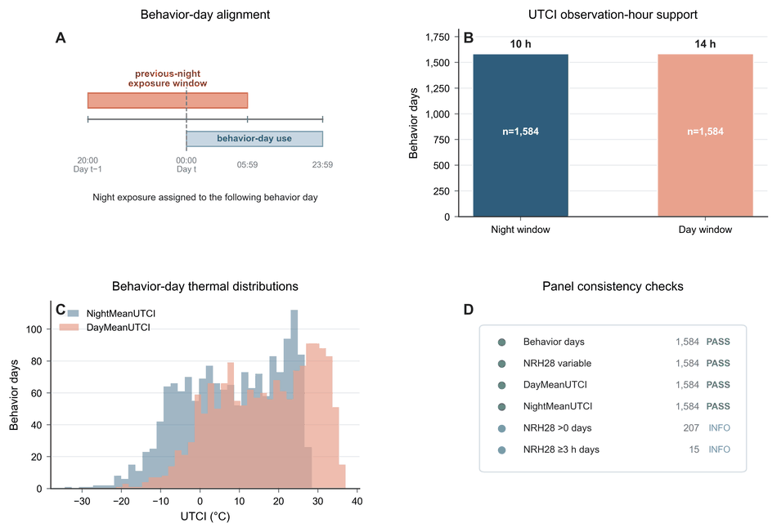
Figure S1. UTCI reconstruction and behavior-day alignment checks. Panel A illustrates how previous-night exposure from 20:00 on day t−1 to 05:59 on day t was assigned to the following behavior day. Panel B summarizes hourly UTCI observation support for the night and day windows. Panel C shows the distributions of nighttime and daytime UTCI values used to construct thermal exposure and control variables. Panel D reports reconstruction-to-panel consistency checks for the derived analysis variables. Panel B uses the nominal window lengths; Table S2 reports date-specific minimum and maximum observation-hour support.
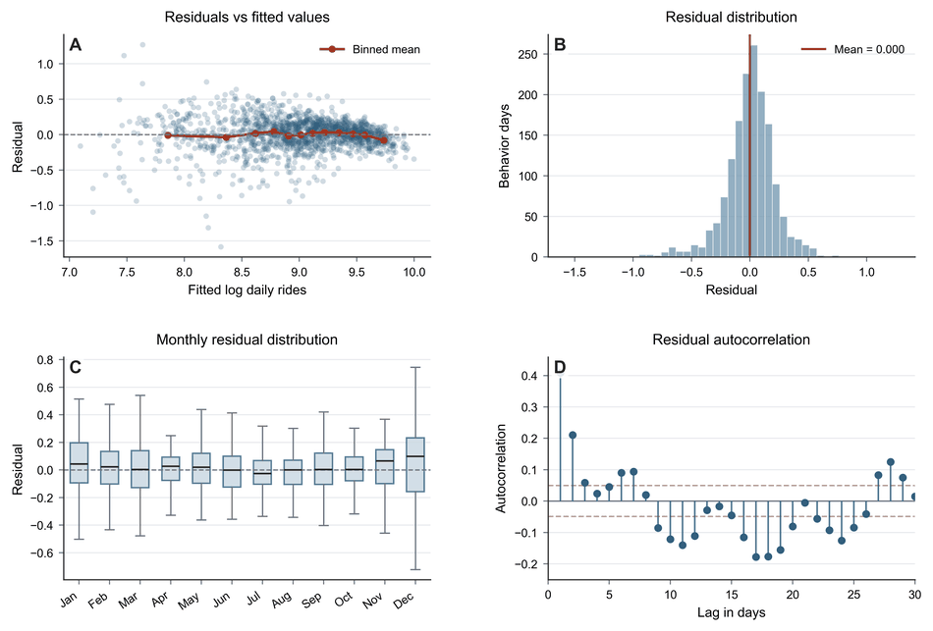
Figure S2. Residual diagnostics for the main fixed-effects model. Panel A shows residuals against fitted log daily rides with a binned mean line. Panel B shows the residual distribution. Panel C summarizes monthly residual distributions. Panel D shows the autocorrelation function of model residuals up to 30 days; dashed lines indicate approximate 95% white-noise bounds. The presence of residual autocorrelation supports the use of Newey-West HAC standard errors.
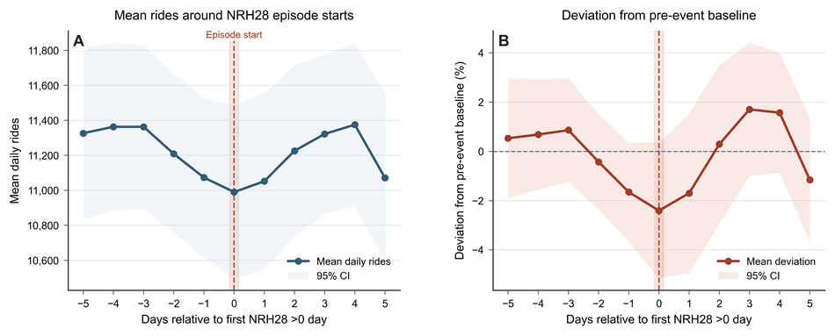
Figure S3. Descriptive episode-centered demand trajectories around first NightRiskHours_28 days in heat-risk episodes. Panel A shows mean daily rides from five days before to five days after the first behavior day with NightRiskHours_28 >0 in each heat-risk episode. Panel B shows percent deviation from the pre-event baseline, defined as the mean rides during days −5 to −1 within each episode window. Shaded bands indicate 95% confidence intervals. These trajectories are descriptive diagnostics and should not be interpreted as causal event-study estimates.
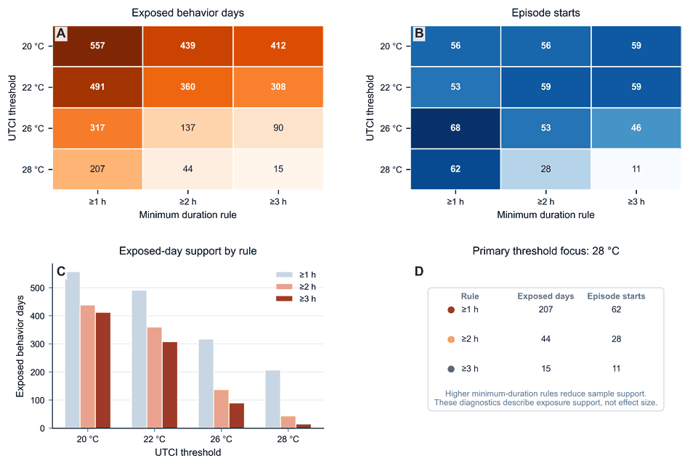
Figure S4. Episode-definition sensitivity across UTCI thresholds and minimum-duration rules. Panel A shows the number of exposed behavior days under alternative UTCI thresholds and minimum-duration rules. Panel B shows the corresponding number of episode starts, defined as exposed days preceded by non-exposed days. Panel C displays exposed-day support by threshold and minimum-duration rule. Panel D focuses on the primary 28 °C threshold. These diagnostics describe exposure support under alternative episode definitions and should not be interpreted as effect-size estimates.
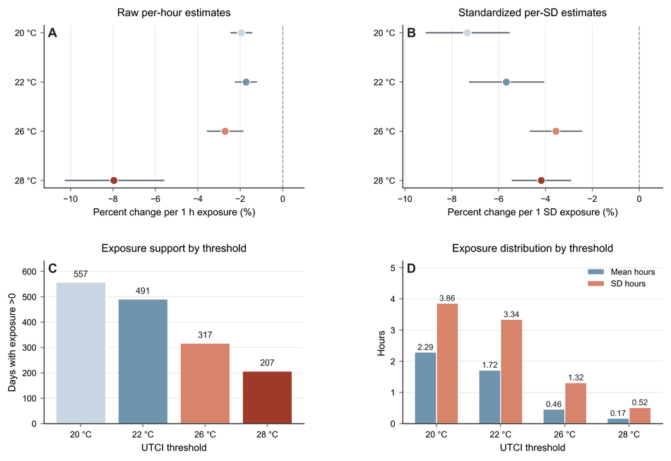
Figure S5. Standardized threshold diagnostics for NightRiskHours indicators. Panel A shows raw per-hour estimates across UTCI thresholds. Panel B shows standardized estimates for one standard-deviation increases in each NightRiskHours indicator. Panel C reports the number of behavior days with nonzero exposure under each threshold. Panel D summarizes the mean and standard deviation of each exposure indicator. Higher UTCI thresholds identify stronger and sparser nocturnal heat-risk states; therefore, raw per-hour and standardized estimates should not be interpreted interchangeably.
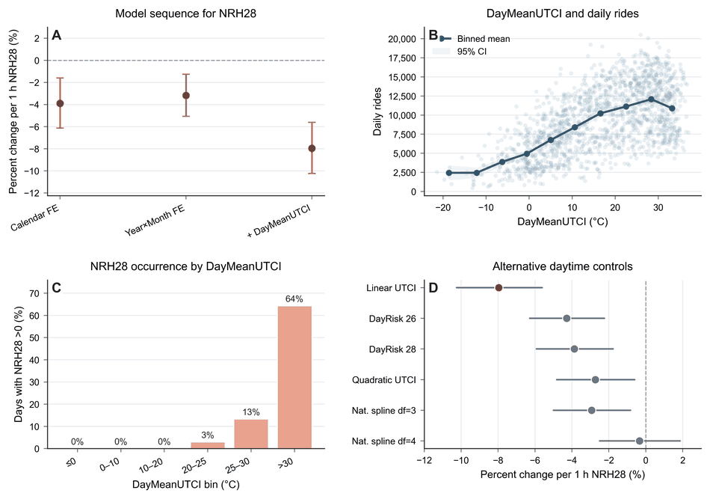
Figure S6. DayMeanUTCI suppression and nonlinear-control diagnostics. Panel A shows the model sequence for NightRiskHours_28 before and after adjusting for daytime thermal background. Panel B shows the descriptive relationship between DayMeanUTCI and daily bikeshare use. Panel C shows the share of behavior days with NightRiskHours_28 >0 across DayMeanUTCI bins. Panel D compares alternative daytime heat-control specifications, including linear UTCI, daytime risk-hour controls, quadratic UTCI, and natural spline specifications. The diagnostic shows that the NightRiskHours_28 estimate changed after adding linear DayMeanUTCI and was attenuated under more flexible daytime-control specifications.
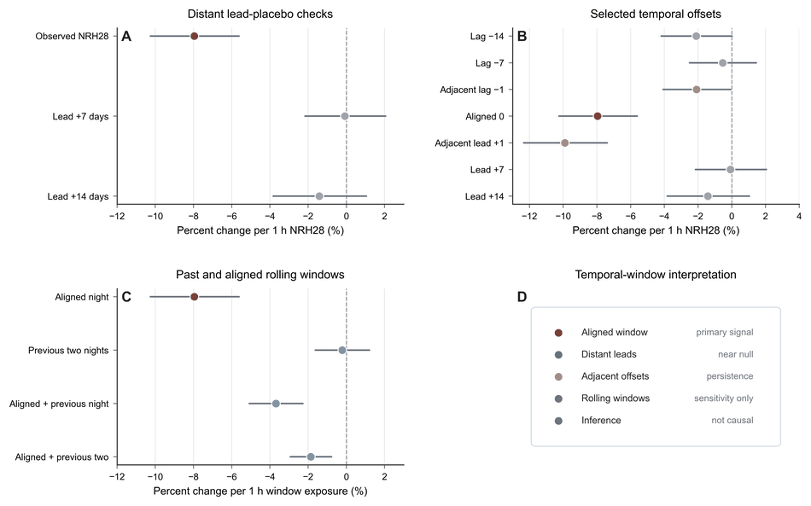
Figure S7. Lag/lead temporal-window diagnostics for NightRiskHours_28. Panel A compares the correctly aligned NightRiskHours_28 estimate with distant future lead-placebo assignments at +7 and +14 days. Panel B summarizes selected temporal offsets, distinguishing the aligned exposure from adjacent and distant lag/lead assignments. Panel C compares the primary aligned night with past and aligned rolling-window definitions. Panel D summarizes the interpretation of the diagnostics. Distant future leads were close to null, whereas adjacent offsets may reflect persistence within the same heat episode. These diagnostics evaluate temporal alignment and should not be interpreted as causal event-study estimates or individual-level mechanism tests.
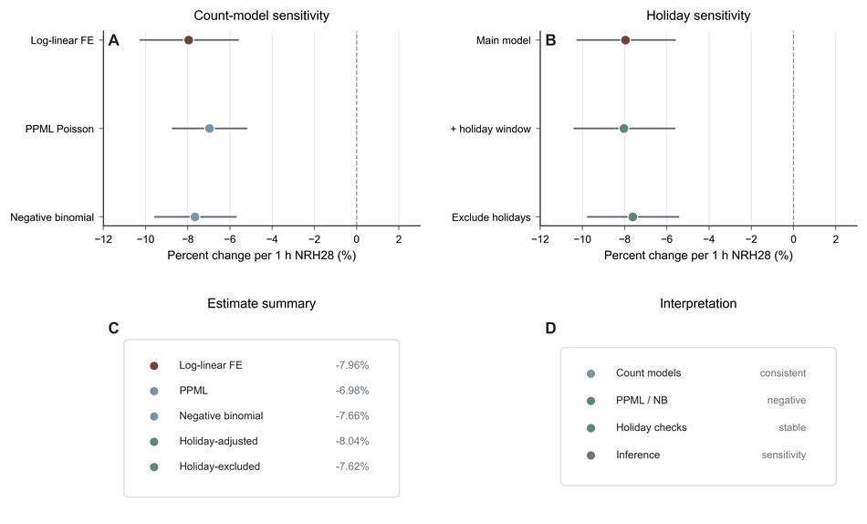
Figure S8. Count-model and holiday sensitivity diagnostics. Panel A compares the main log-linear fixed-effects estimate with PPML Poisson and negative-binomial count-model specifications. Panel B reports holiday-related sensitivity checks, including a federal holiday ±1 day window indicator and exclusion of the federal holiday ±1 day window. Panel C summarizes the estimated percent changes across these checks. Panel D provides a compact interpretation summary. Under the operational linear daytime-control specification, the diagnostics indicate that the negative NightRiskHours_28 association was not driven by the log-transformed outcome scale or holiday-window handling.
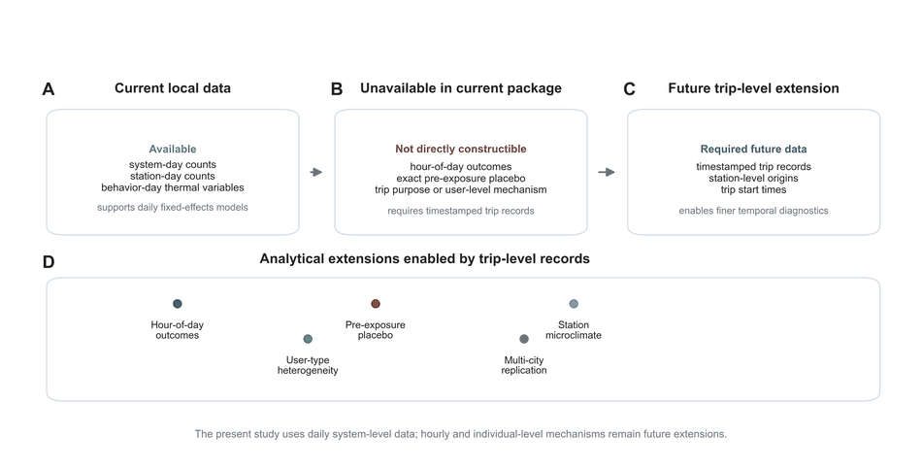
Figure S9. Data limitation and future trip-level extension. Panel A summarizes the local analysis data available for the present study, including daily system-level and station-day counts. Panel B identifies analyses that could not be constructed from the supplied local package, including hour-of-day outcomes and exact pre-exposure outcome placebo tests. Panel C summarizes the trip-level timestamped data required for future extension. Panel D shows analytical extensions that would become possible with trip-level records, including hour-of-day outcomes, exact pre-exposure placebo tests, station-level microclimate linkage, user-type heterogeneity, and multi-city replication. The present study should therefore be interpreted as daily system-level evidence rather than individual-level mechanism evidence.

Supplementary Tables
Table S1. Variable construction and behavior-day alignment rules
Component | Variable | Operational definition | Unit / scale | Alignment rule | Used in analyses
Outcome | rides_total | Total daily Capital Bikeshare pickups aggregated across stations | rides/day | Behavior day t | Descriptive and regression analyses
Outcome | log_total | Natural log of one plus total daily rides: log(1 + rides_total) | log scale | Behavior day t | Fixed-effects models
Nocturnal heat exposure | NightRiskHours_20 | Number of hours in the previous-night window with UTCI ≥20 °C | hours/night | 20:00 Day t−1 to 05:59 Day t; assigned to behavior day t | Threshold comparator
Nocturnal heat exposure | NightRiskHours_22 | Number of hours in the previous-night window with UTCI ≥22 °C | hours/night | 20:00 Day t−1 to 05:59 Day t; assigned to behavior day t | Threshold comparator
Nocturnal heat exposure | NightRiskHours_26 | Number of hours in the previous-night window with UTCI ≥26 °C | hours/night | 20:00 Day t−1 to 05:59 Day t; assigned to behavior day t | Threshold comparator
Nocturnal heat exposure | NightRiskHours_28 | Number of hours in the previous-night window with UTCI ≥28 °C | hours/night | 20:00 Day t−1 to 05:59 Day t; assigned to behavior day t | Primary exposure
Daytime thermal control | DayMeanUTCI | Mean UTCI during 06:00–19:59 on the behavior day | °C | Behavior day t | Primary daytime thermal background control
Daytime thermal control | DayRiskHours_26 | Number of daytime hours with UTCI ≥26 °C | hours/day | 06:00–19:59 on behavior day t | Alternative daytime heat control
Daytime thermal control | DayRiskHours_28 | Number of daytime hours with UTCI ≥28 °C | hours/day | 06:00–19:59 on behavior day t | Alternative daytime heat control
Weather control | tp_mm_daily | ERA5 total daily precipitation | mm/day | Behavior day t | Weather control
Calendar control | dow | Day-of-week indicator | categorical | Behavior day t | Temporal fixed effect
Calendar control | year_month | Year-by-month indicator | categorical | Behavior day t | Seasonal and long-run temporal fixed effect
Period control | covid_period | Pandemic-period background indicator | categorical | Behavior day t | Period background control
Placebo exposure | NightRiskHours_28_lead7 | NightRiskHours_28 shifted 7 days into the future | hours/night | Future exposure assigned to behavior day t | Lead placebo
Placebo exposure | NightRiskHours_28_lead14 | NightRiskHours_28 shifted 14 days into the future | hours/night | Future exposure assigned to behavior day t | Lead placebo
Holiday sensitivity | holiday_pm1 | Indicator for federal holidays and ±1 day windows | 0/1 | Behavior day t | Holiday sensitivity
Table S2. UTCI reconstruction and behavior-day panel support
Metric | Value
Raw UTCI source | ERA5-HEAT
Precipitation source | ERA5
Original UTCI unit | Kelvin
Unit conversion | °C = K − 273.15
Study period | 2020-05-01 to 2024-08-31
Behavior days | 1,584
Night window | 20:00 Day t−1 to 05:59 Day t
Day window | 06:00–19:59 Day t
NightObsHours mean/min/max | 10.000 / 9 / 11
DayObsHours mean/min/max | 14.000 / 14 / 14
NightRiskHours_20 >0 days | 557
NightRiskHours_22 >0 days | 491
NightRiskHours_26 >0 days | 317
NightRiskHours_28 >0 days | 207
NightRiskHours_28 ≥2 h days | 44
NightRiskHours_28 ≥3 h days | 15
NightRiskHours_28 maximum hours | 5.0
Table S3. Fixed-effects model sequence and threshold-comparator estimates
ID | Model | Term | Beta (95% CI) | Percent change (95% CI) | p | N | R²
M1 | Calendar FE | NightRiskHours_28 | -0.0396 (-0.0632, -0.0161) | -3.89% (-6.13%, -1.59%) | <0.001 | 1,584 | 0.745
M2 | Year×Month FE | NightRiskHours_28 | -0.0323 (-0.0520, -0.0126) | -3.18% (-5.07%, -1.25%) | 0.001 | 1,584 | 0.796
M3 | Full model + DayMeanUTCI | NightRiskHours_28 | -0.0829 (-0.1081, -0.0578) | -7.96% (-10.25%, -5.61%) | <0.001 | 1,584 | 0.844
T-20 | UTCI ≥20 °C night-risk hours | NightRiskHours_20 | -0.0197 (-0.0247, -0.0148) | -1.95% (-2.44%, -1.47%) | <0.001 | 1,584 | 0.845
T-22 | UTCI ≥22 °C night-risk hours | NightRiskHours_22 | -0.0175 (-0.0225, -0.0124) | -1.73% (-2.22%, -1.24%) | <0.001 | 1,584 | 0.844
T-26 | UTCI ≥26 °C night-risk hours | NightRiskHours_26 | -0.0275 (-0.0362, -0.0189) | -2.72% (-3.55%, -1.88%) | <0.001 | 1,584 | 0.843
T-28 | UTCI ≥28 °C night-risk hours | NightRiskHours_28 | -0.0829 (-0.1081, -0.0578) | -7.96% (-10.25%, -5.61%) | <0.001 | 1,584 | 0.844
Table S4. Sample and temporal fixed-effect sensitivity
Specification | Percent change (95% CI) | p | N | Notes
Full sample | -7.96% (-10.25%, -5.61%) | <0.001 | 1,584 | Operational reference specification
Exclude 2020 | -7.57% (-9.96%, -5.11%) | <0.001 | 1,339 | Pandemic-period sensitivity
Exclude 2020–2021 | -7.61% (-10.02%, -5.14%) | <0.001 | 974 | Post-disruption sensitivity
May–September | -5.44% (-7.73%, -3.09%) | <0.001 | 735 | Warm-season sample
June–August | -3.18% (-5.18%, -1.13%) | 0.002 | 460 | Core-summer sample
Month + Year FE | -9.34% (-11.91%, -6.71%) | <0.001 | 1,584 | Alternative temporal FE
Year×Week FE | -7.02% (-9.60%, -4.37%) | <0.001 | 1,584 | Alternative temporal FE
Table S5. Categorical dose-response estimates for NightRiskHours_28
Category | Category N | Beta (95% CI) | Percent change (95% CI) | p
0 h (reference) | 1,377 | Reference | Reference | —
1 h | 163 | -0.1338 (-0.1837, -0.0839) | -12.52% (-16.78%, -8.05%) | <0.001
2 h | 29 | -0.1417 (-0.2042, -0.0792) | -13.21% (-18.47%, -7.62%) | <0.001
≥3 h | 15 | -0.2599 (-0.3484, -0.1714) | -22.89% (-29.41%, -15.75%) | <0.001
Table S6. Lead placebo diagnostics for NightRiskHours_28
Model | Term | Percent change (95% CI) | p | N | Interpretation
Observed NRH28 | NightRiskHours_28 | -7.96% (-10.25%, -5.61%) | <0.001 | 1,584 | Correctly aligned exposure
Lead +7 days | NightRiskHours_28_lead7 | -0.08% (-2.16%, 2.05%) | 0.944 | 1,577 | Future exposure placebo
Lead +14 days | NightRiskHours_28_lead14 | -1.42% (-3.82%, 1.05%) | 0.257 | 1,570 | Future exposure placebo
Table S7. Alternative daytime heat-control models
Specification | Percent change (95% CI) | p | N | R²
Linear DayMeanUTCI control | -7.96% (-10.25%, -5.61%) | <0.001 | 1,584 | 0.844
DayRiskHours_26 control | -4.28% (-6.29%, -2.24%) | <0.001 | 1,584 | 0.798
DayRiskHours_28 control | -3.87% (-5.92%, -1.77%) | <0.001 | 1,584 | 0.796
DayMeanUTCI quadratic control | -2.73% (-4.82%, -0.60%) | 0.012 | 1,584 | 0.860
Natural spline DayMeanUTCI, df=3 | -2.94% (-5.01%, -0.82%) | 0.007 | 1,584 | 0.860
Natural spline DayMeanUTCI, df=4 | -0.34% (-2.50%, 1.86%) | 0.759 | 1,584 | 0.863
Interpretation. Alternative daytime heat-control specifications generally preserved the negative direction, although the estimate was attenuated and became non-significant under the most flexible natural-spline specification. The natural spline df = 4 estimate was -0.34% (95% CI: -2.50%, 1.86%; p = 0.759).
Table S8. Count-model and holiday sensitivity
Module | Specification | Percent change (95% CI) | p | N | SE type / notes
Count model | PPML Poisson | -6.98% (-8.93%, -4.98%) | <0.001 | 1,584 | Newey-West HAC, maxlags=7
Count model | Negative binomial GLM | -7.67% (-9.89%, -5.40%) | <0.001 | 1,584 | Newey-West HAC, maxlags=7
Holiday sensitivity | Add federal holiday and holiday ±1 day indicators | -8.05% (-10.40%, -5.63%) | <0.001 | 1,584 | Newey-West HAC, maxlags=7
Holiday sensitivity | Exclude federal holiday ±1 day window | -7.62% (-9.75%, -5.44%) | <0.001 | 1,446 | Excluded 138 behavior days.
Table S9. Local data audit and enhanced-analysis status
Analysis | Status | Current basis | Required future data
Daily fixed-effects model | Completed | Daily behavior-day panel | Not applicable
Alternative daytime heat controls | Completed | Daily behavior-day panel | Not applicable
PPML and negative-binomial sensitivity | Completed | Daily behavior-day panel | Not applicable
Holiday sensitivity | Completed | Daily behavior-day panel plus federal holiday indicators | Not applicable
Lead placebo | Completed | Lead NightRiskHours_28 variables in daily panel | Not applicable
Hourly outcome | Not completed from supplied local data | System-day / station-day aggregate counts only | Trip-level or hourly timestamped bikeshare data
Exact pre-exposure outcome placebo | Not completed from supplied local data | No Day t−1 06:00–19:59 ride counts in local package | Timestamped trip/hourly data for pre-exposure daytime use

Table S10. Incremental model diagnostics for thermal monitoring metrics.
These diagnostics evaluate the incremental model-fit contribution of NightRiskHours_28 relative to daytime and nighttime thermal summaries. They should not be interpreted as causal evidence for night-specific effects.
Table S10A. Thermal-variable correlation diagnostics.
Variable pair | Pearson r | Spearman ρ | Interpretation
NightRiskHours_28 vs DayMeanUTCI | 0.436 | 0.538 | Moderate overlap
NightRiskHours_28 vs NightMeanUTCI | 0.455 | 0.554 | Moderate overlap
NightRiskHours_28 vs NightMaxUTCI | 0.467 | 0.584 | Moderate overlap
DayMeanUTCI vs NightMeanUTCI | 0.916 | 0.929 | Very high overlap
DayMeanUTCI vs NightMaxUTCI | 0.913 | 0.928 | Very high overlap
NightMeanUTCI vs NightMaxUTCI | 0.983 | 0.980 | Near-equivalent continuous summaries
Note. NightRiskHours_28 showed moderate correlation with DayMeanUTCI and continuous nighttime summaries, whereas DayMeanUTCI, NightMeanUTCI, and NightMaxUTCI were highly correlated.
Table S10B. Variance inflation factor diagnostics.
VIF set | Variable | VIF | Interpretation
Daytime + duration | NightRiskHours_28 | 1.24 | Low collinearity
Daytime + duration | DayMeanUTCI | 1.24 | Low collinearity
Daytime + duration + mean/max | NightRiskHours_28 | 1.28 | Low collinearity
Daytime + duration + mean/max | DayMeanUTCI | 7.76 | High collinearity with continuous summaries
Daytime + duration + mean/max | NightMeanUTCI | 34.76 | Severe collinearity
Daytime + duration + mean/max | NightMaxUTCI | 31.05 | Severe collinearity
Broad thermal | DayRiskHours_26 | 19.40 | Severe collinearity
Broad thermal | DayRiskHours_28 | 15.88 | Severe collinearity
Note. The largest VIF values occurred among continuous daytime and nighttime thermal summaries and daytime risk-hour controls. NightRiskHours_28 itself showed low VIF in the tested sets, indicating that attenuation under flexible daytime controls was not simply a variance-inflation artifact.
Table S10C. Incremental model diagnostics.
ID | Model | Added | R² | ΔR² | Partial R² | AIC | BIC | ΔAIC | Estimate | p
M1 | DayMean | DayMean | 0.8405 | 0.0453 | 0.2213 | -83.75 | 238.31 | -394.24 | 2.32% | <0.001
M2 | Day+NRH28 | NRH28 | 0.8439 | 0.0034 | 0.0216 | -116.34 | 211.09 | -32.59 | -7.96% | <0.001
M3 | Day+NMean | NMean | 0.8407 | 0.0003 | 0.0016 | -84.37 | 243.06 | -0.62 | -0.23% | 0.232
M4 | Day+NMax | NMax | 0.8405 | 0.0000 | 0.0000 | -81.79 | 245.64 | 1.96 | -0.02% | 0.882
M5 | Day+NMean+NRH28 | NRH28 | 0.8440 | 0.0033 | 0.0206 | -115.36 | 217.44 | -30.99 | -7.82% | <0.001
M6 | Day+NMax+NRH28 | NRH28 | 0.8440 | 0.0035 | 0.0219 | -114.90 | 217.90 | -33.11 | -8.11% | <0.001
F2 | Spline3+NRH28 | NRH28 | 0.8602 | 0.0004 | 0.0029 | -288.69 | 44.10 | -2.63 | -2.94% | 0.0067
F4 | Spline4+NRH28 | NRH28 | 0.8625 | 0.0000 | 0.0000 | -313.30 | 24.86 | 1.95 | -0.34% | 0.759
Note. Day denotes linear DayMeanUTCI; NMean and NMax denote NightMeanUTCI and NightMaxUTCI; Spline3 and Spline4 denote natural-spline DayMeanUTCI specifications with 3 and 4 degrees of freedom. The natural-spline DayMeanUTCI df=4 baseline had substantially lower AIC and BIC than the linear DayMeanUTCI baseline; therefore, the linear estimate is interpreted as an operational reference specification rather than as a best-fitting independent night-specific effect.
Table S10D. Duration versus mean/max thermal-summary comparison.
ID | Thermal spec. | Added | ΔR² | Partial R² | ΔAIC | Estimate | p
D1 | DayMean only | DayMean | 0.0453 | 0.2213 | -394.24 | 2.32% | <0.001
D4 | NRH28 only | NRH28 | 0.0005 | 0.0026 | -2.16 | -3.18% | 0.0013
D2 | NMean only | NMean | 0.0167 | 0.0814 | -132.41 | 1.37% | <0.001
D3 | NMax only | NMax | 0.0157 | 0.0768 | -124.57 | 1.29% | <0.001
A3 | Day+NRH28 | NRH28 | 0.0034 | 0.0216 | -32.59 | -7.96% | <0.001
A1 | Day+NMean | NMean | 0.0003 | 0.0016 | -0.62 | -0.23% | 0.232
A2 | Day+NMax | NMax | 0.0000 | 0.0000 | 1.96 | -0.02% | 0.882
A4 | Day+NMean+NRH28 | NRH28 | 0.0033 | 0.0206 | -30.99 | -7.82% | <0.001
A5 | Day+NMax+NRH28 | NRH28 | 0.0035 | 0.0219 | -33.11 | -8.11% | <0.001
Note. Day denotes DayMeanUTCI; NMean and NMax denote NightMeanUTCI and NightMaxUTCI. As a standalone thermal metric, NightRiskHours_28 explained less variation than DayMeanUTCI or continuous nighttime UTCI summaries. Its incremental value appeared after linear DayMeanUTCI adjustment and relative to nighttime mean or maximum summaries.
Table S10E. Same-form daytime and nighttime threshold-duration comparison.
ID | Model | Added | ΔR² | Partial R² | AIC | BIC | ΔAIC | Estimate | p
L1 | Day+DayRisk28 | DayRisk28 | 0.0117 | 0.0730 | -201.89 | 125.54 | -118.14 | -2.81% | <0.001
L2 | Day+NRH28 | NRH28 | 0.0034 | 0.0216 | -116.34 | 211.09 | -32.59 | -7.96% | <0.001
L3 | Day+DayRisk28+NRH28 | NRH28 | 0.0017 | 0.0113 | -217.83 | 114.97 | -15.94 | -5.68% | <0.001
L4 | Day+NRH28+DayRisk28 | DayRisk28 | 0.0099 | 0.0632 | -217.83 | 114.97 | -101.49 | -2.63% | <0.001
F1 | Spline4+DayRisk28 | DayRisk28 | 0.0004 | 0.0032 | -318.32 | 19.85 | -3.07 | 0.95% | 0.0058
F2 | Spline4+NRH28 | NRH28 | 0.0000 | 0.0000 | -313.30 | 24.86 | 1.95 | -0.34% | 0.7593
F3 | Spline4+DayRisk28+NRH28 | NRH28 | 0.0000 | 0.0001 | -316.45 | 27.09 | 1.87 | 0.54% | 0.6260
F4 | Spline4+NRH28+DayRisk28 | DayRisk28 | 0.0004 | 0.0032 | -316.45 | 27.09 | -3.14 | 0.99% | 0.0039
Note. DayRisk28 denotes DayRiskHours_28; NRH28 denotes NightRiskHours_28. Both are threshold-duration metrics. The comparison evaluates whether the NRH28 signal remains after accounting for same-form daytime threshold-duration exposure and flexible daytime thermal background. These diagnostics assess monitoring-model increment and should not be interpreted as causal evidence for night-specific effects.

