Supplementary table 01: Characteristics of village-level demographic, socioeconomic, and WASH predictors in Mizoram (n = 852 Villages)
Predictors | Categories | Frequency (%) | Mean (SD) | Median (Range)
Population (N=1062775) |  |  | 1247.4 (1122.5) | 895.5 (27–12,339)
Pucca households (N=197959) |  |  | 232.4 (235.6) | 162 (0–2,393)
Households with no latrines (N=7499) |  |  | 16.1 (38.8) | 0 (0–396)
Number of Anganwadis with good infrastructure (N=188391 ) |  |  | 1.75 (1.82) | 1 (0–11)
Households with piped water (N=134730) |  |  | 158.1 (180.2) | 112 (0–1,308)
Households receiving food grains from FPS (N= 1490) |  |  | 221.1 (193.3) | 165 (0–1,165)
Waste disposal | No | 281 (32.9)
 | Yes | 571 (66.9)
Open drainage | No | 176 (20.6)
 | Yes | 676 (79.2)
Villages declared ODF | No | 161 (18.9)
 | Yes | 691 (81.0)
WASH committee | No | 168 (19.7)
 | Yes | 684 (80.2)
Solid waste collection | No | 529 (62.0)
 | Yes | 323 (37.9)
Water chlorination | No | 412 (48.3)
 | Yes | 440 (51.6)
Water testing | No | 589 (69.1)
 | Yes | 263 (30.8)
Distance to Sub-Centre | Within village | 463 (54.3)
 | <1 km | 73 (8.6)
 | 1–2 km | 42 (4.9)
 | 2–5 km | 62 (7.3)
 | 5–10 km | 59 (6.9)
 | >10 km | 153 (18.0)
Distance to Public Transport | Within village | 612 (71.8)
 | <1 km | 7 (0.8)
 | 1–2 km | 5 (0.6)
 | 2–5 km | 17 (2.0)
 | 5–10 km | 53 (6.2)
 | >10 km | 158 (18.5)
Pucca road | Fully covered | 157 (18.4)
 | Partially covered | 494 (58.0)
 | Not covered | 201 (23.6)
Electricity hours | 1–4 hours/day | 37 (4.3)
 | 4–8 hours/day | 113 (13.3)
 | 8–12 hours/day | 202 (23.7)
 | >12 hours/day | 464 (54.5)
 | No electricity | 36 (4.2)
Continuous variables are presented as median, minimum, and maximum values, while categorical variables are presented as frequencies and percentages. Population and pucca households represent aggregated counts across all study villages. N= total number of population/ households, ODF = Open Defecation Free; SC = Sub-Centre; WASH = Water, Sanitation and Hygiene; FPS = Fair Price Shop; AWC = Anganwadi Centre.
Supplementary figure 01: Spearman correlation of village-level predictors for enteric fever incidence in Mizoram
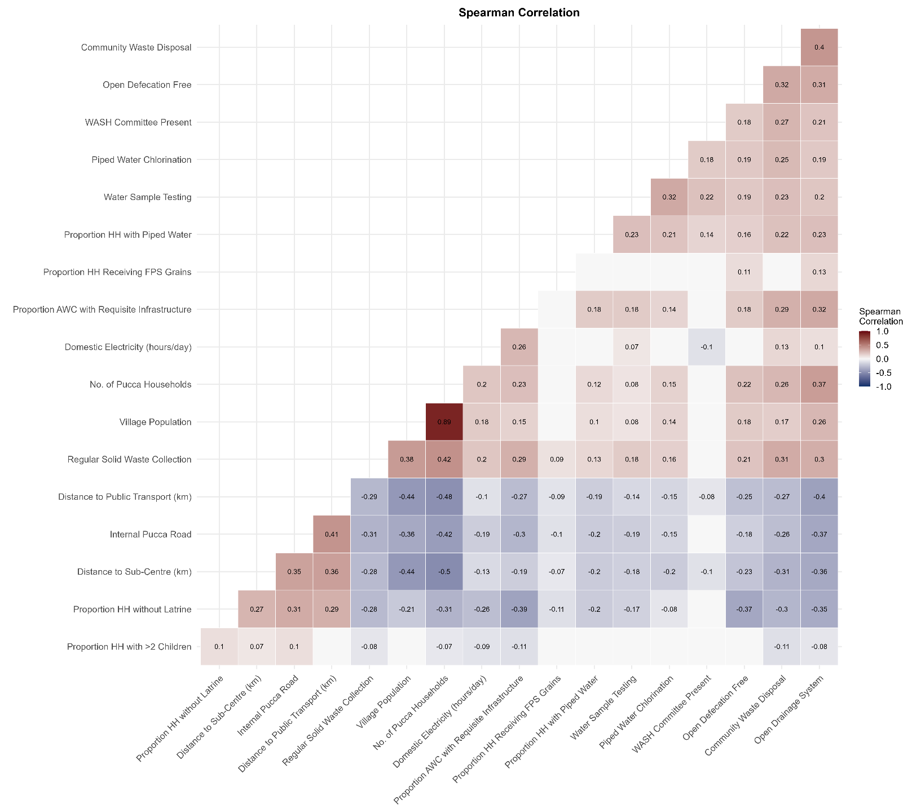
Cell values indicate Spearman’s rank correlation coefficients (ρ), with red and blue colors representing positive and negative correlations, respectively. Strong correlations (|ρ| ≥ 0.70) were examined for potential multicollinearity before inclusion in regression models.

Supplementary figure 02: Variance Inflation Factor (VIF) Assessment of Village-Level Predictors for Enteric Fever Incidence in Mizoram
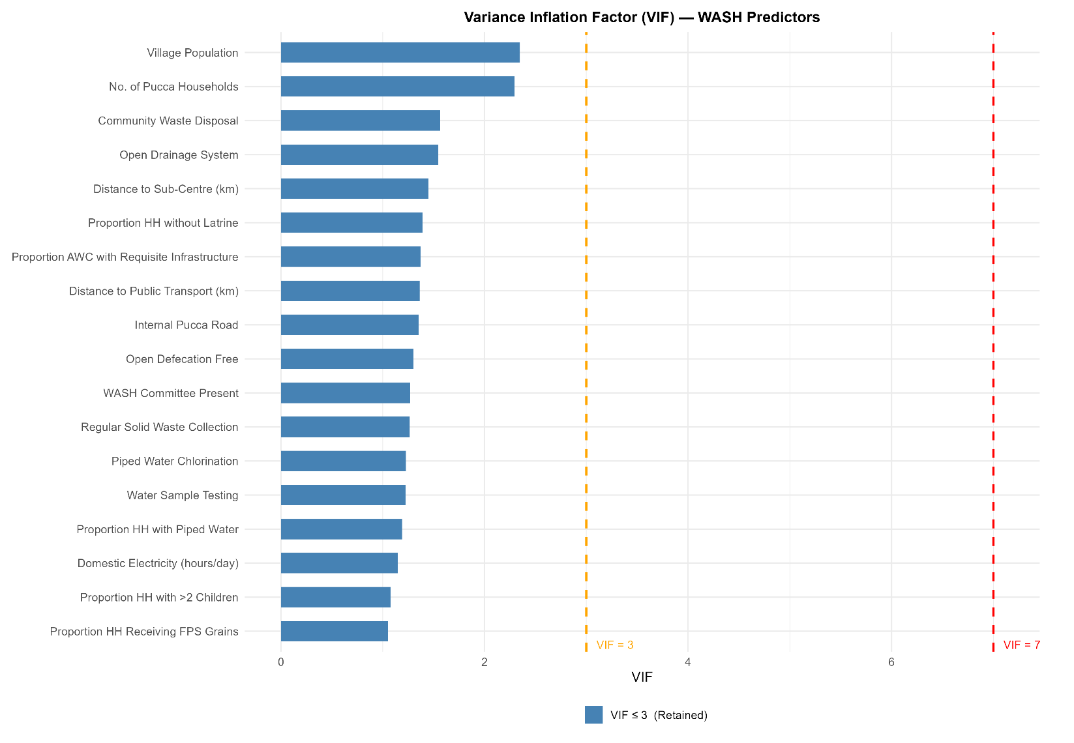
All predictors had VIF values < 3, indicating low multicollinearity and supporting their inclusion in multivariable analyses. The dashed lines represent commonly used VIF thresholds of 3 and 7.
Supplementary figure 3: Year-wise distribution of enteric fever cases reported across Mizoram from 2022-2025 (n=47,656)
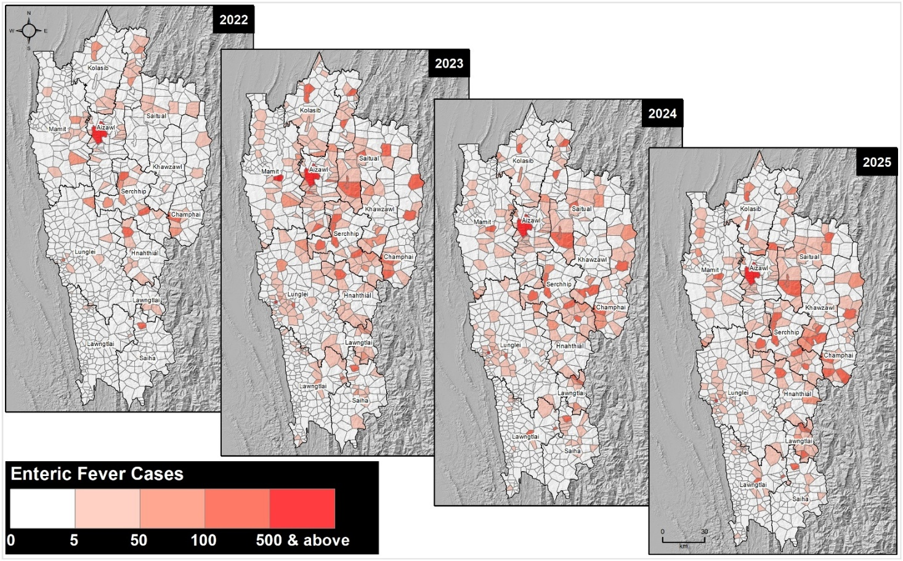
Darker shades indicate higher numbers of reported cases. Administrative boundaries and district names are shown for reference.
Supplementary figure 04: Monthly distribution of sex-wise enteric fever cases in Mizoram
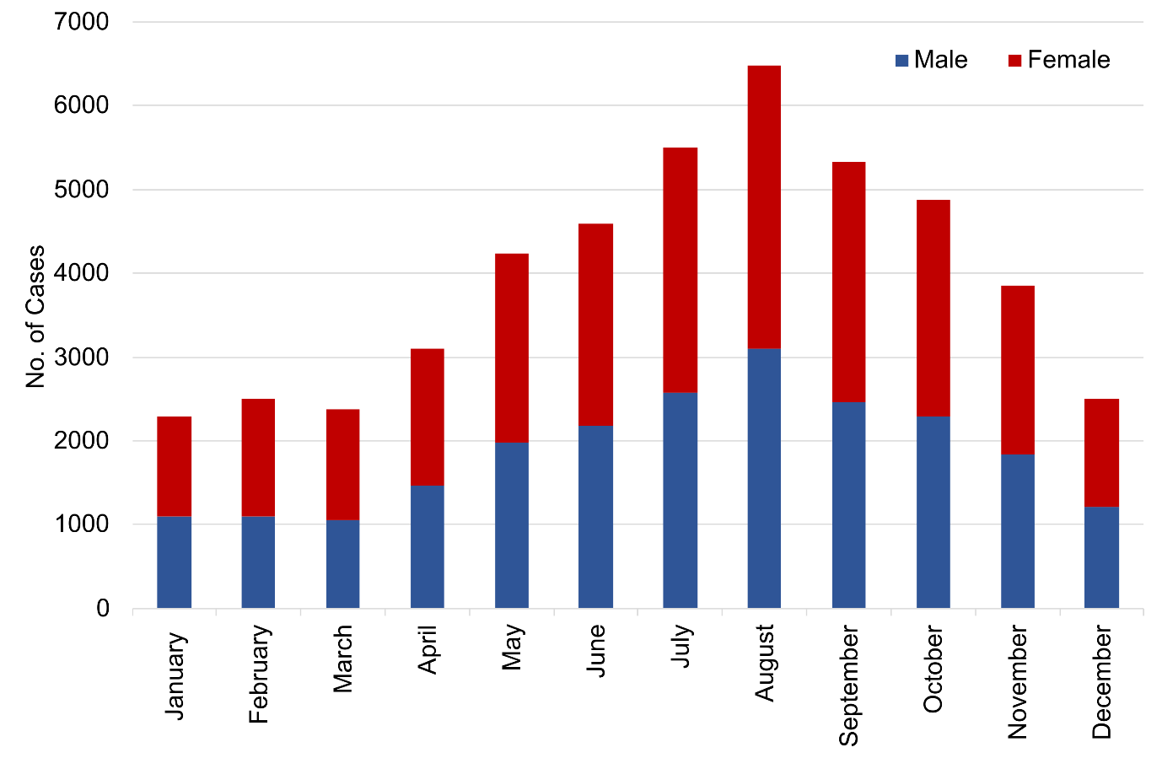
Monthly counts represent aggregated reported enteric fever cases stratified by sex; the peak during monsoon months suggests a possible association with seasonal environmental factors
Supplementary figure 05: District-wise distribution of enteric fever cases and incidence by age group (<15 years and ≥15 years) in Mizoram

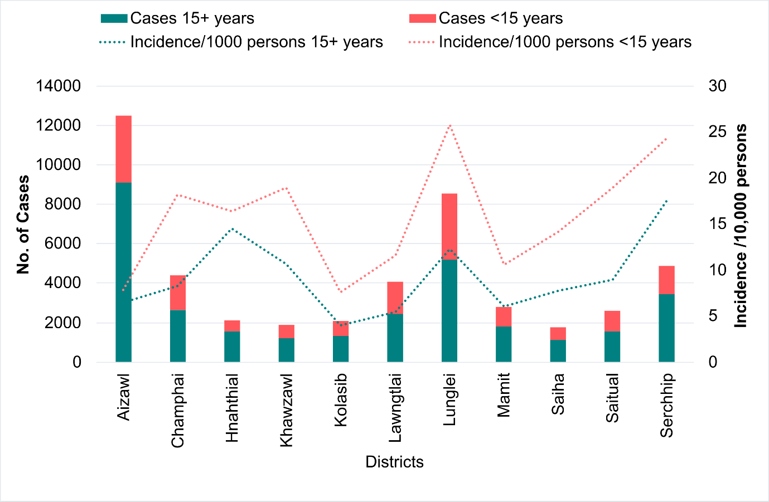
Bars represent the number of reported enteric fever cases by age group, while dotted lines indicate incidence per 10,000 persons; incidence was calculated using age-specific population denominators for each district.

Supplementary table 02: Socio-demographic and clinical profile of reported enteric fever cases affecting hospitalization in Mizoram (2022-2025)
 | OPD | IPD | Total | P value
District
Aizawl | 10841 (24.3%) | 1652 (55.0%) | 12493 (26.2%) | 0.000**
Champhai | 4316 (9.7%) | 92 (3.1%) | 4408 (9.2%) | 0.000**
Hnahthial | 2110 (4.7%) | 25 (0.8%) | 2135 (4.5%) | 0.000**
Khawzawl | 1839 (4.1%) | 41 (1.4%) | 1880 (3.9%) | 0.000**
Kolasib | 1804 (4.0%) | 295 (9.8%) | 2099 (4.4%) | 0.000**
Lawngtlai | 3755 (8.4%) | 321 (10.7%) | 4076 (8.6%) | 0.000**
Lunglei | 8368 (18.7%) | 177 (5.9%) | 8545 (17.9%) | 0.000**
Mamit | 2692 (6.0%) | 98 (3.3%) | 2790 (5.9%) | 0.000**
Saiha | 1693 (3.8%) | 61 (2.0%) | 1754 (3.7%) | 0.000**
Saitual | 2502 (5.6%) | 84 (2.8%) | 2586 (5.4%) | 0.000**
Serchhip | 4733 (10.6%) | 157 (5.2%) | 4890 (10.3%) | 0.000**
Year
2022 | 4125 (9.2%) | 374 (12.5%) | 4499 (9.4%) | 0.000**
2023 | 14363 (32.2%) | 830 (27.6%) | 15193 (31.9%) | 0.000**
2024 | 12918 (28.9%) | 1005 (33.5%) | 13923 (29.2%) | 0.000**
2025 | 13247 (29.7%) | 794 (26.4%) | 14041 (29.5%) | 0.000**
Season^
Winter (November to January) | 8004 (17.9%) | 646 (21.5%) | 8650 (18.2%) | 0.000**
Spring (February to April) | 7375 (16.5%) | 601 (20.0%) | 7976 (16.7%) | 0.000**
Summer (May to August) | 19636 (44.0%) | 1192 (39.7%) | 20828 (43.7%) | 0.000**
Autumn (September to October) | 9638 (21.6%) | 564 (18.8%) | 10202 (21.4%) | 0.000**
Sex
Male | 20879 (46.8%) | 1476 (49.2%) | 22355 (46.9%) | 0.011*
Female | 23765 (53.2%) | 1527 (50.8%) | 25292 (53.1%) | 0.011*
Age group
below 2 years | 1857 (4.2%) | 194 (6.5%) | 2051 (4.3%) | 0.000**
2-4 years | 3945 (8.8%) | 224 (7.5%) | 4169 (8.7%) | 0.000**
5-14 years | 9661 (21.6%) | 371 (12.4%) | 10032 (21.1%) | 0.000**
15- 44 years | 18911 (42.4%) | 1213 (40.4%) | 20124 (42.2%) | 0.000**
45 years and above | 10279 (23.0%) | 1001 (33.3%) | 11280 (23.7%) | 0.000**
Symptoms
Acute fever (<7 days) | 21134 (47.3%) | 1631 (54.3%) | 22765 (47.8%) | 0.000**
Prolonged fever (≥7 days) | 7598 (17.0%) | 542 (18.0%) | 8140 (17.1%) | 0.000**
Typhoid symptoms˜ | 15921 (35.7%) | 830 (27.6%) | 16751 (35.1%) | 0.000**
Test performed
Widal | 18661 (41.8%) | 1538 (51.2%) | 20199 (42.4%) | 0.000**
ICT (Typhoid) | 24735 (55.4%) | 1335 (44.5%) | 26070 (54.7%) | 0.000**
Others† | 1256 (2.8%) | 130 (4.3%) | 1386 (2.9%) | 0.000**
Hospital type
Public | 35818 (80.2%) | 1181 (39.3%) | 36999 (77.6%) | 0.000**
Private | 8835 (19.8%) | 1822 (60.7%) | 10657 (22.4%) | 0.000**
The transgenders in the dataset were excluded due to their negligible count (n=4); ˜ Typhoid symptoms – Fever, headache, diarrhoea, and rashes in some cases; † Others- Culture, NAAT, IgM ELISA
Chi square was performed. Significance: * - p<0.05, ** p <0.001.

Supplementary figure 6: DHARMa Residual Diagnostics for the Zero-Inflated Negative Binomial (ZINB) Model of Enteric Fever Cases in Mizoram

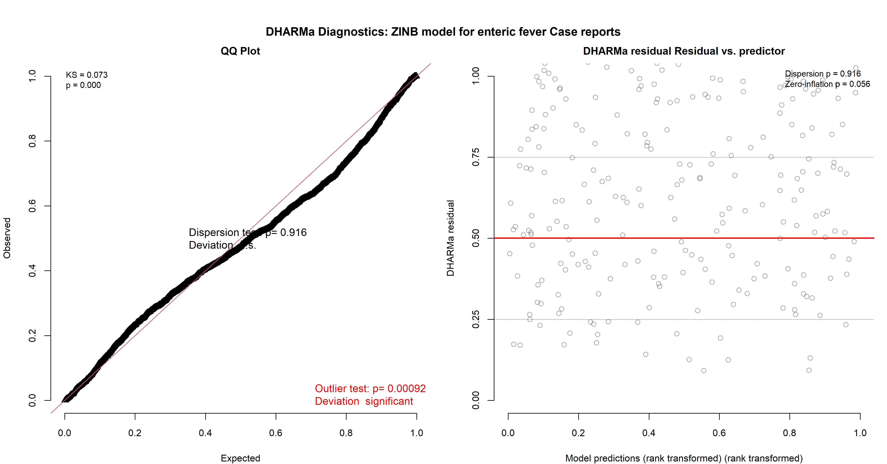
DHARMa residual diagnostics for the final ZINB model. The QQ plot (left) compares observed and expected residual distributions, while the residual-versus-predicted plot (right) assesses model fit across predicted values. Dispersion (p = 0.916) and zero-inflation (p = 0.056) tests indicated no evidence of overdispersion or excess zero inflation. Although the Kolmogorov–Smirnov and outlier tests were statistically significant, residuals showed no systematic pattern, supporting the overall adequacy of the model fit.

Supplementary figure 7: DHARMa Residual Diagnostics for the Negative Binomial Model of Enteric Fever Hospitalizations in Mizoram
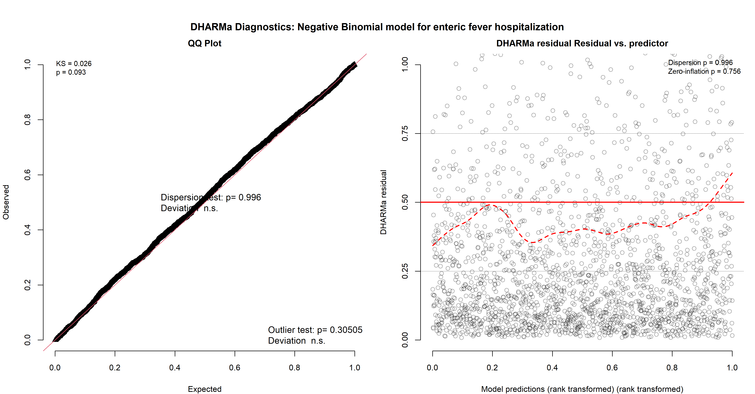
DHARMa residual diagnostics for the final negative binomial model of enteric fever hospitalizations. The QQ plot (left) demonstrates close agreement between observed and expected residual distributions, while the residual-versus-predicted plot (right) shows no substantial departures from model assumptions. Tests for dispersion (p = 0.996), zero inflation (p = 0.756), and outliers (p = 0.305) were non-significant, indicating an adequate model fit and no evidence of overdispersion, excess zeros, or influential outliers.

