Supplementary Material

Behavioural thermoregulation in an aquatic-surface Neotropical frog is detectable only when physiological integrity allows movement

Figure S1. Schematic of the experimental arena (170 × 55 × 70 cm, length × width × height) showing the thermal gradient generated by a 150 W infrared lamp at the hot end and crushed ice at the cold end. Surface temperatures range from ~ 20 °C at the cold end to ~ 40 °C at the hot end along the length axis. The arena floor was kept covered by a 1 cm layer of water to prevent dehydration during the trial; the lamp was suspended ~ 50–60 cm above the floor. Frogs were placed at randomly selected starting positions along the length axis and observed for 90 s after a mechanical stimulus.

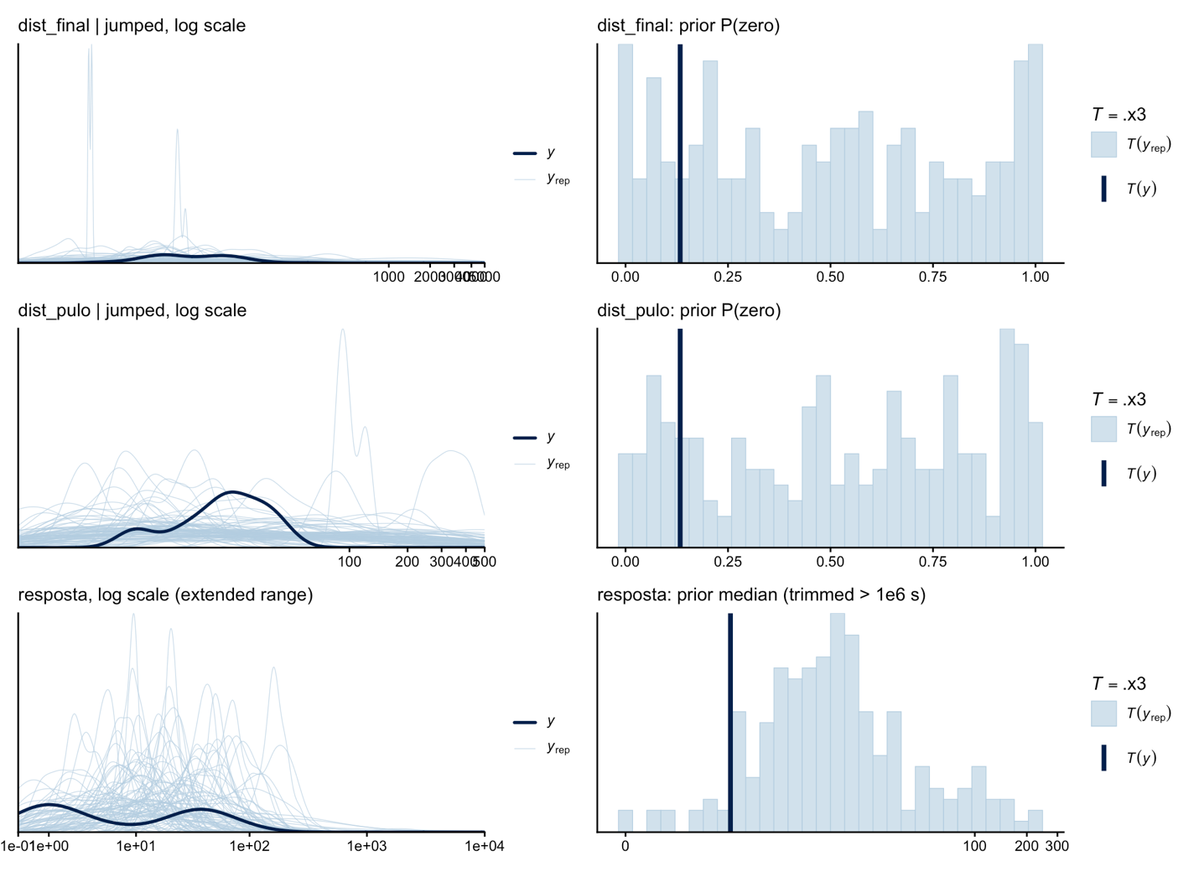

Figure S2. Prior predictive checks for the three Bayesian models. Left column: density of replicated responses on log-scale, restricted to the jumping subset for the two distance models; full-data density for the response-time model. Right column: prior predictive distribution of summary statistics that the model is meant to recover (proportion of zeros for the hurdle models; prior median for the response-time model). Vertical dark lines: observed values. Filled histograms / coloured curves: prior predictive draws. Priors were chosen to be weakly informative without placing mass at biologically implausible values; the prior predictive distributions span the observed range without dominating it.

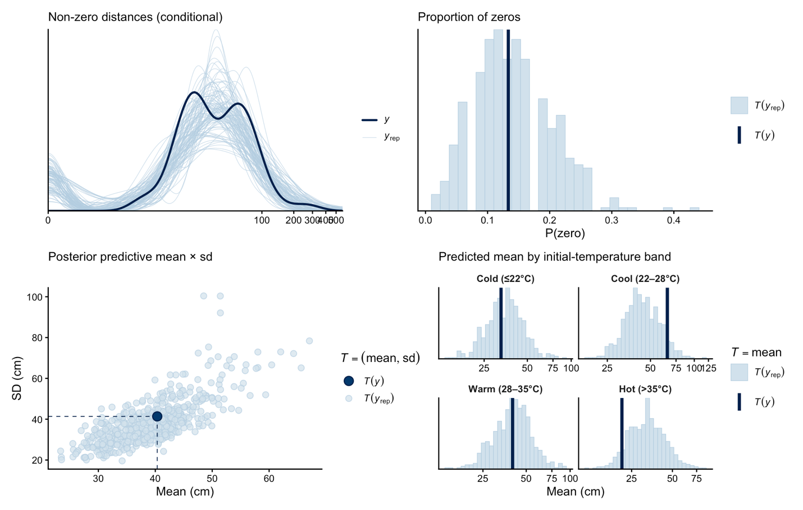

Figure S3. Four-panel posterior predictive check for the focal model M_{T} (total jumping distance ~ final temperature, hurdle log-normal). (a) Density overlay of observed vs replicated non-zero distances on log-scale (jumping subset only). (b) Posterior predictive distribution of the proportion of zeros, with the observed proportion marked. (c) Joint posterior predictive distribution of the mean and the standard deviation of total jumping distance (ppc_stat_2d); the observed (mean, sd) pair falls within the bivariate posterior predictive cloud. (d) Posterior predictive distribution of the per-band mean total jumping distance (cold, cool, warm, hot bins of initial temperature). Grouping by initial-temperature band avoids the circular conditioning that would result from grouping by the hurdle outcome itself.

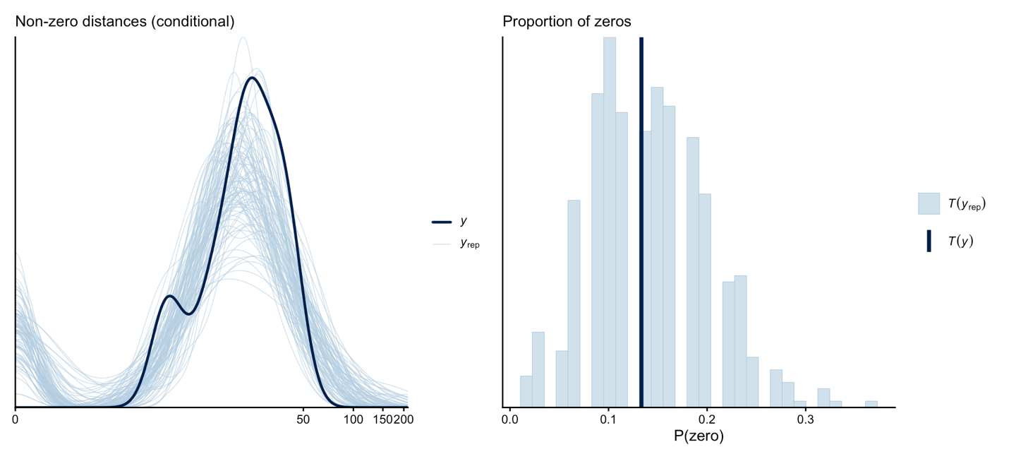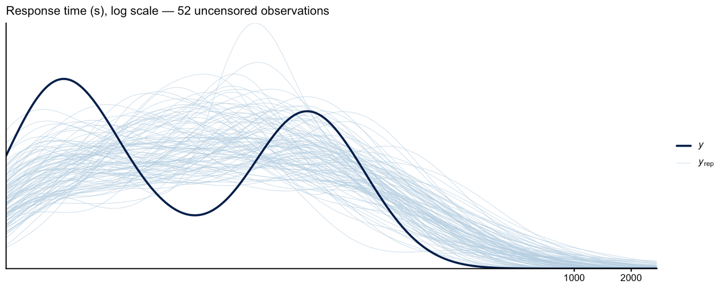

Figure S4. Posterior predictive checks for the first-jump-distance model (top row, hurdle log-normal on initial temperature) and the response-time model (bottom panel, Weibull AFT with right-censoring on initial temperature). For the first-jump-distance model: density overlay of non-zero distances on log-scale, and posterior predictive distribution of the proportion of zeros. For the response-time model: density overlay restricted to the 52 uncensored observations (the 8 right-censored values are excluded by bayesplot::ppc_dens_overlay by design for brms censored models). All three checks indicate adequate fit of the chosen families to the observed data.

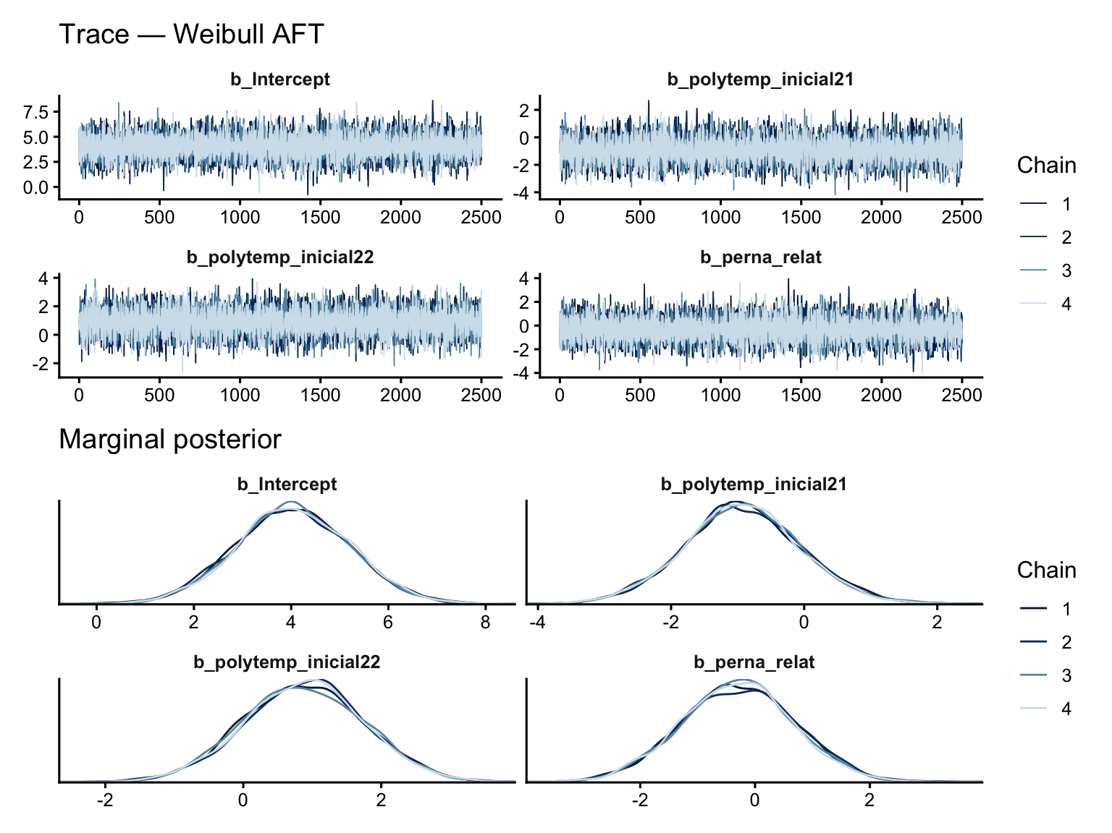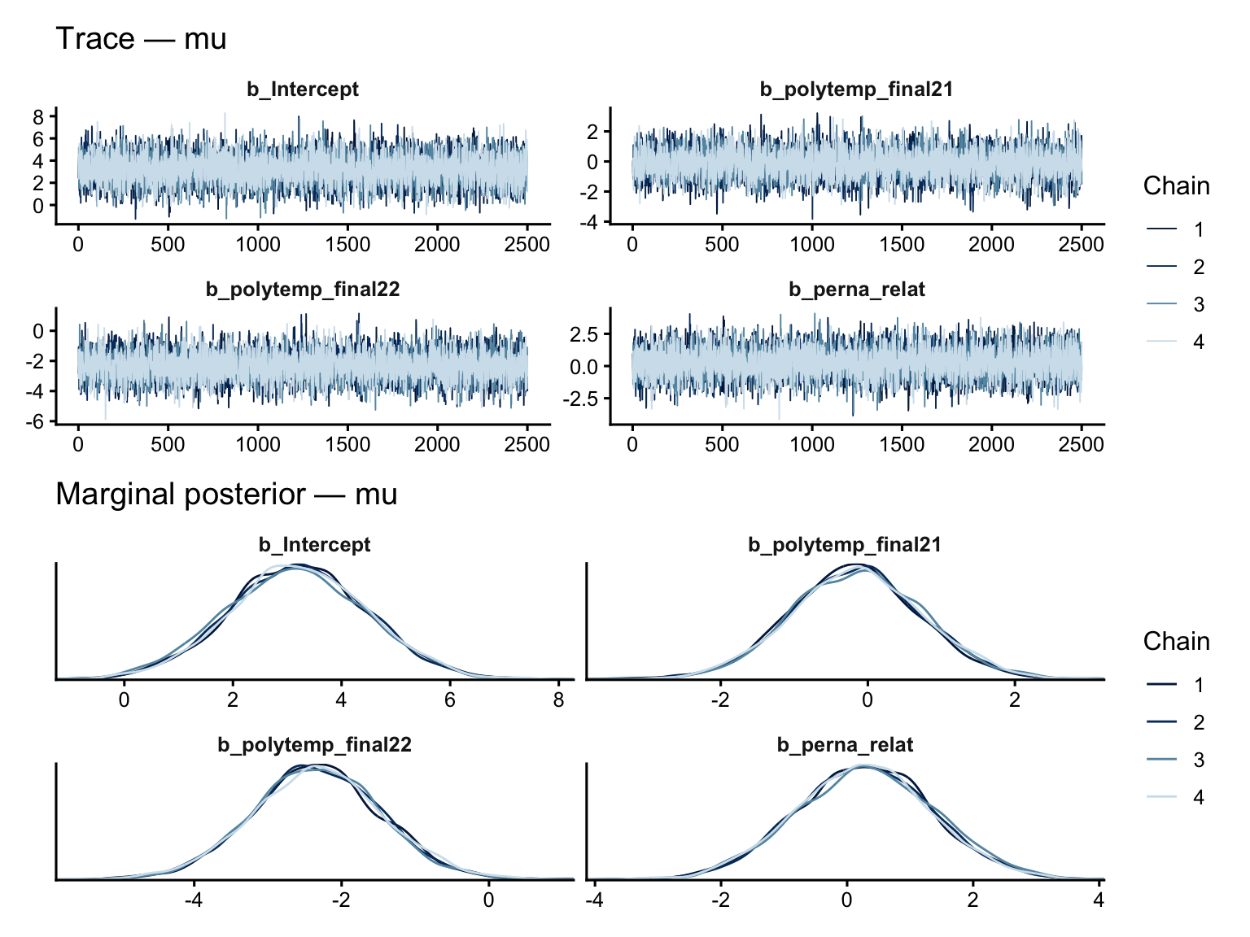

Figure S5. MCMC trace plots and marginal posterior densities for the population-level parameters of the focal model M_{T} (continuous component) and of the Weibull AFT response-time model. The four chains are well-mixed and stationary; the marginal posteriors are unimodal and approximately Gaussian on the link scale. R̂ ≤ 1.00 and bulk/tail effective sample sizes ≥ 6,500 for every parameter (Section ‘MCMC diagnostics' of the main text).

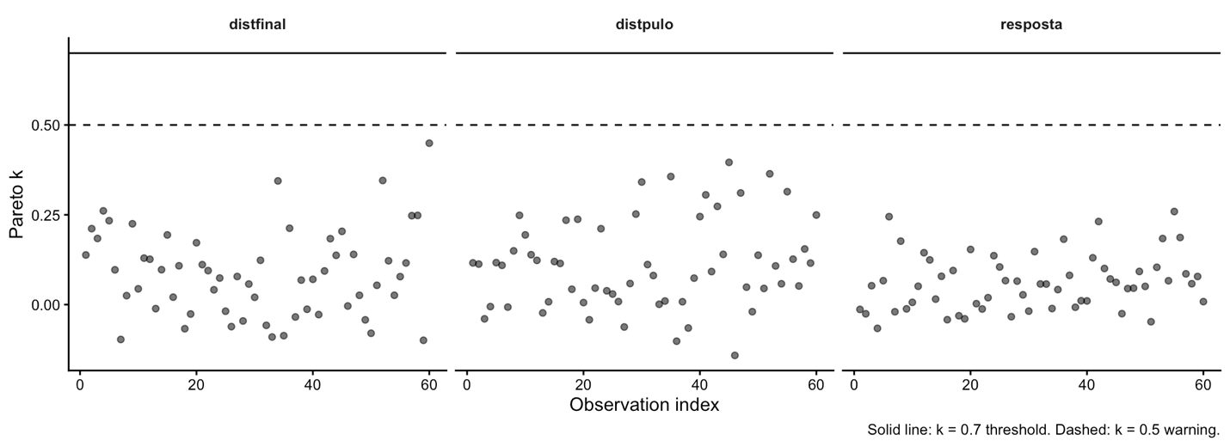

Figure S6. Pareto-k diagnostic values for each of the 60 observations in each of the three Bayesian models. Dashed horizontal line at k = 0.5 (warning threshold); solid horizontal line at k = 0.7 (unreliable importance sampling). All values are well below 0.5 in every model, indicating that the standard Pareto-smoothed importance-sampling leave-one-out cross-validation (PSIS-LOO-CV) is reliable for the model comparison reported in the main text.

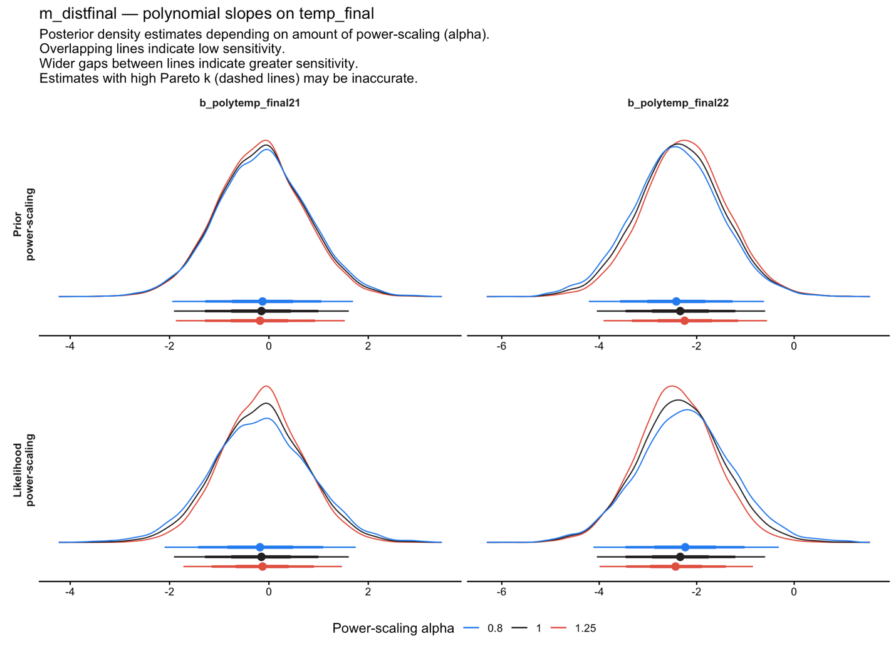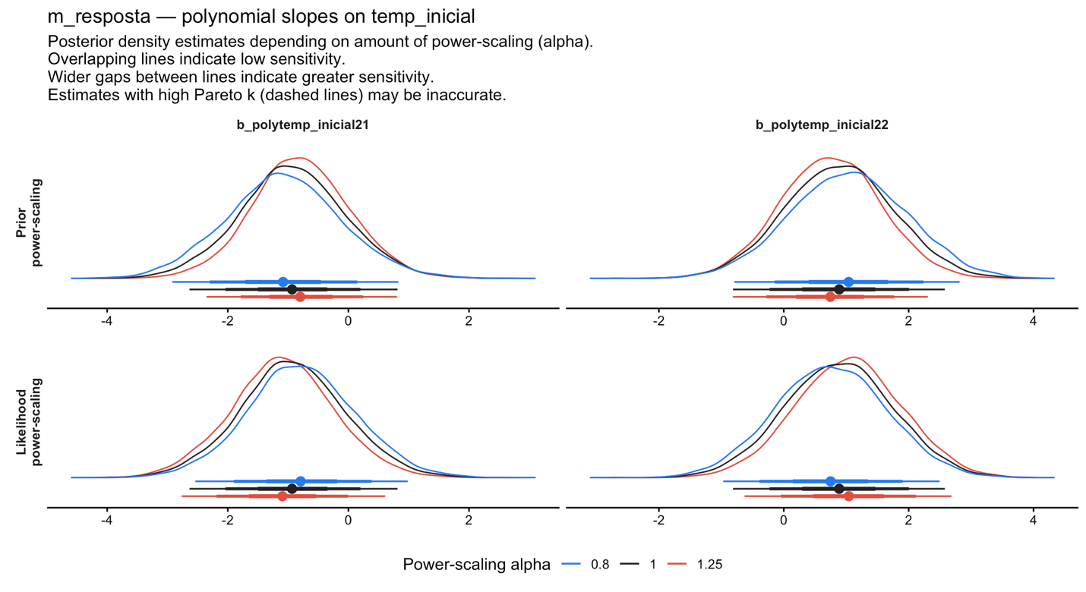

Figure S7. Power-scaling prior sensitivity diagnostics (priorsense::powerscale_plot_dens) for the polynomial slope coefficients of the focal model M_{T} (top) and of the Weibull AFT response-time model (bottom). Posterior densities are essentially indistinguishable across prior scaling factors α ∈ {0.8, 1, 1.25}, indicating that the posteriors of the focal parameters are dominated by the likelihood rather than the priors. Kallioinen et al. (2024) sensitivity statistics did not exceed the recommended warning threshold for any parameter.

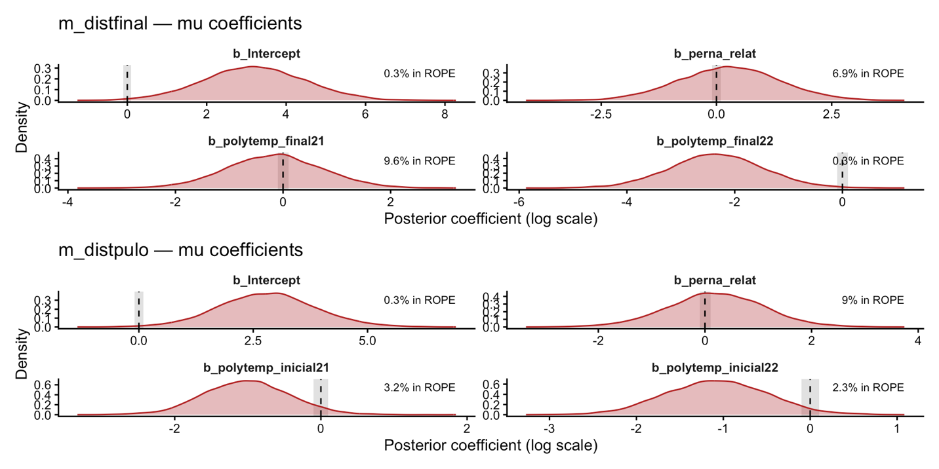

Figure S8. Posterior densities of the polynomial fixed-effect coefficients of the two hurdle log-normal models (M_{T} and M_{J}), shown with the Region of Practical Equivalence (ROPE; Kruschke 2018) shaded in grey. ROPE bounds: ±0.10 log-units for the μ component (≈ 10 % proportional change in distance). Numerical labels: percentage of the 95 % posterior contained within the ROPE — see also Table S2 for full pd and ROPE values.

Figure S9. Directed acyclic graph (DAG) summarising the architecture of all three Bayesian models jointly: the focal hurdle log-normal model for total jumping distance (M_{T}), the analogous hurdle log-normal model for first-jump distance (M_{J}), and the Weibull accelerated-failure-time model with right-censoring for response time (M_{R}). Hexagons: weakly informative priors (Section ‘Priors' of the main text). Yellow ellipses: parameters. Blue rectangles: observed predictors. Green ellipses: linear predictors derived from the parameters and predictors. Orange double octagons: the three observed response variables. Dashed edges: prior dependence. Solid coloured edges: deterministic mapping. Censoring of the response-time outcome is shown as an explicit cens() edge into Y_{R}.

Table S1. Posterior median, posterior standard deviation, 2.5 % and 97.5 % credible-interval bounds, potential scale reduction factor (R̂; Vehtari et al. 2021) and bulk/tail effective sample sizes for every population-level parameter of the three Bayesian models. The table is the printable form of the diag_table() call in the tbl-diagnostics chunk of analise_v2.qmd. Convergence is excellent (R̂ ≤ 1.00 throughout) and effective sample sizes are far above 1,000 for every parameter.
model | variable | mean | sd | 2.5% | 97.5% | Rhat | ESS_bulk | ESS_tail
distfinal | b_Intercept | 3.199 | 1.274 | 0.695 | 5.717 | 1.000 | 11640.784 | 7752.906
 | b_hu_Intercept | -1.921 | 0.379 | -2.704 | -1.225 | 1.000 | 11245.891 | 7197.281
 | b_polytemp_final21 | -0.155 | 0.894 | -1.911 | 1.607 | 1.001 | 9027.429 | 7682.457
 | b_polytemp_final22 | -2.335 | 0.881 | -4.048 | -0.595 | 1.000 | 9407.204 | 7865.287
 | b_perna_relat | 0.274 | 1.089 | -1.874 | 2.419 | 1.000 | 11599.755 | 7945.413
 | b_hu_polytemp_inicial21 | -2.193 | 1.671 | -5.523 | 1.037 | 1.001 | 11133.338 | 8114.914
 | b_hu_polytemp_inicial22 | 1.247 | 1.683 | -2.069 | 4.534 | 1.000 | 12130.185 | 7089.004
 | sigma | 0.707 | 0.075 | 0.578 | 0.871 | 1.000 | 11701.856 | 7541.708
distpulo | b_Intercept | 2.808 | 1.064 | 0.725 | 4.937 | 1.000 | 13377.251 | 7071.880
 | b_hu_Intercept | -1.930 | 0.388 | -2.744 | -1.214 | 1.000 | 12442.586 | 6599.204
 | b_polytemp_inicial21 | -1.012 | 0.588 | -2.142 | 0.141 | 1.000 | 12733.842 | 7984.724
 | b_polytemp_inicial22 | -1.075 | 0.586 | -2.208 | 0.074 | 1.001 | 12414.335 | 7823.106
 | b_perna_relat | 0.200 | 0.909 | -1.634 | 1.970 | 1.000 | 13390.157 | 7115.361
 | b_hu_polytemp_inicial21 | -2.200 | 1.687 | -5.532 | 1.095 | 1.000 | 12183.957 | 7801.938
 | b_hu_polytemp_inicial22 | 1.280 | 1.663 | -2.024 | 4.569 | 1.000 | 10707.167 | 7326.104
 | sigma | 0.549 | 0.058 | 0.449 | 0.678 | 1.000 | 12060.884 | 7309.553
resposta | b_Intercept | 4.036 | 1.164 | 1.748 | 6.322 | 1.001 | 11737.109 | 6804.351
 | b_polytemp_inicial21 | -0.923 | 0.875 | -2.636 | 0.816 | 1.000 | 10867.465 | 7253.069
 | b_polytemp_inicial22 | 0.884 | 0.866 | -0.813 | 2.580 | 1.000 | 12080.212 | 7561.107
 | b_perna_relat | -0.299 | 0.982 | -2.226 | 1.604 | 1.001 | 11642.197 | 6937.028
 | shape | 0.552 | 0.062 | 0.438 | 0.678 | 1.000 | 9527.865 | 7100.849

Table S2. For each fixed-effect coefficient of the three Bayesian models: posterior median, 95 % credible interval, Probability of Direction (pd; Makowski et al. 2019), and percentage of the 95 % posterior contained within the Region of Practical Equivalence (ROPE; Kruschke 2018). ROPE bounds: ±0.10 log-units on the log-distance and log-time scales (μ components and Weibull AFT); ±0.18 logit units on the hurdle scale (hu components). Values flagged with pd > 0.975 and < 5 % in ROPE are considered well-supported by the posterior.
model | parameter | pd | rope
distfinal | b_Intercept | 0.995 | 0.3%
 | b_hu_Intercept | 1.000 | 0.0%
 | b_polytemp_final21 | 0.571 | 9.6%
 | b_polytemp_final22 | 0.995 | 0.3%
 | b_perna_relat | 0.605 | 6.9%
 | b_hu_polytemp_inicial21 | 0.906 | 3.3%
 | b_hu_polytemp_inicial22 | 0.773 | 6.0%
distpulo | b_Intercept | 0.995 | 0.3%
 | b_hu_Intercept | 1.000 | 0.0%
 | b_polytemp_inicial21 | 0.957 | 3.2%
 | b_polytemp_inicial22 | 0.969 | 2.3%
 | b_perna_relat | 0.590 | 9.0%
 | b_hu_polytemp_inicial21 | 0.904 | 3.9%
 | b_hu_polytemp_inicial22 | 0.781 | 6.3%
resposta | b_Intercept | 1.000 | 0.0%
 | b_polytemp_inicial21 | 0.856 | 4.6%
 | b_polytemp_inicial22 | 0.843 | 5.7%
 | b_perna_relat | 0.617 | 8.0%

Table S3. Approximate leave-one-out cross-validation (PSIS-LOO-CV; Vehtari et al. 2017) comparison between each focal model and a reduced version omitting the morphological covariate (relative hind-limb length). Expected log pointwise predictive density (ELPD) differences and their standard errors are reported. All three differences fall within ~ 1 SE of zero, indicating that relative hind-limb length adds essentially no predictive information beyond the temperature polynomial.

Response variable
distfinal | elpd_diff | se_diff
m_distfinal_nm | 0.0 | 0.0
m_distfinal | -0.6 | 0.2

distpulo
m_distfinal_nm | 0.0 | 0.0
m_distfinal | -1.1 | 0.4

resposta
m_distfinal_nm | 0.0 | 0.0
m_distfinal | 0.0 | 0.1

