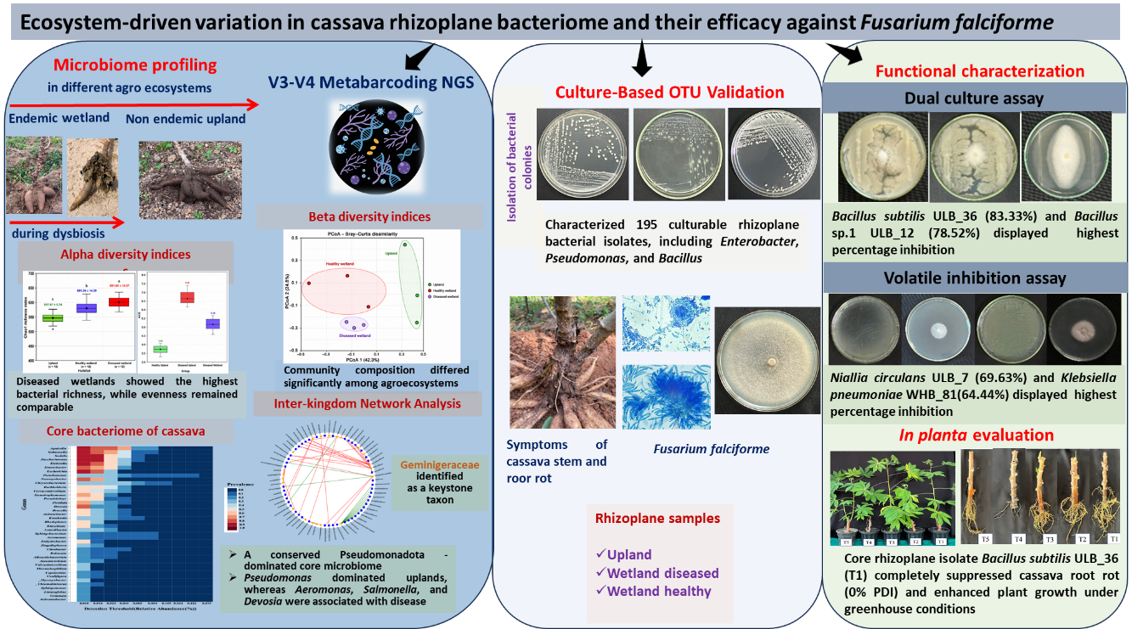
Pictorial abstract highlighting the key results of the study

