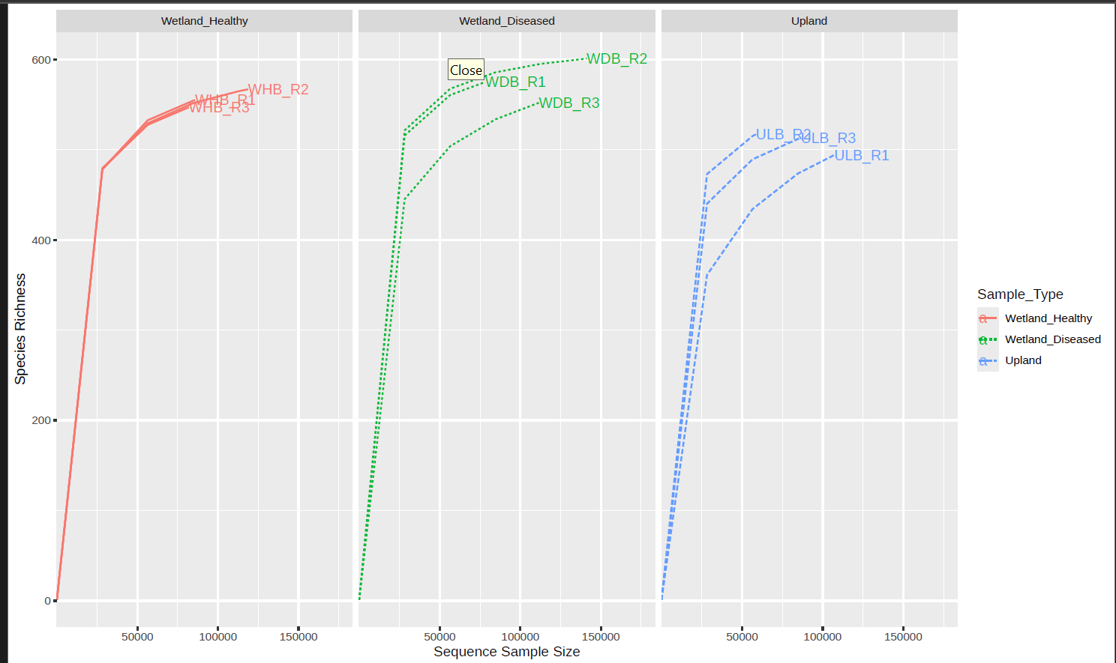

Supplementary Fig. 1 Rarefaction curves depicting species richness as a function of sequencing depth across cassava rhizoplane microbiome samples

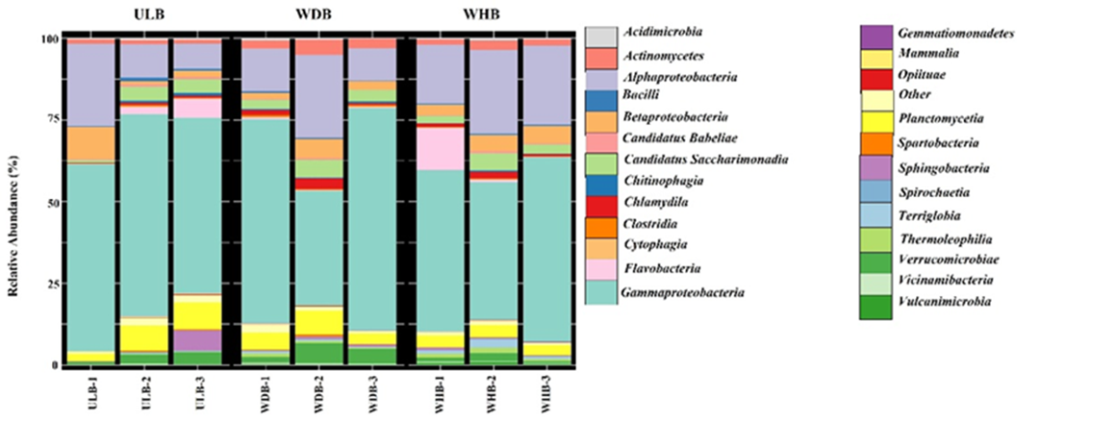

Supplementary Fig. 2 Distribution and abundance of cassava rhizoplane microbiome at class level

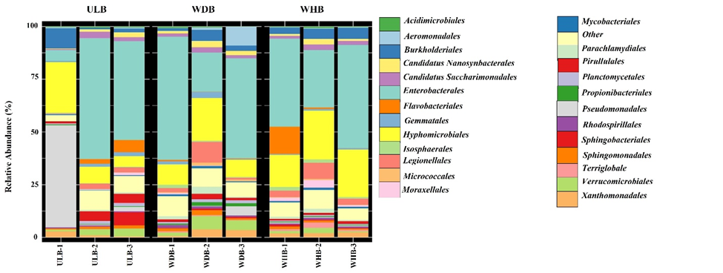

Supplementary Fig. 3 Distribution and abundance of cassava rhizoplane microbiome at order level

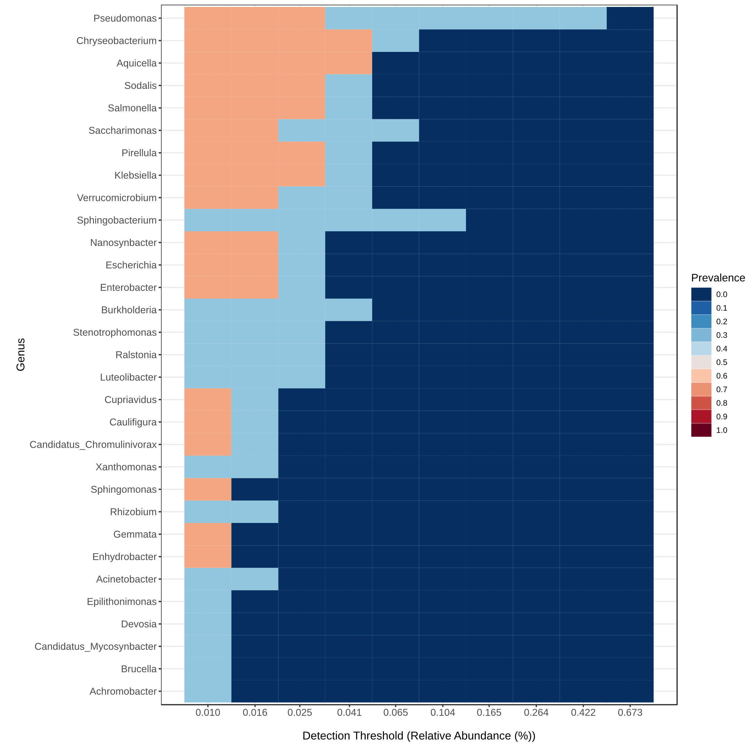

Supplementary Fig. 4 Core microbiome of cassava rhizoplane representing upland eubiosis state

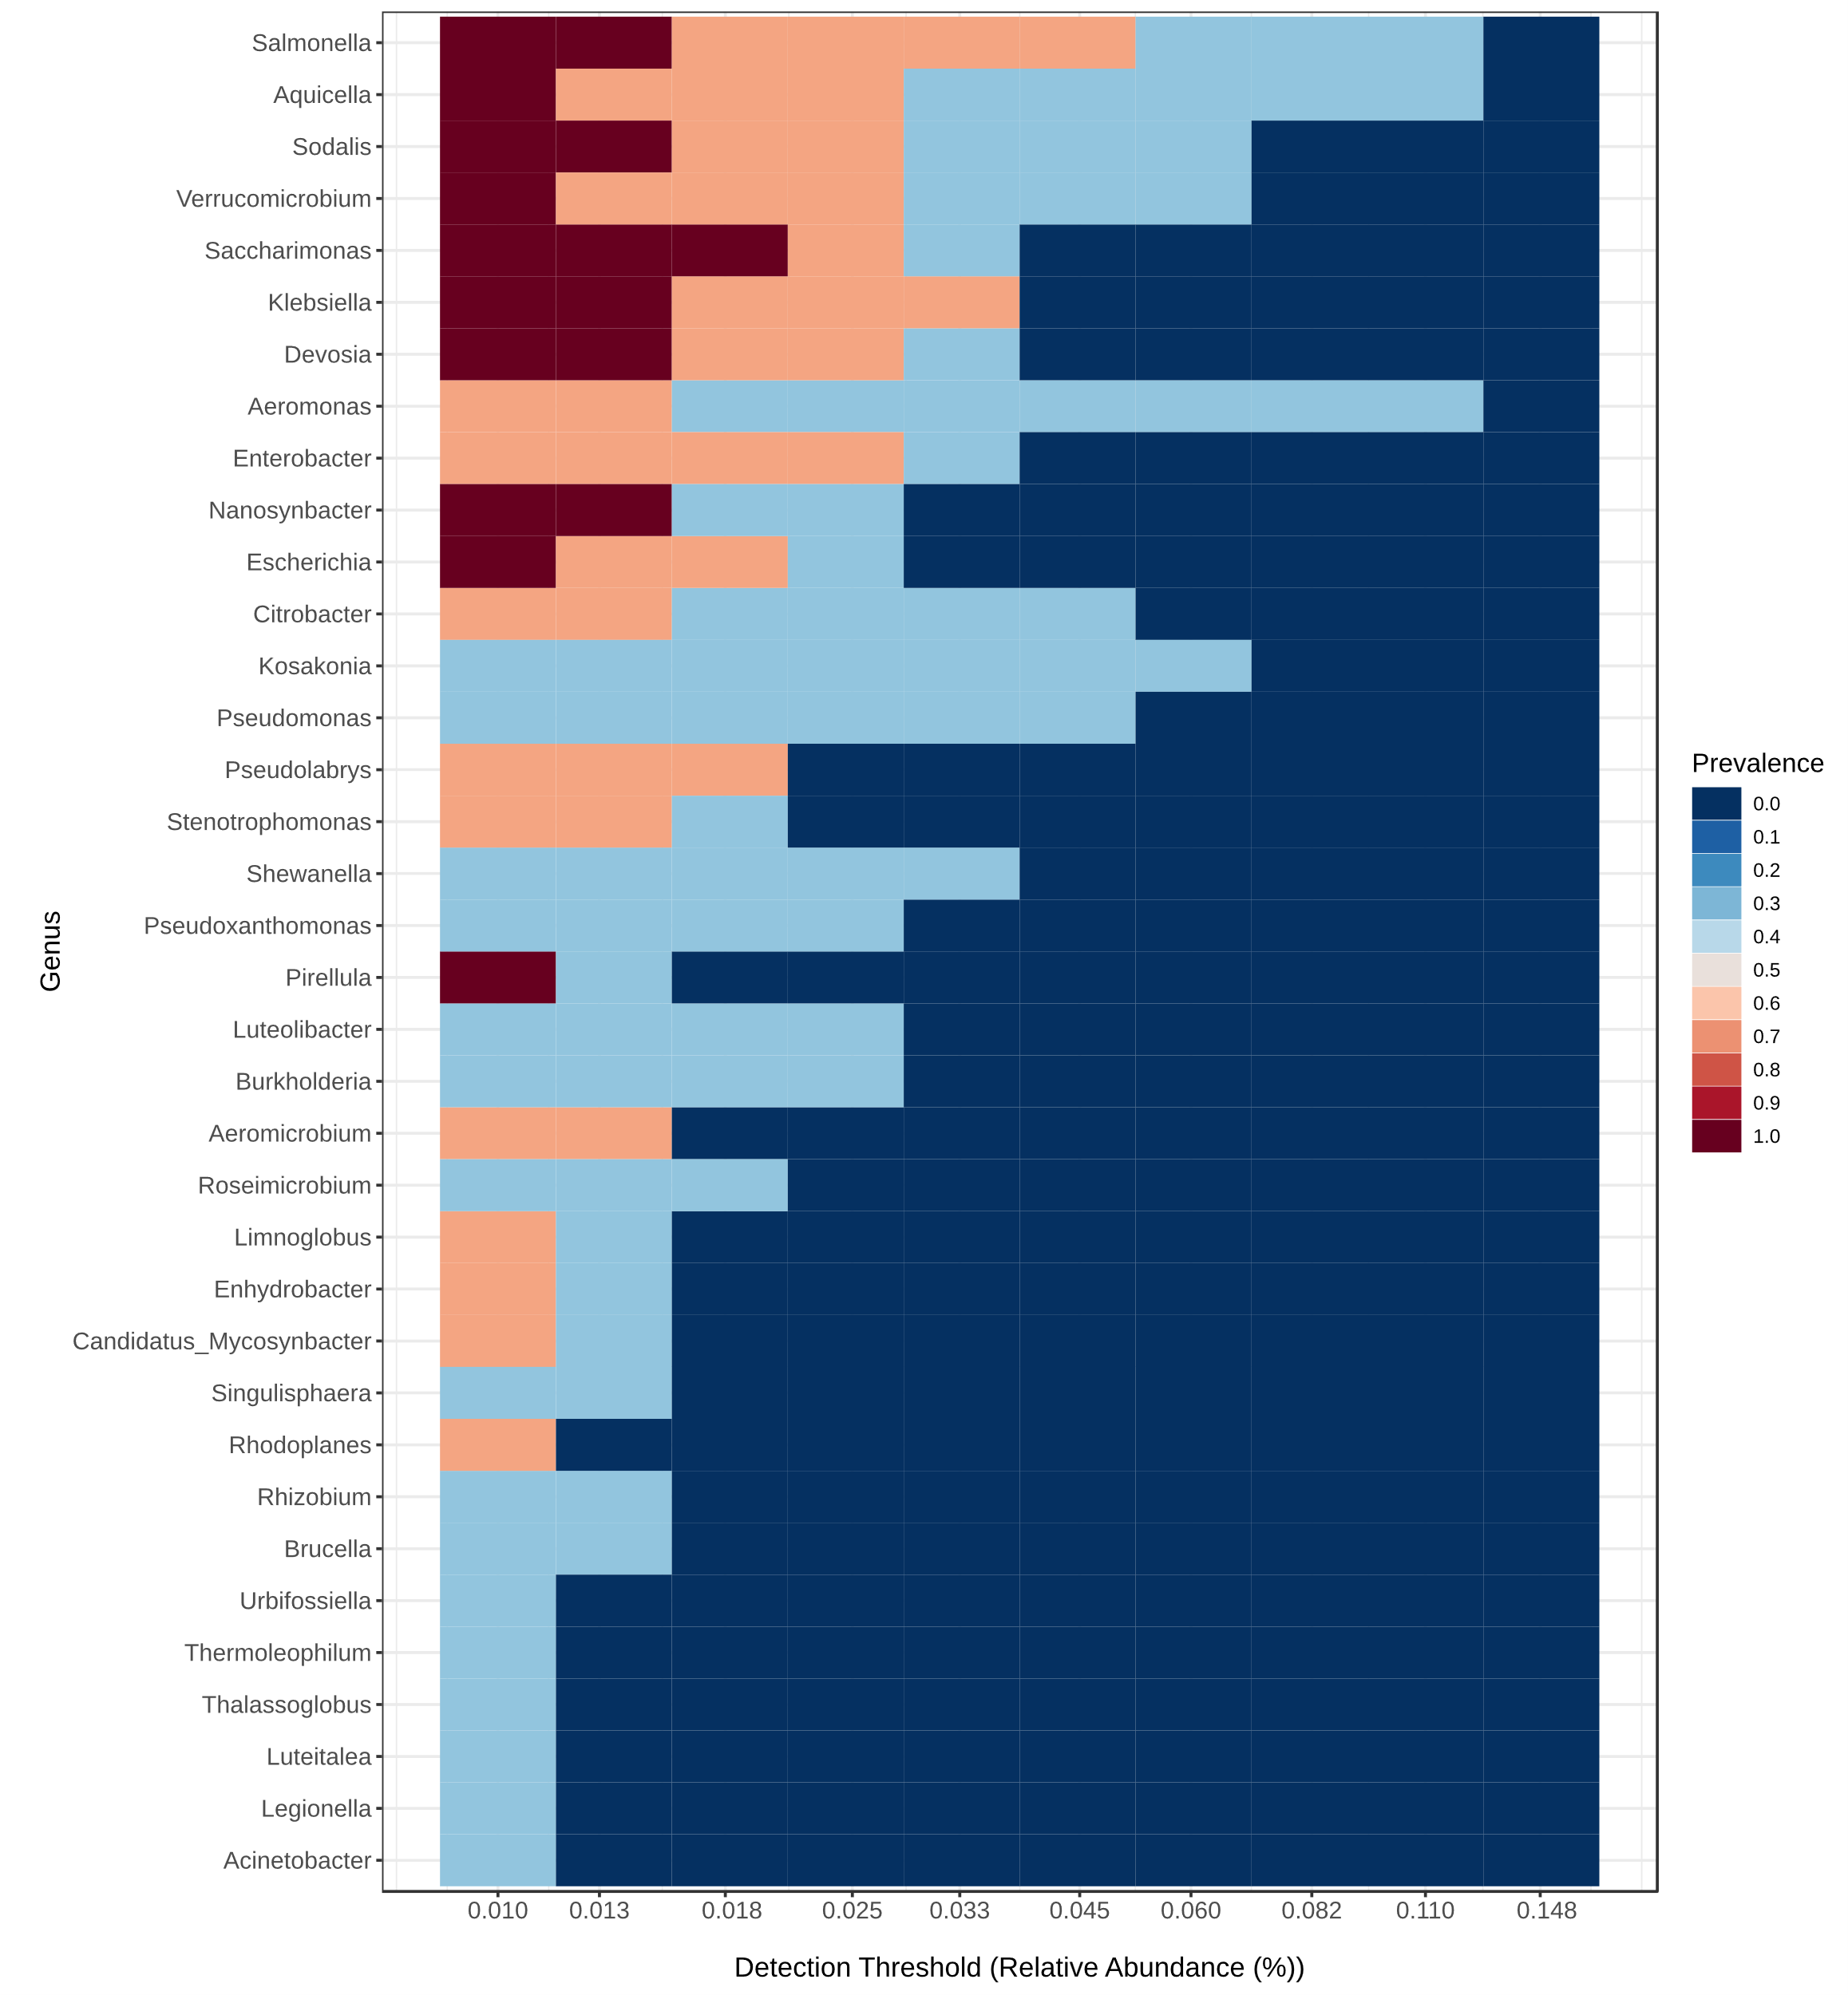

Supplementary Fig. 5 Core microbiome of cassava rhizoplane representing wetland dysbiosis state
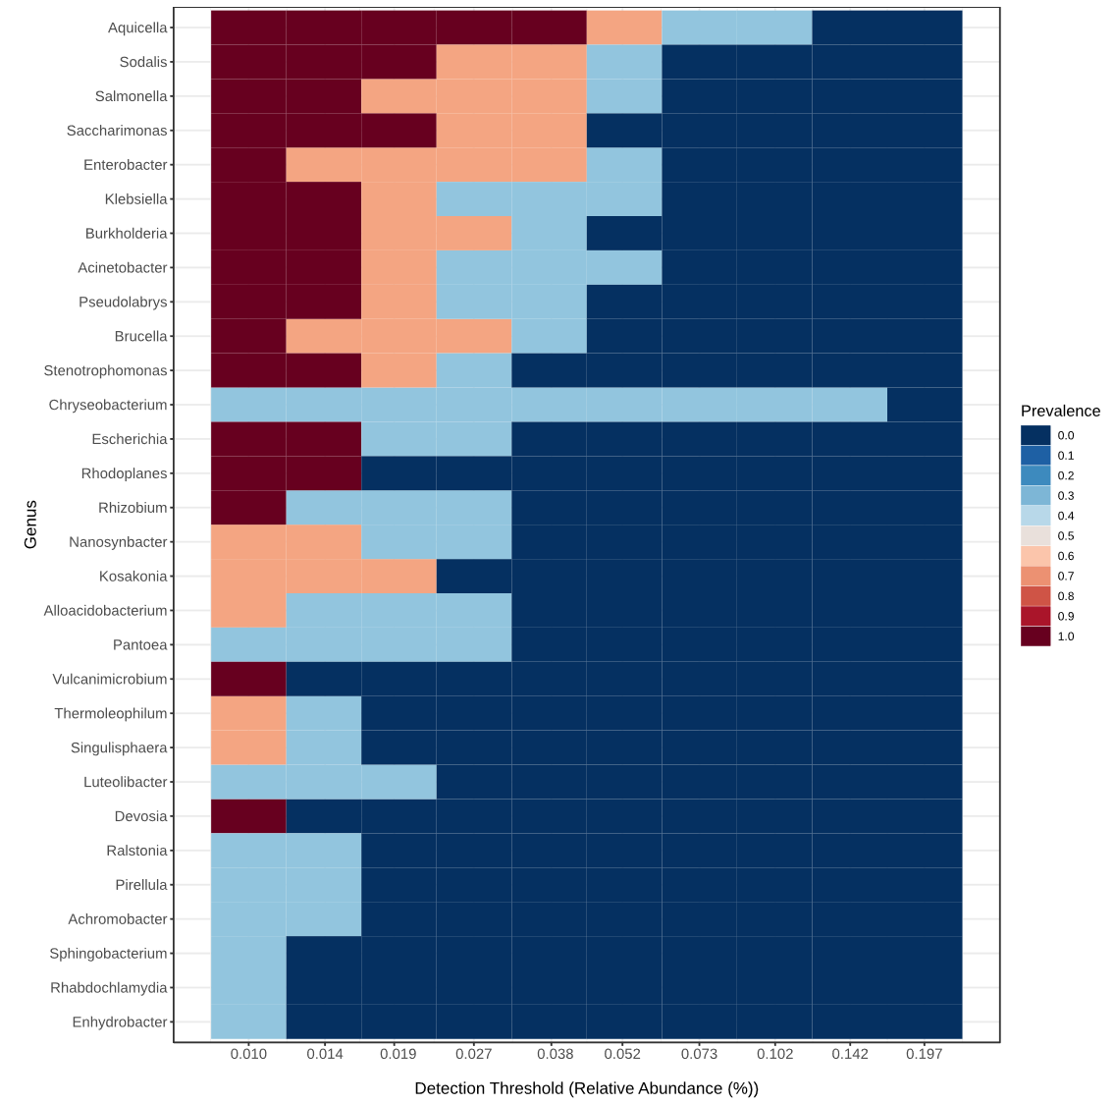

Supplementary Fig. 6 Core microbiome of cassava rhizoplane representing wetland eubiosis state

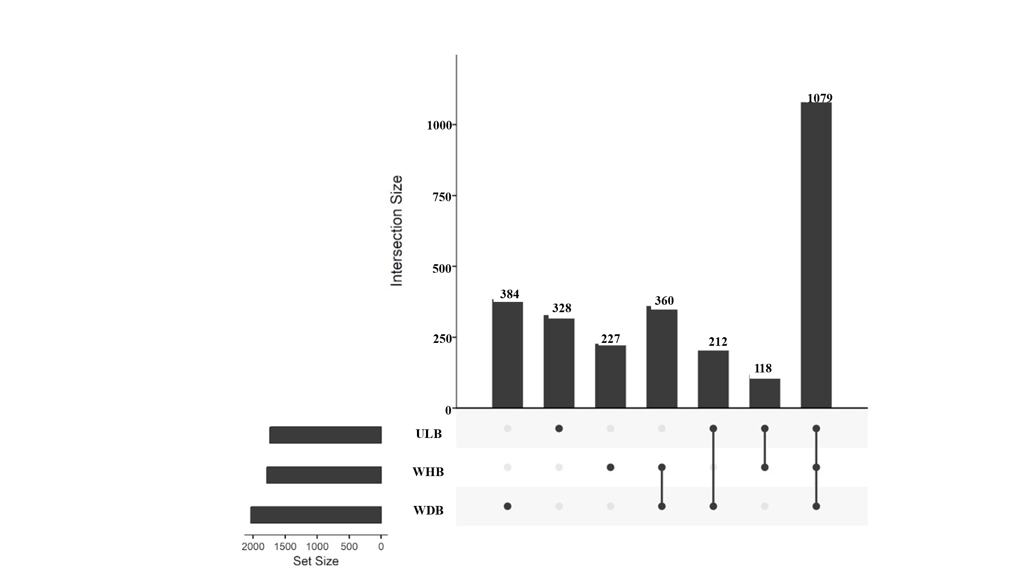

Supplementary Fig. 7 Shared taxa of the three rhizoplane microbiome sample groups

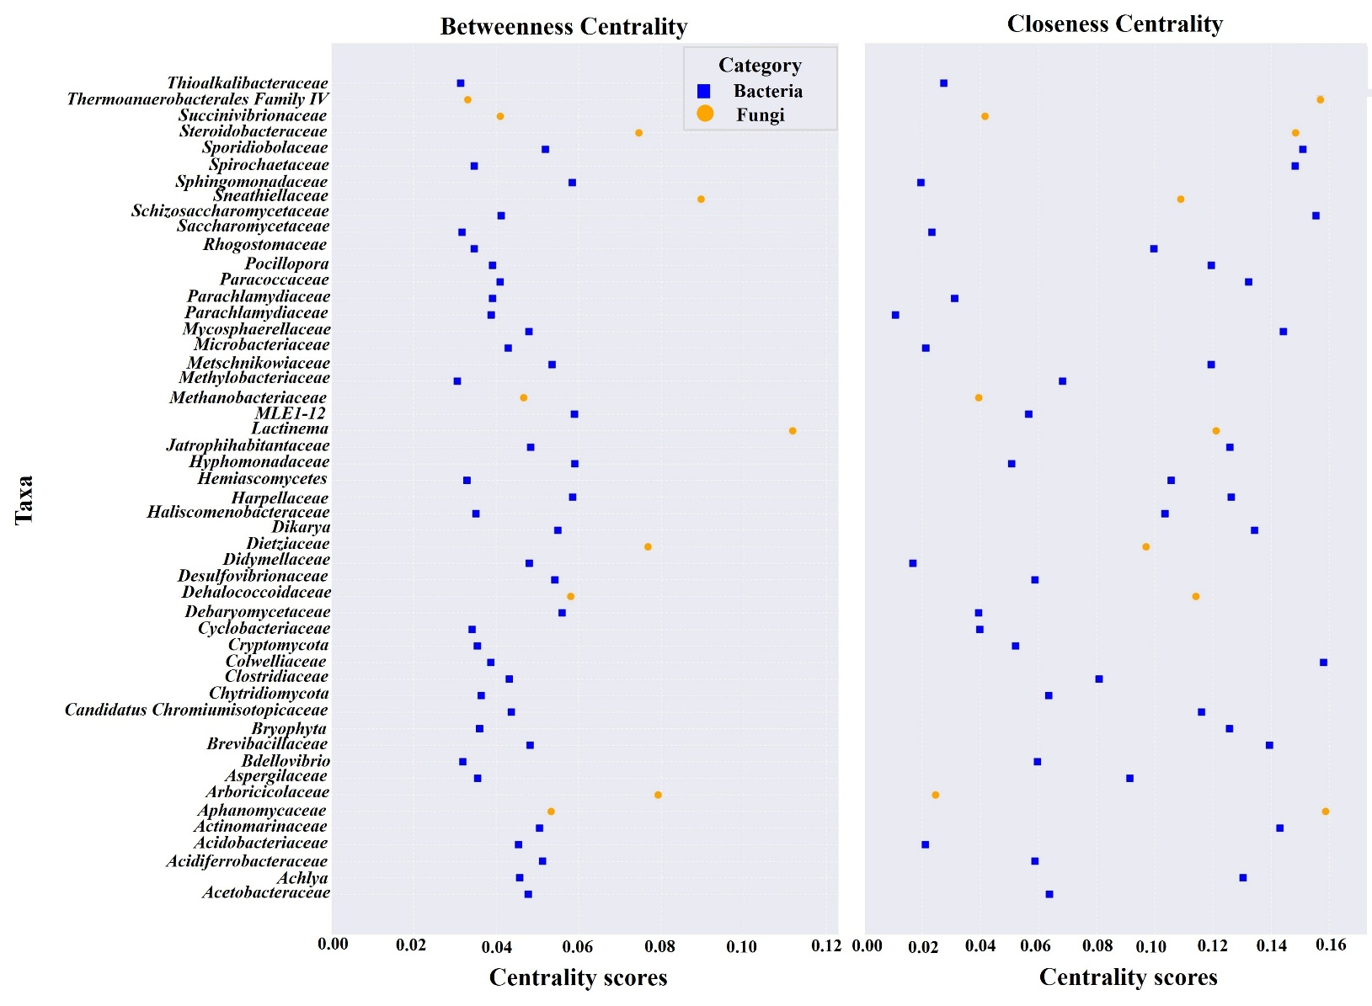

Supplementary Fig. 8 Betweenness and closeness centrality of microbial taxa in cassava rhizoplane-associated microbiome networks

Rhizoplane bacterial isolate | Dual culture assay | Rhizoplane bacterial isolate | Dual culture assay
Bacillus subtilisULB_36 | 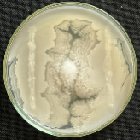 | Bacillus sp.WDB_25 | 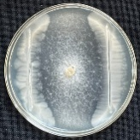
Bacillus sp.1ULB_12 | 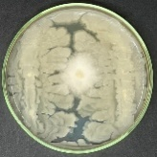 | Klebsiella aerogenes3ULB_39 | 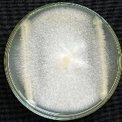
Pseudomonas aeruginosaULB_13 | 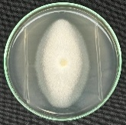 | Pseudomonas sp.1ULB_33 | 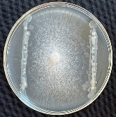
Acinetobacter sp.WHB_6 | 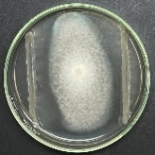 | Burkholderia cenocepaciaULB_43 | 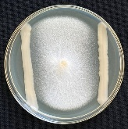
Kosakonia sp.7WHB_75 | 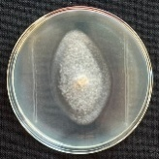 | Priestia sp.1WHB_14 | 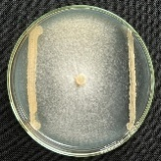
Bacillus sp.2ULB_25 | 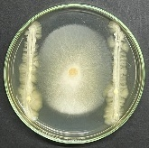 | Stenotrophomonas sp.ULB_18 | 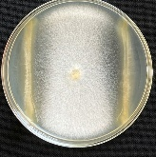
Bacillus aerophilusULB_53 | 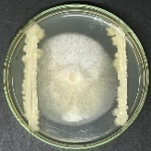 | Kosakonia sp.3WDB_58 | 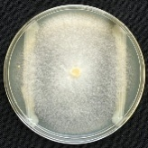
Kosakonia sp.1WHB_4 | 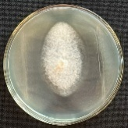 | Kosakonia sp.1WDB_41 | 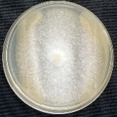
Klebsiella pneumoniaeWHB_81 | 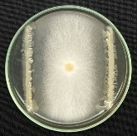 | Burkholderia sp.ULB_22 | 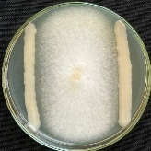
Enterobacter sp.2ULB_31 | 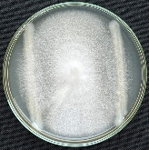 | Control | 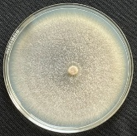

Supplementary Fig. 9 Dual culture assay demonstrating the antagonistic potential of rhizoplane bacterial isolates against Fusarium falciforme

Rhizoplane bacterial isolate | Volatile-mediated assay |  | Isolate | Volatile-mediated assay
Rhizoplane bacterial isolate | Bacterial isolate | Volatile-exposed pathogen |  | Bacterial isolate | Volatile-exposed pathogen
Niallia circulansULB_7 | 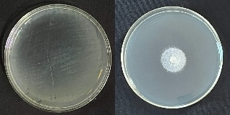 |  | Kosakonia sp.1WHB_4 | 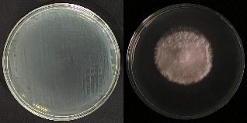
Klebsiella pneumoniaeWHB_81 | 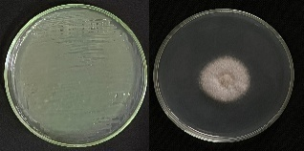 |  | Stenotrophomonas sp.2WHB_8 | 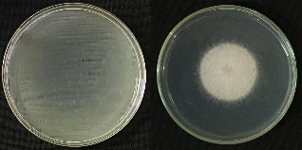
Pseudomonas knackmussiiWDB_84 | 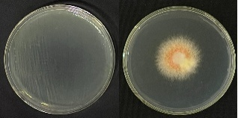 |  | Cytobacillus oceanisediminis3WHB_35
Pseudomonas sp.1WHB_83 | 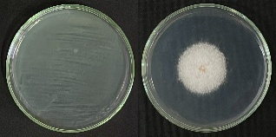 |  | Stutzerimonas stutzeriWDB_11 | 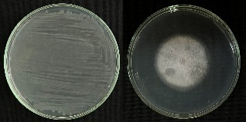
Bacillus infantisWDB_4 | 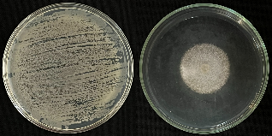 |  | Bacillus sp.2ULB_25 | 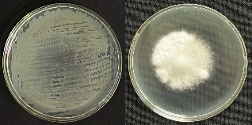
Pseudomonas sp.1ULB_33 | 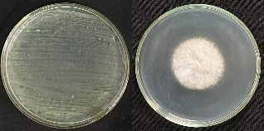 |  | Pseudomonas aeruginosaULB_13 | 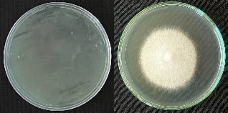
Pseudomonas alloputidaWHB_65 | 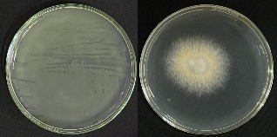 |  | Cytobacillus kochiiWDB_12 | 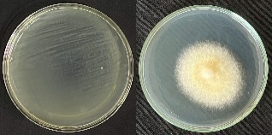
Stenotrophomonas sp.1WHB_2 | 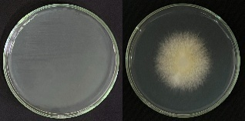 |  | Priestia aryabhattaiULB_17 | 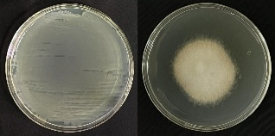
Bacillus subtilisULB_36 | 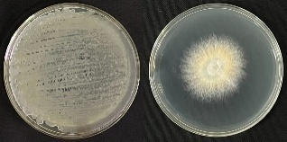 |  | Pantoea dispersa2WHB_67 | 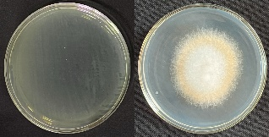
Pantoea dispersa1WHB_55 | 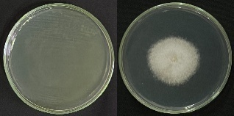 |  | Negative control | 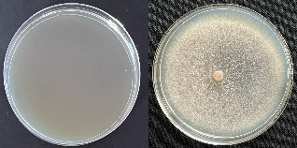

Supplementary Fig. 10 Rhizoplane bacterial volatile-mediated suppression of Fusarium falciforme

