Fig. 1S. Demographically viable underserved zones for heart transplantation in Colombia.
White and blue shading depict the current access footprint to the nearest licensed heart transplant centre, classified as optimal (white; ≤4 h) and suboptimal (blue; 4–6 h). Polygons indicate potential expansion zones located outside the current footprint, defined as spatially coherent areas beyond the clinically acceptable threshold (>6 h) that intersect populations ≥100,000.

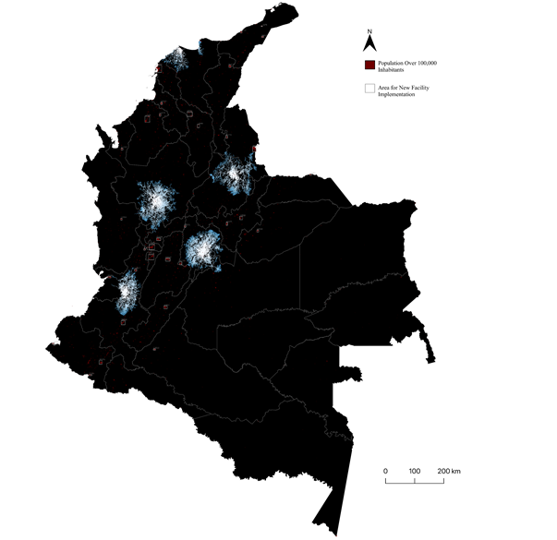

Fig. 2S. Demographically viable, underserved lung-transplantation zones in Colombia.
White and blue shading depict the current access footprint, classified as optimal (white; ≤6 h) and suboptimal (blue; 6–8 h). Polygons indicate potential expansion zones outside the footprint, defined as areas beyond the threshold (>8 h) that intersect populations ≥100,000.

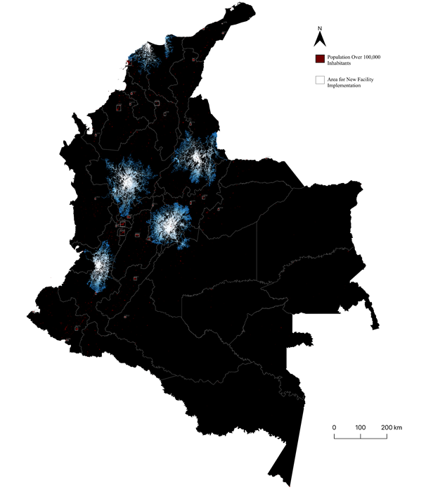
Fig. 3S. Demographically viable underserved zones for liver transplantation in Colombia.
White and blue shading depict the current access footprint, classified as optimal (white; ≤6 h) and suboptimal (blue; 6–8 h). Polygons indicate potential expansion zones outside the footprint, defined as areas beyond the threshold (>8 h) that intersect populations ≥100,000.

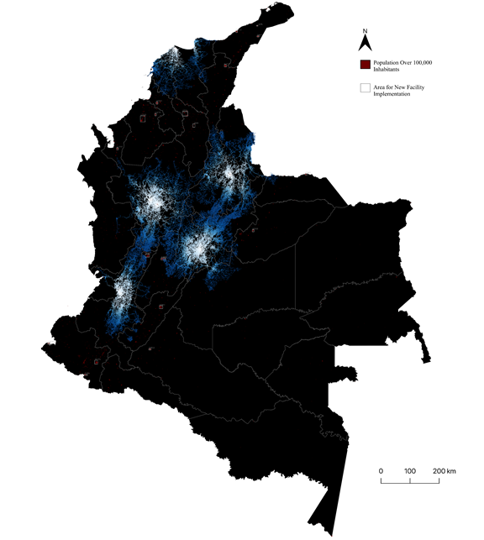
Fig. 4S. Demographically viable underserved zones for bone tissue transplantation in Colombia.
White and blue shading depict the current access footprint, classified as optimal (white; ≤16 h) and suboptimal (blue; 16–18 h). Polygons indicate potential expansion zones outside the footprint, defined as areas beyond the threshold (>18 h) that intersect populations ≥100,000.

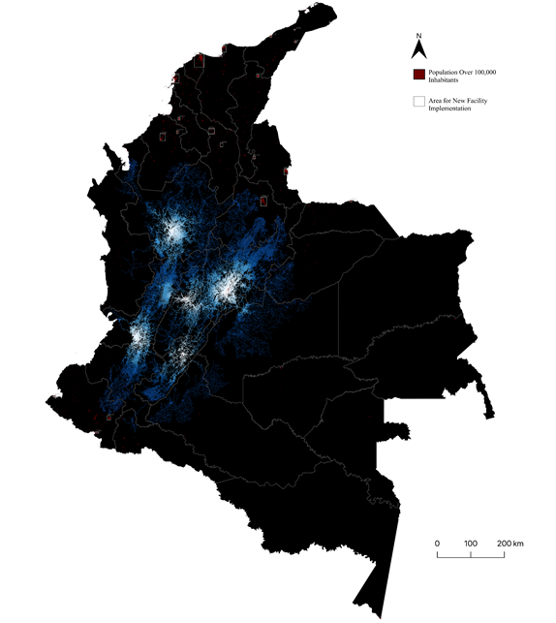

Fig. 5S. Demographically viable underserved zones for cardiac valve transplantation in Colombia.
White and blue shading depict the current access footprint, classified as optimal (white; ≤4 h) and suboptimal (blue; 4–6 h). Polygons indicate potential expansion zones outside the footprint, defined as areas beyond the threshold (>6 h) that intersect populations ≥100,000.

