Table 1. Optimization of the reaction conditions
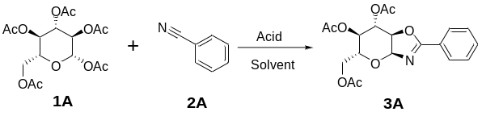
Entry | TfOH (eq.) | Water (eq.) | Solvent | Time | Tem. | Yield ª
1 | 1.0 | 0.1 | DCM | 2h | rt | 33%
2 | 1.0 | 0.5 | DCM | 2h | rt | 38%
3 | 1.0 | 1.0 | DCM | 2h | rt | 40%
4 | 1.0 | 2.0 | DCM | 2h | rt | 21%
5 | 0.5 | 1.0 | DCM | 2h | rt | 28%
6 | 2.0 | 1.0 | DCM | 2h | rt | 74%
7 | 3.0 | 1.0 | DCM | 2h | rt | 51%
8 | 2.0 | 1.0 | DCM | 12h | 0℃ | 57%
9 | 2.0 | 1.0 | DCM | 2h | 40℃ | 20%
10 | 2.0 | 1.0 | DCM | 6h | rt | 75%
11 | 2.0 | 1.0 | DCM | 12h | rt | 9%
12 | 2.0 | 1.0 | EA | 2h | rt | 0
13 | 2.0 | 1.0 | Acetone | 2h | rt | 0
14 | 2.0 | 1.0 | EtOH | 2h | rt | 0
ª: HPLC yield; rt: room temperature.

Table 2. Screening of the benzonitriles

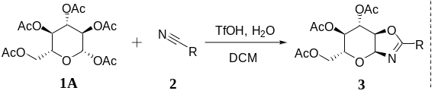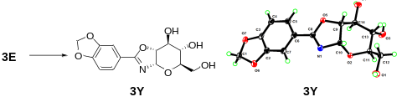
Comp. | R | Yield | α: β | Comp. | R | Yield | α: β | Comp. | R | Yield | α: β
3A | 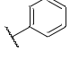 | 74% | 12:1 | 3I | 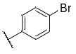 | 22% | 2:1 | 3Q | 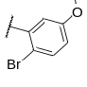 | 50% | α only
3B | 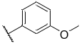 | 57% | 5:1 | 3J | 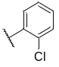 | 35% | α only | 3R | 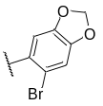 | 54% | 6:1
3C | 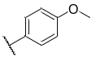 | 57% | 2:1 | 3K | 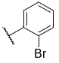 | 38% | 10:1 | 3S | 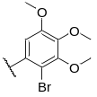 | 44% | 30:1
3D | 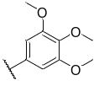 | 90% | 4:1 | 3L | 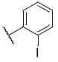 | 56% | 9:1 | 3T | 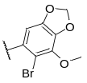 | 54% | α only
3E | 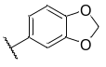 | 62% | 10:1 | 3M | 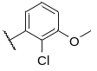 | 24% | 11:1 | 3U | 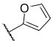 | 69% | 1:1
3F | 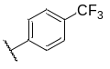 | 21% | 2:1 | 3N | 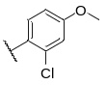 | 67% | 10:1 | 3V | 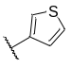 | 76% | 2:1
3G | 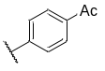 | 35% | 3:1 | 3O | 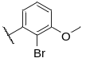 | 47% | 6:1 | 3W | 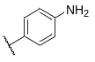 | n.p.
3H | 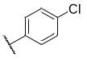 | 27% | 3:1 | 3P | 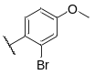 | 44% | 3:1 | 3X | 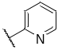 | n.p.

